## 4.7 Draft Interface Designs (Woodland University College Corporate Website)

### 4.4.1 Wireframes

The skeletal view or the blueprint of the software project is represented bye the wireframe method. This wireframe is related with the WUC’s website. It represents the initial web-layout interface of the system. Any type of users is directed initially to the homepage layout of the website. So, its key screen elements and content functionalities has been wireframed.

Homepage Web Portal layout

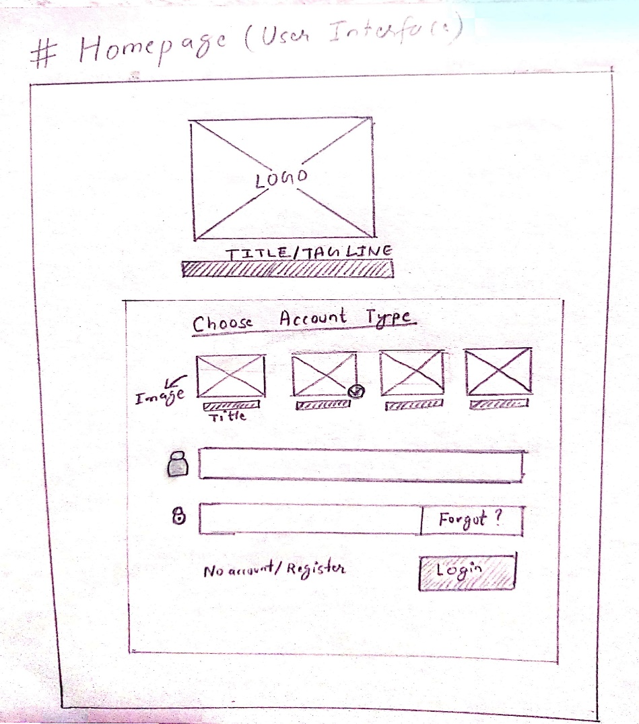

Fig1.1 Web layout (WUC)