DECLARATION

I, Sanjiv Tamang, hereby declare that the work contained herein is entirely my own, except were stated otherwise by reference or acknowledgement, and has not been published or submitted elsewhere, in whole or in part, for the requirement for any other degree or professional qualification. Any literature, data or works done by others and cited within this report has been given due acknowledgement and listed in the reference section.

***Name of the Student***

- Sanjiv Tamang

- B.Sc. hons. Computing (Software Engineering)

- Level 6

- U o N Id: 21422144

PRELIMINARY DRAFTS

Chat GPT in Academia: A Stepping Stone or a Stumbling Block?

An Analysis of Impact on Learning, Teaching and Evaluation Modality

Sanjiv Tamang*

B.Sc. hons Computing Student

NAMI College/ University of Northampton

Kathmandu Bagmati Nepal

sanjiv.2021209@nami.edu.np

ABSTRACT

Write the abstract last because it will change when your focus of paper changes.

**Four sentences:**

1. **State the problem**
2. **Why it’s an interesting problem**
3. **What’s your solution achieved?**
4. **What follows from your solution?**

CCS CONCEPTS

• Insert CCS text here • Insert CCS text here   • Insert CCS text here

**KEYWORDS**

Artificial Intelligence, Chatbot, Chat GPT

ACM Reference Format:

1. Introduction

In the computing world, Artificial Intelligence has been flourishing its unparallel performance in a wider range. This paper explores one of the most talked-about AI-based dialogue models, Chat GPT (Generative Pre-Trained Transformer), developed by Open AI. The study presented in this document analyzes several aspects of Chat GPT’s impact including its trustworthiness, accountability, and ethical implications. The paper also discusses the evolution of model and how these factors collectively influence the academic world of software engineering. Academics such as teachers, students, researchers and many more use it due to the diverse range of NLP (Natural Language Processing) functions, and making it popular choice in the academic community.

Chat GPT is an AI based large language model (LLM) that is designed to continuously learn and improve its performance through user interactions, resulting in accurate responses over time. IDENTIFICATION OF RESEARCH GAP…………………….

* 1. Purpose and Research Questions

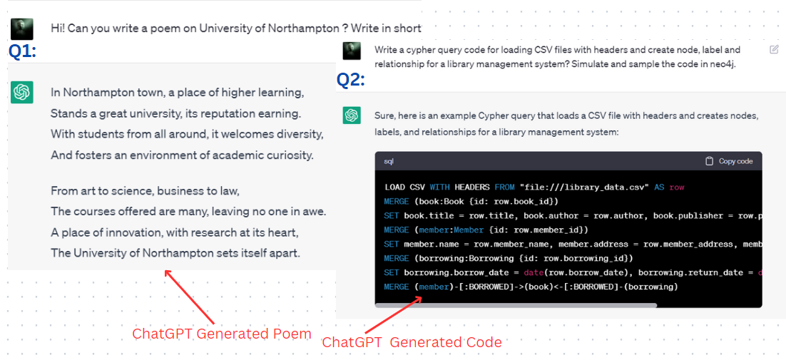

*Fig1.1:* *Chat GPT: (left: Chat GPT generated poem & right: Cypher query generated by Chat GPT in response)*

Some of the observed questions that raises problems are listed below:

1. Let us consider a student ask two different questions and the screenshots of responses generated by Chat GPT are shown in fig1.1, one being text-based and the other being code-based. Given this, how can academic circles such as universities, colleges, and schools maintain academic integrity in terms of plagiarism, honesty, novelty, utility, and quality?
2. Are there any limitations on Chat GPT learning environment for student’s edition to ensure that they preserve their creativity skills?
3. Is it warning to the teachers in terms of teaching and evaluation modality? Does Chat GPT passes the learning approaches like: Learning to Learn (L2L), Learning to Change (L2C) and Learning to Adapt (L2A)?

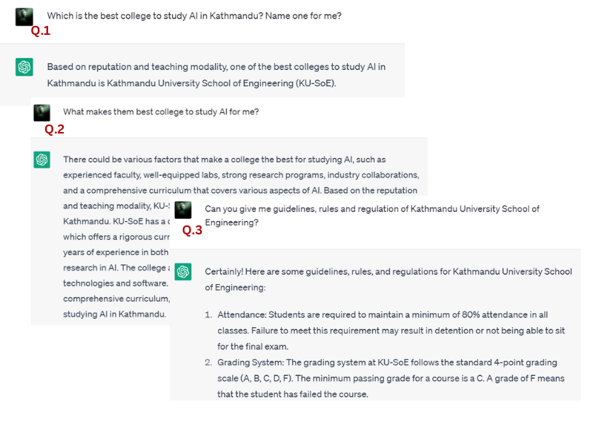

*Fig1.2: Chat GPT: Responding the user best college to study AI*

1. Based on Figure 1.2, do the decision-making information delivered by the model hold organizational, legal, and ethical accountability? What are the sources of data that can provide legitimacy and earn our trust for academic tasks such as research, thesis, presentation, writing reports, and so on?

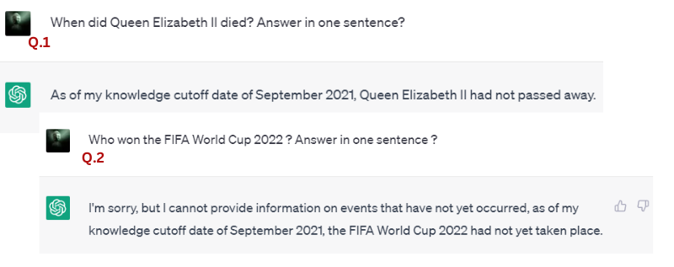

*Fig1.3: Chat GPT-3 models knowledge cut-off is September 2021*

1. Are the data provided by Chat GPT models accurate or outdated? What are the consequences if the response data is not up to date in the field of academic libraries?
2. Is it good or bad means of technology in educational field?

The following are the fundamental purposes and contributions of this research paper, listed below in a formal manner:

* To experiment and analyze the performance of Chat GPT on principle of academic integrity.
* To understand the wider range of functionalities, development process, and general architecture of Chat GPT. Also, to determine whether its audience is targeted based on performance or not.
* To analyze the probability of Chat GPT's impact on traditional teaching and evaluation modalities in academic institutions.
* To research Chat GPT's performance and accuracy in terms of accountability, trustworthiness, and ethical implications.
* To verify the accuracy of the data provided by Chat GPT.
* To critically analyze all arguments, review, comments in literature review section.
* To conclude the overall research paper theme.
  1. Progression of Chatbot

The Turing Test, proposed by Alan Turing in 1950, tests a machine's ability to engage in natural language conversations indistinguishable from those between humans. It was the first idea of a chatbot. And Chatbot, Virtual Personal Assistant and AI bot are the fundamental progression of Chatbots over time.

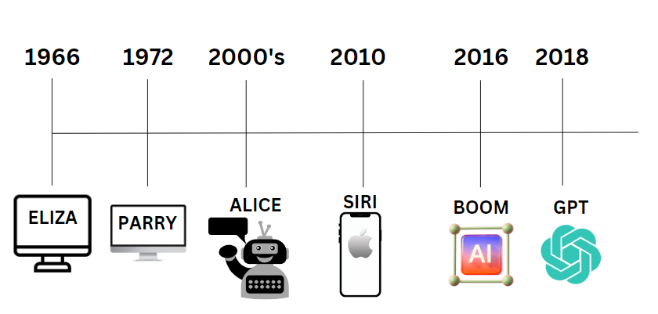

*Fig1.4: Prominent scene progression of Chatbot*

**1. Chatbot:** A Chatbot is a computer program designed to interact (either voice or text) with humans or understand user’s questions and response automatically by using Artificial Intelligence and Natural Language Processing.

Followings are the list of prominent names in the history of Chatbot development: -

* **ELIZA (1966):** First Chatbot designed to simulates the conversation that intended to be a psychotherapist.
* **PARRY (1972) , ALICE (Artificial Linguistic Internet Computer Entity- 2000’s**)

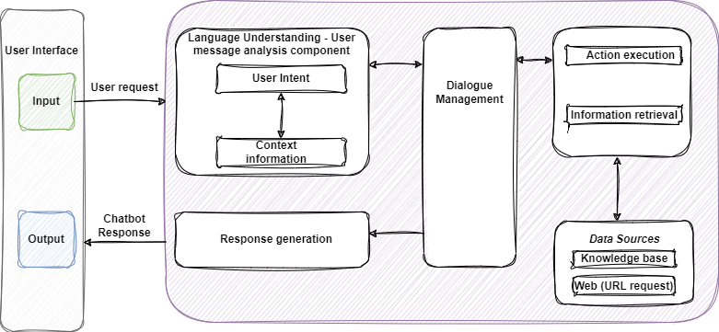

*Fig1.5: General Architecture of Chatbot*

**2. Virtual Personal Assistant:**

* **APPLE’s SIRI (2010):** First Chatbot as a Personal Virtual Agent.

Due to its broader abilities, Multiple industrial sectors have associated with this technology to enhance their performance. Main benefits are:

* Boost customer involvement and attachment to the brand resulting in loyalty
* Cost effective and increases productivity
* Acquire potential customers and ensure customer’s satisfaction

Generally, Chatbot can be categorized into two types:

|  |  |
| --- | --- |
| AI Based | Rule Based |
| These are intelligent bots that uses machine learning algorithms that understand and learns from the experiences whereas | These bots operate from the pre-defined rules and does not learn from experiences |
| It includes Open domain, conversational, task-based, personal assistant and social chatbots. | Based on knowledge domain it includes FAQ (Frequently Asked Questions), Single-turn and Retrieval-based chatbots. |

**3. AI bots**

Chat GPT:

Model/Transformer Architecture:

There are two concepts in Chat GPT (Generative Pre-trained Transformer)’s Architecture: One: Multi-head Attention, Other: Positional Embeddings.

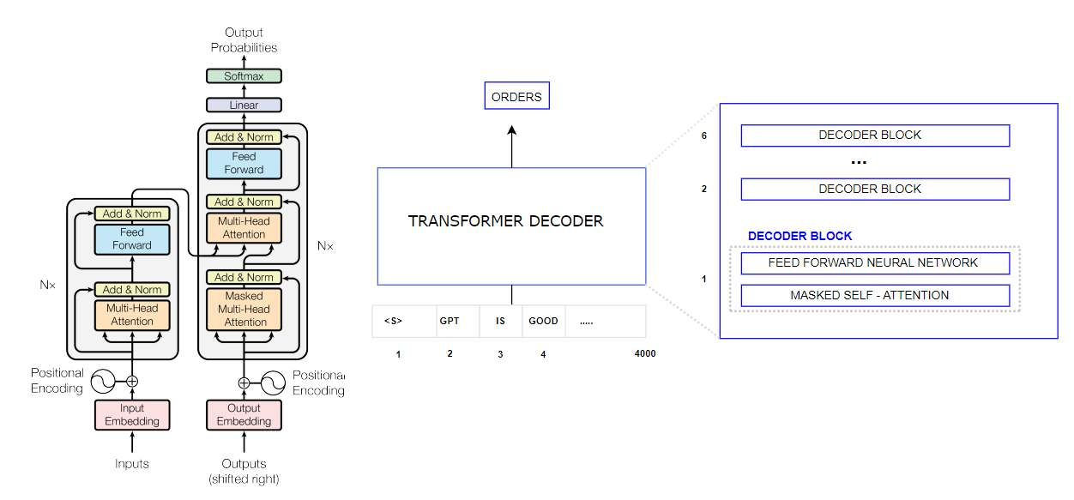

*Fig1.6: General Architecture of GPT (Generative Pre-Trained Transformer)*

Encoder and Decoder Structure:

There are also two essential components: Encoder and Decoder that are used for processing and generation sequential data, such as natural language text.

1. Literature Review

The main purpose of this literature review is to demonstrate the impact of Chat GPT on teaching, learning and evaluation modality in the education domain and understand, identify the potential challenges and its benefits.

1. Critical Analysis
2. Project Management