Electronic Appliance Store Management System
Database Management Systems (DBMS) — Review 2: Database Implementation & Backend Integration
Item | Detail
Student | Sanjiv Shine Fernandas
Subject | Database Management Systems
Evaluation | Review 2 — Database Implementation & Backend Integration
Database | Oracle Database 21c XE, pluggable database XEPDB1, schema appliance_app
Backend | Python Flask, python-oracledb (Thin mode)
Frontend | HTML5, CSS3, vanilla JavaScript
Environment | Windows local demonstration

> Submission: repository <https://github.com/sanjiv283/Electronic_Appliance_Store_Manager> (default branch main). Companion files: docs/Review_2_Presentation.pptx, docs/demo_guide.md, README.md.
> Verification disclosure. The report and code were authored in an environment with no Oracle Database. On 2026-10-22 the student ran the 16 live integration tests (INT-01..16) on a real Oracle Database 21c XE (XEPDB1, separate test schema): 16 PASSED, and executed all 16 queries in queries.sql on the demo schema without error. The offline checks in §24 remain as listed. The live results were transcribed from the student's console output into docs/test_results.xml; they were not produced by the authoring environment. Anything not covered by those two runs is labelled in §24 and §28.

Table of Contents
- 1. Abstract
- 2. Introduction
- 3. Problem statement
- 4. Objectives
- 5. Scope and limitations
- 6. Functional requirements
- 7. Non-functional requirements
- 8. Software and hardware requirements
- 9. System architecture
- 10. Database design
- 11. ER diagram
- 12. Table descriptions
- 13. Keys and constraints
- 14. Normalization
- 15. Implementation
- 16. Flask and Oracle connectivity
- 17. CRUD operations
- 18. Transactions and inventory consistency
- 19. SQL joins, subqueries, aggregations
- 20. View, procedure, function, trigger
- 21. CRUD and sales screens
- 22. Database access safeguards
- 23. Testing methodology
- 24. Verified testing matrix
- 25. Results and discussion
- 26. Known limitations
- 27. Installation summary
- 28. Faculty evaluation cross-reference
- 29. Conclusion
- 30. References

1. Abstract
The Electronic Appliance Store Management System is a database-driven web application for a retail appliance shop. A normalized Oracle 21c schema of seven tables stores categories, suppliers, products, customers, employees, sales and sale items. A Flask service layer using python-oracledb provides CRUD for four master entities and transactional multi-item sales with row-level inventory locking. Oracle-side logic consists of one view, one stored procedure, one stored function and one integrity trigger. Sixteen documented SQL queries demonstrate joins, subqueries, aggregation and analytic features. The application connects with a least-privilege account and uses bind variables for all SQL. 76 automated tests ran and passed without Oracle (fake connection), and the 16 live-Oracle integration tests passed on a real Oracle 21c XE instance (run by the student on 2026-10-22).

2. Introduction
Appliance retailers handle high-value items with changing prices and limited stock. Spreadsheet records lead to oversold items, lost price history and inconsistent customer data. A relational database with enforced integrity and transactional sales processing addresses these issues. This project implements that system for Review 2, which evaluates database creation, keys and constraints, sample data, queries, advanced objects, connectivity and CRUD/transactions.

3. Problem statement
Design and implement a relational database and web front end that (a) stores store master data without redundancy, (b) records sales with historical prices, (c) prevents negative or oversold inventory even with simultaneous users, and (d) answers business questions (revenue, best sellers, low stock, customer spend).

4. Objectives
- Create a normalized (3NF) Oracle schema with full integrity constraints.
- Provide deterministic fictional sample data.
- Provide exactly 16 documented queries and four advanced database objects.
- Connect Flask to Oracle securely with python-oracledb Thin mode.
- Implement CRUD and an atomic sales transaction that never oversells.
- Provide automated tests with honest, status-labelled results.

5. Scope and limitations
In scope: master-data CRUD, sales entry and history, restock, backend–Oracle connectivity. Out of scope for Review 2: user authentication/authorization, dashboards and report screens, returns and refunds, taxes/discounts, purchase orders to suppliers, multi-currency, employee CRUD screens (employees are seeded and selectable on sales). Further limitations in §26.

6. Functional requirements
- FR1 Manage products, categories, suppliers, customers (create, list/search, edit, delete).
- FR2 Record a sale with one or more products; totals and prices come from the database.
- FR3 Deduct stock exactly once per sale; reject insufficient stock.
- FR4 Restock a product.
- FR5 Browse sales history and sale details; search by invoice, customer or employee.
- FR6 Health endpoint reporting real database connectivity.

7. Non-functional requirements
- Integrity: all rules enforced in the database where possible (PK/FK/UNIQUE/CHECK).
- Security (database access): no secrets in code, bind variables, least privilege.
- Reliability: transactions commit atomically or roll back; connections always closed.
- Maintainability: service-layer separation; tests per layer.
- Portability: Windows 10/11 local setup.

8. Software and hardware requirements
Item | Requirement
OS | Windows 10/11 (development sandbox was Linux, used only for non-Oracle checks)
Python | 3.11+ (3.13 used in the sandbox)
Python packages | Flask, oracledb, python-dotenv, pytest (python-docx, reportlab for report build)
Database | Oracle Database 21c XE with XEPDB1
Tools | SQL*Plus (bundled with XE), PowerShell, a modern browser
Hardware | 2+ CPU cores, 4 GB RAM minimum (Oracle XE limit 2 GB database RAM), ~5 GB disk

Technology stack
Layer | Technology
Presentation | HTML5, CSS3, vanilla JavaScript, Jinja2 templates (CRUD forms)
Application | Python, Flask, python-dotenv, service-layer modules
Database access | python-oracledb Thin mode (no Oracle Client install needed)
Database | Oracle Database 21c XE, PDB XEPDB1, PL/SQL
Quality | pytest, fake DB connection, Flask test client
Documentation | Markdown source, python-docx, ReportLab, python-pptx

9. System architecture
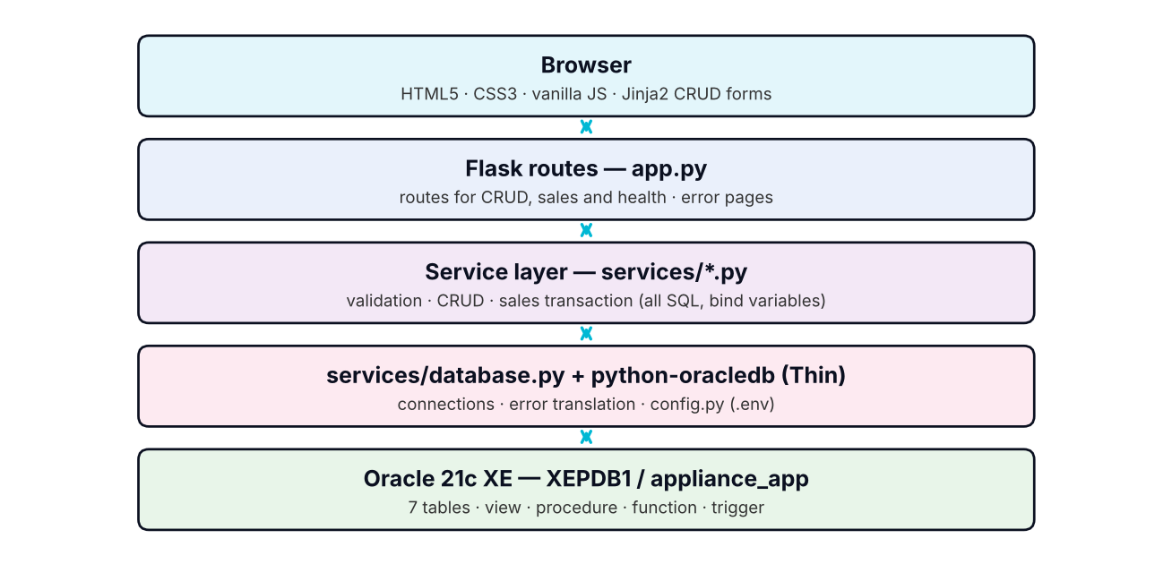
System architecture
Routes call services only; services own all SQL; the database layer is the only module importing oracledb's connect call.

10. Database design
Naming: upper-case Oracle identifiers; PK_, FK_, UQ_, CK_, IX_ prefixes. Surrogate keys use NUMBER GENERATED ALWAYS AS IDENTITY. Money columns are NUMBER(p,2) (Python Decimal, never float). Timestamps use TIMESTAMP. Deletion behaviour: every foreign key is NO ACTION (restrict) — there is no cascade, so historical sales cannot be destroyed by deleting a customer, employee or product (ORA-02292, reported to users as a friendly 409). Indexes: FK columns (IX_PRODUCTS_CATEGORY, IX_PRODUCTS_SUPPLIER, IX_SALES_CUSTOMER, IX_SALES_EMPLOYEE, IX_SALE_ITEMS_PRODUCT) and the report filter IX_SALES_DATE; PK/UNIQUE constraints supply their own indexes (including UQ_SALE_ITEMS_LINE (SALE_ID, PRODUCT_ID) which serves lookups by sale).

11. ER diagram
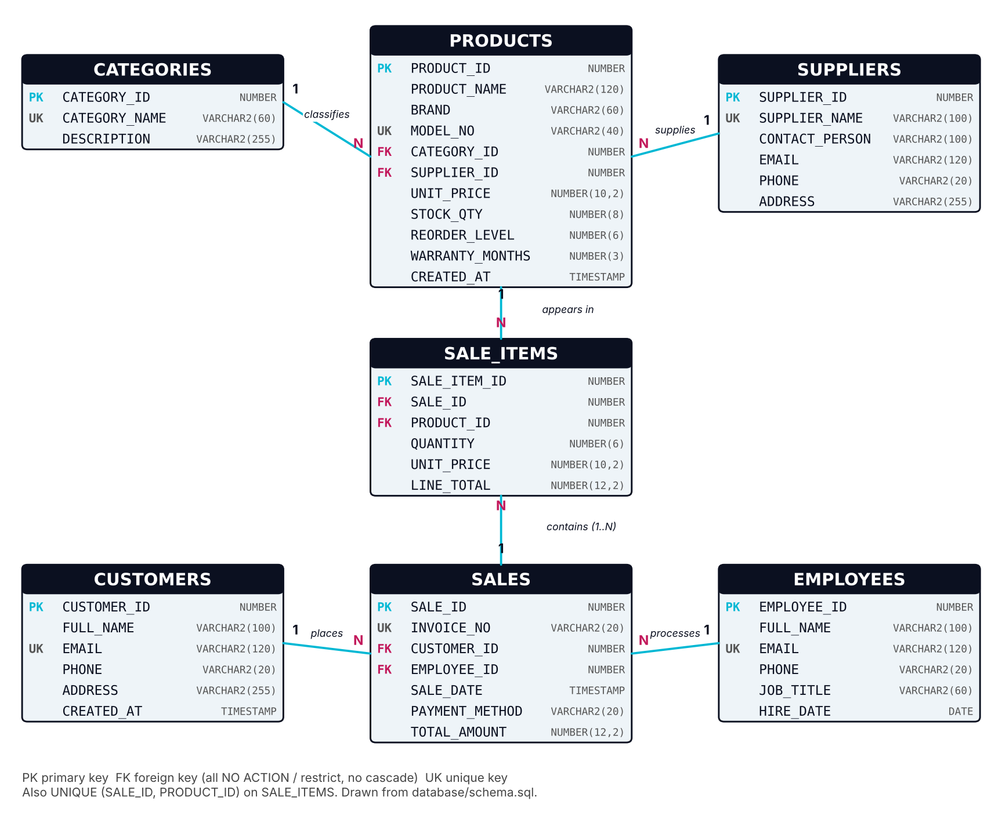
ER diagram generated from database/schema.sql
Mermaid source of the same diagram (renders on GitHub; omitted from the PDF/DOCX where the image above is used):

12. Table descriptions and relationships
Table | Purpose | Key columns
CATEGORIES | Product groups | PK CATEGORY_ID; UK CATEGORY_NAME
SUPPLIERS | Vendors | PK SUPPLIER_ID; UK SUPPLIER_NAME
PRODUCTS | Central product catalogue and live stock | PK PRODUCT_ID; UK MODEL_NO; FK CATEGORY_ID, SUPPLIER_ID
CUSTOMERS | Buyers | PK CUSTOMER_ID; UK EMAIL
EMPLOYEES | Staff who process sales | PK EMPLOYEE_ID; UK EMAIL
SALES | One row per invoice | PK SALE_ID; UK INVOICE_NO; FK CUSTOMER_ID, EMPLOYEE_ID
SALE_ITEMS | Lines of a sale with historical price/quantity | PK SALE_ITEM_ID; UK (SALE_ID,PRODUCT_ID); FK SALE_ID, PRODUCT_ID

Relational schema (PK underlined by convention, → marks a foreign key):
CATEGORIES (CATEGORY_ID, CATEGORY_NAME, DESCRIPTION)
SUPPLIERS (SUPPLIER_ID, SUPPLIER_NAME, CONTACT_PERSON, EMAIL, PHONE, ADDRESS)
PRODUCTS (PRODUCT_ID, PRODUCT_NAME, BRAND, MODEL_NO, CATEGORY_ID→CATEGORIES, SUPPLIER_ID→SUPPLIERS,
UNIT_PRICE, STOCK_QTY, REORDER_LEVEL, WARRANTY_MONTHS, CREATED_AT)
CUSTOMERS (CUSTOMER_ID, FULL_NAME, EMAIL, PHONE, ADDRESS, CREATED_AT)
EMPLOYEES (EMPLOYEE_ID, FULL_NAME, EMAIL, PHONE, JOB_TITLE, HIRE_DATE)
SALES (SALE_ID, INVOICE_NO, CUSTOMER_ID→CUSTOMERS, EMPLOYEE_ID→EMPLOYEES, SALE_DATE,
PAYMENT_METHOD, TOTAL_AMOUNT)
SALE_ITEMS (SALE_ITEM_ID, SALE_ID→SALES, PRODUCT_ID→PRODUCTS, QUANTITY, UNIT_PRICE, LINE_TOTAL)
Relationships (all one-to-many): a category has many products; a supplier supplies many products; a customer has many sales; an employee processes many sales; a sale contains one or more items (≥1 enforced by the service); a product appears in many sale items. A product row is never duplicated by a sale — SALE_ITEMS references it and keeps the price and quantity at the time of sale.

13. Primary keys, foreign keys and integrity constraints
Table | Constraints (names as in schema.sql)
CATEGORIES | PK_CATEGORIES, UQ_CATEGORIES_NAME, CATEGORY_NAME NOT NULL
SUPPLIERS | PK_SUPPLIERS, UQ_SUPPLIERS_NAME, SUPPLIER_NAME NOT NULL
CUSTOMERS | PK_CUSTOMERS, UQ_CUSTOMERS_EMAIL, FULL_NAME/EMAIL/PHONE NOT NULL
EMPLOYEES | PK_EMPLOYEES, UQ_EMPLOYEES_EMAIL, FULL_NAME/EMAIL/JOB_TITLE/HIRE_DATE NOT NULL
PRODUCTS | PK_PRODUCTS, UQ_PRODUCTS_MODEL, FK_PRODUCTS_CATEGORY, FK_PRODUCTS_SUPPLIER, CK_PRODUCTS_PRICE (UNIT_PRICE >= 0), CK_PRODUCTS_STOCK (STOCK_QTY >= 0), CK_PRODUCTS_REORDER (>= 0), CK_PRODUCTS_WARRANTY (0..120)
SALES | PK_SALES, UQ_SALES_INVOICE, FK_SALES_CUSTOMER, FK_SALES_EMPLOYEE, CK_SALES_PAYMENT (CASH, CARD, UPI, BANK_TRANSFER), CK_SALES_TOTAL (TOTAL_AMOUNT > 0)
SALE_ITEMS | PK_SALE_ITEMS, UQ_SALE_ITEMS_LINE (SALE_ID, PRODUCT_ID), FK_SALE_ITEMS_SALE, FK_SALE_ITEMS_PRODUCT, CK_SALE_ITEMS_QTY (> 0), CK_SALE_ITEMS_PRICE (>= 0), CK_SALE_ITEMS_TOTAL (LINE_TOTAL = QUANTITY * UNIT_PRICE)

E-mail and phone *format* validation is performed at the application level (services/validation.py) as specified. Sequence SEQ_INVOICE_NO (start 1000) generates invoice numbers INV-001000…; seed invoices use INV-000001… so they never collide.

14. Normalization analysis (1NF → 3NF)
1NF. Every column holds a single atomic value and no table has repeating groups: the "many products in one sale" requirement is modelled by rows in SALE_ITEMS rather than columns such as PRODUCT1, PRODUCT2. Each table has a primary key. (An address is kept as one atomic text attribute because the application never queries its parts; splitting it would be a refinement, not a 1NF requirement here.)
2NF. All tables use a single-column surrogate primary key, so partial dependencies on part of a key cannot occur. For SALE_ITEMS the natural candidate key is the composite (SALE_ID, PRODUCT_ID): QUANTITY and UNIT_PRICE depend on *both* (how many of which product on which invoice). Product attributes such as name or category are deliberately not copied into SALE_ITEMS; they would depend on PRODUCT_ID alone (a partial dependency) and are kept only in PRODUCTS.
3NF. No non-key attribute depends on another non-key attribute, with the examples:
Table | Functional dependencies | Why in 3NF
CATEGORIES | CATEGORY_ID → CATEGORY_NAME, DESCRIPTION; CATEGORY_NAME → CATEGORY_ID | Both determinants are candidate keys
SUPPLIERS | SUPPLIER_ID → all; SUPPLIER_NAME → all | Determinants are keys
PRODUCTS | PRODUCT_ID → all; MODEL_NO → all | Category and supplier *names* are not stored — only FKs — so no PRODUCT_ID → CATEGORY_ID → CATEGORY_NAME transitive dependency
CUSTOMERS | CUSTOMER_ID → all; EMAIL → all | Determinants are keys
EMPLOYEES | EMPLOYEE_ID → all; EMAIL → all | Determinants are keys
SALES | SALE_ID → all; INVOICE_NO → all | Customer/employee names are not stored (only FKs)
SALE_ITEMS | SALE_ITEM_ID → all; (SALE_ID, PRODUCT_ID) → QUANTITY, UNIT_PRICE, LINE_TOTAL | See the documented exception below

Documented, deliberate redundancy (not hidden).
- SALE_ITEMS.LINE_TOTAL = QUANTITY × UNIT_PRICE is a derived column: {QUANTITY, UNIT_PRICE} → LINE_TOTAL has a non-key determinant, so strictly SALE_ITEMS is *not* in 3NF. It is stored for audit and fast reporting, and the anomaly risk is removed by CK_SALE_ITEMS_TOTAL.
- SALES.TOTAL_AMOUNT equals the sum of its lines' LINE_TOTAL. It is computed once by the service from database prices; V_SALES_SUMMARY.TOTAL_MATCHES exposes any mismatch. A CHECK cannot span tables, so this one is enforced by the service, not by a constraint.
- SALE_ITEMS.UNIT_PRICE repeats the *name* of PRODUCTS.UNIT_PRICE but not its meaning: it is the price at the moment of sale (history), whereas the product price is the current price.

15. Implementation details
- database/schema.sql — re-runnable DDL via an anonymous block that tolerates only ORA-00955.
- database/seed.sql — generated from fixed data; MERGE by natural keys; totals computed, not hand-typed.
- database/queries.sql — 16 numbered queries; database/advanced_features.sql — four objects plus self-rolling-back verification blocks; database/setup_user.sql — one-time admin script (password typed at a hidden prompt).
- Sample data (seed.sql, fictional; 6 categories, 4 suppliers, 14 products, 8 customers, 4 employees, 8 sales, 15 sale items). Examples:
Model | Product | Price (₹) | Stock
ARC-RF260 | Arctiva 260L Double Door Refrigerator | 28,999.00 | 12
WW-FL70 | WashWell 7kg Front Load Washing Machine | 31,999.00 | 6
CB-AC10 | CoolBreeze 1.0 Ton Window AC | 26,499.00 | 2 (below reorder level 3)
VV-TV55 | VistaView 55in 4K Smart TV | 49,999.00 | 4 (at reorder level 4)
KP-MG75 | KitchenPro Mixer Grinder 750W | 3,299.00 | 25

Sale INV-000001 (Anita Rao, card): 1 × ARC-RF260 + 2 × KP-MG75 = ₹35,597.00. The eight seeded sales total ₹339,582.00 (hand-checked against the seed values; not yet confirmed by a live query). Two products (VV-TV32, AU-EK18) are intentionally never sold, and one customer has no sales, to give the NOT EXISTS and LEFT JOIN queries meaningful output.
- Python: config.py; services/*; app.py (25 routes); Jinja templates and static assets.

16. Flask and Oracle connectivity
config.load_db_settings() reads DB_HOST, DB_PORT, DB_SERVICE_NAME, DB_USER, DB_PASSWORD from the environment (python-dotenv loads .env at app start). Values still in <placeholder> form count as missing; errors list variable *names* only; SYS/SYSTEM/SYSDBA/SYSOPER are refused. services.database.get_connection() opens a Thin-mode connection per unit of work (oracledb.connect(user, password, dsn="host:port/XEPDB1")) and connection() always closes it (rolling back on error). oracledb.defaults.fetch_decimals = True returns money as Decimal. Diagnostics: python -m services.database and GET /health — both report success only after SELECT USER … FROM DUAL returned. Unavailable Oracle yields HTTP 503 with remediation text and no invented figures.

17. CRUD operations
Products, categories, suppliers and customers each have list (search/filter/pagination), create, update (edit form pre-filled via ?edit=<id>) and delete (POST, confirmation dialog, CSRF). Each service validates input, then runs a parameterized statement in its own short transaction. Constraint errors are translated: ORA-00001 → 409 "already exists", ORA-02291 → 400 invalid reference, ORA-02292 → 409 "referenced by other records", ORA-02290 → 400 rule violation, ORA-30006 → 409 "inventory busy". Restock calls SP_RESTOCK_PRODUCT.

18. Transaction management and inventory consistency
services/sales.create_sale (single connection, no autocommit):
- Validate ids, payment method and items (non-empty, quantity 1–1000, ≤50 lines; duplicate products merged). No SQL runs if validation fails.
- Verify the customer and employee exist.
- For each product in ascending id order run SELECT … FOR UPDATE WAIT 10 (consistent lock order → no deadlock between sales; bounded wait → ORA-30006 instead of hanging).
- After *all* locks are held, re-check stock; any shortage → InsufficientStockError listing the products.
- Compute each line and the total as Decimal from the locked database rows (client prices/totals are never accepted — create_sale has no price/total parameters).
- INSERT the sale (invoice from SEQ_INVOICE_NO, RETURNING SALE_ID), INSERT each item, UPDATE PRODUCTS SET STOCK_QTY = STOCK_QTY - :qty — the only place stock is deducted (the trigger deliberately does not touch inventory).
- One COMMIT. Any exception → rollback (the connection() context manager and the connection close both enforce it).
Oracle's default READ COMMITTED isolation plus row locks prevents overselling: a concurrent buyer blocks on the lock, then re-reads the committed lower stock. CK_PRODUCTS_STOCK is the final safety net. Unit tests prove ordering, single commit, rollback and parameterization against a fake connection; the live concurrency proof is integration test INT-16 "concurrent sales cannot oversell" (PASSED on Oracle 21c XE).

19. SQL joins, subqueries and aggregations
# | Query | Concept
1 | In-stock products over ₹20,000 | SELECT, WHERE, ORDER BY
2 | Products in categories matching a pattern | IN subquery
3 | Products with category | INNER JOIN
4 | Products with supplier | JOIN
5 | Customers with their sales (incl. none) | LEFT JOIN
6 | Employee sales performance | LEFT JOIN + COUNT/SUM
7 | Full invoice lines | 5-table JOIN
8 | Products per category | GROUP BY + COUNT
9 | Monthly revenue | SUM/COUNT/AVG by date expression
10 | Categories with revenue > 50,000 | HAVING
11 | Products above average price | Scalar subquery
12 | Products above their category average | Correlated subquery
13 | Products never sold | NOT EXISTS
14 | Top 5 products by units | Aggregation + FETCH FIRST
15 | Customer spend ranking | RANK() analytic
16 | Inventory value and reorder status | CASE KPI

Example queries (verbatim from `database/queries.sql`)
-- Query 7: Full invoice lines (five-table JOIN)
-- Concept: SALES - CUSTOMERS - EMPLOYEES - SALE_ITEMS - PRODUCTS.
SELECT s.INVOICE_NO, TO_CHAR(s.SALE_DATE, 'YYYY-MM-DD') AS SALE_DAY,
c.FULL_NAME AS CUSTOMER, e.FULL_NAME AS EMPLOYEE,
p.PRODUCT_NAME, si.QUANTITY, si.UNIT_PRICE, si.LINE_TOTAL
FROM SALES s
JOIN CUSTOMERS c ON c.CUSTOMER_ID = s.CUSTOMER_ID
JOIN EMPLOYEES e ON e.EMPLOYEE_ID = s.EMPLOYEE_ID
JOIN SALE_ITEMS si ON si.SALE_ID = s.SALE_ID
JOIN PRODUCTS p ON p.PRODUCT_ID = si.PRODUCT_ID
ORDER BY s.SALE_DATE, s.INVOICE_NO, p.PRODUCT_NAME;
-- Query 10: Categories with revenue above 50,000
-- Concept: HAVING filters groups after aggregation.
SELECT c.CATEGORY_NAME, SUM(si.LINE_TOTAL) AS CATEGORY_REVENUE
FROM SALE_ITEMS si
JOIN PRODUCTS p ON p.PRODUCT_ID = si.PRODUCT_ID
JOIN CATEGORIES c ON c.CATEGORY_ID = p.CATEGORY_ID
GROUP BY c.CATEGORY_ID, c.CATEGORY_NAME
HAVING SUM(si.LINE_TOTAL) > 50000
ORDER BY CATEGORY_REVENUE DESC;
-- Query 12: Products priced above the average of their OWN category
-- Concept: correlated subquery (inner query references the outer row).
SELECT p.PRODUCT_NAME, p.CATEGORY_ID, p.UNIT_PRICE
FROM PRODUCTS p
WHERE p.UNIT_PRICE > (SELECT AVG(p2.UNIT_PRICE)
FROM PRODUCTS p2
WHERE p2.CATEGORY_ID = p.CATEGORY_ID)
ORDER BY p.CATEGORY_ID, p.UNIT_PRICE DESC;
-- Query 13: Products that have never been sold
-- Concept: NOT EXISTS anti-join (dead stock report).
SELECT p.PRODUCT_ID, p.PRODUCT_NAME, p.STOCK_QTY
FROM PRODUCTS p
WHERE NOT EXISTS (SELECT 1 FROM SALE_ITEMS si WHERE si.PRODUCT_ID = p.PRODUCT_ID)
ORDER BY p.PRODUCT_NAME;
-- Query 15: Customer spending ranking
-- Concept: LEFT JOIN, aggregation and the RANK() analytic function.
SELECT c.FULL_NAME, COUNT(s.SALE_ID) AS PURCHASES,
NVL(SUM(s.TOTAL_AMOUNT), 0) AS TOTAL_SPENT,
RANK() OVER (ORDER BY NVL(SUM(s.TOTAL_AMOUNT), 0) DESC) AS SPEND_RANK
FROM CUSTOMERS c
LEFT JOIN SALES s ON s.CUSTOMER_ID = c.CUSTOMER_ID
GROUP BY c.CUSTOMER_ID, c.FULL_NAME
ORDER BY SPEND_RANK, c.FULL_NAME;
Status: all 16 statements parse with sqlglot (Oracle dialect) — a static syntax check; in addition all 16 queries were executed live on Oracle 21c XE (2026-10-22) without error. With the seed data Q13 should return VV-TV32 and AU-EK18, Q10 should list Televisions (₹139,996), Air Conditioners (₹63,498) and Washing Machines (₹50,998), Q16 flags CB-AC10 (2 ≤ 3) and VV-TV55 (4 ≤ 4) as REORDER NOW (expected values derived by hand from the seed). The live run matched Q13, Q16 and the Q10 Televisions and Washing Machines figures; Q10 Air Conditioners showed ₹100,497 instead of ₹63,498 because the demo database also holds one extra sale (INV-001000, CoolBreeze 1.5 Ton Split AC ₹36,999) recorded through the web application.

20. View, procedure, function and trigger
Object | Purpose | Errors / behaviour
View V_SALES_SUMMARY | One row per sale with customer, employee, line/unit counts and TOTAL_MATCHES | Sales without items still appear (LEFT JOIN); used by sales history and dashboard
Procedure SP_RESTOCK_PRODUCT(p_product_id, p_quantity) | Add stock under a row lock; does not commit (caller owns the transaction) | ORA-20001 invalid quantity, ORA-20002 unknown product; used by the Restock button
Function FN_CUSTOMER_TOTAL_SPEND(p_customer_id) | Lifetime spend of a customer, 0 if none | ORA-20010 unknown customer; callable from SQL
Trigger TRG_SALES_PROTECT_HISTORY | Integrity: blocks DELETE of a sale and UPDATE of customer, employee, invoice, date, total, payment | ORA-20030 / ORA-20031; no inventory logic; documented test-cleanup bypass via CLIENT_INFO

CREATE OR REPLACE VIEW V_SALES_SUMMARY AS
SELECT s.SALE_ID, s.INVOICE_NO, s.SALE_DATE, s.PAYMENT_METHOD,
s.CUSTOMER_ID, c.FULL_NAME AS CUSTOMER_NAME,
s.EMPLOYEE_ID, e.FULL_NAME AS EMPLOYEE_NAME,
COUNT(si.SALE_ITEM_ID) AS LINE_COUNT,
NVL(SUM(si.QUANTITY), 0) AS UNIT_COUNT,
s.TOTAL_AMOUNT,
CASE WHEN s.TOTAL_AMOUNT = NVL(SUM(si.LINE_TOTAL), 0) THEN 'Y' ELSE 'N' END AS TOTAL_MATCHES
FROM SALES s
JOIN CUSTOMERS c ON c.CUSTOMER_ID = s.CUSTOMER_ID
JOIN EMPLOYEES e ON e.EMPLOYEE_ID = s.EMPLOYEE_ID
LEFT JOIN SALE_ITEMS si ON si.SALE_ID = s.SALE_ID
GROUP BY s.SALE_ID, s.INVOICE_NO, s.SALE_DATE, s.PAYMENT_METHOD,
s.CUSTOMER_ID, c.FULL_NAME, s.EMPLOYEE_ID, e.FULL_NAME, s.TOTAL_AMOUNT;
CREATE OR REPLACE PROCEDURE SP_RESTOCK_PRODUCT (
p_product_id IN NUMBER,
p_quantity IN NUMBER
) AS
v_stock PRODUCTS.STOCK_QTY%TYPE;
BEGIN
IF p_quantity IS NULL OR p_quantity <= 0 OR p_quantity <> TRUNC(p_quantity) THEN
RAISE_APPLICATION_ERROR(-20001, 'Restock quantity must be a positive whole number.');
END IF;
SELECT STOCK_QTY INTO v_stock
FROM PRODUCTS
WHERE PRODUCT_ID = p_product_id
FOR UPDATE;
UPDATE PRODUCTS SET STOCK_QTY = v_stock + p_quantity
WHERE PRODUCT_ID = p_product_id;
EXCEPTION
WHEN NO_DATA_FOUND THEN
RAISE_APPLICATION_ERROR(-20002, 'Product ' || p_product_id || ' does not exist.');
END SP_RESTOCK_PRODUCT;
CREATE OR REPLACE FUNCTION FN_CUSTOMER_TOTAL_SPEND (
p_customer_id IN NUMBER
) RETURN NUMBER AS
v_exists NUMBER;
v_total NUMBER;
BEGIN
SELECT COUNT(*) INTO v_exists FROM CUSTOMERS WHERE CUSTOMER_ID = p_customer_id;
IF v_exists = 0 THEN
RAISE_APPLICATION_ERROR(-20010, 'Customer ' || p_customer_id || ' does not exist.');
END IF;
SELECT NVL(SUM(TOTAL_AMOUNT), 0) INTO v_total
FROM SALES WHERE CUSTOMER_ID = p_customer_id;
RETURN v_total;
END FN_CUSTOMER_TOTAL_SPEND;
CREATE OR REPLACE TRIGGER TRG_SALES_PROTECT_HISTORY
BEFORE DELETE OR UPDATE OF CUSTOMER_ID, EMPLOYEE_ID, INVOICE_NO, SALE_DATE, TOTAL_AMOUNT, PAYMENT_METHOD
ON SALES
FOR EACH ROW
BEGIN
IF SYS_CONTEXT('USERENV', 'CLIENT_INFO') = 'ITEST_CLEANUP' THEN
RETURN;
END IF;
IF DELETING THEN
RAISE_APPLICATION_ERROR(-20030, 'Sales records are historical and cannot be deleted.');
ELSE
RAISE_APPLICATION_ERROR(-20031, 'Posted sales cannot be modified.');
END IF;
END TRG_SALES_PROTECT_HISTORY;
Each has example invocation and verification SQL in advanced_features.sql (the verification blocks roll back). Live: all four objects load as VALID and integration tests INT-03 and INT-08..11 PASSED on Oracle 21c XE.

21. CRUD and sales screens (screenshots)
The Flask routes render server-side forms for the CRUD operations and the sale transaction. Each form posts to a real route that calls a service module; there are no mock stubs in the application code.
How these screenshots were produced. No Oracle database was available. Figures 1–3 show the *real* Flask routes and Jinja templates rendered in headless Chromium with the service functions replaced by seed-equivalent sample data; they demonstrate the CRUD and sale screens, not live database results. Figure 4 is the unmodified application started without database configuration and shows how a connectivity/configuration failure is reported (HTTP 503, no invented figures).
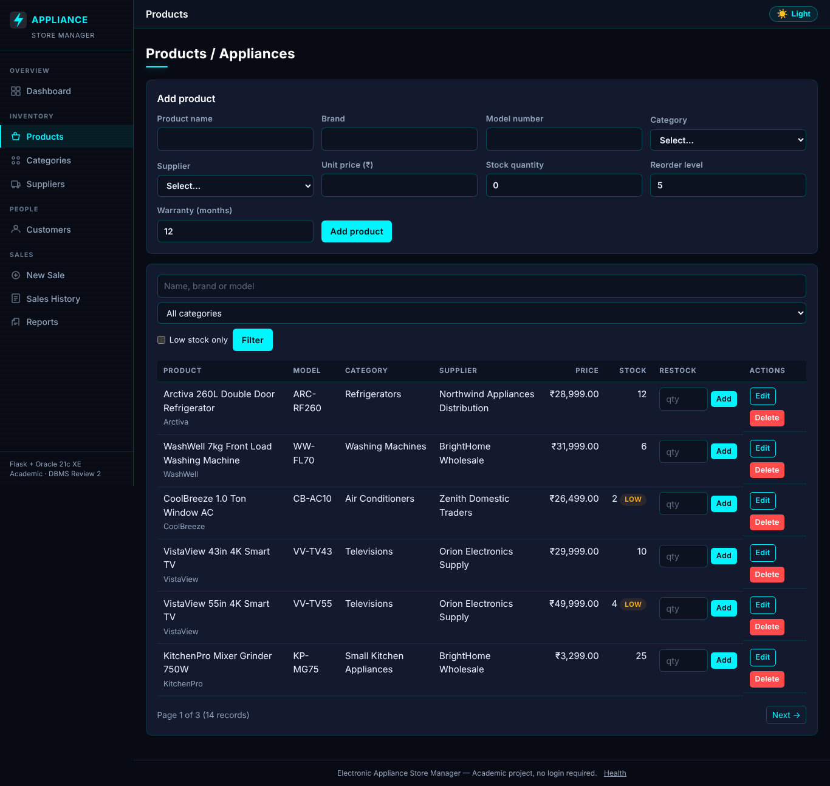
Figure 1 – Products: create form, search/filter, edit, delete and restock (sample data)
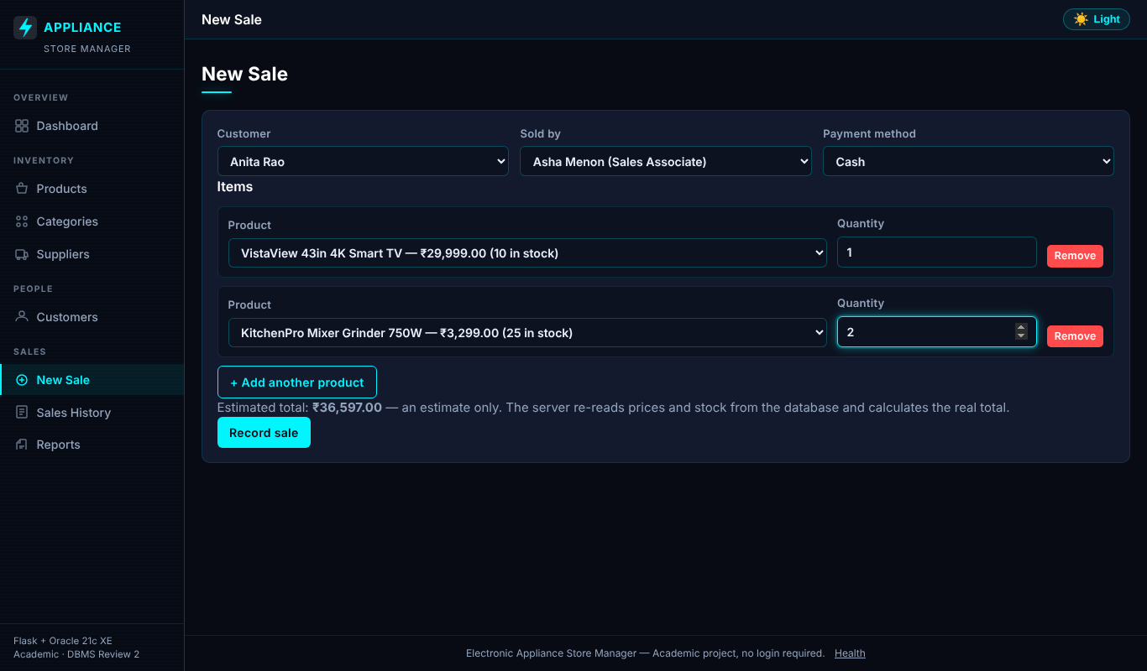
Figure 2 – New sale with two lines; the total shown is only an estimate, the server recalculates from database prices (sample data)
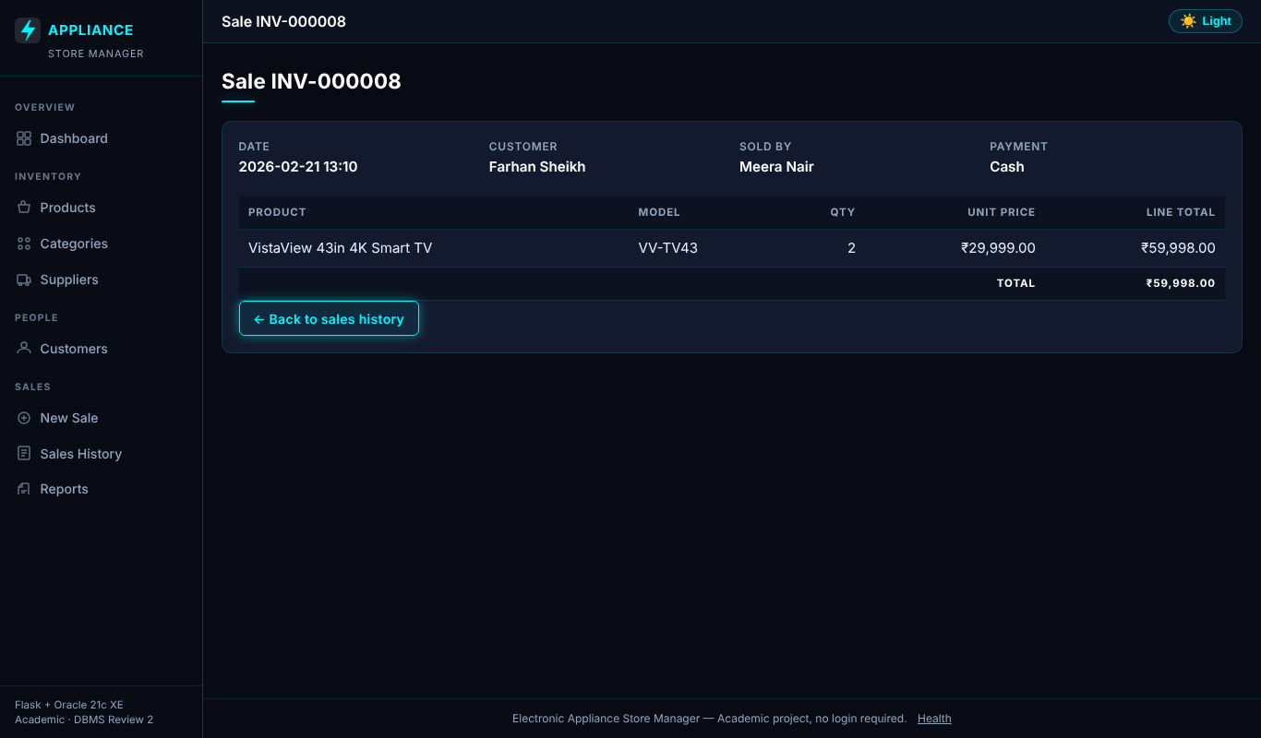
Figure 3 – Sale detail after a sale (sample data)
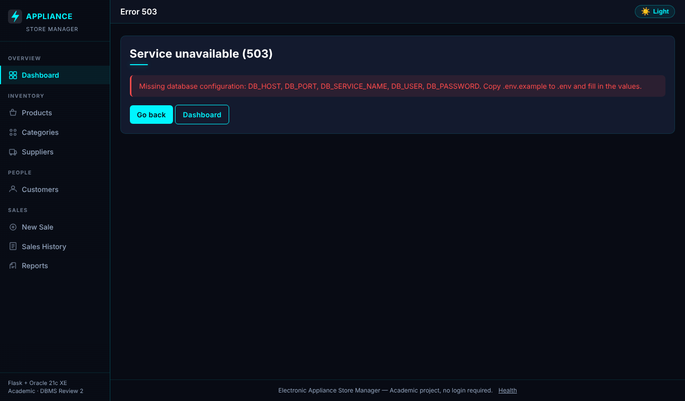
Figure 4 – Real application without a configured database: honest 503 page

22. Database access safeguards
- All SQL uses bind variables; user text never enters a statement (injection test SVC- in the matrix).
- The application connects only as the least-privilege user appliance_app (six CREATE privileges, no DBA); configuration rejects SYS/SYSTEM; administrator setup is the separate manual script database/setup_user.sql.
- Database errors are translated to safe messages (ORA codes, SQL and credentials go only to the server log).
- CHECK, UNIQUE and FK constraints reject negative price/stock/quantity and protect history; the trigger blocks edits to posted sales.
- Login/roles are not part of Review 2 (see §26).

23. Testing methodology
pytest suites: test_config (settings), test_services (validation, CRUD and transaction logic against a fake connection that records SQL, parameters, commits, rollbacks and closes), test_routes (Flask test client with stubbed services: CSRF, status codes, escaping, headers, health), test_oracle_integration (live Oracle, separate test schema, tagged rows, explicit opt-in). Status vocabulary — PASSED: executed and passed · FAILED: executed and failed · NOT RUN: intentionally skipped · BLOCKED: required dependency unavailable. Fakes prove application logic, not Oracle semantics (locking, constraint enforcement, PL/SQL), which is why the integration suite exists. Mutation sanity checks: removing the lock-order sort, and adding a mid-sale commit, each made tests fail (then reverted).

24. Verified testing matrix
Generated from the actual pytest result file (docs/test_results.xml) by docs/build_reports.py.
ID | Test description | Expected outcome | Actual outcome | Status | Remarks
CFG-01 | Valid DB_* variables produce settings and the XEPDB1 DSN | host:port/service DSN, no error | Executed; assertions held | PASSED | Pure logic
CFG-02 | Missing DB_PASSWORD and DB_HOST are reported by NAME only | ConfigError lists names, leaks no value | Executed; assertions held | PASSED | Pure logic
CFG-03 | Values copied unchanged from .env.example (<set-locally>) | treated as missing configuration | Executed; assertions held | PASSED | Pure logic
CFG-04 | DB_USER set to an administrator account (3 parameter sets) | ConfigError (app must use appliance_app only) | Executed; assertions held | PASSED | Pure logic
CFG-05 | Non-numeric or out-of-range DB_PORT (3 parameter sets) | ConfigError | Executed; assertions held | PASSED | Pure logic
CFG-06 | repr() of the settings object | does not contain the password | Executed; assertions held | PASSED | Pure logic
CFG-07 | FLASK_SECRET_KEY missing or placeholder | ConfigError with generation hint | Executed; assertions held | PASSED | Pure logic
CFG-08 | APP_ENV=production | secure cookies on, debug off even if FLASK_DEBUG=1 | Executed; assertions held | PASSED | Pure logic
SVC-01 | Valid monetary strings (3 parameter sets) | accepted and quantised to 2 decimals | Executed; assertions held | PASSED | Fake DB connection - proves SQL/transaction logic, not Oracle behaviour
SVC-02 | Negative, non-numeric, 3-decimal, NaN, too-large prices (6 parameter sets) | ValidationError | Executed; assertions held | PASSED | Fake DB connection - proves SQL/transaction logic, not Oracle behaviour
SVC-03 | Malformed email / phone numbers | ValidationError; valid ones accepted | Executed; assertions held | PASSED | Fake DB connection - proves SQL/transaction logic, not Oracle behaviour
SVC-04 | Zero, negative, non-integer, None, absurd IDs (6 parameter sets) | ValidationError | Executed; assertions held | PASSED | Fake DB connection - proves SQL/transaction logic, not Oracle behaviour
SVC-05 | Duplicate products merged, lock order ascending | [(1, 3), (5, 2)] | Executed; assertions held | PASSED | Fake DB connection - proves SQL/transaction logic, not Oracle behaviour
SVC-06 | Blank form rows ignored; only blanks -> empty sale rejected | ValidationError | Executed; assertions held | PASSED | Fake DB connection - proves SQL/transaction logic, not Oracle behaviour
SVC-07 | Zero, negative, non-numeric, fractional or huge quantity (5 parameter sets) | ValidationError | Executed; assertions held | PASSED | Fake DB connection - proves SQL/transaction logic, not Oracle behaviour
SVC-08 | Two-item sale | one commit, DB-priced total 35597.00 (Decimal), stock deducted per item, connection closed | Executed; assertions held | PASSED | Fake DB connection - proves SQL/transaction logic, not Oracle behaviour
SVC-09 | Items supplied as 3,1,2 | FOR UPDATE issued for 1,2,3 (consistent order -> no deadlock), all before any INSERT | Executed; assertions held | PASSED | Fake DB connection - proves SQL/transaction logic, not Oracle behaviour
SVC-10 | Request 3 of a product with 2 in stock | InsufficientStockError, nothing inserted or updated, no commit, rolled back | Executed; assertions held | PASSED | Fake DB connection - proves SQL/transaction logic, not Oracle behaviour
SVC-11 | Product id 999 does not exist | ValidationError, no writes, no commit | Executed; assertions held | PASSED | Fake DB connection - proves SQL/transaction logic, not Oracle behaviour
SVC-12 | Customer id missing in DB | ValidationError before any product is locked | Executed; assertions held | PASSED | Fake DB connection - proves SQL/transaction logic, not Oracle behaviour
SVC-13 | Stock UPDATE fails (CHECK violation) after sale+item inserted | ValidationError, rollback, NO commit | Executed; assertions held | PASSED | Fake DB connection - proves SQL/transaction logic, not Oracle behaviour
SVC-14 | Bad payment method / empty items / bad ids (4 parameter sets) | ValidationError and zero SQL executed | Executed; assertions held | PASSED | Fake DB connection - proves SQL/transaction logic, not Oracle behaviour
SVC-15 | Every statement uses bind variables; create_sale has no price/total input | no literals from user data in SQL | Executed; assertions held | PASSED | Fake DB connection - proves SQL/transaction logic, not Oracle behaviour
SVC-16 | advanced_features.sql trigger body | contains no UPDATE of PRODUCTS (single deduction point) | Executed; assertions held | PASSED | Fake DB connection - proves SQL/transaction logic, not Oracle behaviour
SVC-17 | SQL-injection text in a product name | stays in bind params, never in the SQL string | Executed; assertions held | PASSED | Fake DB connection - proves SQL/transaction logic, not Oracle behaviour
SVC-18 | Negative price or stock in the form | ValidationError before any SQL | Executed; assertions held | PASSED | Fake DB connection - proves SQL/transaction logic, not Oracle behaviour
SVC-19 | UPDATE affecting 0 rows | NotFoundError (404) | Executed; assertions held | PASSED | Fake DB connection - proves SQL/transaction logic, not Oracle behaviour
SVC-20 | ORA-02292 on delete | ConflictError with friendly text, no ORA code/constraint name leaked | Executed; assertions held | PASSED | Fake DB connection - proves SQL/transaction logic, not Oracle behaviour
SVC-21 | ORA-00001 on insert | ConflictError (409) with generic message | Executed; assertions held | PASSED | Fake DB connection - proves SQL/transaction logic, not Oracle behaviour
SVC-22 | Listener down (ORA-12541) | DatabaseUnavailableError (503) without host/user/password details | Executed; assertions held | PASSED | Fake DB connection - proves SQL/transaction logic, not Oracle behaviour
SVC-23 | Restock 10 units | SP_RESTOCK_PRODUCT called with (id, qty), exactly one commit | Executed; assertions held | PASSED | Fake DB connection - proves SQL/transaction logic, not Oracle behaviour
SVC-24 | Procedure raises ORA-20002 | NotFoundError, rolled back | Executed; assertions held | PASSED | Fake DB connection - proves SQL/transaction logic, not Oracle behaviour
SVC-25 | oracledb.connect raising ORA-01017 (bad login) | DatabaseUnavailableError, no credentials in message | Executed; assertions held | PASSED | Fake DB connection - proves SQL/transaction logic, not Oracle behaviour
SVC-26 | No DB configured | health_check returns (False, message) - never claims success | Executed; assertions held | PASSED | Fake DB connection - proves SQL/transaction logic, not Oracle behaviour
RTE-01 | Dashboard with stubbed DB figures | 200 and the figures are rendered | Executed; assertions held | PASSED | Services stubbed; Flask test client
RTE-02 | Oracle unavailable | HTTP 503 error page, no statistics shown | Executed; assertions held | PASSED | Services stubbed; Flask test client
RTE-03 | Category name containing <script> | rendered escaped, never as live markup | Executed; assertions held | PASSED | Services stubbed; Flask test client
RTE-04 | POST with no CSRF token | 400 and the service is never called | Executed; assertions held | PASSED | Services stubbed; Flask test client
RTE-05 | POST with a forged CSRF token | 400 | Executed; assertions held | PASSED | Services stubbed; Flask test client
RTE-06 | Valid CSRF token + valid form | service called, 303 redirect (post/redirect/get) | Executed; assertions held | PASSED | Services stubbed; Flask test client
RTE-07 | X-CSRF-Token header instead of form field | accepted | Executed; assertions held | PASSED | Services stubbed; Flask test client
RTE-08 | GET on delete / update / restock URLs | 405 Method Not Allowed | Executed; assertions held | PASSED | Services stubbed; Flask test client
RTE-09 | Service raises ValidationError | HTTP 400 with the message | Executed; assertions held | PASSED | Services stubbed; Flask test client
RTE-10 | Delete of a referenced row | HTTP 409 with friendly message | Executed; assertions held | PASSED | Services stubbed; Flask test client
RTE-11 | Sale rejected for insufficient stock | HTTP 409 with product detail | Executed; assertions held | PASSED | Services stubbed; Flask test client
RTE-12 | Forged price/total/employee fields in the sale POST | price and total ignored; employee id comes from the login session | Executed; assertions held | PASSED | Services stubbed; Flask test client
RTE-13 | Sale form with no product lines | HTTP 400, create_sale never reached | Executed; assertions held | PASSED | Services stubbed; Flask test client
RTE-14 | Unknown URL -> 404; non-numeric sale id -> 404 | Unknown URL -> 404; non-numeric sale id -> 404 | Executed; assertions held | PASSED | Services stubbed; Flask test client
RTE-15 | Unexpected exception text with a secret | HTTP 500, page shows a generic message only | Executed; assertions held | PASSED | Services stubbed; Flask test client
RTE-16 | Any response | CSP, nosniff and frame protection headers set | Executed; assertions held | PASSED | Services stubbed; Flask test client
RTE-17 | No Oracle configured | /health returns 503 and database=unavailable, never 'ok' | Executed; assertions held | PASSED | Services stubbed; Flask test client
RTE-18 | health_check reporting success | /health 200 with no secrets in the body | Executed; assertions held | PASSED | Services stubbed; Flask test client
RTE-19 | Products, customers, sales, sale detail, new sale, reports pages | all render 200 with stubbed data | Executed; assertions held | PASSED | Services stubbed; Flask test client
INT-01 | Connect to XEPDB1 as the test application user | connected, user is not SYS/SYSTEM | Executed; assertions held | PASSED | Live Oracle 21c XE, separate test schema (student run 2026-10-22)
INT-02 | USER_TABLES | all 7 required tables exist | Executed; assertions held | PASSED | Live Oracle 21c XE, separate test schema (student run 2026-10-22)
INT-03 | USER_OBJECTS | view, procedure, function, trigger all VALID | Executed; assertions held | PASSED | Live Oracle 21c XE, separate test schema (student run 2026-10-22)
INT-04 | Negative price/stock, duplicate model, bad category FK | ORA-02290 / ORA-00001 / ORA-02291 | Executed; assertions held | PASSED | Live Oracle 21c XE, separate test schema (student run 2026-10-22)
INT-05 | SALE_ITEMS with LINE_TOTAL != QUANTITY*UNIT_PRICE | ORA-02290 | Executed; assertions held | PASSED | Live Oracle 21c XE, separate test schema (student run 2026-10-22)
INT-06 | Delete category/customer/product that history references | ConflictError (ORA-02292 translated) | Executed; assertions held | PASSED | Live Oracle 21c XE, separate test schema (student run 2026-10-22)
INT-07 | Create, read, update, delete a category and customer through the services | each step reflected in DB | Executed; assertions held | PASSED | Live Oracle 21c XE, separate test schema (student run 2026-10-22)
INT-08 | SP_RESTOCK_PRODUCT | +5 stock on success; ORA-20001 for 0, ORA-20002 unknown product | Executed; assertions held | PASSED | Live Oracle 21c XE, separate test schema (student run 2026-10-22)
INT-09 | FN_CUSTOMER_TOTAL_SPEND | 0 before sales, equals sale total after, ORA-20010 for unknown customer | Executed; assertions held | PASSED | Live Oracle 21c XE, separate test schema (student run 2026-10-22)
INT-10 | TRG_SALES_PROTECT_HISTORY | DELETE -> ORA-20030, UPDATE total -> ORA-20031 | Executed; assertions held | PASSED | Live Oracle 21c XE, separate test schema (student run 2026-10-22)
INT-11 | V_SALES_SUMMARY | shows the new sale with correct line/unit counts and TOTAL_MATCHES = 'Y' | Executed; assertions held | PASSED | Live Oracle 21c XE, separate test schema (student run 2026-10-22)
INT-12 | Two-item sale | totals from DB prices (2*100.00+3*49.50=348.50), stock 10->8 and 5->2, items stored | Executed; assertions held | PASSED | Live Oracle 21c XE, separate test schema (student run 2026-10-22)
INT-13 | Quantity above stock | InsufficientStockError; no sale row, stock unchanged | Executed; assertions held | PASSED | Live Oracle 21c XE, separate test schema (student run 2026-10-22)
INT-14 | Valid line + nonexistent product | ValidationError and the valid line's stock is untouched | Executed; assertions held | PASSED | Live Oracle 21c XE, separate test schema (student run 2026-10-22)
INT-15 | Another session holds FOR UPDATE on a product | sale waits then fails with ConflictError (ORA-30006), stock intact | Executed; assertions held | PASSED | Live Oracle 21c XE, separate test schema (student run 2026-10-22)
INT-16 | 8 threads each buy 1 unit of a product with 5 in stock | exactly 5 succeed, 3 InsufficientStockError, final stock 0 | Executed; assertions held | PASSED | Live Oracle 21c XE, separate test schema (student run 2026-10-22)

Totals by pytest case: PASSED 92
Other checks executed (sandbox: Linux, Python 3.13, no Oracle)
Check | Command | Result
Python compilation | python -m compileall -q app.py config.py services tests | PASSED
JavaScript syntax | node --check static/js/app.js | PASSED
Query count | grep -c "^-- Query [0-9]*:" database/queries.sql | 16 — PASSED
SQL static parse | sqlglot (Oracle dialect) over 16 queries and 7 seed MERGE statements | PASSED (syntax only; PL/SQL scripts not parsed — NOT RUN)
Flask smoke | python app.py then GET /health, GET /products, POST /categories without token | 503, 503, 400 as designed — PASSED
Connection diagnostic | python -m services.database with an unreachable listener | exit 1, sanitized message, no secrets — PASSED
Secret scan | recursive grep for credential-like assignments | only obviously fake test dummies; PASSED
Live Oracle: schema, seed, queries, PL/SQL, integration tests | README §7, §9 | PASSED — run by the student on Oracle 21c XE, 2026-10-22: 16/16 integration tests, 16/16 queries (no ORA- errors)

25. Results and discussion
Everything that can run without Oracle ran and passed: configuration rules, validation, service logic including the full sale transaction path (lock order, stock re-check, single commit, rollback on failure), error translation (no leakage of credentials or ORA internals), route behaviour (400/404/409/503 statuses, honest health reporting, forms reaching the services). The design choice of one deduction point (service) and sorted row locks gives deterministic concurrency behaviour that is straightforward to test. The live Oracle run then confirmed the parts fakes cannot prove: acceptance of the DDL/PL/SQL scripts, constraint and trigger behaviour, the query results quoted in §19, and the row-lock and concurrency tests (INT-15, INT-16).

26. Known limitations
- No authentication/authorization or per-user audit trail.
- Screenshots use sample data behind the real templates (no live Oracle); only Figure 4 shows unmodified runtime behaviour.
- The live results come from one run on one machine (Oracle 21c XE, single user); no load or multi-machine testing was done.
- SALES.TOTAL_AMOUNT ↔ line totals consistency is service-enforced, not a constraint; LINE_TOTAL is a documented derived column.
- Trigger contains a test-cleanup bypass that should be removed for production-style use.
- No returns, discounts, taxes, multi-currency; employees have no CRUD screen.
- LIKE searches treat %/_ as wildcards; per-request connections (no pool) are adequate for a demo, not for load.
- The seed is first-run oriented: it never overwrites changed rows, so edits to seeded products persist.

27. Installation and execution summary
See README §4–§9. In brief (PowerShell): create appliance_app once as admin with database\setup_user.sql; py -3.11 -m venv .venv; activate; pip install -r requirements.txt; copy .env.example to .env and fill in the password and a generated secret key; run schema.sql, advanced_features.sql, seed.sql with sqlplus appliance_app@localhost:1521/XEPDB1 @database\<file>.sql; python -m services.database; python -m pytest tests -v; python app.py; open http://127.0.0.1:5000.
Demonstration (10 minutes, details in `docs/demo_guide.md`): (1) python -m services.database and open the app; (2) show schema.sql constraints and the failing inserts; (3) verify seed counts; (4) run queries Q7, Q10, Q12, Q13; (5) show the four PL/SQL objects; (6) /health and CRUD; (7) record a two-item sale and watch stock fall, then try an oversized sale (HTTP 409); (8) show the test matrix (76 offline and 16 live cases PASSED).

28. Faculty evaluation cross-reference
# | Criterion | Where implemented | How to demonstrate | Verification status
1 | Database and table creation | database/schema.sql, setup_user.sql, README §5–§7 | Run scripts; SELECT table_name FROM user_tables | Live: scripts ran on Oracle 21c XE; 7 tables confirmed by INT-02 — PASSED
2 | Keys and constraints | PK/FK/UQ/NOT NULL/CHECK in schema.sql; §13 | user_constraints query; demo_guide §2 failing inserts | Live enforcement confirmed by INT-04/05/06 — PASSED
3 | Meaningful sample data | database/seed.sql (7 tables, 8 multi-item sales) | demo_guide §3 | Live load ran on Oracle 21c XE; rows visible in query output — PASSED
4 | Joins, subqueries, aggregations | database/queries.sql — exactly 16 | Run file; demo_guide §4 | Count checked; all 16 executed live without error — PASSED
5 | Advanced database features | database/advanced_features.sql (view, procedure, function, trigger) | Verification blocks; demo_guide §5 | Live PASSED (integration tests exist)
6 | Backend–database connectivity | config.py, services/database.py, /health, python -m services.database | demo_guide §6 | Config/error handling PASSED (unit); real connection INT-01 and the running app — PASSED
7 | CRUD and transactions | services/*.py, app.py, templates/*, services/sales.py | UI workflow; demo_guide §7–§8 | Logic PASSED with fakes; Oracle transactions and locking INT-07, INT-12..16 — PASSED

Live verification covers the database, queries, integration tests and CRUD/sales transactions as listed above. The browser walkthrough of the criteria table was not recorded as a formal test.

29. Conclusion
The project delivers a normalized seven-table Oracle design, deterministic data, sixteen documented queries, four PL/SQL-side objects, a layered Flask application with an atomic, lock-ordered sales transaction, and a status-honest test suite. All checks that can run without Oracle pass; the live Oracle checks were then run by the student on Windows against Oracle 21c XE (16/16 integration tests and 16/16 queries passed).

30. References
- Oracle Database 21c Documentation: SQL Language Reference; PL/SQL Language Reference; Database Concepts (data concurrency and consistency).
- python-oracledb documentation, <https://python-oracledb.readthedocs.io/>.
- Flask documentation, <https://flask.palletsprojects.com/>.
- OWASP Cheat Sheet Series: SQL Injection Prevention; Cross-Site Request Forgery Prevention.
- Elmasri, R. and Navathe, S., *Fundamentals of Database Systems*, Pearson — normalization chapters.

