Electronic Appliance Store Management System — DBMS Review 3 Report
Student: Sanjiv Shine Fernandas · Stack: Flask, python-oracledb (Thin), Oracle Database 21c XE (XEPDB1), HTML/CSS/JavaScript, pytest
> Verification disclosure. The code was written in an environment without Oracle. On 2026-10-22 the student ran the 19 live integration tests on a real Oracle Database 21c XE (separate test schema): 19 PASSED (14.04 s), and executed all 16 queries of queries.sql without error. These live results were transcribed from the student's console output into the test matrix; the authoring environment did not produce them. The offline suite (140 tests) was run by the authoring environment. Not verified: a recorded browser walkthrough of every role scenario, HTTPS deployment, multi-process behaviour of the login throttle, load testing.

1. Abstract
Review 2 delivered the Oracle schema, queries, PL/SQL objects and the backend. Review 3 completes the final web application: sign-in with two roles (Manager and Cashier), employee and user-account management, role-aware navigation, security hardening, a production-style launcher and a deployment guide. The database grows from seven to eight tables (USERS, in a separate script auth.sql). Every page except sign-in and the health check is protected by a default-deny gate.

2. Scope of Review 3 and criteria map
Criterion | Implementation | Evidence | Status
Completion of all proposed functionalities | CRUD for products, categories, suppliers, customers, employees and user accounts; sales, restock, reports, dashboard | Sidebar pages; app.py routes | Offline tests PASSED; sale/CRUD service paths PASSED live (INT-07, INT-12..16, INT-19)
Frontend–backend–database integration | Jinja forms → Flask routes → services/* → python-oracledb → Oracle; atomic sale with row locks | README §8; live tests | PASSED live
User interface and usability | Dark/light cyberpunk theme, responsive layout, role-filtered navigation, confirmations, clear errors | Screenshots in §9 (sample data) | Rendered in a browser; not a recorded test
Authentication and role-based access | /login, /logout, scrypt password hashes, USERS table, Manager/Cashier roles, default-deny gate, login throttle, 8-hour sessions, change password, manage.py bootstrap | tests/test_auth.py; live tests INT-17, INT-18 | Offline PASSED; table and hashing PASSED live
Database correctness and integrity | 8 tables, PK/FK/UNIQUE/CHECK, no-cascade FKs, protective trigger, atomic sale transaction | schema.sql, auth.sql; INT-02..06 | PASSED live
Search, filtering, reports, dashboard | Search/filter/pagination; dashboard; five reports | /products?q=, /reports | Offline PASSED; the 16 queries ran live
Error handling and basic security | Bind variables, CSRF on every POST, escaped output, CSP, safe error pages, hashed passwords, least-privilege DB user | test_routes.py, test_auth.py | Offline PASSED
Testing and demonstration | pytest (unit, route, auth, live Oracle); docs/demo_guide.md | §12 | 140 offline + 19 live PASSED
Project documentation | README, docs/deployment.md, demo guide, Review 2 report, this report | — | Delivered

3. Architecture
Browser → Flask routes (app.py: login gate, CSRF, roles) → services/*.py (all SQL) → python-oracledb → Oracle XEPDB1
Routes never contain SQL. Stock is deducted in exactly one place (services/sales.create_sale), never in a trigger. Configuration comes only from environment variables (.env, git-ignored); the application connects only as appliance_app and config.py rejects SYS/SYSTEM.

4. Database design
The seven Review 2 tables (CATEGORIES, SUPPLIERS, PRODUCTS, CUSTOMERS, EMPLOYEES, SALES, SALE_ITEMS) are unchanged. database/auth.sql adds an eighth table:
Column | Type / rule
USER_ID | identity primary key
USERNAME | unique, CHECK lower-case
PASSWORD_HASH | scrypt hash (never the password)
ROLE | CHECK IN ('MANAGER','CASHIER')
EMPLOYEE_ID | UNIQUE foreign key to EMPLOYEES (one login per employee)
CREATED_AT, LAST_LOGIN | timestamps

Run order: schema.sql, advanced_features.sql, seed.sql, auth.sql. auth.sql was loaded and its six named constraints confirmed in the student's Oracle instance; live test INT-17 checks that the role, username and unique-employee rules are enforced.

5. Authentication and access control
- No default accounts. The first manager is created from the server with python manage.py create-user USERNAME ROLE EMPLOYEE_EMAIL (hidden password prompt). Passwords need at least 10 characters.
- Default deny. A before_request gate requires sign-in for every endpoint except login, health and static. Endpoints a cashier may use are listed explicitly (CASHIER_ENDPOINTS); everything else is manager-only. A test enumerates every registered route.
- Sessions. 8 hours, HttpOnly, SameSite; Secure when APP_ENV=production (HTTPS only). Sign-out is a POST.
- Throttle. 5 failed sign-ins per (username, client address) within 5 minutes return HTTP 429. This is in-process only (see §11).
- Open-redirect protection. After sign-in next= accepts only same-site paths; control characters, backslashes and // are rejected.
 | Manager | Cashier
Sales (new, history, detail) | yes | yes; the seller is always the signed-in employee
Products | CRUD + restock | view
Customers | CRUD | list, add, edit
Dashboard, reports, categories, suppliers, employees, user accounts | yes | no (HTTP 403)
Change own password | yes | yes

Manager accounts cannot be deleted in the application, which also means nobody can delete their own account or the last manager. A cashier account can be deleted by a manager.

6. Employee and user management
Managers add, edit and delete employees (referenced rows are protected by the RESTRICT foreign keys and reported as a clear 409 message) and create sign-in accounts for employees who do not yet have one. The user-accounts page marks the signed-in account as "you" and manager rows as "protected". Role changes take effect at the next sign-in.

7. Atomic sales (carried over, verified live)
The sale transaction locks the product rows in ascending id order (SELECT … FOR UPDATE WAIT), re-checks stock, inserts the sale and its items with prices read from the database, deducts stock once and commits once; any error rolls everything back. Live tests confirmed: a two-item sale deducts stock and uses database prices (INT-12), insufficient stock changes nothing (INT-13), an invalid line rolls back the whole sale (INT-14), a held row lock makes the sale wait and fail cleanly (INT-15) and eight concurrent buyers of five units give exactly five successes (INT-16).

8. Security hardening
Finding | Fix
next=/<TAB>/evil.example became the external URL //evil.example; a newline caused HTTP 500 | safe_next rejects control characters, backslashes and //
manage.py printed a traceback on missing configuration | Prints FAILED: … and exits with status 1
/health revealed the database user, service name and configuration variable names | Status-only response {"app","database"} with HTTP 200 or 503; the detail goes to the server log
Flask default session lifetime is 31 days | PERMANENT_SESSION_LIFETIME set to 8 hours
Oracle returns identity values as Decimal; the session cookie stored them as text, so the "cannot delete yourself" check could be bypassed and a Delete button appeared on one's own row | All user and employee ids are cast to int; regression tests added
Previously used database passwords | Treated as compromised; rotate (ALTER USER … IDENTIFIED BY), keep only in .env

The Decimal defect was found by the student during manual testing, after the offline tests had passed. It is a concrete example of why the fake-database tests do not replace running against Oracle.

9. User interface
Screenshots below use the real templates rendered with sample data (no database), so they show layout and role behaviour, not live records.
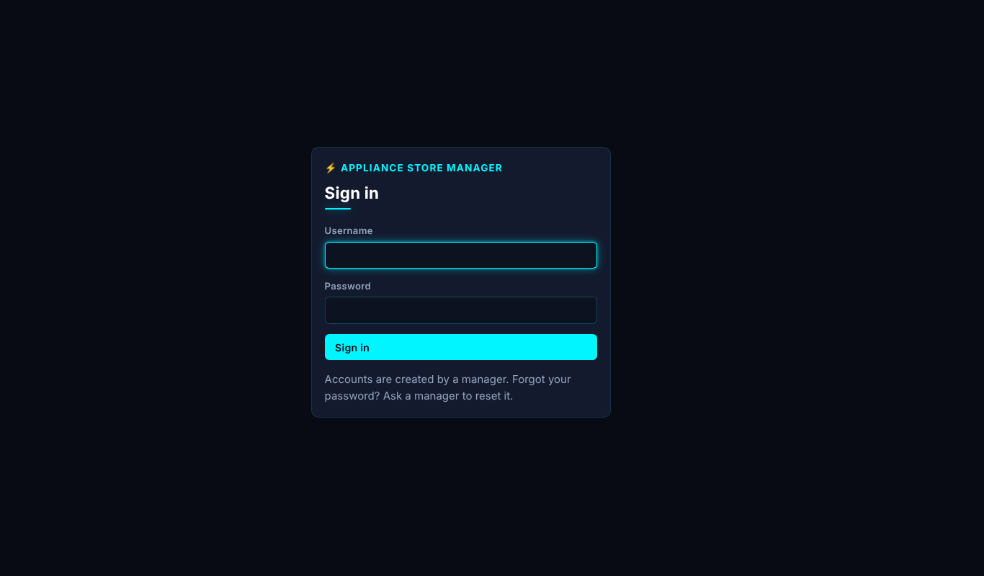
Sign-in page
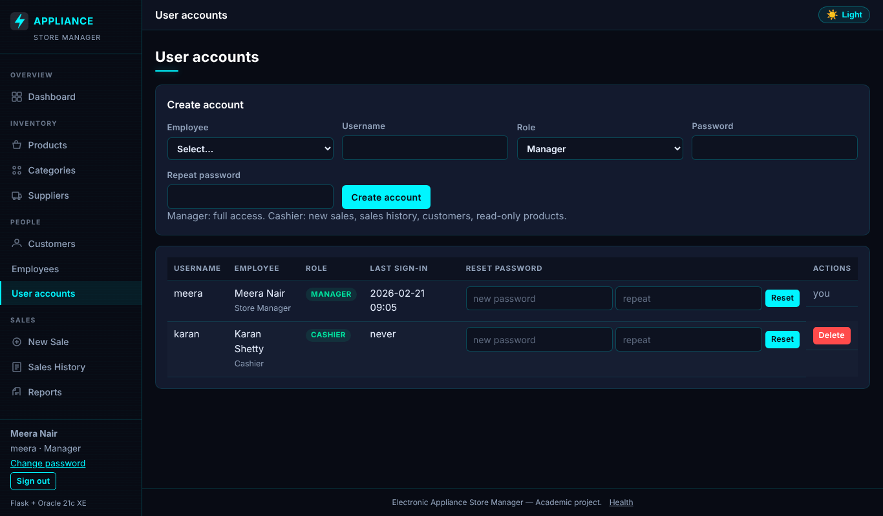
User accounts page (manager)
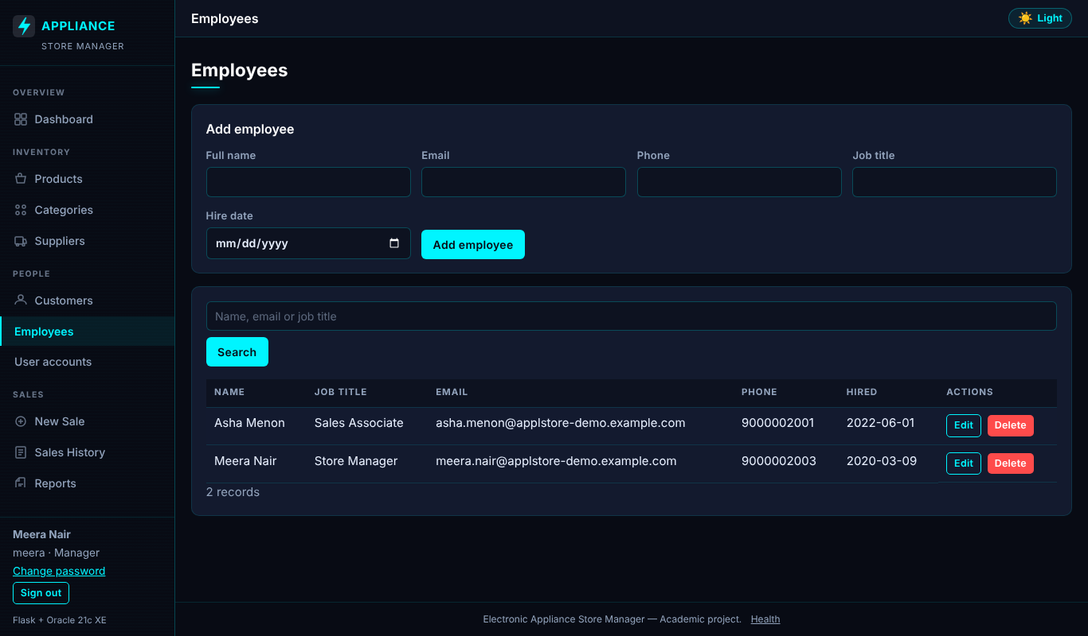
Employees page (manager)
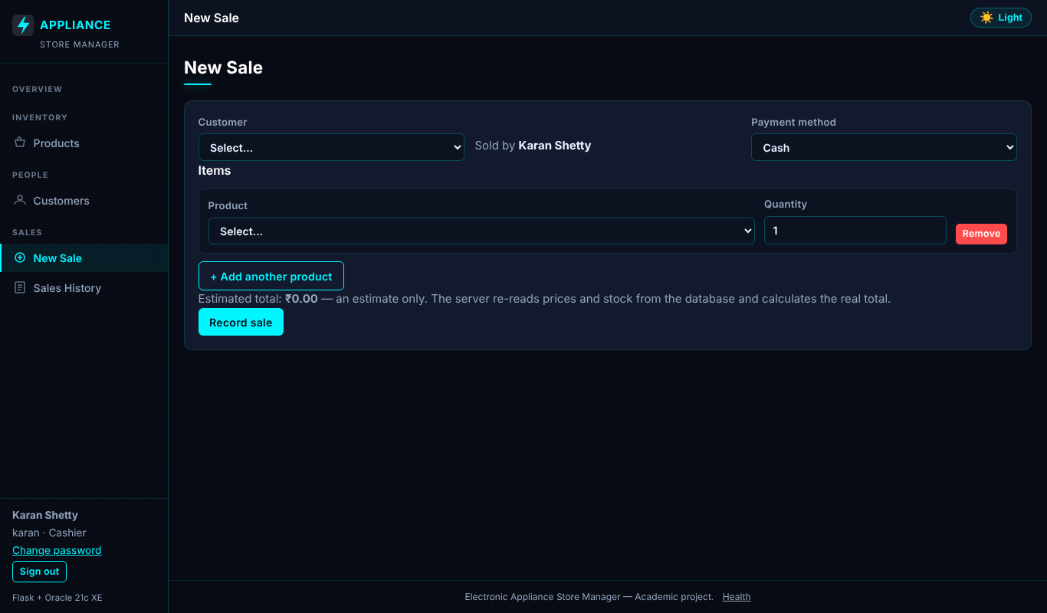
Cashier new-sale page: restricted navigation
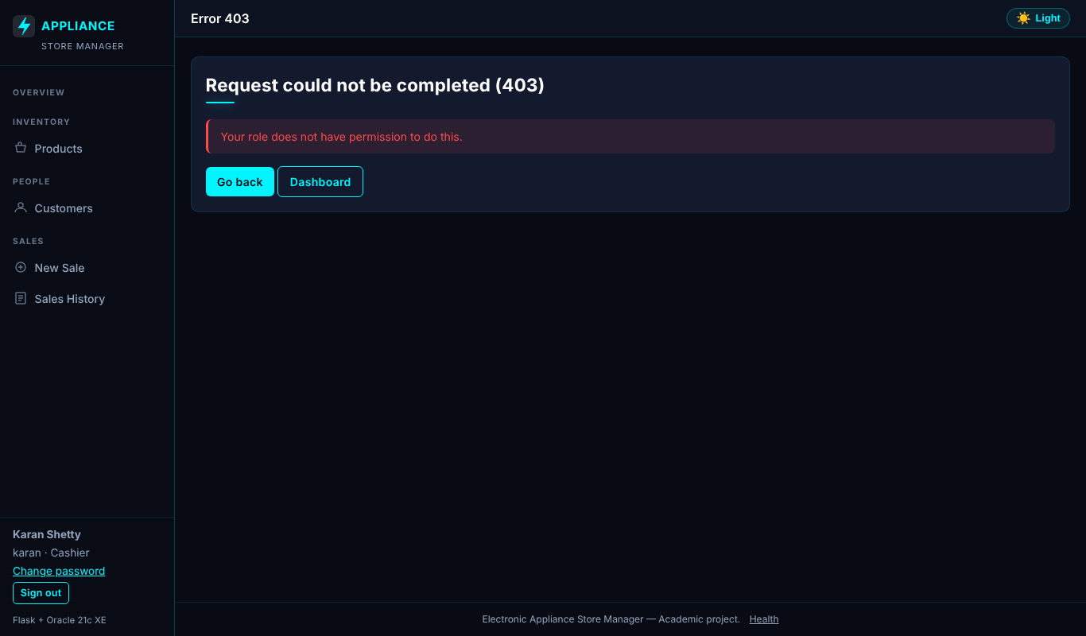
HTTP 403 for a cashier opening a manager page

10. Deployment
python serve.py runs the application under waitress (8 threads, no debug), listening on 127.0.0.1:8000 unless HOST/PORT are set. For anything beyond localhost, terminate HTTPS in a reverse proxy and set APP_ENV=production. docs/deployment.md covers setup, Task Scheduler start-up, backups (expdp/RMAN), password rotation, removing a manager with SQL and the health endpoint. HTTPS deployment was not exercised.

11. Known limitations
- Login throttle: in-process dictionary, unbounded memory for many distinct usernames, not proxy-aware (uses the socket address), counters reset on restart and are per worker, and locking by username allows a targeted lockout. Recommended follow-up: bounded or Oracle-backed store, ProxyFix with an exact hop count, progressive delays.
- No self-registration, password-reset e-mail or multi-factor sign-in; a manager resets passwords.
- Role and account changes apply at the next sign-in (sessions last 8 hours).
- No connection pool; single-currency display; no returns, tax or discount model.
- The history-protection trigger contains a documented test-cleanup bypass (CLIENT_INFO = 'ITEST_CLEANUP') that should be removed for production.
- Live results come from one single-user run on one machine.

12. Testing
Suites: test_config, test_services (fake connection), test_routes (Flask test client), test_auth (every route requires sign-in, role matrix, throttle, open redirect, hashing) and test_oracle_integration (live Oracle, separate test schema, tagged ITEST- rows removed afterwards). Status vocabulary — PASSED: executed and passed · FAILED: executed and failed · NOT RUN: intentionally skipped · BLOCKED: dependency unavailable.
On the first live run 18 of 19 tests passed; the one failure (test_function_customer_total_spend) was a mistake in the test itself (a bind variable named like a helper argument), not in the application or database. It was fixed and the whole suite then passed 19 of 19.
ID | Test description | Expected outcome | Actual outcome | Status | Remarks
CFG-01 | Valid DB_* variables produce settings and the XEPDB1 DSN | host:port/service DSN, no error | Executed; assertions held | PASSED | Pure logic
CFG-02 | Missing DB_PASSWORD and DB_HOST are reported by NAME only | ConfigError lists names, leaks no value | Executed; assertions held | PASSED | Pure logic
CFG-03 | Values copied unchanged from .env.example (<set-locally>) | treated as missing configuration | Executed; assertions held | PASSED | Pure logic
CFG-04 | DB_USER set to an administrator account (3 parameter sets) | ConfigError (app must use appliance_app only) | Executed; assertions held | PASSED | Pure logic
CFG-05 | Non-numeric or out-of-range DB_PORT (3 parameter sets) | ConfigError | Executed; assertions held | PASSED | Pure logic
CFG-06 | repr() of the settings object | does not contain the password | Executed; assertions held | PASSED | Pure logic
CFG-07 | FLASK_SECRET_KEY missing or placeholder | ConfigError with generation hint | Executed; assertions held | PASSED | Pure logic
CFG-08 | APP_ENV=production | secure cookies on, debug off even if FLASK_DEBUG=1 | Executed; assertions held | PASSED | Pure logic
SVC-01 | Valid monetary strings (3 parameter sets) | accepted and quantised to 2 decimals | Executed; assertions held | PASSED | Fake DB connection - proves SQL/transaction logic, not Oracle behaviour
SVC-02 | Negative, non-numeric, 3-decimal, NaN, too-large prices (6 parameter sets) | ValidationError | Executed; assertions held | PASSED | Fake DB connection - proves SQL/transaction logic, not Oracle behaviour
SVC-03 | Malformed email / phone numbers | ValidationError; valid ones accepted | Executed; assertions held | PASSED | Fake DB connection - proves SQL/transaction logic, not Oracle behaviour
SVC-04 | Zero, negative, non-integer, None, absurd IDs (6 parameter sets) | ValidationError | Executed; assertions held | PASSED | Fake DB connection - proves SQL/transaction logic, not Oracle behaviour
SVC-05 | Duplicate products merged, lock order ascending | [(1, 3), (5, 2)] | Executed; assertions held | PASSED | Fake DB connection - proves SQL/transaction logic, not Oracle behaviour
SVC-06 | Blank form rows ignored; only blanks -> empty sale rejected | ValidationError | Executed; assertions held | PASSED | Fake DB connection - proves SQL/transaction logic, not Oracle behaviour
SVC-07 | Zero, negative, non-numeric, fractional or huge quantity (5 parameter sets) | ValidationError | Executed; assertions held | PASSED | Fake DB connection - proves SQL/transaction logic, not Oracle behaviour
SVC-08 | Two-item sale | one commit, DB-priced total 35597.00 (Decimal), stock deducted per item, connection closed | Executed; assertions held | PASSED | Fake DB connection - proves SQL/transaction logic, not Oracle behaviour
SVC-09 | Items supplied as 3,1,2 | FOR UPDATE issued for 1,2,3 (consistent order -> no deadlock), all before any INSERT | Executed; assertions held | PASSED | Fake DB connection - proves SQL/transaction logic, not Oracle behaviour
SVC-10 | Request 3 of a product with 2 in stock | InsufficientStockError, nothing inserted or updated, no commit, rolled back | Executed; assertions held | PASSED | Fake DB connection - proves SQL/transaction logic, not Oracle behaviour
SVC-11 | Product id 999 does not exist | ValidationError, no writes, no commit | Executed; assertions held | PASSED | Fake DB connection - proves SQL/transaction logic, not Oracle behaviour
SVC-12 | Customer id missing in DB | ValidationError before any product is locked | Executed; assertions held | PASSED | Fake DB connection - proves SQL/transaction logic, not Oracle behaviour
SVC-13 | Stock UPDATE fails (CHECK violation) after sale+item inserted | ValidationError, rollback, NO commit | Executed; assertions held | PASSED | Fake DB connection - proves SQL/transaction logic, not Oracle behaviour
SVC-14 | Bad payment method / empty items / bad ids (4 parameter sets) | ValidationError and zero SQL executed | Executed; assertions held | PASSED | Fake DB connection - proves SQL/transaction logic, not Oracle behaviour
SVC-15 | Every statement uses bind variables; create_sale has no price/total input | no literals from user data in SQL | Executed; assertions held | PASSED | Fake DB connection - proves SQL/transaction logic, not Oracle behaviour
SVC-16 | advanced_features.sql trigger body | contains no UPDATE of PRODUCTS (single deduction point) | Executed; assertions held | PASSED | Fake DB connection - proves SQL/transaction logic, not Oracle behaviour
SVC-17 | SQL-injection text in a product name | stays in bind params, never in the SQL string | Executed; assertions held | PASSED | Fake DB connection - proves SQL/transaction logic, not Oracle behaviour
SVC-18 | Negative price or stock in the form | ValidationError before any SQL | Executed; assertions held | PASSED | Fake DB connection - proves SQL/transaction logic, not Oracle behaviour
SVC-19 | UPDATE affecting 0 rows | NotFoundError (404) | Executed; assertions held | PASSED | Fake DB connection - proves SQL/transaction logic, not Oracle behaviour
SVC-20 | ORA-02292 on delete | ConflictError with friendly text, no ORA code/constraint name leaked | Executed; assertions held | PASSED | Fake DB connection - proves SQL/transaction logic, not Oracle behaviour
SVC-21 | ORA-00001 on insert | ConflictError (409) with generic message | Executed; assertions held | PASSED | Fake DB connection - proves SQL/transaction logic, not Oracle behaviour
SVC-22 | Listener down (ORA-12541) | DatabaseUnavailableError (503) without host/user/password details | Executed; assertions held | PASSED | Fake DB connection - proves SQL/transaction logic, not Oracle behaviour
SVC-23 | Restock 10 units | SP_RESTOCK_PRODUCT called with (id, qty), exactly one commit | Executed; assertions held | PASSED | Fake DB connection - proves SQL/transaction logic, not Oracle behaviour
SVC-24 | Procedure raises ORA-20002 | NotFoundError, rolled back | Executed; assertions held | PASSED | Fake DB connection - proves SQL/transaction logic, not Oracle behaviour
SVC-25 | oracledb.connect raising ORA-01017 (bad login) | DatabaseUnavailableError, no credentials in message | Executed; assertions held | PASSED | Fake DB connection - proves SQL/transaction logic, not Oracle behaviour
SVC-26 | No DB configured | health_check returns (False, message) - never claims success | Executed; assertions held | PASSED | Fake DB connection - proves SQL/transaction logic, not Oracle behaviour
RTE-01 | Dashboard with stubbed DB figures | 200 and the figures are rendered | Executed; assertions held | PASSED | Services stubbed; Flask test client
RTE-02 | Oracle unavailable | HTTP 503 error page, no statistics shown | Executed; assertions held | PASSED | Services stubbed; Flask test client
RTE-03 | Category name containing <script> | rendered escaped, never as live markup | Executed; assertions held | PASSED | Services stubbed; Flask test client
RTE-04 | POST with no CSRF token | 400 and the service is never called | Executed; assertions held | PASSED | Services stubbed; Flask test client
RTE-05 | POST with a forged CSRF token | 400 | Executed; assertions held | PASSED | Services stubbed; Flask test client
RTE-06 | Valid CSRF token + valid form | service called, 303 redirect (post/redirect/get) | Executed; assertions held | PASSED | Services stubbed; Flask test client
RTE-07 | X-CSRF-Token header instead of form field | accepted | Executed; assertions held | PASSED | Services stubbed; Flask test client
RTE-08 | GET on delete / update / restock URLs | 405 Method Not Allowed | Executed; assertions held | PASSED | Services stubbed; Flask test client
RTE-09 | Service raises ValidationError | HTTP 400 with the message | Executed; assertions held | PASSED | Services stubbed; Flask test client
RTE-10 | Delete of a referenced row | HTTP 409 with friendly message | Executed; assertions held | PASSED | Services stubbed; Flask test client
RTE-11 | Sale rejected for insufficient stock | HTTP 409 with product detail | Executed; assertions held | PASSED | Services stubbed; Flask test client
RTE-12 | Forged price/total/employee fields in the sale POST | price and total ignored; employee id comes from the login session | Executed; assertions held | PASSED | Services stubbed; Flask test client
RTE-13 | Sale form with no product lines | HTTP 400, create_sale never reached | Executed; assertions held | PASSED | Services stubbed; Flask test client
RTE-14 | Unknown URL -> 404; non-numeric sale id -> 404 | Unknown URL -> 404; non-numeric sale id -> 404 | Executed; assertions held | PASSED | Services stubbed; Flask test client
RTE-15 | Unexpected exception text with a secret | HTTP 500, page shows a generic message only | Executed; assertions held | PASSED | Services stubbed; Flask test client
RTE-16 | Any response | CSP, nosniff and frame protection headers set | Executed; assertions held | PASSED | Services stubbed; Flask test client
RTE-17 | No Oracle configured | /health returns 503 and database=unavailable, never 'ok' | Executed; assertions held | PASSED | Services stubbed; Flask test client
RTE-18 | health_check reporting success | /health 200 with no secrets in the body | Executed; assertions held | PASSED | Services stubbed; Flask test client
RTE-19 | Products, customers, sales, sale detail, new sale, reports pages | all render 200 with stubbed data | Executed; assertions held | PASSED | Services stubbed; Flask test client
AUT-01 | Every non-public route requested without signing in | 302 redirect to /login (default deny) | Executed; assertions held | PASSED | Flask test client, fake database
AUT-02 | POST to a write route without login | redirected, service not called | Executed; assertions held | PASSED | Flask test client, fake database
AUT-03 | is_allowed over every endpoint | manager: all; cashier: only the documented list | Executed; assertions held | PASSED | Flask test client, fake database
AUT-04 | Cashier calling manager-only pages/actions (12 parameter sets) | HTTP 403 and no service call | Executed; assertions held | PASSED | Flask test client, fake database
AUT-05 | Cashier opens New Sale, Sales History, Products (read), Customers | HTTP 200 | Executed; assertions held | PASSED | Flask test client, fake database
AUT-06 | Cashier views products | no add form, restock or edit/delete buttons rendered | Executed; assertions held | PASSED | Flask test client, fake database
AUT-07 | Cashier submits a sale with a forged employee_id | create_sale receives the cashier's own employee id | Executed; assertions held | PASSED | Flask test client, fake database
AUT-08 | Valid credentials | 303 to dashboard (manager) / new sale (cashier); session holds the user; password never stored in session | Executed; assertions held | PASSED | Flask test client, fake database
AUT-09 | Wrong credentials | HTTP 401, same message for unknown user or bad password, no session | Executed; assertions held | PASSED | Flask test client, fake database
AUT-10 | 5 failed attempts for one username | 6th attempt gets HTTP 429 even with the right password | Executed; assertions held | PASSED | Flask test client, fake database
AUT-11 | Login with a next= parameter (8 parameter sets) | only same-site relative paths are followed (no open redirect) | Executed; assertions held | PASSED | Flask test client, fake database
AUT-12 | Login POST without a CSRF token | HTTP 400, authenticate never called | Executed; assertions held | PASSED | Flask test client, fake database
AUT-13 | GET /logout rejected; POST /logout with token ends the session | 405 then redirect to login, protected page redirects again | Executed; assertions held | PASSED | Flask test client, fake database
AUT-14 | Already signed in and opening /login | redirected to the landing page | Executed; assertions held | PASSED | Flask test client, fake database
AUT-15 | Session lifetime configured and cookie hardening present | 8-hour lifetime | Executed; assertions held | PASSED | Flask test client, fake database
AUT-16 | Create a user | the INSERT carries a salted hash, never the plain password; username lower-cased | Executed; assertions held | PASSED | Flask test client, fake database
AUT-17 | Bad username, role, short/mismatched/equal password, bad employee id (7 parameter sets) | ValidationError and no SQL | Executed; assertions held | PASSED | Flask test client, fake database
AUT-18 | ORA-00001 on user insert | ConflictError (409) | Executed; assertions held | PASSED | Flask test client, fake database
AUT-19 | Correct password -> user dict and LAST_LOGIN update; wrong password or unknown user -> None | Correct password -> user dict and LAST_LOGIN update; wrong password or unknown user -> None | Executed; assertions held | PASSED | Flask test client, fake database
AUT-20 | Delete own account / another manager | ConflictError and no DELETE; deleting a cashier works | Executed; assertions held | PASSED | Flask test client, fake database
AUT-21 | Wrong current password | ValidationError; correct current + valid new -> hashed UPDATE | Executed; assertions held | PASSED | Flask test client, fake database
AUT-22 | Create an employee | bind variables incl. a real date object; commit once | Executed; assertions held | PASSED | Flask test client, fake database
AUT-23 | Future/invalid hire date, bad email, missing job title (5 parameter sets) | ValidationError and no SQL | Executed; assertions held | PASSED | Flask test client, fake database
AUT-24 | Deleting an employee referenced by sales/users (ORA-02292) | ConflictError, safe text | Executed; assertions held | PASSED | Flask test client, fake database
AUT-25 | Importing serve.py | does not start a server; waitress is installed | Executed; assertions held | PASSED | Flask test client, fake database
AUT-26 | Manager opens Employees and User accounts | pages render with data and password inputs | Executed; assertions held | PASSED | Flask test client, fake database
AUT-27 | manage.py list-users with no database configuration | prints 'FAILED: Missing database configuration...' and returns 1 (no traceback) | Executed; assertions held | PASSED | Flask test client, fake database
AUT-28 | GET /health (not signed in) when the database answers | HTTP 200, body is exactly {app, database}; no user/service/connection details | Executed; assertions held | PASSED | Flask test client, fake database
AUT-29 | GET /health when the database is down | HTTP 503 with {app, database: unavailable} only; the reason is written to the server log | Executed; assertions held | PASSED | Flask test client, fake database
AUT-30 | GET /health with no DB_* settings (real health_check, nothing stubbed) | 503 and the body does not name the missing variables | Executed; assertions held | PASSED | Flask test client, fake database
AUT-31 | GET /health anonymous vs signed-in manager | no login redirect, and signed-in users do not get extra database details either | Executed; assertions held | PASSED | Flask test client, fake database
AUT-32 | authenticate when Oracle returns Decimal ids | session user has int id/employee_id (survives the cookie round trip) | Executed; assertions held | PASSED | Flask test client, fake database
AUT-33 | users.delete with the acting id as text ('3', as read back from the session cookie) | ConflictError, no DELETE issued | Executed; assertions held | PASSED | Flask test client, fake database
AUT-34 | Sign in through the real authenticate() with Decimal ids, then open /users | own row shows 'you', the other manager shows 'protected'; no Delete button on either | Executed; assertions held | PASSED | Flask test client, fake database
AUT-35 | Two managers and one cashier listed | exactly one Delete button, and it belongs to the cashier | Executed; assertions held | PASSED | Flask test client, fake database
AUT-36 | POST /users/<manager id>/delete as a manager | HTTP 409 and nothing deleted | Executed; assertions held | PASSED | Flask test client, fake database
INT-01 | Connect to XEPDB1 as the test application user | connected, user is not SYS/SYSTEM | Executed; assertions held | PASSED | Live Oracle 21c XE, separate test schema (student run 2026-10-22)
INT-02 | USER_TABLES | all 7 required tables exist | Executed; assertions held | PASSED | Live Oracle 21c XE, separate test schema (student run 2026-10-22)
INT-03 | USER_OBJECTS | view, procedure, function, trigger all VALID | Executed; assertions held | PASSED | Live Oracle 21c XE, separate test schema (student run 2026-10-22)
INT-04 | Negative price/stock, duplicate model, bad category FK | ORA-02290 / ORA-00001 / ORA-02291 | Executed; assertions held | PASSED | Live Oracle 21c XE, separate test schema (student run 2026-10-22)
INT-05 | SALE_ITEMS with LINE_TOTAL != QUANTITY*UNIT_PRICE | ORA-02290 | Executed; assertions held | PASSED | Live Oracle 21c XE, separate test schema (student run 2026-10-22)
INT-06 | Delete category/customer/product that history references | ConflictError (ORA-02292 translated) | Executed; assertions held | PASSED | Live Oracle 21c XE, separate test schema (student run 2026-10-22)
INT-07 | Create, read, update, delete a category and customer through the services | each step reflected in DB | Executed; assertions held | PASSED | Live Oracle 21c XE, separate test schema (student run 2026-10-22)
INT-08 | SP_RESTOCK_PRODUCT | +5 stock on success; ORA-20001 for 0, ORA-20002 unknown product | Executed; assertions held | PASSED | Live Oracle 21c XE, separate test schema (student run 2026-10-22)
INT-09 | FN_CUSTOMER_TOTAL_SPEND | 0 before sales, equals sale total after, ORA-20010 for unknown customer | Executed; assertions held | PASSED | Live Oracle 21c XE, separate test schema (student run 2026-10-22)
INT-10 | TRG_SALES_PROTECT_HISTORY | DELETE -> ORA-20030, UPDATE total -> ORA-20031 | Executed; assertions held | PASSED | Live Oracle 21c XE, separate test schema (student run 2026-10-22)
INT-11 | V_SALES_SUMMARY | shows the new sale with correct line/unit counts and TOTAL_MATCHES = 'Y' | Executed; assertions held | PASSED | Live Oracle 21c XE, separate test schema (student run 2026-10-22)
INT-12 | Two-item sale | totals from DB prices (2*100.00+3*49.50=348.50), stock 10->8 and 5->2, items stored | Executed; assertions held | PASSED | Live Oracle 21c XE, separate test schema (student run 2026-10-22)
INT-13 | Quantity above stock | InsufficientStockError; no sale row, stock unchanged | Executed; assertions held | PASSED | Live Oracle 21c XE, separate test schema (student run 2026-10-22)
INT-14 | Valid line + nonexistent product | ValidationError and the valid line's stock is untouched | Executed; assertions held | PASSED | Live Oracle 21c XE, separate test schema (student run 2026-10-22)
INT-15 | Another session holds FOR UPDATE on a product | sale waits then fails with ConflictError (ORA-30006), stock intact | Executed; assertions held | PASSED | Live Oracle 21c XE, separate test schema (student run 2026-10-22)
INT-16 | 8 threads each buy 1 unit of a product with 5 in stock | exactly 5 succeed, 3 InsufficientStockError, final stock 0 | Executed; assertions held | PASSED | Live Oracle 21c XE, separate test schema (student run 2026-10-22)
INT-17 | USERS table (auth.sql) | role CHECK, lower-case username CHECK and one-account-per-employee UNIQUE enforced (ORA-02290 / ORA-00001) | Executed; assertions held | PASSED | Live Oracle 21c XE, separate test schema (student run 2026-10-22)
INT-18 | Create user, sign in, wrong password, change password, delete | password stored hashed, authenticate works only with the right password | Executed; assertions held | PASSED | Live Oracle 21c XE, separate test schema (student run 2026-10-22)
INT-19 | Create, update, delete an employee through the service | each step reflected in the database | Executed; assertions held | PASSED | Live Oracle 21c XE, separate test schema (student run 2026-10-22)

Totals by pytest case: PASSED 159
Live query run (2026-10-22, demo schema `appliance_app`): all 16 queries executed without an ORA- error. Figures match the seed except where the demo database also contains one sale entered through the web application (INV-001000, ₹36,999), which is why, for example, Air Conditioners revenue shows ₹100,497.

13. Conclusion
Review 3 turns the database project into a complete, role-protected web application: a default-deny sign-in gate, Manager and Cashier roles, employee and account management, hardened error and health handling, a production-style launcher and a deployment guide. 140 offline tests and 19 live Oracle tests passed, and all 16 queries ran live. The main open items are the deferred throttle redesign, HTTPS deployment and a recorded end-to-end browser walkthrough.

