LoginLens
Statistical Detection of Unusual Login Activity Using R
Probability and Statistics Course Project - Final Report

Field | Details (edit before submission)
Student name | [Student name]
Registration number | [Registration number]
Department | [Department]
Institution | [Institution]
Course | [Course code and title - Probability and Statistics]
Faculty guide | [Faculty guide]
Academic year | [Academic year]
Date of submission | [Date]

All data used in this project are synthetic and fictional. No real login records were collected or used.

Contents
1
(Right-click the table of contents in Word and choose Update Field to refresh page numbers.)

1. Abstract
LoginLens is an R/Shiny application that flags statistically unusual login events using transparent, explainable rules. A seeded generator produces 3179 synthetic login events for 25 fictional users over 60 days: a 30-day baseline period used only to learn each user's habits, and a 30-day evaluation period into which 93 anomalies were deliberately injected (unusual login hours, abnormally high daily login counts, and bursts of failed logins). The detector combines three evidence sources - a smoothed, circular, user-specific login-hour probability; a user-specific z-score for the running count of logins in a day; and a count of failed logins in a trailing ten-minute window - into one score with three threshold profiles (relaxed, balanced, strict). Ground-truth labels are used only after detection to compute a confusion matrix, precision, recall, specificity, false-positive rate, accuracy and F1-score.
On the fixed dataset (seed 42) the balanced profile flagged 91 of 1667 evaluation events with precision 0.308, recall 0.301 and F1 0.304; moving to the strict profile raised recall to 0.505 and lowered precision to 0.255. These figures describe a simulation designed with deliberately subtle anomalies and are not evidence about real systems. A flag means 'statistically unusual', never 'confirmed attack'.
Keywords: anomaly detection; z-score; empirical probability; Laplace smoothing; circular statistics; confusion matrix; precision and recall; synthetic data; R; Shiny.

2. Introduction and Motivation
Authentication logs record who tried to sign in, when, and whether the attempt succeeded. Security analysts review them for signs of misuse, but the volume is large and 'unusual' depends on the person: a login at 3 a.m. is routine for a night-shift worker and suspicious for someone who always signs in at 9 a.m. This is a classic application of probability and statistics: describe what is normal for each individual using data, then measure how improbable a new observation is under that description.
The project was chosen because it exercises core course ideas on a realistic problem - empirical probability, expectation and variance, standardisation (z-scores), conditional reasoning (the behaviour of one user given their history), the trade-off between two types of error, and evaluation of a classifier with a confusion matrix - while remaining small enough to be implemented, tested and explained in full.

2.1 Problem statement
Given a history of login events for a set of users, identify new events whose hour of day, daily frequency or failure pattern is statistically unusual relative to that user's own past behaviour, explain why each event was flagged, and quantify how many flags are correct and how many genuine anomalies are missed.

2.2 Aim, objectives, scope and expected contribution
Aim. To build and evaluate a transparent statistical detector of unusual login behaviour, with an interactive dashboard.
- Generate a reproducible synthetic dataset with user-specific behaviour and a controlled set of injected anomalies.
- Estimate per-user baselines from a baseline period only, avoiding data leakage.
- Score evaluation-period events with explainable rules and three configurable threshold profiles.
- Evaluate the detector with a confusion matrix and standard metrics, handling undefined metrics safely.
- Provide an interactive Shiny dashboard and an automated test suite.
Scope. One-dimensional behavioural features (hour of day, daily count, recent failures) on synthetic data. Device and location are generated and displayed but are not used by the detector. No machine learning, no real data, no deployment. Expected contribution. A worked, tested example of explainable statistical anomaly detection and an honest account of its strengths and weaknesses.

3. Probability and Statistics Concepts Used
Concept | Where it appears in LoginLens
Empirical probability / relative frequency | P(hour | user) estimated from counts of past logins per hour
Smoothing (additive / Laplace) | Avoids zero probabilities for hours never seen in the baseline
Mean, variance, standard deviation | Per-user mean and sd of daily login counts
Standardisation (z-score) | How many standard deviations a day's running login count lies above the user's mean
Surprisal / information content | -log2 P(hour) turns a small probability into an additive score (bits)
Circular statistics | 23:00 and 00:00 are one hour apart; circular mean and distance on a 24-hour clock
Over-dispersed count data | Why a normal-based z-score on login counts is only approximate
Type I / Type II errors | False positives (false alarms) and false negatives (missed anomalies)
Classifier evaluation | Confusion matrix, precision, recall, specificity, accuracy, F1-score
Pseudo-random sampling and reproducibility | Seeded generator; the same seed yields the same dataset

Table 1: Course concepts and their role in the project.

4. Statistical Formulas and Worked Examples
[CODE FACT] All formulas below are taken from R/detector.R and R/evaluate.R. Numerical examples are labelled MEASURED (computed from the project's real data by the code) or ILLUSTRATIVE (small hand-made numbers for teaching).

4.1 Smoothed, circular login-hour probability
For a user with N baseline logins, let n_h be the number of logins in hour h (h = 0,...,23). To let neighbouring hours share evidence, the counts are first spread with a circular Gaussian kernel K, then additive smoothing is applied:
P_u(h) = ( (K n)_h + α ) / ( N + 24 α ), K_hk ∝ exp( - d_c(h,k)² / (2σ²) )
d_c(h,k) = min( |h - k| , 24 - |h - k| )
In the code α = 0.5 and σ = 1 hour (BASELINE_PARAMS). Each row of K is normalised to sum to 1, so the spread counts still sum to N; therefore Σ_h P_u(h) = (N + 24α)/(N + 24α) = 1 and every P_u(h) > 0, which keeps the surprisal -log2 P finite. The circular distance d_c means that hour 23 and hour 0 are 1 hour apart, not 23.
[ILLUSTRATIVE] Suppose N = 10 logins, all at hour 23, and ignore the kernel (σ → 0) for simplicity. Then P(23) = (10 + 0.5)/(10 + 12) = 0.477 and, for any unseen hour, P = 0.5/22 = 0.0227. Without smoothing the unseen hours would have probability 0 and infinite surprisal.

4.2 Hour-rarity rule
The surprisal of an event at hour h is s = -log2 P_u(h) bits. An event breaches the hour rule when P_u(h) < r/24, where r is the profile's hour ratio (relaxed 0.10, balanced 0.20, strict 0.30). Since a uniform guess would give 1/24 per hour, r expresses 'this hour is rarer than r times a uniform guess'. In bits the threshold is -log2(r/24).
[MEASURED] Event E03082 (user U12, 2025-04-30 17:56:14 UTC, hour 17; this user's circular mean login hour is 7.5) had P = 0.00575, so s = -log2(0.00575) = 7.44 bits. The balanced threshold is -log2(0.20/24) = 6.91 bits. Ratio s/threshold = 1.078 ≥ 1, so the hour rule fires.

4.3 Daily-frequency z-score
For each user the baseline daily counts (including days with zero logins) give a mean x̄ and a sample standard deviation s. For the k-th login of a user-day in the evaluation period:
z = min( (k - x̄) / max(s, 1) , 10 )
The floor max(s, 1) prevents division by zero when a user's daily count never varies; the cap of 10 keeps scores finite; and only events up to the current one are counted, so no future information is used. A z-score expresses distance from the mean in units of standard deviation; under a normal model about 0.13% of observations exceed z = 3, but see the limitations section: daily login counts are discrete and skewed, so this is a heuristic, not an exact tail probability.
[MEASURED] User U16 made 59 baseline logins over 30 days, so x̄ = 59/30 = 1.9667, s = 1.5421. On 2025-04-27 the 10th login of the day (event E02922) gives z = (10 - 1.9667) / 1.5421 = 5.209. The balanced threshold is 3.0, so the ratio is 1.736 ≥ 1 and the frequency rule fires.

4.4 Failed-login burst count
For a failed login by user u at time t, B is the number of failed logins by u in the window (t - 10 min, t], including the current event. The rule fires when B ≥ b (relaxed 6, balanced 4, strict 3).
[MEASURED] Event E02489 (user U23, 2025-04-19 20:06:00 UTC) was the 9th failure in ten minutes; with b = 4 the ratio is 9/4 = 2.25 ≥ 1.

4.5 Combined score and decision rule
S = max( s / (-log2(r/24)) , max(z,0) / z* , B / b ) flag if S ≥ 1
Each component is divided by its own threshold so that all three are on the same scale and S ≥ 1 means 'at least one rule is breached'. Taking the maximum makes the rule system an OR of three tests and makes the explanation easy: the reason text lists every rule with a ratio ≥ 1. The three threshold profiles are:
Profile | Hour ratio r | z threshold z* | Burst size b | Meaning
relaxed | 0.10 | 3.5 | 6 | fewest flags (highest cut-offs)
balanced | 0.20 | 3.0 | 4 | middle setting
strict | 0.30 | 2.5 | 3 | most flags (lowest cut-offs)

Table 2: Threshold profiles (from threshold_profiles() in R/detector.R). The values were chosen as round, interpretable numbers before the results were examined, not tuned to the labels.

4.6 Confusion matrix and evaluation metrics
After detection, each evaluation event is compared with its ground-truth label: TP (flagged and truly injected), FP (flagged but normal), TN (not flagged and normal), FN (not flagged but injected).
Precision = TP/(TP+FP); Recall = TP/(TP+FN); FPR = FP/(FP+TN)
Specificity = TN/(TN+FP) = 1 - FPR; Accuracy = (TP+TN)/N; F1 = 2·P·R/(P+R)
If a denominator is zero the metric is reported as NA (never 0, NaN or infinity). Accuracy alone is misleading here because most events are normal: a detector that flags nothing would score about 94% accuracy.
[ILLUSTRATIVE] Hand-made example: 8 events, 3 flagged; 3 truly anomalous of which 2 were flagged. Then TP = 2, FP = 1, FN = 1, TN = 4. Precision = 2/3 = 0.667, recall = 2/3 = 0.667, FPR = 1/5 = 0.200, specificity = 4/5 = 0.800, accuracy = 6/8 = 0.750, F1 = 2(2/3)(2/3)/(4/3) = 0.667. The automated tests check exactly these values.
[MEASURED] Balanced profile on the real evaluation data: TP = 28, FP = 63, TN = 1511, FN = 65. Precision = 28/91 = 0.308; recall = 28/93 = 0.301; FPR = 63/1574 = 0.040; specificity = 0.960; accuracy = (28+1511)/1667 = 0.923; F1 = 0.304.

5. Dataset Generation and Reproducibility
The generator is generate_login_data() in R/generate_data.R. It calls set.seed(seed) with a default seed of 42, so repeating the call reproduces the same data (an automated test asserts identical output for the same seed and different output for another seed). Running the file as a script (Rscript R/generate_data.R) writes data/login_events.csv.

5.1 How a normal user is simulated
- Each of 25 users has a preferred login hour (drawn uniformly from 8-15 h with probability 0.8, otherwise from 19-23.5 h) and an hour standard deviation drawn uniformly from 1.2-3 h.
- Daily login counts follow a negative binomial distribution (size 4, mean = user rate × weekday factor) so they are over-dispersed; the rate is uniform on 0.8-3.5 per weekday and weekends are multiplied by 0.6.
- Each login hour is drawn from a rounded normal around the user's preferred hour, except 10% of logins that occur at a uniformly random hour (benign 'odd' logins).
- Each login fails with a user-specific probability (uniform 0.02-0.08). In addition, 1% of logins are preceded by 2-3 quick failures (30-120 s apart) before a success, imitating mistyped passwords. These benign behaviours make normal activity sometimes look unusual.
- Device (two per user) and location (a fictional home city 95% of the time) are generated for display only.

5.2 Injected anomalies (evaluation period only)
- unusual_time: 30 logins at an hour 4-12 hours away from the user's preferred hour (some are only mildly unusual).
- high_frequency: 6 user-days with 3-8 extra logins at the user's usual hours (29 extra events in this dataset).
- failed_burst: 6 bursts of 3-9 failed logins within 8 minutes at the user's usual time (34 events).

5.3 Measured dataset characteristics
Property | Value (measured from data/login_events.csv)
Total events | 3179
Users | 25
Baseline period events (2025-03-03 to 2025-04-01) | 1512
Evaluation period events (2025-04-02 to 2025-05-01) | 1667
Injected anomalies (all in evaluation) | 93 = 30 unusual_time + 29 high_frequency + 34 failed_burst
Anomaly rate in evaluation | 5.6%
Time span (UTC) | 2025-03-03 00:44:49 to 2025-05-01 23:45:22
Missing values / duplicate event IDs | 0 / 0 (checked in the final validation run)
Users with fewer than 20 baseline events | 1 (uses the pooled hour profile and gets no frequency evidence)

Table 3: Dataset facts.
Timestamps are stored to whole seconds in UTC. The columns are: event_id, user_id, timestamp, login_hour, day_of_week, status, device, location, period, data_note (always 'SYNTHETIC'), is_injected_anomaly and anomaly_type. The last two columns are ground truth and are used only for evaluation.

6. System Architecture and Workflow
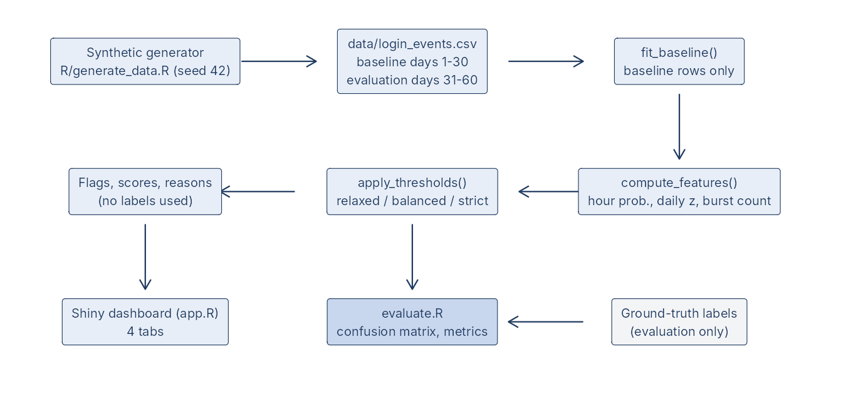
Figure 1: End-to-end workflow. Ground-truth labels enter only at the evaluation step.
File | Role
R/generate_data.R | Seeded synthetic data generator, CSV writer and reader, circular-distance helper
R/detector.R | fit_baseline(), compute_features(), apply_thresholds(), score_events(), threshold_profiles()
R/evaluate.R | confusion_metrics(), compare_profiles(), filter_events(), export_csv()
app.R | Shiny user interface and server (four tabs)
www/style.css, www/app.js | Dashboard styling and sidebar navigation behaviour
tests/ | testthat suite (tests/testthat) and one-command runner (tests/run_tests.R)
report/ | Result scripts (results.R, final_results.R), measured result CSVs, figures, screenshots and documents

Table 4: Repository components.

7. The R Implementation

7.1 Baseline estimation - fit_baseline()
fit_baseline() receives only the baseline-period events. For every user it stores the number of events, the smoothed hour probabilities, the circular mean login hour, and the mean and sd of daily counts over all calendar days in the baseline window (days without logins count as zero). It also stores a pooled (all-user) hour profile used for users with fewer than min_events = 20 baseline events or users never seen in the baseline.

7.2 Feature computation - compute_features()
compute_features() selects only the columns event_id, user_id, timestamp and status (the constant DETECTOR_INPUT_COLS) and so cannot read the label columns. It adds the login hour, circular distance from the user's mean hour, hour probability and surprisal, the running count of logins in the user-day with its z-score, and the trailing-window failure count. Rows with a missing user or timestamp are marked invalid and not scored.

7.3 Thresholding and explanation - apply_thresholds()
apply_thresholds() converts the features and a profile into the three ratios, the combined score S, the flag S ≥ 1, and a text reason. Flagged reasons end with 'unusual, not a confirmed attack' so the dashboard never presents a flag as a verdict. Because features are separated from thresholds, the Threshold Lab can re-score instantly when sliders move.

7.4 Evaluation - confusion_metrics() and compare_profiles()
confusion_metrics() takes the flags and the truth vector, drops pairs containing NA, counts TP, FP, TN and FN, and returns the metrics with safe division (NA for a zero denominator). compare_profiles() applies each profile to the same feature table and evaluates them on the same events.

7.5 Dashboard
The Shiny application has four tabs: Overview (event, user and flag counts, activity over time, hour distribution, normal-versus-flagged chart), Login Explorer (filters by user, date, status and flag, text search, table with scores and reasons, CSV export of the filtered rows), Threshold Lab (three named profiles plus a custom profile with sliders, metric table and chart) and Statistical Insights (methodology text and live results).
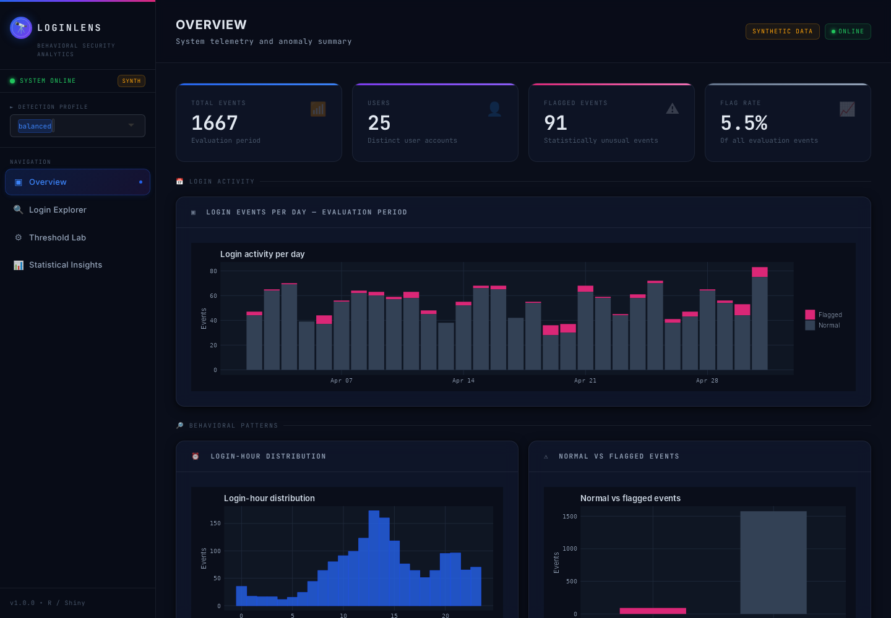
Figure 2: Overview tab of the running application (real screenshot, headless Chromium, balanced profile).
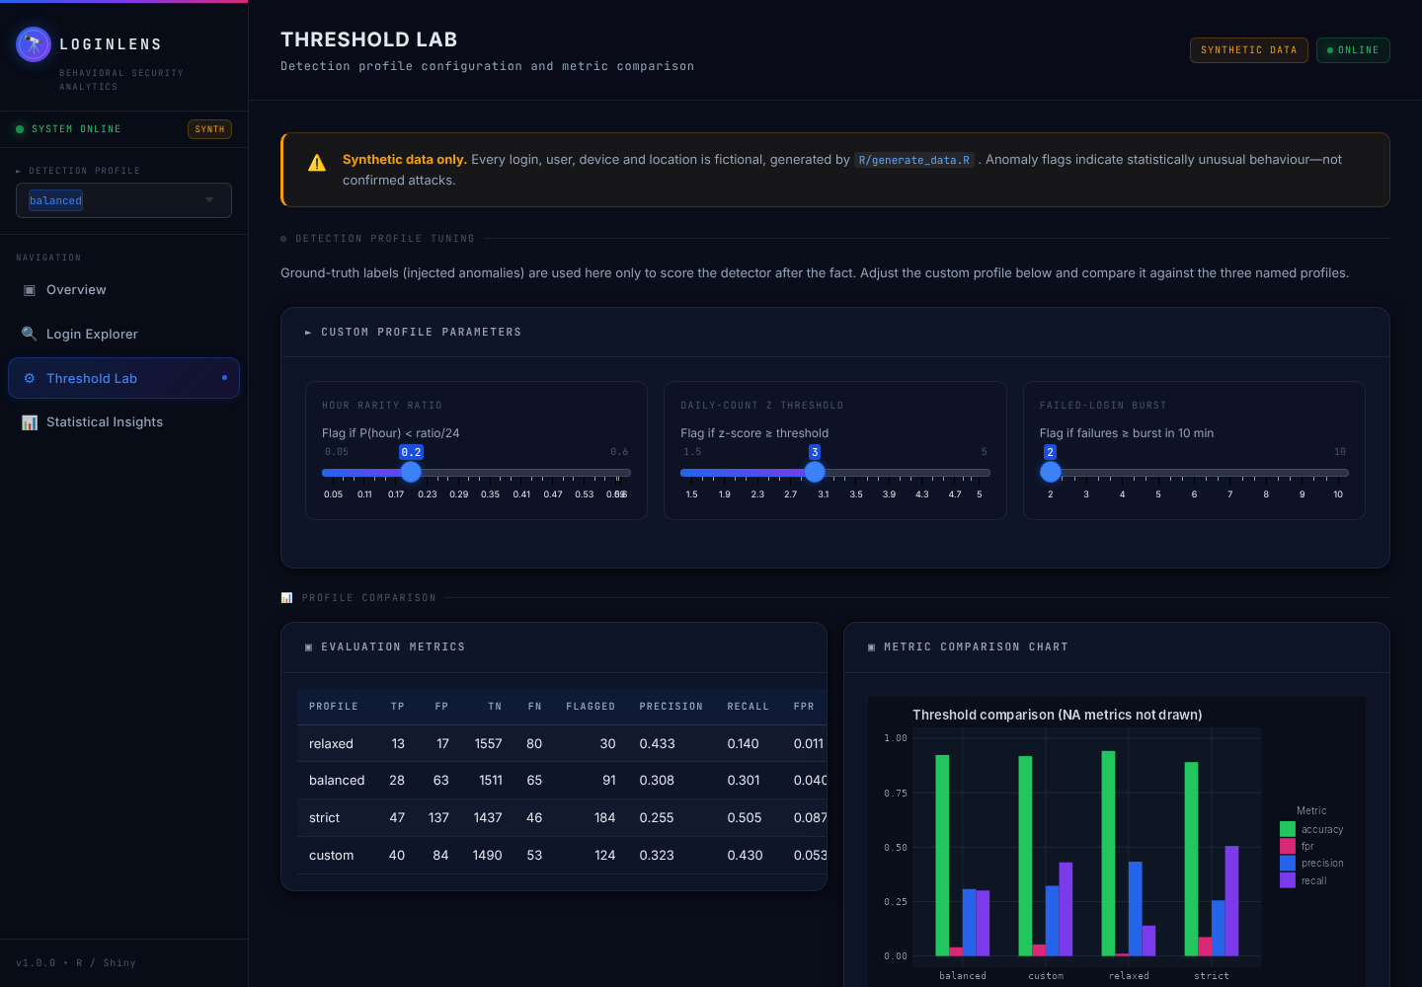
Figure 3: Threshold Lab tab (real screenshot; the custom profile has been moved to burst size 2).

8. Baseline/Evaluation Separation and Prevention of Data Leakage
- Time split: days 1-30 are the baseline; days 31-60 are the evaluation period. fit_baseline() is called with only baseline rows (app.R and report/final_results.R filter on period == 'baseline').
- No labels in the baseline: all injected anomalies occur in the evaluation period (a test asserts this), so the baseline contains only normal behaviour, including the benign odd-hour logins and mistyped-password streaks.
- No labels in the detector: compute_features() keeps only four input columns. A test shows that shuffling or removing the label columns leaves the computed features identical, and that the output has no label columns.
- No look-ahead: the daily count and the failure window use only events up to the current one.
- Labels are used afterwards: only confusion_metrics() and compare_profiles() receive the truth vector.
[CODE FACT] A caveat: the dataset's 'period' column is derived from the date by the generator. It is not a label and the detector itself does not read it; the application and scripts use it to choose which rows form the baseline.

9. Experimental Setup and Results
Setup. Dataset: data/login_events.csv (seed 42). Baseline: 1512 events. Evaluation: 1667 events, 93 of them injected anomalies. Profiles as in Table 2. Results below are the output of report/final_results.R and are stored in report/results/*.csv.

9.1 Threshold comparison (measured, seed 42)
Profile | TP | FP | TN | FN | Flagged | Prec. | Recall | FPR | Spec. | Acc. | F1
Relaxed | 13 | 17 | 1557 | 80 | 30 | 0.433 | 0.140 | 0.011 | 0.989 | 0.942 | 0.211
Balanced | 28 | 63 | 1511 | 65 | 91 | 0.308 | 0.301 | 0.040 | 0.960 | 0.923 | 0.304
Strict | 47 | 137 | 1437 | 46 | 184 | 0.255 | 0.505 | 0.087 | 0.913 | 0.890 | 0.339

Table 5: Confusion counts and metrics for the three profiles on the same evaluation data (measured).
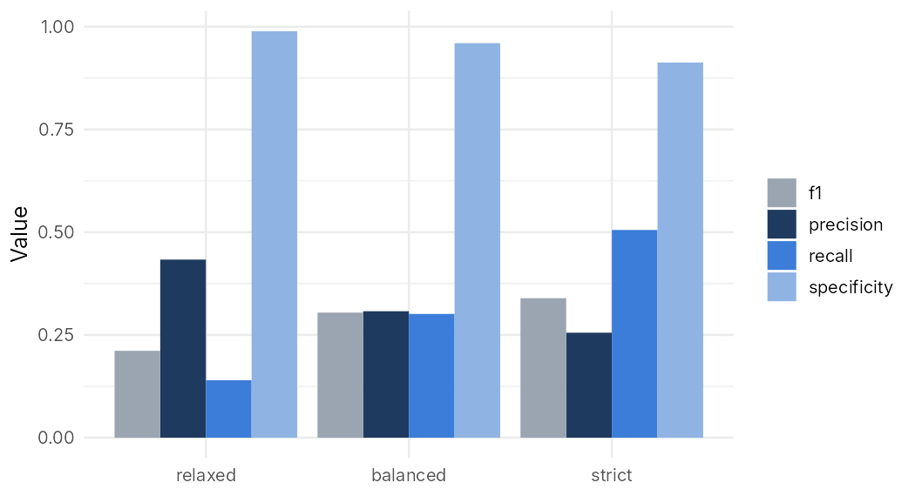
Figure 4: Precision, recall, specificity and F1 by profile (measured, seed 42).

9.2 Recall by anomaly type (measured, seed 42)
Profile | Anomaly type | Injected | Detected | Recall
Relaxed | unusual_time | 30 | 1 | 0.033
Relaxed | high_frequency | 29 | 5 | 0.172
Relaxed | failed_burst | 34 | 7 | 0.206
Balanced | unusual_time | 30 | 6 | 0.200
Balanced | high_frequency | 29 | 6 | 0.207
Balanced | failed_burst | 34 | 16 | 0.471
Strict | unusual_time | 30 | 17 | 0.567
Strict | high_frequency | 29 | 8 | 0.276
Strict | failed_burst | 34 | 22 | 0.647

Table 6: Detected injected events by type (measured). An event counts as detected if the detector flagged it for any reason.
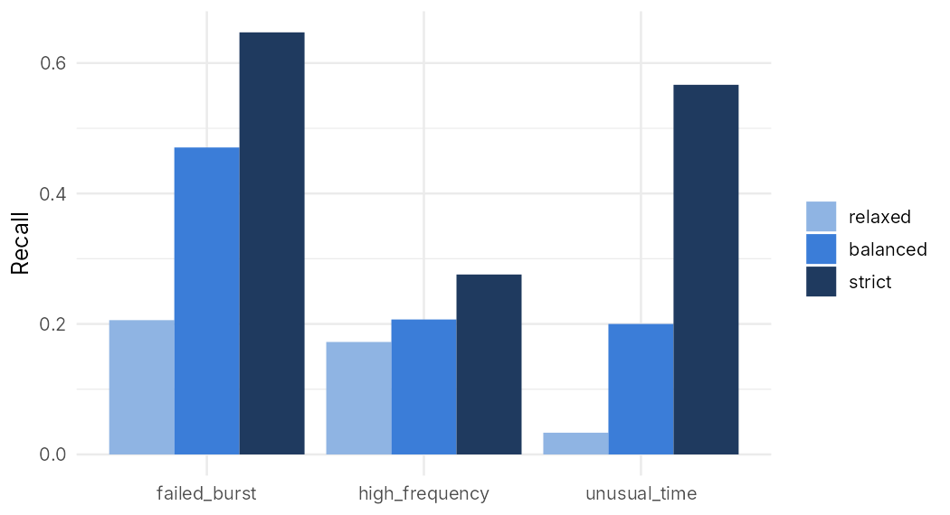
Figure 5: Recall by anomaly type and profile (measured).

9.3 Variability across random seeds (measured)
A single dataset can be lucky or unlucky. To see how much the results depend on the random draw, the whole pipeline (generate, fit, score, evaluate) was repeated for seeds 1 to 20 with the thresholds unchanged. Table 7 reports the mean and standard deviation across those 20 synthetic datasets.
Profile | Precision | Recall | FPR | F1
Relaxed | 0.442 ± 0.130 | 0.137 ± 0.042 | 0.012 ± 0.004 | 0.207 ± 0.060
Balanced | 0.371 ± 0.064 | 0.312 ± 0.046 | 0.036 ± 0.007 | 0.338 ± 0.049
Strict | 0.305 ± 0.042 | 0.492 ± 0.047 | 0.075 ± 0.012 | 0.375 ± 0.038

Table 7: Mean ± standard deviation over 20 seeds (measured; seeds 1-20, which do not include the seed-42 dataset used elsewhere).
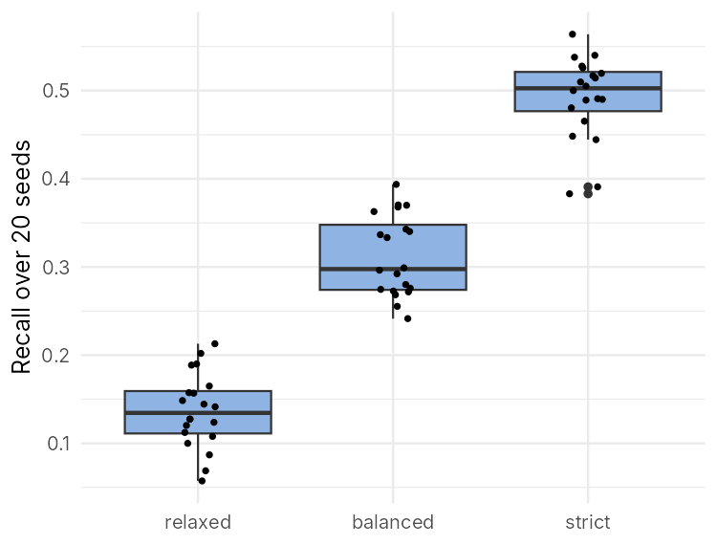
Figure 6: Recall over 20 seeds for each profile (measured).

9.4 Interpretation
- Trade-off (measured): lowering the thresholds from relaxed to strict raised recall (0.140 → 0.505) and F1 (0.211 → 0.339) while precision fell (0.433 → 0.255) and the false-positive rate rose (0.011 → 0.087). The 20-seed means show the same ordering, so the pattern is not an accident of seed 42.
- Accuracy is high for every profile (0.890-0.942) because about 94% of events are normal; this is why precision, recall and F1 are reported as well.
- Absolute performance is modest. Even the strict profile flags 184 events to catch 47 of 93 anomalies, and 137 flags are false alarms. This is a consequence of the design of the simulation (subtle anomalies, noisy normal behaviour) and of simple one-dimensional rules; it should not be read as a property of real login data.
- Detection depends on the anomaly type (measured, Table 6). The hour rule rarely fires for the relaxed profile, because the cut-off P < 0.1/24 is very small compared with the smoothed probability of an hour seen even a few times, whereas bursts are detected more often. The reasons offered here for the differences (the size of thresholds relative to the smoothing, the 10% benign random-hour logins that make rare hours common enough in the baseline, and the mildly unusual injected hours that sit within a user's plausible range) are plausible explanations from the design and were not separately tested.

10. Verification and Testing
The automated suite (tests/testthat, run with Rscript tests/run_tests.R) contained 111 expectations at the time of the final validation run and all passed. It covers: data schema and valid values; reproducibility; baseline-only fitting; label separation; circular distance and hour probabilities; zero-variance and insufficient-history behaviour; missing and empty inputs; threshold monotonicity (stricter profiles never flag fewer events); hand-computed confusion matrices including F1, specificity and undefined (NA) metrics; filtering and CSV export including empty results; Shiny server logic via shiny::testServer; and an HTTP start-up check.
In addition, the running application was exercised in headless Chromium: all four sidebar items switch the visible tab and keep the highlighted item and page title in sync; the profile selector changes the Overview counts; Explorer flag, user, date and text filters change the table; the exported CSV matches the filtered rows and excludes ground-truth columns; an empty filter shows 'No data available' and exports a header-only CSV; and moving a Threshold Lab slider changes the custom row.
[CODE FACT] Not tested: the application on Windows/R 4.6 (verification was done on Linux with R 4.3.3), Safari/Firefox, screen readers, load or security testing, and any real login data.

11. Limitations, Assumptions and Sources of Error
- Synthetic data. The data follow the generator's assumptions and the anomalies were injected by the same author as the detector; results do not demonstrate real-world performance.
- Normality assumption for counts. Daily login counts are non-negative integers with right skew and over-dispersion (the generator uses a negative binomial). A z-score treats them as roughly normal, so z = 3 does not correspond exactly to a 0.13% tail probability. A Poisson or negative-binomial model, or a robust statistic such as median and MAD, would be more principled.
- Running count versus daily mean. The k-th login of a day is compared with the mean of whole-day counts, so the z-score rises through the day by construction; it is a simple heuristic for 'more logins than usual so far today'.
- Stable-behaviour assumption. New jobs, travel or time-zone changes would produce false positives; the baseline is fixed, not updated.
- Clean-baseline assumption. Contamination of the baseline by real anomalies would inflate the standard deviation and hide later anomalies.
- Small samples. Users with few baseline events have noisy estimates (one user has 16 events and uses the pooled profile).
- Multiple testing. Three rules are combined with OR, which increases false alarms relative to any single rule.
- Threshold choice. The profile values are round, hand-chosen numbers; a real deployment would tune them to a tolerable false-alarm budget on separate validation data.
- Not used: device, location, IP address and sequence information.
- Interpretation. A flag means statistically unusual behaviour and requires human review; it is never proof of an attack.

12. Future Improvements
- Replace the normal z-score by a Poisson or negative-binomial tail probability for daily counts.
- Use rolling or exponentially weighted baselines and test the detector on drifting behaviour.
- Add device and location novelty as extra evidence; combine rules with a calibrated probability rather than a maximum of ratios.
- Select thresholds with a validation set and report ROC or precision-recall curves.
- Evaluate on public, properly anonymised authentication datasets, where permitted.

13. Conclusion
LoginLens shows how a small set of probability and statistics tools - empirical probabilities with smoothing, standardised scores, a trailing failure count and a confusion-matrix evaluation - can build an explainable detector of unusual login behaviour, implemented as a tested R/Shiny application. On the synthetic data the detector exhibits the expected trade-off between false alarms and missed anomalies (e.g. recall 0.140 to 0.505 and precision 0.433 to 0.255 from the relaxed to the strict profile), while absolute performance is modest because the anomalies were designed to be subtle. The project's main value is methodological: it demonstrates baseline/evaluation separation, avoidance of label leakage, safe handling of edge cases and honest reporting of results and limitations.

14. Installation, Running and Reproducing the Results
Windows PowerShell (from the project folder; if Rscript is not on PATH use the full path, for example & "C:\Program Files\R\R-4.6.1\bin\Rscript.exe"):
Rscript -e "install.packages(c('shiny','ggplot2','dplyr','lubridate','tidyr','DT','testthat','rmarkdown','knitr'))"
Rscript R/generate_data.R # regenerate data/login_events.csv (seed 42)
Rscript -e "shiny::runApp('.')" # start the application
Rscript tests/run_tests.R # run the automated tests
Rscript report/final_results.R # recompute all measured results and figures

Results in this report were produced by the last command; the tables and figures can be regenerated from the repository. The Word documents themselves were assembled from those result files by a script, so numbers in them can be traced to report/results/*.csv.

15. References
- Chandola, V., Banerjee, A. and Kumar, V. (2009). Anomaly detection: A survey. ACM Computing Surveys, 41(3), Article 15.
- Fawcett, T. (2006). An introduction to ROC analysis. Pattern Recognition Letters, 27(8), 861-874.
- Powers, D. M. W. (2011). Evaluation: From precision, recall and F-measure to ROC, informedness, markedness and correlation. Journal of Machine Learning Technologies, 2(1), 37-63.
- Mardia, K. V. and Jupp, P. E. (2000). Directional Statistics. Wiley.
- Manning, C. D., Raghavan, P. and Schütze, H. (2008). Introduction to Information Retrieval. Cambridge University Press (discussion of add-one / additive smoothing).
- Shannon, C. E. (1948). A mathematical theory of communication. Bell System Technical Journal, 27(3), 379-423 and 27(4), 623-656.
- Montgomery, D. C. and Runger, G. C. Applied Statistics and Probability for Engineers. Wiley (any edition; general reference for z-scores, normal distribution and error types).
- R Core Team. R: A Language and Environment for Statistical Computing. R Foundation for Statistical Computing, Vienna, Austria. https://www.R-project.org/
- Chang, W., Cheng, J., Allaire, J. J. et al. shiny: Web Application Framework for R. Package documentation: https://shiny.posit.co/
- Wickham, H. (2021). Mastering Shiny. O'Reilly Media. https://mastering-shiny.org/
- Wickham, H. (2016). ggplot2: Elegant Graphics for Data Analysis. Springer. Package documentation: https://ggplot2.tidyverse.org/
- Grolemund, G. and Wickham, H. (2011). Dates and times made easy with lubridate. Journal of Statistical Software, 40(3), 1-25.
- Wickham, H. (2011). testthat: Get started with testing. The R Journal, 3(1), 5-10.
The reference list names standard textbooks, papers and official software documentation; page numbers are given only where the author is confident of them. Please check each entry against your library or the publisher's page before submission.

