LoginLens: Statistical Detection of Unusual Login Activity Using R
Probability and Statistics project report (synthetic data only)

1. Introduction
LoginLens flags statistically unusual login events using transparent, explainable rules. All data are synthetic and fictional; no real login records were used. Results therefore describe behaviour on simulated data and are not evidence about real systems. A flag means “unusual”, never “confirmed attack”.

2. Workflow
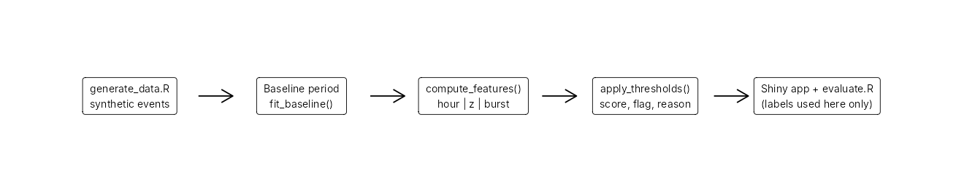
Architecture / workflow

3. Synthetic data
R/generate_data.R (seed 42) simulates 3179 events for 25 fictional users over 60 days: a 30-day baseline (1512 events, no injected anomalies) and a 30-day evaluation period (1667 events, 93 injected anomalies). Each user has a preferred hour (mean/sd), a mean daily login rate with negative-binomial over-dispersion, weekend dampening, a failure probability, devices and a home location. Normal behaviour deliberately looks odd sometimes: 10% of logins occur at a random hour, and 1% of logins are preceded by 2-3 mistyped-password failures. Injected anomalies: unusual login hour (4-12 h from the user’s usual), high daily frequency (3-8 extra logins), failed-login bursts (3-9 failures in 8 minutes). Ground-truth columns (is_injected_anomaly, anomaly_type) are dropped inside compute_features() and used only by evaluate.R.

4. Method and derivations
Hour rarity. For user $u$ with baseline hour counts $n_{h}$ ($N$ events):
$$P_{u}\left(h\right)=\frac{{\left(Kn\right)}_{h}+α}{N+24α}, K_{hk}∝exp​\left(−{d_{c}{\left(h,k\right)}^{2}}/{2σ^{2}}\right), d_{c}\left(h,k\right)=min\left(\left|h−k\right|,24−\left|h−k\right|\right)$$
with $α=0.5$, $σ=1$ h, and $K$ row-normalised so h​Knh=N and hence h​Puh=1 and every $P_{u}\left(h\right)>0$ (no infinite surprisal). The circular distance makes 23:00 and 00:00 neighbours. Surprisal is $−\log_{2}P_{u}\left(h\right)$. Flag if $P_{u}\left(h\right)<r/24$ ($r$ = hour ratio: 0.10, 0.20, 0.30). Users with fewer than 20 baseline events use the pooled profile.
Daily frequency. For the $k$-th login of a user-day:
$$z=min​\left(\frac{k−{\overset{‾}{x}}_{u}}{max\left(s_{u},1\right)}, 10\right)$$
where ${\overset{‾}{x}}_{u},s_{u}$ are the mean and sd of the user’s baseline daily counts (zero-count days included). The floor of 1 handles $s_{u}=0$; the cap keeps scores finite; only same-day past events are used. Users without enough history get no frequency evidence. Limitation: daily counts are discrete and right-skewed, so a normal-based z-score is only approximate; a Poisson/negative-binomial model would be better.
Failed bursts. $B_{i}$ = number of failures by the same user in the 10 minutes up to and including event $i$ (trailing window, no look-ahead). Flag if $B_{i}≥b$ ($b$ = 6, 4, 3).
Combined score. $S=max\left({−\log_{2}P_{u}\left(h\right)}/{−\log_{2}\left(r/24\right)}, {max\left(z,0\right)}/{z^{*}}, B/b\right)$; flag iff $S≥1$. The reason text states which rules fired.
Profile | hour ratio r | z* | burst b
relaxed | 0.10 | 3.5 | 6
balanced | 0.20 | 3.0 | 4
strict | 0.30 | 2.5 | 3
Thresholds were fixed before looking at results (principled round values), not tuned to the labels.
Evaluation. With TP, FP, TN, FN: precision = TP/(TP+FP), recall = TP/(TP+FN), FPR = FP/(FP+TN), accuracy = (TP+TN)/total. A zero denominator gives NA.

5. Results (actual computed output, evaluation period only)
Confusion counts and metrics per profile (same evaluation data)
profile | TP | FP | TN | FN | flagged | precision | recall | fpr | accuracy
relaxed | 13 | 17 | 1557 | 80 | 30 | 0.433 | 0.140 | 0.011 | 0.942
balanced | 28 | 63 | 1511 | 65 | 91 | 0.308 | 0.301 | 0.040 | 0.923
strict | 47 | 137 | 1437 | 46 | 184 | 0.255 | 0.505 | 0.087 | 0.890
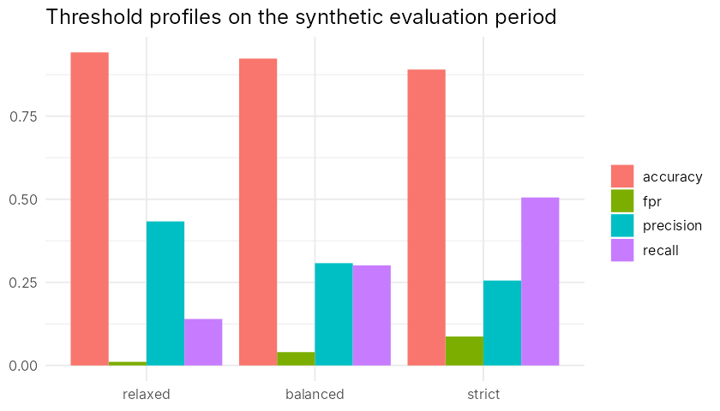
Threshold comparison
Recall by injected anomaly type
profile | type | n | detected | recall
relaxed | unusual_time | 30 | 1 | 0.033
relaxed | high_frequency | 29 | 5 | 0.172
relaxed | failed_burst | 34 | 7 | 0.206
balanced | unusual_time | 30 | 6 | 0.200
balanced | high_frequency | 29 | 6 | 0.207
balanced | failed_burst | 34 | 16 | 0.471
strict | unusual_time | 30 | 17 | 0.567
strict | high_frequency | 29 | 8 | 0.276
strict | failed_burst | 34 | 22 | 0.647
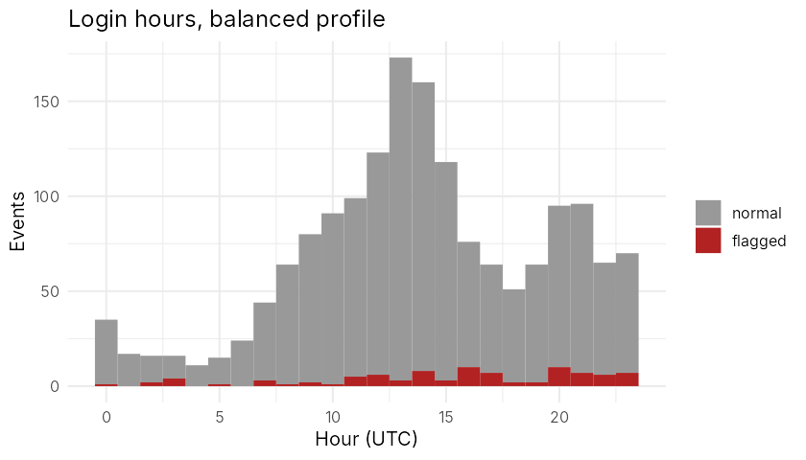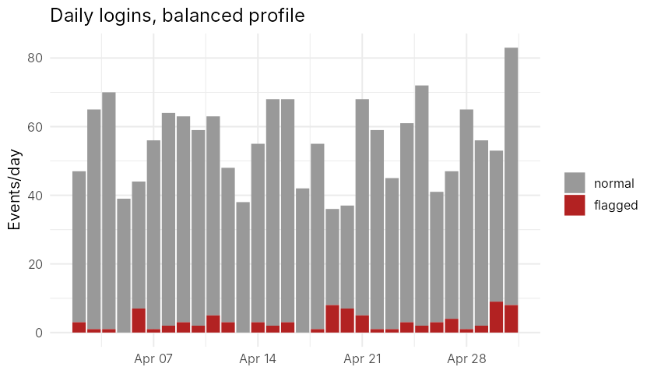
Reading the results. Moving from relaxed to strict raised recall from 0.14 to 0.51 while precision fell from 0.43 to 0.26 and the false-positive rate rose from 0.011 to 0.087. Accuracy is dominated by the ~94% normal events and falls as more events are flagged. These trade-offs are specific to this simulation. Subtle anomalies (hours only 4-5 h from the usual time, small extra-login counts, 3-failure bursts) are often missed by design.

6. Testing
Rscript tests/run_tests.R runs 100 expectations covering schema, reproducibility, label separation, scoring, zero variance, insufficient history, missing/empty input, hand-computed confusion matrices, threshold monotonicity, CSV export, server logic (shiny::testServer) and an HTTP start-up check. Not tested: browser interaction (shinytest2 unavailable); visual appearance was checked via a headless-browser screenshot only.

7. Limitations
Synthetic data and self-injected anomalies; baseline assumed clean; stable habits assumed; device/location unused; normal approximation for counts; no concept drift handling; results are not evidence of real-world performance.

