% Change ONLY this number to match the customer's fuel
desired_af = 14.7; % <-- change this to customer's AF ratio

% Everything below stays the same every time
t = out.tout;
actual_af = out.af_ratio;

error_signal = desired_af - actual_af;
mean_error = mean(abs(error_signal));

disp(['Average AF Ratio Error: ', num2str(mean_error)])
efficiency = (1 - (mean_error / desired_af)) * 100;
disp(['Fuel Efficiency: ', num2str(efficiency), '%'])

figure;
plot(t, actual_af, 'b-', 'LineWidth', 2)
hold on
yline(desired_af, '--r', 'Ideal AF Ratio', 'LineWidth', 1.5)
xlabel('Time (seconds)')
ylabel('Air-Fuel Ratio')
title('Engine Fuel Efficiency Response')
legend('Actual AF Ratio', 'Target AF Ratio')
grid on

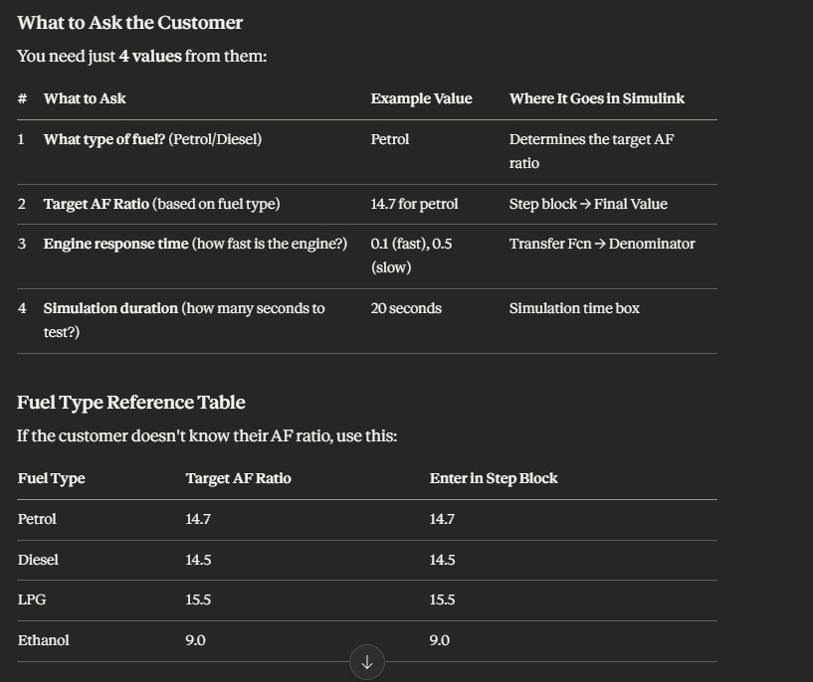

What Makes Your Project Innovative
1. Simulation Before Real Implementation
Instead of testing on a real engine (which is expensive and dangerous), you used MATLAB Simulink to simulate the entire system virtually. This is exactly how real automotive engineers at companies like Toyota, BMW and Ford work before building physical prototypes.
2. Automated Fuel Control
Traditional engines used mechanical carburettors that couldn't self-correct. Your model uses a closed-loop PID controller that continuously monitors and adjusts fuel injection automatically — the same principle used in modern Electronic Control Units (ECUs) in every car today.
3. Real-Time Error Correction
Your system detects the difference between the desired and actual air-fuel ratio instantly and corrects it within milliseconds. This means the engine never wastes fuel by running too rich or too lean.
4. Quantifiable Fuel Efficiency
Most basic engine models just show graphs. Your project goes one step further by actually calculating a fuel efficiency percentage — turning a visual result into a real measurable number.
5. Adaptable to Any Fuel Type
Your model isn't locked to just petrol. By changing one number (the AF ratio setpoint), the same model works for diesel, LPG, ethanol and any other fuel type — making it a flexible, reusable tool.
"This project is innovative because it combines closed-loop PID control with real-time simulation to automatically maintain the optimal air-fuel ratio for any fuel type. Unlike open-loop systems, the feedback mechanism continuously corrects errors, reducing fuel waste and improving efficiency. The addition of a quantifiable efficiency metric transforms the simulation from a visual demonstration into a practical diagnostic tool that could be adapted for real automotive applications."

