Commit and Push from IDE to GitHub
Package Creation
- Install a development environment (e.g., IntelliJ IDEA).
- Create a Java or Automation project.
- Right-click on the project src-main-Java-click **New > Package**.
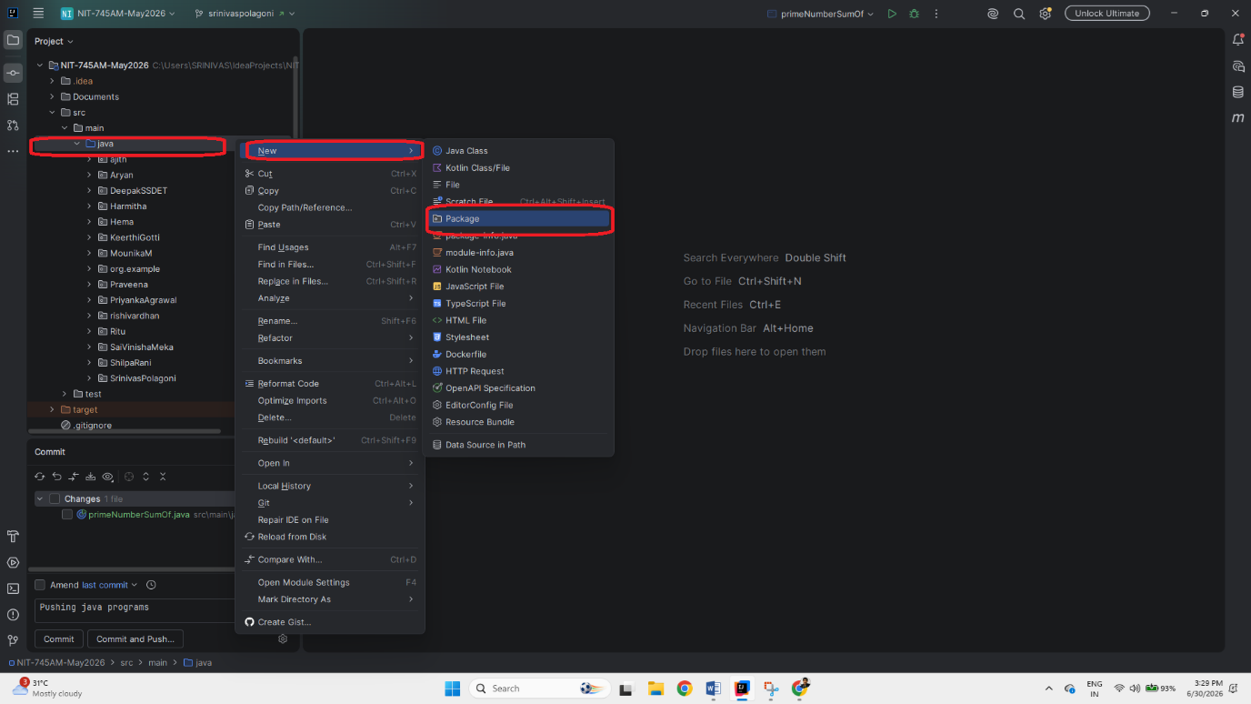

- After clicking **Package**, enter the package name (Ex: SrinivasPolagoni) Package names must not contain spaces. Press Enter.
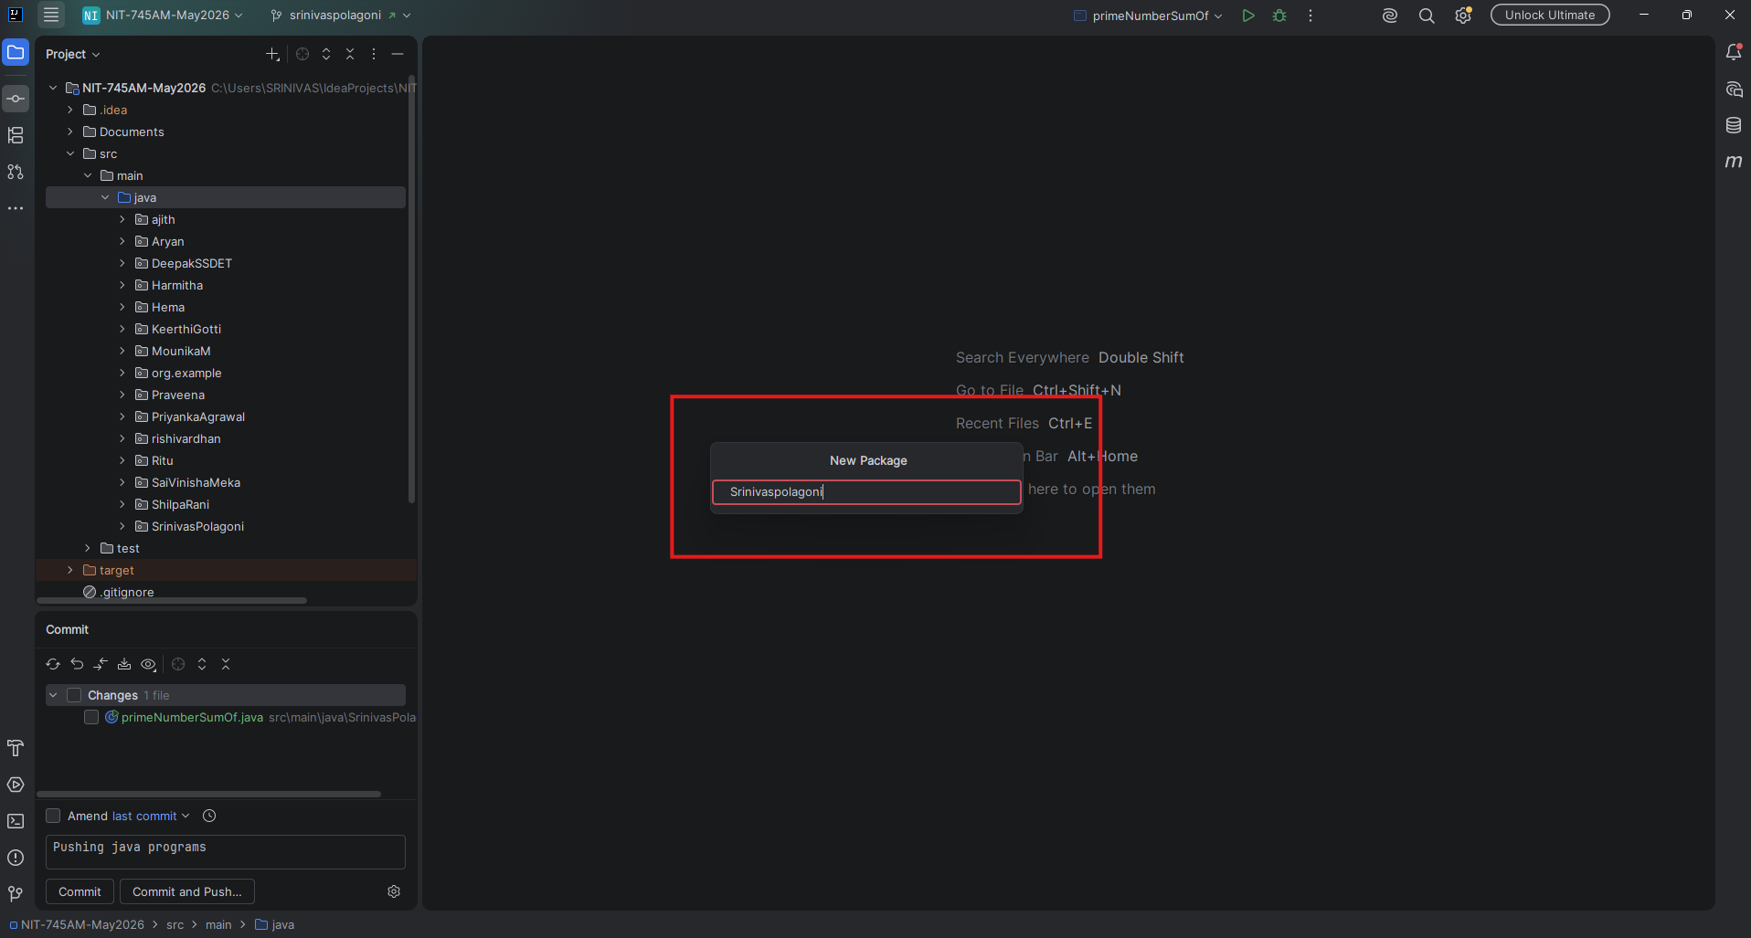

- Package “srinivasPolagoni” created
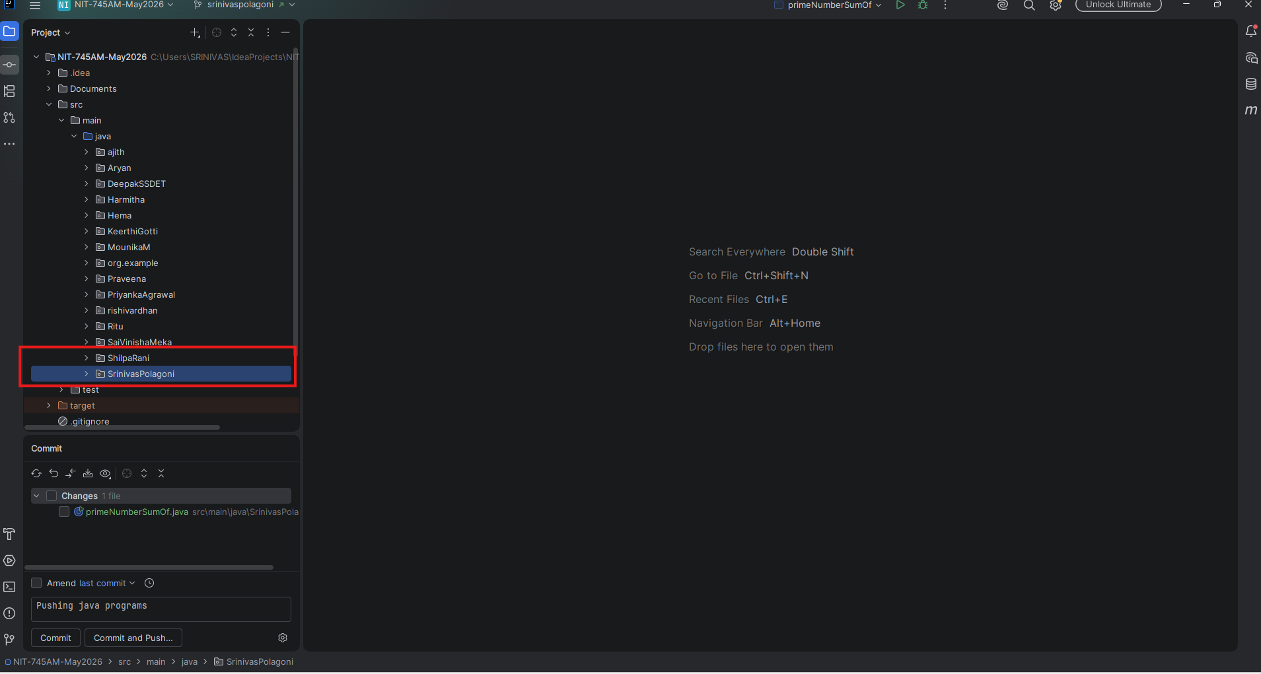

Creating a Branch:
- Right-click on the project select Git-click Branches or New Branch.
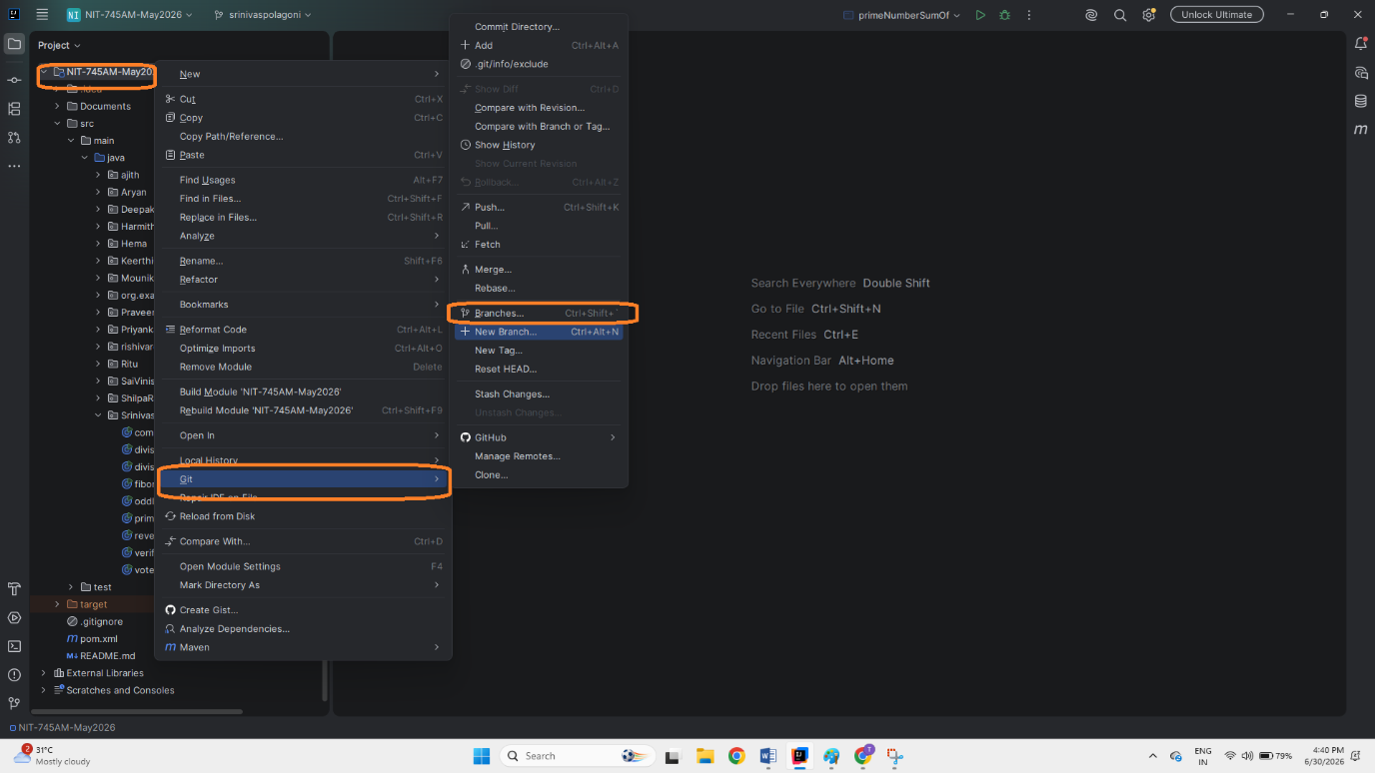

- After click the git-branch- go to –origin-main-select new branch from origin main and click
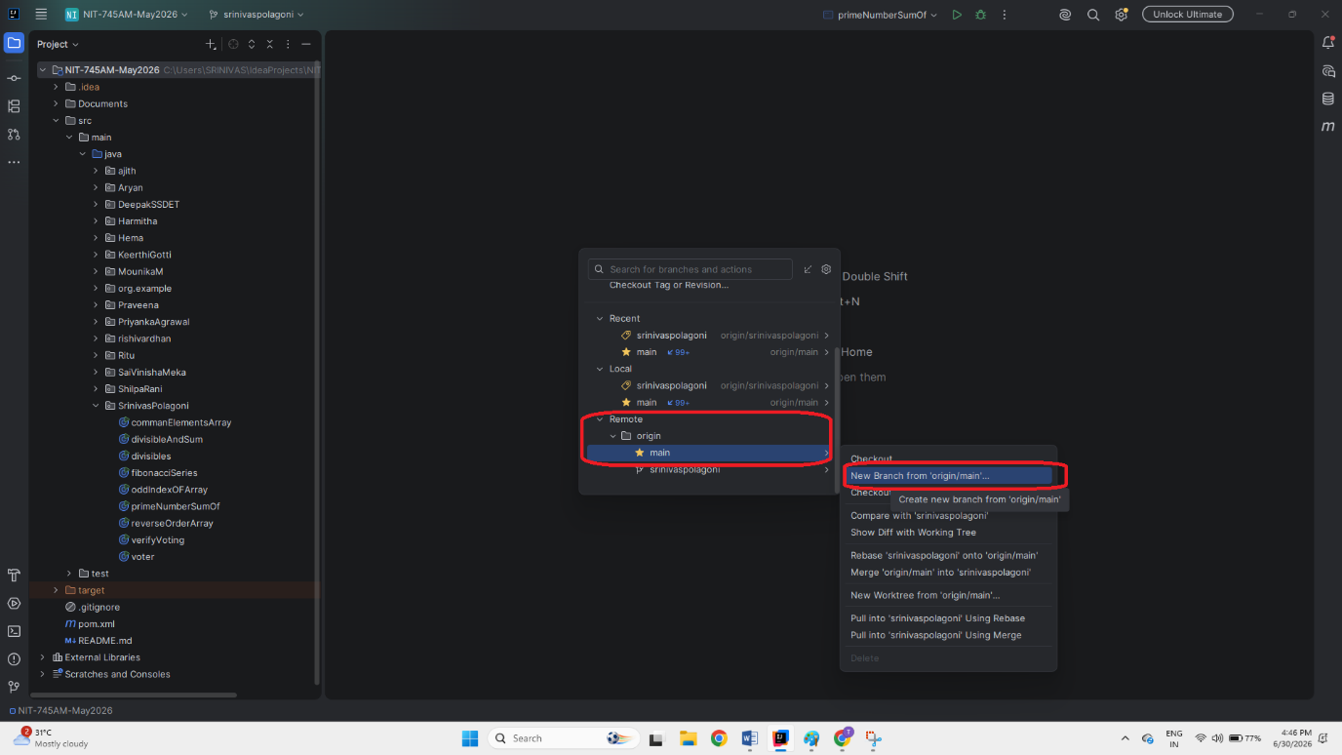
- After clicking the new Branch from origin/main and give me branch name and click create.
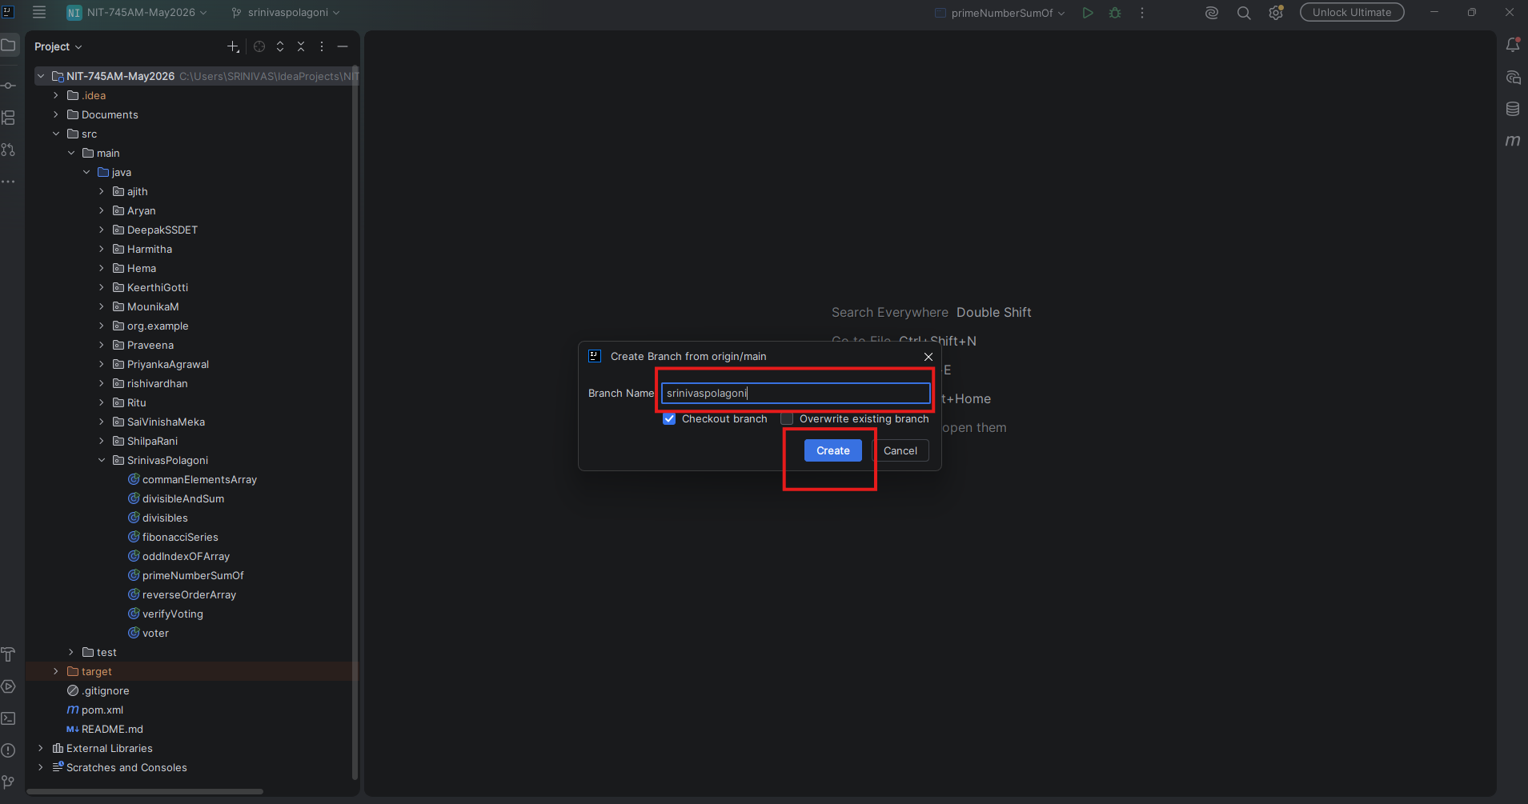

- Branch created successfully without issues.
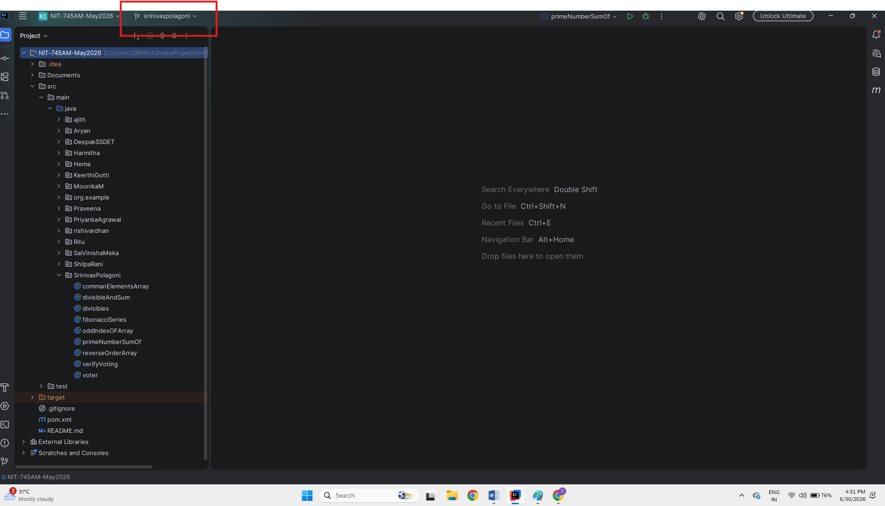

Commit and Push Java Programs from the IDE:
- Write the Java programs or copy and paste the Java programs inside Package.
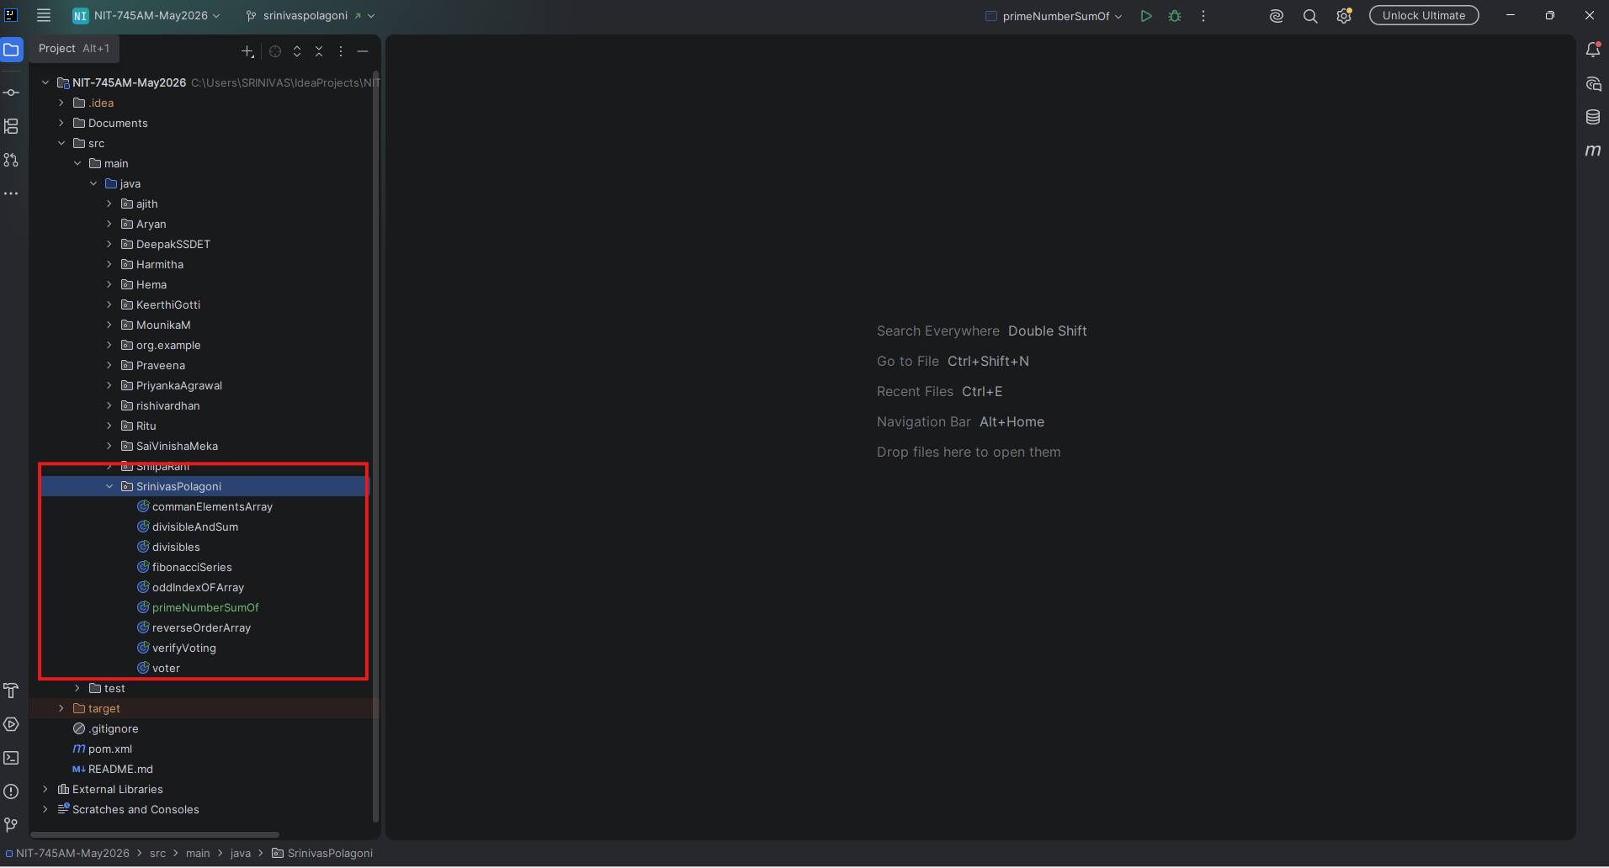

2. Commit the Java programs two ways
A).First way to commit the Java programs from toolbar will show the commit option
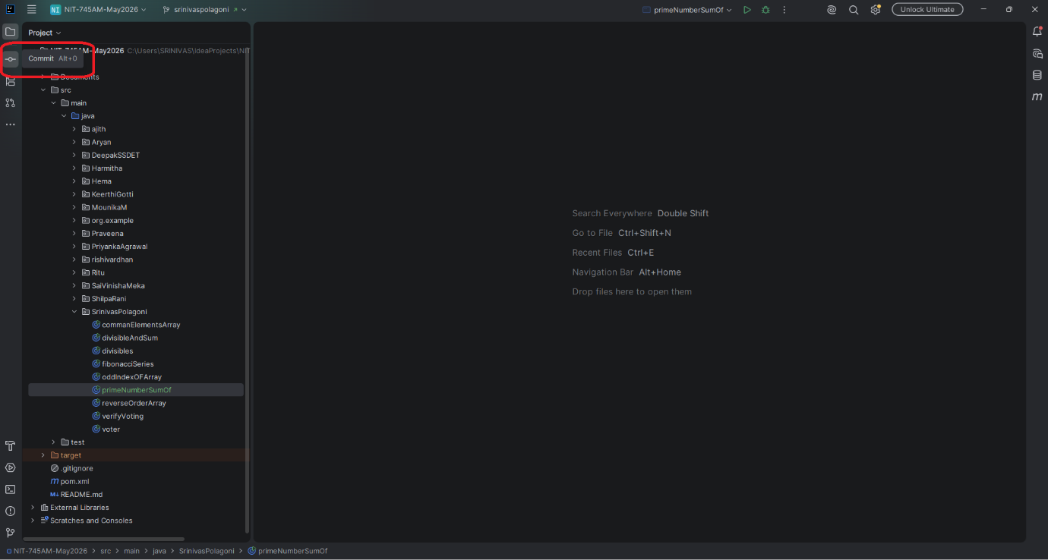
B). Second way to commit the Java programs right click the Java programs-Git-Commit Files
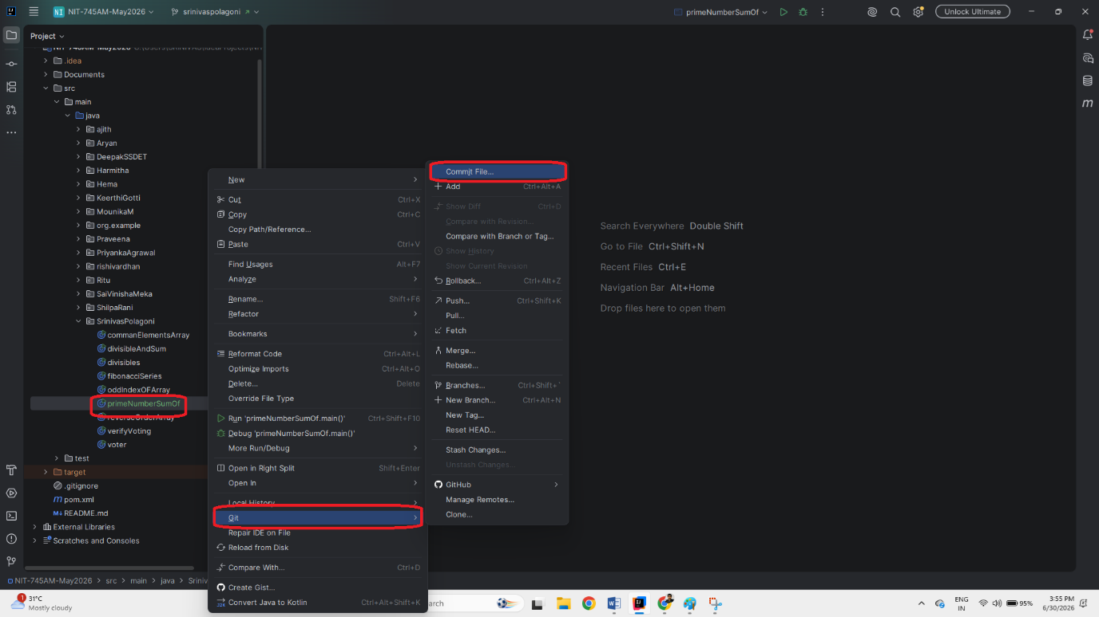

- Click commit option above mentioned any one way after clicking the commit option
Commit panel will show which programs are available or things to commit.

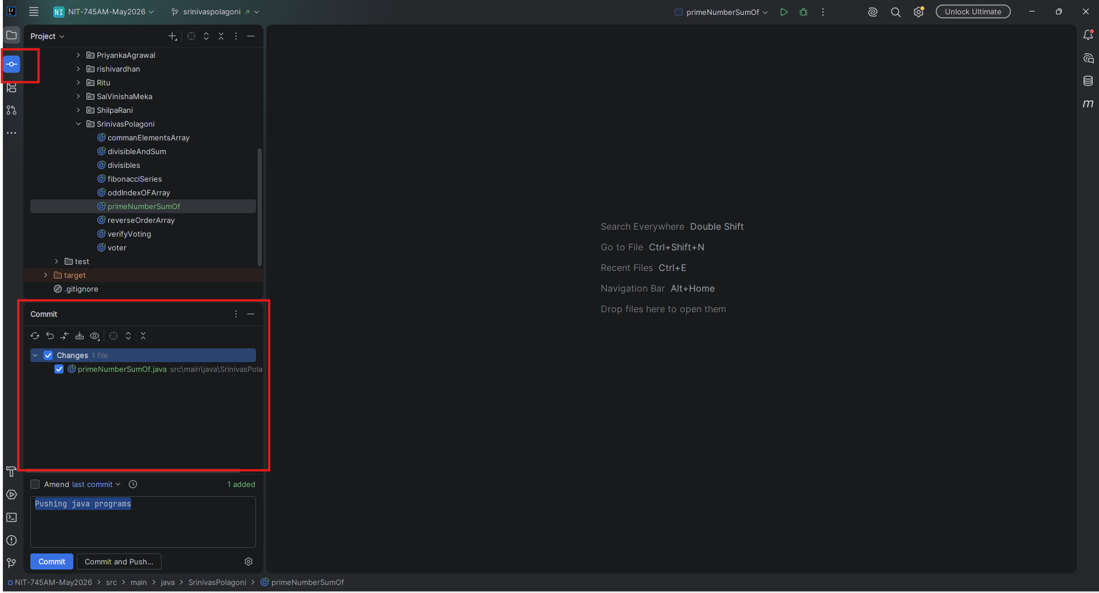

- Clicking the commit option will show which programs to commit select those programs write comment about pushing programs or documents and click the option “Commit and Push”

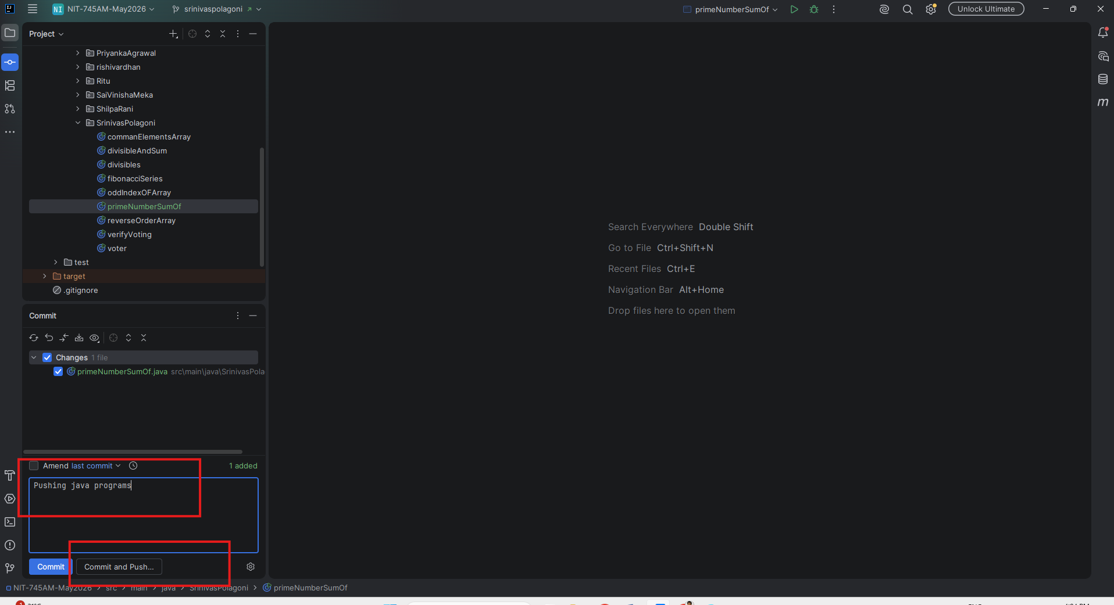

- After clicking the commit and push will show all pushing items in the project at this time first check which origin or branch you are pushing files after everything correct click push.

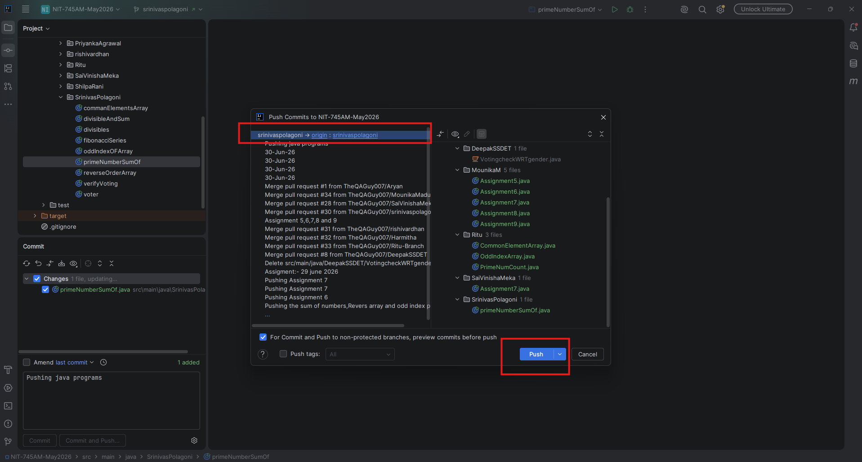

- After clicking the Push button will get notification like below screen short
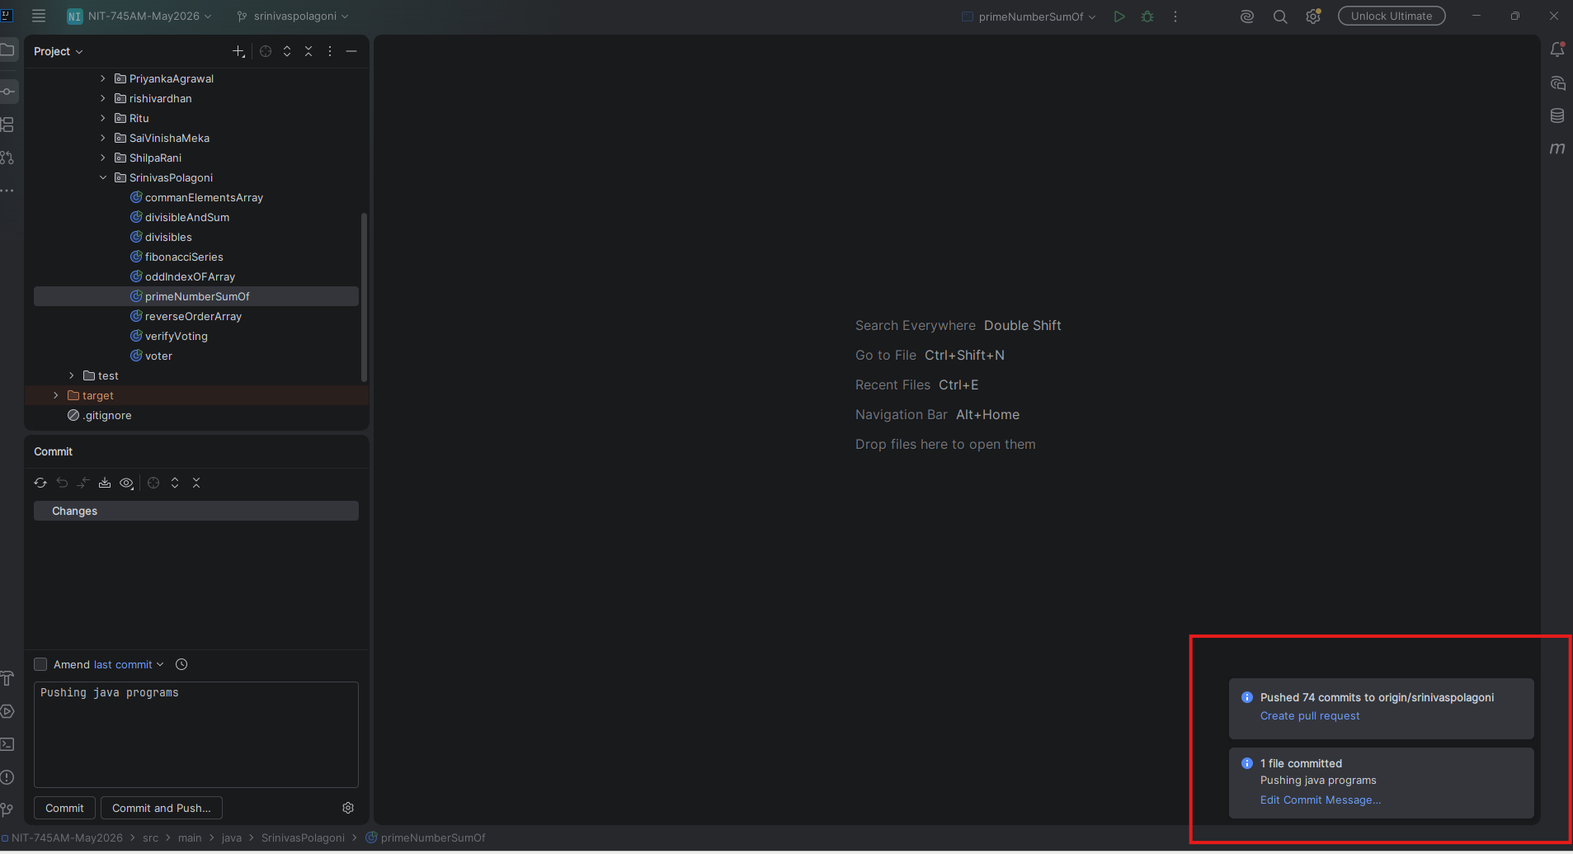

- Completing commit and push from IDE open the GitHub in Browser select specific project

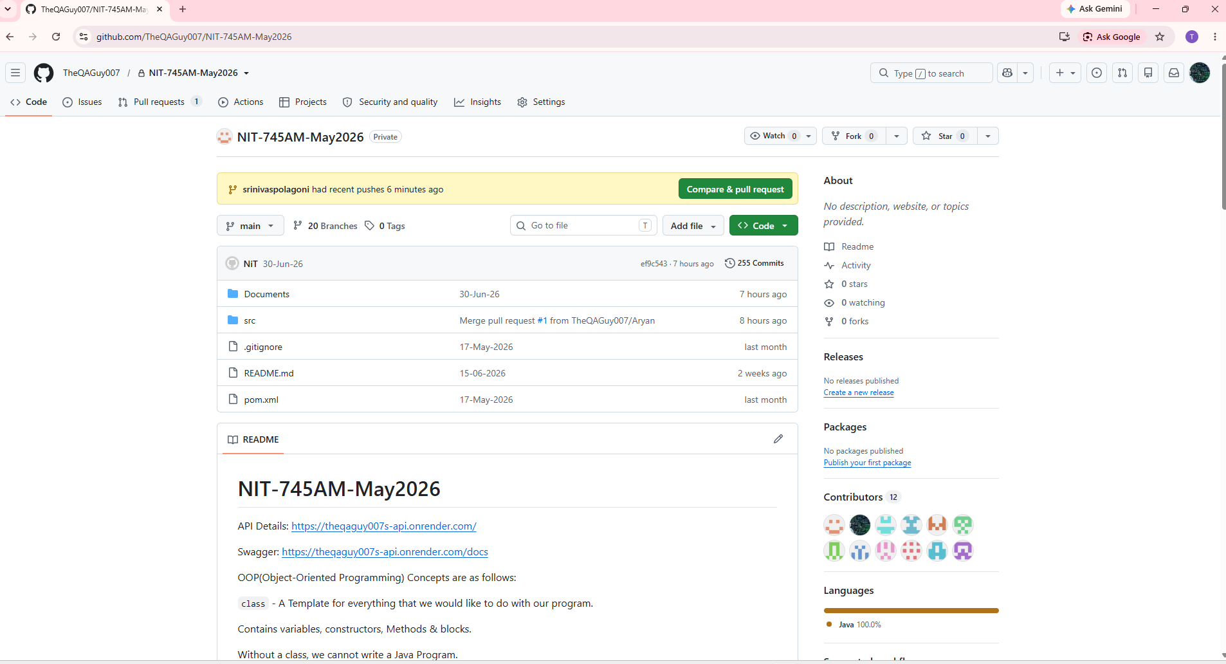

- Click the Branch and go to your specific branch ( Ex : srinivas Polagoni)

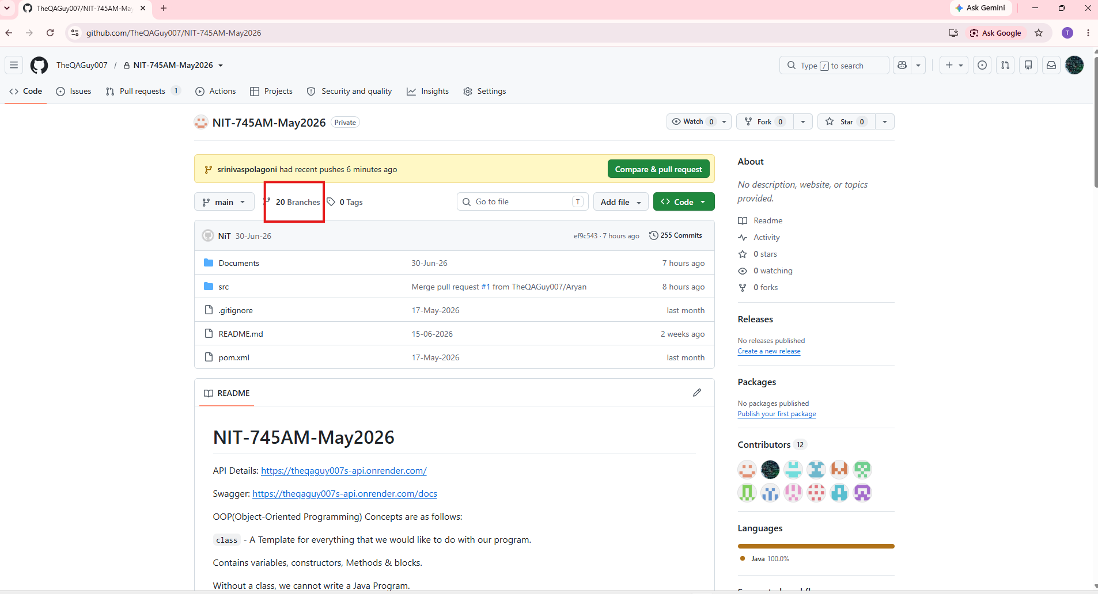
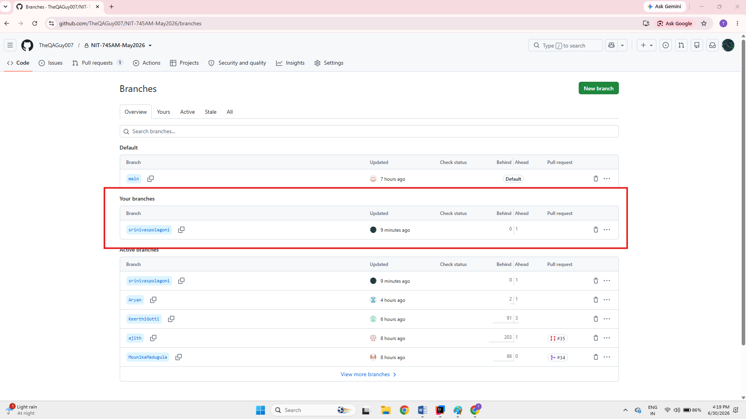

- Click the three dots in your Branch Raise “New Pull Request”(PR) add your comments click the “Create Pull Request” after Admin will check your PR related code or documents and merge in your project.

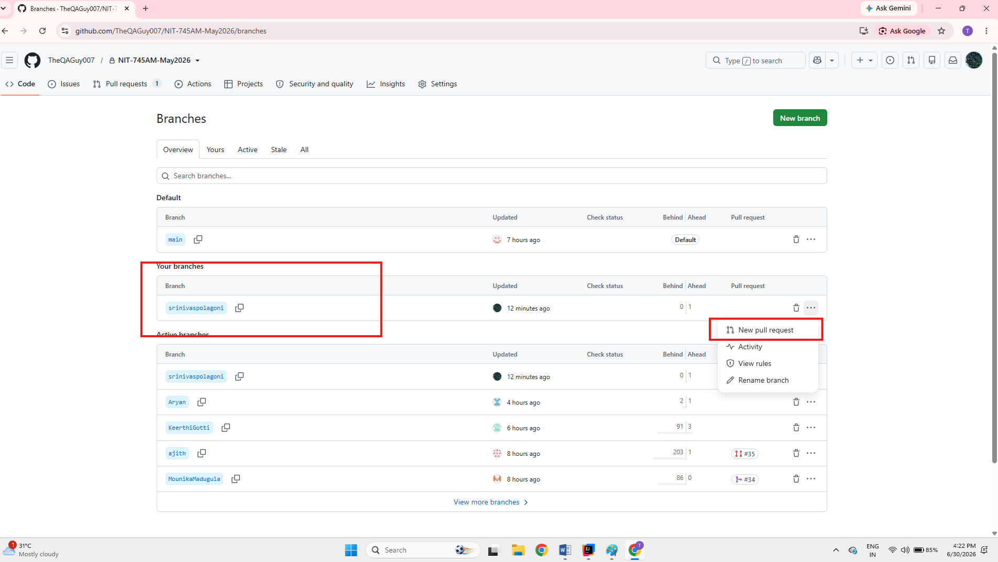

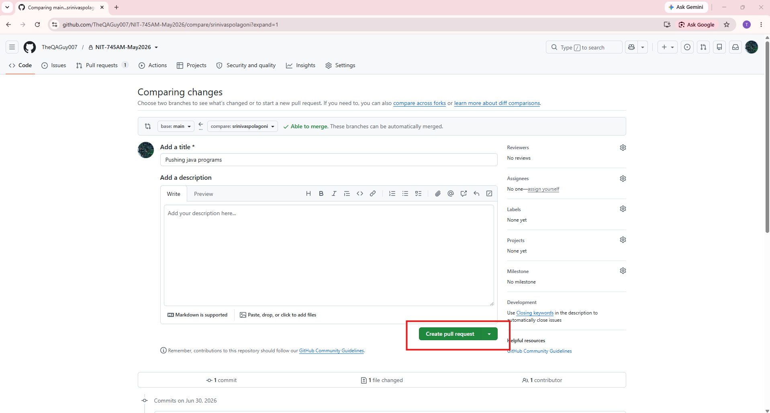

- After creating the PR will show the request in “Open” and ready for merge waiting for admin approval
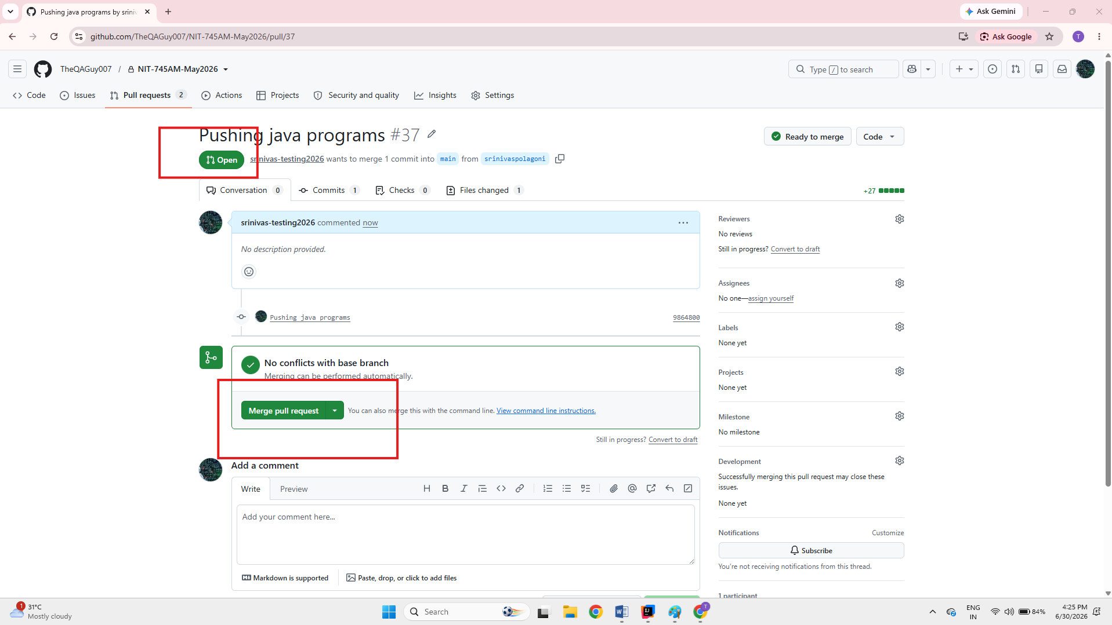

Pull the Latest Changes from the Main Branch:
- Right-click the project Git-Pull-select Main branch and click Pull
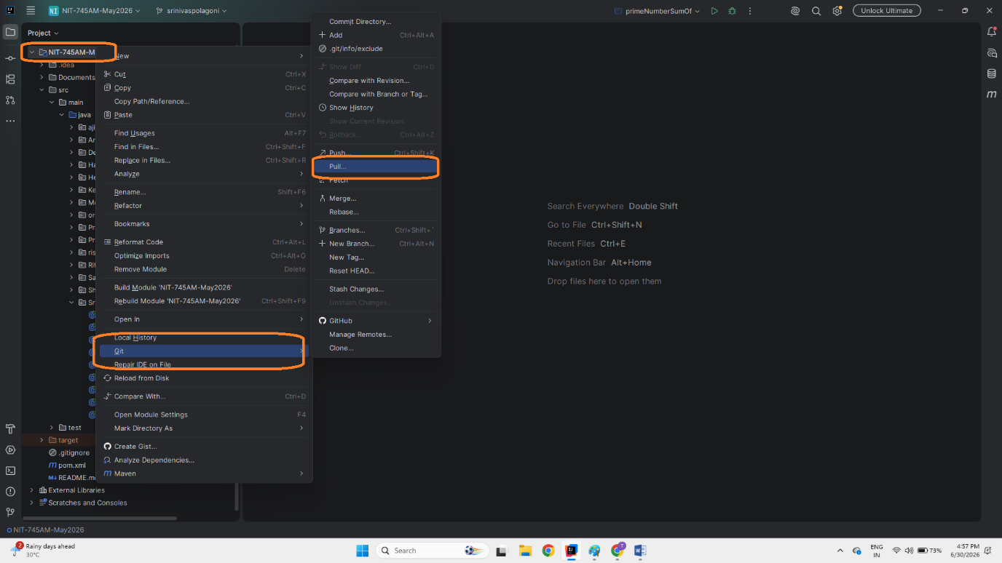

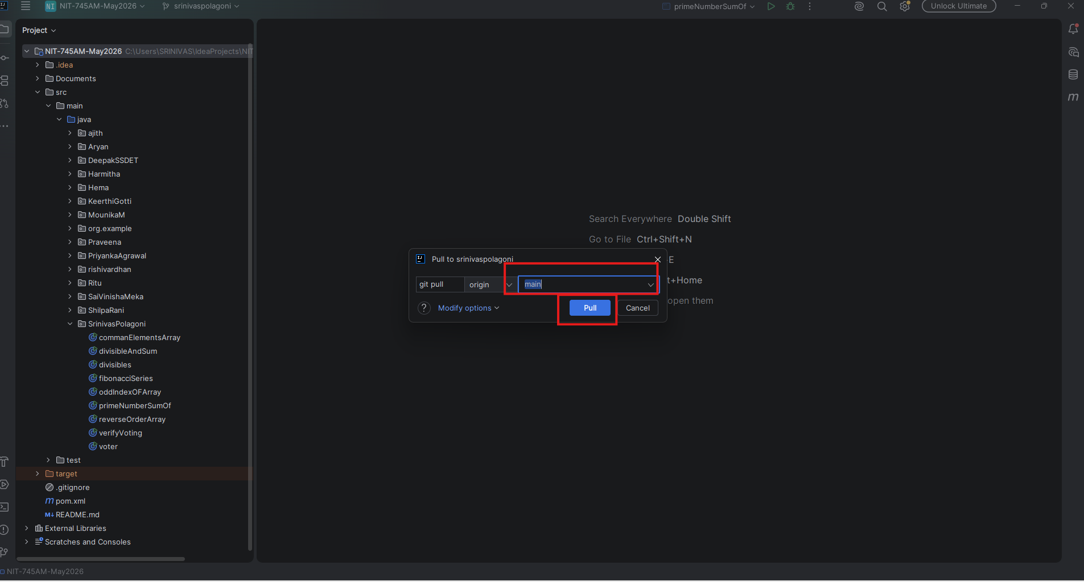

- After Clicking the Pull button you will get notification
