Newman
Newman is a command-line tool used to run Postman collections outside of the Postman application.
- Postman → GUI tool to create and test APIs.
- Newman → CLI (Command Line Interface) tool to execute those Postman collections from the terminal.

Why is Newman used?
Newman is mainly used for automation.

1. Run API tests from the command line
Instead of opening Postman and clicking "Run", you can execute:
newman run MyCollection.json

2. Continuous Integration (CI/CD)
It can be integrated with tools like:
- Jenkins
- GitHub Actions
- GitLab CI/CD
This allows API tests to run automatically whenever new code is deployed.

3. Generate Test Reports
Newman can create reports in formats such as:
- CLI (console output)
- HTML reports
- JSON reports
- JUnit reports
Example:
newman run MyCollection.json -r cli,html

4. Scheduled Testing
You can schedule API tests to run daily or before releases without manually opening Postman.

Newmen Installation:
Step 1.
Open the cmd and check node js installed or not by using this below command
node --version
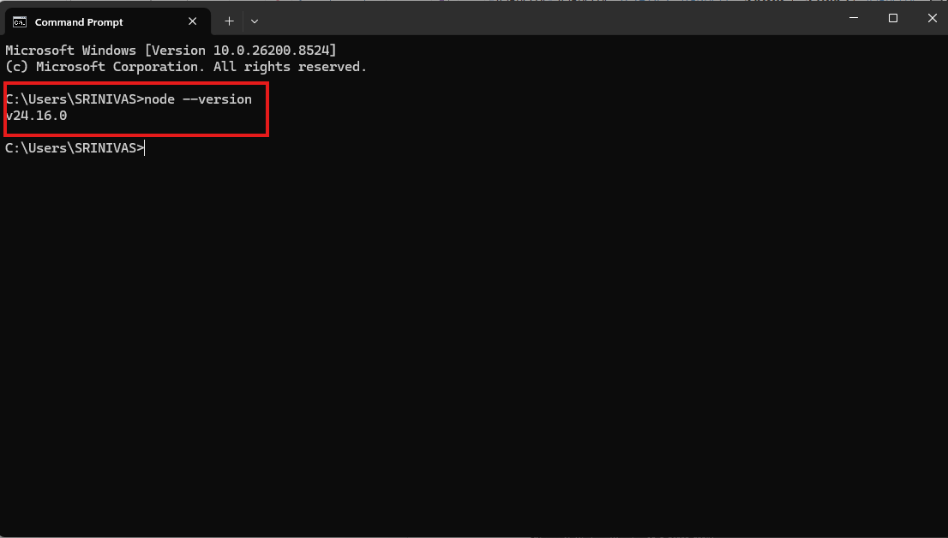

Step 2.
Install newmen by using below command in the cmd prompt
CMD : npm install –g newman
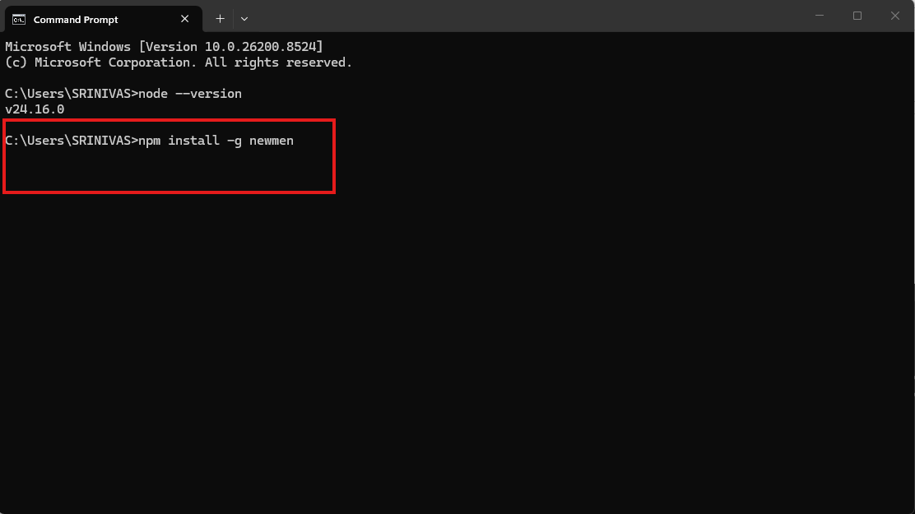
After clicking the enter newmen successfully installed
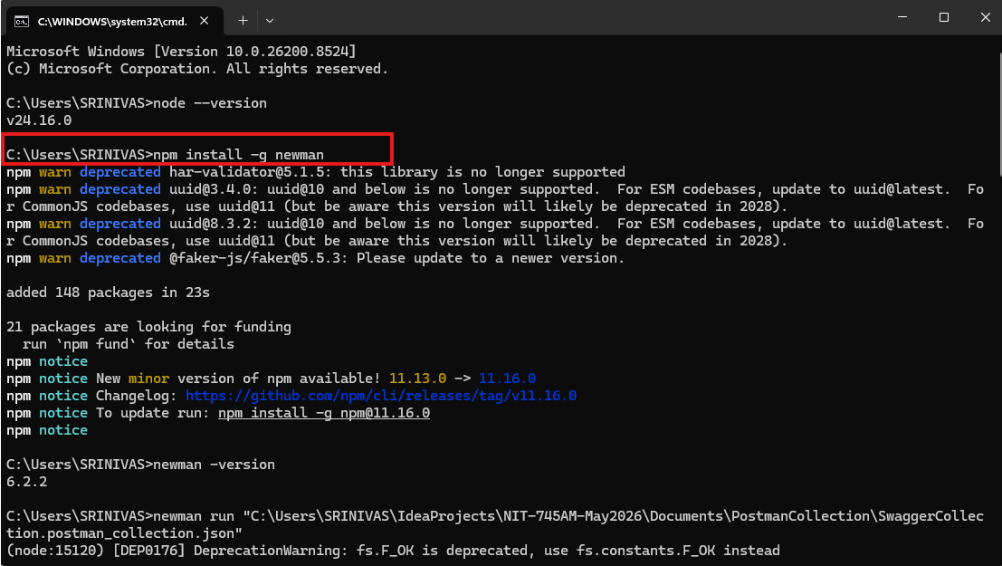

Run the json collection by using newmen command prompt with by using below command
CMD : run “C:\Users\SRINIVAS\IdeaProjects\NIT-745AM-May2026\Documents\PostmanCollection\SwaggerCollection.postman_collection.json”

