**Assignment**

1. **When you login as non-existent users or username ?**

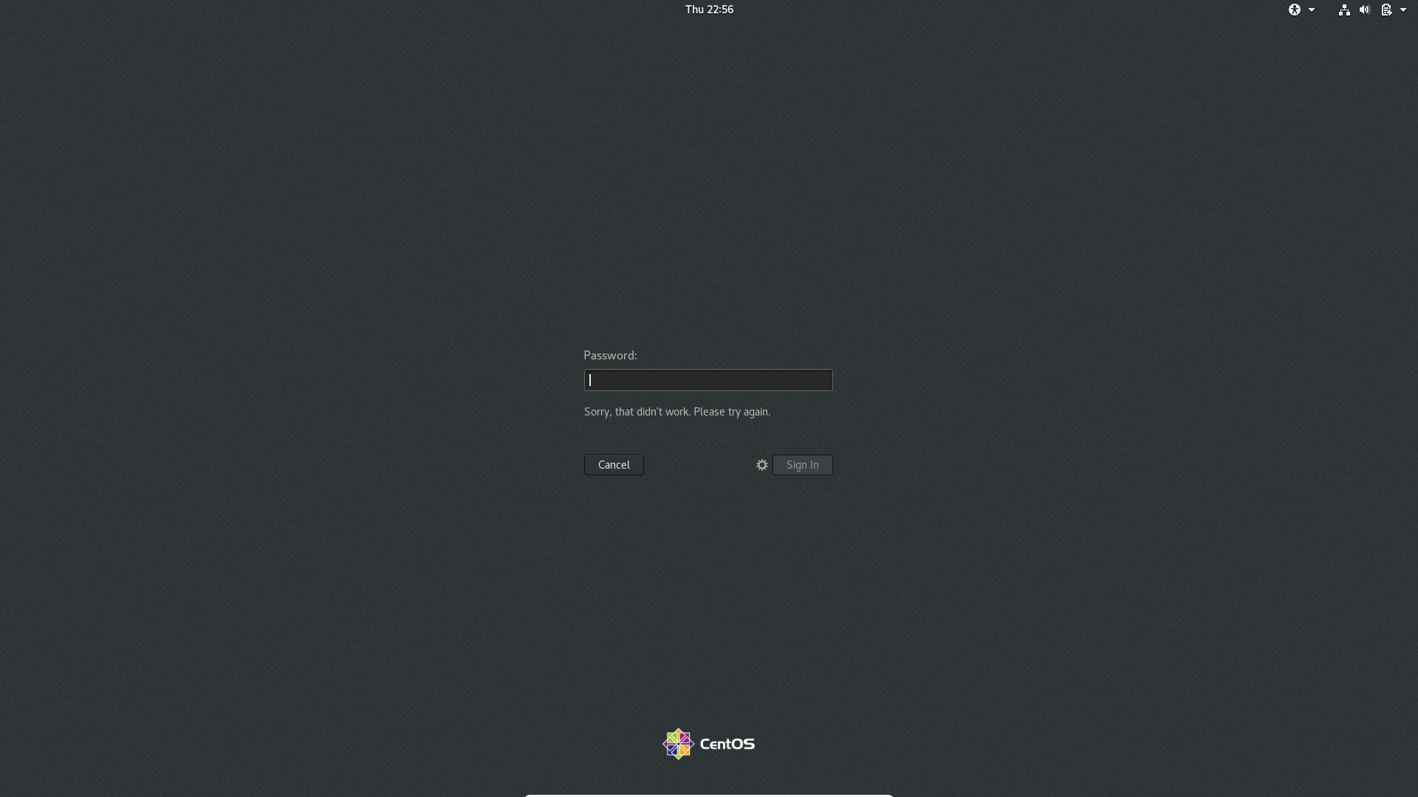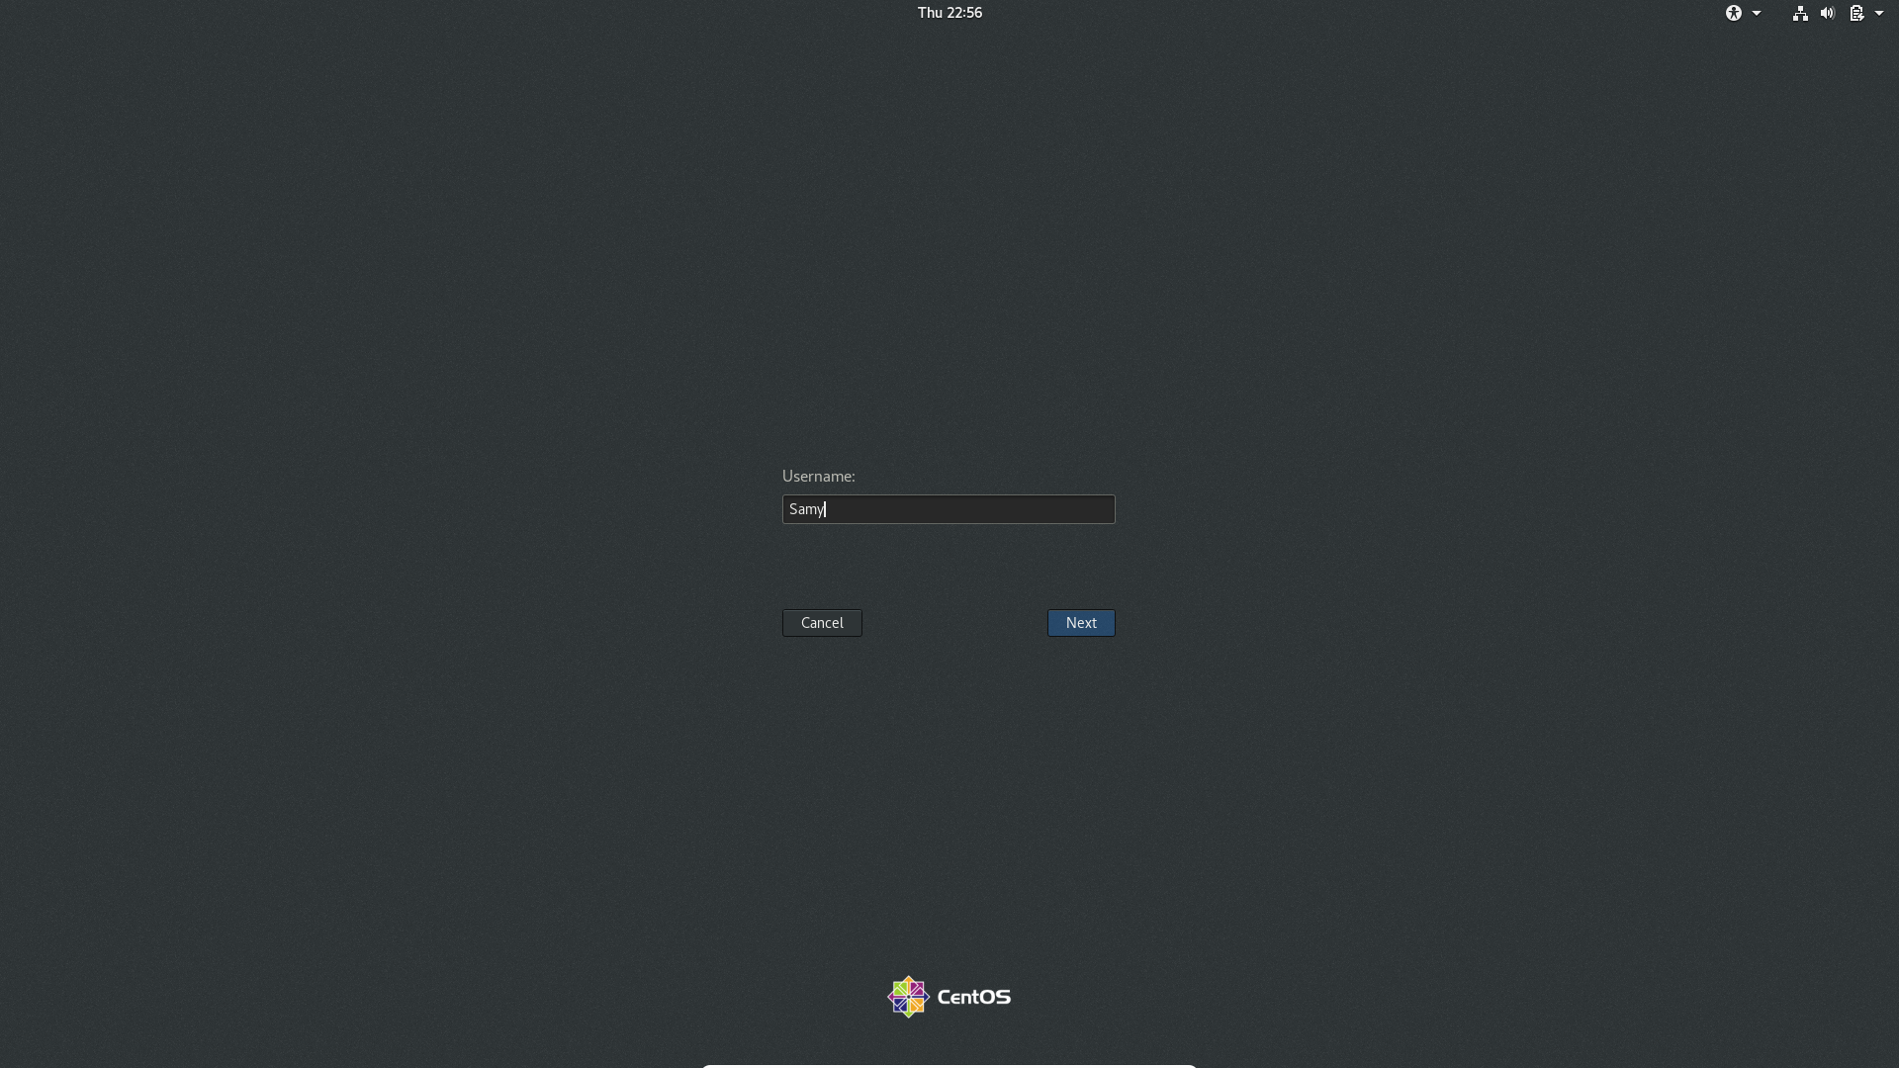

I clicked not listed to login as a non-existent user, it asked for the username then after entering an non-existent username, it asked for the password , as I entered a random password it says “Sorry, that didn’t work. Please try again”

Assignment 2

Changing the Password to Ineur0n#42:

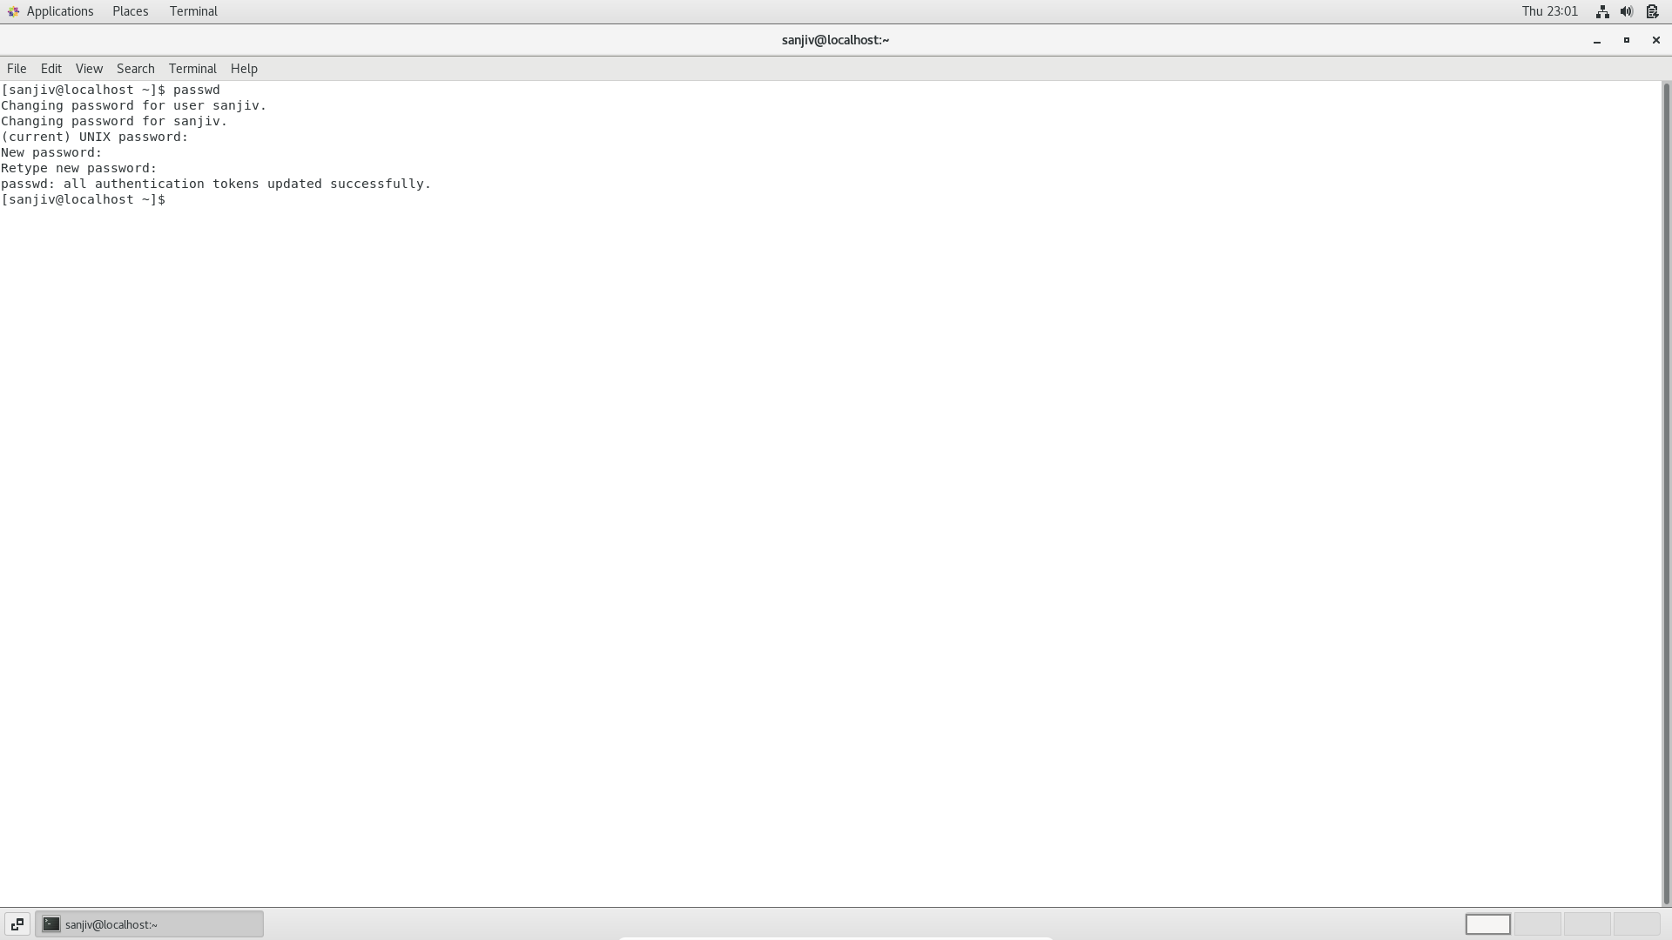

I tried changing the password using the command “passwd” in the terminal

It asked for current UNIX password, then asked for new password “Ineur0n#42” after entering it said all **authentication tokens updated successfully.**

**Changing the password to 1234:**

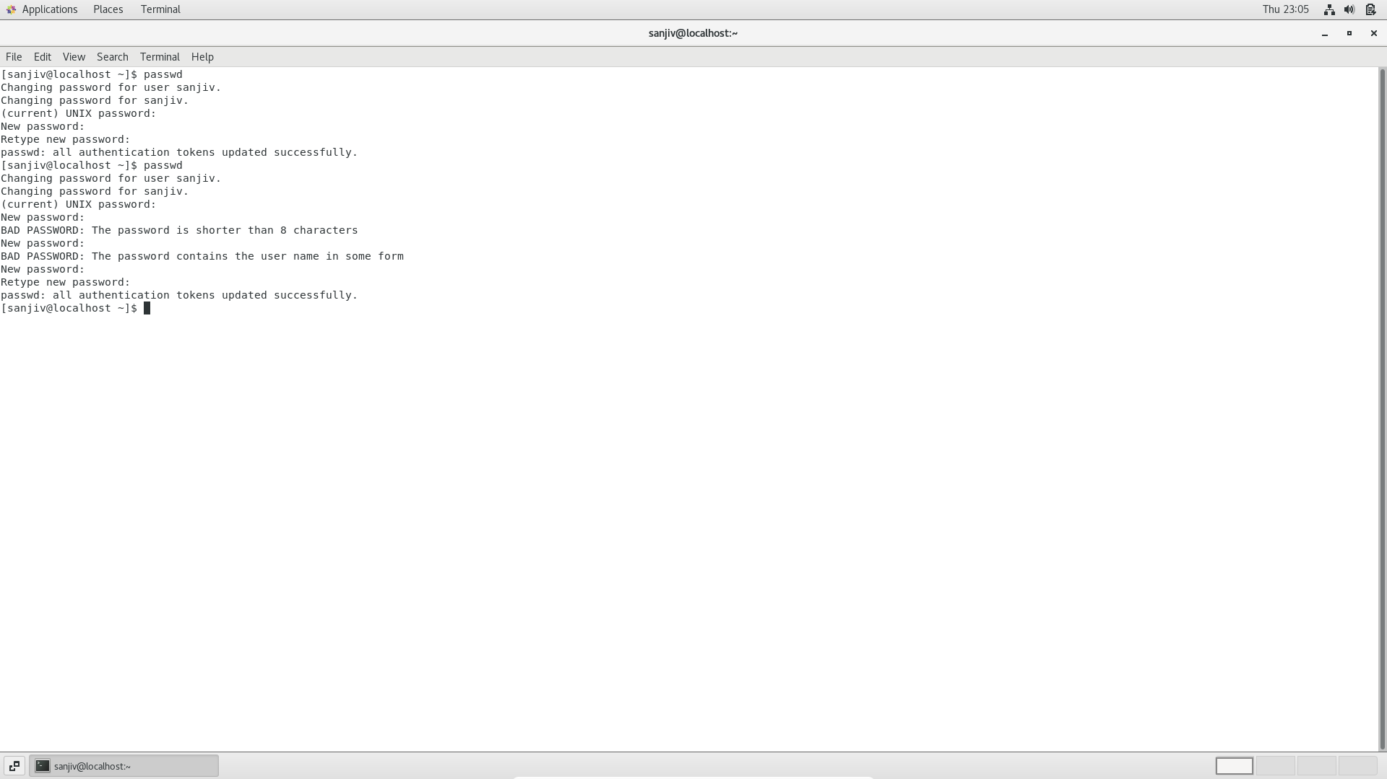

When tried changing the password to 1234, it returned “The password is shorter than 8 characters”

**Changing the password without entering anything:**

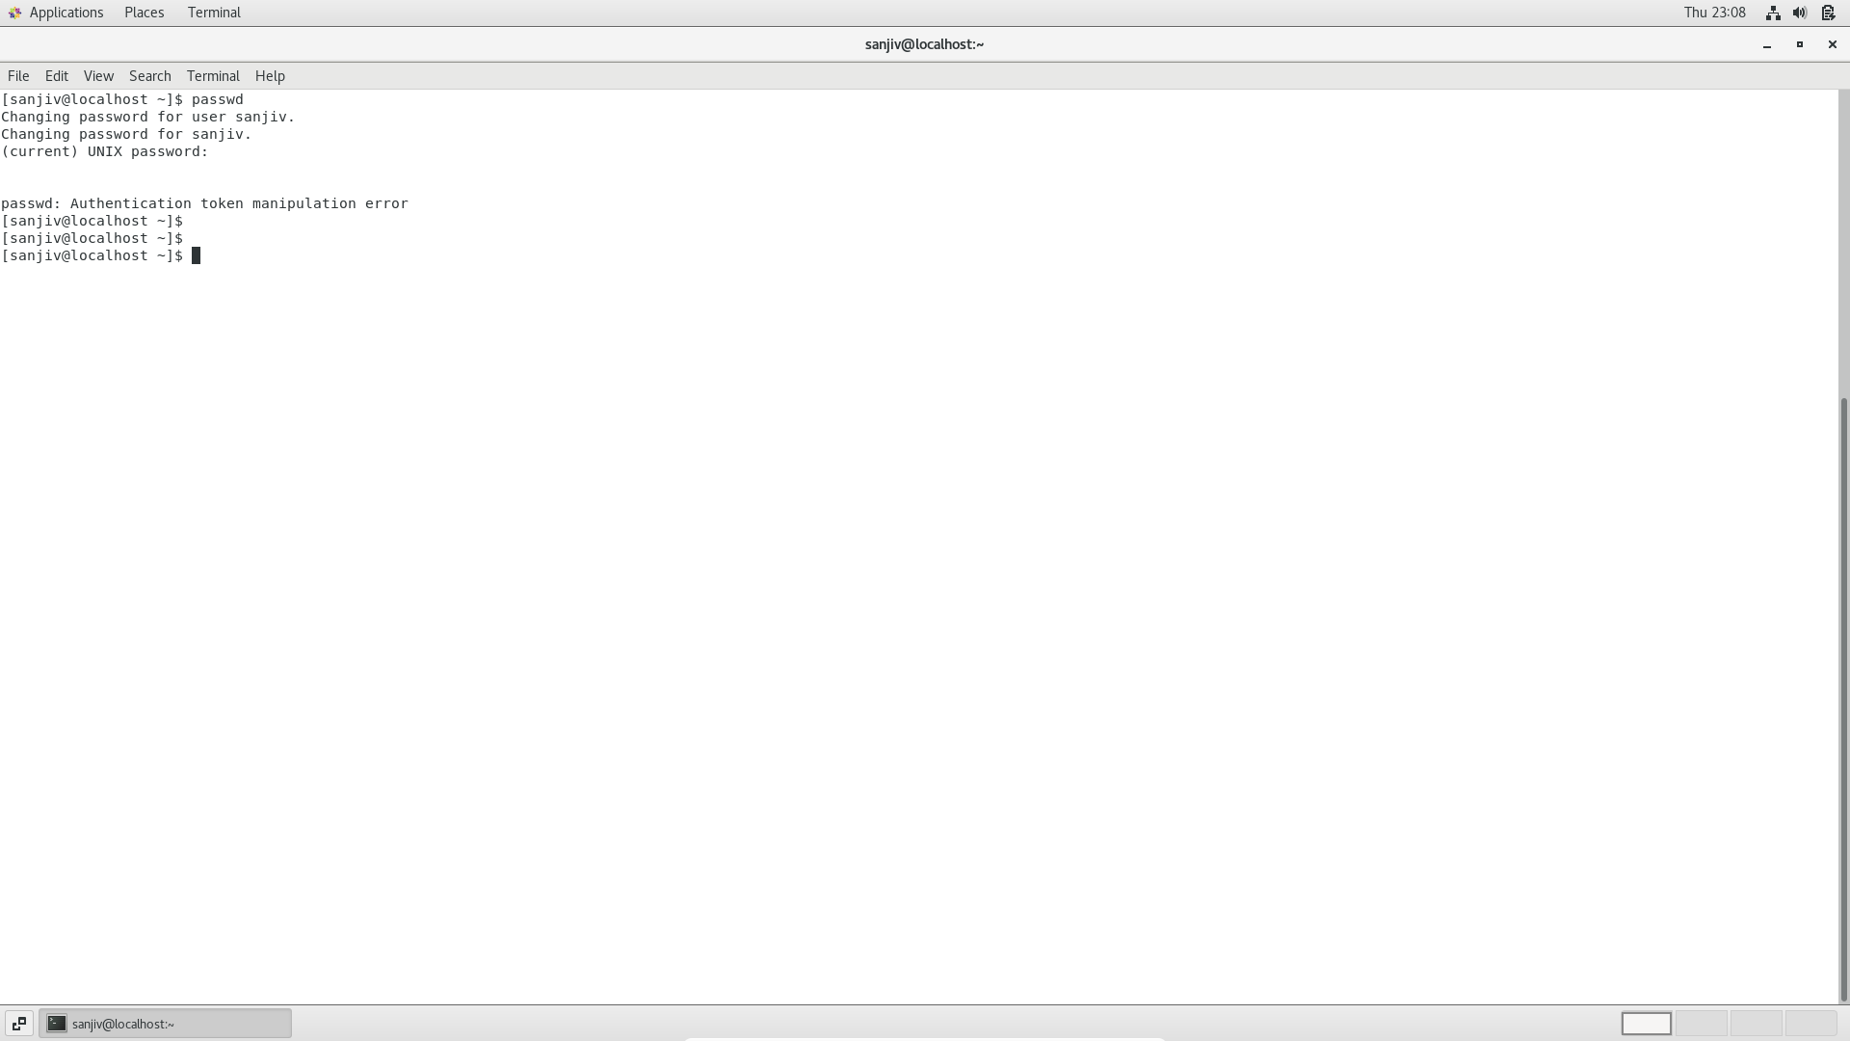

When tried changing the password again without entering anything it returned **“Authentication token manipulation error”**

**Assignment 3:**

**Working with directories**

1. Cd / and ls

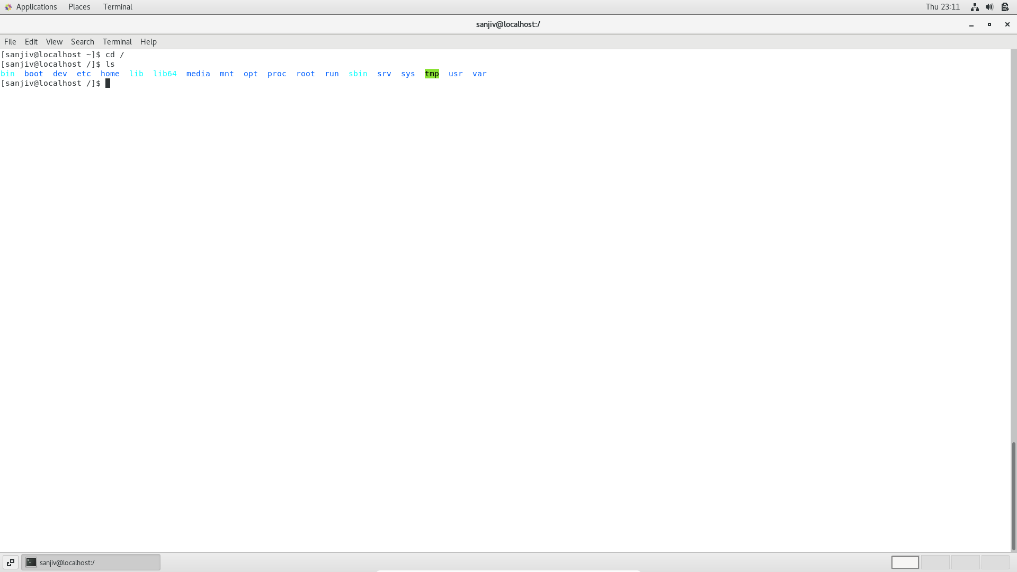

Cd is change directory command; it is used to change the current working directory.

As I entered cd /, I entered root directory which is the first directory in the filesystem hierarchy. The change was indicated with the forward slash instead of tilde.

Once I entered the root directory, I used “ls” in the terminal which resulted in listing out different directories of root. The following were listed out,

Bin, boot, dev, etc, home, lib, lib64, media, mnt, opt, proc, root, run, sbin, srv, sys, tmp, usr, var

Cd /home :

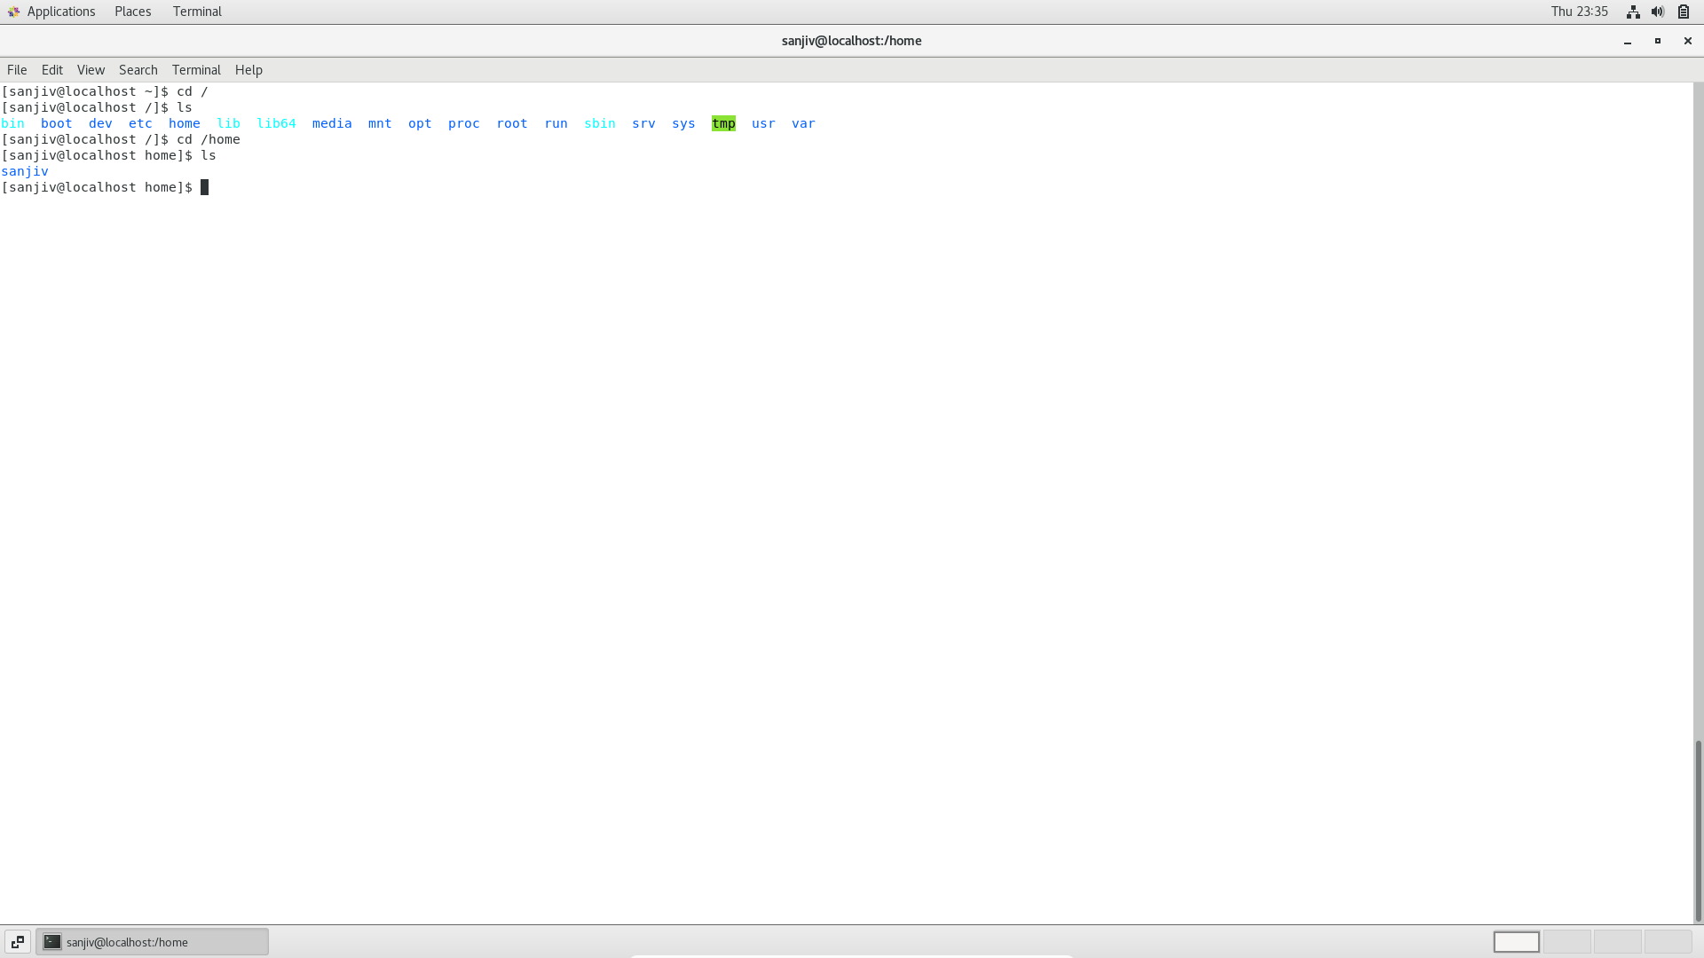

This command takes us to the home directory, when ‘ls’ command is used in the home directory it lists the users.

Cd .. :

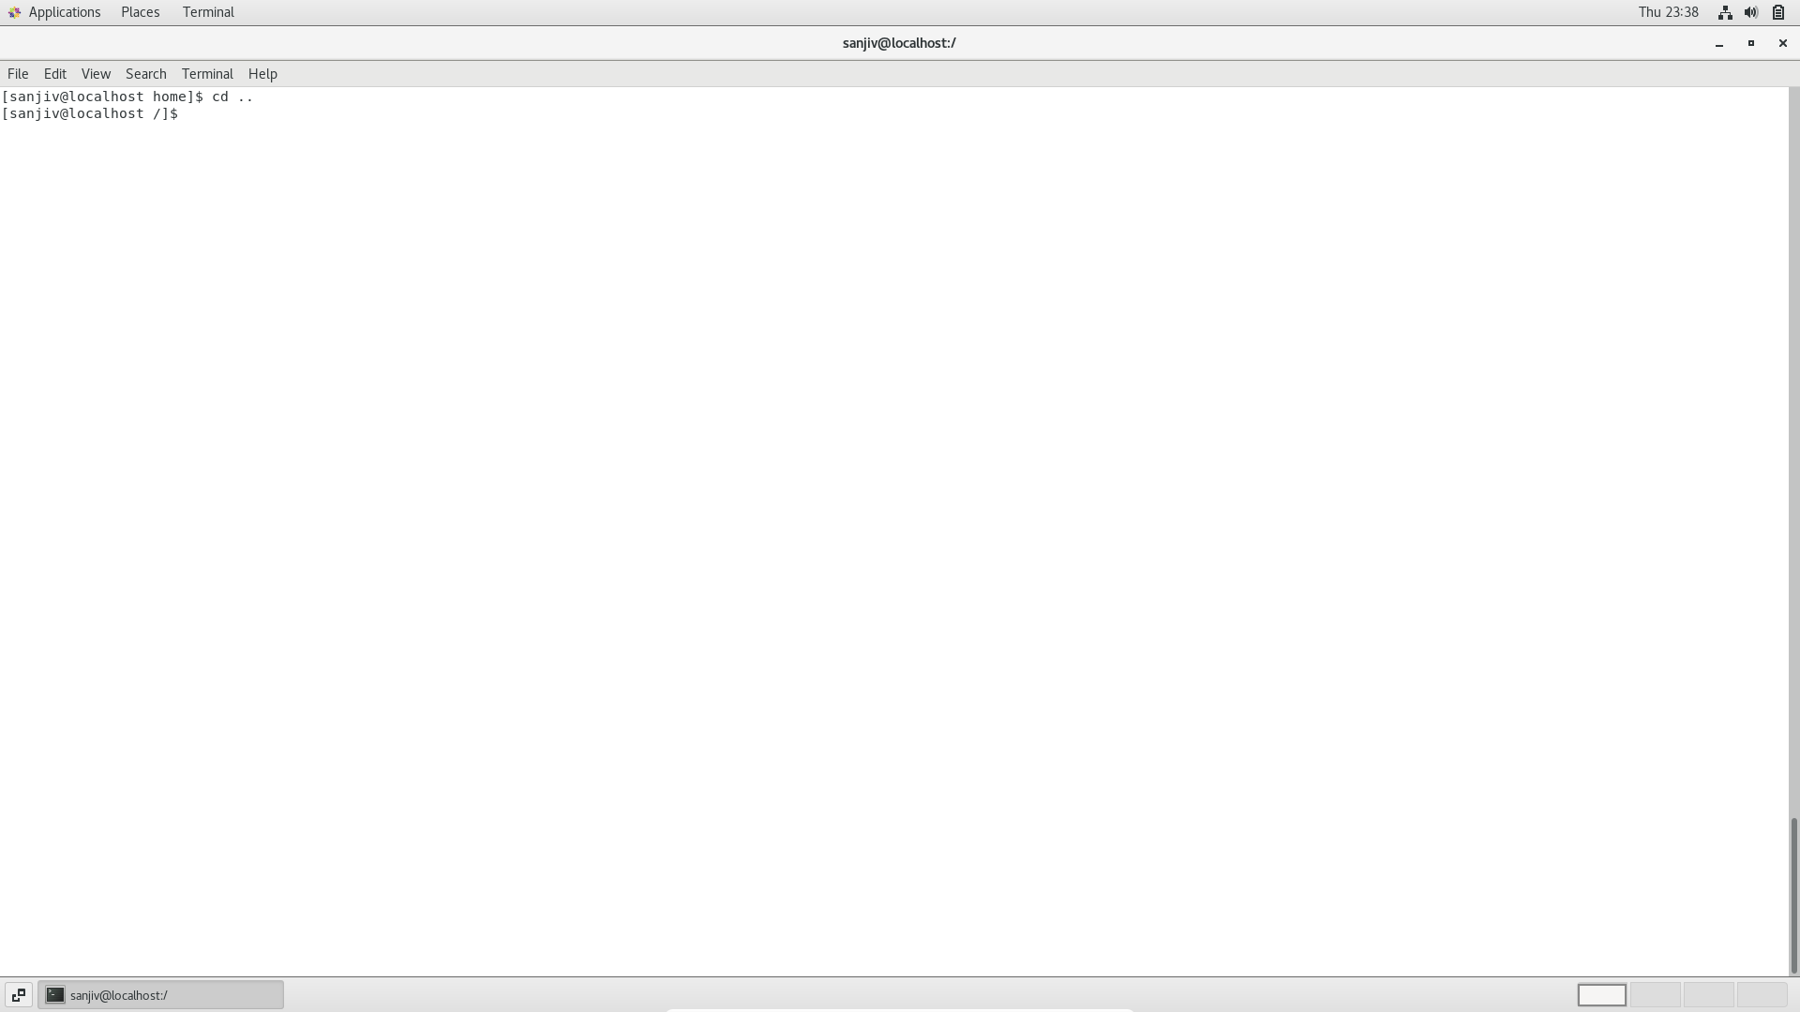

On using cd .. command, it takes us to the parent directory of the current directory.

Cd /var/www/html :

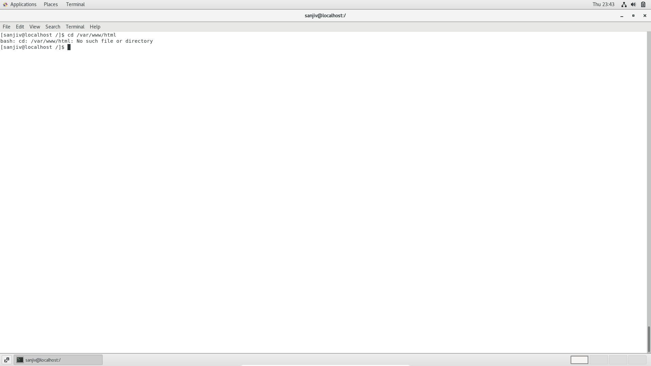

On entering cd /var/www/html it says, no such file or directory

Cd /root

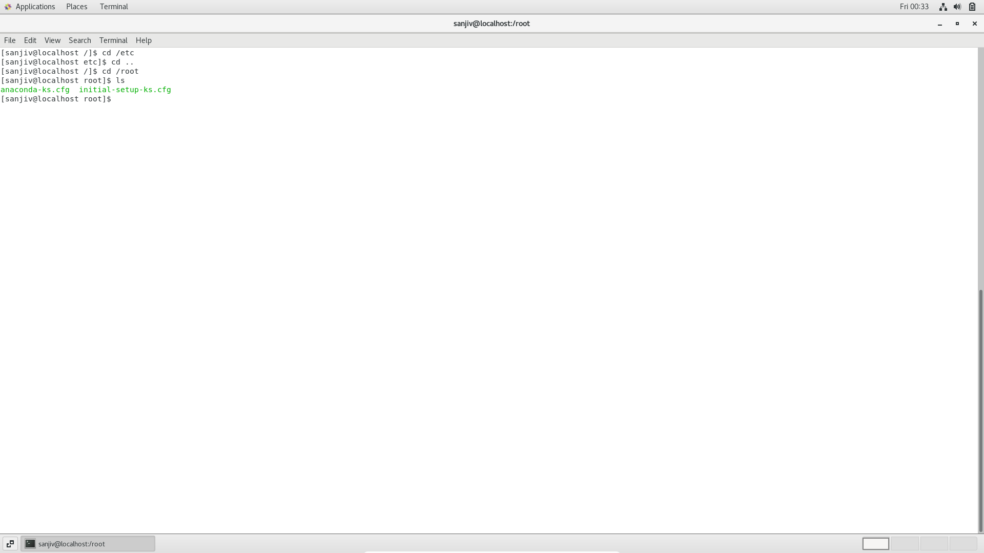

On using ‘ls’ in cd /root we get two files like anaconda-ks.cfg and initial – setup-ks.cfg

Assignment 4: cd /etc

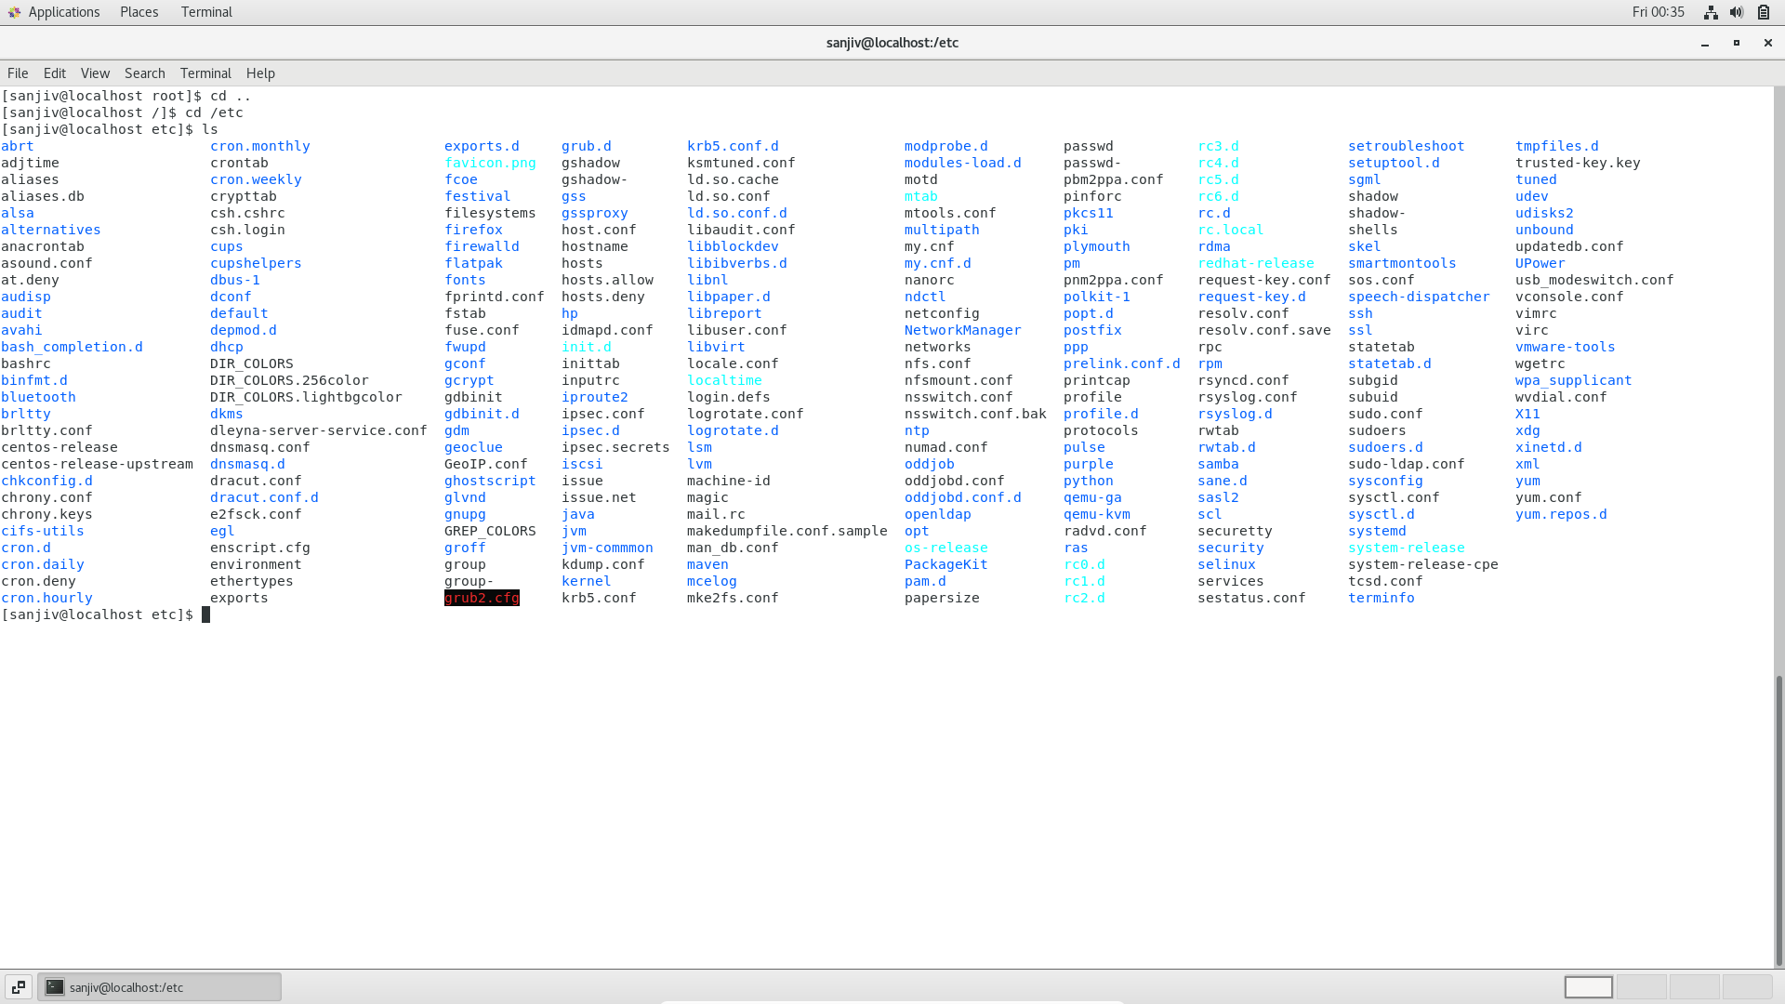

The command cd /etc enters into etc directory and using ‘ls’ command we get all the directories and files inside ‘etc’

Ls -al:

**ls -al command**, display all files and subdirectories in the current directory, including hidden “.” And “..”

ls -i:

this command prints the index number of each file.

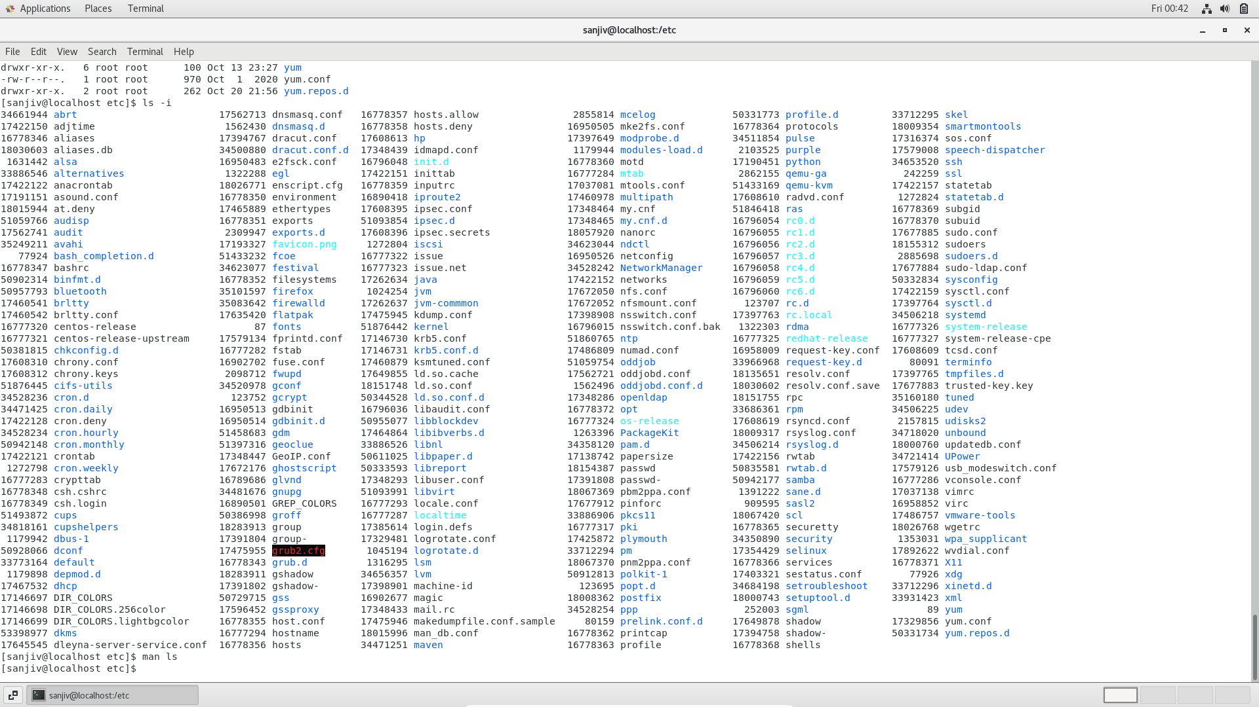

Ls -help:

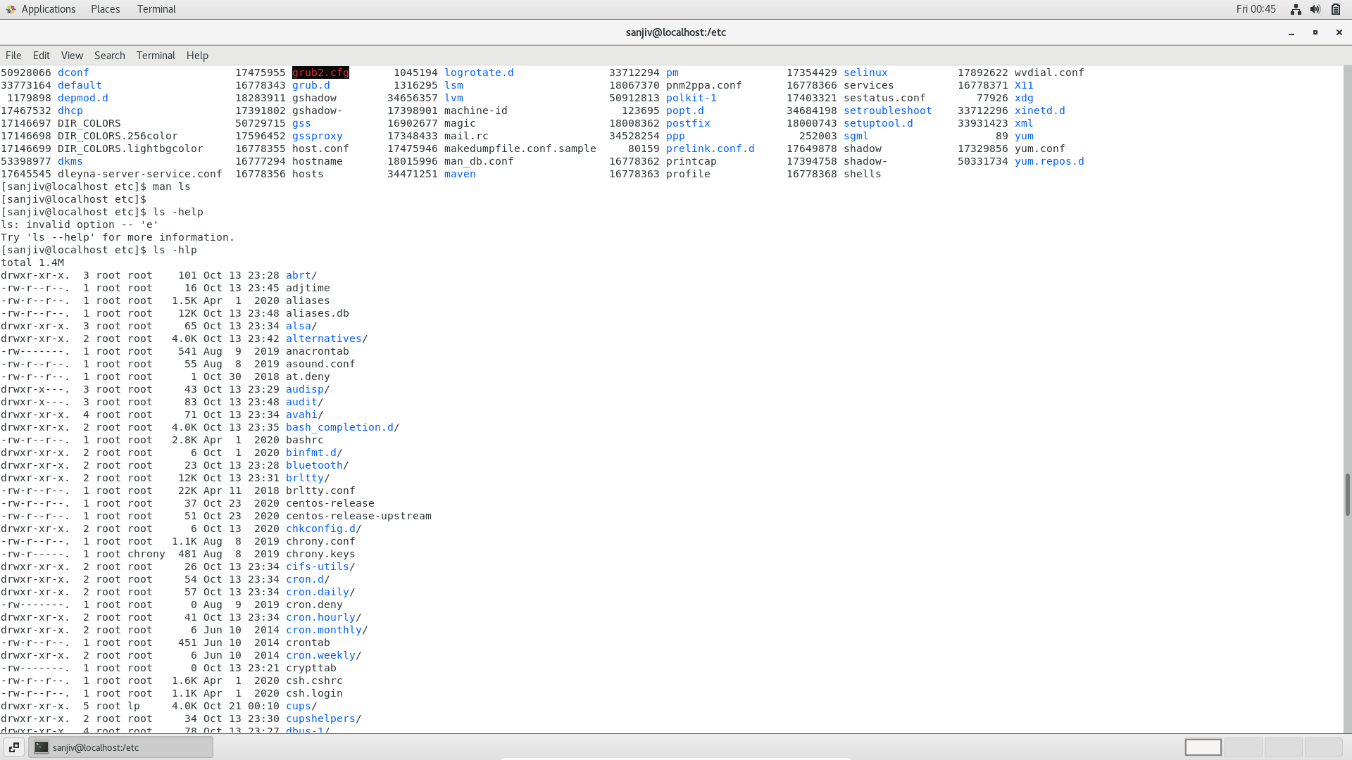

Assignment 5:

