Assignment Part 3

Playing with files

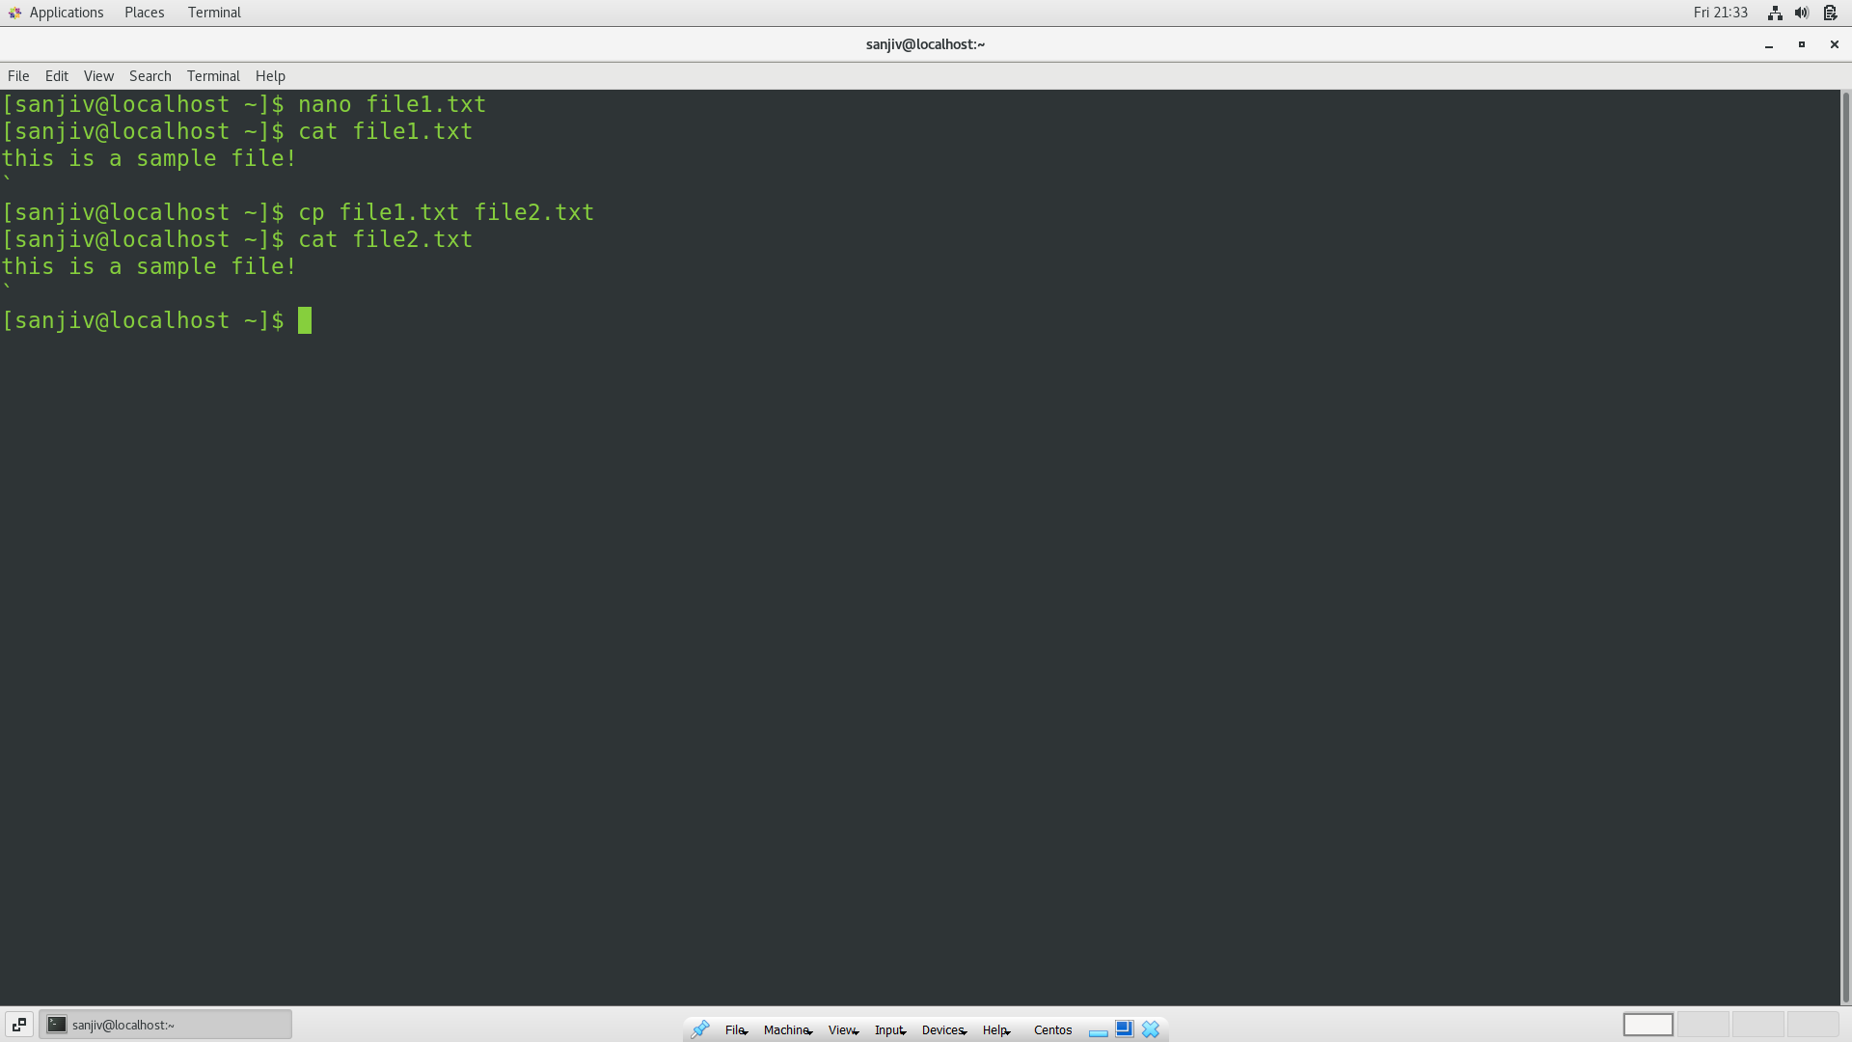

Moved the file2.txt to /home using cd /home command,

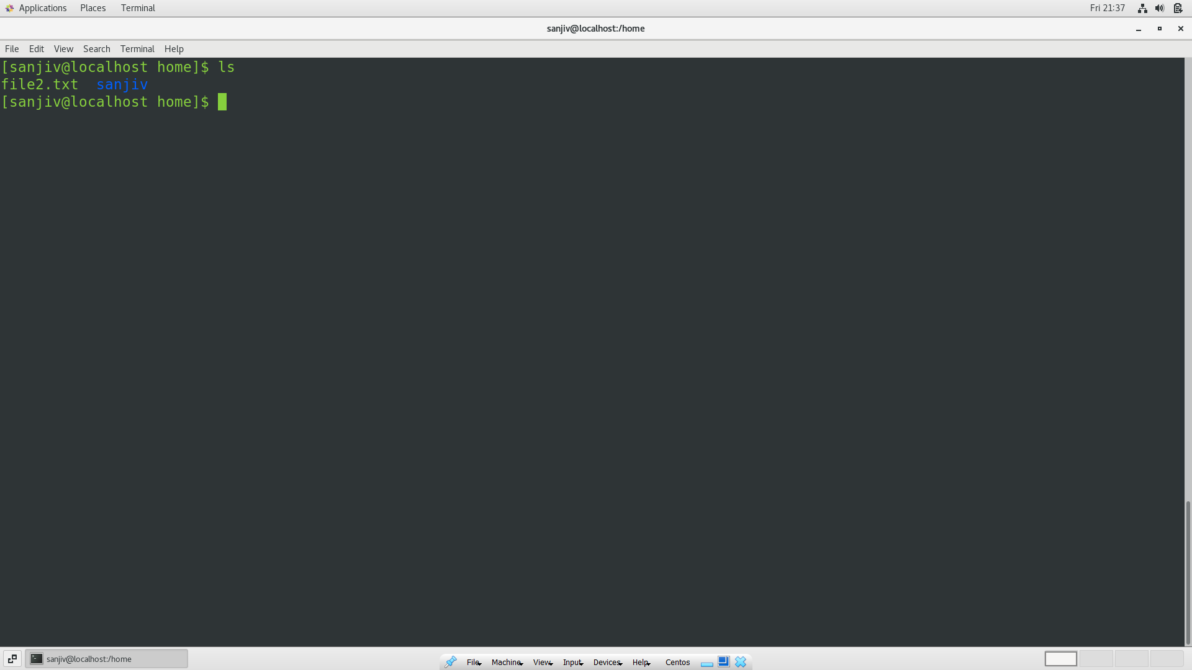

Creating file3.txt and file4.txt:

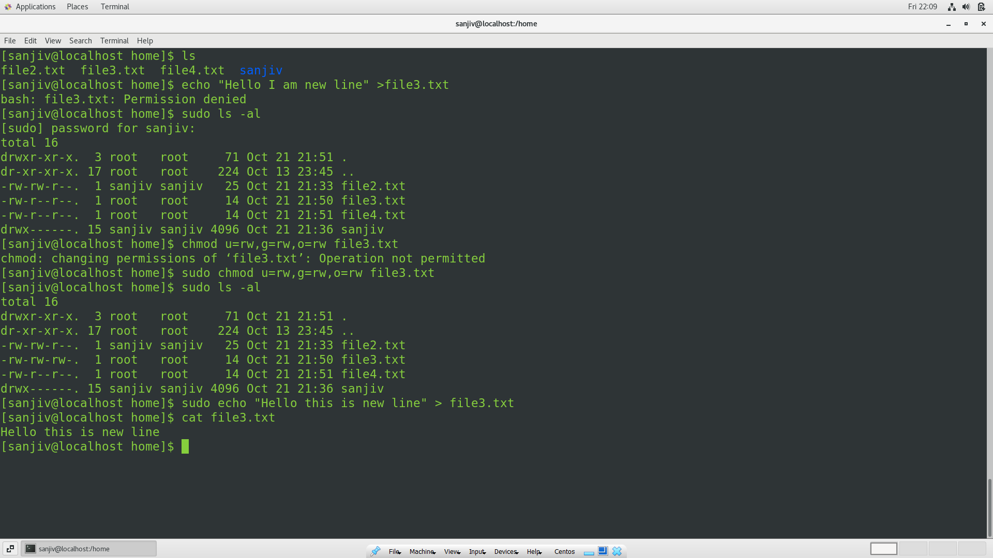

File3.txt and file4.txt were created using the following command:

On file3.txt, the following text was written: “This is file3.txt”

On file4.txt, the following text was written: “This is file4.txt”

Sudo nano file3.txt and sudo nano file4.txt

Then to file3.txt I tried echo”Hello I am a newline” but it echo didn’t work, so I checked for file permission of file3.txt which had “rw,r,r” so I had to change the file permission, so that echo works.

Difference between > and >>:

With “>” the file is rewritten by replacing “This is file3” but with “>>” the new line is appended to the previously written sentence.

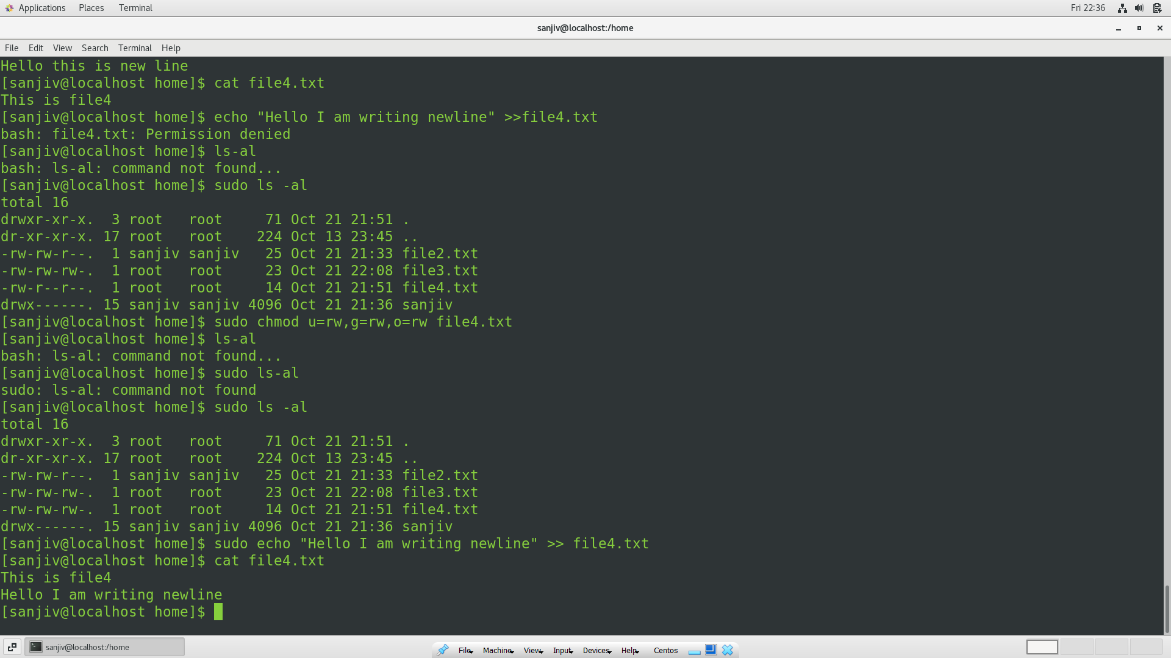

Removing the file with rm :

