MyMainScript 1
Your code here 1

MyMainScript
tic;

Your code here
str="lion";
str2="moon";
myUnsharpMasking("../data/lionCrop.mat", 'lion', 0);
myUnsharpMasking("../data/superMoonCrop.mat", "moon", 1);
toc;
Sharpened Image for weight = 2.5 Sigma =5
Sharpened Image for weight = 3 Sigma =7
Elapsed time is 0.560646 seconds.
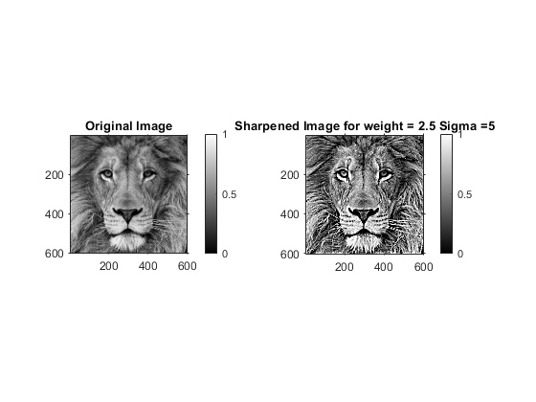
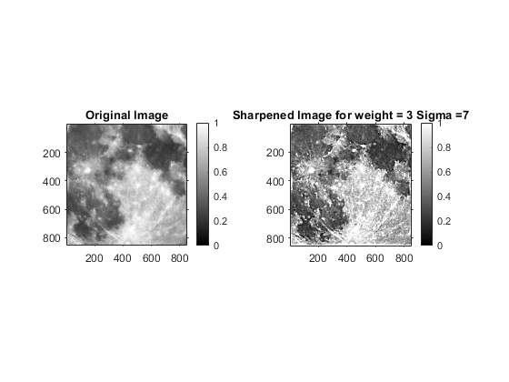
Published with MATLAB® R2020a

