MyMainScript 1
Your code here 1

MyMainScript
tic;

Your code here
str="grass";
str2="barbara";
str3="honey";
img = imread('../data/grass.png');
load("../data/barbara.mat", "imageOrig");
img3 = imread('../data/honeyCombReal.png');
myBilateralFilter(img, str);
myBilateralFilter(imageOrig, "barbara");
myBilateralFilter(img3, str3);
toc;
For Grass Optimal sigma_s is 0.8 and Optimal sigma_i is 0.16
RMSD for Grass for sigma_s 0.8 sigma_i 0.16 is 0.028895
RMSD for Grass for sigma_s 0.8 sigma_i 0.144 is 0.028992
RMSD for Grass for sigma_s 0.8 sigma_i 0.176 is 0.028953
RMSD for Grass for sigma_s 0.72 sigma_i 0.16 is 0.029118
RMSD for Grass for sigma_s 0.88 sigma_i 0.16 is 0.029099
For Barbara Optimal sigma_s is 0.9 and Optimal sigma_i is 0.05
RMSD for Barbara for sigma_s 0.9 sigma_i 0.05 is 0.013052
RMSD for Barbara for sigma_s 0.9 sigma_i 0.045 is 0.013085
RMSD for Barbara for sigma_s 0.9 sigma_i 0.055 is 0.013143
RMSD for Barbara for sigma_s 0.81 sigma_i 0.05 is 0.013161
RMSD for Barbara for sigma_s 0.99 sigma_i 0.05 is 0.013033
For HoneyComb Optimal sigma_s is 0.95 and Optimal sigma_i is 0.15
RMSD for HoneyComb for sigma_s 0.95 sigma_i 0.15 is 0.028555
RMSD for HoneyComb for sigma_s 0.95 sigma_i 0.135 is 0.028749
RMSD for HoneyComb for sigma_s 0.95 sigma_i 0.165 is 0.028596
RMSD for HoneyComb for sigma_s 0.855 sigma_i 0.15 is 0.028773
RMSD for HoneyComb for sigma_s 1.045 sigma_i 0.15 is 0.028653
Elapsed time is 28.357556 seconds.
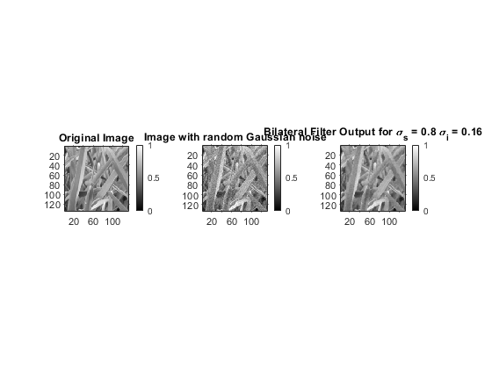
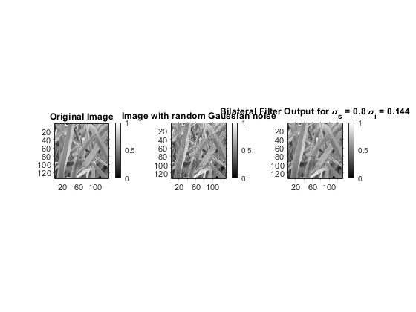
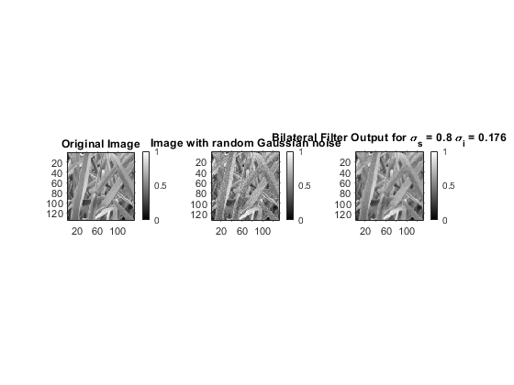
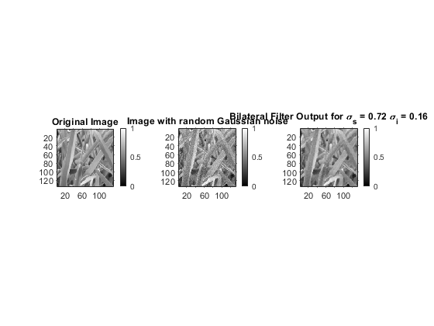
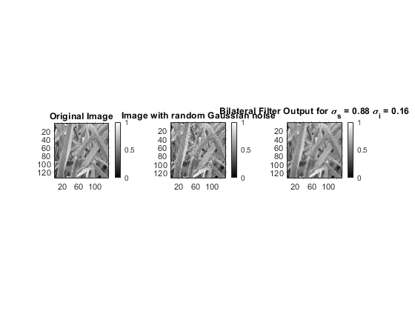
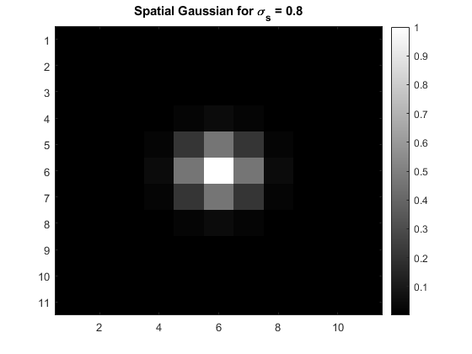
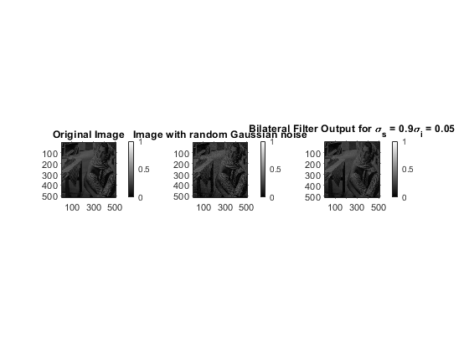
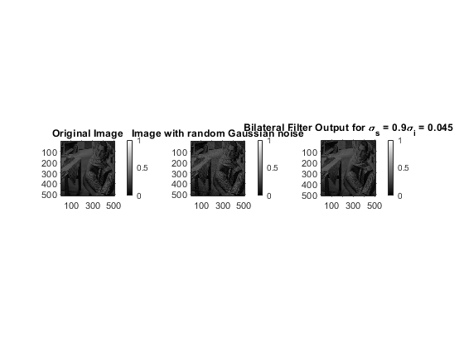
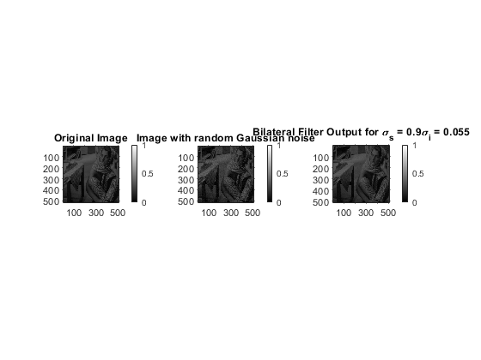
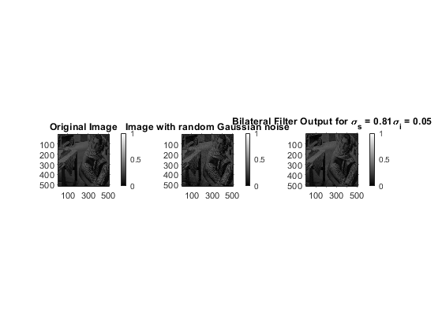
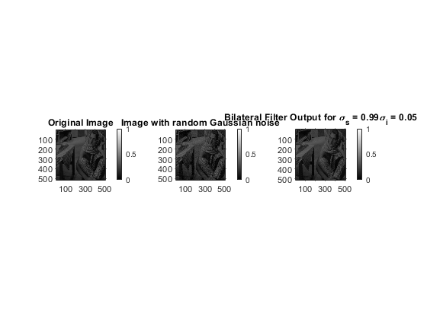
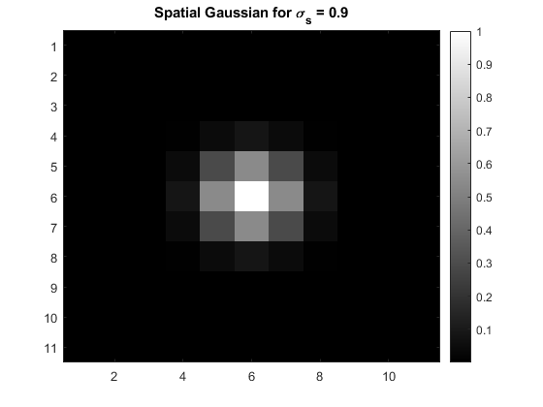
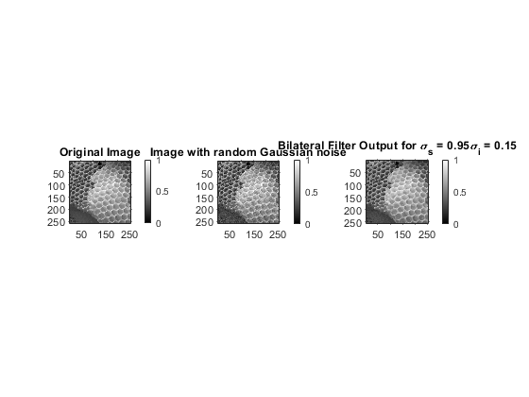
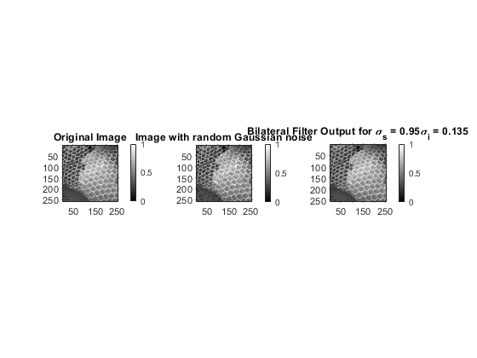
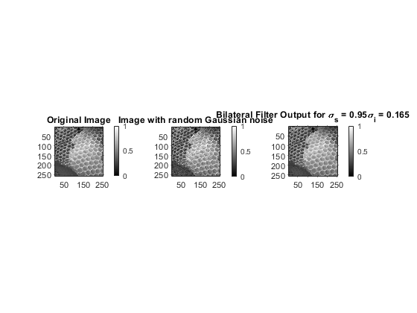
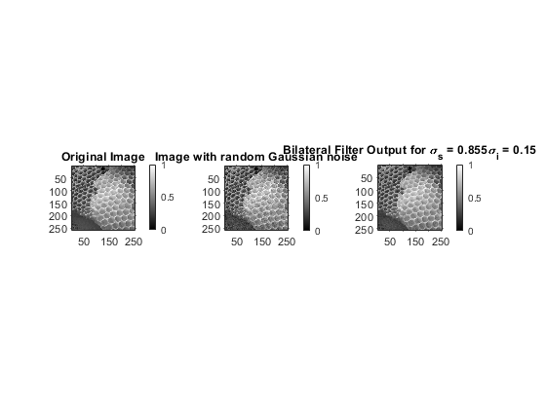
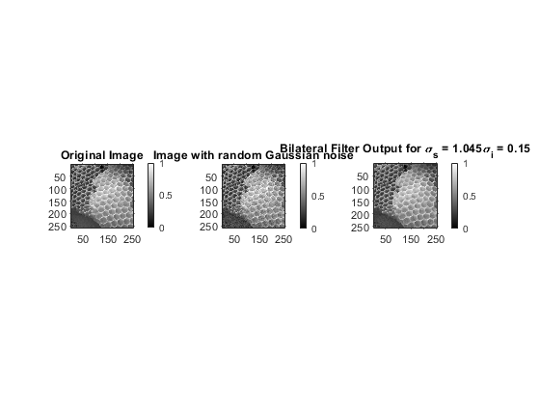
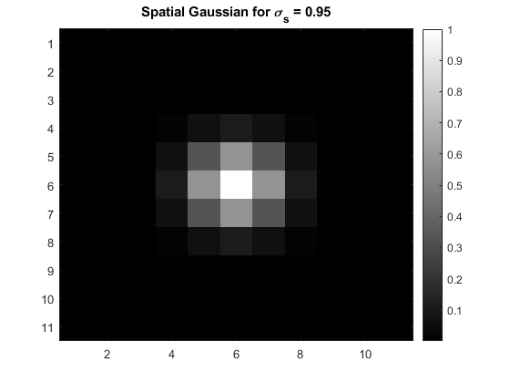
Published with MATLAB® R2020a

