Name: ______Sanjna Puri_____

SQL SELECT, WHERE, DISTINCT practice

1. Write a select statement to return all columns and rows from the customer table.

SELECT * from customer

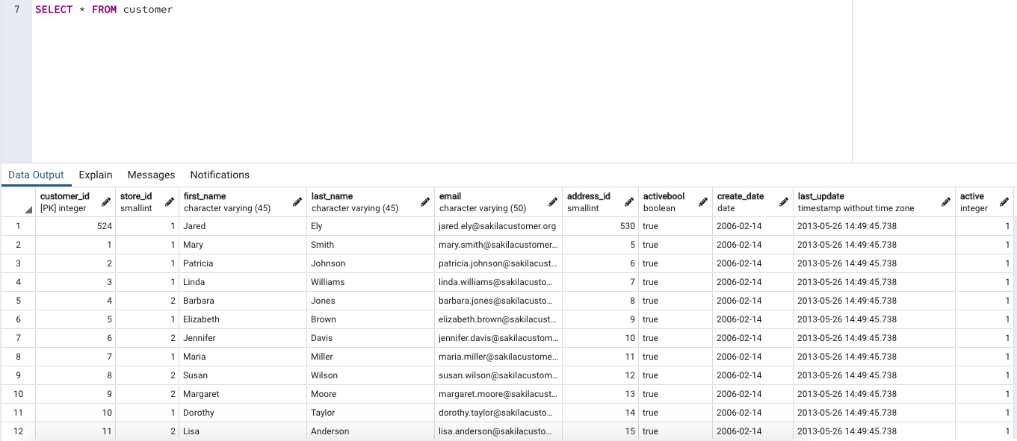

1. Write a query to select first name, last name, and email from the customer table.

SELECT first_name, last_name, email FROM customer

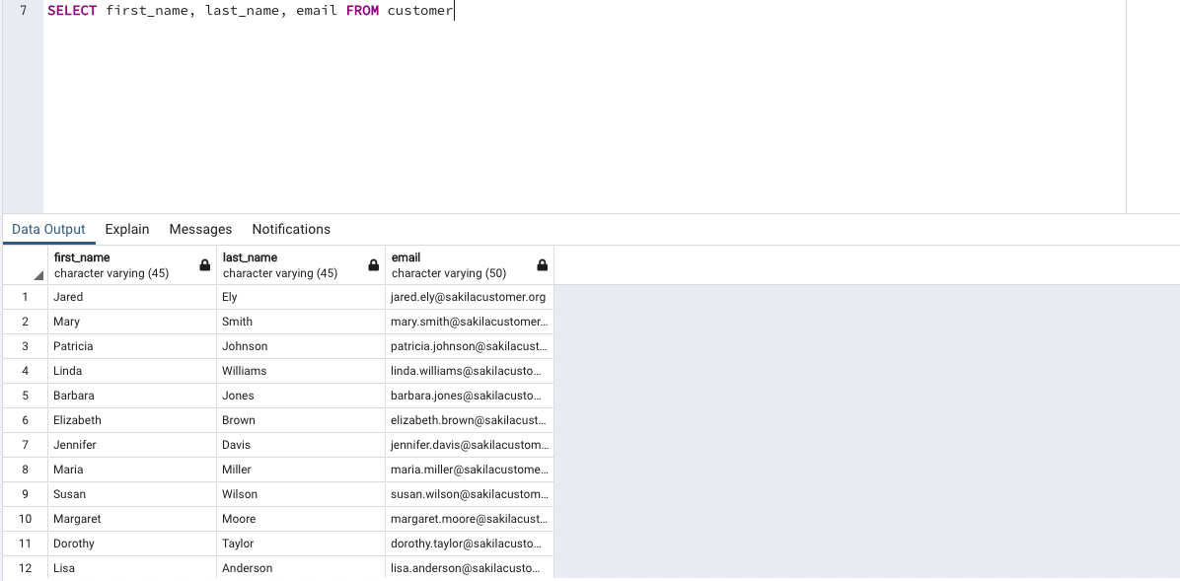

1. Write a query to return all rows and columns from the film table.

SELECT * FROM film

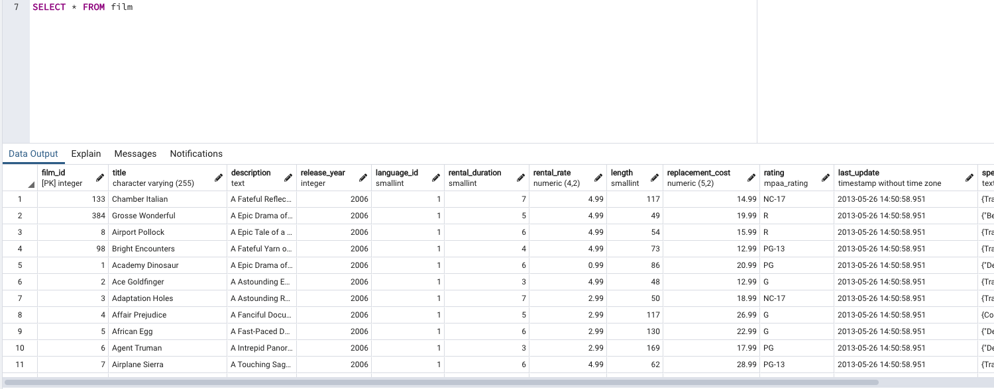

1. Write a query to return unique rows from the release_year column in the film table.

SELECT release_year FROM film

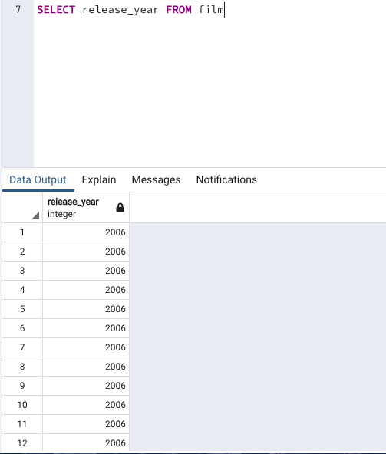

1. Write a query to return unique rows from the rental_rate column in the film table.

SELECT rental_rate FROM film

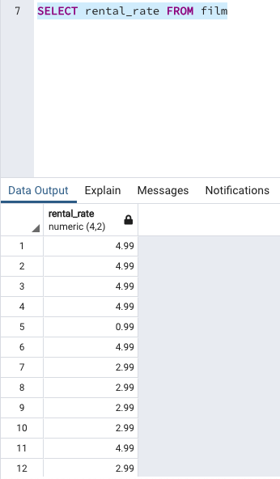

1. A customer left us some feedback about our store. Write a query to find her email address – for Nancy T homas.

SELECT email from customer

WHERE first_name = 'Nancy' AND last_name = 'Thomas'

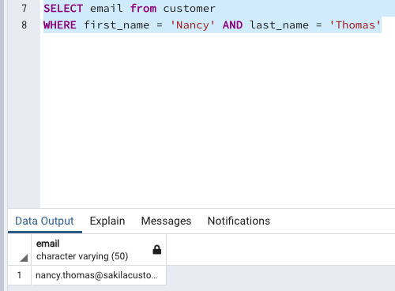

1. We’re trying to find a customer located at a certain address ‘259 Ipoh Drive’ – can you find their phone number?

SELECT phone FROM address

WHERE address = '259 Ipoh Drive'

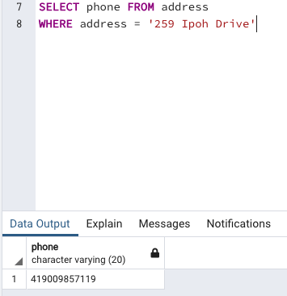

1. Write a query from the customer table, where store id is 1 and address id is greater than 150.

SELECT * FROM customer

WHERE store_id=1 AND address_id>150

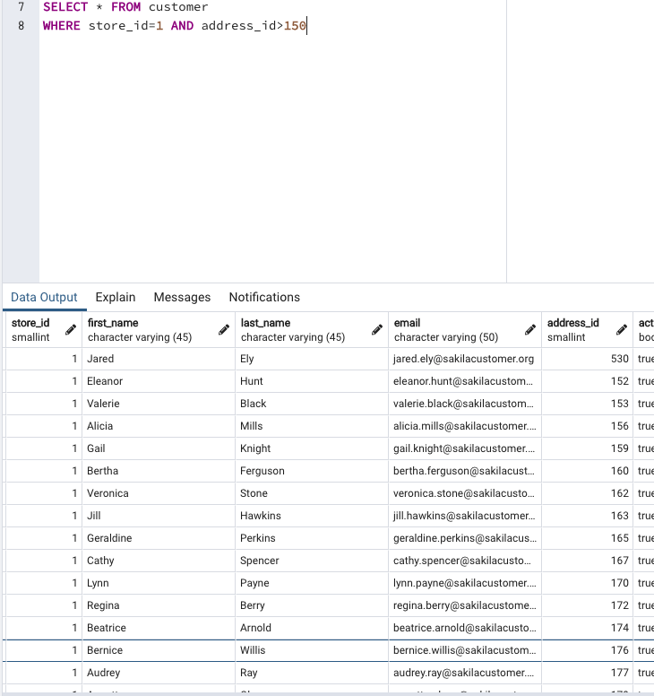

1. Write a query from the payment table where the amount is either 4.99 or 1.99.

SELECT * FROM payment

WHERE amount = 4.99 or amount = 1.99

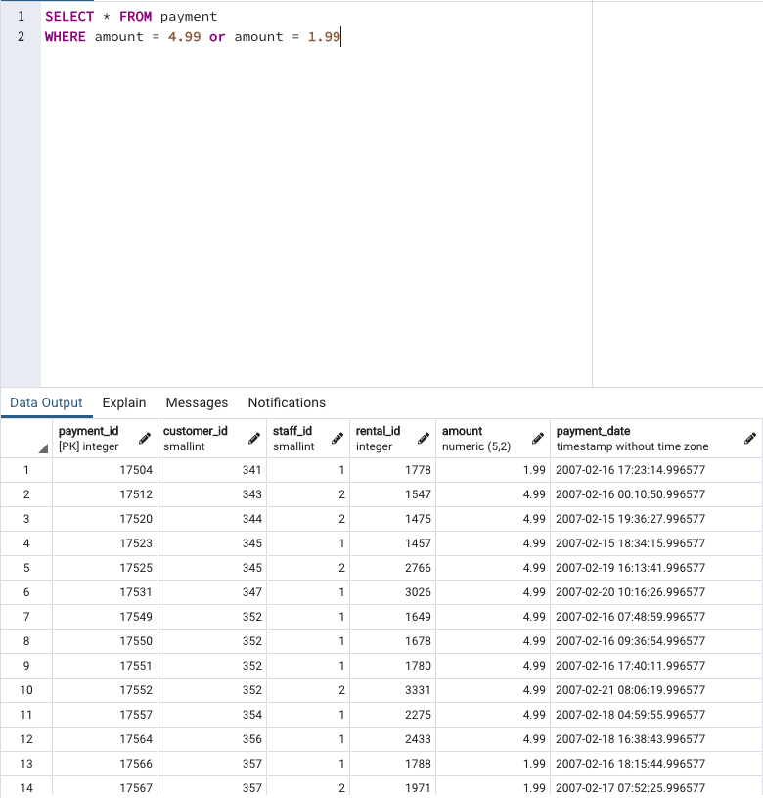

1. Write a query to return a list of transitions from the payment table where the amount is greater than 5.

SELECT * FROM payment

WHERE amount > 5

