Name: _______Sanjna Puri_____

Lesson 5: Joins and Unions

1. Join the film to the film_actor table.

select * from film

Inner join film_actor

On film.film_id = film_actor.film_id

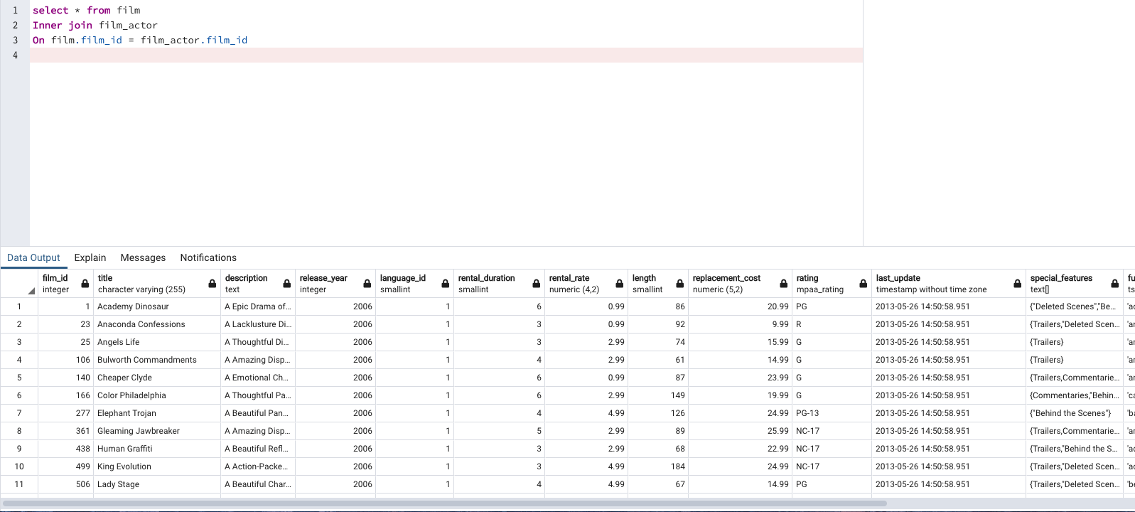

1. Join the actor table to the film_actor table.

select actor.actor_id, actor.first_name, actor.last_name, film_actor.film_id,

film_actor.last_update from actor

inner join film_actor

on actor.actor_id = film_actor.actor_id

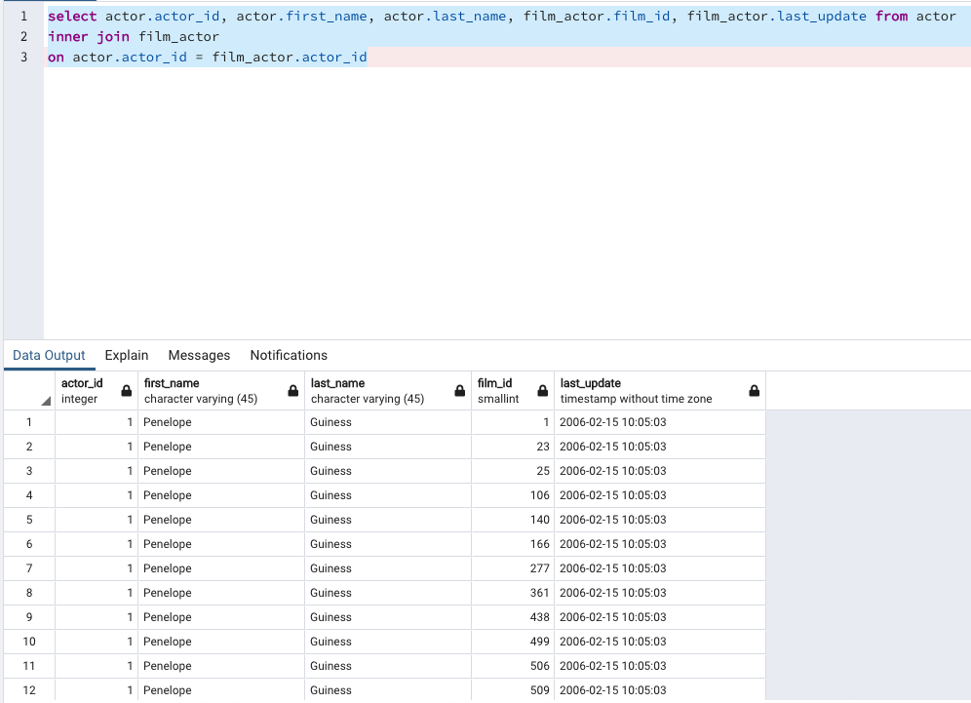

1. Try to join the actor, film_actor, and film table together (3 joins!)

select * from actor

inner join film_actor

on actor.actor_id = film_actor.actor_id

inner join film

on film.film_id = film_actor.film_id

