**Institute for Arts, Science and Technology**

**Department of Computing**

**BSc(Hons) Computing Programmes**

**Level: 6 (Full-time equivalent Year 3)**

**Module: COM609 Emerging Technology**

**Assignment: Futurology**

**Issue date: Friday27thJune 2014**

**Submission deadline: Presentation: 1st August 2014**

**Report: 11:55 pm, Monday 17th August 2014**

**Estimated completion time: 50 hours (combined group/individual)**

**Set by: Vic Grout**

**Verified by: John Worden**

|  |  |
| --- | --- |
| To be completed by student:  **I certify that, other than where collaboration has been explicitly permitted, this work is the result of my individual effort and that all sources for materials have been acknowledged.  I also confirm that I have read and understood the codes of practice on plagiarism contained within the Glyndwr Academic Regulations and that, by signing this printed form or typing my name on an electronically submitted version, I am agreeing to be dealt with accordingly in any case of suspected unfair practice.** | Name: Sanjok Gurung  ------------------------------------------------------------------------------  Student number: s13003260  ------------------------------------------------------------------------------  Date submitted:18/08/2014  ------------------------------------------------------------------------------  Signature:sG☺ |
| Are extenuating circumstances being claimed? YES/NO If so, give reference number:  -------------------------------------- | |
| To be completed by lecturer:  Summary of specific feedback on *this* work:  Summary of advice for improvement of *future* work:  Detailed comments follow, either on separate sheets or annotated to student’s work …  **Grade/Mark**: | |

GAMING

S13003260

Sanjok Gurung

Contents

Abstract 2

introduction 2

Few facts of video game industry 3

Current video game technologies 4

emerging technologies 5

Future applications 6

EThical issues 7

conclusion 7

references: 8

# Abstract

The main aim of this report is video gaming, it walks through the history, evolution, gaming platform, 3D data streaming, Augmented Reality, cloud gaming , future and impact of gaming in the modern society. From low computing processors to nano computers and even quantum computers led gaming. Now there is a possibility of integration of technology and computers with human everyday life as they have become one.

***Keywords****: gaming, history, methods, current and future platforms, motion capture, remote and virtual gaming, augmented reality, artificial intelligence, and future, ethical and social views*

# introduction

Video games have become fastest growing and popular forms of entertaintment over the last two decade. The video game went from becoming a technological hack to the most popular forms of entertainment.

Video game is a computer controlled where players control characters and environment from an input device called the joystick or a keyboard. The joystick consists of buttons. The term “video“in video games emphasise that the game played is displayed on a video. The electronic platforms on which video games are run and played are called video game consoles. PlayStation, Sega console, Xbox etc are all forms of console. Games have defined objectives and obstacles that require the user to perform and contribute which makes the game fun and engaging. Players nowadays can compete in gaming against each other or against a computer or, with anyone across a geographic location.

The video game industry has become immensely advanced and social and grossing more than the Hollywood entertainment industry.

# Few facts of video game industry

*“Our industry has a remarkable upward trajectory. Computer and video games are a form of entertainment enjoyed by a diverse, worldwide consumer base that demonstrates immense energy and enthusiasm for games. With an exciting new generation of hardware, outstanding software, and unmatched creativity, technology, and content, our industry will continue to thrive in the years ahead.” -* ***Michael D. Gallagher, president and CEO, Entertaintment Software Association***

According to the Entertaintment software association, 59% of Americans play video games. And those numbers of household on average at least own one dedicated video game console. There are average of **two**  gamers in each game-playing household.

Demographics of the game owners shows that 52% are male game players and 48% are female which is an interesting figure because the society stereotypes the gamers as a male dominated activity.

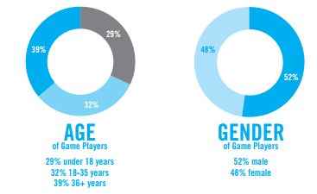

The number of female gamers age 50 and older increased by 32%from 2012 to 2013 and the average age of the game buyers is 35.

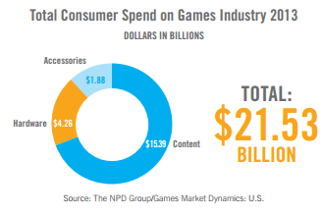

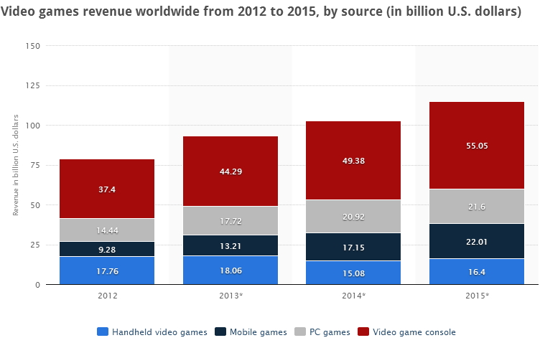

By the charts we can prove that the video game is a big booming industry. At 2013, the highest grossing movie was Marvel’s Iron man 3 which grossed about $372 million in its first weekend, during the same year Grand Theft Auto 5 was released and it grossed $1 billion just three days of its release.

# Current video game technologies

**Cloud Gaming**:

Cloud gaming has been the most discussed term in information technology over the past few years. Games played on the web and on social sites require tremendous game service powers, which is achieved by mixture of own data centres and cloud computing. According to its CTO, Zynga adds as many as a thousand servers per week to deliver about a petabyte of data or 1 million gigabytes.

Games on demand service providers such as Gaikai, OnLive or Otoy are aiming to shift the computing power required to play games out of homes and into their data centres. Thereby eliminating the need to buy consoles and game discs. Games will be streamed directly to the user’s device like YouTube video clips to PCs, Macs, mobile devices.

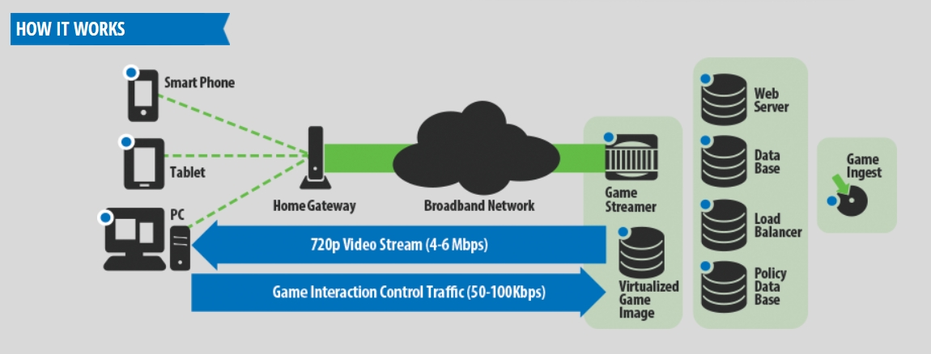

**Motion Sensing interfaces.**

Nintendo’s Wii console came into the public spectrum at 2006, since then it has also become more important feature of selling consoles. Microsoft Kinect is also a motion sensing device, it is a Natural user interface for controller-free gaming.

Microsoft Xbox does not only serve as a game controller but it also serves as a entertainment system with voice recognition technologies, tiny movement detectors, gesture control features etc.

Sensors with similar capabilities can be found in smartphones, vehicles, home applicances and the urban space.

Broadcom a set top box producer has developed a similar chip to start merging motion-sensing features for its remote control free gesture control.

Motion sensing is not the overall solution in fact it stops to its dead end when it meets accessibility. Elderly people and people with physical disabilities might have tremendous difficulty in using movement base controlling.

**3D:**

Nowadays game developers are enhancing their delivery of 3d experience to the user. Stereoscopy display is the dominant of the 3d displays in cinema and in home movies, but it requires the user to wear a special spectacle which is the barrier for accepting 3d technologies.

Many different organizations have an eye on the standardization of 3d films and broadcasting. The “glass-free 3d” is based on the number of competing technologies, which use the characteristic and combination of micro-optics and LCD elements.

# emerging technologies

**Nano Electronics:**

IST – FET announced that the emerging technology field is Nano electronics. Nano electronics are molecular structured electronics. It prepares for the base of IC technology. Three long term direction are targeted

One is to develop hybrid molecular scale developments on nanometer scale semiconductor platform. Two is to develop 1 dimensional structures such as nanotubes and nanowires for connectivity etc and three the understanding of electrical charachresitics of single molecules

**Bio Inspired intelligent information systems**

Reverse Engineering, decoding of the brain and its neuron functions could open a door to the development of truly intelligent information systems. Understanding complex patterns of sensory stimuli and generate sequences of elementary actions that satisfy high level goals. The system should show autonomous growth in perceptual motor and cognitive abilities. IT architechtures receive information from neuron and developing mechanisms of self healing like something out of a science fiction movie. Intelligent systems that throught the neurons generate and exploit the environment and make self aware.

**Quantum Computing:**

Quantum computing can be thought of supercomputers which is very promising and holds some answers into todays computer problems like large integer factorial, high coefficient password cracking. This would lead to system successfully implementing quantum algorithms for processing writing and reading in qubits. Encouraging to develop qubits applications for example in the area of metrology and simulation systems. But the problems that arise are physical aspects of quantum information for concepts such as, works on communication, complexity, relation with classical computational complexity theory.

**Augmented Reality:**

The expression “Augmented Reality” –usually abbreviated with the acronym AR- refers to the emerging technology that is blending of the digital information processed by the computer in the real world and displaying it real-time. Augmented Reality makes the processed information readily presentable. Augmented reality is also available on mobile phone platforms. The  first attempts  towards making AR useable on mobile phones began several years  before  the  release  of  Wikitude  World  Browser  in  2008,  the  first  AR browser  for  smarphones  (Wikitude  2010 A hefty work was carried out by Kato and Billinghurst (1999). the AR toolkit was a software library for building AR applications which adopted square fiducial images which was based on templates for recognition. It is available as open source under the GPL license. it is very popular in the AR society. the predictability is that the ever increasing number of users by area. but there is still unanswered question and obstacles preventing the progress and adaptation of AR in our daily lives. Similar  to  most  emerging  technologies  AR  needs  to  overcome  challenges  of different  nature  before  it  can  be  used  by  a  wider  audience.    The  number  of obstacle  AR  faces  is  mostly  a  matter  of  iterative  changes  that  many  other technologies went through.

# Future applications

**Motion sensor:**

Future application of 3D Motion Gesture Control technology was demoed at E3. It was named project Natal where user would control and communicate with gestures. The technology was so smart that it picked up subtle gestures. Mobile phone camera could be used as a viewfinder to amplify the signal used for tracing user’s gestures. It would also help scientists examining molecules or energy experts studying oil exploration maps. This is definitely a new and creative way to interact with your devices and not limiting itself to keyboards and input buttons.

**3d Technology:**

In the future, 3d technology plays a crucial role in making such large-scale modelling possible, with integrated virtual reality engines. Imagine remodelling the ruins of Rome, with the help of 3d Technology. So visitors would walk around the ruins of Rome and the computer would start modelling in 3d based on the map and its surroundings.

**Video Gaming:**

Gaming will be used beyond the barrier of just entertainment. It will be used if the form of eduction, science, arts, business, industry and entertainment. Games already model real world life in 3 dimensional virtual worlds. Gaming can be used in the military application where, soldiers are provided with a simulated war environment where soldiers learn to train which mitigates the risk of casualties in training. Similarly pilots both civil and military are being trained on the simulation to provide maximum real-world experience, which mitigates the training mishaps and accidents.

# EThical issues

**Social Responsibility:**

Ethical issues in gaming are different from that of the real world. In the real world laws regulate many ethical situations. The same is true for games as well. In a game breaking a “law” is much more difficult. T breaking the law in gaming is much more difficult, the person needs to be technically correct while breaking the law, because to break the law you need to be technically knowledgeable, most people refrain from doing so. these people who break the laws knows what they are doing and are timing themselves correctly.. The punishment for cheating is a ban. It can last anywhere from a few hours to a lifetime permanent ban. It is the responsibility of the players to report cheaters. When playing a game one must remember who the game is meant for. Take Halo for example. It is an extremely popular multiplayer game. It is also rated for mature users.

But the industry’s biggest sellers are violent video games (LeClaire, 2006). people are more demoralised these days and desensituzed. they practically walk past violent crimes instead of reporting the police or helping out the victim, and they have lost the capability to think twice or glance a second time. Is violent video games to blame? are the violent behaviour on young adult generation applied and the moral desensitzation because of video game violence? studies have showed that how violent video games affect their antisocial behavior, social life, health and attitude towards life. But video games at the same time can be educational purposeful, and one of the best learning tools that any children and teenagers can come across. this issue can always be debatable what it does to the overall health of the individual

# conclusion

Gaming is the most booming industry in the 21st century. with the improvement in the technology of all branches, the gaming is moving towards a more immerseful experience, gaming projects nowadays are more sophisticated, complex and involves a whole poplulation of creative armies, environment developers, designers, scripwriters, actors, programmers, researchers, animators etc. however the gaming industry is still in its booming phase so who knows what lies ahnead of us, but one thing can be sure, that we can always expect the most debatable issues, the most groundbreaking facts, the most creative masterpieces.

Video games do provide many positive features, that it increasing brain activity which is very important for young growing children and adolescent kids. because of that the braink which controls the motor movement, increasing problem solving skill, logic mapping etc all will be nutionalised. (RaiseSmartKid.com 2011)In 2003 surgeons conducted a test to see whether the students who had played video game had any effect on the surgical procedurs. the result showed that students who playes games made 37% fewer errors than who did not. Those same students were 27% faster at advanced surgical procedures. This proves that video games improves cognitive, perceptual and motor skills and increases focus on activities.

# references:

[1] Wei Chen, Sibrecht Bouwstra, Sidarto Bambang Oetomo and LoeFeijs (2010). Intelligent Design for Neonatal Monitoring withWearable Sensors, Intelligent and Biosensors, Vernon S. Somerset(Ed.), ISBN: 978-953-7619-58-9, InTech,

[2] Kumar, P.; Lee, H.J. Security issues in healthcare applications using wireless medical sensor networks: A survey. *Sensors* **2012**

[3] J.A. Stankovic, Q. Cao, and T. Doan, “Wireless sensor networks forin home healthcare: potential and challenges,” in Proceedings of the High Confidence Medical Device Software and Systems Workshop (HCMDSS ’10), 2010.

[4] Maulin Patel and Jian Feng Wang, “Applications,Challenges and Prospective In Emerging Body AreaNetworking Technologies”, IEEE Wireless Communications,IEEE, 2010

[5] Ming Li and Wenjing Lou “Data security and Privacy Inwireless body area networks”, IEEE WirelessCommunications, February 2010

[6] Xigang Huangy, Hangguan Shany, and Xuemin Shen, “OnEnergy Efficiency of Cooperative Communications inWireless Body Area Networks”, IEEE,2011.

[7] J. Espina *et al*., “Towards Easy-to-use, Safe, and Secure Wireless Medical Body Sensor Networks,” in *MobileHealth Solutions for Biomedical Applications*, P. Ollaand J. Tan, Eds., IGI Global, 2009

[8] Kim, D.J.; Prabhakaran, B. Motion Fault Detection and Isolation in Body Sensor Networks. In Proceedings of the 9th Annual IEEE International Conference on Pervasive Computing and Communications (PerCom 2011), Seattle, WA, USA, 21–25 March 2011

[9] Ghasemzadeh, H.; Jafari, R. Physical movement monitoring using body sensor networks: A phonological approach to construct spatial decision trees. *IEEE Trans. Ind. Inf.* **2011**

[10] Paola Antonelli, senior curator of the Museum of Modern Art’s department of architecture and design.

[11] Michael D. Gallagher, president and CEO, Entertainment Software Association.

[12] Herman, Leonard The History of Video Games 2001 www.[gamespot](Herman,%20Leonard%20The%20History%20of%20Video%20www.gamespot.com/gamespot/features/video/hov/p5_01.html).com/gamespot/features/video/hov/p5_01