**Thesis Report**

**On**

**“Suicidal Tendency Prediction Using Machine Learning”**

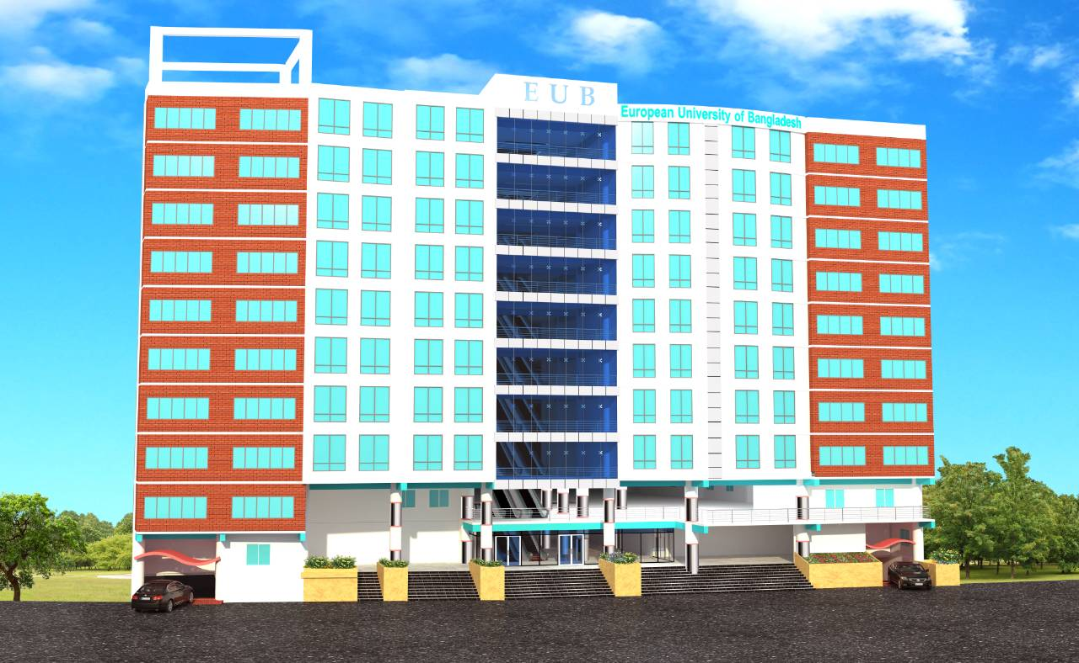**Submitted By**

**Md. Manik Mia**

ID: 190322079

**Mst.Fatematuz Zuhura**

ID: 190322009

**Md. Jahidul Islam**

ID: 180322033

**Sanjoy Roy**

ID: 190322074

**Abdul Kuddus**

ID: 190322040

**Pritam Kumar Kundu**

ID: 190322014

**Md. Refat Hossen**

ID: 190322006

**Md Manik Mia**

ID: 190322079

**Mst. Fatematuz Zuhura**

ID: 190322009

**Supervised by**

Khandaker Iftakher Ahmed

Lecturer

Department of Computer Science and Engineering

**This project submitted in partial fulfillment of the requirements for the degree of Bachelor of Science in Computer Science and Engineering.**

**Department of Computer Science and Engineering**

**European University of Bangladesh**

2/4, Gabtoli, Mirpur, Dhaka-1216

January 2023

**CANDIDATE’S DECLARATION**

This is to certify that the work presented in this Thesis, titled, “Suicidal Tendency Prediction Using Machine Learning” is the outcome of the investigation and research carried out by us under the supervision of Khandaker Iftakher Ahmed. It is also declared that neither this project nor any part thereof has been submitted anywhere else for the award of any degree, diploma or other qualifications.

----------------------------

Sanjoy Roy

Student ID: 190322074

----------------------------

Abdul Kuddus

Student ID: 190322040

----------------------------

Pritam Kumar Kundu

Student ID: 190322014

----------------------------

Md. Refat Hossen

Student ID: 190322006

----------------------------

Md. Manik Mia

Student ID: 190322079

----------------------------

Mst.Fatematuz Zuhura

Student ID: 190322009

----------------------------

Md. Jahidul Islam

Student ID: 180322033

**CERTIFICATE OF APPROVAL**

This Thesis titled, “Suicidal Tendency Prediction Using Machine Learning Algorithm” submitted by the group as mentioned in the candidates’ declaration page has been accepted as satisfactory in partial fulfillment of the requirements for the degree B.Sc. in Computer Science and Engineering in December-2022.

Signature of Supervisor:

----------------------------------------

Khandaker Iftakher Ahmed

Lecturer

Department of Computer Science and Engineering

European University of Bangladesh, Dhaka, Bangladesh.

Signature of Chairperson:

-----------------------------------------

Md. Obaidur Rahman

Associate Professor & Chairman

Department of Computer Science and Engineering

European University of Bangladesh, Dhaka, Bangladesh

**ACKNOWLEDGEMENT**

This thesis we are representing was only possible to complete with guidance from some conscientious people. We want to thank each of them. Especially obligated to European University of Bangladesh for the direction and constant supervision by my honourable teacher Khandaker Iftakher Ahmed. I would like to be thankful to my supervisor for his kind support, guidance, and encouragement and I want to express my gratitude towards my parents, teachers, batch mates, and my seniors of EUB for their kind assistance and advice to complete us study.

**ABBREVIATIONS**

ML = Machine Learning.

JS = Java script.

MERN = MySQL, Express, React, Node.

SRBs = Suicide-Related Behaviors.

NLP = Natural Language Processing.

DNN = Deep Neural Networks.

HTML = Hypertext Markup Language.

WEB = World Wide Web.

REST = Representational State Transfer.

API = Application Programming Interface.

HTTPS = Hypertext Transfer Protocol Secure.

UI = User Interface.

CRUD = Create Read Update Delete.

XML = Extensible Markup Language.

JSON = JavaScript Object Notation.

SQL = Structured Query Language.

ES6 = EcmaScript 6.

**Table of Contents**

|  |  |  |  |
| --- | --- | --- | --- |
| SL No | Chapter Name | | Page No |
| 01 | Project Details Front Page | | I |
| 02 | Candidates Declaration | | II-III |
| 03 | Certificate of Approval | | IV |
| 04 | Acknowledgement | | V |
| 05 | Abbreviations | | VI |
| 06 | Abstract | | XI |
| Chapter-1: Introduction | | | |
| 1 | Introduction | | 1-2 |
| 1.1 | Motivation | | 3 |
| 1.2 | Objective | | 3 |
| Chapter-2: Background | | | |
| 2 | Background | | 4-5 |
| 2.1 | Symptoms | | 5 |
| Chapter-3: Related works | | | |
| 3 | Related Works | | 6 |
| Chapter-4: Implementations | | | |
| 4 | | Implementations | 7 |
| 4.1 | | ML Model | 7 |
| 4.2 | | Project Model | 8 |
| 4.3 | | Visual Studio Code | 9 |
| 4.4 | | Node.js | 9 |
| 4.5 | | Express.js | 10 |
| 4.6 | | Brain.js | 10 |
| 4.7 | | MySql | 11 |
| 4.8 | | React.js | 11 |
| 4.9 | | Axios | 12 |
| 4.10 | | Rechart | 12 |
| 4.11 | | c-Pannel | 13 |
| 4.12 | | Backend | 14 |
| 4.13 | | Backend Code | 15-19 |
| 4.14 | | Backend Deploy | 20-21 |
| 4.15 | | Frontend | 22 |
| 4.16 | | Frontend Code | 23-25 |
| 4.17 | | Frontend Deploy | 26 |
| 4.18 | | Prediction | 27-35 |
| 4.19 | | Web Application | 36-37 |

|  |  |  |
| --- | --- | --- |
| Chpter-5: Result & Conclusion | | |
|  | Result | 38-39 |
|  | Conclusion | 40 |
|  | References | 41 |

**List of Figures**

|  |  |  |
| --- | --- | --- |
| Figure No | Name | Page No |
| 01 | ML Model | 7 |
| 02 | Project Model | 8 |
| 03 | Visual Studio Code | 9 |
| 04 | Node.js | 9 |
| 05 | Express.js | 10 |
| 06 | Brain.js | 10 |
| 07 | MySql | 11 |
| 08 | React.js | 11 |
| 09 | Axios | 12 |
| 10 | Recharts | 12 |
| 11 | c-Pannel 1 | 13 |
| 12 | c-Pannel 2 | 13 |
| 13 | Backend Code 1 | 15 |
| 14 | Backend Code 2 | 15 |
| 15 | Backend Code 3 | 16 |
| 16 | Backend Code 4 | 16 |
| 17 | Backend Code 5 | 17 |
| 18 | Backend Code 6 | 17 |
| 19 | Backend Code 7 | 18 |
| 20 | Backend Code 8 | 18 |
| 21 | Backend Code 9 | 19 |
| 22 | Backend Code 10 | 19 |
| 23 | Backend Files | 20 |
| 24 | Backend c-Pannel Files | 20 |
| 25 | c-Pannel Node.js 1 | 21 |
| 26 | c-Pannel Node.js 1 | 21 |
| 27 | Frontend Code 1 | 23 |
| 28 | Frontend Code 2 | 23 |
| 29 | Frontend Code 3 | 24 |
| 30 | Frontend Code 4 | 24 |
| 31 | Frontend Code 5 | 25 |
| 32 | Frontend Code 6 | 25 |
| 33 | Frontend Files | 26 |
| 34 | Data Input 1 | 27 |
| 35 | Predict Result 1 | 29 |
| 36 | Data Input 2 | 30 |
| 37 | Predict Result 2 | 32 |
| 38 | Data Input 3 | 33 |
| 39 | Predict Result 3 | 35 |
| 40 | WebSite Home Page | 36 |
| 41 | WebSite Data Input Page | 36 |
| 42 | Website Result Page | 37 |
| 43 | Website Login and SignUp Page | 37 |
| 44 | Result 1 | 38 |
| 45 | Result 2 | 39 |
| 46 | Result 3 | 39 |

**ABSTRACT**

Suicida1 Tendency Prediction utilizing data from Social Media is a recent factor that influences suicide-related event behavior. Suicide is the world’s eleventh leading cause of death, according to the World Health organization (WHO). Suicide identification is influenced by societal and environmental factors as well as individual factors. Suicide has recently become a ‘social’ menace. Some question is rapidly being explored as a source that shows and detects a person’s psychological status. The goal of this work is to check if Question about suicides can be categorized based on their content. This is accomplished through the repetitive application of deep learning and machine learning algorithms, as well as the involvement of coders. Question data has been scrutinized for a series of suicide words and remarks using the public API. Suicide related questions are gathered using keywords connected to suicide and saved in a database, which serves as the dataset. A recursive neural network is then used to classify these questions in order to determine whether or not a suicide can take place. The proposed model identifies users who have a proclivity for suicide, referred for psychiatric care, thereby benefiting them and potentially saving their lives.