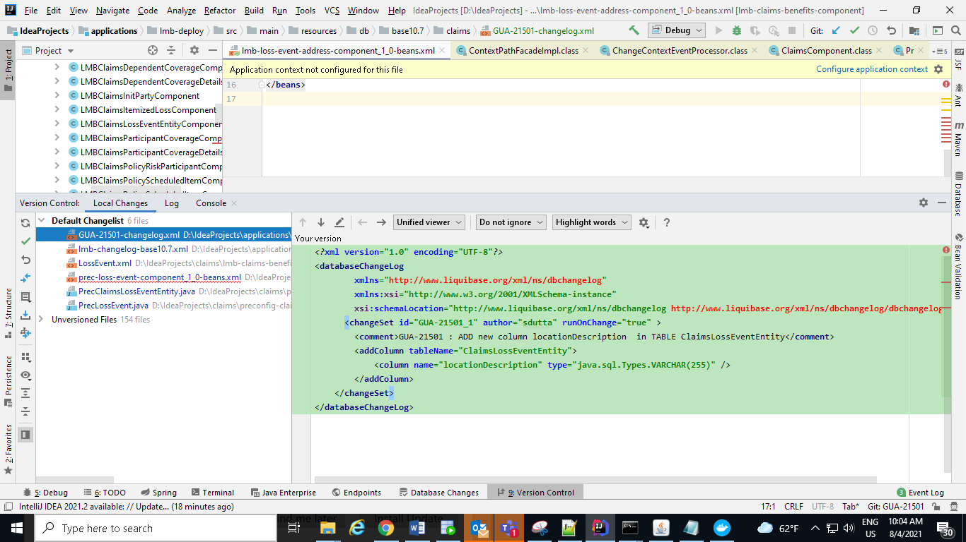

GUA-21501-changelog.xml:

*<?***xml version="1.0" encoding="UTF-8"***?>*<**databaseChangeLog  
 xmlns="http://www.liquibase.org/xml/ns/dbchangelog"  
 xmlns:xsi="http://www.w3.org/2001/XMLSchema-instance"  
 xsi:schemaLocation="http://www.liquibase.org/xml/ns/dbchangelog http://www.liquibase.org/xml/ns/dbchangelog/dbchangelog-3.0.xsd"**>  
 <**changeSet id="GUA-21501_1" author="sdutta" runOnChange="true"** >  
 <**comment**>GUA-21501 : ADD new column locationDescription in TABLE ClaimsLossEventEntity</**comment**>  
 <**addColumn tableName="ClaimsLossEventEntity"**>  
 <**column name="locationDescription" type="java.sql.Types.VARCHAR(255)"** />  
 </**addColumn**>  
 </**changeSet**>  
</**databaseChangeLog**>

lmb-changelog-base10.7.xml:

------------------------------------------

*<?***xml version="1.0" encoding="UTF-8"***?>*<**databaseChangeLog xmlns="http://www.liquibase.org/xml/ns/dbchangelog"  
 xmlns:xsi="http://www.w3.org/2001/XMLSchema-instance" xmlns:ext="http://www.liquibase.org/xml/ns/dbchangelog-ext"  
 xsi:schemaLocation="http://www.liquibase.org/xml/ns/dbchangelog http://www.liquibase.org/xml/ns/dbchangelog/dbchangelog-3.0.xsd  
 http://www.liquibase.org/xml/ns/dbchangelog-ext http://www.liquibase.org/xml/ns/dbchangelog/dbchangelog-ext.xsd"**>  
 <**preConditions**>  
 <**or**>  
 <**dbms type="oracle"** />  
 <**dbms type="mssql"** />  
 <**dbms type="hsqldb"** />  
 </**or**>  
 </**preConditions**>  
  
  
 <**include file="db/base10.7/claims/GUA-21501-changelog.xml"** />  
  
</**databaseChangeLog**>

Prec-loss-event-component_1_0-beans.xml:

*<?***xml version="1.0" encoding="UTF-8"***?>*<**beans xmlns="http://www.springframework.org/schema/beans"  
 xmlns:xsi="http://www.w3.org/2001/XMLSchema-instance" xmlns:util="http://www.springframework.org/schema/util"  
 xmlns:p="http://www.springframework.org/schema/p"  
 xsi:schemaLocation="http://www.springframework.org/schema/beans http://www.springframework.org/schema/beans/spring-beans-3.0.xsd  
 http://www.springframework.org/schema/util http://www.springframework.org/schema/util/spring-util-3.0.xsd"**>  
  
 <**bean id="PrecLossEventComponent_1_0" parent="LossEventComponent_3_0"  
 class="com.exigen.ipb.preconfig.claims.benefits.component.PrecClaimsLossEventEntityComponent"**>  
 <**constructor-arg index="0"**>  
 <**value**>com.exigen.ipb.preconfig.claims.benefits.component.entity.PrecClaimsLossEventEntity  
 </**value**>  
 </**constructor-arg**>  
 *<!-- component properties -->* <**property name="name" value="PrecLossEvent"** />  
 <**property name="version" value="1.0"** />  
 <**property name="componentType" value="General"** />  
 <**property name="description" value="Preconfig Claims Loss Event Information"** />  
 <**property name="defaultTabLabel" value="Preconfig Claims Loss Event Basic Info"** />  
 <**property name="claimEventPublisher" ref="claimEventPublisher"**/>  
 <**property name="claimsDao" ref="claimsDao"**/>  
  
 <**property name="lookupAccessFacade" ref="lookupAccessFacade"** />  
  
 <**property name="providedDataInterfaces"**>  
 <**set merge="true"**>  
 <**value**>com.exigen.ipb.preconfig.claims.benefits.component.entity.PrecClaimsLossEventEntity  
 </**value**>  
 </**set**>  
 </**property**>  
  
  
<**property name="views"**>  
 <**map key-type="com.exigen.ipb.components.domain.ViewType"  
 value-type="java.lang.String" merge="true"**>  
 <**entry key="dataGather"  
 value="/ipb/preconfig/components/claims/benefits/PrecLossEvent_3_0_edit.xhtml"** />  
 </**map**>  
</**property**>  
  
<**property name="attributesMetadata"**>  
 <**map merge="true"**>  
   
  
 <**entry key="locationDescription"**>  
 <**bean parent="pf.attributeMetaTemplate" p:orderNr="1120" p:name="locationDescription"  
 p:label="Location Description"  
 p:dataType="String" p:pathToEntityField="locationDescription" p:displayable="true"**>  
 <**property name="attributeConstraints"**>  
 <**bean class="com.exigen.ipb.components.domain.AttributeConstraints" p:minLength="0" p:maxLength="399"**/>  
 </**property**>  
 </**bean**>  
 </**entry**>  
 </**map**>  
 </**property**>  
 </**bean**>  
</**beans**>

Domain class or Entity Class:

PrecClaimsLossEventEntity.java:

**package** com.exigen.ipb.preconfig.claims.benefits.component.entity;  
  
**import** java.util.*;  
**import** javax.persistence.*;  
  
**import** com.exigen.ipb.base.annotations.CanExtend;  
**import** com.exigen.ipb.base.annotations.CanInvoke;  
**import** com.exigen.ipb.base.datatypes.DataTypeFieldLengthConstants;  
**import** com.exigen.ipb.claims.component.entity.ClaimsLossEventEntity;  
**import** org.hibernate.annotations.ForeignKey;  
**import** org.hibernate.annotations.IndexColumn;  
  
@Entity  
@CanExtend  
@CanInvoke  
**public class** PrecClaimsLossEventEntity **extends** ClaimsLossEventEntity {  
  
 **private static final long *serialVersionUID*** = 1L;  
  
  
 @Column(length = DataTypeFieldLengthConstants.***REPORT_STATUS_FIELD_LENGTH***)  
 **private** String **locationDescription**;  
  
 **public** String getLocationDescription() {  
 **return locationDescription**;  
 }  
  
 **public void** setLocationDescription(String locationDescription) {  
 **this**.**locationDescription** = locationDescription;  
 }  
  
}

Model or dto:

PrecLossEvent.java:

*/* Copyright © 2016 EIS Group and/or one of its affiliates. All rights reserved. Unpublished work under U.S. copyright laws.  
 CONFIDENTIAL AND TRADE SECRET INFORMATION. No portion of this work may be copied, distributed, modified, or incorporated into any other media without EIS Group prior written consent.*/***package** com.exigen.ipb.preconfig.claims.benefits.dto;  
  
**import** java.util.Date;  
**import** java.util.List;  
  
**import** com.exigen.ipb.base.annotations.Internal;  
**import** com.exigen.ipb.claims.api.dto.ClaimsComponentNameAware;  
**import** com.exigen.ipb.claims.api.dto.ClaimsDTO;  
  
  
*/**  
 * DTO representing Loss Event during claim creation for Preconfig Claims Benefits  
 *   
 \** ***@author*** *rqiu  
 \** ***@since*** *2016SP6  
 */*@Internal  
**public class** PrecLossEvent **implements** ClaimsDTO, ClaimsComponentNameAware {  
  
 **private static final long *serialVersionUID*** = 1L;  
   
 */**  
 * Component name of building block for which instance should be created  
 */* **private** String **componentName**;  
   
 **public** String getLocationDescription() {  
 **return locationDescription**;  
 }  
  
 **public void** setLocationDescription(String locationDescription) {  
 **this**.**locationDescription** = locationDescription;  
 }  
  
 **private** String **locationDescription**;  
  
  
   
  
}

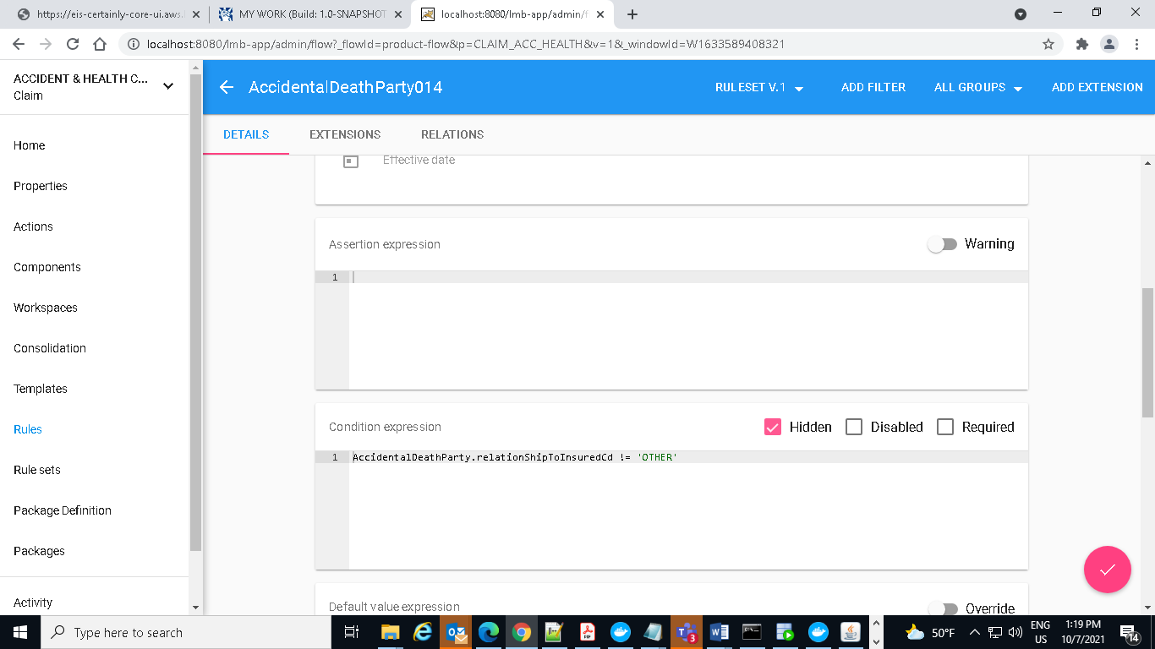

EIS Version:10.7.2

BatchJob:

**public class** CphReceiveSqsMessageJob **extends** BaseAuditingJob

**public** JobResults doExecute(Map map, Auditor auditor) **throws** SchedulerJobException {

} **catch** (Exception e) {  
 ***LOG***.error(**"Error receiving SQS messages.from "** + **queueUrl**, e);  
 auditor.error(**"Error receiving SQS messages from "** + **queueUrl** + **". "** + e.getCause());  
 **return** JobResults.***JOB_FAILED***;  
}  
**return** JobResults.***JOB_SUCCESSFUL***;

AsyncTask:

**public class** LmbCWBatchProcessingJob **extends** BaseAuditingTaskGenerationJob

select * from lookuplist where lookupname='AHAVClaimsBenefitCoverage' --2478458000

select * from lookupvalue where lookuplist_id='2478458000'

