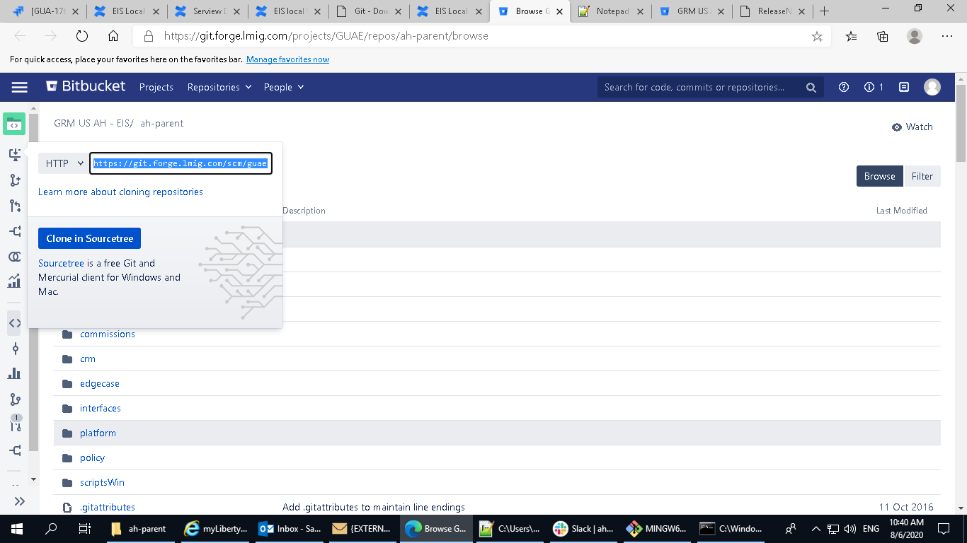

<https://git.forge.lmig.com/projects/GUAE/repos/ah-parent/browse>

<https://git.forge.lmig.com/projects/GUAE/repos/ah-parent/commits>