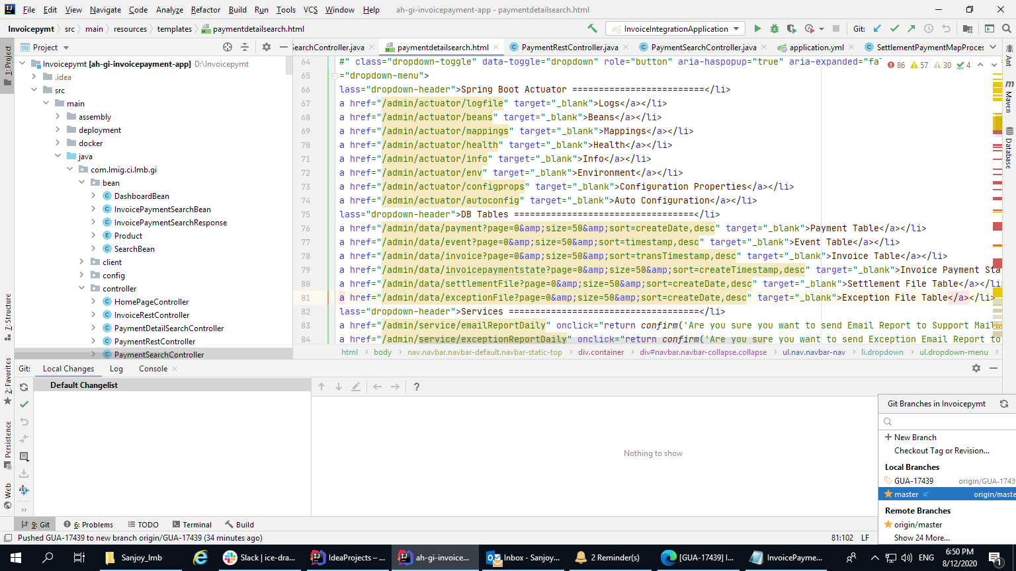

Write click on master---create a branch with (give the story point)

Go to Git and local changes and then commit and push