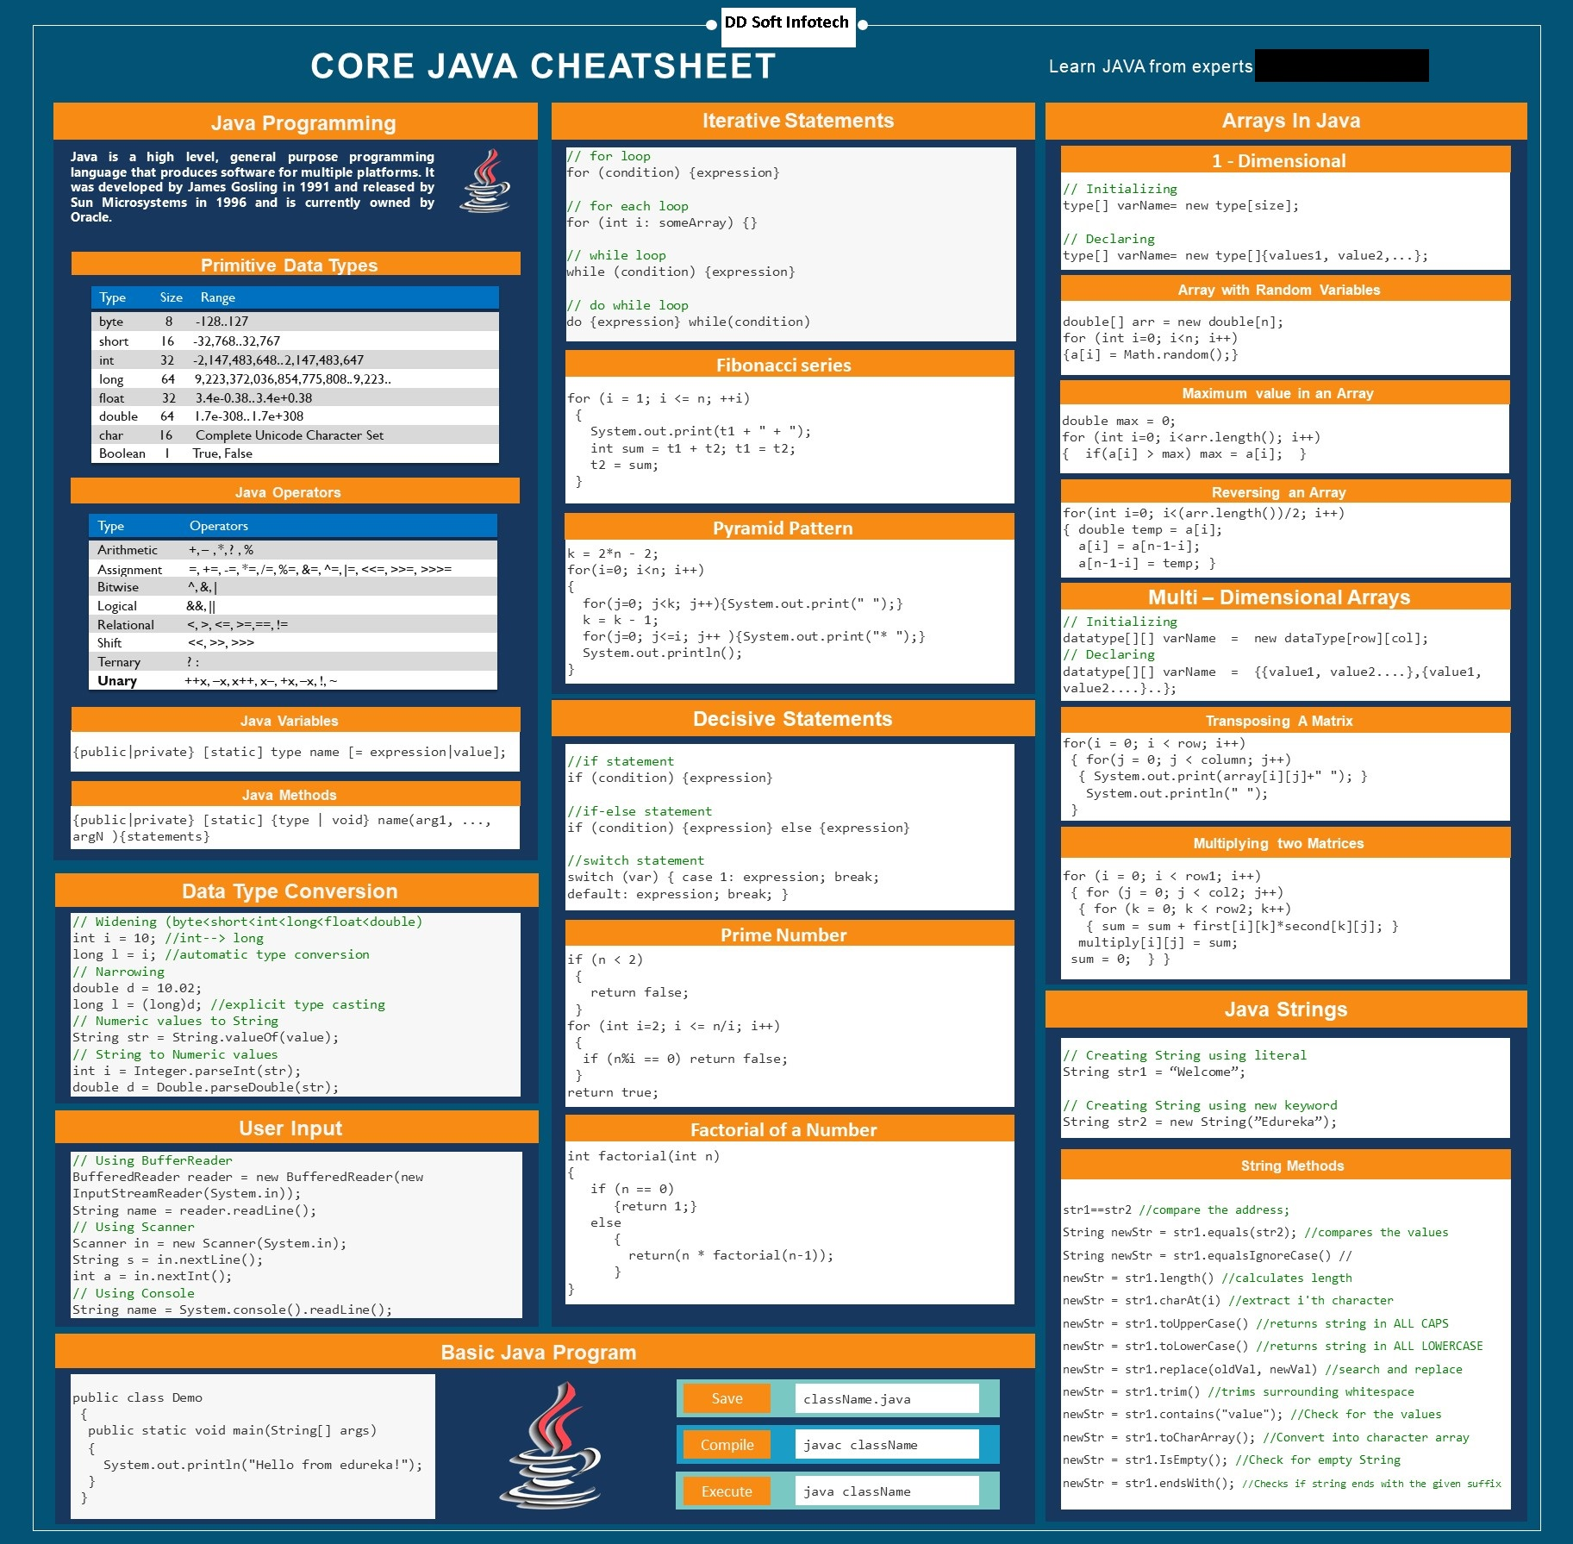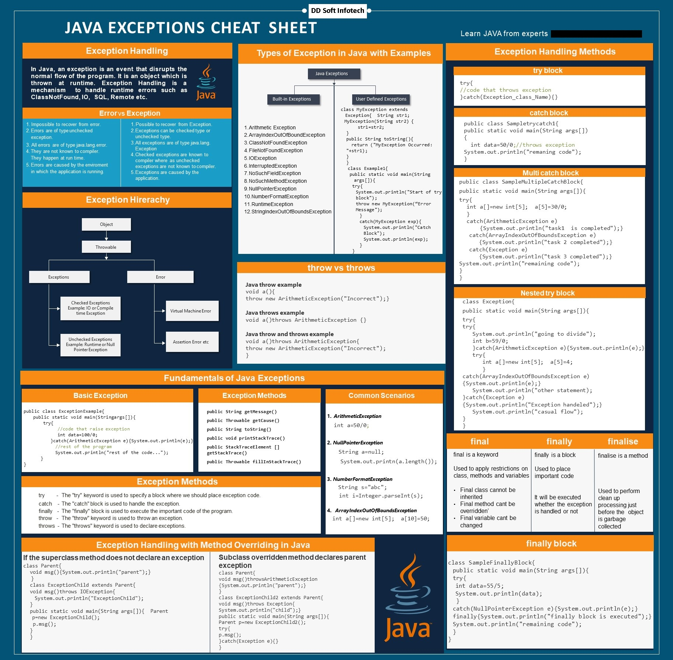

### Class loader and explain the types of class loader

Class loaders are the part of the Java Runtime Environment that dynamically loads Java classes into the Java virtual machine. It is responsible for locating libraries, reading there content and loading the classes contained within the libraries. When JVM is started three class loaders are used  
  
1. **Bootstrap class loader**  
  
2. **Extensions class loader**  
  
3. **System class loader**  
**Bootstrap class loader** loads the core java libraries. It is written in native code. The bootstrap class loader is responsible for loading key java classes like java.lang.Object and other runtime code into memory. The runtime classes are packaged inside jre/lib/rt.jar file.   
  
**Extensions class loader** loads the code in the extension directories. It is implemented by ExtClassLoader class.  
  
**System class loader** the code found on the java.class.path which map to the system class path variables. It is implemented by AppClassLoader class. All user classes by default are load by the system class loader.