Intelli Ji Activation Code:

Paste below server address and click on Activate

<http://license-jetbrains.lmig.com>

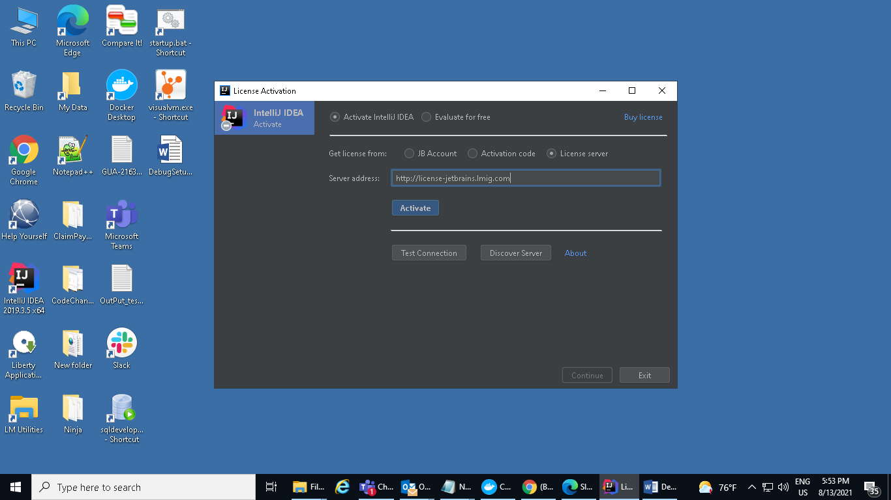

Select import project:

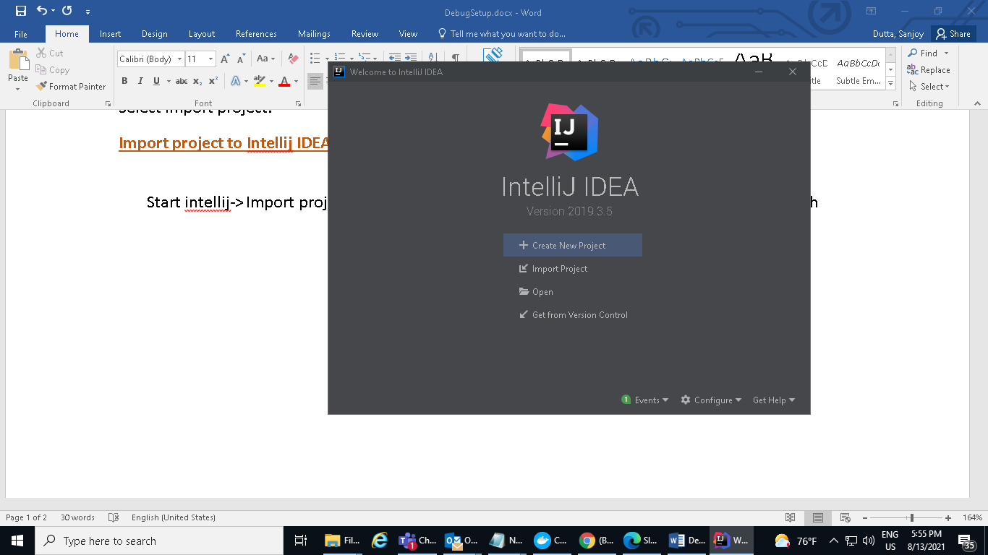

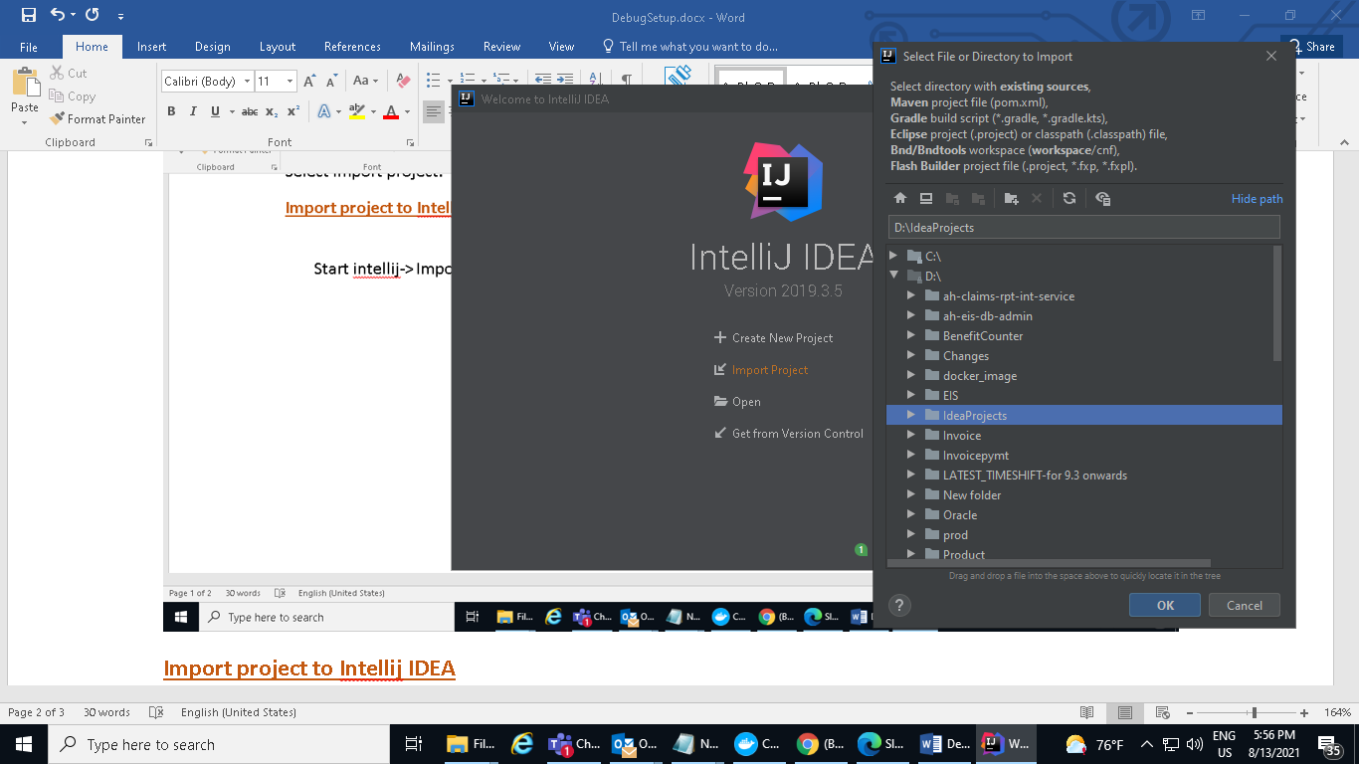

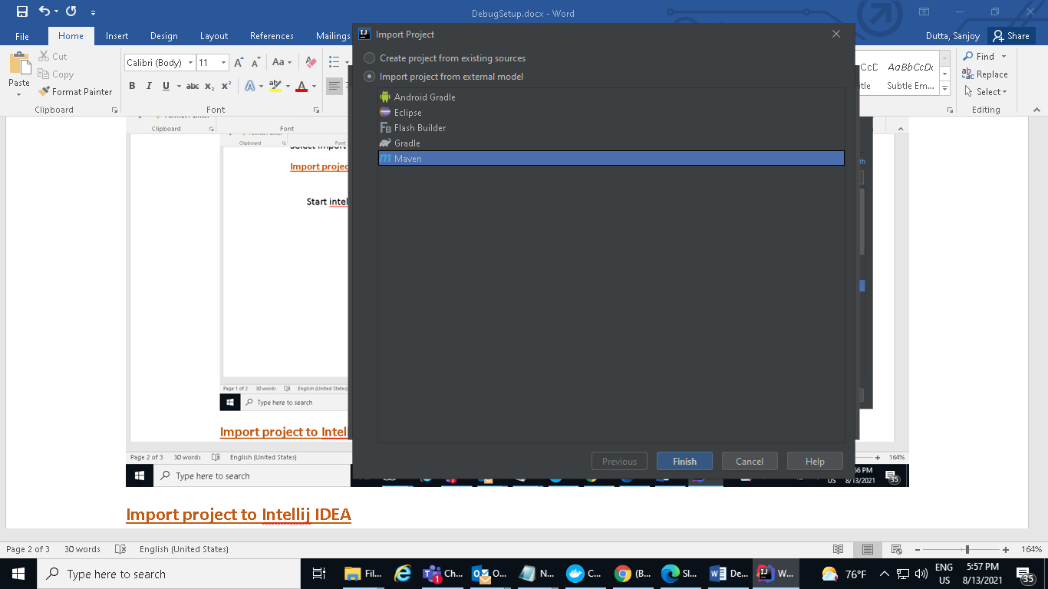

**Import project to Intellij IDEA**

Start intellij-> Import project->import project from external model->select maven->next->finish

