Set JAVA_HOME and M2_HOME and MAVEN_HOME

And run in command line to see the every thing works fine or not:

Java –version

Mvn –version

And any problem check the jdk version in maven (D:\apache-maven-3.5.2\bin\mvn.cmd)

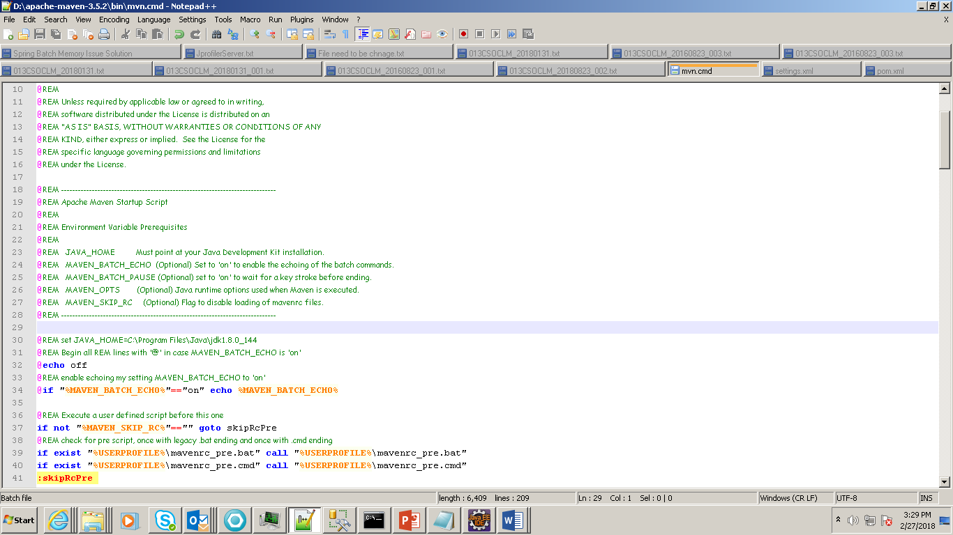

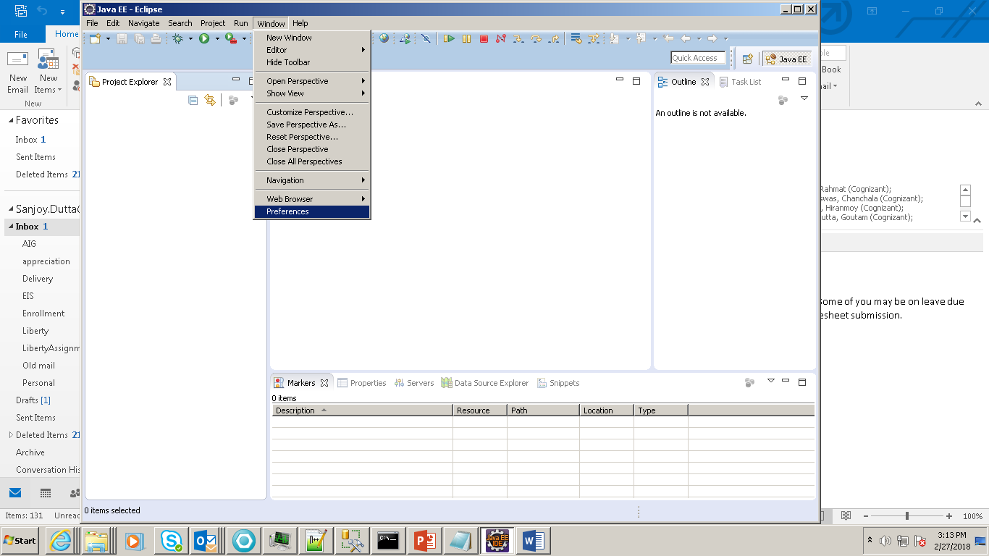

2.

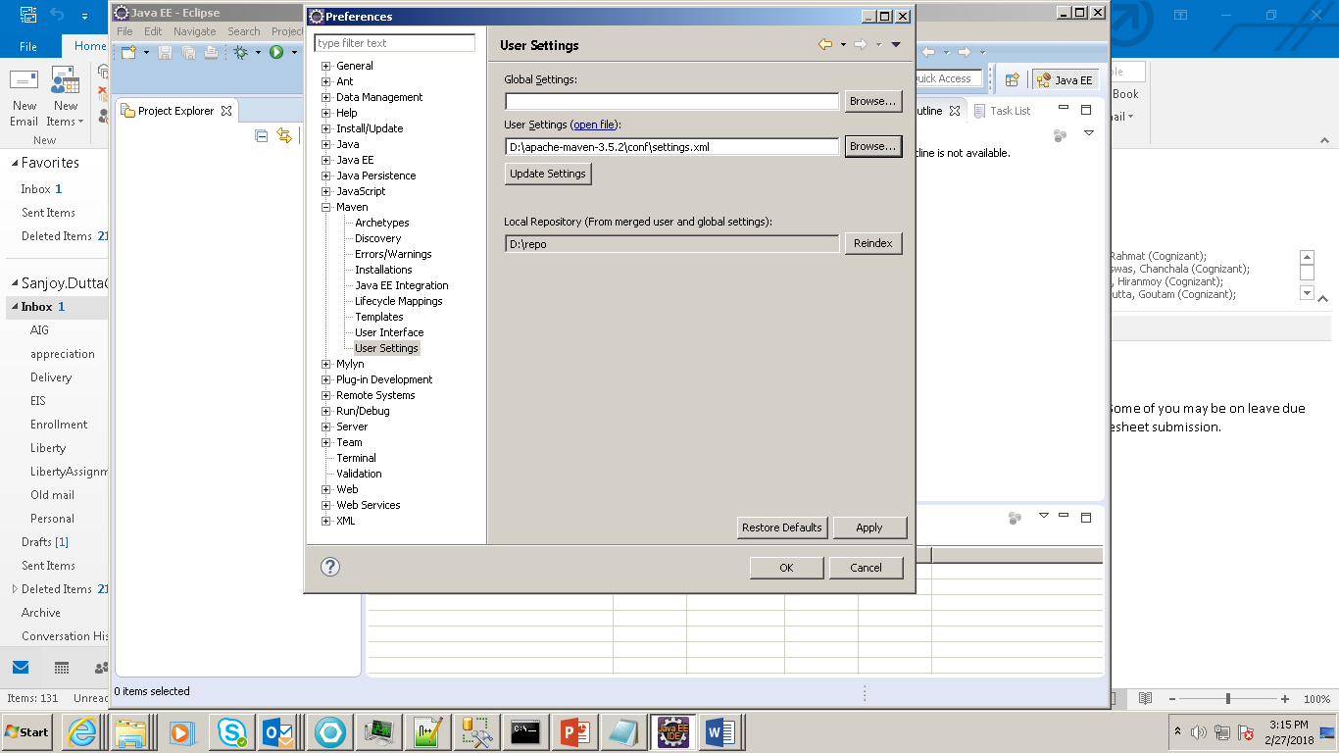

Click on Installation and Add

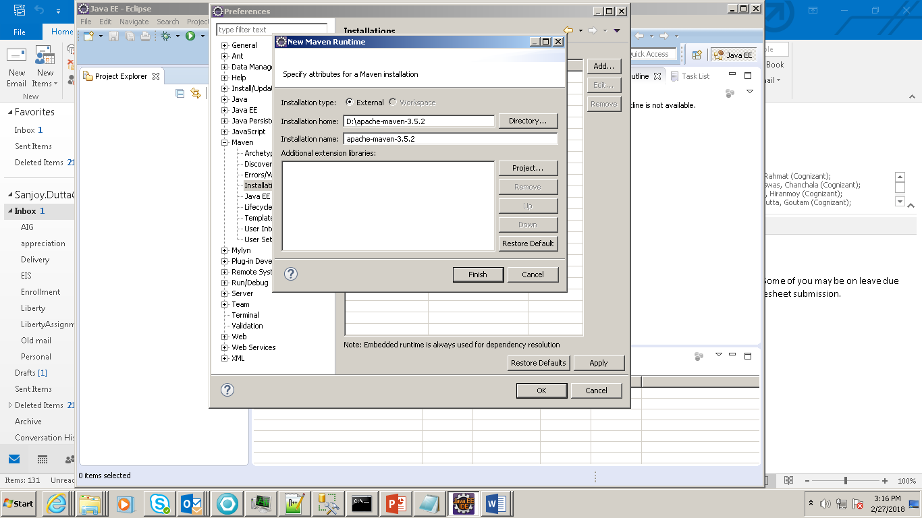

Click on checkbox and apply

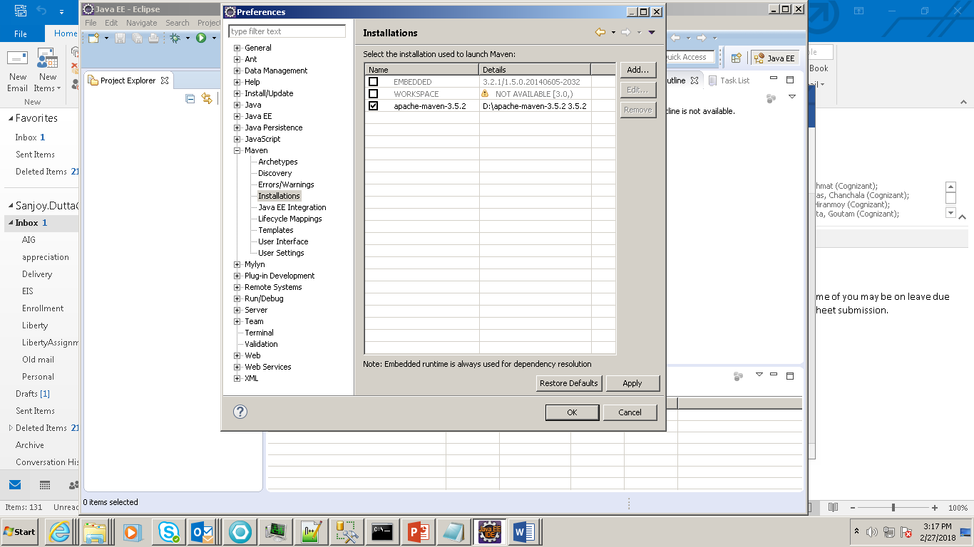

Change in setting.xml of Maven:

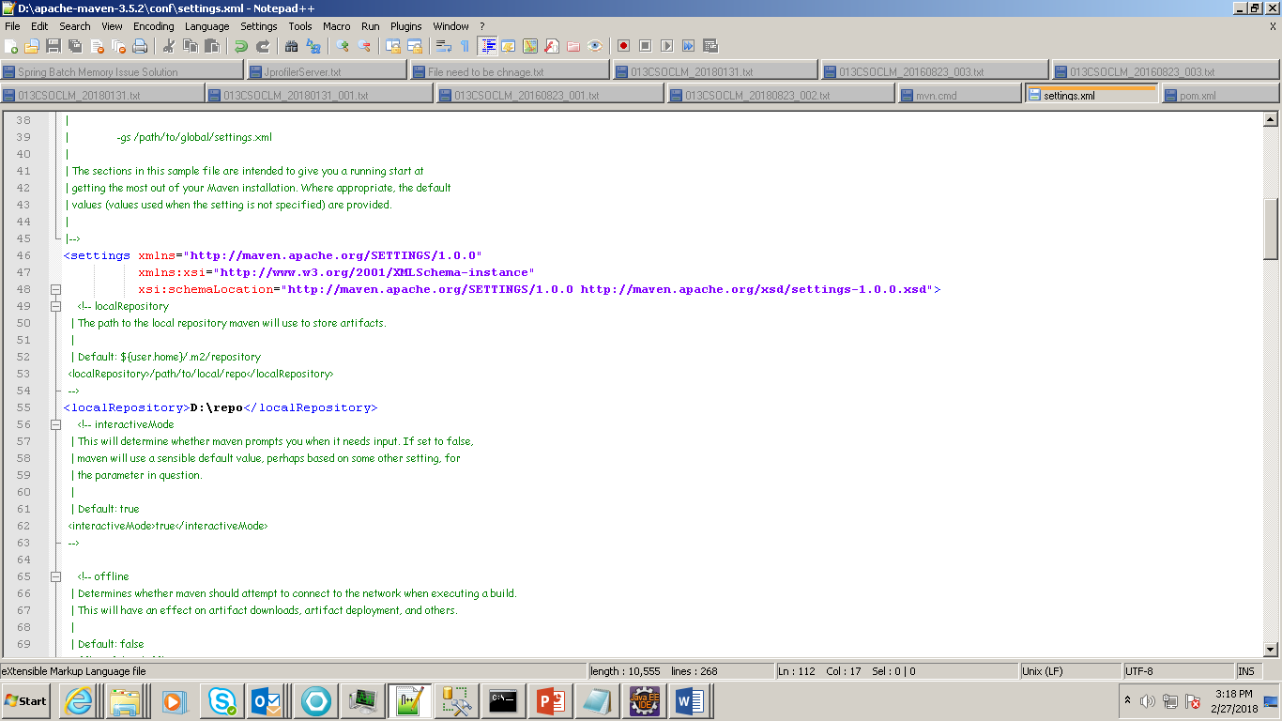

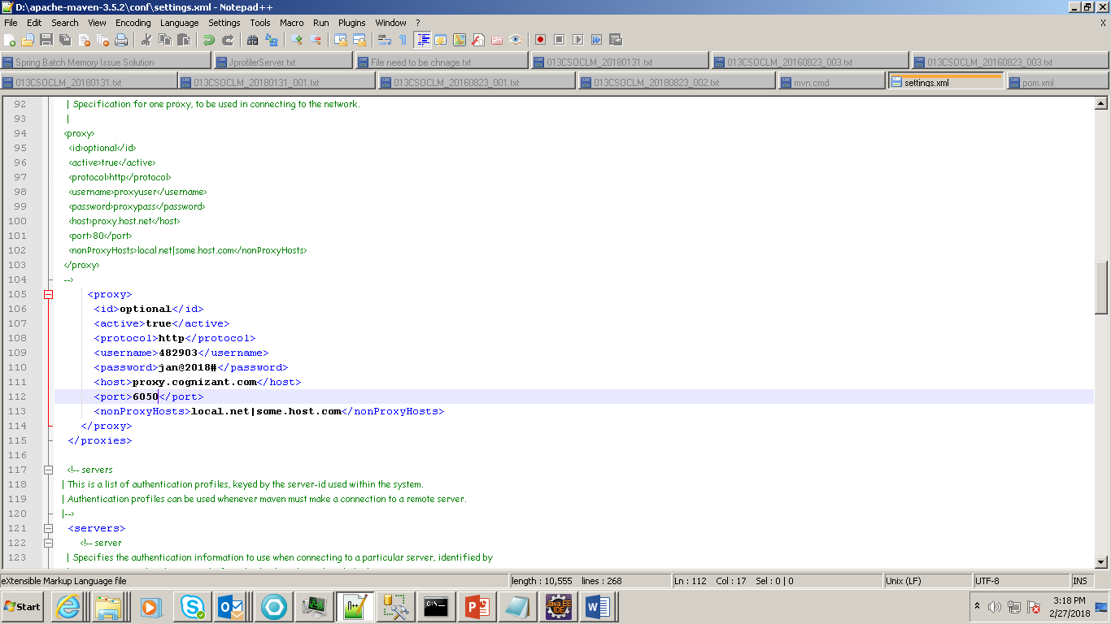

Now Import the Maven project:

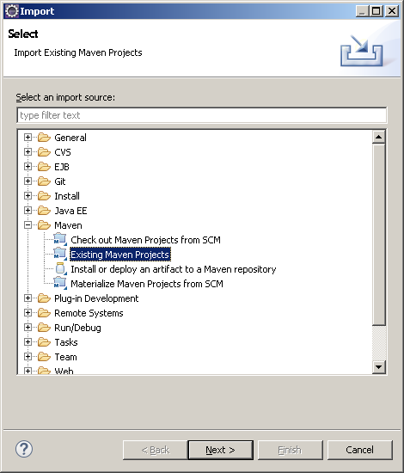

D:\spring-boot-web-jsp>mvn spring-boot:run

mvn clean install