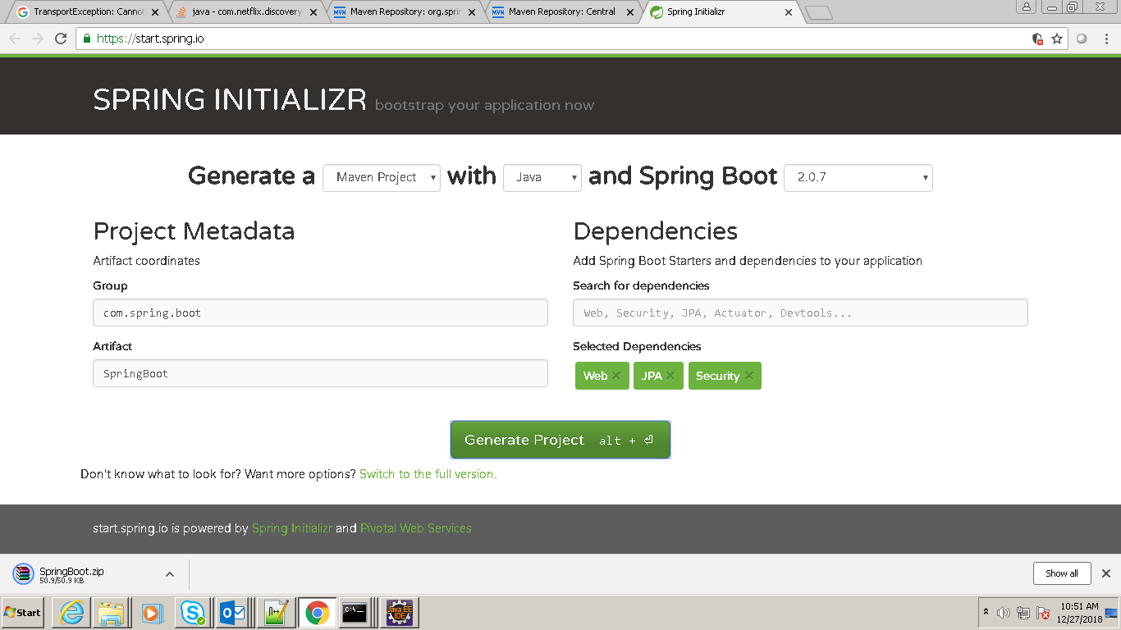

Go to the site (<https://start.spring.io/>) and select the **version:2.0.7 and add the dependencies**

**And** write **the group name and artifact and** click on

Now create a workspace in eclipse and extract the zip file and go to the command prompt and type the below command:

***D:\SpringBootWsapce\SpringBatchDemo>mvn clean install***

After that

***D:\SpringBootWsapce\SpringBatchDemo>mvn eclipse:eclipse***

And then **import** the project as an **existing maven project**

**Solution for DB Issue:**

Add the following line:

**@EnableAutoConfiguration(exclude = {DataSourceAutoConfiguration.class, DataSourceTransactionManagerAutoConfiguration.class, HibernateJpaAutoConfiguration.class})**

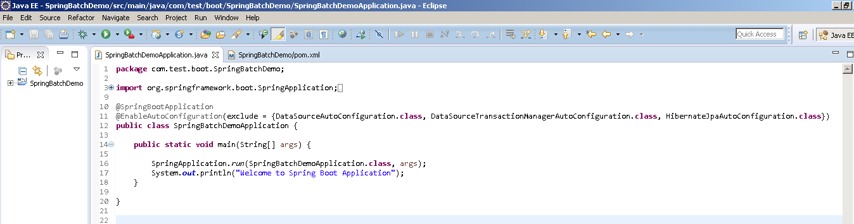

Spring Boot is mainly used to expose the service