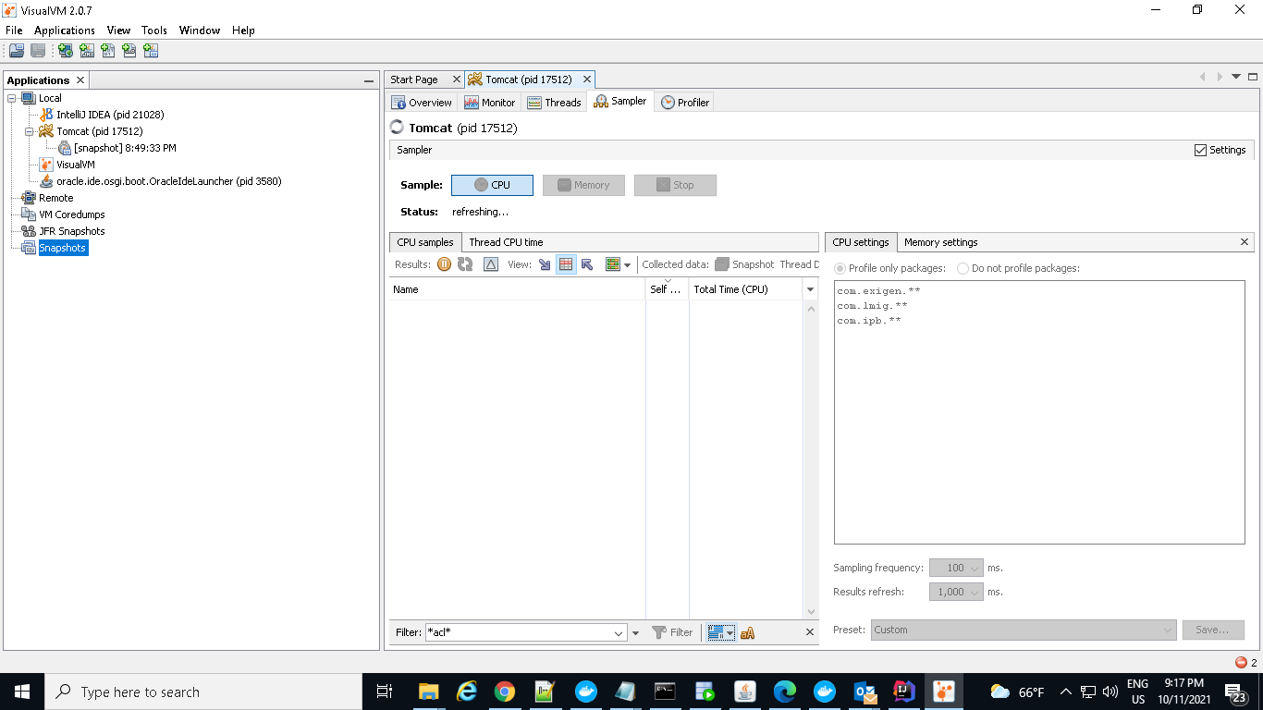

open VisualVM and select local and double click on Tomcat

click on Sampler and select CPU and heat the application URL

and click on snapshot

click on settings add the below packages:

com.exigen.\*\*

com.lmig.\*\*

com.ibp.\*\*ss