[training_user07@majescotraining.com](mailto:training_user07@majescotraining.com) – screen – Train_vdiemp6

**Screen1:**

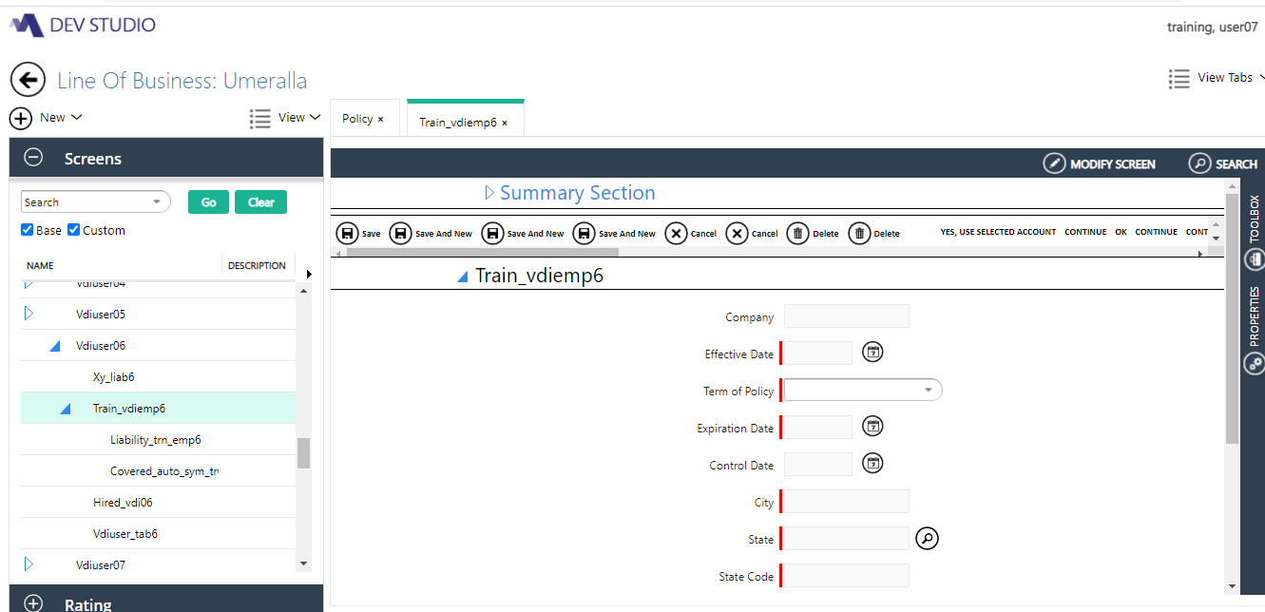

**Rules:**

**UI Rule:**

1.Default Value applied using POC level rule in Company field:

Set Default value=”Cover-all Company”s

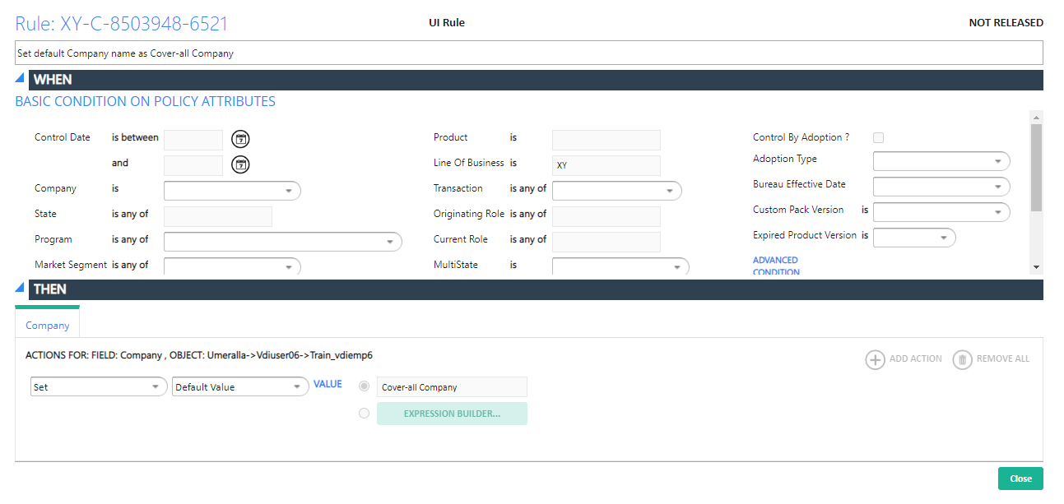

**2.Effective Date:**

Effective date should be defaulted to **SYSDATE:**

**UI Rule:**

Effective date should be defaulted to **SYSDATE**

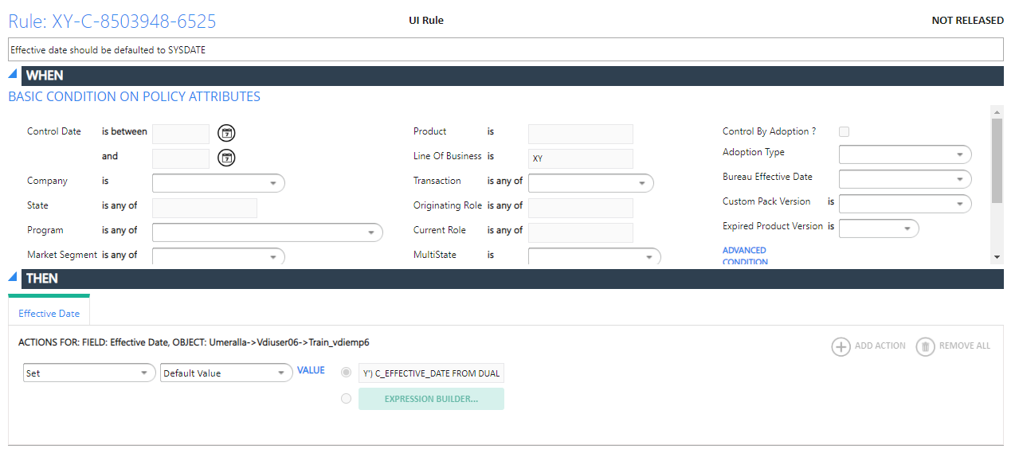

**Query:**

SELECT TO_CHAR(SYSDATE,'MM/DD/YYYY') C_EFFECTIVE_DATE FROM DUAL

**Validation Rule:**

Validate the Effective_date should not be less than sysdate

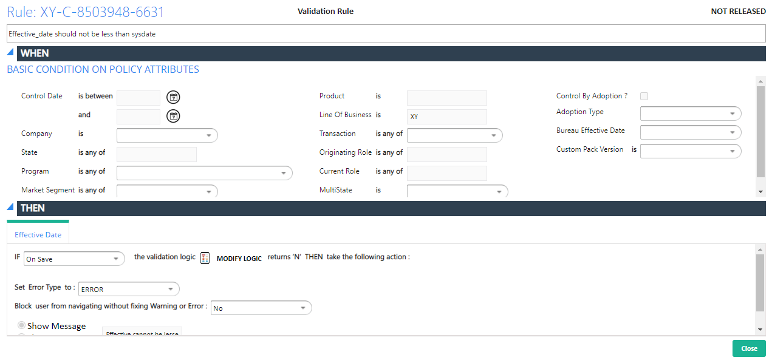

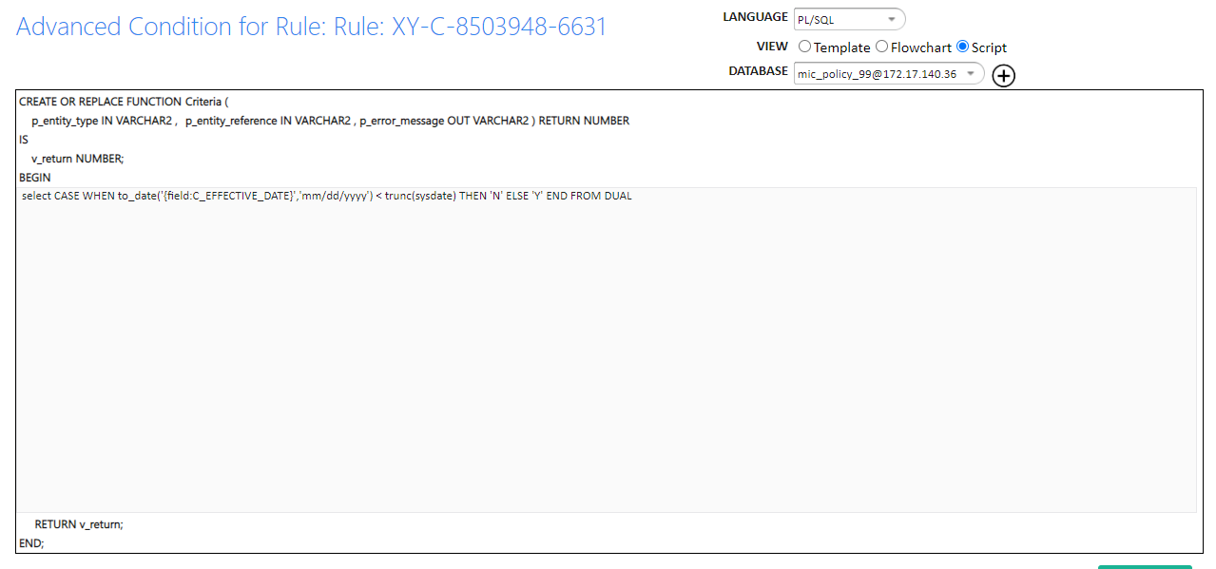

**Query:**

select CASE WHEN to_date('{field:C_EFFECTIVE_DATE}','mm/dd/yyyy') < trunc(sysdate) THEN 'N' ELSE 'Y' END FROM DUAL

**3.Term of Policy:**

Add drop down values Quaterly, Semi Annually, Annually on Term of Policy drop down field

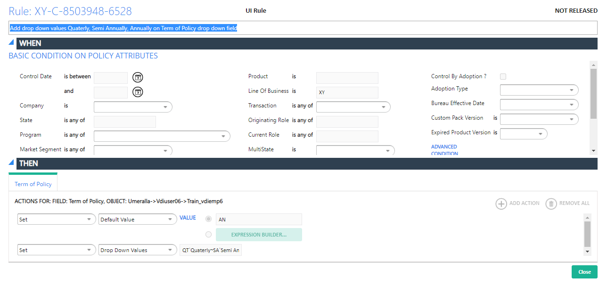

**4.Expiration Date:** Set Default value of Expiration Date = Default to Effective date + 1 year.

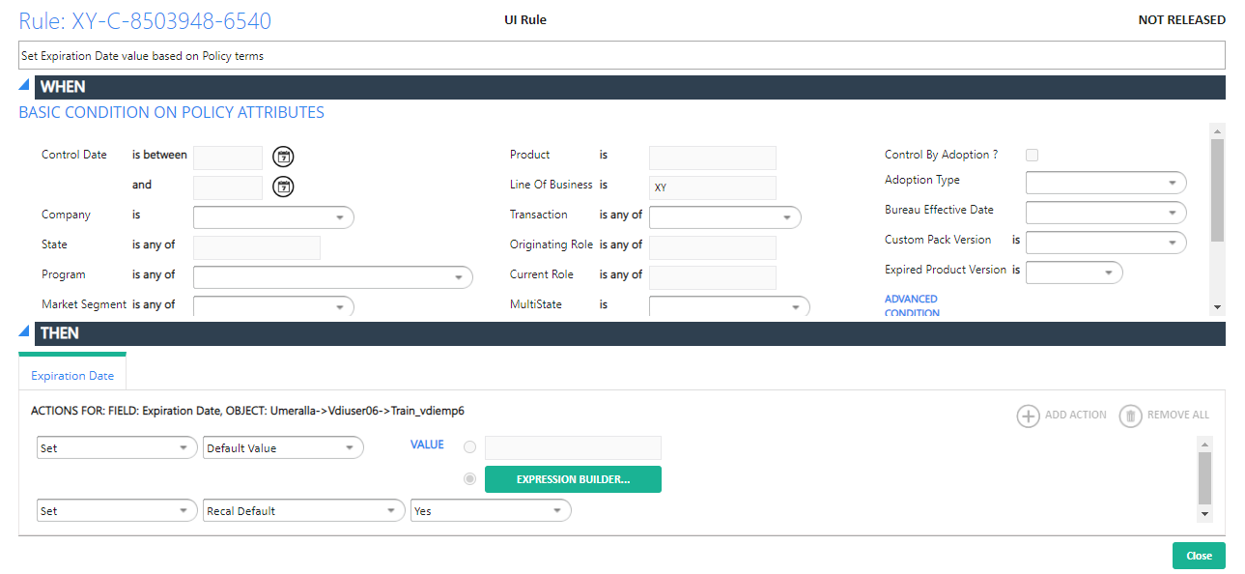

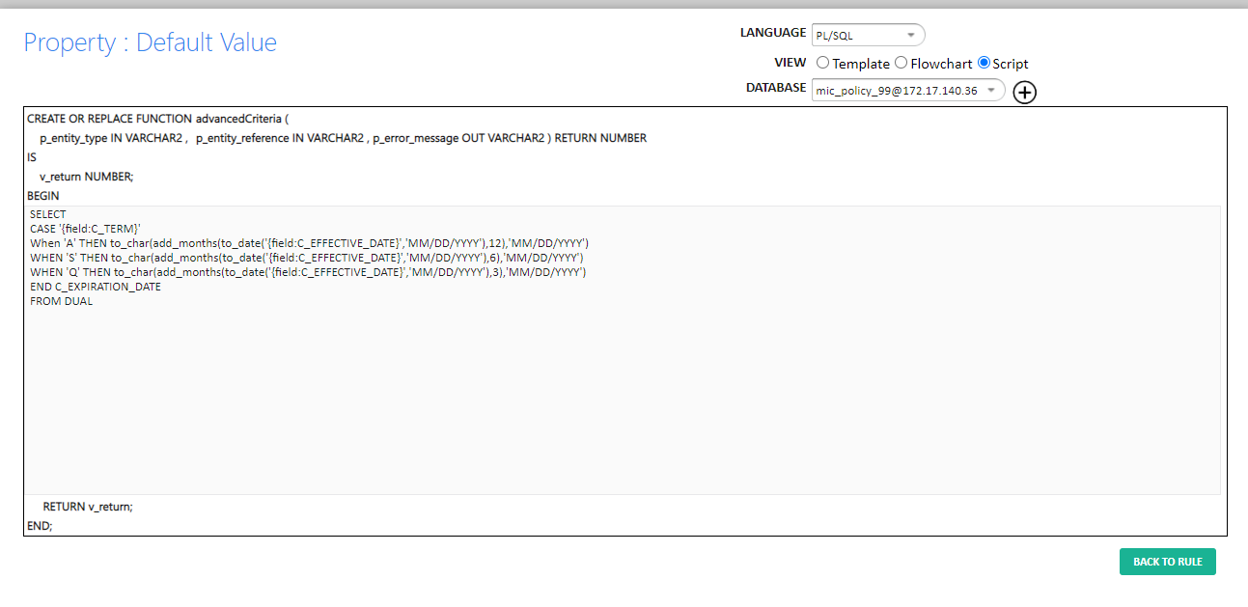

**Query:**

SELECT

CASE '{field:C_TERM}'

When 'A' THEN to_char(add_months(to_date('{field:C_EFFECTIVE_DATE}','MM/DD/YYYY'),12),'MM/DD/YYYY')

WHEN 'S' THEN to_char(add_months(to_date('{field:C_EFFECTIVE_DATE}','MM/DD/YYYY'),6),'MM/DD/YYYY')

WHEN 'Q' THEN to_char(add_months(to_date('{field:C_EFFECTIVE_DATE}','MM/DD/YYYY'),3),'MM/DD/YYYY')

END C_EXPIRATION_DATE

FROM DUAL

**4.Control Date:** Control date should be same as Effective date

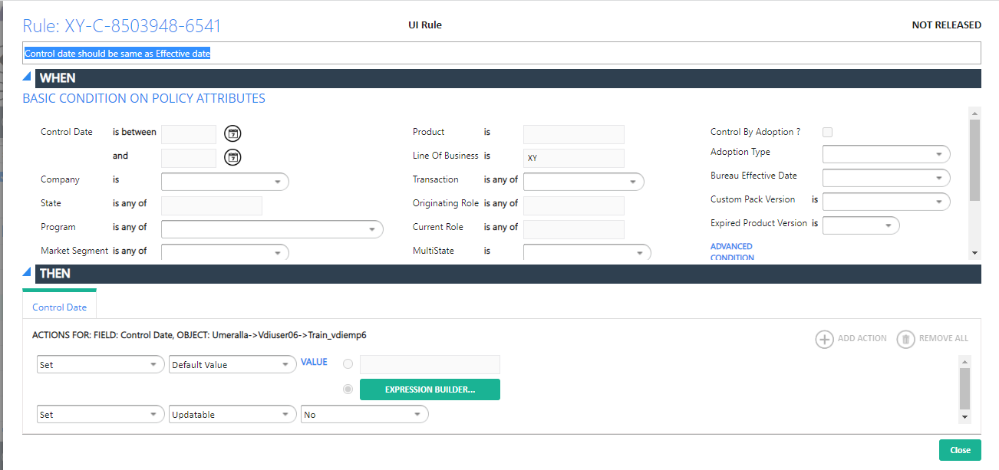

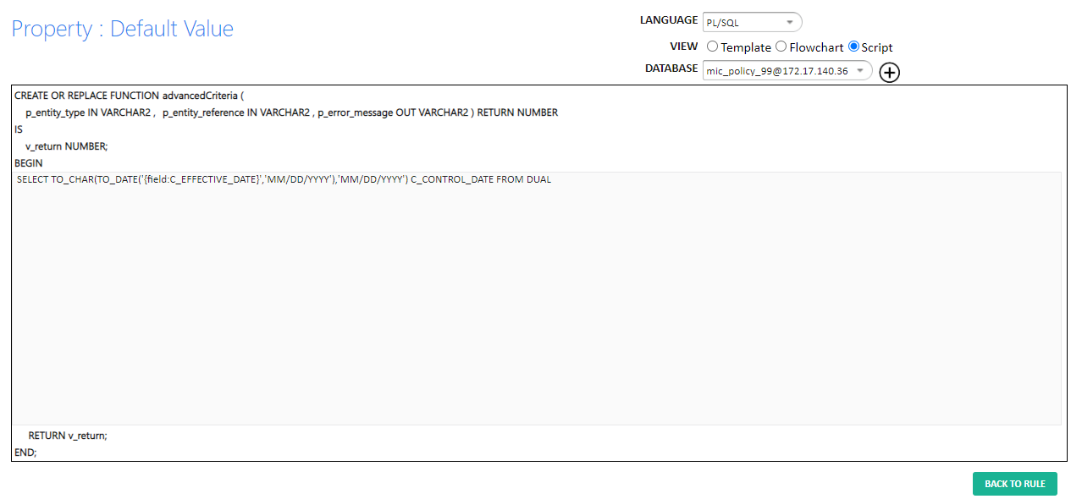

**Query:**

SELECT TO_CHAR(TO_DATE('{field:C_EFFECTIVE_DATE}','MM/DD/YYYY'),'MM/DD/YYYY') C_CONTROL_DATE FROM DUAL

**5.Zip Code:**

Show-lookup query on Zip so that user can select any zip:

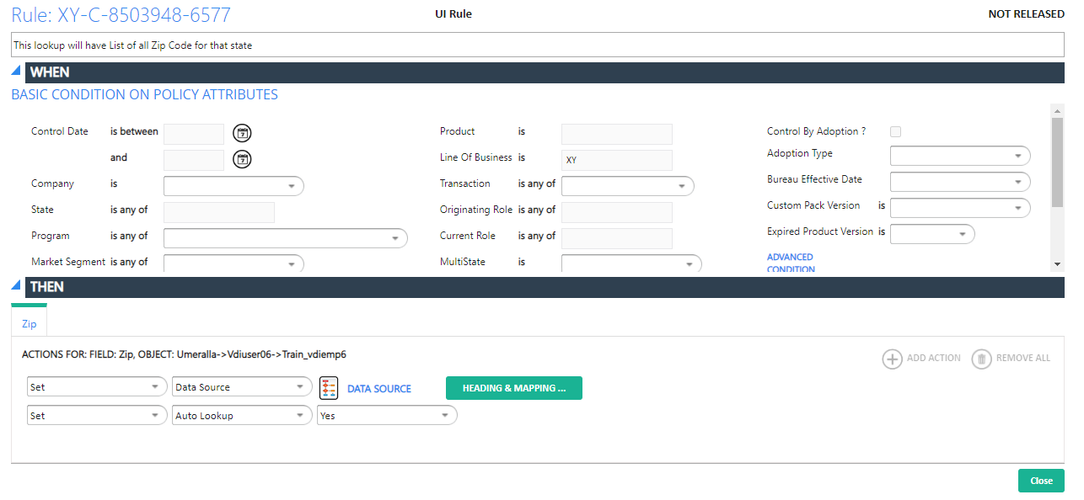

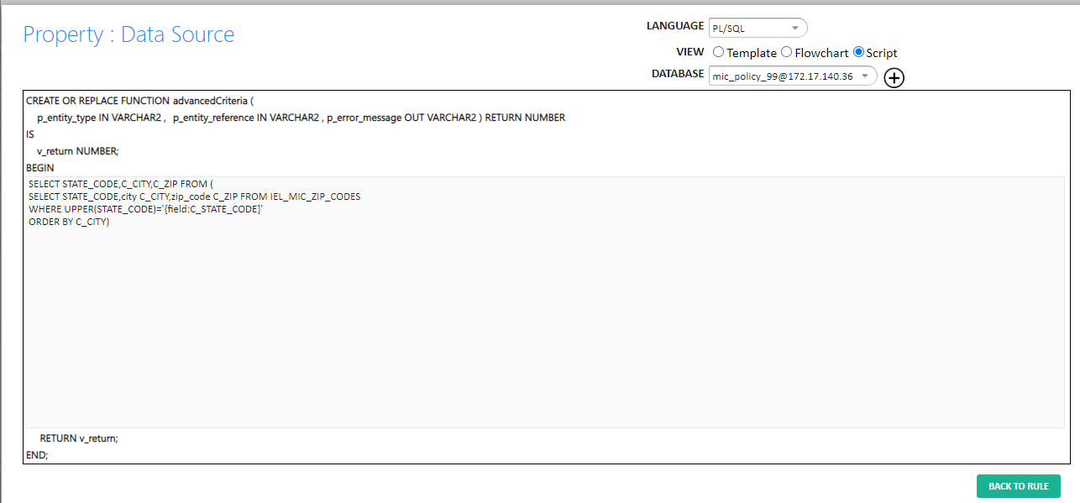

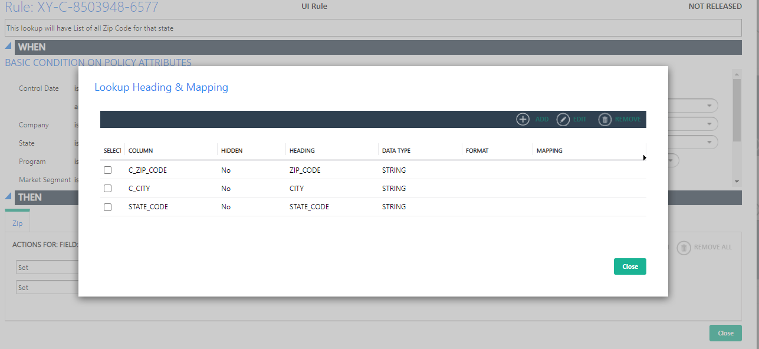

**Query:**

SELECT STATE_CODE,C_CITY,C_ZIP FROM (

SELECT STATE_CODE,city C_CITY,zip_code C_ZIP FROM IEL_MIC_ZIP_CODES

WHERE UPPER(STATE_CODE)='{field:C_STATE_CODE}'

ORDER BY C_CITY)

**6. Liability Training:**

**Action Rule:**

When Liability training checkbox is selected, Liability Training Coverages Object screen must be showed in object tree

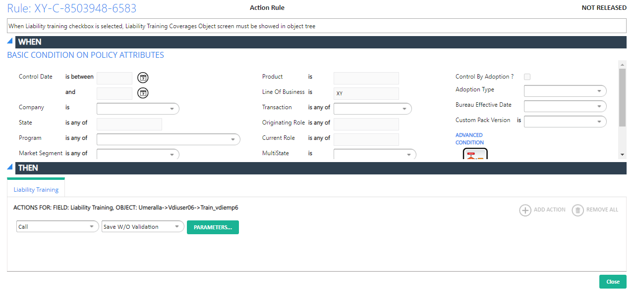

**Screen2:**

**Covered_auto_sym_tr6**

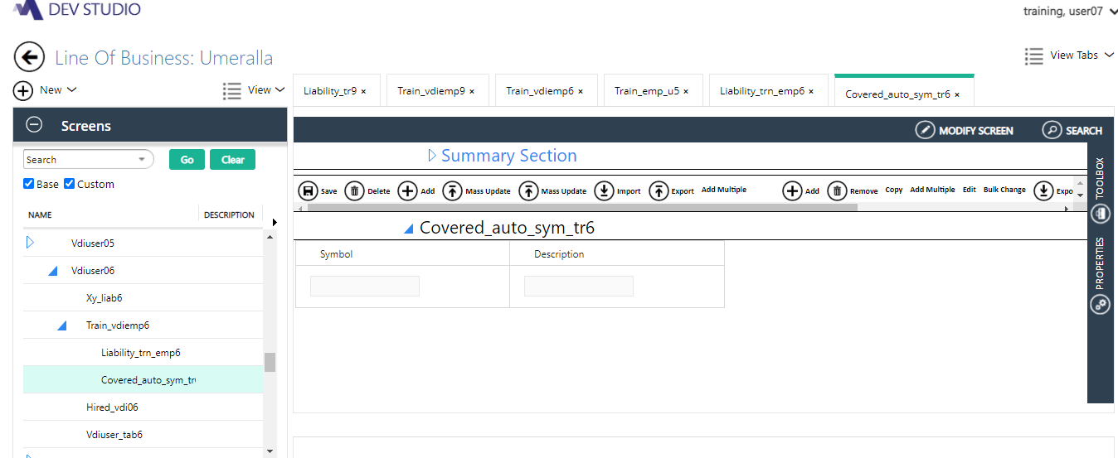

Loading data population from IEL_TR_XY_COVERED_SYM

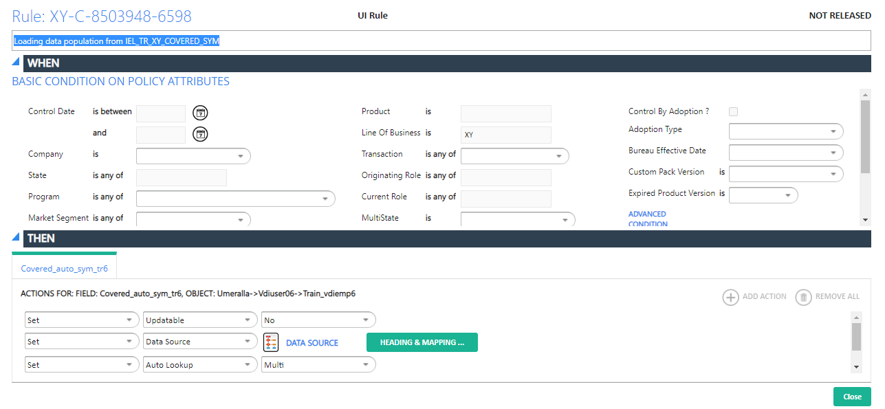

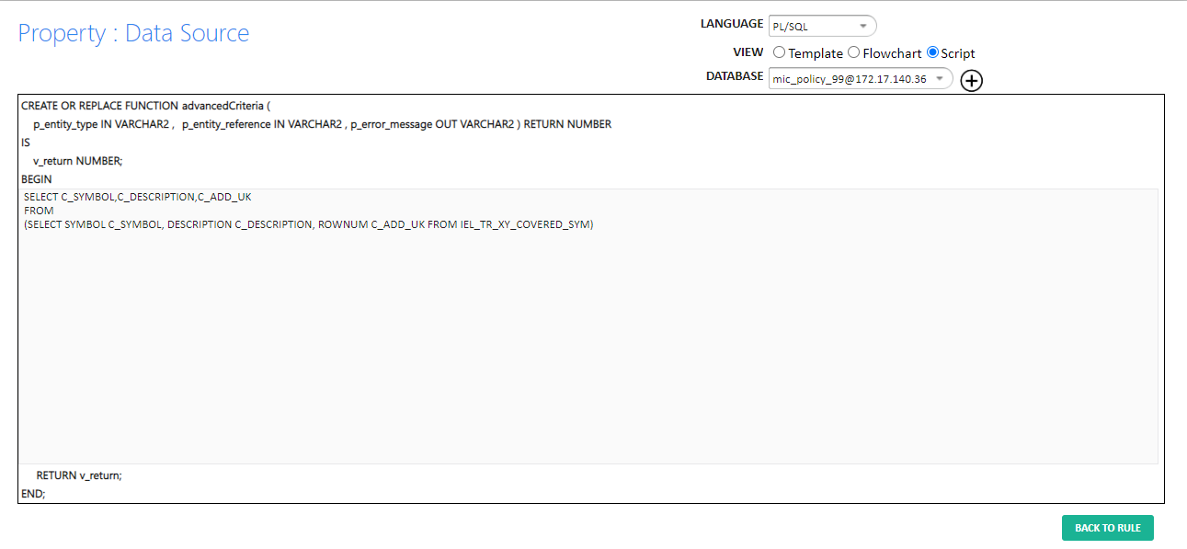

**Query:**

SELECT C_SYMBOL,C_DESCRIPTION,C_ADD_UK

FROM

(SELECT SYMBOL C_SYMBOL, DESCRIPTION C_DESCRIPTION, ROWNUM C_ADD_UK FROM IEL_TR_XY_COVERED_SYM)

**Screen3:**

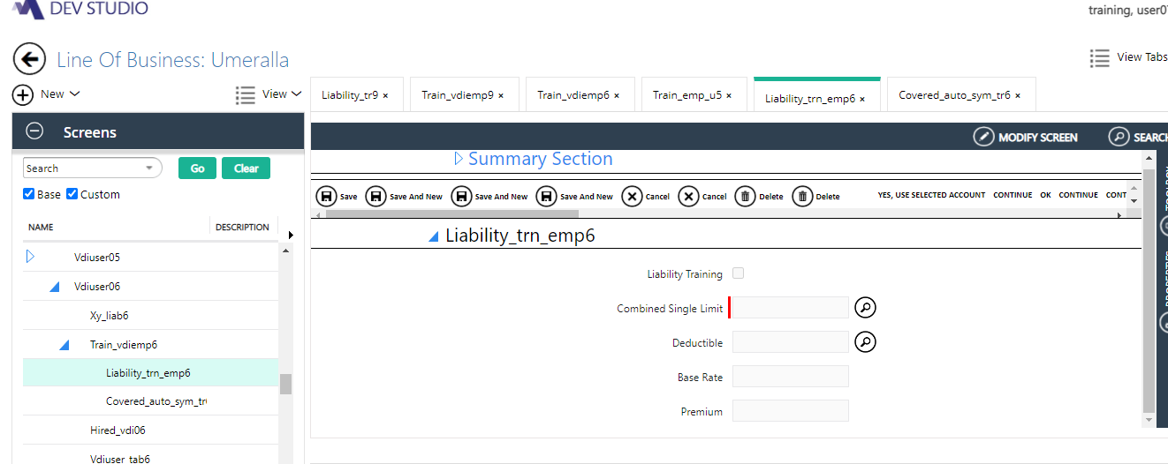

**Liability Training:**

Coverage checkbox selected by default and disabled:

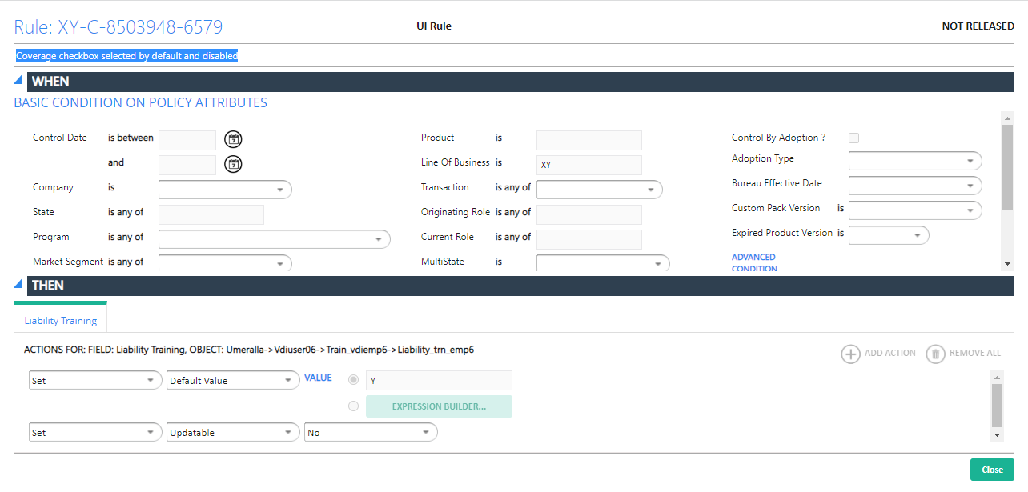

**Combined Single Limit:**

Limit value needs to be populated from iel_tr_xy_csl1

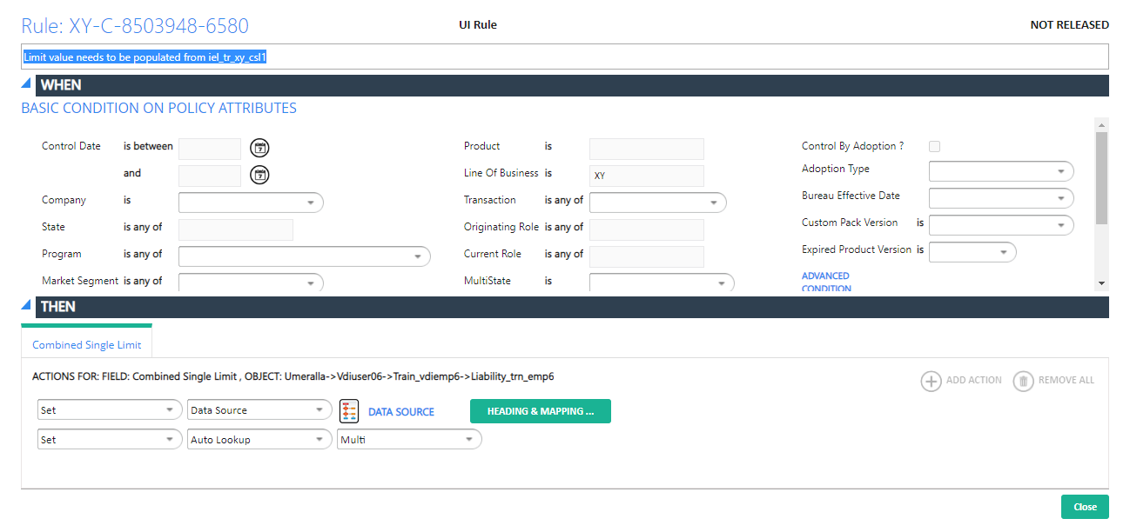

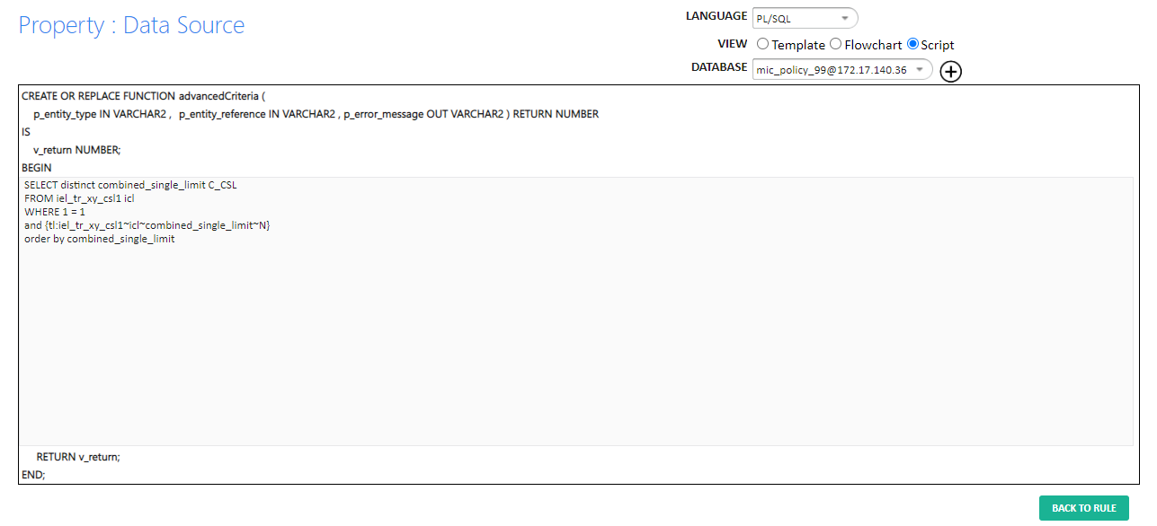

**Query:**

SELECT distinct combined_single_limit C_CSL

FROM iel_tr_xy_csl1 icl

WHERE 1 = 1

and {tl:iel_tr_xy_csl1~icl~combined_single_limit~N}

order by combined_single_limit

**3. Deductible:**

Value needs to be populated from iel_tr_xy_ded1

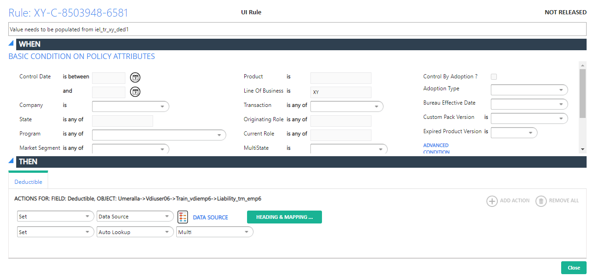

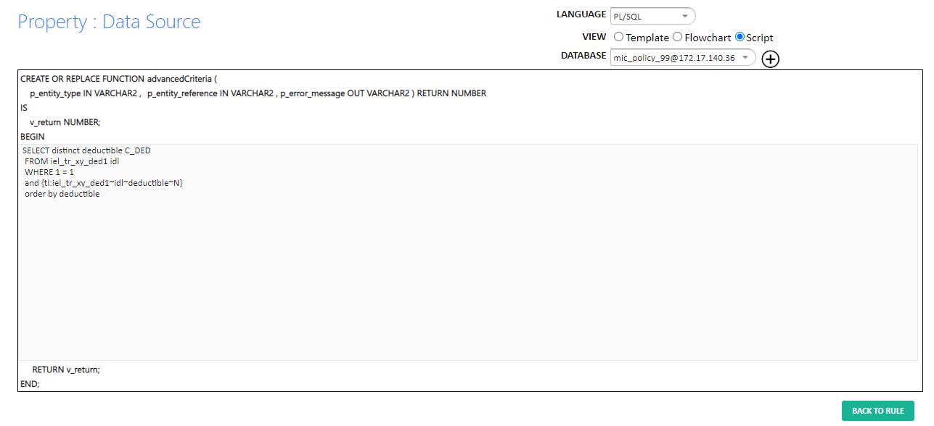

**Query:**

SELECT distinct deductible C_DED

FROM iel_tr_xy_ded1 idl

WHERE 1 = 1

and {tl:iel_tr_xy_ded1~idl~deductible~N}

order by deductible

**Coverage_code:TR-XY-LIAB_TRN6 (XY LIABILITY TRAINING EMP6)**

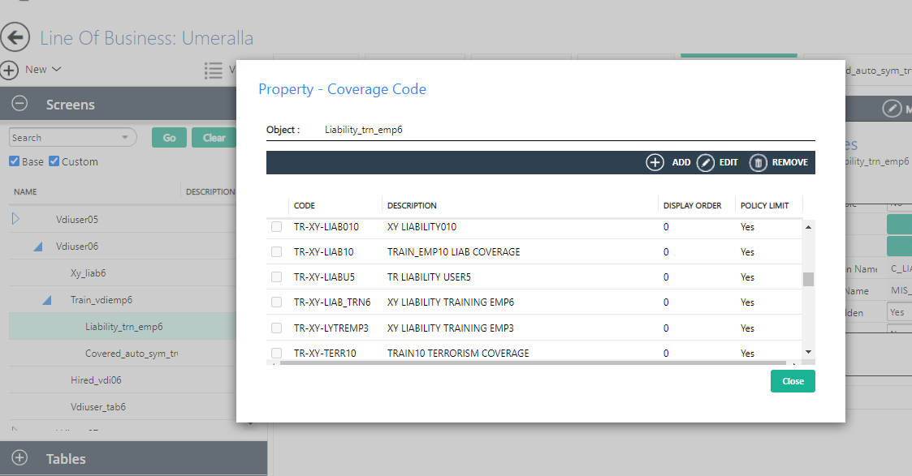

ETL Method:

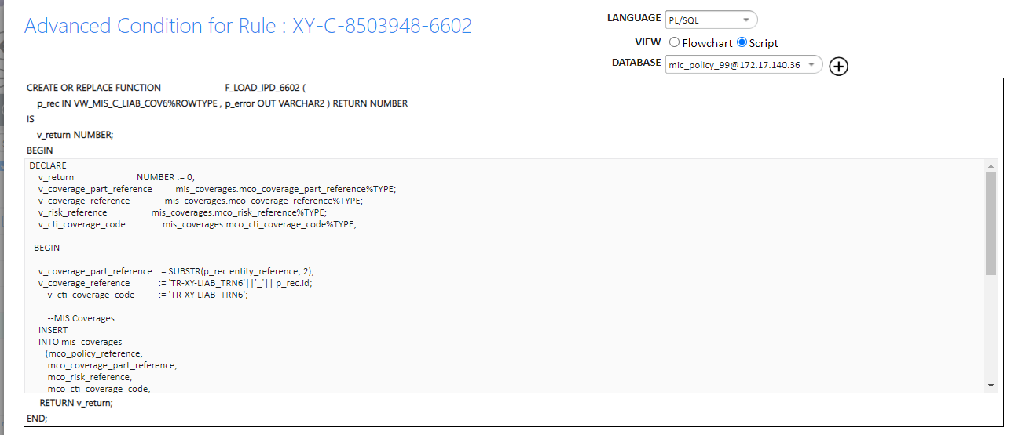

Rating Method:

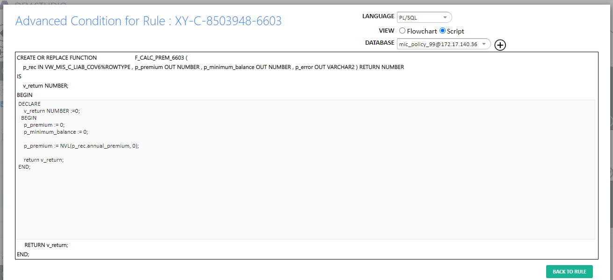

RATING ALGORITHAM:

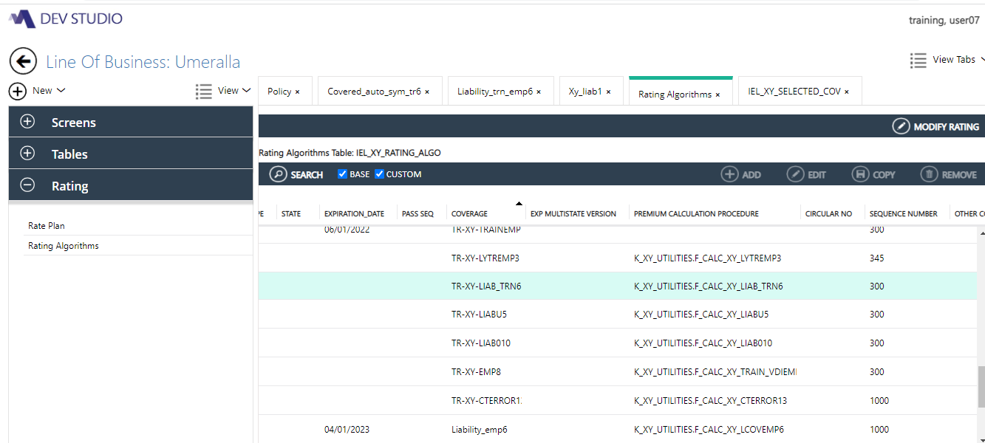

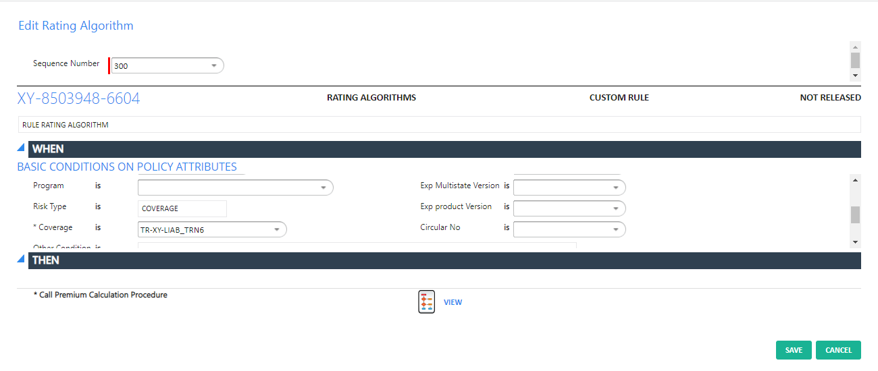

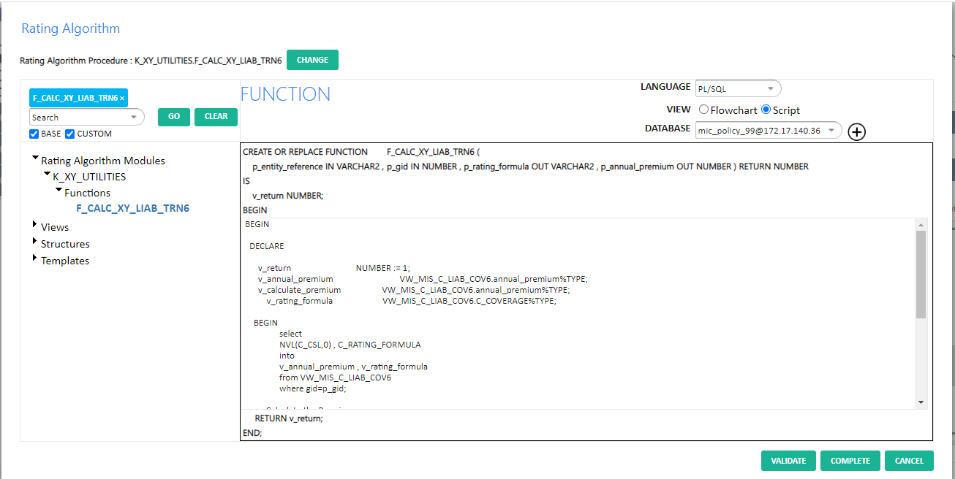

FUNCTION F_CALC_XY_LIAB_TRN6 (

p_entity_reference IN VARCHAR2,

p_gid IN NUMBER,

p_rating_formula OUT VARCHAR2,

p_annual_premium OUT NUMBER

) RETURN NUMBER IS

BEGIN

DECLARE

v_return NUMBER := 1;

v_annual_premium VW_MIS_C_LIAB_COV6.annual_premium%TYPE;

v_calculate_premium VW_MIS_C_LIAB_COV6.annual_premium%TYPE;

v_rating_formula VW_MIS_C_LIAB_COV6.C_COVERAGE%TYPE;

BEGIN

select

NVL(C_CSL,0) , C_RATING_FORMULA

into

v_annual_premium , v_rating_formula

from VW_MIS_C_LIAB_COV6

where gid=p_gid;

-- Calculate the Premium

v_calculate_premium := v_annual_premium ;

-- p_rating_formula := 'Rate';

p_rating_formula := v_rating_formula;

p_annual_premium := v_calculate_premium;

v_return := 0;

RETURN v_return;

END;

END;

IEL_XY_SELECTED_COV:

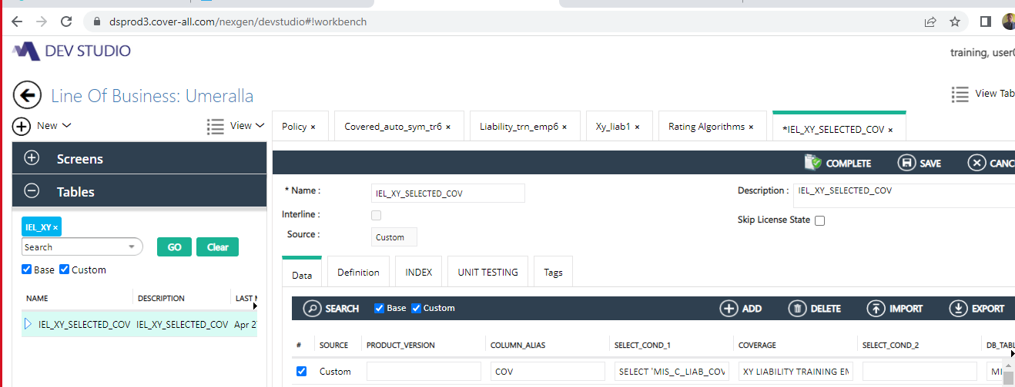

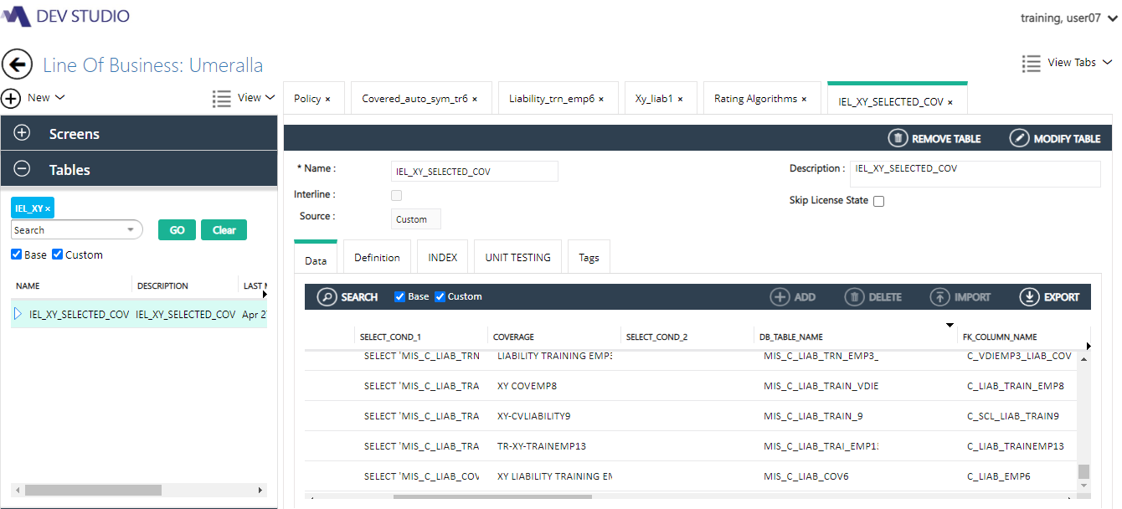

Selected_coverage:

SELECT 'MIS_C_LIAB_COV6' DB_TABLE_NAME,

'COVERAGE' RISK_TYPE,

COV.WRITTEN_PREMIUM WRITTEN_PREMIUM,

NULL DESCRIPTION,

COV.TRANSACTION_PREMIUM TRANSACTION_PREMIUM,

NULL DES,

COV.COMM_RED_FACTOR COMM_RED_FACTOR,

COV.C_COVERAGE_CODE COVERAGE_CODE,

COV.C_RATING_FUNCTION RATING_FUNCTION,

COV.ANNUAL_PREMIUM ANNUAL_PREMIUM,

NULL MANUAL_PREMIUM,

COV.FULL_TERM_PREMIUM FULL_TERM_PREMIUM,

COV.FK_COLUMN_VALUE,

NULL COVERAGE_TYPE,

NULL NAME,

COV.DATE_DELETED DATE_DELETED,

(

CASE

WHEN COV.TRANSACTION_PREMIUM <> 0

THEN 'Y'

WHEN k_document_template_management.f_is_qual_for_attachment (COV.entity_reference, 'MIS_C_LIAB_COV6', 'id = '

|| COV.id, 'C_XY_ANNUAL_PREMIUM', 'Y', 'Y') = 'Y'

THEN 'Y'

ELSE 'N'

END) IS_MODIFIED_ON_ENDT,

COV.ENTITY_REFERENCE ENTITY_REFERENCE,

NULL SEQ,

NULL AUDIT_FLAG,

COV.IS_SUB_TO_COMM_RED IS_SUB_TO_COMM_RED,

COV.ENTITY_TYPE ENTITY_TYPE,

COV.C_COVERAGE COVERAGE,

COV.RISK_STATE RISK_STATE,

NULL RATING_FORMULA,

COV.FK_COLUMN_NAME,

COV.GID GID,

NULL SUBLIMIT,

NULL LIMIT_5,

NULL LIMIT_4,

NULL LIMIT_3,

NULL LIMIT_2,

NULL LIMIT_1,

NULL DESCRIPTION_5,

NULL DESCRIPTION_4,

NULL DESCRIPTION_3,

NULL DESCRIPTION_2,

NULL DESCRIPTION_1,

NULL COV_START_DATE,

NULL COV_END_DATE,

NULL SYS_START_DATE,

NULL SYS_END_DATE,

NULL ESTIMATED_EXPOSURE,

NULL AUDITED_EXPOSURE,

NULL CLASSIFICATION_DESC,

NULL LOCATION_NO,

NULL PERIL,

NULL IRPM_FACT,

COV.ID,

NULL LIMIT ,

COV.C_DED DEDUCTIBLE ,

COV.C_CSL COVERAGE_ANNUAL_PREMIUM ,

NULL COV_CODE ,

NULL PARENT_COVERAGE

FROM RT_MIS_C_LIAB_COV6 COV

WHERE 1 = 1