[training_user07@majescotraining.com](mailto:training_user07@majescotraining.com) – screen - Vdiuser06

Screen1:

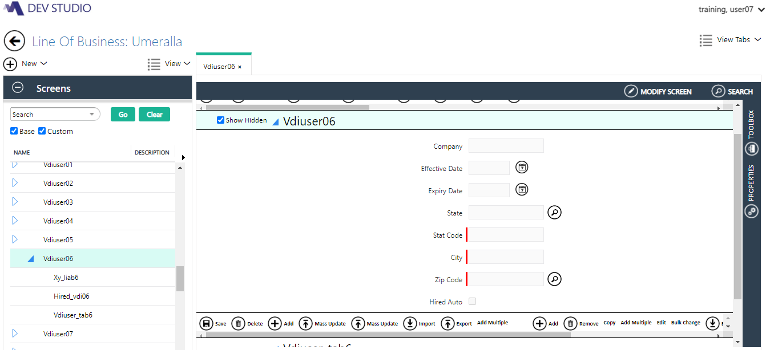

Rules:

UI Rule:

1.Default Value applied using POC level rule in Company field:

Set Default value=”ABC Corporation”

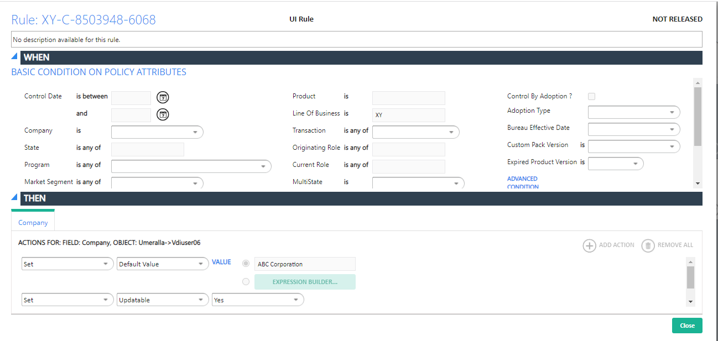

2.Effective Date:

Effective date needs to set system date:

UI Rule:

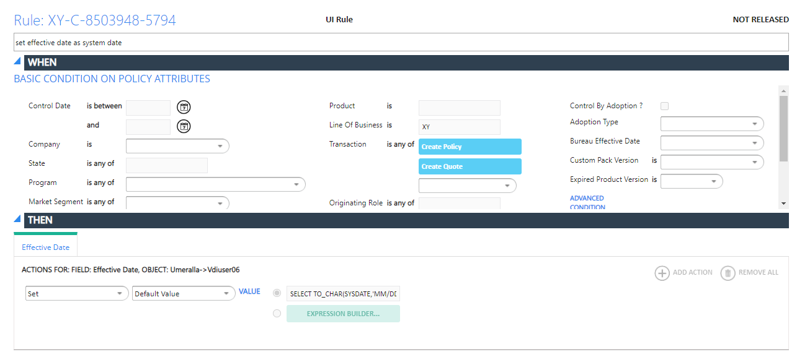

Query:

SELECT TO_CHAR(SYSDATE,'MM/DD/YYYY') C_EFFECTIVE_DATE FROM DUAL

Validation Rule:

Validate the Effective_date should not be less than sysdate

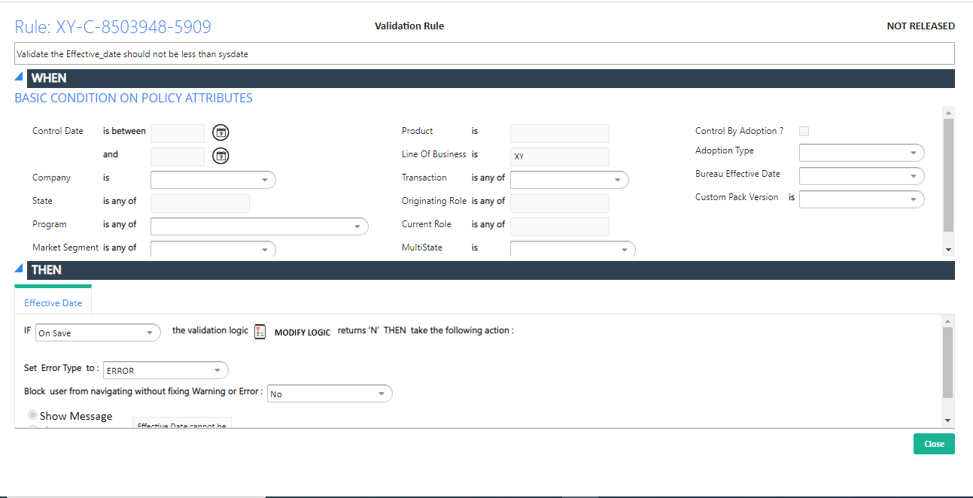

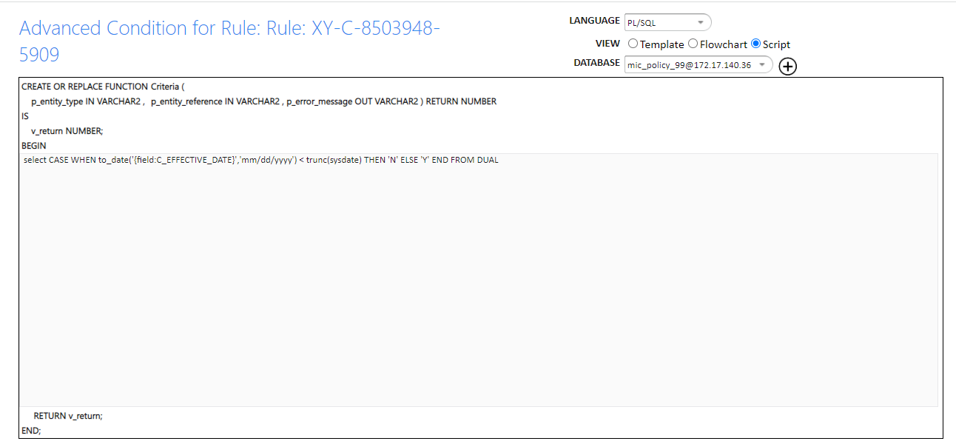

Query:

select CASE WHEN to_date('{field:C_EFFECTIVE_DATE}','mm/dd/yyyy') < trunc(sysdate) THEN 'N' ELSE 'Y' END FROM DUAL

3.Expiry Date: Set Default value of Expiration Date = Policy Effective Date + 12 months

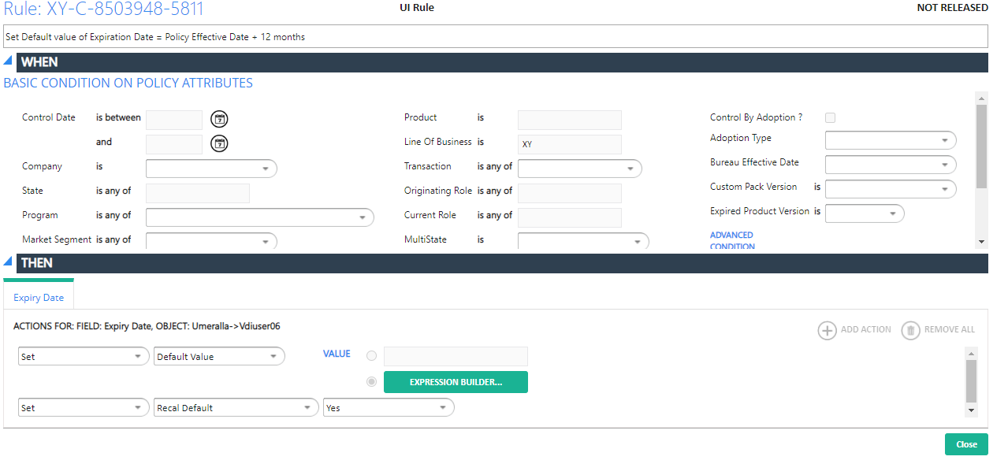

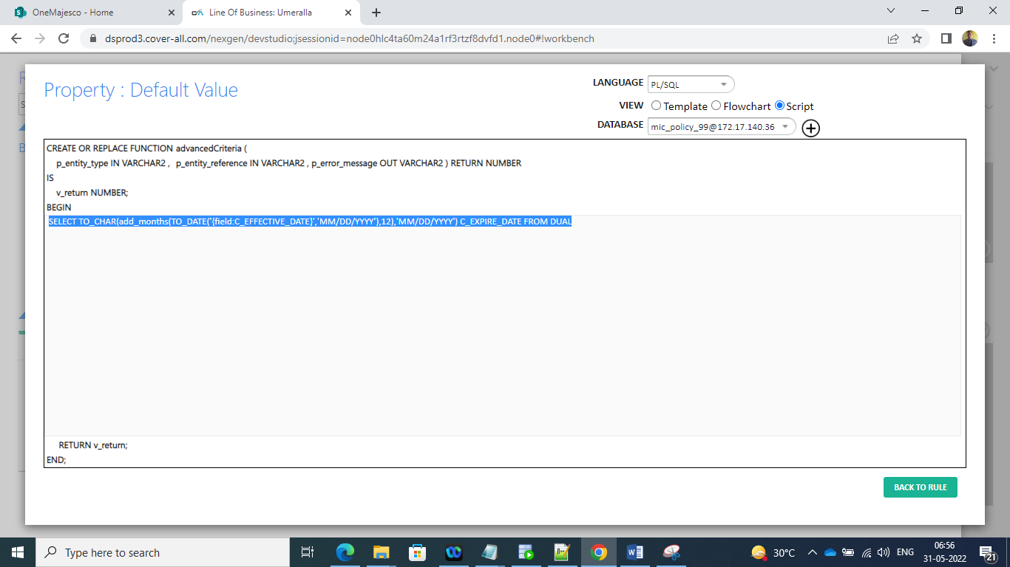

Query:

SELECT TO_CHAR(add_months(TO_DATE('{field:C_EFFECTIVE_DATE}','MM/DD/YYYY'),12),'MM/DD/YYYY') C_EXPIRE_DATE FROM DUAL

4.State:

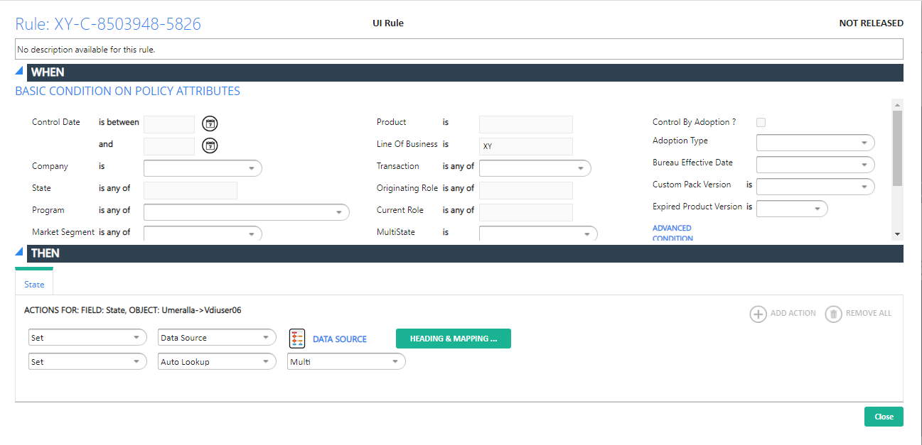

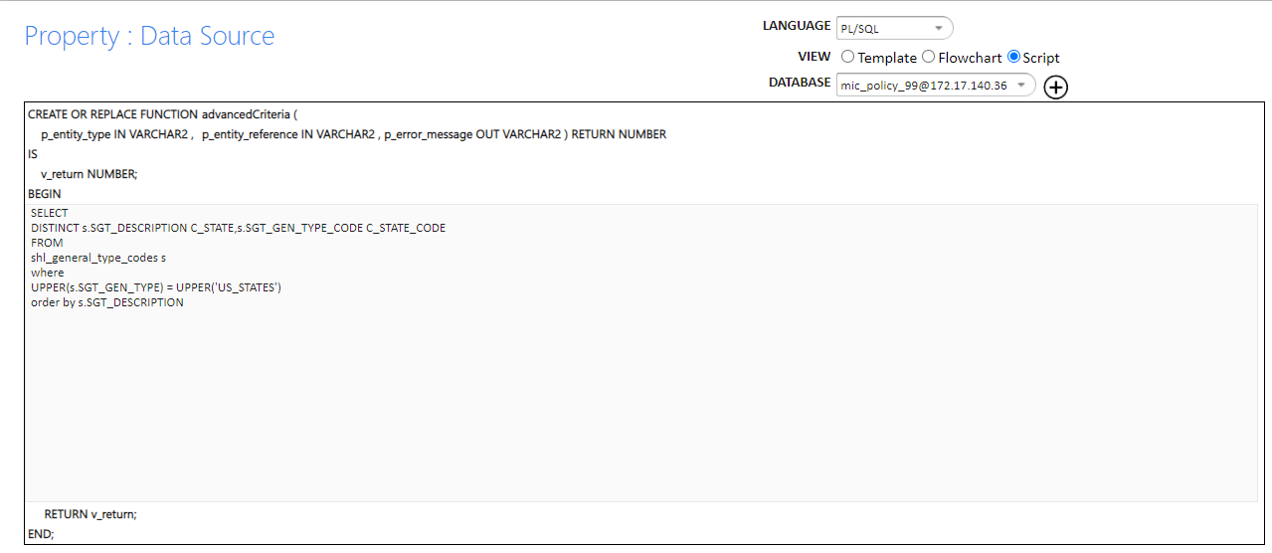

Query used for automatically loading data in state lookup:

SELECT

DISTINCT s.SGT_DESCRIPTION C_STATE,s.SGT_GEN_TYPE_CODE C_STATE_CODE

FROM

shl_general_type_codes s

where

UPPER(s.SGT_GEN_TYPE) = UPPER('US_STATES')

order by s.SGT_DESCRIPTION

5.Zip Code:

Show-lookup query on Zip so that user can select any zip:

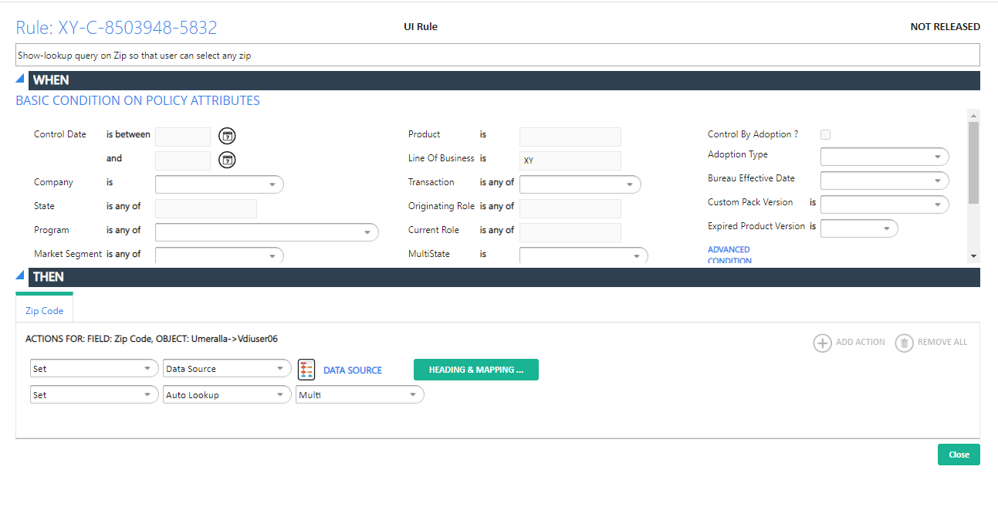

6. Vdiuser_tab6

Auto populate data from IEL_TR_XY_DED_VDIFCT6 table on this screen

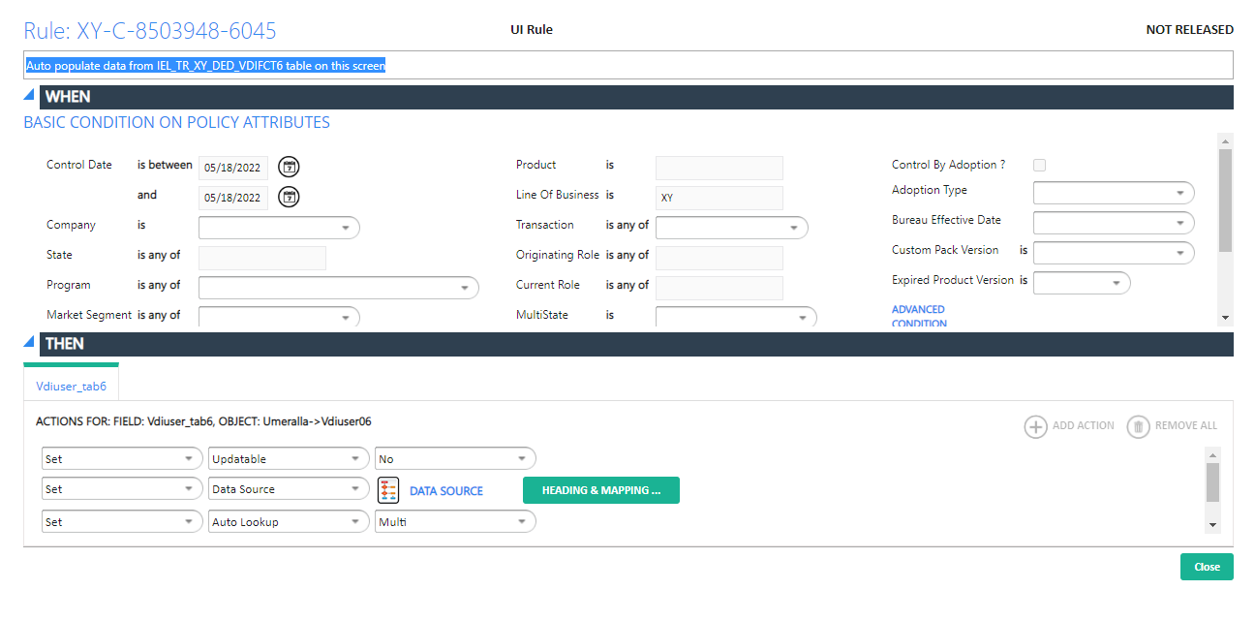

Query:

SELECT C_LOB_CODE,C_STATE,C_DEDUCTIBLE,C_ADD_UK

FROM

(select LOB_CODE C_LOB_CODE,STATE_CODE C_STATE,DEDUCTIBLE_FACTOR C_DEDUCTIBLE,rownum C_ADD_UK from IEL_TR_XY_DED_VDIFCT6)

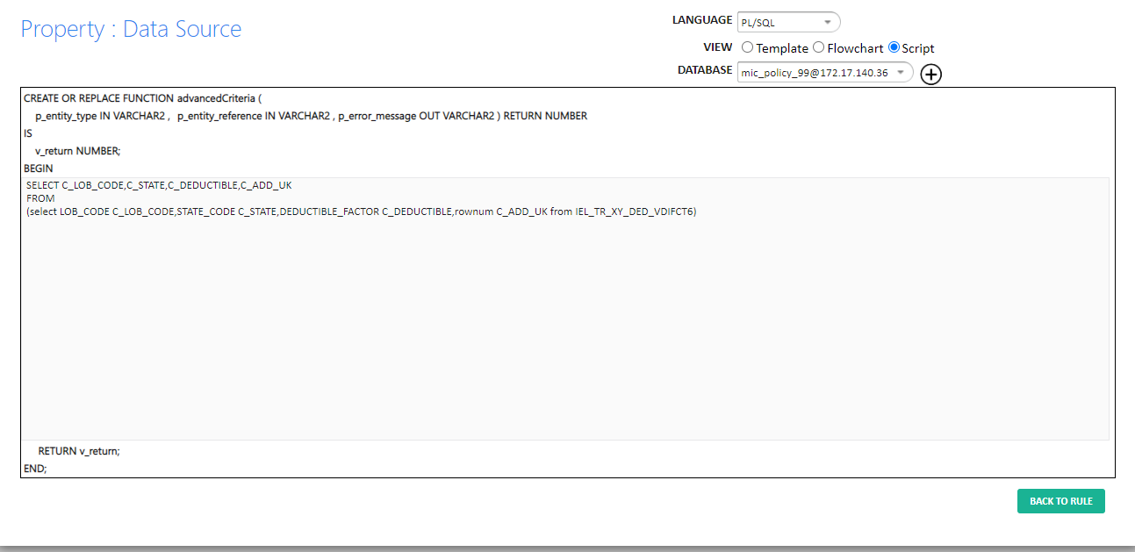

Screen2:

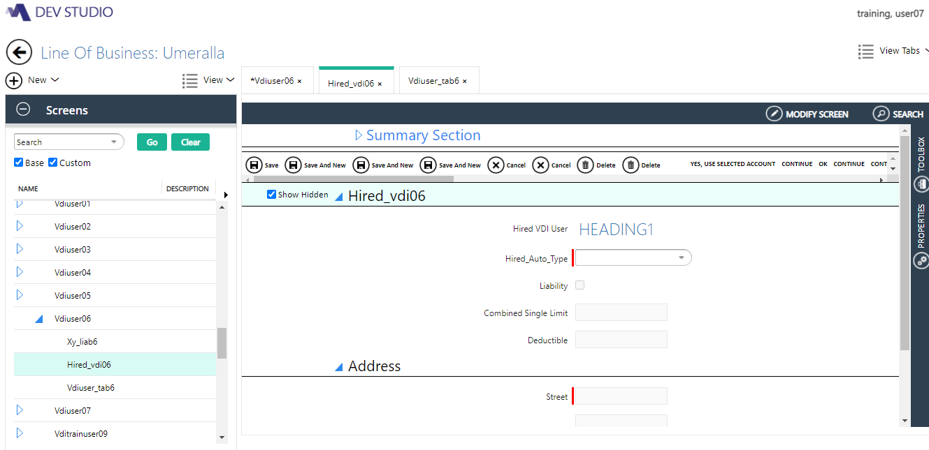

Hired_Auto_Type:

Populating drop down values ¿Truckers, Mobile Equipment, Other¿

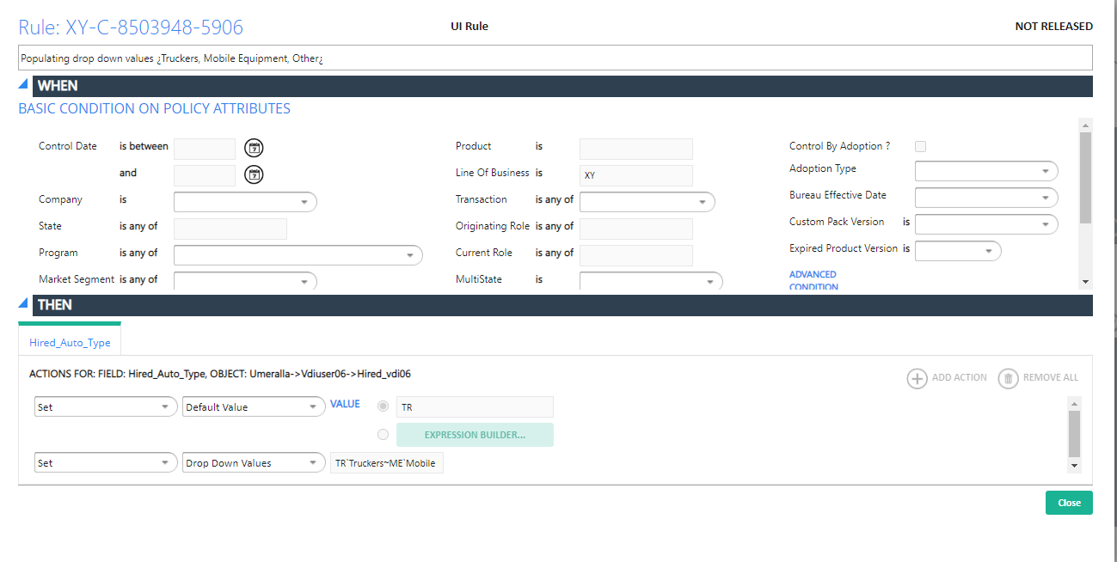

Liability:

Action Rule:

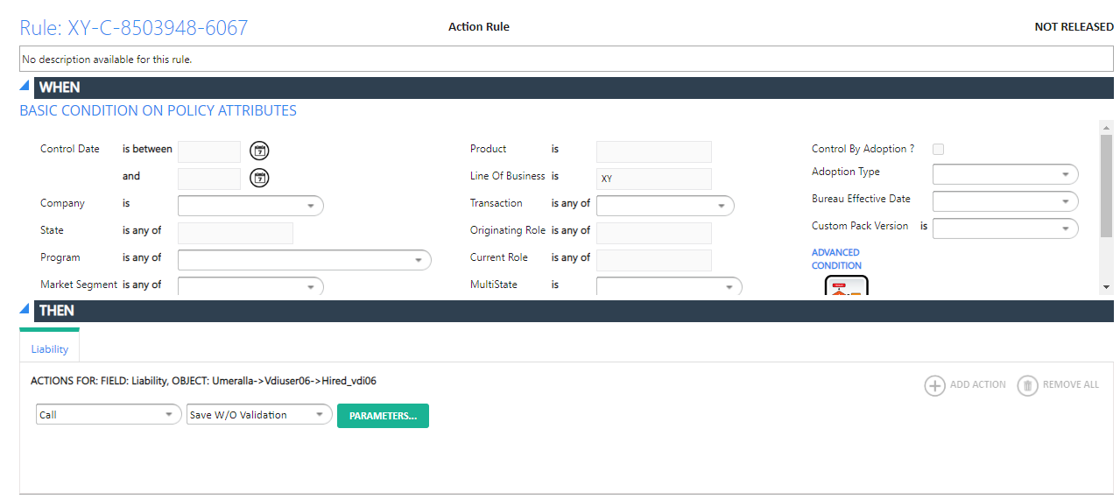

Combined Single Limit:

Screen 3:

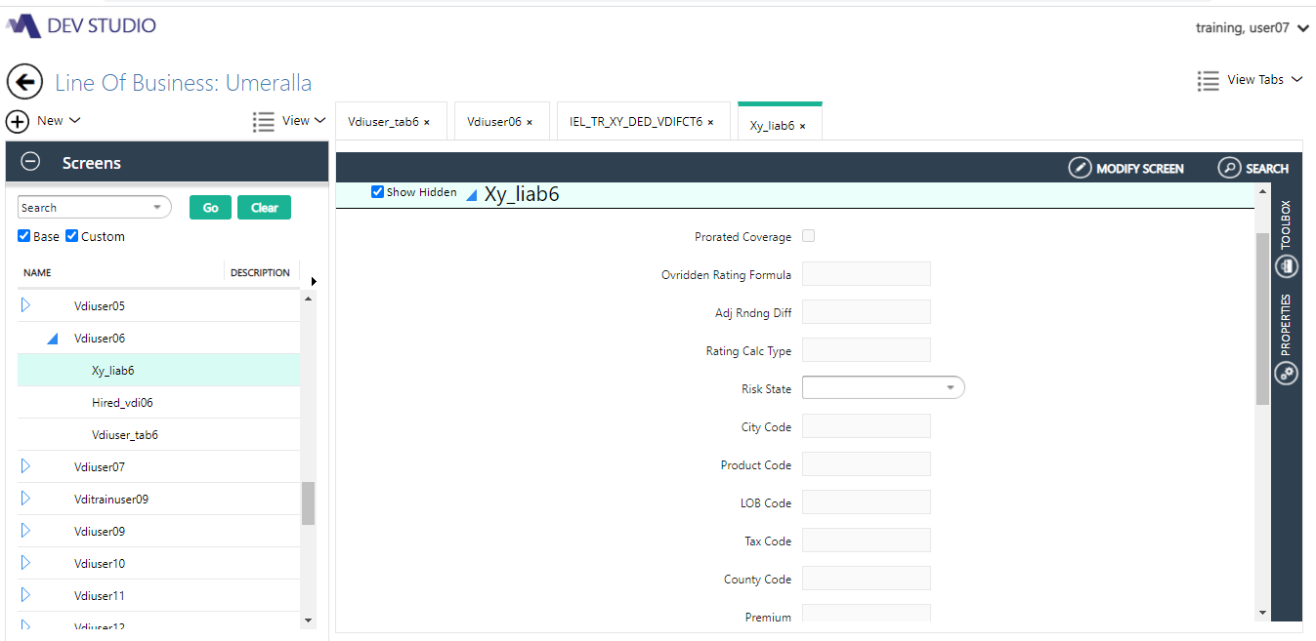

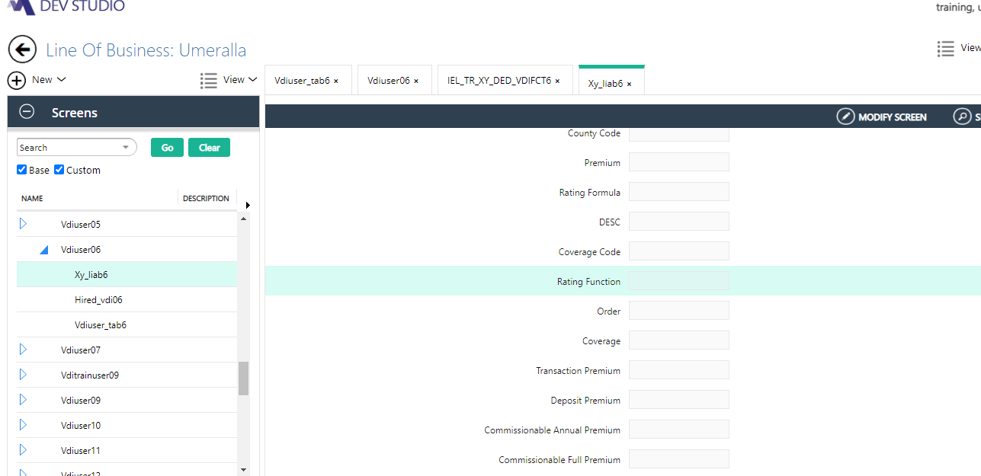

Coverage_code:TR-XY-VLIAB6 (XY LIABILITY6)

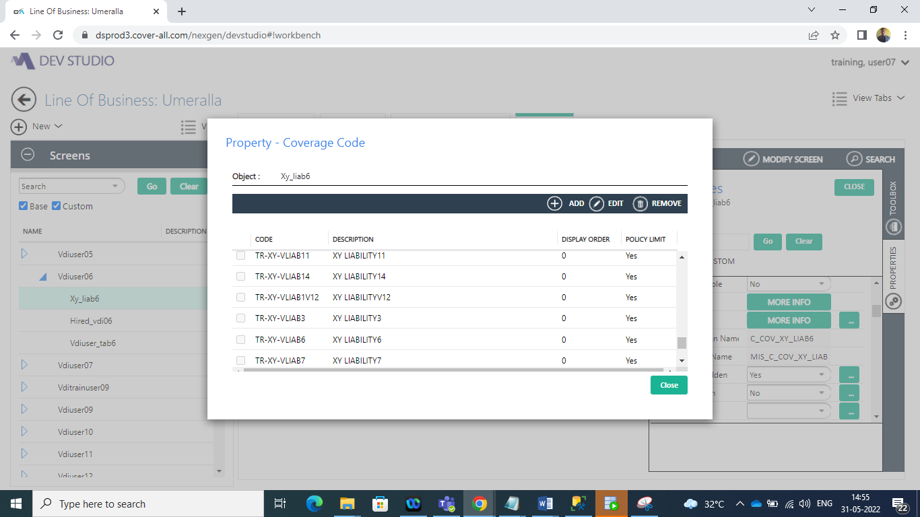

ETL Method:

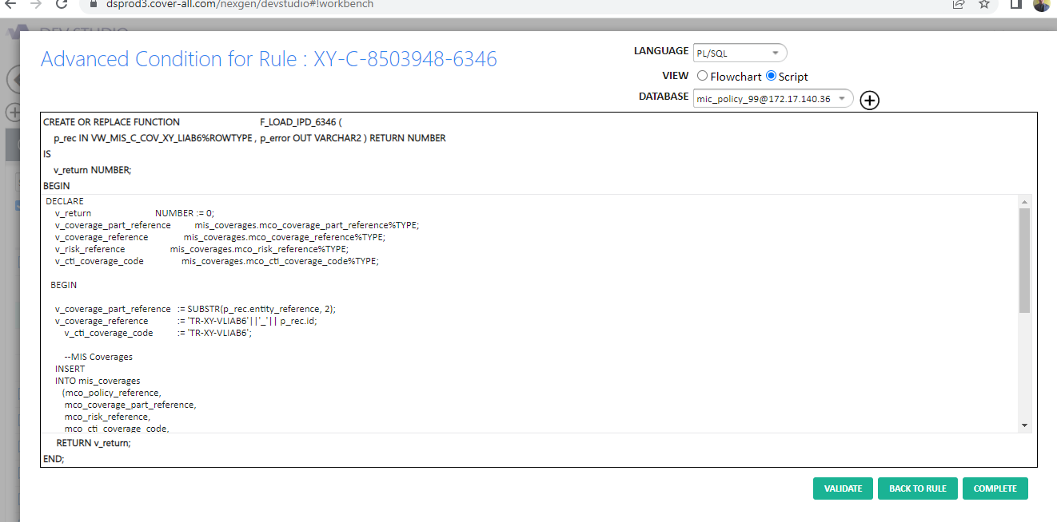

Rating Method:

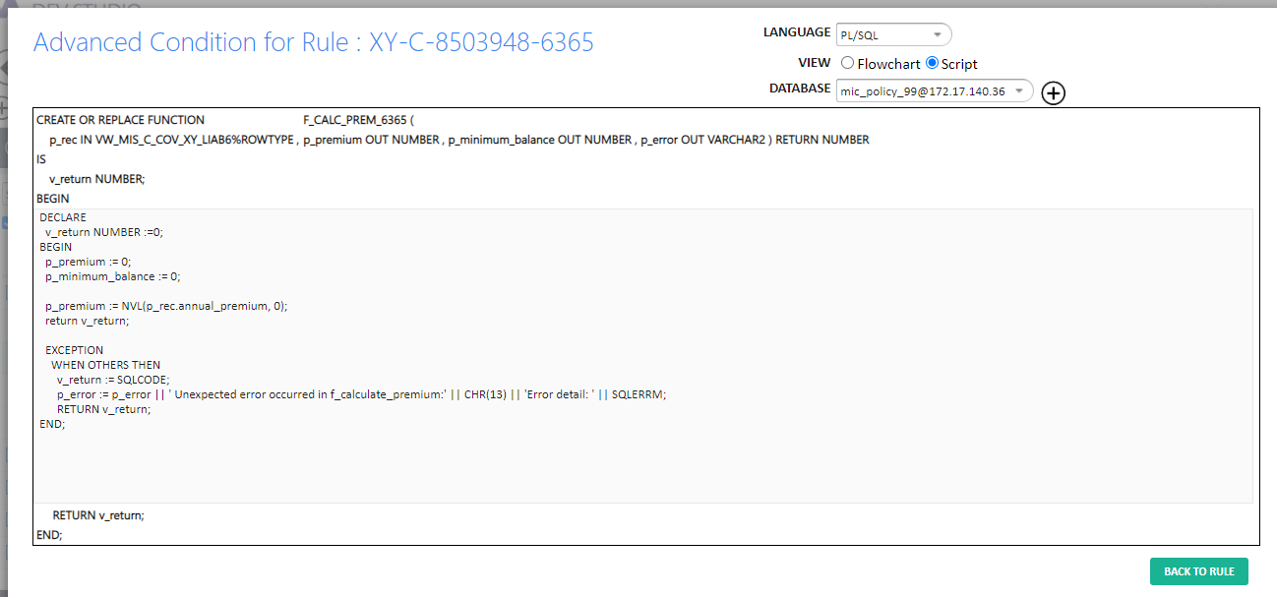

Set Default value=TR-XY-VLIAB6 in Coverage code component.

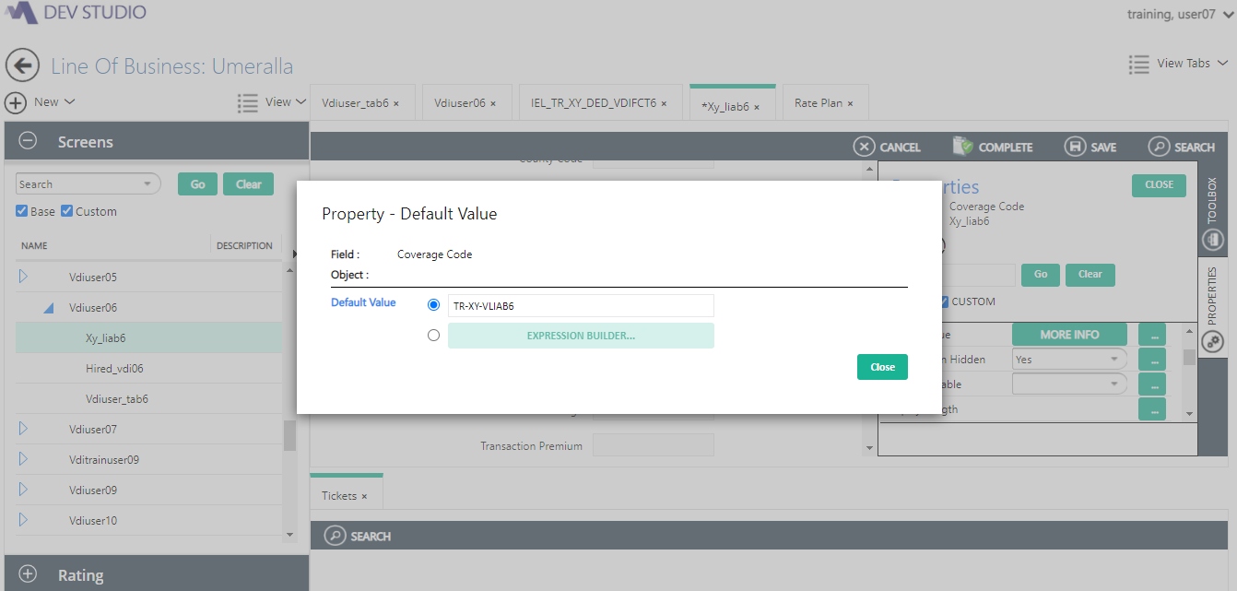

Query Executed:

select * from PCT_OBJECTS where pob_name = 'POLICY';---8008330

select * from PCT_OBJECT_FIELDS where pof_object_id = '8008330' and pof_object_field_id is not null;---8009462

---CP EXPIRATION_DATE : /8009462/

----SELECTED_COVERAGE

select * from PCT_OBJECTS where pob_name = 'POLICY';---8008330

select * from PCT_OBJECT_FIELDS where pof_object_id = '8008330' and pof_object_field_id is not null;----POLICY_LOB_CA--8080051

select * from PCT_OBJECT_FIELDS where pof_object_id = '8076036' ----SELECTED_COVERAGE---8080053

---- CP SELECTED_COVERAGE : /8080051/8080053/

-----DRIVER_CITY

select * from PCT_OBJECTS where pob_name = 'POLICY';---8008330

----select * from PCT_OBJECT_FIELDS where pof_object_id = '8008330' and pof_object_field_id is not null;----POLICY_LOB_CA--8080051

select * from PCT_OBJECT_FIELDS where pof_object_id = '8076036'---LOB_CA_DRIVERS

select * from PCT_OBJECT_FIELDS where pof_object_id = '8008361'----DRIVER_ADDRESS

select * from PCT_OBJECT_FIELDS where pof_object_id = '8009362'----CITY

---- CP DRIVER_CITY : /8080051/8080075/8009939/8009362/

----VEHICLE_STATE

select * from PCT_OBJECT_FIELDS where pof_object_id = '8076036'---LOB_CA_VEHICLES

select * from PCT_OBJECT_FIELDS where pof_object_id = '8076130'---VEHICLE_ADDRESS

select * from PCT_OBJECT_FIELDS where pof_object_id = '8008326'---STATE_DESC

---- CP VEHICLE_STATE : /8080076/8080075/8082851/8009364/

PCT Tool Execution:

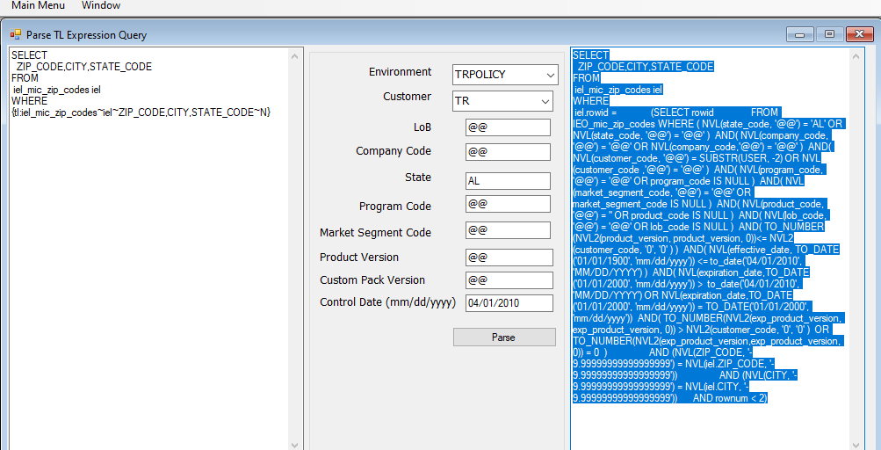

IEL table:

