**1. What is H2 Database?**

H2 is one of the popular in-memory databases written in Java. It can be embedded in Java applications or run in the client-server mode.

Spring Boot provides excellent integration support for H2

## 2. Maven Dependency

To use H2 in Spring boot application, all we need to do is adding H2 runtime jar into dependencies. The best way to add is through maven.

|  |
| --- |
| ***pom.xml*** |
| **<dependency>**  **<groupId>com.h2database</groupId>**  **<artifactId>h2</artifactId>**  **<scope>runtime</scope>**  **</dependency>** |

## 3. H2 Configuration Options

#### 3.1. Simple configuration

Spring provides very easy configuration options to connect to any database using simple properties. Below are the configuration properties, we shall have in application.properties file.

|  |
| --- |
| **application.properties** |
| **spring.datasource.url=jdbc:h2:mem:testdb**  **spring.datasource.driverClassName=org.h2.Driver**  **spring.datasource.username=sa**  **spring.datasource.password=**  **spring.jpa.database-platform=org.hibernate.dialect.H2Dialect** |

Please note by default, Spring Boot configures the in-memory database connection with the username 'sa' and an empty password ' '. If you wish to change these values, override them in above properties options.

#### 3.2. Configure data persistence

The in-memory databases are volatile, by default, and all stored data will be lost when we restart the application. In this case, data is written in temporary memory and as soon as JVM is stopped, data is flushed.

To have a persistent data store, which is capable to storing data between application start/stop, we should store the data in files. For this change the **spring.datasource.url** property.

|  |
| --- |
| **application.properties** |
| **# temporary data storage**  **spring.datasource.url = jdbc:h2:mem:testdb**    **# temporary data storage**  **spring.datasource.url = jdbc:h2:file:/data/sample**  **spring.datasource.url = jdbc:h2:file:C:/data/sample (Windows only)** |

Read More : [H2 database connection URLs](http://www.h2database.com/html/features.html#database_url)

## 4. Create schema and insert data on initialization

We may want to initialize database with some fixed schema (DDL) and insert default data (DML) into tables before the application is ready is run business usecases.

We can achieve this by putting sql files into resources folder (/src/main/resources/).

* **schema.sql** – To initialize the schema ie.create tables and dependencies.
* **data.sql** – To insert default data rows.

|  |
| --- |
| **schema.sql** |
| **DROP TABLE IF EXISTS TBL_EMPLOYEES;**  **CREATE TABLE TBL_EMPLOYEES (**  **id INT AUTO_INCREMENT  PRIMARY KEY,**  **first_name VARCHAR(250) NOT NULL,**  **last_name VARCHAR(250) NOT NULL,**  **email VARCHAR(250) DEFAULT NULL**  **);** |
| **data.sql** |
| **INSERT INTO TBL_EMPLOYEES (first_name, last_name, email) VALUES**  **('Lokesh', 'Gupta', 'abc@gmail.com'),**  **('Deja', 'Vu', 'xyz@email.com'),**  **('Caption', 'America', 'cap@marvel.com');** |

## 5. H2 Console

#### 5.1. Enable H2 console

By default, the console view of H2 database is disabled. We must enable it to view and access it in browser. Note that we can customize the URL of H2 console which, by default, is '/h2'.

|  |
| --- |
| **application.properties** |
| **# Enabling H2 Console**  **spring.h2.console.enabled=true**    **# Custom H2 Console URL**  **spring.h2.console.path=/h2** |

#### 5.2. Accessing H2 console

Start the spring boot application and access the console in browser with URL : **http://localhost:applicationPort/h2**

We can see the console like this.

we set the console path to be */h2*, which is relative to the address and port of our running application. Therefore, if our app is running at *http://localhost:9001*, the console will be available at *http://localhost:9001/h2.*

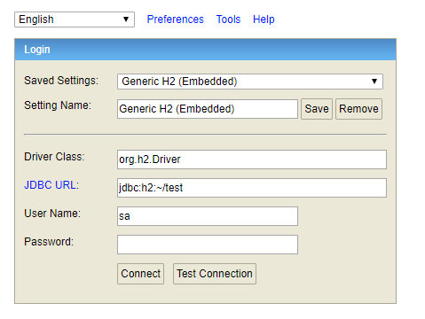H2 Database Console Login Window

Now enter the configured username and password. We can verify the table structure and default data inserted through SQL files.

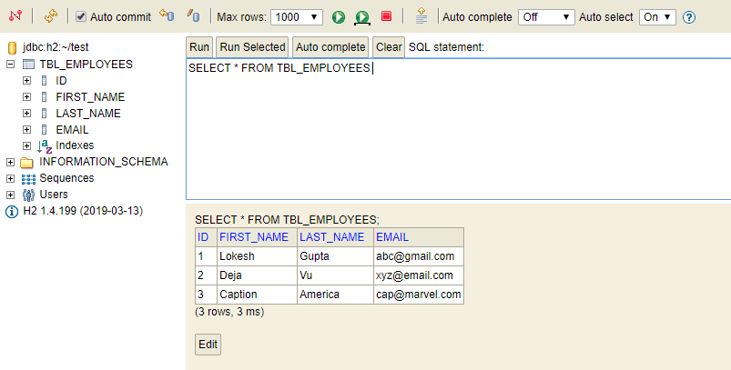H2 Console View