# A-1 Referral Package /Template

**Context: Business Process**

* Initial transaction in the series of recording interactions between the Individual/Family/Support Network, partner organization(s) and the Navigator
* Referring organization has verified the Individual/Family/Support Network is committed to enrolling for the program and engaging the Navigator
* The referring organization, in conjunction with the Individual/Family/Support Network, completes the entire referral form (almost all fields are mandatory and the referral will not be accepted if not complete)
* Information on the referral triggers information on the Case and Support Team list, and provides the Navigator with important information going in to the first interviews with the Individual.

**Purpose**

* Provide contact tombstone information to open a new case
* Provide initial Support Team contacts when beginning Build the Picture process
* Provide critical checklist information needed to assist the Navigator introduce themselves to the Individual/Family/Support Network for the first time and make optimum impression
* Provide a vehicle on which to attach the consent and proof of diagnosis

**Process Tool**

* A template for the referral can be completed manually by the Individual/Family/Support Network; from a manual form, the data must be manually entered into the new Case when it is opened. Note that the Navigator support is available to help them complete the form.
* Preferably electronic in order to automatically load the data contained on it to the various files where the information needs to go
* Submit the referral (electronically by the referring organization or hard copy by the Individual/ Family/Support Network
* Forward proof documents along with the referral: fully completed consent and diagnosis which are scanned /copied into the Restricted Navigator document file:
* Consent Form
* Confirmation of Diagnosis (psychological assessment; a letter or attestation by a registered psychologist or certified school psychologist)
* Navigator verifies all the data is complete and the requisite documents received. If electronic, the Navigator has the ability to “accept” the referral,
* When the Navigator accepts the electronic referral to enroll the individual, automatic transactions occur:
  + The “open EIS Case” occurs in both Restricted and Collaborative space
  + Tombstone data from the referral populates the Navigator Case
  + Support Team contact data populates the Support Team List
  + Checklist data populates the Case Notes in both Restricted and Collaborative space
  + A confirmation notification is generated from the Navigator to the referring organization (i.e. referral is received/ accepted and new case is opened)
* If the referral is manual/hardcopy, the Navigator opens the EIS case without automation; all the above steps must be performed manually, data entered manually

**Data**

Individual Tombstone Data **(* Mandatory Data**)

* * Names (First, Middle, Last)
* * Addresses (Physical and Mailing)
* * Gender
* * Date of Birth
* Email Address
* * Phone Number
* * Consent on File Indicator
* * Assessment on File Indicator
* *Representation Agreement Indicator

Alternative Contact Person Information

* * Names (First, Middle, Last)
* * Relationship to Individual (Family, Friend, Legal Rep)
* Mailing address
* * Phone Number
* Email Address

School Contact

* Is the individual attending school? If yes, the Contact Name and Phone Number field are mandatory)
* Contact Names (First, Middle, Last)
* Professional Role of the Individual
* School
* Phone Number
* Email Address

CFD Contact

* Is the individual being supported by an MCFD Child and Youth with Special Needs Worker? If yes, the Contact Name and Phone Number field are mandatory)
* Names (First, Middle, Last)
* Professional Role of the Individual
* Office
* Phone Number
* Email Address

CLBC Contact

* Is the individual eligible for CLBC Services and over the age of 19? (If yes, the Facilitator’s Contact Name and Phone Number field are mandatory)
* Contact Names (First, Middle, Last)
* Professional Role of the Individual
* Office
* Phone Number
* Email Address

Health Authority Contact

* Is the individual utilizing Health Authority Services? (If yes, the Contact Name and Phone Number field are mandatory)
* Contact Names (First, Middle, Last)
* Professional Role of the Individual
* Office
* Phone Number
* Email Address

DDMH (Mental Health) Contact

* Is the individual utilizing DDMH Services? (If yes, the Contact Name and Phone Number field are mandatory)
* Contact Names (First, Middle, Last)
* Professional Role of the Individual
* Office
* Phone Number
* Email Address

Checklist

* Key information for the Navigator to be aware of when contacting the individual/family. (This is a series of free-text boxes for the referrer to add any notes that they have about the individual that the Navigator will need to know before contacting the individual and conducting the “Build the Picture” interviews. In this box the referrer comment on
  + Language in the home*
  + DAA or other cultural or spiritual involvement*
  + Special limitations (hearing, sight, mobility, behavioral)*
  + Recent Assessments*
  + Existing protocols/safeguards*
  + What services they are waiting for
  + What agencies are currently involved

**Integration with other Process Tools**

* Case notes
* Support Team and potentially the Services/Support, Equipment/Supplies and Protocols/Safeguards Lists

## SAMPLE

This is for illustration only and is not a representation of what the screens or content will be or look like in the final product.

|  |  |  |  |
| --- | --- | --- | --- |
| **REFERRAL** |  |  |  |
| Submitted by: | BCeID / IDIR | Organization | Date |
|  | *optional - if reg.user* |  | *(sys-date)* |
|  |  |  |  |
| **Individual Info** |  |  |  |
| first name | middle name | last name | birth date |
|  |  |  | *yyyy-mm-yy* |
| Mailing Address |  |  |  |
| street1 | street2 | city | postal code |
|  |  |  |  |
| Physical Address (if different from above) | |  |  |
| street1 | street2 | city | postal code |
|  |  |  |  |
| Phone# Home | Phone# mobile | Phone# Other | email address |
|  |  |  |  |
| Consent on File Indicator | Assessment on File Indicator | Representation Agreement Indicator | gender |
| *y/n* | *y/n* | *y/n* | *m / f* |
| **Checklist** *\*=mandatory* | |  |  |
| *Language in the home\** | |  |  |
| *DAA or other cultural or spiritual involvement\** | |  |  |
| *Special limitations (hearing, sight, mobility, behavioral)\** | |  |  |
| *Recent Assessments\** | |  |  |
| *Existing protocols/safeguards\** | |  |  |
| *What services you are waiting for* | |  |  |
| *What agencies are currently involved* | |  |  |
|  |  |  |  |
| **Alternate Contact Info** | |  |  |
| Individual Info |  |  |  |
| first name | middle name | last name | Relationship |
|  |  |  | *drop-down* |
| Mailing Address |  |  |  |
| street1 | street2 | city | postal code |
|  |  |  |  |
| Physical Address (if different from above) | |  |  |
| street1 | street2 | city | postal code |
|  |  |  |  |
| Phone# Home | Phone# mobile | Phone# Other | email address |
|  |  |  |  |
|  |  |  |  |
| **School Contact** | Is Individual Attending School [Y] [N] *{Y= all fields mandatory}* | | |
| first name | middle name | last name | Professional Role |
|  |  |  |  |
| School | Phone#1 | Phone#2 | email address |
|  |  |  |  |
|  |  |  |  |
| **CFD Contact** | Is Individual CFD-Supported [Y] [N] *{Y= all fields mandatory}* | | |
| first name | middle name | last name | Professional Role |
|  |  |  |  |
| Office | Phone#1 | Phone#2 | email address |
|  |  |  |  |
|  |  |  |  |
| **CLBC Contact** | Is Individual CLBC-Supported [Y] [N] *{Y= all fields mandatory}* | | |
| first name | middle name | last name | Professional Role |
|  |  |  |  |
| Office | Phone#1 | Phone#2 | email address |
|  |  |  |  |
|  |  |  |  |
| **Health Authority Contact** | |  |  |
| first name | middle name | last name | Professional Role |
|  |  |  |  |
| Office | Phone#1 | Phone#2 | email address |
|  |  |  |  |
|  |  |  |  |
| **DDMH Contact** | Individual using DDMH services? [Y] [N] *{Y= all fields mandatory}* | | |
| first name | middle name | last name | Professional Role |
|  |  |  |  |
| Office | Phone#1 | Phone#2 | email address |
|  |  |  |  |

# A-2 Building the Picture

**Context: Business Process**

* One of 4 cornerstone tools of the Integrated Service Delivery Model
* A plain-language, interactive tool, specifically geared for individuals with developmental disabilities to elicit information from them, about themselves, from their perspective
* Person-centric – this is a personalized process – customized by and for the individual
* Holistic view – not just a list of assessments, clinical opinions and services
* Utilizes existing tools (if a similar process has been done) to initiate the conversation – complete much of the information – e.g. PATH, MAPS (schools) or Discovery Goal Based Planning Process (CLBC) –use as start
* If the school has not already performed the PATH/MAPS process, then the Navigator could partner and do the Picture as part of the school’s personal profile (NB: TBD – discussed but not confirmed – permissions, etc.)
* This contains important information – though not in a ‘clinical’ format – to inform the Support / Transition Team and potentially practitioners or clinicians
* Inform the Transition Plan
* This does NOT replace individual protocols or formal procedures for care; it is NOT clinical.
* This does NOT replace care plans or other practices nor does it replace the information the Support/Transition Team enters in the Personal Profile (Collaborative Space files). The health information elicited in this process is strictly from the individual’s perspective to inform and must be matched by the Team with diagnostic information on CAP and reports.

**The Picture Template – Process Tool**

* Utilize a standard template of topics and subjects – at a very high level , all Pictures are similar
* Expandable and customizable by the individual as necessary
* “All about me” – everything there is to know about the individual from their perspective
* Use individual’s own pictures where possible
* Incorporates flexibility – use voice or video or both for descriptive
* Use representative or interpretive pictures (e.g. cinnamon bun for a teacher) if that is what the individual associates with the person/activity/thing
* Use icons to represent concepts if pictures not available (Action item – inventory of icons – see Tools Required below)
* As this is NOT eliciting clinical information, labels, descriptions and input from the individual should be in their language – plain language, not the interviewer’s

**Format:**

* The introduction page tells the story of the individual (in the centre) and their support network surrounding the individual. The pictures associated with each depict the nature of the relationship from the individual’s perspective. These people include his or her family, doctor, teacher, integrated support workers and community contacts.
* The rest of the document consists of areas where the individual can tell others about his or her life in his or her own words with pictures that reflect what they wish written about these topics. For example, if the individual likes to hike, a picture of him or her hiking in a favourite spot could be added. Topics include
  + My Family and Friends
  + My Interests
  + My School/Work
  + My Leisure Time
  + My Community
  + My Unique Talents
  + My Values and Beliefs
  + My Goals and Aspirations
  + What’s Great About Me
  + My Health
  + Services and Supports that Help Me.
* Electronic document – stored centrally, accessible to all team members in Collaborative Space
* Linked to scanned copies of IEP and PLAN

**Tools Required:**

* ‘Universal’ package of icons and generic pictures on portable media – standardized labels on each so that anyone else looking at them can recognize the concept pictured. Icons are categorized (e.g. people, professions, activities, places, emotions, etc.) so that when a title on a category on the interactive tool

**Purpose**

* Individual-directed reflection of how the individual sees themselves and what they do, what they are involved in
* Foster self-assurance, encourage self-determination
* Encourage confidence that the individual can describe themselves and define and reach goals
* Part of the process that they own – is theirs from the start and theirs to maintain
* Means of communicating, building trust between Navigator and individual and family/network support
* Trigger early consideration of strengths and potential areas for improvement – a consideration for the individual and family/support network for the planning phase
* Alert workers to needs of the individual that may have been overlooked
* To prevent the story from having to be retold by the individual

**Data**

* name, phone number and email of each support network member (will be matched to support contact data already captured from the referral form from the family or the school/CLBC/CFD to avoid duplicates or outdated info)
* interview or IEP – known current services – add to individual’s list, where latter is different
* interview or IEP – known current supports – add to individual’s list, where latter is different
* IEP – date on file
* PATH – date completed
* PATH – where on file

**Integration with other Process Tools**

* List of support and services including contact information – in personal profile to inform the Transition Plan
* Goals & Aspirations – inform the Transition Plan
* Indicate potential need for additional work/assistance: e.g. assessment, remedial health/DDMH, physical support, therapies
* List of assessments done by the school – from the IEP – into CAP

**Picture Template/Tool**

* Series of ‘pages’, each representing a category or grouping of information around a theme in the life of the individual
* Pages could be laid out to make a poster or kept in a binder
* More than one page could be attributed to a category as the youth / adult gets older and the contents are updated
* Each page has a companion template of questions and subjects that could be broached in the interviews with the individual
* in the sample attached these are examples only and not an exhaustive list

**Approach**

* Utilized material from meetings, minutes, Allan’s books, process discussions
* Utilized many of the CAP domains for correlations between categorization and questions, approach. Intent is to provide multiple dimensions of information for planning through a single series of responses (e.g. interests are not just activities but are done in the context of with who thereby highlighting relationships or lack thereof)
* Where it appeared appropriate, incorporated the prerequisites for building personal supports: particularly the properties of regular-interval contacts and social contexts
* Visual impacts:
  + Incorporate individual’s picture and title on each page
  + Different colours on each page
  + Different shapes on each page – eventually relate shapes and colours to the context for easier navigation around the document
* Utilize a binary or graduated ‘faces’ icon
  + Permit the labelling of a response with – “makes me happy / unhappy” ; the latter can potentially be targeted for remediation in the planning phased
  + Provides an opportunity to change a negative to a positive later in the process – show progress
* Always provide a place to add comments not attributable to one of the categories available on the page
* Assumes an interactive tool. Optimally, as each component title is highlighted, have an inventory of pictures and icons open automatically

**Cautions**

* Sample only – finished product would be professionally prepared
* Early draft – minimal examples of questions for the template
* Requires feedback from full working group
* Will always be some overlap between categories – not duplication – different perspectives on similar activities. E.g. My Interests – what I like to do with friends; My Leisure – what I do for fun with….(and where)

## SAMPLE MOCK UP

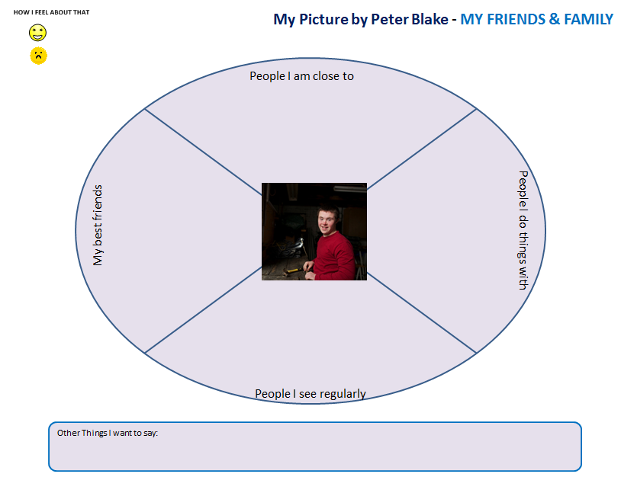

People I’m close to – and trust

Who do you talk to when you feel sad or need help?

Best Friends – do you have a lot of friends or a few?

Who are they?

What makes them your best friends?

People I do things with – and what do you do with them?

People I see regularly – acquaintances –

And where do you see them? (Store? Pharmacy? Restaurant?)

What do you talk about?

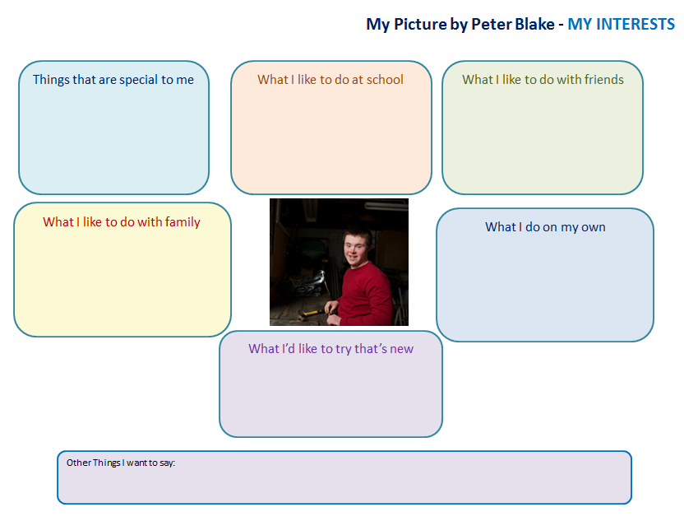

INTERESTS: Think about the things you like to do in different places, with different people or on your own. Do you like to

Read?

Collect things

Exercise

Sports

Team things

Games

Special interests (dogs, books, science fiction)

Go out – restaurants, music

Watch sports (which ones)? Listen to music?

Play video games?

Where else do you do things that you like – what are they (church? Rec centre?)

What have you done for a long time?

What have you wanted to do for a long time?

What do you do on a regular basis – daily, weekly or monthly?

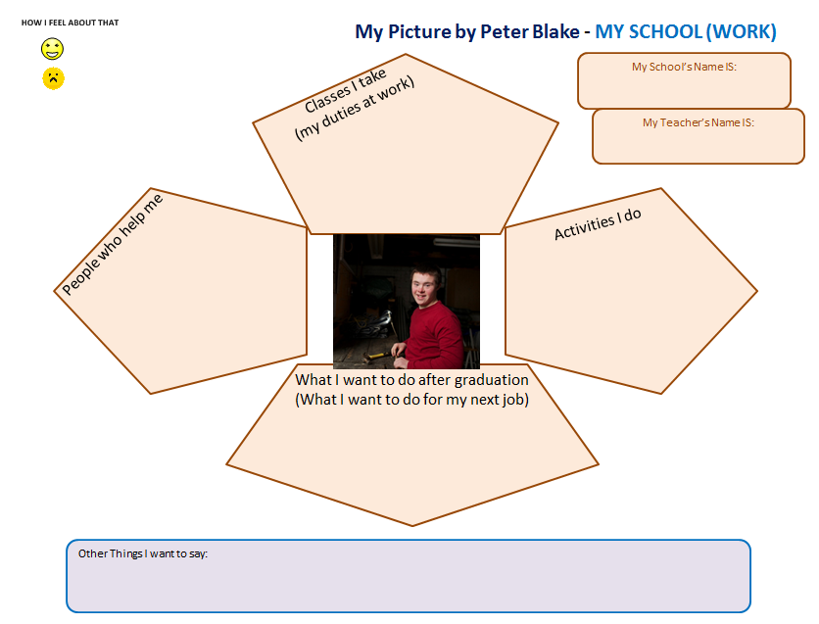

Classes and Activities

Things I do well

Things I like

Do you have friends in your classes?

Do you do things with friends at school – activities after class, work experience?

Are there skills-based classes at your school – do you take part?

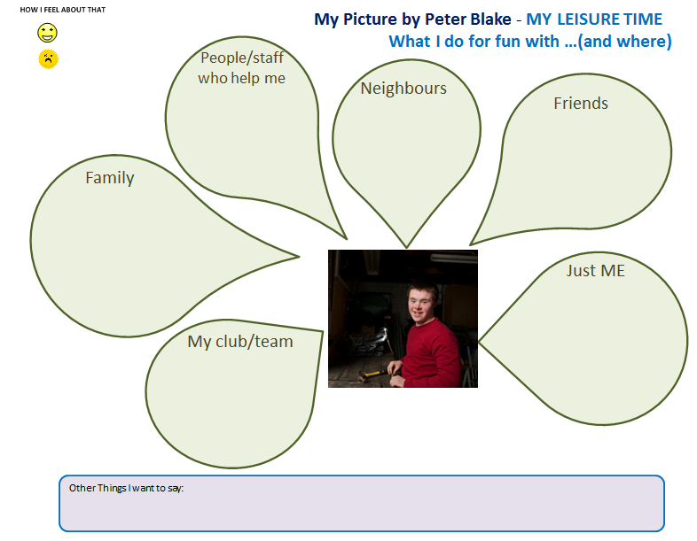

What do you do for fun regularly with your family? With your friends? With support staff?

Do you like to be inside or outside?

Do you like to watch movies or sports?

Do you play sports?

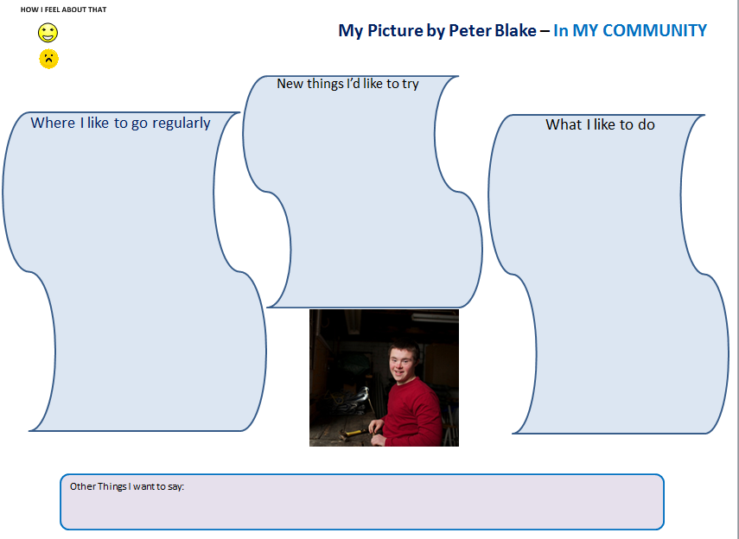

Where to you go in your community and what do you do there?

Do you do things regularly – like

Church

Library

Bank

Rec Centre

Special meeting places

Theatre

Community Centres

Do you do things around your community?

Paper route

Volunteer

Help neighbours

Mentor younger people

Lead a group

What new things would you like to try?

Do you feel that you belong?

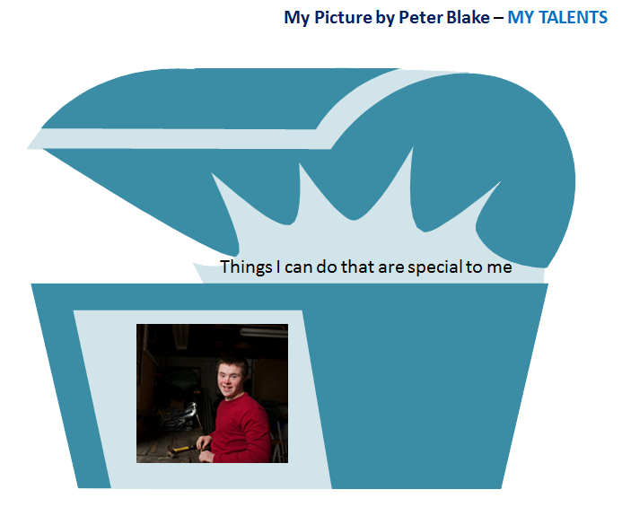

Think about what you can do that is special or cool – it can be anything!

Do you make people laugh?

Can you tell a good story?

Sing or play an instrument?

Do you like to cook?

Or make something special?

Do you like collecting special things?

Talk to new people easily? Make new friends quickly?

Tricks like magic or juggling

A sport or activity?

Do you like to draw, paint

Do you like to build stuff (lego, woodworking?)

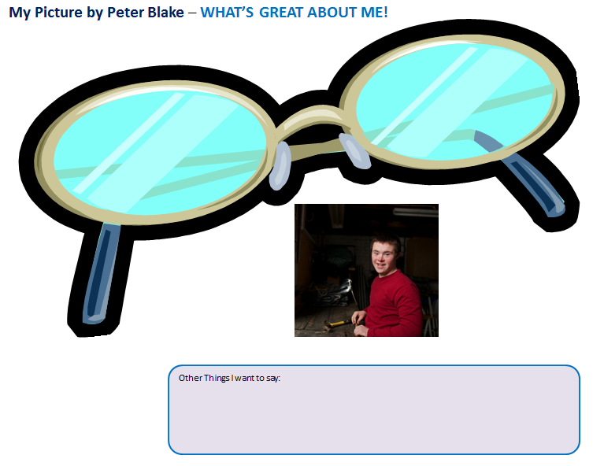

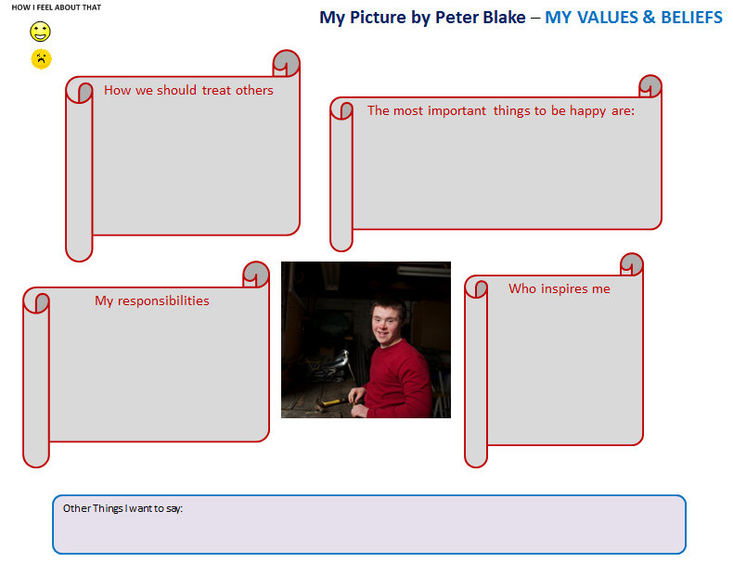

What do you believe is important to be happy? NB: see CLBC Rights booklet for language

Choose for myself

Family around me

Have friends

Have a home

Feel good about myself

Being confident

Feel safe

Belonging

How should we treat others?

The way I want others to treat me

With respect

Be kind and help others

Be polite

Give compliments

Appreciate other’s talents

Who do I know that inspires me and how (my role models, their qualities)

Someone in my family

A teacher

An advocate

Someone in church

Sports person, celebrity

What are my responsibilities

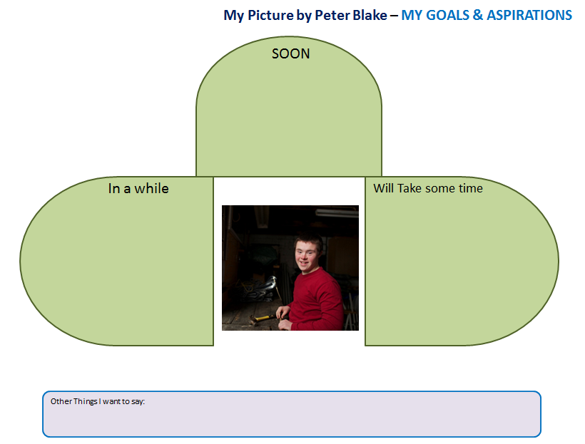

These are things we plan for; sometimes it takes a long time – can it be soon, in a while, in a longer while. What are your goals and when can they happen?

Live where I want

Find a new home

Have a job I like

Learn a trade

Learn to take the bus

Learn to cook my own meals

Do my own shopping

Go to college

Have money to buy things

Have friends I like

Have my own transportation

Be active, do things I like

Learn something new

Find things I like

Fall in love, be loved, maybe get married, have a family

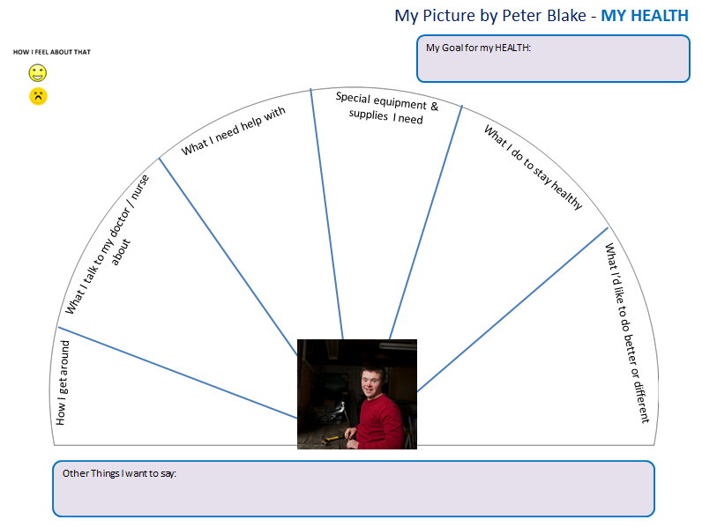

How I get around – whether inside or outside – does it involve special equipment?

Mobility e.g. doing errands on my own

Accessibility in my environment

What I talk to my doctor about

Vision

Dental

Eating and digestion problems

Sleeping

How I feel

What I need help with – not including special equipment

Managing stress or controlling my feelings

Seeing or hearing

Personal care

Special equipment & supplies I need –

Gloves

Lifts

Incontinence supplies

A special bed

Nutritional supplements

What do I do to stay healthy?

Exercise – classes, activities, yoga

Eat good meals – no junk food

Walk to school or work

What I’d like to do better

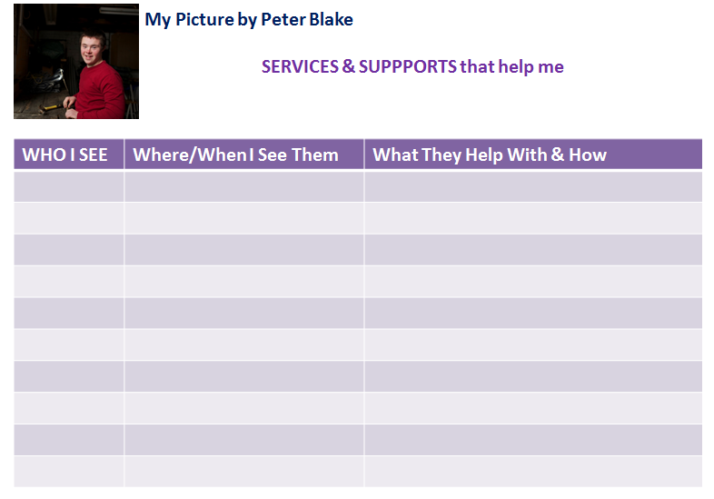

Who – name and organization if known

Where – school, home, office (office name if known),

When – interval – daily, weekly, biweekly, etc.

What – health, home, activities, transportation, communication

How – physio (other therapies), drive me, mental health, how I deal with others

**A-3 Common Assessment Platform (CAP)**

A common assessment platform is not the same as a common assessment tool. Most professionals and many service systems have their own assessment tools which are used for a variety of purposes. An assessment platform, on the other hand, captures information from those tools regarding all the elements (domains) that shape considerations necessary to provide an individual appropriate supports and services.

CAP supports integrated service design/delivery, collaborative practices, accessible processes and a shared perception of an individual in specific situations by different systems throughout their lifespan.

In Building the Picture, historical information, relevant to the individual in their current environment, can be found in school records (the IEP), CYSN case files, and CLBC case files (for the individual over 19 years of age).

As an example, the following information could be found by a CYSN worker in a File Review, triggered by the individual’s consent to utilize the services of the Navigator. From this, significant detail can be summarized in CAP. (*The balance would be added to the Services/Supports list in Collaborative space*.)

* Functional Behavioral Assessment
* Psychology assessments
* OT, PT, Speech and Language information
* Mental Health assessment
* *Supported Child Care*
* *Comprehensive Plan of Care*
* *Extra services, youth care workers, home makers*
* *Additional Autism supports*
* *Clinical – Nursing Services being received*
* *Additional Nursing support needs that may be covered by CFD*
* *Equipment/Supplies being received*
* *Respite support information*

During transition and into adulthood, any new assessments completed will inform the process in progress and strategies for assisting the individual going forward. Those assessment summaries should also be found in CAP for use by all participating organizations.

**Context: Business Process**

* Second of 4 cornerstone tools of the Integrated Service Delivery Model
* Initially designed for individuals with developmental disabilities; once the Common Assessment Platform concept and function has been tested in the IES, there may be potential to expand its processes and functions to other persons with disabilities
* Early in the process (Build the Picture), organizations will use existing tools and information to populate the function domains; e.g. IEP (school) or Discovery Goal Based Planning Process (CLBC) – will have assessments attached or referenced and the summary data from them is used
* Later in the process, a Support/Transition Team member may refer an individual for a new or replacement assessment due to:
  + Response to a change in circumstances
  + Invoking a care protocol,
  + Response to a crisis situation or
  + Implementation of a contingency plan
* Government employees in the partner organizations of the Support/Transition Team can post summary entries in the Functional Domain; approved practitioners with a BCeID can do the same; contracted third party practitioners TBA.
* Inform the Support / Transition Team members; new or updated assessment information may impact or otherwise affect decisions on and level of supports or services
* Inform the Transition Plan – particularly the Services/Supports list as designed/negotiated by the partner organizations

**Assessment Platform – Process Tool**

* Utilizes a standard template of domains; as much as possible over the longer term, standardize the language utilized to minimize duplication or questioning of judgements
* Simple and straightforward compilation of key data (structured) regarding assessments of the individual with a concise, free format (unstructured) summary of findings/results
* All of an individual’s assessments are linked to the individual’s case file which is managed by the Navigator
* Physical copies of assessment reports are not associated with CAP; the originator keeps and controls access to the physical report. Potential exception: the behavioural consultant’s or psychologist’s report (confirming diagnosis) is scanned – but to the case file managed by the Navigator. Sensitive but critical reports may also be sent to the Navigator and noted on case.
* The Support/Transition Team members are associated with the individual’s case file and limit access to the assessments
* Access and privacy controls to ensure ‘need-to-know’ basis for both practitioners (professionals outside government) and staff; clear and explicit consent by the individual/ family/support network to share their information with the participating organizations
* Strict protocols for entry and use of the data stored on the platform
* Update only capability, by the author only, on any posted assessment; if an update is posted the original entry is archived in history for future reference. **Exception**: if an assessment or update is made in error (e.g. on the wrong file, wrong person), application is made to the system administrator to delete the changes and refresh the record to its original state.
* Workspace is available in CAP, attached to an individual’s file, for entries by government staff that have assessment information but are unsure of the domain. Staff should consult the Navigator to resolve. Otherwise, notification to the Navigator of the posting triggers the Navigator to inspect the entry and attribute to a domain. **Caution:** if workspace becomes a dumping ground, causing backlogs for the Navigator, this capability may need to be withdrawn.

**Purpose**

* Assess functional adaption for the purpose of better, more consistent and more efficient planning.
* Prevent the individual/family story from having to be retold multiple times
* Reduce duplication of assessments – eliminate necessity for the individual to undergo the very same assessment that they previously completed with another professional.
* By making assessment information available to all participant organizations, alert workers to needs of the individual that may have been overlooked due to lack of information
* Collect and collate information, and help professionals see other facets of an individual’s life, for a more holistic picture of that person.
* Facilitate a collaborative and cross-discipline approach to the care and support of individuals through collaborative practices – including recognizing that the individual has the right to consent to share their collected information for their benefit.

**Data**

* External practitioners (or BCeID) reference file:
  + Name (surname, first, middle)
  + BCeID
  + Business address including postal code
  + Business phone
  + Email address(es)
  + Professional designation / college
* Individual’s CareCard# (verified to stored personal data)
* Date entered
* Entered by (could be government personnel or practitioner)
* Role – if staff – org and title
* Date of assessment
* Assessment type
* Assessment summary – of results, information
* Domain cross-reference – alternative domains where results may be relevant
* Note: historical information from assessments located through CYSN worker’s file search and school’s IEP will be entered by the organizations

**Integration with other Process Tools**

* Picture - List of assessments done by the school – from the IEP
* Informs the Support/Transition Team for planning
* Informs the list of supports and services (Transition Plan)

**SAMPLE**

These are for illustration only and are not a complete representation of what the screens or content will be or look like in the final product.

NOTE: The “Individual CareCard# has now been replaced with the EIS Case Number



**A-4 Transition Plan:**

The transition plan template is organized around the Quality of Life domains that are the elements of a validated survey tool used by CLBC (see “Include Me!” on the CLBC website).    The CLBC aging strategy and the Consolidated Assessment Platform (CAP) use these same domains. There are three high-level categories and 8 sub-categories.

To further break down these very broad quality of life domains into outcome-oriented segments, the Quality Assurance report was used for guidance. Overall there are potentially many goals and outcomes to choose from, and in every individual’s life a particular array that they would want to work toward. To populate examples for this next level of detail the following sources were also used:

* Self-Advocate Engagement Report
* Network Support Engagements Report
* CFD Transition Plan Checklist
* CLBC Transition Planning reports and documents
* Ministry of Education Guidelines: Career/Life Transitions for Youth with Diverse Needs; Individual Education Planning for Students with Special Needs
* Literature from the advocacy community

**Context: Business Process**

* Third of four cornerstone tools of the Integrated Service Delivery Model
* Like the picture, has two components: the interactive tool used by the Navigator for interviews with the individual and family/support network to build the plan and a template of potential discussion items classified by the overall domains of the Consolidated Assessments Platform
* The interactive tool is designed to elicit information from individuals with developmental disabilities and their families/support networks regarding their perspective on their future goals and targets, and how they will reach them
* With the template as a discussion guide, the interactive tool is a means for the Navigator to broach subjects possibly new to the individual/family/support network and include goals which are more directed to independence, self-reliance and autonomy
* Inform the Support / Transition Team; assist each member to focus on areas where their particular supports are involved or those not previously identified
* Very similar to existing tools utilized in different agencies but with a different perspective and consolidating information so that each ministry does not have to replicate the process
* Provide the basis for progress reporting and quality assurance

## Transition Plan Template– Discussion Guide

The template is organized by CAP (Quality of Life) domains; these are the first and second levels or categories. Within the domains are more specific life goals that are examples of each domain (“What I want to do”). Within the life goals are examples of milestones – shorter term, directed and specific goals – which will cumulatively bring the individual to meet their version of the higher order goal. The plan discussion should also include who will be accountable for reaching the milestone (“Who will help”). The final discussion point is dates and priority as these should be both realistic (to manage expectations) but also reasonable – closure and success is the desired outcome. There are two dates: review date and completion date.

| **Life Foundations** | **What's Important** | **What I want to do**  **(My Goals)** | **How I will get there**  **(Steps – Milestones)** | **Who will Help** | **Date Priority** |
| --- | --- | --- | --- | --- | --- |
| **Independence** | **Personal Development** | Make the most of my time in high school | Look at whether another year of school would help me be better prepared |  |  |

* Far more structured than the Picture which is for the benefit of the individual alone
* Utilize a standard template of topics and subjects – background tool for the Navigator in discussions but also a guide for the family/support network should they wish to complete the process themselves. This is not as likely in the EIS as the agreement is to go forward with Navigator assistance.
* The Transition Plan template is designed to be used by the Individual/Family/Support Network. It should make sense to them and be in language that they can understand and relate to.
* Expandable and customizable by the individual; the list of goals and milestones are recommended topics only and can be expanded to cover any realistic goal the individual may have

**Purpose**

The template is not designed to be all-encompassing or limiting. It is not restricted to a single age or period (it will require adjustment for aged individuals and transition for aging). The template is designed to:

* Provide a starting place
* Give a menu of choices
* Focus on the individual, in the community, building capacity and reaching independence
* Highlight items that are important
* Inspire interest in what might be considered
* Open up ideas to families who are inexperienced, insular or isolated and encourage broader opportunity

**Integration with other Process Tools**

* Consistent hierarchy, at the top two levels, with CAP

**Interactive Transition Plan – Process Tool**

The interactive process tool will organize the plan into manageable, attainable units.

* In the background, utilize the template of topics and subjects – discussion tool for the Navigator/family
* Like the Picture, this is also “All about me” – everything there is to know about the individual’s goals and aspirations, and how to reach them, from their perspective
* Expandable and customizable by the individual/family/support network if necessary

**Format**

* Layout should be in varied colours and fonts to be visually engaging.
* Like the Picture, use icons as a visual cue for the subject, if doing so triggers more active participation by the individual or assists them in recognizing and relating to the subject. If necessary, use representative or interpretive pictures if that is what the individual associates with the activity. (Icon inventory covered in the section on the Picture under Tools Required.)
* The introduction page tells the story of the individual (in the centre) and their support network surrounding the individual. The pictures associated with each depict the nature of the relationship from the individual’s perspective. These people include his or her family, doctor, teacher, integrated support workers and community contacts.
* Goal information is a “heading” for the sections that follow; it details the goal and the milestones needed to reach it, in the individual’s words. The goal is the only piece of structured data
* Groups of detailed activities follow the goal. For each milestone listed in the heading, a series of activities are defined; all fields are mandatory except the priority:
  + What the milestone is
  + Who is responsible for the activity
  + What the activity is
  + Review-by date
  + Priority (deadline if applicable)
  + Completed date
* The milestone-activities groups are structured data. Those activities associated with organizational partners (i.e. all those not associated with the individual/family/support network) are monitored by the Navigator.

**Purpose**

* Generate an Action Plan of activities to accomplish goals
* Generate a calendar of priorities, especially as the youth nears adulthood
* Foster self-assurance, encourage self-determination
* Encourage confidence that the individual can define and reach goals
* Means of communicating, building trust between Navigator and individual and family/network support
* Provide a starting place for the partner organizations in the Support Team to build their Service and Support lists, review current supports and organize what supports will be required to meet the Plan (See the business process narrative for Build Transition Plan)
* Alert partner organizations to needs of the individual that may have been overlooked and which will entail their participation

**Data**

* individual contact data (linked from Identify)
* goal
* associated milestone(s)
* associated activities – as many as listed by milestone – linked to milestone
* responsibility – by activity
* review-by date – by activity
* priority (deadline – e.g. a ‘can’t miss’ date such as PWD, birthdate, apply-by, etc.) – by activity
* completed date – by activity

**Integration with other Process Tools**

* Linked to the Consolidated Assessment Platform, contents of which inform the Plan
* Domains consistent with the Consolidated Assessment Platform
* Should reflect Goals & Aspirations from the Picture
* Indicate potential need for additional work/assistance to meet planned goals: e.g. assessment, remedial health/DDMH, physical support, therapies
* Include Action Plans (and calendars) by accountability matrix
* Provide basis for some reporting from Quality Assurance tool

**TRANSITION PLAN - SAMPLE ‘PAGE**’

|  |  |
| --- | --- |
| WELL-BEING | |
| Material Well-Being – How I will make sure I’m comfortable & secure | |
| My goal is: | **C:\Users\Millder-Consulting\AppData\Local\Microsoft\Windows\Temporary Internet Files\Content.IE5\DFL2ZR6R\MC900089218[1].wmfLearn Transportation Skills** |
| It is important to me because: | **I want to be free to go where I**  **want with my friends** |
| To reach my goal, these are the important steps | **Learn how to use the bus** |

|  |  |  |  |  |  |
| --- | --- | --- | --- | --- | --- |
|  | C:\Users\Millder-Consulting\AppData\Local\Microsoft\Windows\Temporary Internet Files\Content.IE5\18A52B0B\MC900089286[1].wmfTo reach my goal, to complete step {next milestone}, here are the actions that will happen: | | | | |
| PERSON [name] | | Activity Description | Review by | Priority | Completed |
| I will | | Buy a bus pass |  |  |  |
| My family will | | Give me part of my monthly allowance for a bus pass |  |  |  |
| My cousin will | | Take me to the store and show me how to buy a pass |  |  |  |
|  | To reach my goal, to complete step {next milestone}, here are the actions that will happen: | | | | |
| PERSON [name] | | C:\Users\Millder-Consulting\AppData\Local\Microsoft\Windows\Temporary Internet Files\Content.IE5\DFL2ZR6R\MC900186086[1].wmfActivity Description | Review by | Priority | Completed |
| I will | | Learn the bus route and get to know the  bus drivers |  |  |  |
| [My family/network] will | |  |  |  |  |
| [my resource teacher] will | |  |  |  |  |
| [my health provider] will | |  |  |  |  |
| [my therapist] will | |  |  |  |  |
|  | To reach my goal, to complete step {next milestone}, here are the actions that will happen: | | | | |
| PERSON [name] | | Activity Description | Review by | Priority | Completed |
| I will | | Practice getting on and off the bus with my sister  C:\Users\Millder-Consulting\AppData\Local\Microsoft\Windows\Temporary Internet Files\Content.IE5\QMMR609L\MC900056914[1].wmf |  |  |  |
| [My family/network] will | |  |  |  |  |
| [my resource teacher] will | |  |  |  |  |
| [my health provider] will | |  |  |  |  |
| [my therapist] will | |  |  |  |  |
|  | |  |  |  |  |
|  | To reach my goal, to complete step {next milestone}, here are the actions that will happen: | | | | |
| PERSON [name] | | C:\Users\Millder-Consulting\AppData\Local\Microsoft\Windows\Temporary Internet Files\Content.IE5\4V5RMC78\MC900363256[1].wmfActivity Description | Review by | Priority | Completed |
| I will | | Go to the plaza with my friend by myself  on the bus |  |  |  |
| [My family/network] will | |  |  |  |  |
| [my resource teacher] will | |  |  |  |  |
| [my health provider] will | |  |  |  |  |

**Getting from Here to Becoming an Adult   
My Plan and How Others Will Help Me With It**

**I am <xx> years old and my 19th birthday will be on <xxx>**

*< In brackets, the text would change depending on the individual’s age and transition stage>*

Moving <towards adulthood>, I need to make plans for my future and what I need to do to get there.

I need to consider:

* My independence – where I want to live, what I want to do and what I want to learn
* My social participation – having others in my life, my rights and responsibilities
* Well-being – how I will make sure that I’m healthy physically and emotionally

This is me and my support team:

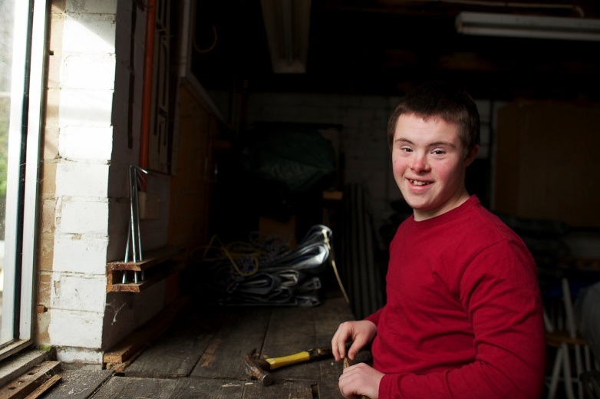

**Me - Peter Blake**

**Phone:**

**Email:**

**MY INDEPENDENCE**

|  |  |
| --- | --- |
| Personal Development – How I want to grow as a person | |
| My goal is |  |
| It is important to me because: |  |
| To reach my goal, these are the important steps | *{list milestones]* |

|  |  |  |  |  |  |
| --- | --- | --- | --- | --- | --- |
|  | To reach my goal, to complete step {next milestone}, here are the actions that will happen: | | | | |
| PERSON [name] | | Activity Description | Review by | Priority | Completed |
| I will | |  |  |  |  |
| [My family/network] will | |  |  |  |  |
| [my resource teacher] will | |  |  |  |  |
| [my health provider] will | |  |  |  |  |
| [my therapist] will | |  |  |  |  |
|  | |  |  |  |  |
|  | To reach my goal, to complete step {next milestone}, here are the actions that will happen: | | | | |
| PERSON [name] | | Activity Description | Review by | Priority | Completed |
| I will | |  |  |  |  |
| [My family/network] will | |  |  |  |  |
| [my resource teacher] will | |  |  |  |  |
| [my health provider] will | |  |  |  |  |
| [my therapist] will | |  |  |  |  |
|  | |  |  |  |  |
|  | To reach my goal, to complete step {next milestone}, here are the actions that will happen: | | | | |
| PERSON [name] | | Activity Description | Review by | Priority | Completed |
| I will | |  |  |  |  |
| [My family/network] will | |  |  |  |  |
| [my resource teacher] will | |  |  |  |  |
| [my health provider] will | |  |  |  |  |
| [my therapist] will | |  |  |  |  |
|  | |  |  |  |  |

|  |  |
| --- | --- |
| Self-Determination – How I want to learn about making choices | |
| My goal is |  |
| It is important to me because: |  |
| To reach my goal, these are the important steps | *{list milestones]* |

|  |  |  |  |  |  |
| --- | --- | --- | --- | --- | --- |
|  | To reach my goal, to complete step {next milestone}, here are the actions that will happen: | | | | |
| PERSON [name] | | Activity Description | Review by | Priority | Completed |
| I will | |  |  |  |  |
| [My family/network] will | |  |  |  |  |
| [my resource teacher] will | |  |  |  |  |
| [my health provider] will | |  |  |  |  |
| [my therapist] will | |  |  |  |  |
|  | |  |  |  |  |

**SOCIAL PARTICIPATION**

|  |  |
| --- | --- |
| Interpersonal Relationships – How I will connect with people | |
| My goal is |  |
| It is important to me because: |  |
| To reach my goal, these are the important steps | *{list milestones]* |

|  |  |
| --- | --- |
| Social Inclusion – How I will be part of my community | |
| My goal is |  |
| It is important to me because: |  |
| To reach my goal, these are the important steps | *{list milestones]* |

|  |  |
| --- | --- |
| Rights – How I will understand more about my rights & responsibilities | |
| My goal is |  |
| It is important to me because: |  |
| To reach my goal, these are the important steps | *{list milestones]* |

**WELL-BEING**

|  |  |
| --- | --- |
| Emotional Well-Being – How I will take care of my feelings | |
| My goal is |  |
| It is important to me because: |  |
| To reach my goal, these are the important steps | *{list milestones]* |

|  |  |
| --- | --- |
| Physical Well-Being – How I will be healthy | |
| My goal is |  |
| It is important to me because: |  |
| To reach my goal, these are the important steps | *{list milestones]* |

|  |  |
| --- | --- |
| Material Well-Being – How I will make sure I’m comfortable & secure | |
| My goal is |  |
| It is important to me because: |  |
| To reach my goal, these are the important steps | *{list milestones]* |

**TRANSITION PLAN TEMPLATE – MATRIX - DRAFT**

| **Life Foundations** | **What's Important** | **What I want to do**  **(My Goals)** | **How I will get there**  **(Steps – Milestones)** | **Who will Help** | **Date Priority** |
| --- | --- | --- | --- | --- | --- |
| **Independence** | **Personal Development** | **Make the most of my time in high school** | Look at whether another year of school would help me be better prepared |  |  |
| Attend graduation |  |  |
| Build better numeracy / literacy skills |  |  |
| Work on leisure and social skills |  |  |
| Join a club at school |  |  |
| Build independent living skills |  |  |
| Learn about good decision-making / goal-setting skills |  |  |
| Develop learning strategies skills |  |  |
| Develop employment-readiness skills (interviews, job search) |  |  |
|  |  |  |
|  | | | |
| **Continue advanced Education** | Find post-secondary opportunities |  |  |
| Take academic preparation program |  |  |
| Learn study techniques; find study tools |  |  |
| Go to college |  |  |
|  |  |  |
|  | | | |
| **Develop Life-long Learning Skills** | Join the library |  |  |
| Research adult education programs |  |  |
| Learn how to use the internet |  |  |
|  |  |  |
|  | | | |
| **Learn a trade** | Identify a trade I’m interested in |  |  |
| Attend a trade school |  |  |
| Apprentice with a mentor |  |  |
|  |  |  |
|  | | | |
| **Make something** | Explore my special talent/interest |  |  |
| Obtain volunteer opportunity (Habitat) |  |  |
| Create art (in a class, program, lessons, or free-style) |  |  |
| Participate in music (choir, program, lessons, band) |  |  |
|  |  |  |
|  | | | |
| **Get more training** | Take online courses |  |  |
| Take sponsored courses (FoodSafe) |  |  |
| Take an adult education class/program |  |  |
| Determine where to get job coaching |  |  |
|  |  |  |
|  | | | |
| **Get work experience** | Join an environmentally friendly organization |  |  |
| Join charitable organizations |  |  |
| Work in the community |  |  |
| Work in a Local business |  |  |
| Get a job shadowing opportunity |  |  |
| Co-operative program (school/work) |  |  |
|  |  |  |
|  | | |
| **Employment** | Have a resume /graduation portfolio | letters of recommendation |  |
| Custom employment | Connect with Employment Pgm |  |
| Apprenticeship |  |  |
| Job placement |  |  |
| My own business |  |  |
|  |  |  |
|  | | | |
| **Self-Determination** | **Find Information** | Transition |  |  |
|  | Community services |  |  |
| People like me |  |  |
| Advocacy |  |  |
| Vocational opportunities |  |  |
|  |  |  |
|  | | | |
| **Manage my money** | Use my bank account |  |  |
| Have a credit card |  |  |
| Pay bills |  |  |
|  |  |  |
|  | | | |
| **Live in my own home** | Find an apartment |  |  |
| Join a group home |  |  |
| Home Share |  |  |
| My own space |  |  |
|  |  |  |
|  | | | |
| **Travel to places** | Plan a family trip |  |  |
| Join a group with a travel goal |  |  |
|  |  |  |
|  | | | |
| **Social Participation** | **Inter-Personal Relations** | **Make More Friends** | A new environment – go to a new place regularly |  |  |
| Join special interest / hobby group |  |  |
| Begin to learn/do self-advocacy |  |  |
| Find friends who are not staff |  |  |
|  |  |  |
|  | | | |
| **Build Social Skills (interaction)** | Learn to understand the levels of friendship |  |  |
| Learn ways to maintain relationships |  |  |
| Overcome bad experiences |  |  |
| Learn how to tell if someone really wants to be friends (reciprocity) |  |  |
|  |  |  |
|  | | | |
| **Language/ Communication** | Arrange for medical equipment (e.g. hearing aid |  |  |
|  | Obtain other tools and aids to help |  |  |
|  | Sign up for speech therapy |  |  |
|  |  |  |  |
|  | | | |
| **Behaviours** | Learn work-related behaviours |  |  |
|  | Work on family & living-together skills |  |  |
|  | Learn ways to make new friends |  |  |
|  | Speak for others; be an advocate |  |  |
|  |  |  |  |
|  | | | |
| **Technology** | Learn to take advantage of social media |  |  |
|  | Get a cell phone (and learn to use it) |  |  |
|  | Buy /program a portable music player |  |  |
|  |  |  |  |
|  |  |  |  |
|  | | | |
| **Social Inclusion** | **Belonging** | Join a club or organization (e.g. at the library) |  |  |
|  | Go out to events |  |  |
|  | Learn about circles of friends |  |  |
|  | Start a new club or activity group |  |  |
|  |  |  |  |
|  | | | |
| **Help People** | Be a resource for others |  |  |
|  | Mentor younger people in school |  |  |
|  | Work with seniors |  |  |
|  | Lead a team doing good works in your community |  |  |
|  |  |  |  |
|  | | | |
| **Make connections** | Join an advocacy group or be a self-advocate |  |  |
|  | Take part in activities in a rec centre |  |  |
|  | Join a local exercise club |  |  |
|  | Take part in activities in your church, cultural group, spiritual group |  |  |
|  | Try out for the Special Olympics |  |  |
|  |  |  |  |
|  | | | |
| **Rights** | **Legal Status** | Learn about options for supported decision-making |  |  |
|  | Take care of consents when they are due |  |  |
|  |  |  |  |
|  | | | |
| **Discrimination** | Report abuse; learn what you should do for others |  |  |
|  | Take part in anti-bullying campaigns |  |  |
|  |  |  |  |
|  | | | |
| **Well-Being** | **Emotional Well-Being** | **Behaviours** | Focus on your strengths |  |  |
|  | Go out to events with friends |  |  |
|  | Build confidence; learn to deal with strangers |  |  |
|  | Work on how to act in situations – meetings, courtesy, meeting new people |  |  |
|  | Find help for problems or issues |  |  |
|  | Learn techniques for managing feelings |  |  |
|  |  |  |  |
|  | | | |
| **Feel Safe in Environment** | Practice online safety |  |  |
|  | Do home renovations |  |  |
|  | Find help with home care |  |  |
|  | Research/ find assisted living, as needed |  |  |
|  | Obtain respite services if needed |  |  |
|  |  |  |  |
|  |  |  |  |
| **Be Safe / Stay Safe** | Learn the signs of who/when to trust |  |  |
|  | Learn to recognize sexual boundaries |  |  |
|  | Build ways to deal with gullibility |  |  |
|  |  |  |  |
|  | | | |
| **Formal Support Networks** | Get help with supports & services |  |  |
|  | Take part in getting updates on progress |  |  |
|  | Give feedback on supports |  |  |
|  | Take an active part in transition planning |  |  |
|  | Do my part in making transition a success |  |  |
|  |  |  |  |
|  | | | |
| **Informal Supports** | Sign up for community activities |  |  |
|  | Apply for community supports |  |  |
|  | Learn about financial planning resources |  |  |
|  | Complete a financial plan using all resources |  |  |
|  |  |  |  |
|  | | | |
| **Physical Well-being** | **Physical function** | Mobility |  |  |
|  | Hearing |  |  |
|  | Vision |  |  |
|  | Motor function |  |  |
|  |  |  |  |
|  | | | |
| **Personal Care** | Eating |  |  |
|  | Bathing |  |  |
|  | Toileting |  |  |
|  | Exercise |  |  |
|  | Hygiene |  |  |
|  | Tooth Brushing |  |  |
|  | Dressing |  |  |
|  |  |  |  |
|  | | | |
| **Daily Living Skills** | Make my own meals |  |  |
|  | Do my laundry |  |  |
|  | Clean up around my house |  |  |
|  | Do my own food shopping |  |  |
|  | Do my own banking |  |  |
|  | Buy my own clothes |  |  |
|  |  |  |  |
|  | | | |
| **Transportation Skills** | Learn how to get where I want to go |  |  |
|  | Buy my own transportation (e.g. a bike) |  |  |
|  | Take public transit |  |  |
|  | Take a bus or a train out of town |  |  |
|  |  |  |  |
|  | | | |
| **Physical Health** | Dental |  |  |
|  | Vision |  |  |
|  | Bones & joints |  |  |
|  | Eating & digestion |  |  |
|  | Sexual health |  |  |
|  | Relaxation and leisure |  |  |
|  |  |  |  |
|  | | | |
| **Mental Health** | See a specialist or therapist for a problem |  |  |
|  | Manage medications |  |  |
|  |  |  |  |
|  | | | |
| **Material Well-being** | **Financial Plan** | Have a household budget |  |  |
|  | Find professional help to plan my future |  |  |
|  | Apply for tax credits on income tax |  |  |
|  | Set up an RDSP |  |  |
|  | Set up a trust fund for my future |  |  |
|  | Apply for PWD, if applicable |  |  |
|  |  |  |  |
|  | | | |
| **Special Occasions** | Go on a vacation |  |  |
|  | Buy a computer |  |  |
|  | Buy an iPod |  |  |
|  | Have parties; have friends over |  |  |
|  |  |  |  |
|  | | | |
| **Banking** | Set up a savings account |  |  |
|  | Balance my cheque-book |  |  |
|  |  |  |  |
|  | | | |
| **Identification** | Set up my BCeID |  |  |
|  | Set up my SIN |  |  |
|  |  |  |  |
| **Legal Representative** |  |  |  |

**A-5 Self-Audit Template: Quarterly Team Analysis**

This is a means whereby team members working with the new Service Delivery Model capture and share their thoughts and perspectives on a quarterly basis. Each region is an entity.

Regular and timely reviews of results, ideas, suggestions and failures ensure early “diagnosis” of best and worst practices and thereby optimize probabilities of success.

This may be in effect only for the life of the Early Implementation Sites. For now, this is NOT a formal part of the quality assurance framework but a means of determining what is working and what may not.

**Context: Business Process**

* Fourth and last of 4 cornerstone tools of the Integrated Service Delivery Model
* Designed to gather the reactions, thoughts, ideas, concerns and suggestions of the Navigator and Support/Transition Team members in regards to:
  + the structure of the model and how it functions
  + the matrix structure of the teams and what they do well and what needs work
* Bring the team together on a regular (quarterly) basis to explore how they each perceive the model and the team dynamic and have a frank and open discussion
* Collaborative work in the review sessions on the positives and negatives they have collectively discovered will help break down residual effects of any silos between organizations

**Purpose:**

* Formalize a reflective, honest and subjective assessment of what each team member finds positive about the model, the team structure and the parts everyone plays in the functioning of the team.
* Formalize a collaborative and frank review of what everyone thinks and feels about the model, their team and themselves in the team – bringing all the subjective views together.
* Provide a means for the team members to report progress, ideas, suggestions and responses to their own organizations and, collectively to the EIS management structure.
* Highlight and celebrate “wins” so that, if a highly successful process in the Early Implementation Sites can be utilized in the current environment, there is a mechanism for implementing it prior to widespread rollout of the model
* Serve as an early-warning system for issues in the process, the matrix team structure or the model overall:
* Identify barriers to success – optimize procedural efficiency by removing or redesigning any process or procedure that is consistently slowing down or otherwise impeding the success of the process
* Help identify performance indicators on our own service delivery for later implementation
* Examine how inter-agency compliance with protocols and collaborative agreements are working in practice compared to process assumptions
* Identify privacy issues not previously identified
* Identify areas for attention, continuing improvement

**SAMPLE**

This is for illustration only and is not a complete representation of what the template or content will be or look like in the final product.

|  |  |  |  |
| --- | --- | --- | --- |
| Project Phases | How many cases in each phase | What is working well | what suggestions do you have for improvement |
| Identify |  |  |  |
| Build Picture |  |  |  |
| Transition Plan |  |  |  |
| Manage Transition |  |  |  |
| Manage Adult Services |  |  |  |
| Your biggest win? Challenge? |  | | |
| How do you think your team is doing in terms of: | Integrated approach to planning and communicating | | |
| How do you think your team is doing in terms of: | Integrated approach to delivering supports and meeting goals/milestones | | |
| Your team’s biggest challenge(s)? |  | | |

**A-6 Phase Questionnaire – Family Template**

Rather than wait for full, in-depth evaluation sessions with the Individual and Family/Support Network, this process is specifically to capture early results and quick wins/fixes so that the EIS Management, Navigators, and partner organizations can better identify processes that have the potential for early rollout and those that may need immediate attention/remediation.

As above, early “diagnosis” of best and worst practices optimize probabilities of success.

This process must be part of the introductory package so that the request for feedback is not a surprise.

**Context: Business Process**

* Questionnaire is completed some short time (few days, week or two) after the end of the phase being assessed (Picture, Plan, Manage Transition) or at regular intervals in a long process (e.g. quarterly or semi-annually for a youth moving more slowly through the stages).
* Meant to be done either by telephone or in person – but not as an integral part of the actual process for which the feedback is being requested
* Could be given to the Individual and Family/Support Network ahead of the interview and could be given to them separately to gather different perspectives
* Must be in a user-friendly form and the Navigator must be able to capture the feedback in whatever form the Individual or Family/Support Network is comfortable with. Like the Picture, could be done with an interactive template with pictures and icons – but that will only work if the interview is completed face-to-face
* Feedback is summarized by theme for reporting to EIS Management and the regional teams

**Purpose**

* On a phase-by-phase basis, capture a quick appraisal from the family on “how we’re doing”
* Provide a means for the Individual/Family/Support Network to report progress, ideas, suggestions and responses to the Navigator and collectively to the EIS management
* Identify processes that are consistently reported as highly desirable and successful from their perspective, potentially for replication across other regions or for long term use
* Serve as an early-warning system for issues in the process or model such as barriers, hot buttons, privacy issues,
* To determine whether the function of the Navigator is working in practice compared to project assumptions

**SAMPLE**

This is for illustration only and is not an accurate representation of what content will be or look like in the final product.

|  |  |
| --- | --- |
| Query | Response |
| Do you think what we’ve done in this phase [name] has been helpful for you? |  |
| What did you like best about it? |  |
| Is there anything you think we should have done differently? |  |
| How could we have improved that? |  |