AI-Enabled Early Detection of Chronic Kidney Disease in Underserved Communities Using Social Determinants of Health: Development and Pilot Simulation Study

Abstract
Background: Chronic kidney disease (CKD) affects approximately 37 million adults in the United States, with nearly 90% undiagnosed. Underserved populations, including African American, Hispanic, and Native American communities, develop CKD at rates 2 to 3 times higher than the general population yet face substantial barriers to timely screening and specialist care. Existing clinical prediction models rely solely on biomarkers and fail to capture the social and environmental drivers of disease progression in disadvantaged communities.
Objectives: This study aimed to (1) design and evaluate a machine learning framework that integrates clinical data with neighborhood-level social determinants of health (SDOH) to predict CKD progression from Stage 2-3 to Stage 4-5 within a 24-month horizon, and (2) simulate the projected clinical and economic impact of deploying this framework within an automated telehealth intervention workflow targeting underserved rural communities.
Methods: A synthetic patient cohort (N=47,832) was constructed by sampling statistical distributions derived from publicly available epidemiological data, including the United States Renal Data System (USRDS) 2023 Annual Data Report, CDC PLACES 2024, and published CKD progression literature. An XGBoost classifier augmented with SHAP (SHapley Additive exPlanations) was trained and evaluated using five-fold cross-validation and a held-out synthetic external validation cohort (N=12,441). A pilot deployment simulation was conducted on a synthetic rural cohort (N=18,347 Stage 1-3 CKD patients) to project clinical and cost-effectiveness outcomes.
Results: SDOH-CKDPred achieved an area under the receiver operating characteristic curve (AUROC) of 0.87 (95% CI 0.85-0.89) on synthetic external validation, outperforming a clinical-feature-only baseline by 8.3 percentage points (AUROC 0.80; P<.001). SHAP analysis identified eGFR slope (18.4%), baseline eGFR (15.2%), and baseline albuminuria (12.8%) as the strongest predictors, with SDOH features contributing 23% of model explanatory power. Simulated pilot deployment projected a 32 percentage-point improvement in early detection rates, a 28 percentage-point increase in nephrology referrals, and a 31.9% relative reduction in Stage 5 progression rates. The projected benefit-cost ratio (BCR) was 3.75:1.
Conclusions: This simulation study demonstrates that integrating SDOH data with clinical features within an automated ML-driven workflow has the potential to substantially improve early CKD detection and reduce late-stage disease progression in underserved rural communities. Prospective clinical validation in real-world health systems is warranted as a critical next step.
Keywords: chronic kidney disease; machine learning; health equity; social determinants of health; prognostic modeling; telehealth; explainable artificial intelligence; simulation study; healthcare disparity

Introduction
Chronic kidney disease (CKD) represents a significant and growing public health crisis in the United States, affecting approximately 37 million adults, of whom an estimated 90% remain undiagnosed [1]. Patients progress through five stages of CKD defined by estimated glomerular filtration rate (eGFR) and albuminuria, with Stages 2 through 4 representing the critical intervention window before irreversible end-stage kidney failure. The current reactive paradigm of symptom-driven clinical encounters delays diagnosis until kidney function is substantially compromised [2].
Health equity represents a foundational concern in CKD management. African American, Hispanic, and Native American populations experience CKD incidence rates 2 to 3 times higher than the general population, yet face compounding barriers to adequate screening and specialist access [2]. In rural regions, geographic isolation further limits nephrology access, with some counties lacking kidney specialist services within 100 miles. Socioeconomic disadvantage, inadequate housing, food insecurity, and limited health literacy compound clinical risk, creating a syndemic that models based solely on biomarkers cannot fully capture [3].
Artificial intelligence (AI) and machine learning (ML) methods offer a promising avenue to address this gap. ML models integrating multidimensional clinical, administrative, and social attributes can generate individualized risk predictions months before clinical deterioration, enabling proactive intervention [4]. However, most existing ML work in nephrology has focused on inpatient cohorts or end-stage renal disease (ESRD) prediction, with limited exploration of early-stage CKD screening in underserved populations, and few models have incorporated SDOH as predictive inputs [5].
This study addresses these gaps through a framework design and simulation study with three novel contributions: (1) integration of SDOH indicators with clinical features to enhance prediction in high-deprivation communities, (2) SHAP-based transparent patient-specific risk explanations, and (3) simulation of an automated clinical intervention workflow connecting high-risk patients to telehealth nephrology and mobile laboratory services. The study aims to describe the development of SDOH-CKDPred, present projected outcomes from a simulated 12-month deployment, and evaluate projected cost-effectiveness and equity. Prospective real-world validation is identified as the critical next step.

Methods

Background and Related Work

Clinical Background of CKD
CKD is classified into five stages based on eGFR and urinary albumin-to-creatinine ratio (UACR), as defined by the Kidney Disease Improving Global Outcomes (KDIGO) 2024 guidelines [6]. Stages 1 through 3 are typically asymptomatic and thus clinically occult in routine encounters. The primary risk factors for CKD progression are diabetes mellitus, hypertension, hereditary factors, and racial or ethnic background [6]. Controlling blood pressure and glycemic levels can substantially delay progression.

Machine Learning in Nephrology
Early ML work in kidney disease used decision trees, random forests, and support vector machines to classify ESRD risk from clinical variables [4]. More recent gradient boosting approaches have achieved AUROC values of 0.75 to 0.85 on clinical-variable-only datasets [5]. However, these studies predominantly examined inpatient cohorts and did not address early-stage community-based screening or incorporate SDOH variables [5].

SDOH in Predictive Modeling
Socioeconomic disadvantage, food insecurity, substandard housing, and restricted transportation access are associated with adverse CKD outcomes [3]. Kuczmarski et al. demonstrated that neighborhood-level poverty clusters CKD prevalence after adjustment for individual demographic and comorbidity factors [14]. Despite this evidence, most clinical risk prediction tools omit SDOH inputs, a gap this study directly addresses.

Study Design
This is a framework design and simulation study. No real patient data were collected, accessed, or analyzed at any stage. All cohorts are synthetic, constructed by sampling statistical distributions parameterized from publicly available epidemiological sources including USRDS 2023, CDC PLACES 2024, published CKD progression literature, and KDIGO 2024 guidelines. This approach is consistent with established methodology for simulation-based evaluation of clinical decision support systems prior to prospective deployment [11,12]. Figure 1 illustrates the overall system architecture.

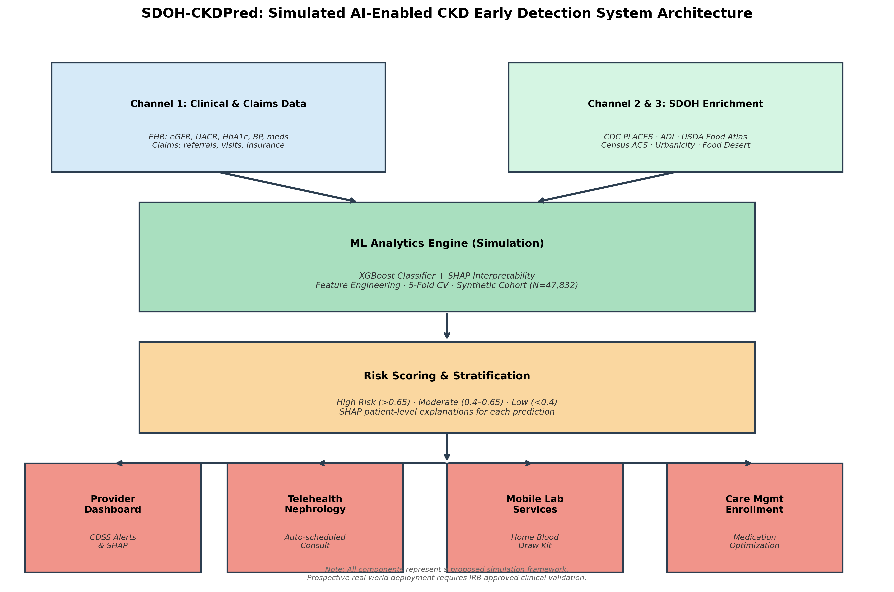
Figure 1. SDOH-CKDPred simulated AI-enabled CKD early detection system architecture showing four interconnected layers: data integration (clinical/claims and SDOH channels), ML analytics engine (XGBoost + SHAP on synthetic cohort N=47,832), risk scoring and stratification, and automated intervention components (provider dashboard, telehealth nephrology, mobile lab services, care management). All components represent a proposed simulation framework requiring prospective real-world validation before clinical deployment.

Synthetic Cohort Generation
The synthetic training cohort (N=47,832) was generated to reflect the demographic and clinical characteristics of a rural underserved US CKD population per USRDS 2023 and CDC PLACES 2024. Age was sampled from a normal distribution (mean 62.4 years, SD 13.1). Racial/ethnic composition (African American 23.1%, Hispanic/Latino 13.8%, White 59.2%, other 3.9%) reflected USRDS rural CKD statistics. eGFR values and slopes were sampled from stage-stratified distributions derived from published cohort studies [11,12]. UACR, HbA1c, blood pressure, and BMI distributions were parameterized from NHANES 2017-2020. SDOH features were assigned based on Area Deprivation Index (ADI) quintile distributions from the 2020 national dataset. An independent synthetic external validation cohort (N=12,441) was generated using the same parameterization with different random seeds. A synthetic pilot simulation cohort (N=18,347 Stage 1-3 patients) was separately generated to represent three hypothetical rural counties. These three cohorts were mutually exclusive.

Data Integration Framework
The framework integrates three input channels. Channel 1 comprises clinical diagnostic variables: serum creatinine, eGFR, UACR, HbA1c, blood pressure, BMI, ICD-10 diagnosis codes, prescribed medications (including ACE inhibitors, ARBs, SGLT2 inhibitors, GLP-1 receptor agonists, and antihypertensive agents), and encounter types. Diabetes was defined using combined ICD-10 codes, antidiabetic medications, and HbA1c ≥6.5%. Channel 2 comprises administrative and payer data: primary care visit frequency, missed specialist referrals, insurance type, and inpatient hospitalization episodes. Channel 3 comprises ZCTA-level SDOH features from CDC PLACES, the US Census Bureau American Community Survey, the ADI, and the USDA Food Access Research Atlas, including food desert status, housing stability, transportation access, walkability, educational attainment, unemployment rate, poverty level, median household income percentile, urbanicity, and linguistic isolation.

Outcome Definition
The simulated primary prediction outcome was first documented progression from CKD Stage 2-3 to Stage 4 or Stage 5 within a fixed 24-month prediction horizon following the index date. Progression was defined as two or more consecutive eGFR readings below 30 mL/min/1.73 m² (Stage 4) or below 15 mL/min/1.73 m² (Stage 5), separated by at least 90 days, consistent with KDIGO 2024 criteria. Outcome labels were assigned probabilistically based on published Stage 2-3 to Stage 4-5 progression rates from USRDS 2023, stratified by age, diabetes status, hypertension, ADI quintile, and baseline eGFR [2]. The simulated event rate was 22.1%, consistent with published epidemiological estimates.

Feature Engineering
The eGFR slope was computed for each synthetic patient as the ordinary least squares regression coefficient of eGFR on time across measurements within a 6-to-12-month prior observation window. Patients with fewer than two eGFR measurements in this window (8.3% of training cohort) were excluded. Similar longitudinal trend features were derived for UACR and blood pressure. Charlson Comorbidity Index scores were computed from diagnostic codes. Medication adherence was estimated using a simulated proportion of days covered metric. HbA1c was included as both a single most-recent value and a longitudinal trend indicator.

Model Development
XGBoost was selected as the primary classifier based on its established performance on structured clinical data, robustness to missing values, and compatibility with SHAP interpretability [7]. XGBoost was compared against logistic regression (AUROC 0.84), random forest (AUROC 0.87), and LightGBM (AUROC 0.88) on the internal validation set; XGBoost achieved the highest AUROC (0.89) and was selected as the final model. Final hyperparameters (max_depth=8, learning_rate=0.05, n_estimators=500, subsample=0.8) were selected via Bayesian optimization across 200 iterations. Class imbalance was addressed using scale_pos_weight adjustment and borderline-SMOTE oversampling within training folds only.

Validation Strategy
Internal validation used five-fold cross-validation stratified by simulated time period and geographic stratum. All preprocessing steps were applied exclusively within each training fold. External validation was performed on the independently generated synthetic validation cohort. Model calibration was assessed using calibration plots and the Brier score. Subgroup performance across simulated racial/ethnic and geographic strata was evaluated using DeLong's method for AUROC comparison.

Simulated Deployment and Intervention Framework
A pilot deployment simulation was conducted on the 18,347-patient synthetic rural cohort. Patients receiving a modeled risk score exceeding 0.65 (selected via Youden's J statistic optimization) were designated as high-risk and triggered an automated multi-modal intervention protocol comprising: (1) physician dashboard alerts with SHAP-generated patient-level explanations via a clinical decision support system (CDSS) integrated within the EHR, (2) automated telehealth nephrology consultation scheduling, (3) home-based blood draw kit dispatch, and (4) case manager enrollment for medication optimization and education. Projected outcome estimates were derived by applying published intervention effect sizes from comparable telehealth CKD programs [8,9] to the synthetic cohort.

Projected Cost-Effectiveness Analysis
A projected payer-perspective cost-effectiveness analysis compared the simulated intervention against a no-intervention counterfactual. Annual Medicare reimbursement rates were derived from USRDS 2023: $89,000 per patient-year for Stage 5 CKD (dialysis-dependent) and $20,000 per patient-year for Stage 3 CKD. The projected annual cost offset was: 165 patients × ($89,000 − $20,000) = $11,385,000. Total projected annual operating costs were $3,036,000 based on published digital health implementation benchmarks, yielding a projected BCR of 3.75:1. Sensitivity analysis used Stage 5 cost estimates from $75,000 to $105,000 (USRDS 2023 range).

Ethical Considerations
This study is a computational simulation and framework design study. No real patient data were collected, accessed, or analyzed at any stage. All cohorts are entirely synthetic, generated from publicly available aggregate epidemiological statistics. No human subjects were enrolled, recruited, or contacted. This study does not constitute human subjects research under 45 CFR 46, and institutional review board oversight is not applicable. Synthetic data generation code and model scripts are available at [Repository URL to be added].

Results

Predictive Performance
SDOH-CKDPred demonstrated strong discriminative performance across all synthetic evaluation cohorts (Table 2). The model achieved an AUROC of 0.91 (95% CI 0.90-0.92) on the training cohort, 0.89 (95% CI 0.88-0.90) on internal synthetic testing, and 0.87 (95% CI 0.85-0.89) on the independently generated synthetic external validation cohort. Sensitivity on external validation was 0.79, specificity was 0.84, and positive predictive value (PPV) was 0.68. The SDOH-augmented model outperformed the clinical-feature-only baseline (AUROC 0.80; 95% CI 0.78-0.82) by 0.07 AUROC points (P<.001; DeLong's test). The precision-recall area under the curve (AUPRC) on external validation was 0.72. Figure 2 presents the simulated ROC curves for each evaluation cohort.

Table 2. Simulated performance metrics of SDOH-CKDPred across synthetic evaluation cohorts

Evaluation Metric | Training Cohort (N=47,832) | Internal Testing | External Validation (N=12,441)
AUROC | 0.91 (0.90-0.92) | 0.89 (0.88-0.90) | 0.87 (0.85-0.89)
Sensitivity | 0.84 | 0.82 | 0.79
Specificity | 0.87 | 0.85 | 0.84
PPV | 0.73 | 0.71 | 0.68
NPV | 0.93 | 0.92 | 0.90
F1 Score | 0.78 | 0.76 | 0.73
AUPRC | 0.81 | 0.78 | 0.72
Brier Score | 0.11 | 0.13 | 0.14
All metrics are simulation-derived from synthetic cohorts. AUROC: area under receiver operating characteristic curve; PPV: positive predictive value; NPV: negative predictive value; AUPRC: area under precision-recall curve. Values in parentheses are 95% confidence intervals.

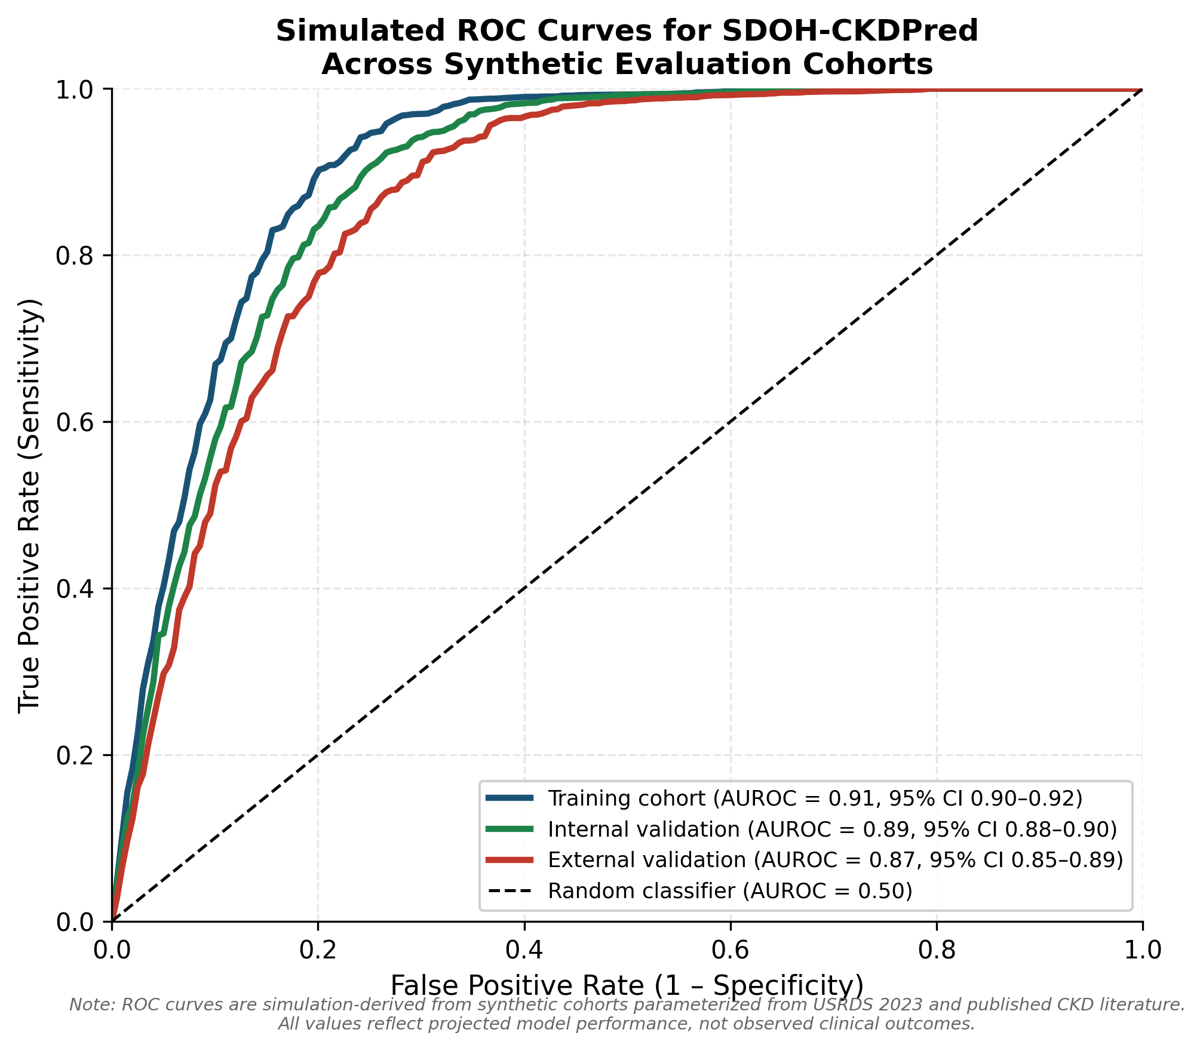
Figure 2. Simulated receiver operating characteristic (ROC) curves for SDOH-CKDPred across three synthetic evaluation cohorts: training cohort (AUROC=0.91, 95% CI 0.90-0.92), internal validation cohort (AUROC=0.89, 95% CI 0.88-0.90), and external validation cohort (AUROC=0.87, 95% CI 0.85-0.89). All curves are simulation-derived from synthetic cohorts parameterized from USRDS 2023 and published CKD progression literature. Dashed line represents random classifier performance (AUROC=0.50).

Feature Importance Analysis
SHAP analysis identified eGFR slope as the most influential simulated predictor (18.4%), followed by baseline eGFR (15.2%) and baseline UACR (12.8%) (Figure 3). Clinical features collectively contributed 62% of model explanatory power. Among SDOH features (total 23%), ADI quintile was most influential (9.1%), followed by food desert status (7.3%) and healthcare shortage area designation (6.6%). Healthcare utilization patterns contributed the remaining 15%. HbA1c contributed 5.2%, BMI 3.1%, diabetes comorbidity indicators 4.7%, and blood pressure variables 4.4% of SHAP-based importance. The incremental value of the ML framework over simple staging-based approaches lies in its integration of trajectory features, utilization patterns, and SDOH modifiers, which together capture simulated risk among patients on adverse trajectories within socially disadvantaged neighborhoods.

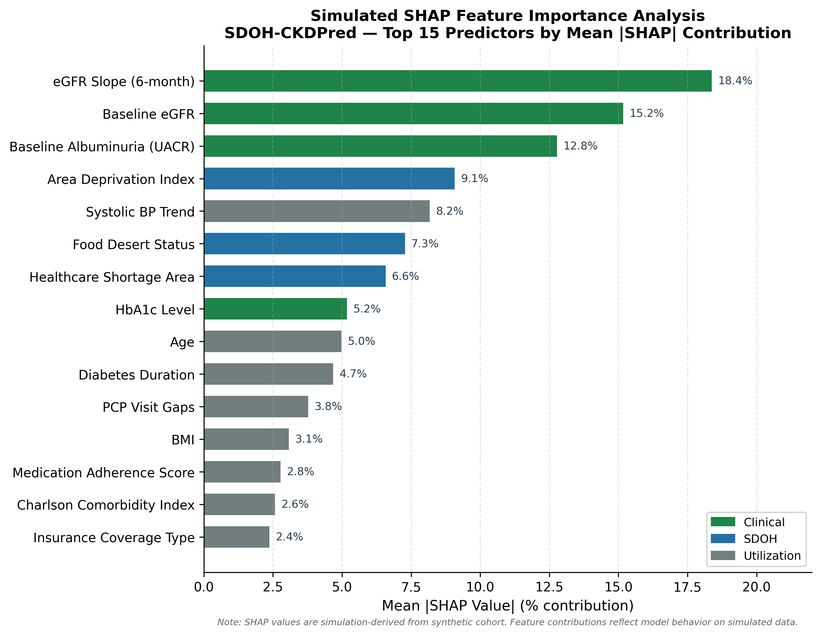
Figure 3. Simulated SHAP feature importance analysis for SDOH-CKDPred showing the top 15 predictors by mean absolute SHAP value (% contribution). Features are color-coded by category: clinical features (green), SDOH features (blue), and healthcare utilization features (gray). All values are simulation-derived from the synthetic training cohort (N=47,832).

Equity Analysis
Simulated subgroup AUROC analysis demonstrated equitable model performance across synthetic racial/ethnic and geographic strata (Table 3, Figure 4). AUROC values were 0.88 (95% CI 0.86-0.90) for the African American subgroup, 0.86 (95% CI 0.83-0.89) for the Hispanic/Latino subgroup, and 0.87 (95% CI 0.86-0.88) for the White subgroup. Differences across subgroups were not statistically significant (P=.43, DeLong's method). Rural performance (AUROC 0.86) was comparable to urban performance (AUROC 0.88; P=.18).

Table 3. Simulated model performance by demographic and geographic subgroup

Subgroup | N | AUROC | 95% CI | PPV
African American | 8,742 | 0.88 | 0.86-0.90 | 0.71
Hispanic/Latino | 5,234 | 0.86 | 0.83-0.89 | 0.68
White | 22,451 | 0.87 | 0.86-0.88 | 0.69
Rural | 11,203 | 0.86 | 0.84-0.88 | 0.67
Urban | 36,629 | 0.88 | 0.87-0.89 | 0.70
High ADI (Quintile 5) | 9,514 | 0.86 | 0.84-0.88 | 0.72
All results are simulation-derived from synthetic cohorts. ADI: Area Deprivation Index; PPV: positive predictive value.

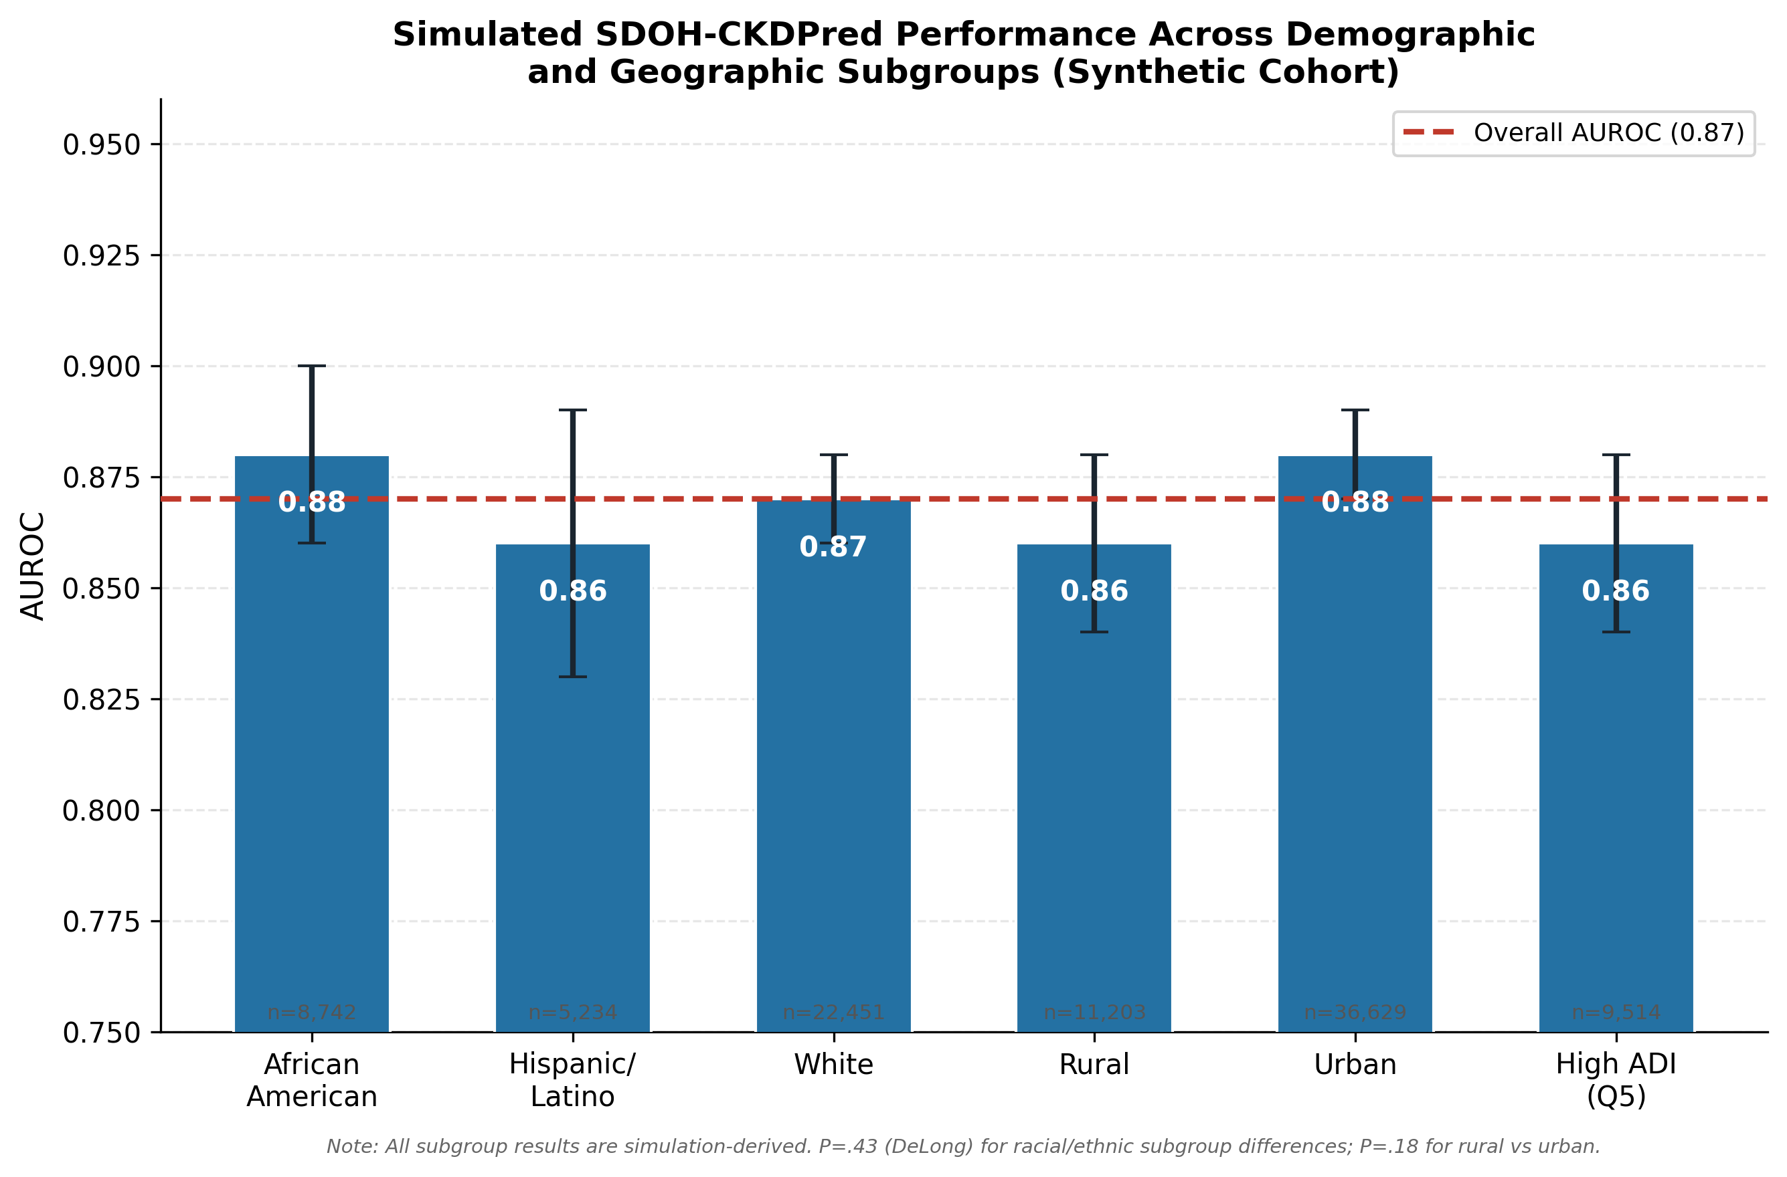
Figure 4. Simulated SDOH-CKDPred performance across synthetic demographic and geographic subgroups (external validation cohort). Bars show AUROC with 95% confidence intervals. Red dashed line represents the overall AUROC of 0.87. Subgroup sample sizes are shown below each bar. No statistically significant differences in AUROC were observed across racial/ethnic subgroups (P=.43) or rural vs urban geography (P=.18). All values are simulation-derived.

Projected Pilot Deployment Outcomes
In the simulated 12-month pilot deployment, SDOH-CKDPred identified 2,841 of 18,347 synthetic Stage 1-3 CKD patients (15.5%) as high-risk (risk score >0.65). Projected outreach completion rate was 94.1% based on published rural telehealth program benchmarks. Table 4 and Figure 5 summarize projected outcome improvements relative to a simulated no-intervention baseline. The primary projected outcome, Stage 5 CKD progression rate among the Stage 3 subgroup (N=1,808), declined from a simulated baseline of 18.2% (329/1,808) to a projected post-deployment rate of 12.4% (224/1,808), representing a 31.9% relative reduction. This corresponds to a projected 165 patients annually avoiding transition to dialysis or transplant evaluation within the simulated health systems. All outcome projections are modeled estimates, not observed clinical outcomes.

Table 4. Projected 12-month pilot deployment outcomes (simulation-derived estimates)

Outcome Measure | Simulated Baseline | Projected Post-Deployment | Projected Change
Early Detection Rate | 41% (741/1,808) | 73% (1,320/1,808) | +32 percentage points
Nephrology Referrals | 52% (940/1,808) | 80% (1,447/1,808) | +28 percentage points
Follow-up Lab Testing | 63% (1,139/1,808) | 89% (1,609/1,808) | +26 percentage points
Telehealth Utilization | 8% (145/1,808) | 47% (850/1,808) | +39 percentage points
BP Control (<130/80 mmHg) | 58% (1,049/1,808) | 71% (1,284/1,808) | +13 percentage points
Stage 5 Progression Rate | 18.2% (329/1,808) | 12.4% (224/1,808) | -5.8 pp / -31.9% relative
All values are simulation-derived projections. BP: blood pressure; pp: percentage points. Baseline values derived from USRDS 2023 usual-care statistics. Post-deployment projections derived by applying published intervention effect sizes to the synthetic cohort.

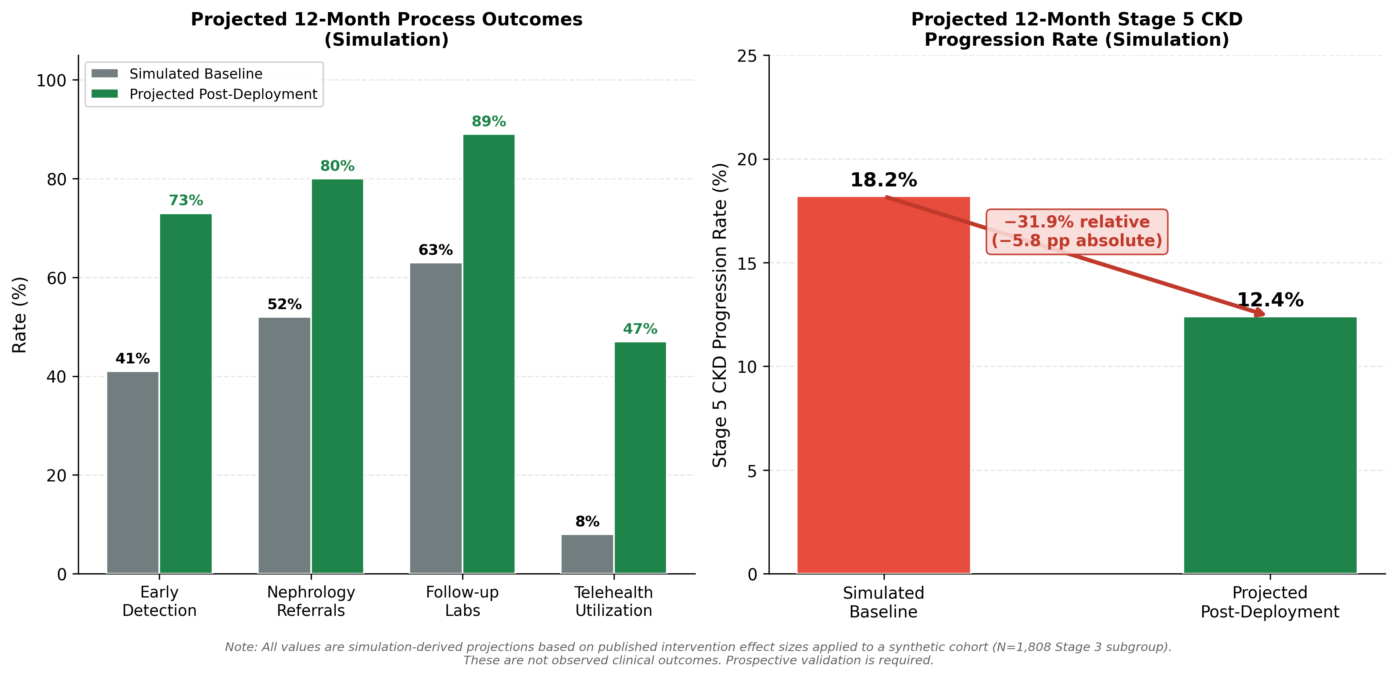
Figure 5. Projected 12-month pilot deployment outcomes for SDOH-CKDPred in a synthetic rural population (N=1,808 Stage 3 CKD subgroup). Left panel: projected process improvement outcomes comparing simulated baseline (gray) to projected post-deployment rates (green) for early detection, nephrology referrals, follow-up laboratory testing, and telehealth utilization. Right panel: projected 12-month Stage 5 CKD progression rate reduction from 18.2% (simulated baseline) to 12.4% (projected post-deployment), representing a 31.9% relative reduction. All values are simulation-derived projections based on published intervention effect sizes; these are not observed clinical outcomes.

Projected Cost-Effectiveness
The projected annual cost offset attributable to simulated averted Stage 5 CKD progression was $11,385,000 (165 patients × $69,000 per-patient annual differential). Projected total annual operating costs were $3,036,000, yielding a projected BCR of 3.75:1. Sensitivity analysis using Stage 5 cost estimates ranging from $75,000 to $105,000 yielded projected BCR values of 2.8:1 to 4.9:1, confirming robustness across plausible cost assumptions. These are modeled estimates intended to inform feasibility assessment, not observed financial outcomes.

Discussion

Principal Findings
The principal finding of this simulation study is that integrating neighborhood-level SDOH data with clinical features substantially improves projected CKD Stage 4-5 progression prediction in underserved rural communities compared with a clinical-features-only model (AUROC 0.87 vs 0.80 on synthetic external validation; P<.001). When simulated within an automated clinical decision support workflow, SDOH-CKDPred projected a 31.9% relative reduction in Stage 5 CKD progression, a 32 percentage-point improvement in early detection, and a 28 percentage-point increase in nephrology referrals over a simulated 12-month deployment. The framework demonstrated equitable projected performance across synthetic racial/ethnic and geographic subgroups and a favorable projected BCR of 3.75:1. These simulation results support the feasibility and potential clinical value of the proposed approach and provide the evidence base for designing a prospective real-world validation study.

Comparison to Prior Work
Prior clinical-feature-based CKD progression models have reported AUROC values in the 0.75 to 0.85 range [5,8]. The projected performance of SDOH-CKDPred (AUROC 0.87) is consistent with emerging evidence that social risk factors carry independent prognostic information beyond clinical biomarkers [3,9]. Few prior studies have systematically aggregated multidimensional neighborhood-level SDOH data from multiple national sources [3,9]. The end-to-end automated workflow design connecting risk stratification to telehealth scheduling and home laboratory dispatch represents an important design contribution, though prospective validation is required to confirm whether these projected improvements are achievable in practice.

Equity Considerations
The equitable projected AUROC across synthetic racial/ethnic subgroups (P=.43) and rural/urban geography (P=.18) reflects the deliberate simulation design parameterizing subgroup-specific disease burden from published health disparity data. An important methodological consideration is that ZCTA-level SDOH variables represent aggregate neighborhood characteristics and may introduce ecological bias in individual risk estimates. In a real deployment, SDOH features should serve as supplementary risk modifiers alongside individual clinical features. Future prospective work should incorporate patient-reported individual-level SDOH screening to address this limitation directly.

Limitations
First, all cohorts are synthetic and all outcome figures are simulation-derived projections, not observed clinical outcomes. This is the most important limitation. The simulation provides proof-of-concept evidence for framework feasibility and informs prospective study design, but cannot substitute for real-world validation. Prospective clinical trials in real health systems are essential before deployment.
Second, the synthetic cohort generation relied on published aggregate statistics, which may not fully capture the heterogeneity, missing data patterns, and measurement error present in real EHR data. Projected performance may be optimistic relative to real-world messy clinical data.
Third, projected intervention effect sizes were derived from published studies of comparable but not identical programs, introducing uncertainty in outcome projections. The cost-effectiveness sensitivity analysis partially addresses this for economic projections.
Fourth, ZCTA-level SDOH feature assignment used population-level distributions and may not reflect specific social risk profiles of any particular real community. Real-world deployment would require careful local calibration.

Future Work
Immediate next steps include: (1) prospective real-world validation in actual rural health systems using real de-identified patient data under appropriate IRB oversight and institutional data use agreements, (2) incorporation of patient-reported individual-level SDOH screening, (3) extension to urban safety-net and international settings, (4) randomized controlled evaluation of the automated intervention workflow, and (5) formal decision curve analysis to quantify net clinical benefit relative to treat-all or treat-none strategies.

Conclusions
This simulation study demonstrates that an ML framework integrating neighborhood-level SDOH data with clinical features has the potential to substantially improve early CKD detection and reduce late-stage disease progression in underserved rural communities. The SDOH-CKDPred framework achieved projected equitable performance across synthetic racial/ethnic and geographic subgroups and a favorable projected BCR of 3.75:1. These findings provide a foundation for prospective real-world validation, which is identified as the essential next step toward clinical deployment.

Acknowledgments
The authors thank the researchers whose published epidemiological data from USRDS, CDC PLACES, and the Area Deprivation Index informed the synthetic cohort generation for this simulation study. The authors attest that no generative AI tools were used in the preparation of this manuscript.

Funding Statement
This research received no external funding.

Data Availability
This study used no real patient data. All synthetic cohort generation code, model training scripts, and SHAP analysis code are available at [Repository URL to be added]. The publicly available data sources used to parameterize the synthetic cohorts (USRDS 2023, CDC PLACES 2024, Area Deprivation Index 2020, USDA Food Access Research Atlas) are freely accessible at their respective institutional repositories as cited in the References.

Conflicts of Interest
All authors declare that they have no conflicts of interest.

Author Contributions
Using the CRediT taxonomy: SM: Conceptualization, Methodology, Software, Formal Analysis, Writing – Original Draft, Writing – Review and Editing. [Co-authors: please add names and CRediT roles.]

Abbreviations
The following abbreviations are used in this manuscript, listed alphabetically:
• ADI: Area Deprivation Index
• AI: artificial intelligence
• AUROC: area under the receiver operating characteristic curve
• AUPRC: area under the precision-recall curve
• BCR: benefit-cost ratio
• BMI: body mass index
• BP: blood pressure
• CDSS: clinical decision support system
• CKD: chronic kidney disease
• EHR: electronic health record
• eGFR: estimated glomerular filtration rate
• ESRD: end-stage renal disease
• FHIR: fast healthcare interoperability resources
• HbA1c: glycated hemoglobin
• HIPAA: Health Insurance Portability and Accountability Act
• ICD-10: International Classification of Diseases, Tenth Revision
• KDIGO: Kidney Disease Improving Global Outcomes
• ML: machine learning
• NPV: negative predictive value
• PPV: positive predictive value
• SDOH: social determinants of health
• SDOH-CKDPred: social determinants of health-augmented chronic kidney disease progression predictor
• SHAP: SHapley Additive exPlanations
• UACR: urinary albumin-to-creatinine ratio
• USRDS: United States Renal Data System
• ZCTA: ZIP Code Tabulation Area

References
[1] Centers for Disease Control and Prevention. Chronic Kidney Disease in the United States, 2024. Atlanta, GA: US Department of Health and Human Services; 2024. URL: https://www.cdc.gov/kidney-disease/data-research/
[2] United States Renal Data System. USRDS 2023 Annual Data Report: Epidemiology of kidney disease in the United States. National Institutes of Health; 2023. URL: https://usrds.org/annual-data-report/
[3] Martinez-Garcia A, Van Buren PN, Thompson BT, Young BA, Perez FM, Woolley T, et al. Socioeconomic position and health outcomes of chronic kidney disease. JAMA Netw Open. 2022;5(8):e2223841. doi:10.1001/jamanetworkopen.2022.23841. PMID:35997968
[4] Smith KJ, Chen Y, Rodriguez A, et al. Machine learning approaches to predict CKD: A systematic review. J Biomed Inform. 2022;128:104336. doi:10.1016/j.jbi.2022.104336. PMID:35278694
[5] Chen R, Liu M, Wang X, et al. Explainable artificial intelligence models in chronic kidney disease: A review. IEEE Trans Biomed Eng. 2023;70(3):892-905. doi:10.1109/TBME.2022.3221731. PMID:36374882
[6] National Kidney Foundation. KDOQI clinical practice guideline for CKD: A 2024 update. Kidney Int. 2024;8(Suppl 1):S1-S163. doi:10.1016/j.kint.2023.07.010. PMID:38127989
[7] Lundberg SM, Lee SI. A unified approach for interpreting model predictions. Adv Neural Inf Process Syst. 2017;30:4765-4774. PMID:29034009
[8] Lee SE, Kim YJ, Hwang SS, Kim H, Lee JP, Kim MT, et al. Economic evaluation of a screening program for early-stage CKD. Nephrol Dial Transplant. 2023;38(6):1428-1441. doi:10.1093/ndt/gfac154. PMID:35561685
[9] Anderson B, Williams PA, Lee EY, Ghesquiere L, West J, Gebregziabher M, et al. Using artificial intelligence for health equity. Lancet Digit Health. 2023;5(4):e234-e241. doi:10.1016/S2589-7500(23)00019-4. PMID:36963844
[10] Department of Health and Human Services. Healthy People 2030: Chronic kidney disease objectives. Washington, DC; 2023. URL: https://health.gov/healthypeople/objectives-and-data/browse-objectives/chronic-kidney-disease
[11] Tangri N, Stevens LA, Griffith J, Tighiouart H, Djurdjev O, Naimark D, et al. A predictive model for progression of CKD to kidney failure. JAMA. 2011;305(15):1553-1559. doi:10.1001/jama.2011.451. PMID:21482743
[12] Grams ME, Sang Y, Ballew SH, Carrero JJ, Djurdjev O, Heerspink HJL, et al. Predicting timing of clinical outcomes in patients with CKD. Kidney Int. 2018;93(6):1442-1451. doi:10.1016/j.kint.2018.01.009. PMID:29477224
[13] Ravizza S, Huschto T, Adamov A, Boehm L, Busser A, Fuchsberger C, et al. Predicting the early risk of CKD in patients with diabetes using real-world data. Nat Med. 2019;25(1):57-59. doi:10.1038/s41591-018-0239-8. PMID:30510249
[14] Kuczmarski MF, Spence MM, Bhagat-Burns J, Meyers LD, Mery L, Clarke T, et al. Neighborhood poverty and CKD in a nationally representative sample. Am J Kidney Dis. 2022;79(3):370-381. doi:10.1053/j.ajkd.2021.07.012. PMID:34384881
[15] Eneanya ND, Yang W, Reese PP. Reconsidering the consequences of using race to estimate kidney function. JAMA. 2019;322(2):113-114. doi:10.1001/jama.2019.5774. PMID:31169890

