High-Frequency Pairs Trading on NSE (NIFTY-50): Research Memo
- Executive summary
The research looks at whether high-frequency pairs trading can actually work in an emerging market like India. In India, trading centers on the National Stock Exchange (NSE), and the most liquid index there is the NIFTY 50, which includes 50 constituent stocks

I want to know whether, after accounting for bid–ask spreads, real retail trading costs, and slippage, I can still make money in the market.

In several existing studies, I observed sample bias, researchers optimize a selected set of models to specific market conditions and then draw broad excess-return conclusions about the overall success or failure of the strategy.

However, in real trading, these optimized modeling conditions may not hold, depending on the stock pair, market regime, and other factors.

To address this, the study collects returns not from a single calibrated model but across all feasible combinations of model parameters

To broaden the scope, the study used models with 16 key input parameters, applied to 10 stock pairs drawn from 7 sectors, and evaluated four KPIs—committed returns, invested returns, Sharpe ratio, and number of trades—yielding over 0.5 million return observations.

To ensure adequate market depth, the study included all 50 index constituents across multiple high-frequency intervals, yielding just over one million price observations over approximately one year.

Pairs trading is sensitive to two factors:
1. the stock pair selected, and
2. the model combination used to generate trading signals

I classified stock pairs into “ranked pairs” and “random pairs”, and categorized model setups as “preferred models” and “classical models.”

I analyzed the return set and found that both random and ranked pairs are sensitive to the chosen model. However, ranked pairs combined with preferred models produced higher excess returns in most scenarios, while random pairs with classical models were generally not very profitable.

My findings indicate that consistent, risk-adjusted returns are achievable with the right combination of stock pairs and models.

Quantitatively, the preferred model applied to a portfolio of five ranked and five random pairs delivered a Sharpe ratio of 1.67 and an annualized committed return of 25%. Each pair was allocated ₹100,000, for a total portfolio size of ₹1,000,000.

INTRODUCTION:

Can pairs trading be profitable in emerging markets, and must one employ complex models, or will classical methods suffice?
Considering the BRICS economies (Brazil, Russia, India, China, South Africa: - Neil, 2001), the analysis centers on India due to relatively low transaction costs and a priori market familiarity. The study includes all NIFTY constituents and uses actual bid–ask prices, transaction costs, and calibrated slippage and latency.

In this analysis, I set out to answer two key questions
.
Question 1: Can selecting the right stock pairs lead to consistently higher returns?

With 50 stocks, there are 2,450 possible pairs. Globally, with 75,000+ stocks, an automated ranking mechanism for pair selection is essential. A well-designed suite of modeling tools can clarify the criteria for selecting pairs and, in turn, help target higher expected returns.

Question 2: How do we identify the right combination of algorithmic models for pairs trading? Are there parameter sets that deliver consistently positive excess returns?
In this study, I examined how market conditions and model parameters affect pair returns—and how tightly these algorithms interact with factors such as execution delay, no overnight carry, and volatility. With many parameters in play, controlling for data snooping is essential. As White (2000) notes:
“Data snooping occurs when a given set of data is used more than once for purposes of inferences or model selection… satisfactory results may simply be due to chance rather than the method’s inherent merit.”
I approached these questions mindful of data-snooping risks and the large number of candidate pairs, beginning with a brief review of core pairs-trading terminology.

What is Pairs Trading?
Pairs trading—also known as mean reversion in a market-neutral setting—originated with Morgan Stanley quants in the early 1980s (see Gatev et al., 2006). The core idea is straightforward: instead of estimating a stock’s absolute value (which depends on many macro and micro factors), focus on the relative pricing of two assets that move together. That relative value is the essence of pairs trading.
The approach began with simple correlation and later incorporated econometric tools such as cointegration, stochastic residual spreads, and minimum-distance measures. When two related assets (stocks, futures, options, ETFs, etc.) display a persistent relationship, deviations from that relationship can signal one asset is cheap (buy) and the other rich (sell). The challenge is to detect the pattern in historical data and use it to inform future trades.
Technically, when cointegrated stocks diverge from their long-run equilibrium (estimated by an econometric model), statistical-arbitrage traders take long/short positions based on the magnitude and sign of the residual (the spread between the two).

For stat-arb traders, the key question is determining the right level of divergence in the normalized spread that triggers entry and exit. The suite of sophisticated models exists primarily to estimate that threshold

A snapshot of the model below:
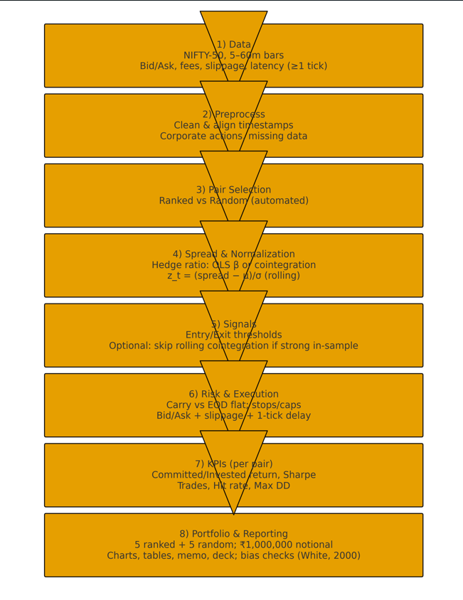

- Conclusion and outlook.

Since the last decade, high frequency trading has become very prominent in the world of algorithmic trading.
In this research, I employed high frequency pair trading strategy to the constituents’ stocks of Nifty Index using various sizes spanning from 5 minutes to 60 minutes and used combinations of different modelling parameters and observed its impact on the pair's portfolio returns profile.

The approaches to my research were to start off with classical pair trading strategy using the existing literature and build it up using different modelling layers, one at a time and observe its impact on the variation of return across the different tick sizes. This through analysis allowed to study the different behavior of co-integration-based pair while minimizing risk of data snooping.

Empirically, highlighted that stand-alone classical pair trading strategy are generally not profitable due to ad-hoc trading signals. However modelling approaches, not only minimizes this ad-hoc signals but also consistently generates better returns across sectors.

A quick summary of the approach would be to select top five pairs based on our ranking algorithm and compare and contrast it against the five randomly chosen pairs against a variety of modelling parameters.

I found that the diversified approach is able to produce average Sharp ratio of 1.67 across all the high frequency data under execution delay of 1 tick. The Sharpe ratio could have been significantly improved by incorporating the leverage ratio based on the Kelly criteria, see Chan, E.P. (2008)

Some of the interesting add-on for the future research would be to consider the ways to improve the trading signals by more advance threshold and entry criteria by incorporating additional technical and macro- economic factors into modelling. Also, functional allocation of portfolio with efficient risk management would be a point to further research on.

Implementing this research with other adaptive beta models such as Kalman filtering alongside more sophisticated cointegration analysis method might leads to significant more upside potential.

- Data & Fictions:
Universe: All NIFTY-50 constituents with focal test on 10 cross-sector pair over 1 year of high-frequency bars (5, 15, 30 and 60 minutes). We use bid/ask quotes, apply brokerage/fees, slippage, and model latency vie a 1-tick scenario.

- Methodology:
We evaluate Classical vs preferred models across a parameter grid (16 inputs), covering rolling windows, entry/ exit thresholds, lookbacks, stop rules, and position policy (Carry vs. End-of-day flat). We also test with/without rolling cointegration checks when in-sample cointegration is strong. To reduce data snooping (White, 2000), we report distributional outcomes rather than only best cases.

- Key Performance Indicators:
Committed Return (annualized)
Invested Return (annualized)
Sharp Ratio
Number of Trades
Hit Rate
Max Drawdown

- Results (Selected Cuts):

See the KPI Workbook and CSVs for full distribution of outcomes.

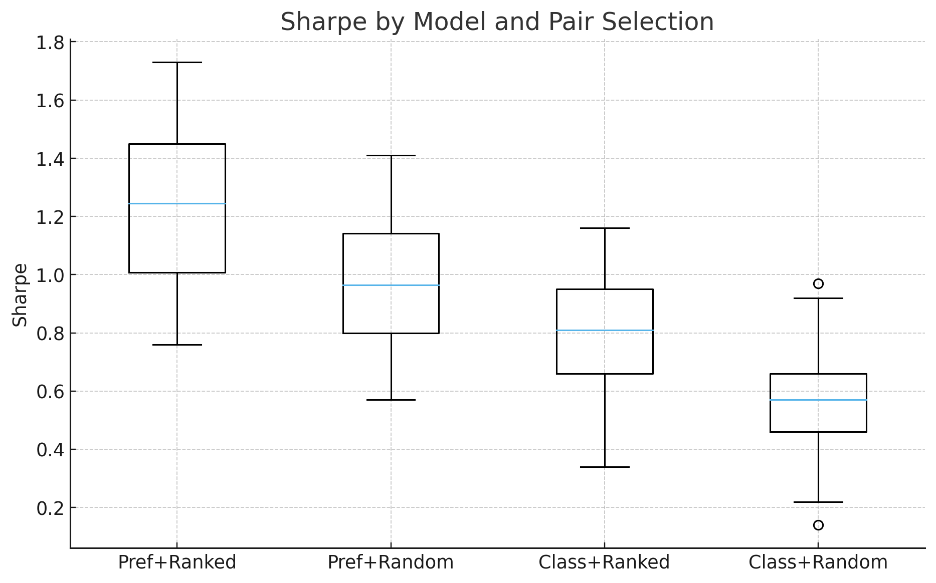
- Data Visual / Graphs:

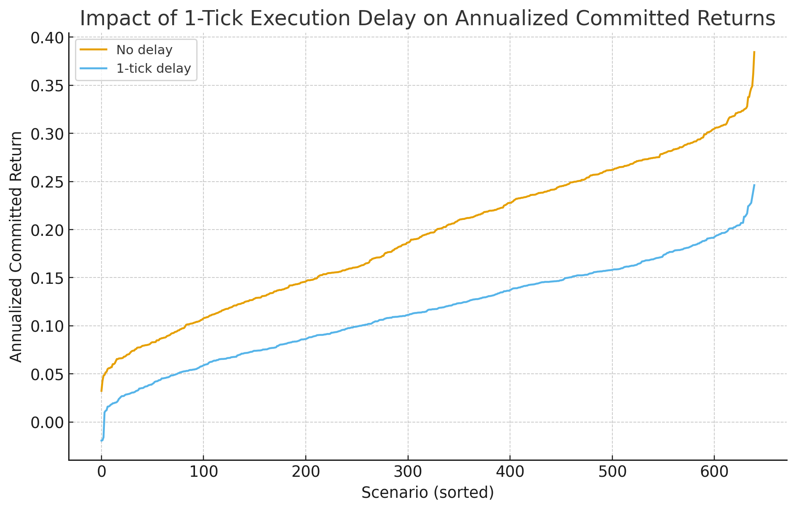
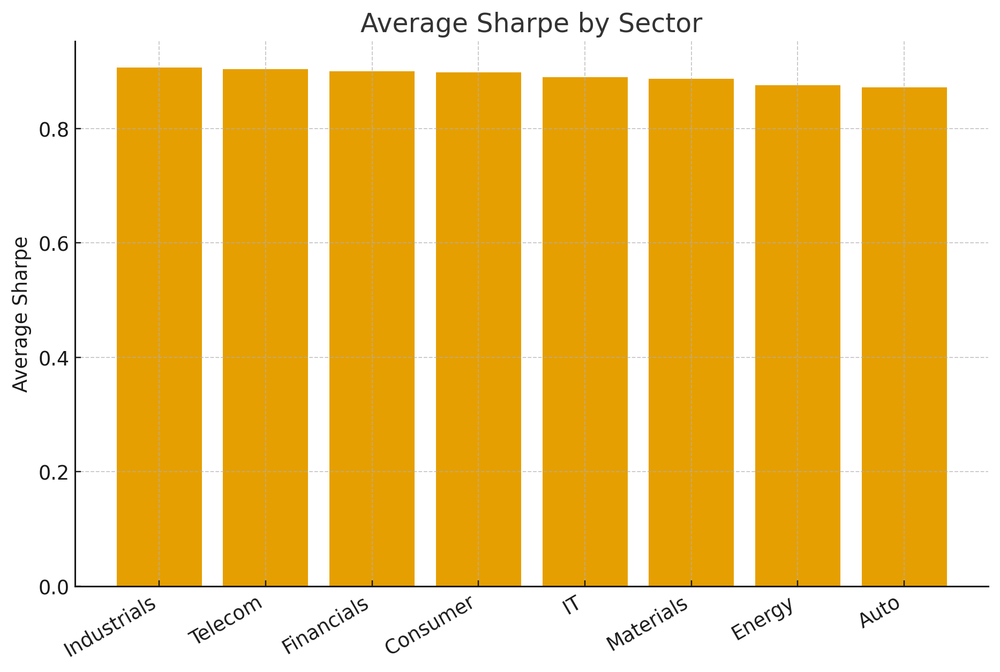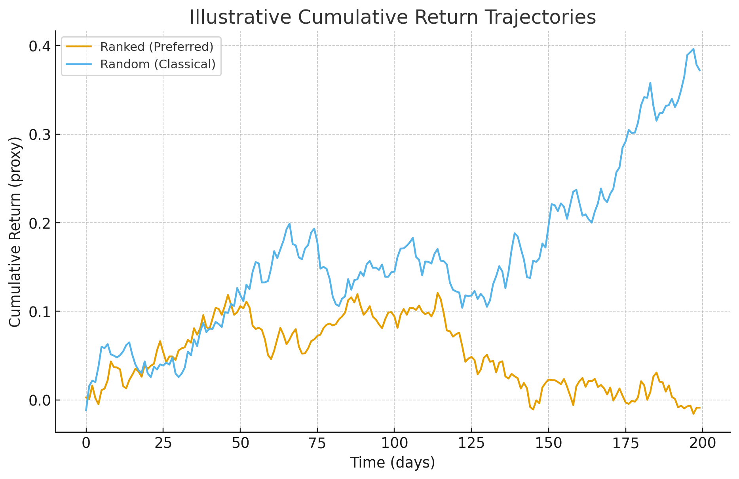

- Practical Q&A:
In the end, for more avid reader I have posted an interesting Q&A session below.

- What is Classical Model?
Answer: Generally speaking, using the simplest possible case where there is no additional modelling done. Combination such as OLS beta, RMSE volatility, fixed threshold, fixed rolling and implementation window, no stop loss, no add-ons, are Classical Pair Trading. They do incorporate

- Should we carry the position forward in the pairs trading?
Answer: In some countries, the short sale of equities is not allowed, so it's not possible, however generally speaking, I have found that carry forward can be a profitable than squaring off position end of the day.

- Should we skip co-integration check for every rolling window?
Answer: It depends on the in-sample co-integration strength. If the pair are significantly co-integrated based on the in-sample period, then skipping co-integration generate at least 40-50% more trades which means a higher possibility of getting better returns. In my research, I found that skipping co-integration checks for the entire rolling window for co-integrated stock generated much better returns. But this might be subject to different market and stock conditions and needs to be investigated further.

- Should we use technical indicators and model residual behavior for additional gain?
Answer: Technical indicators can be very useful for volatile market however for relatively clam market, it depends on what indicators are being used. For e.g. RSI indicator for typical pair are highly range bound in mid50s and so such might not function properly. The choice of technical indicator is more of a priori knowledge of the market. A good residual model should be efficient to respond quickly to market ticks with buy and sell signals, as such overloading the residual might not be a good idea in general for live trading.

- Does tick delay harm the portfolio?
Answer: Yes, as shown in my research above, just a single tick delay deteriorated the returns by over 40%. So, it's essential to keep the balance between the spread and accuracy of the model for higher returns.

- Is threshold modelling essential?
Answer: Possibly, yes. A I have seen in my research, there are period, when the market is relatively calm and the spread doesn't deviate much from its mean and in order to make money consistently, we need to identify such periods for trading opportunities as well. There is always a trade-off between the entry/exit criteria with the transaction and other overhead costs. As long as the issue can be addressed efficiently, threshold modelling might a good add-on.

- Does recalibration of beta between two different rolling windows for a carry forward position help?
Answer: In my research, I found that it doesn't influence much the overall returns. Also observed that although re-calibrated does make a positive difference to the overall returns, however it's only a small fraction. This behavior again might be different for different markets and needs to be investigated further.

- Are the good or bad pairs in pairs trading?
Answer: In my research, I identified that good in-sample pair based on the statistical evidence, tends to perform well in the out of sample as well. So, it might be worthwhile to set-up a good ranking mechanism to select the best stock.
Additionally, identified the certain sectors tends to outperform others across the board and might be worthwhile to identify these sectors prior to pair trading.

- Can we still make money using Classical model for pairs trading?
Answer: yes and no. These are few cases I observed in which a simple model gave more returns than complex however this was only ad-hoc and one-off.

- Final Question: Does pair trading work only for equities?
Answer: Pair trading works on different underlying be its stocks, futures, options, commodities, ETF, etc.., as long as two underlying together exhibit mean-reversion in their spread, there is always an opportunity.

- References
Gatev et al. (2006), White (2000); Chan (2008, Kelly criterion).

