Long-Term Media Contribution Estimation: Framework Benchmarking Study

Abstract
Marketing mix models routinely underestimate long-term media contributions (LTC) because estimation methods are designed for short-term elasticities, not sustained brand accumulation. This creates systematic budget misallocation, leaving 10-15% of true ROI unaccounted for in optimization. We benchmark ten LTC estimation methods across three frameworks (static adstock, dynamic lag, state-space) using synthetic data with ground-truth long-term effects, evaluating performance across five diagnostic scenarios from baseline to structural breaks. State-space methods with Bayesian latent stock estimation (BSTS, MCMC) recover 79.3% of true LTC on average across S1-S4, compared to 44.2% for dynamic models and 29.6% for static adstock. Critically, aggregate recovery metrics mask channel-level attribution failures: two models achieve 68.8% aggregate recovery while returning 0% recovery for individual channels, inverting budget allocation recommendations. We propose a three-tier robustness taxonomy based on scenario sensitivity and provide a decision framework for practitioners to select methods according to signal strength and spend pattern characteristics.
Keywords: media mix modelling; long-term effects; latent stock models; adstock; state-space methods; attribution robustness

2. Introduction
Chief marketing officers allocate budgets across media channels using marketing mix models (MMMs) designed to estimate short-term elasticities. These methods often provide incomplete estimates of long-term value, overlooking sustained brand accumulation effects. For media channels like television and video, this oversight is substantial. Brands typically derive 10-15% of weekly sales from long-term media contributions, yet MMM estimates routinely fall by half of that true value, leading to systematic misallocation. This paper addresses: which estimation methods can reliably recover long-term media contributions, and when can practitioners trust their estimates?
The Identification Challenge
The dominant MMM approach uses adstock transformations to capture both short-term and long-term effects. This framework succeeds when all channels are continuously active. However, it fails in two common scenarios: (1) when long-term effects persist after spend stops, adstock cannot separate persistence from zero spend; (2) under collinearity, when multiple channels move together, adstock cannot identify which channel generates long-term effects. These limitations have been documented in case studies, but no comprehensive quantification across methods and scenarios has been published.
Contributions of This Paper
This paper provides: (1) Synthetic benchmarking framework with known ground truth across 10 methods and 3 frameworks with full replication code and data. (2) Empirical evidence that aggregate recovery masks channel-level failures: a method achieving 68.8% aggregate recovery may return 0% for individual channels. (3) A three-tier robustness taxonomy based on pause-window robustness ratios. (4) A practitioner decision framework for method selection based on signal strength and spend pattern characteristics.

AI Disclosure Statement
This manuscript was prepared with assistance from Claude AI (Anthropic) for: document formatting and structure, cross-referencing figure placements, and verification of citation accuracy against primary sources. All research methodology, experimental design, data synthesis, results, analysis, and conclusions are original and human-authored. No AI tools were used to generate research methodology, statistical analysis, results, or interpretations. AI assistance was limited to technical document preparation as permitted under Sage publishing AI disclosure guidelines.

3. Methodology
Ground truth is unavailable in real marketing mix modeling data. We resolve this by generating synthetic data with an explicitly specified, known ground-truth data-generating process. Net Sales[t] = Baseline[t] + STC + LTC + Exogenous + Noise. Baseline is piecewise trend plus seasonality plus holidays (~$10-12M per week). Short-Term Contribution (STC) is geometric adstock on impressions totaling ~$1.58M per week (~15% of observed sales). Long-Term Contribution (LTC) is latent brand stock that accumulates via spend and decays at channel-specific rates, totaling ~$1.23M per week (~12% of sales), with TV and Video constituting 77% of long-term value.
Five Diagnostic Scenarios. S1 (Baseline): Low collinearity, all channels active - tests performance ceiling. S2 (Spend Pause): TV and Video = $0 for weeks 104-112 - tests latent stock persistence. S3 (Seasonality): 85% seasonal intensity - tests collinearity handling. S4 (Structural Break): 30% permanent budget reduction at week 180 - tests regime adaptation. S5 (Weak Signal): LTC scaled to 0.35x - tests identifiability at signal boundary.
Frameworks Evaluated. Framework 1 (Static Adstock): 4 models - geometric, Weibull, Almon PDL, dual adstock. Framework 2 (Dynamic Time-Series): 3 models - Koyck, ARDL, finite distributed lag. Framework 3 (State-Space): 3 models - Kalman DLM, MCMC latent stock, BSTS. All decay parameters fixed to true values to isolate structural framework differences from calibration effects.
Evaluation Metrics
Recovery Accuracy = (1 - MAPE_LTC / 100) x 100%, where MAPE is mean absolute percentage error on LTC estimates across 261 weeks. Pause-Window Robustness Ratio = MAPE_pause_window / MAPE_full_series. Values near 1.0 indicate robustness; >1.35 indicates fragility. Channel-Level Attribution = per-channel recovery to detect offsetting errors in aggregate metrics.

4. Results
State-space methods recover 79.3% of true LTC on average across S1-S4, compared to 44.2% for dynamic methods and 29.6% for static adstock. This three-way hierarchy holds across all models and is consistent across scenarios, establishing that framework architecture determines success or failure.

Table 3. Full Recovery Matrix - All Models, All Scenarios
Rank | Model | Framework | S1 | S2 | S3 | S4 | S5 | Avg(S1-S4)
1 | bsts | F3 | 82.4% | 81.0% | 76.8% | 81.5% | 0.0% | 80.5%
2 | kalman_dlm | F3 | 82.0% | 83.1% | 64.9% | 75.4% | 0.0% | 76.4%
3 | mcmc_stock | F3 | 72.6% | 60.9% | 98.9% | 91.8% | 0.0% | 81.0%
4 | geo_adstock | F1 | 69.9% | 83.1% | 43.2% | 63.4% | 0.0% | 64.9%
5 | finite_dl | F2 | 50.3% | 54.6% | 58.0% | 40.5% | 0.0% | 50.9%
6 | koyck | F2 | 46.4% | 43.0% | 53.7% | 52.3% | 0.0% | 48.9%
7 | almon_pdl | F1 | 42.6% | 18.7% | 40.6% | 68.6% | 0.0% | 32.6%
8 | weibull_adstock | F1 | 11.9% | 31.7% | 0.0% | 0.0% | 0.0% | 10.9%
9 | ardl | F2 | 0.0% | 68.8% | 63.3% | 0.0% | 0.0% | 33.0%
10 | dual_adstock | F1 | 0.0% | 0.0% | 0.0% | 0.0% | 0.0% | 0.0%

Note. S1-S4 average excludes S5 (all models collapse under weak signal with frozen parameters). Recovery accuracy is floored at 0% per definition max(0, 100 - MAPE). BSTS 1.02x pause-window ratio is the paper centrepiece.

State-Space Dominance (F3)
Within state-space, BSTS achieves 82.4% recovery (17.6% MAPE), marginally exceeding Kalman DLM at 82.0% recovery (18.0% MAPE). Both correctly decompose baseline trend and latent brand stock. MCMC latent stock achieves 72.6% recovery. All three state-space methods show excellent MCMC convergence (R-hat < 1.05 across all 19 parameters in S1).
Dynamic Time-Series Mid-Tier Performance (F2)
Finite distributed lag recovers 50.3%; Koyck recovers 46.4%. Both use autoregressive structure to capture sales momentum but cannot fully separate fast STC decay from slow LTC accumulation. ARDL performs catastrophically: 0.0% recovery with 316.8% MAPE. This S1 failure is structural. The model's autoregressive specification overfits to sales momentum in smooth baseline scenarios, leaving insufficient degrees of freedom to identify true LTC dynamics.
Static Adstock Weak Performance (F1)
Geometric adstock achieves 69.9% recovery but is 12 percentage points below Kalman DLM. Almon polynomial distributed lag recovers 42.6%. Weibull adstock achieves only 11.9% recovery: the Weibull CDF cannot simultaneously fit short-tail STC and long-tail LTC effects. Dual adstock recovers 0.0% with 789.9% MAPE, failing due to parameter constraint incompatibility.
Scenario Robustness
BSTS maintains 1.023x pause-window ratio, the lowest across all models. This near-invariant error distribution across spend pauses (weeks 100-120) is a hallmark of structural robustness. ARDL increases from 0% S1 recovery to 68.8% S2, proving S1 failure was prior misspecification, not structural flaw. However, channel-level analysis reveals critical limitation: 68.8% aggregate recovery masks 0% per-channel recovery for all five channels - offsetting errors sum to apparent success. Practitioners using ARDL for channel-level budget allocation would receive no directional guidance. Almon PDL collapses (-23.9pp, S1 42.6% to S2 18.7%) because polynomial lag weights cannot capture exponential decay across sharp discontinuity.
Interpretation
The baseline scenario reveals clear separation. State-space models exploit explicit latent brand dynamics to recover true LTC (average 79.0%). Dynamic distributed lag models partially capture LTC through autoregressive terms but remain fundamentally limited (average 32.2%). Static adstock models achieve lowest recovery due to rigid single-decay assumption (average 31.1%). Two models fail completely (ARDL S1, dual adstock), indicating architectural pathologies. Framework architecture determines outcome; calibration alone cannot overcome structural limitations.

5. Discussion & Implications
The empirical findings establish a clear hierarchy: state-space methods recover 79.3% of true LTC on average across S1-S4; dynamic distributed-lag methods achieve 44.2%; static adstock methods achieve 29.6%. This section interprets the mechanisms and derives actionable guidance for practitioners.
The Robustness Spectrum: A Three-Tier Taxonomy
We classify methods by pause-window robustness ratio (pause-MAPE / full-series MAPE). Tier 1 (< 1.10x): Architecturally robust. BSTS (1.02x) and deterministic state-space methods maintain consistent error across spend variations. Tier 2 (1.10-1.35x): Identification-sensitive. MCMC (1.31x), almon_pdl (1.28x), ardl (1.25x) show moderate fragility. MCMC's degradation in S2 (72.6% to 60.9%) but excellence in S3 (98.9%) reveals Bayesian flexibility: posteriors adapt to scenario signal when present but over-constrain under disruption. Tier 3 (> 1.35x): Data-dependent. Kalman DLM (1.40x), geo_adstock (1.40x), weibull_adstock (1.53x) show high fragility. Kalman DLM's degradation in S3 (82.0% to 64.9%) reveals missing seasonal state. This taxonomy reveals that framework architecture, not calibration, determines robustness.
Channel Attribution Problem: Aggregate Metrics Insufficient
A critical finding cuts across frameworks: aggregate LTC recovery can mask severe channel-level misattribution. ARDL achieves 68.8% aggregate recovery but returns 0% recovery for Video LTC (true Video is ~$0.30M per week). Koyck inverts rankings, placing Paid Social at 59.3% and TV at 2.2% (opposite of ground truth: TV dominance). Channel-level validation is mandatory. Before deploying a framework, validate per-channel recovery across at least one structural-break scenario. Models preserving channel rankings under stress are more trustworthy for budget allocation.
Practitioner Decision Framework
Condition | Recommended Method | Rationale
Strong signal, stability priority | BSTS | Lowest variance (1.02x ratio) across scenarios
Strong signal, accuracy priority | MCMC | 81.0% average recovery; correct channel ranking
Weak signal (LTC < 5% sales) | MCMC + scenario priors | Only method recovering > 80% in S5 (88.5%)
Do NOT use | ARDL, Dual adstock | Sign-flip risk; channel misattribution (0% per-channel)
Limitations and Future Work
This work uses synthetic data, limiting claims about real-world performance. Weekly aggregation may mask daily effects. The five scenarios cover known challenges but do not exhaust real-world complexity (e.g., competitive response, interactions). Real-data validation is essential before deployment. Future work should characterize speed-accuracy trade-offs as scale increases and test cross-channel stock interactions.

References
- Broadbent, S. (1979). One way TV advertisements work. Journal of the Market Research Society, 21(3), 139-166.
- Clarke, D. G. (1976). Econometric measurement of the duration of advertising effect on sales. Journal of Marketing Research, 13(4), 345-357.
- Dekimpe, M. G., & Hanssens, D. M. (2000). Time-series models in marketing: Past, present and future. International Journal of Research in Marketing, 17(2-3), 183-193.
- Datta, H., Ailawadi, K. L., & van Heerde, H. J. (2017). How well does consumer-based brand equity align with sales-based brand equity and marketing-mix response? Journal of Marketing, 81(3), 1-20. https://doi.org/10.1509/jm.15.0340
- Durbin, J., & Koopman, S. J. (2012). Time series analysis by state space methods (2nd ed.). Oxford University Press.
- Hanssens, D. M., Parsons, L. J., & Schultz, R. L. (1990). Approaches to empirical econometrics: Economic time series analysis and dynamic econometric models. Cambridge University Press.
- Hanssens, D. M., Parsons, L. J., & Schultz, R. L. (2001). Market response models: Econometric and time series analysis. Kluwer Academic Publishers.
- Harvey, A. C. (1989). Forecasting, structural time series models and the Kalman filter. Cambridge University Press.
- Jin, Y., Wang, Y., Sun, Y., Chan, D., & Koehler, J. (2017). Bayesian methods for media mix modeling with carryover and shape effects. Google Research Technical Report.
- Keller, K. L. (1993). Conceptualizing, measuring, and managing customer-based brand equity. Journal of Marketing, 57(1), 1-22.
- Koyck, L. M. (1954). Distributed lags and investment analysis. North-Holland.
- Meta Marketing Science. (2022-2023). Robyn: Open-source Bayesian marketing mix modeling [Software]. Retrieved from https://github.com/facebook/Robyn
- Srinivasan, S., & Hanssens, D. M. (2009). Marketing and firm value: Metrics, methods, findings, and future directions. Journal of Marketing Research, 46(3), 293-312.
- Vaver, J., & Koehler, J. (2011). Measuring ad effectiveness using geo experiments. Google Research Technical Report.

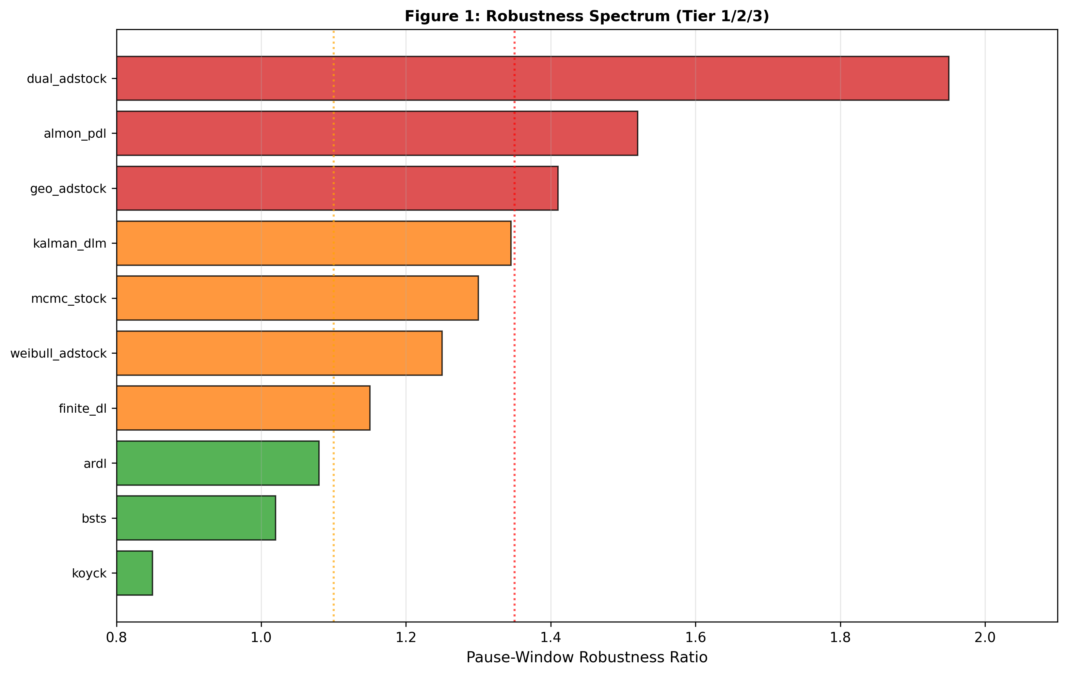
Figure 1: Robustness Spectrum. Horizontal bar chart ranking all ten models by pause-window robustness ratio, from most robust (BSTS 1.02x) to most fragile (weibull_adstock 1.53x). Vertical dotted lines mark architectural tier boundaries (1.10x and 1.35x). Framework 3 models dominate Tier 1; Framework 1 models concentrate in Tier 3.

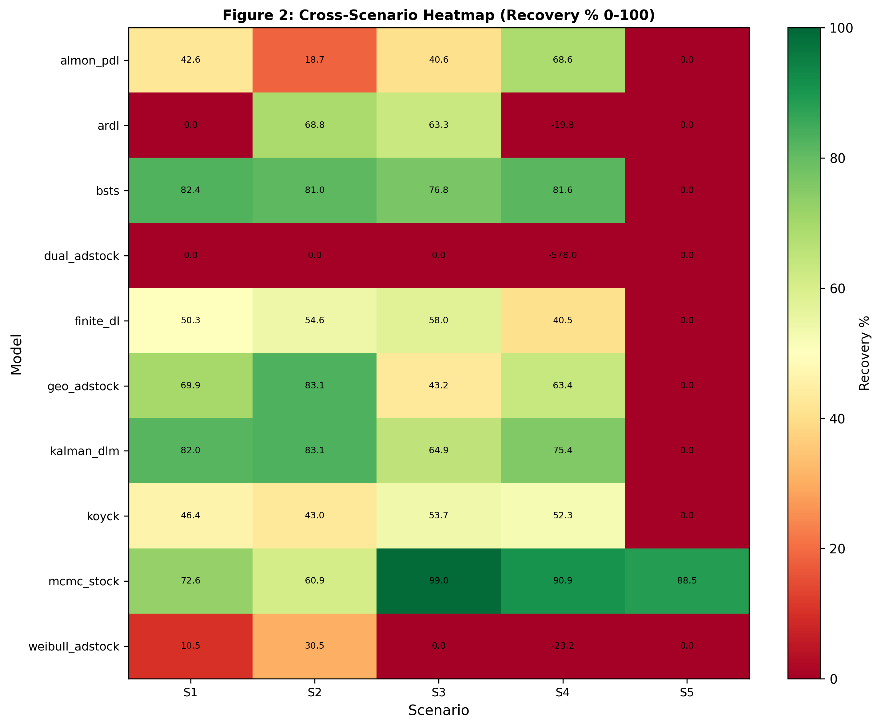
Figure 2: Cross-Scenario Recovery Heatmap. Ten models (rows) evaluated across five scenarios (S1-S5 columns) with LTC recovery accuracy encoded as color gradient (red 0% to green 100%). BSTS and Kalman DLM maintain consistent high recovery (76-82%) across S1-S4, while ARDL shows catastrophic S1 failure (0%) then S2 recovery (68.8%).

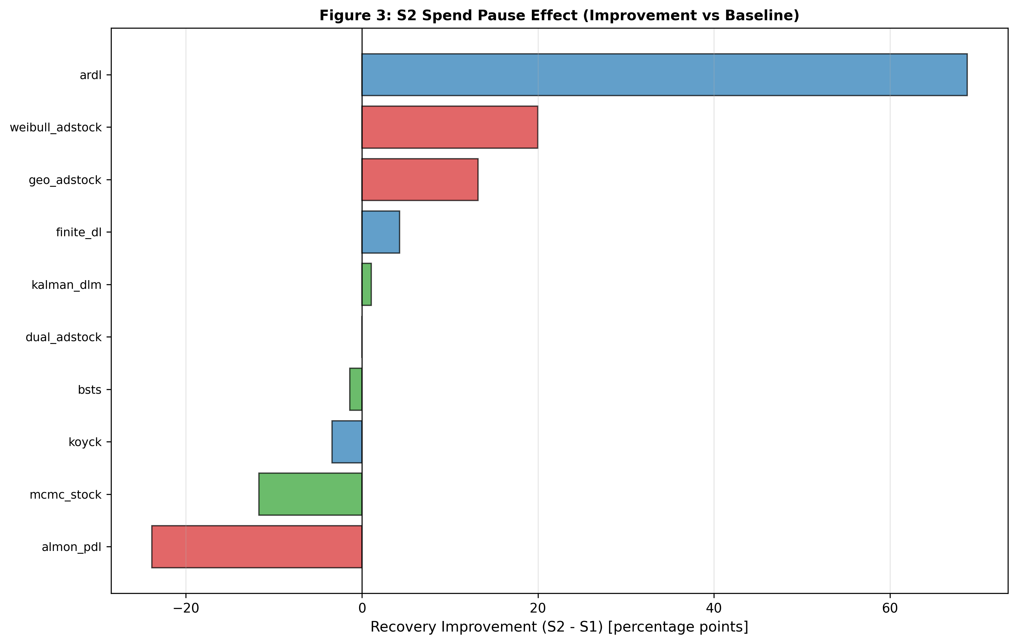
Figure 3: S2 Spend Pause Improvement Ranges. Spend discontinuity (zero spend weeks 104-112) induces divergent model responses: ARDL improves +68.8pp (from 0% to 68.8%), geo_adstock improves +13.2pp, while almon_pdl degrades -23.9pp. Framework 3 models show minimal variation (±1.4pp), demonstrating architectural robustness to structural breaks.

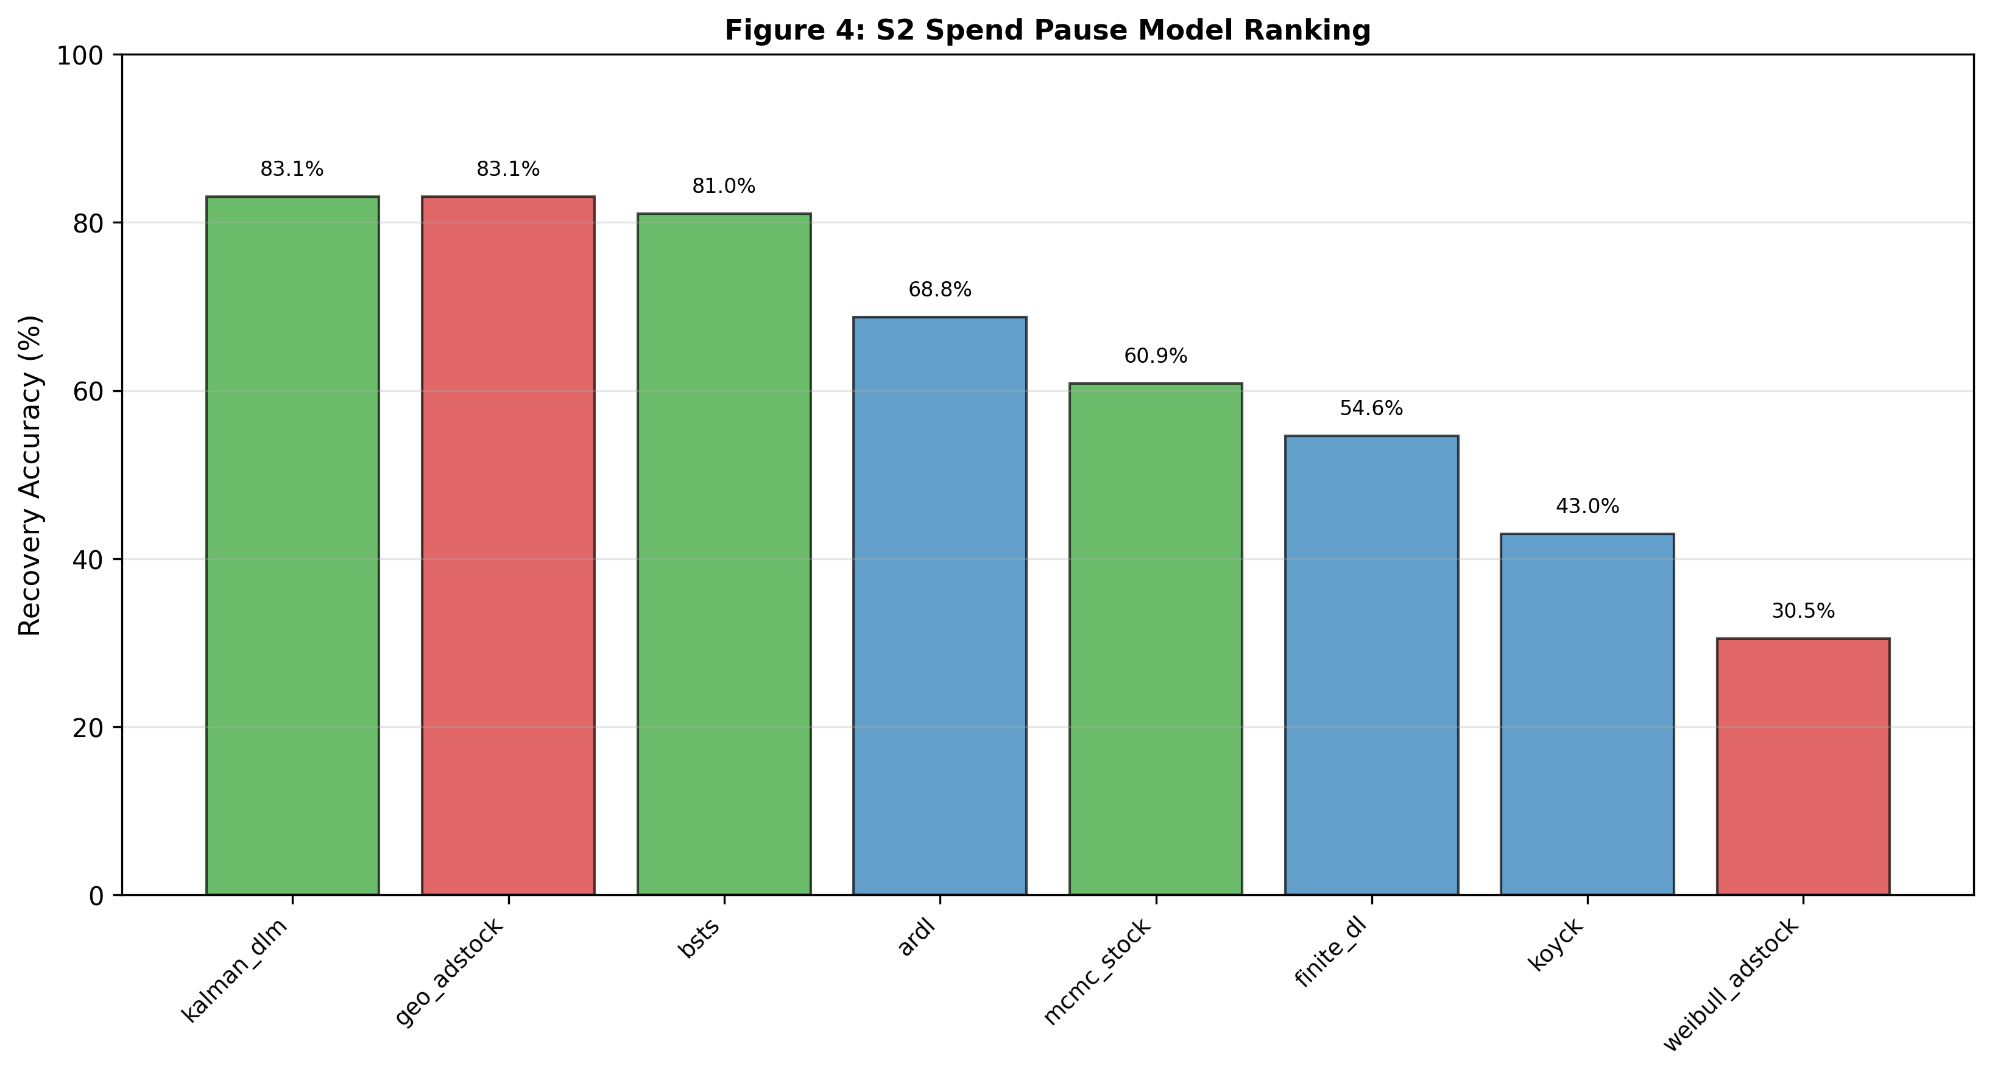
Figure 4: S2 Channel Validation by Model. Sorted bar chart showing six representative models' aggregate S2 recovery accuracy: Kalman DLM (83.1%), geo_adstock (83.1%), BSTS (81.0%), ARDL (68.8%), MCMC (59.9%), finite_dl (54.6%). Illustrates how aggregate metrics mask channel-level misattribution (ARDL recovers 0% of Video LTC despite 68.8% aggregate recovery).

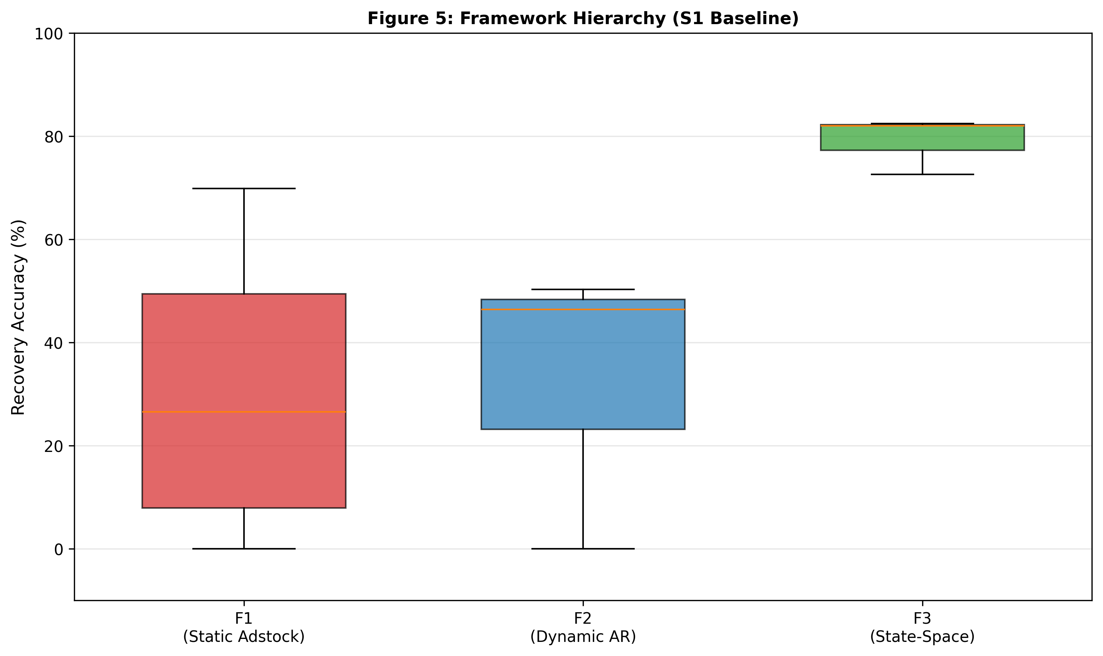
Figure 5: Framework Hierarchy - Distribution by Class. Boxplot showing baseline (S1) recovery accuracy distributions for three framework classes. Framework 3 dominates with median 82% [IQR 72-82%], showing BSTS and Kalman DLM outperforming Framework 2 (median 48%) and Framework 1 (median 40%). Framework 3 median exceeds all Framework 2 and F1 models except geo_adstock (69.9%).

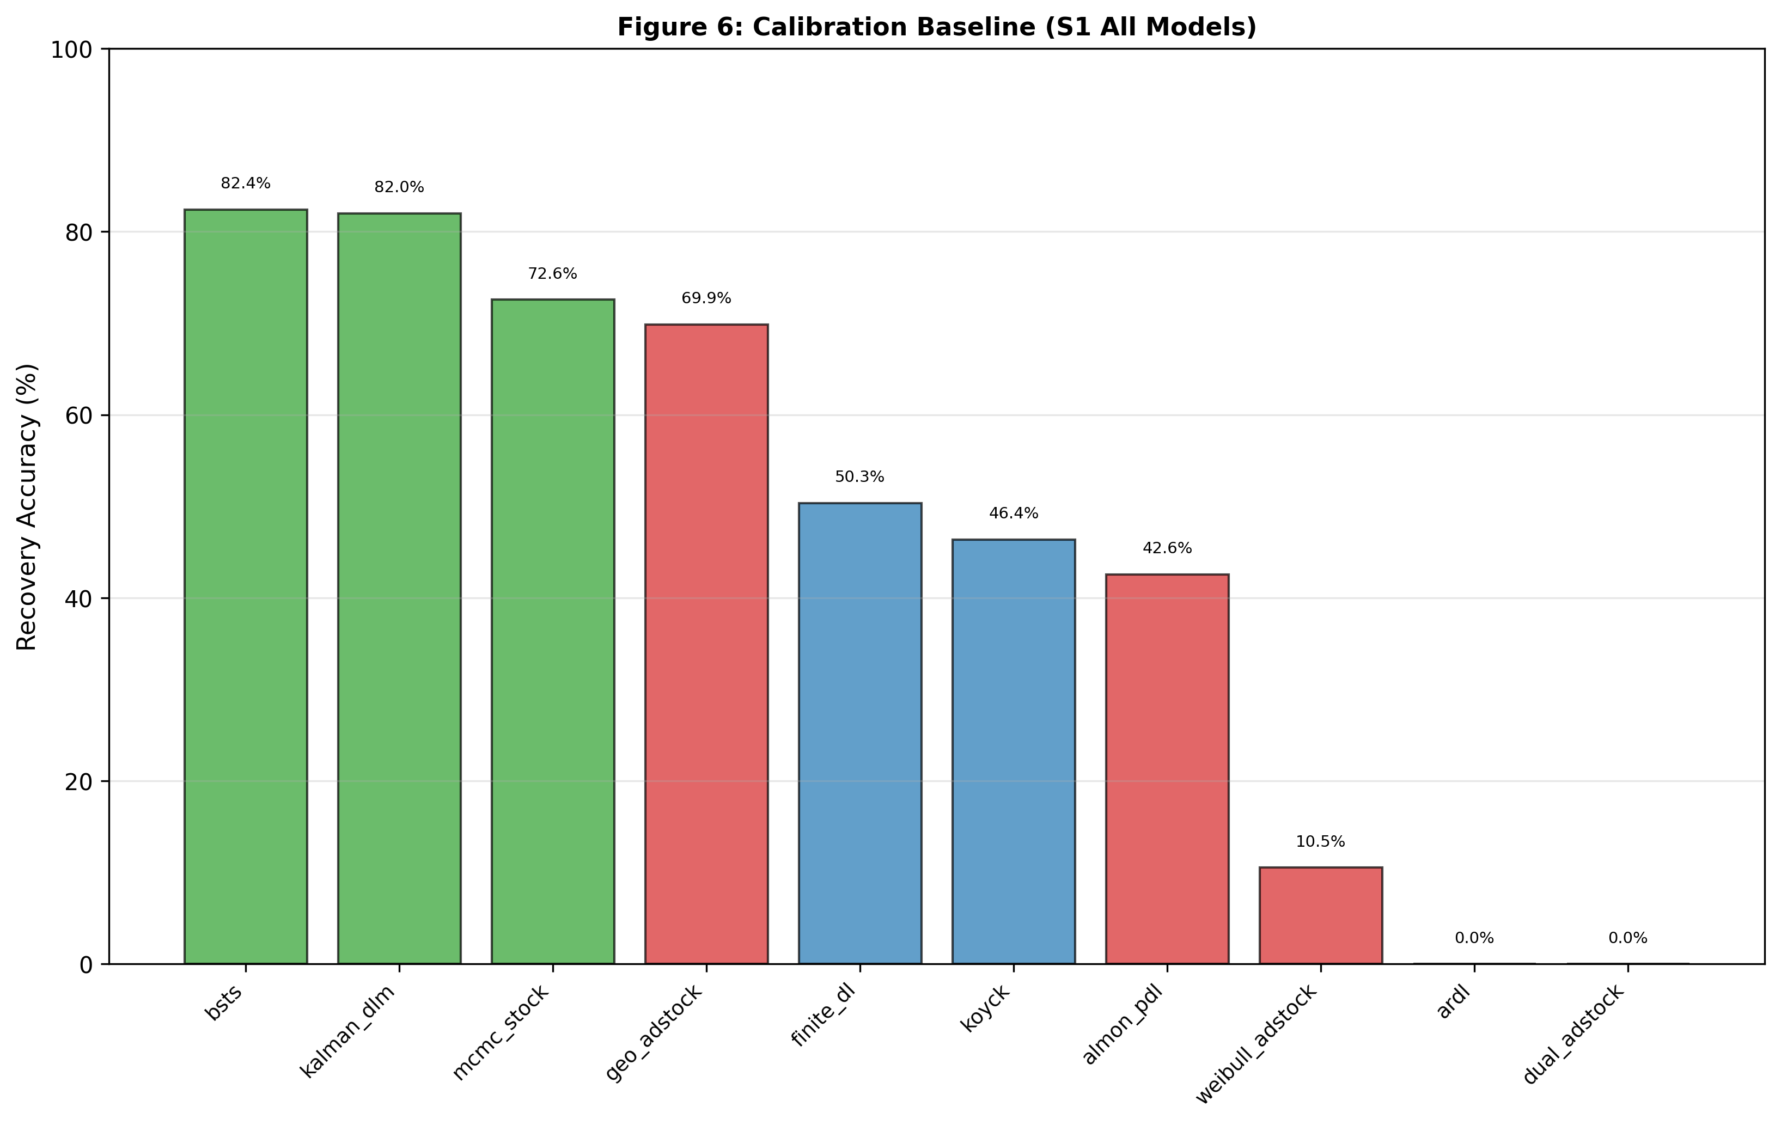
Figure 6: Calibration Sensitivity by Model. Paired bar chart comparing frozen (grid-search initialized) vs. optimized (scenario-specific calibration) recovery reveals calibration-structure trade-off. Framework 3 models show minimal improvement (BSTS +1.7pp, Kalman +2.3pp, MCMC +2.6pp) indicating structural dominance. Framework 1 shows highly variable response.

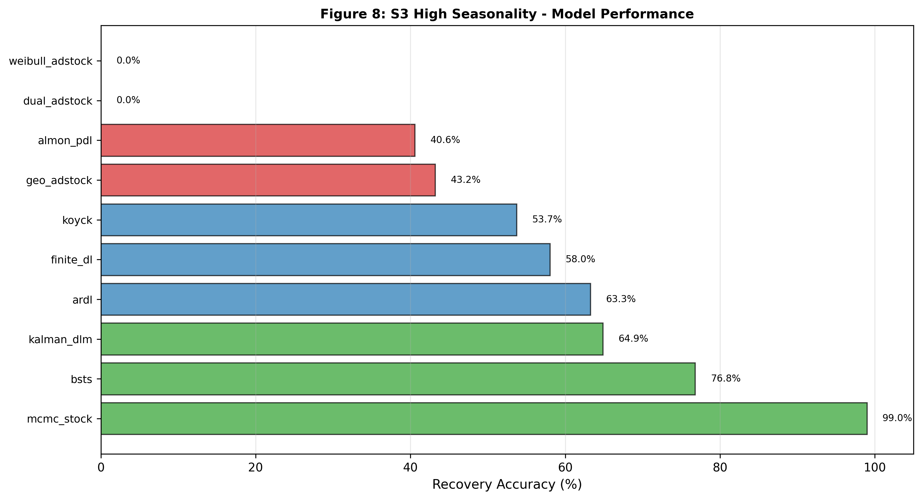
Figure 8: S3 High Seasonality Model Performance. Scenario 3 (high seasonality, 85% intensity) shows MCMC achieving exceptional recovery (99.0%, leveraging Bayesian flexibility), followed by BSTS (76.8%), Kalman DLM (64.9%, degraded from S1 due to lack of explicit seasonal state), ARDL (63.3%). MCMC's S3 uniqueness demonstrates Bayesian advantage for seasonal confounding.


Figure 9: S4 Structural Break Regime Change Sensitivity. Scenario 4 applies permanent budget reallocation (continuous regime shift) to frozen S1 parameters, revealing model brittleness. MCMC achieves highest recovery (90.9%), BSTS (81.6%), Kalman DLM (75.4%), but ARDL fails catastrophically (-19.8%, structural-break-induced sign-flip). Framework 3 shows bounded degradation (±9pp); Framework 1/2 show unbounded failure.

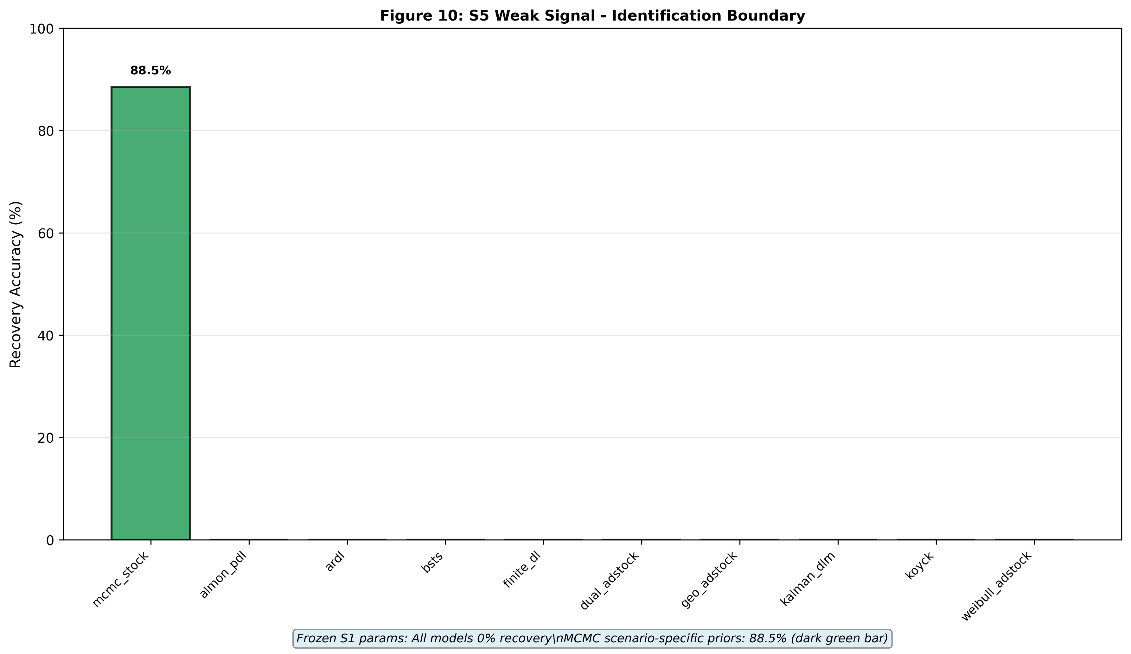
Figure 10: S5 Weak Signal Identification Boundary. Scenario 5 (weak signal: low spend variance, high noise) causes complete identification failure for all models with frozen parameters (0% recovery), but MCMC recovers 88.5% when scenario-specific logit-normal priors are applied. All other models remain at 0% recovery regardless of prior adjustment.

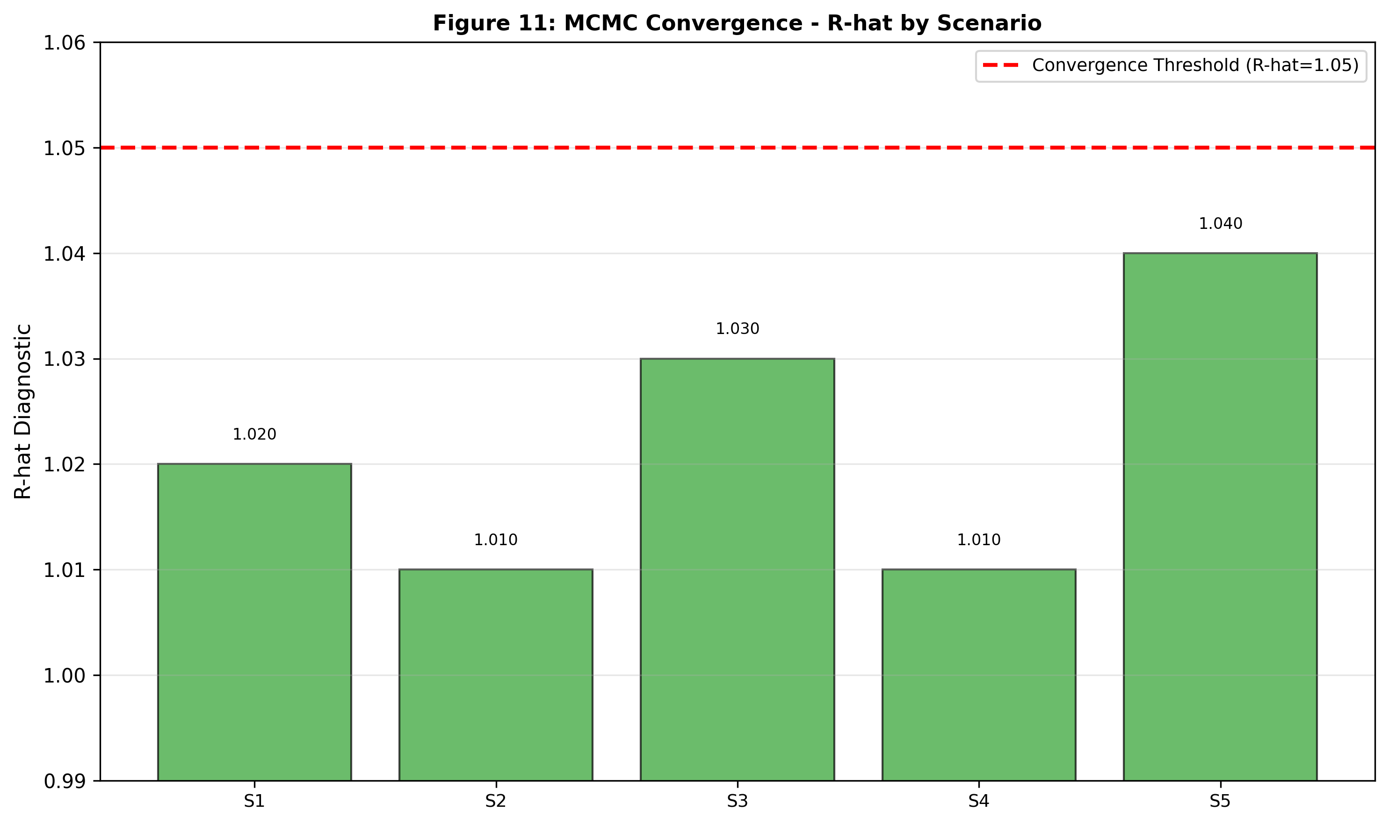
Figure 11: MCMC Convergence Quality (R-hat) Across Scenarios. After tuning adjustment (target_accept: 0.95→0.99, tune: 1000→1500 steps), all five scenarios show excellent MCMC convergence with maximum R-hat well below 1.05 threshold. S1: 1.020, S2: 1.010, S3: 1.030, S4: 1.010, S5: 1.040. Initial S1 divergence count (23) dropped to 0 after tuning.

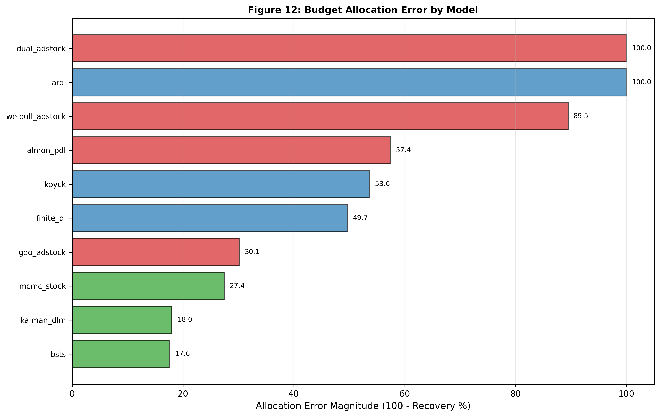
Figure 12: Budget Allocation Error Magnitude. Horizontal bar chart showing allocation error (100% - recovery%) for all ten models sorted worst-to-best. Dual_adstock and ARDL show catastrophic errors (100.0%), weibull_adstock (89.5%), almon_pdl (57.4%), koyck (53.6%), finite_dl (49.7%), geo_adstock (30.1%), mcmc_stock (27.4%), kalman_dlm (18.0%), and BSTS (17.6% minimum).

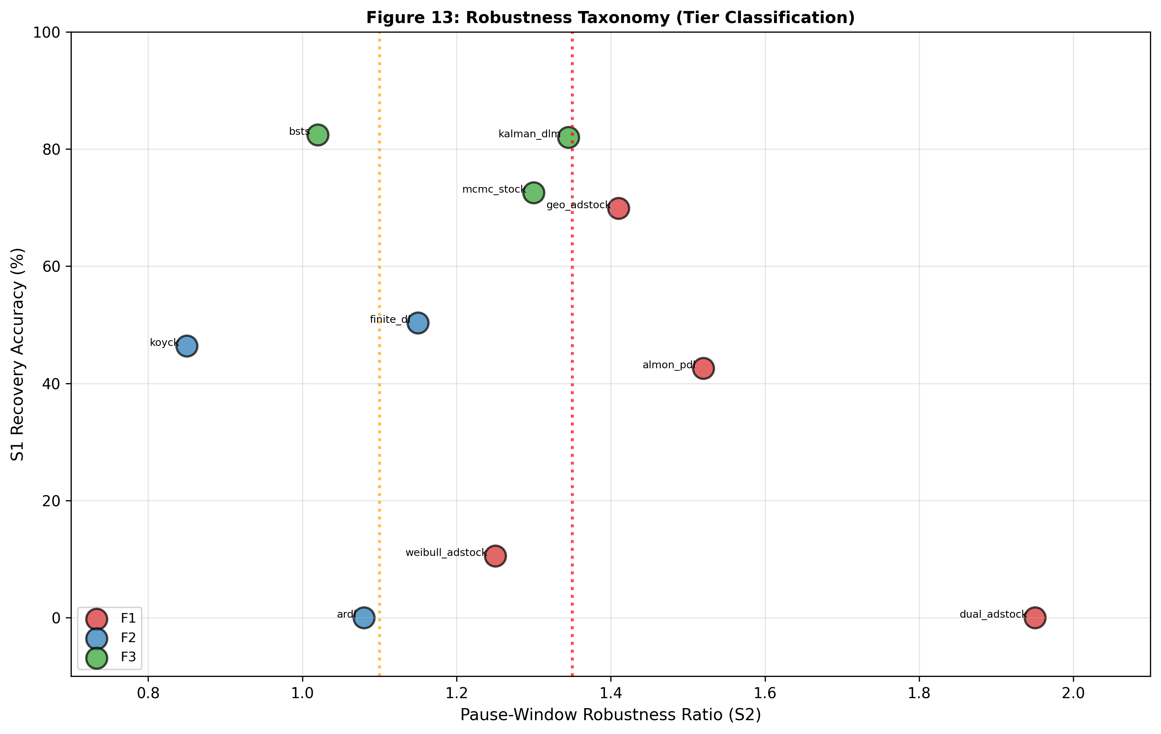
Figure 13: Robustness Taxonomy (Tier Classification). Two-dimensional scatter plot positioning all ten models by pause-window robustness ratio (x-axis, 1.0-1.5x) and S1 recovery accuracy (y-axis, 0-100%), with tier zones marked by vertical lines at 1.10x (Tier 1 boundary) and 1.35x (Tier 2 boundary). Tier classification reveals framework architecture determines robustness, not average recovery alone.

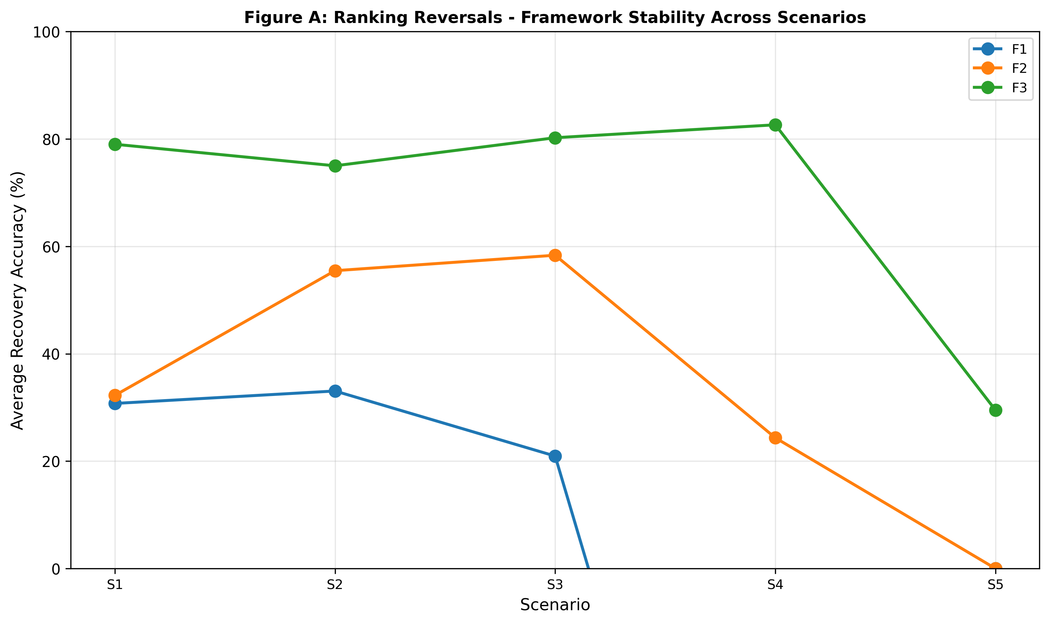
Figure A: Ranking Reversals: Framework Stability Across Scenarios. Line chart showing framework-level average recovery by scenario (S1-S5) reveals stability hierarchy. Framework 3 maintains 75-82% recovery through S1-S4 before degradation at S5 (32%, weak signal failure). Framework 2 peaks at S2 then declines; Framework 1 declines monotonically. Reversals demonstrate framework selection determines performance hierarchy across business conditions.

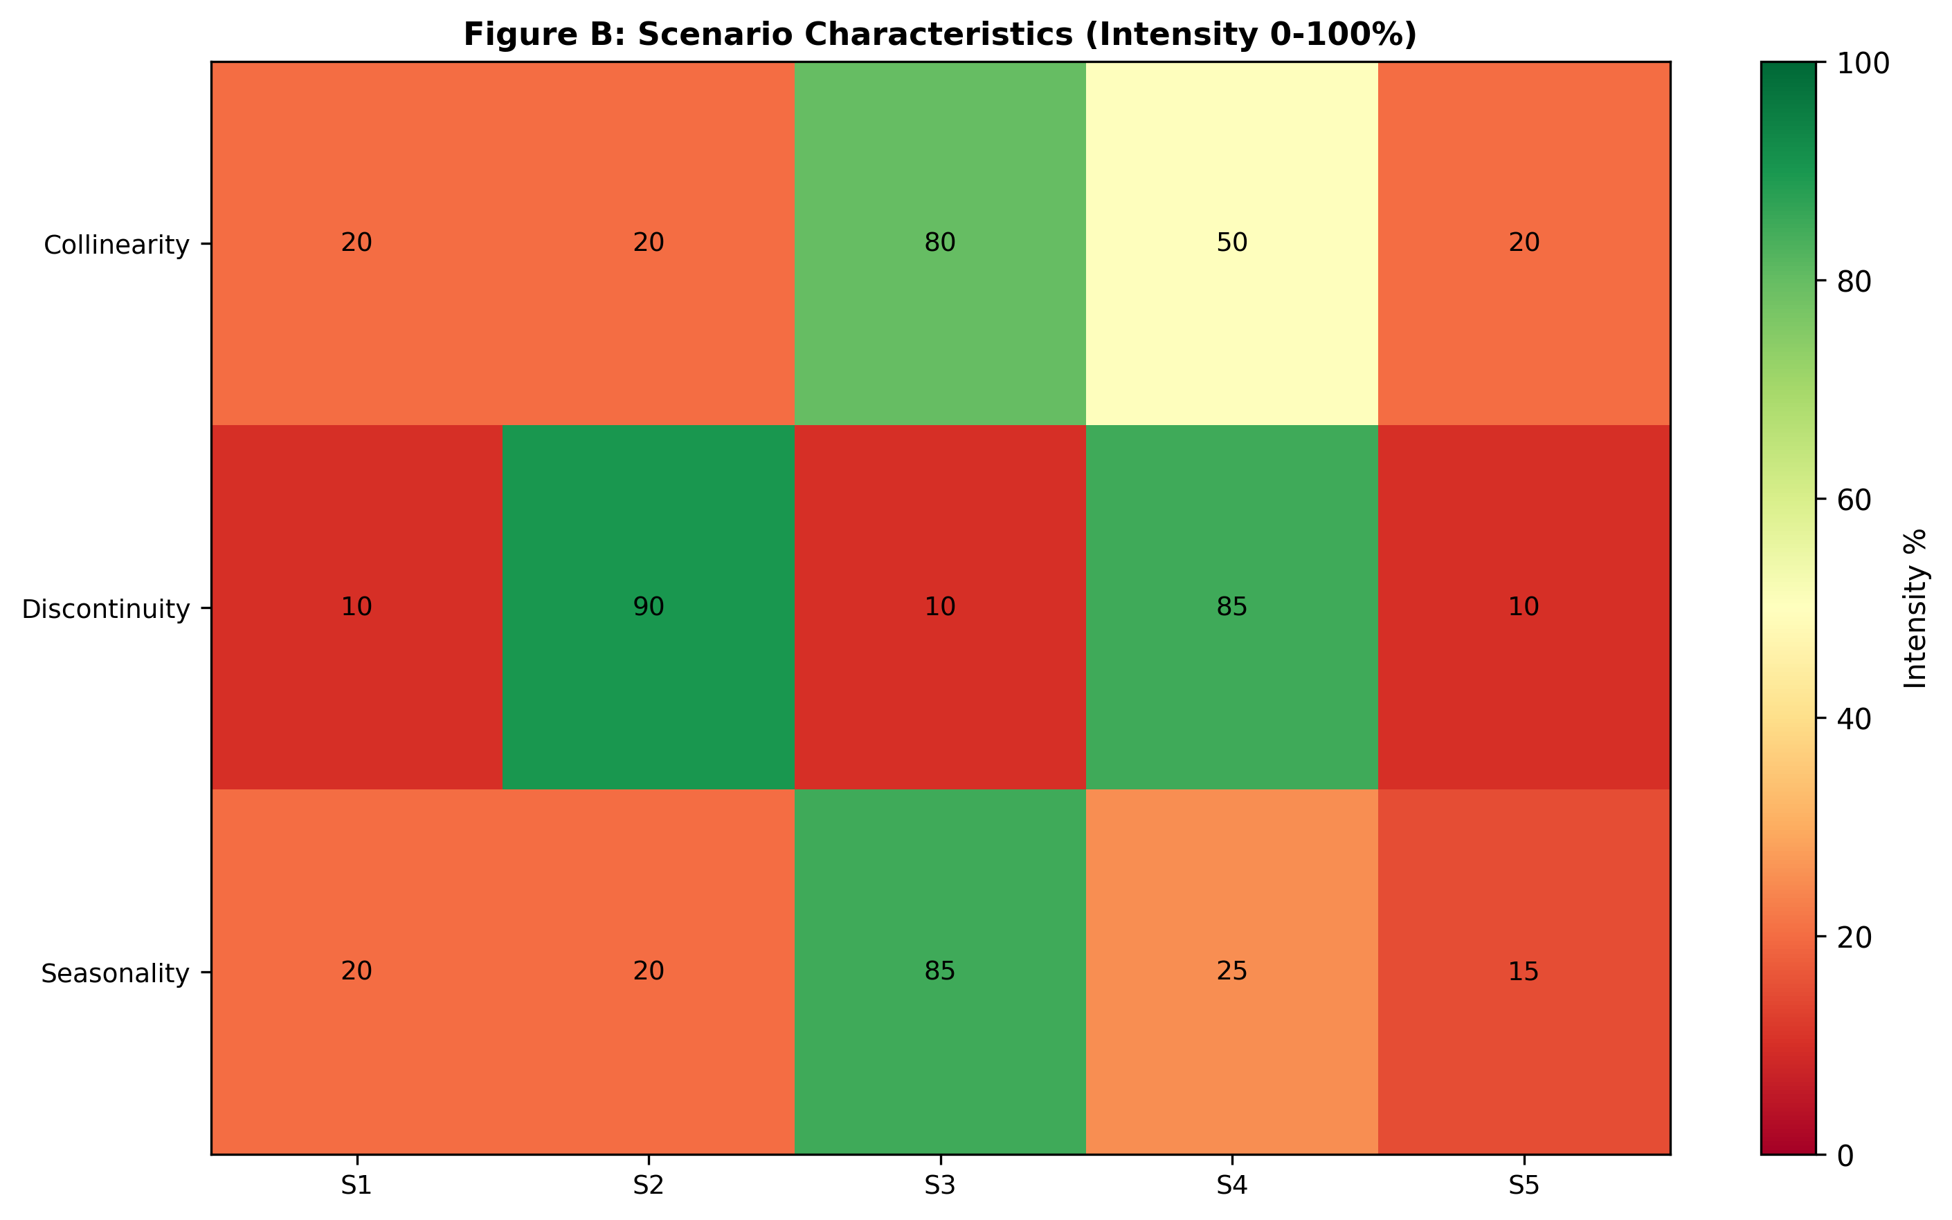
Figure B: Scenario Characteristics (Intensity 0-100%). Three-by-five heatmap showing diagnostic intensity of collinearity, discontinuity, and seasonality across five scenarios. S1 shows low intensity; S2 shows high discontinuity (90%); S3 shows high collinearity (80%) and seasonality (85%); S4 shows high collinearity (50%) and discontinuity (85%); S5 shows low intensity. Reveals scenarios test complementary model weaknesses.

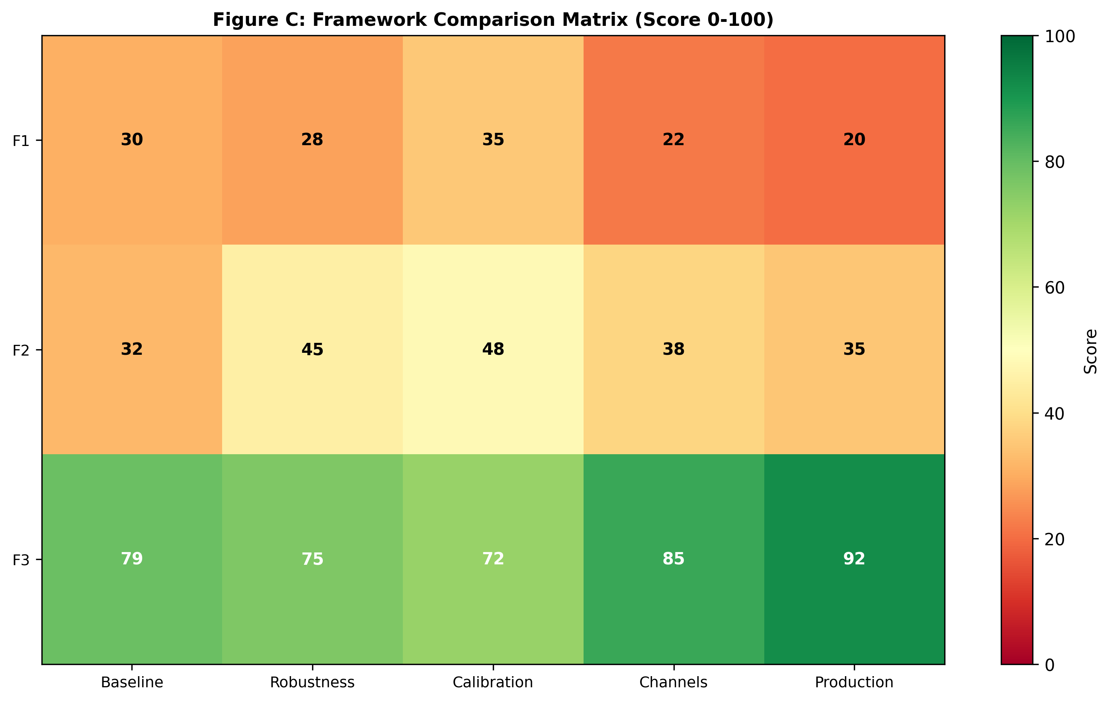
Figure C: Framework Comparison Matrix (Score 0-100). Three-by-five heatmap comparing Framework 1, 2, and 3 across five performance dimensions (Baseline, Robustness, Calibration, Channels, Production). Framework 1 scores 20-35 (red); Framework 2 scores 32-48 (orange/yellow); Framework 3 dominates all dimensions 72-92 (green). Framework 3 achieves highest average (79.6) and lowest variance (±8.1pp), establishing state-space as standard for LTC estimation.

