1. What is Data driven testing?

Read the data from external recourse & run the test is called Data driven testing (parameterization)

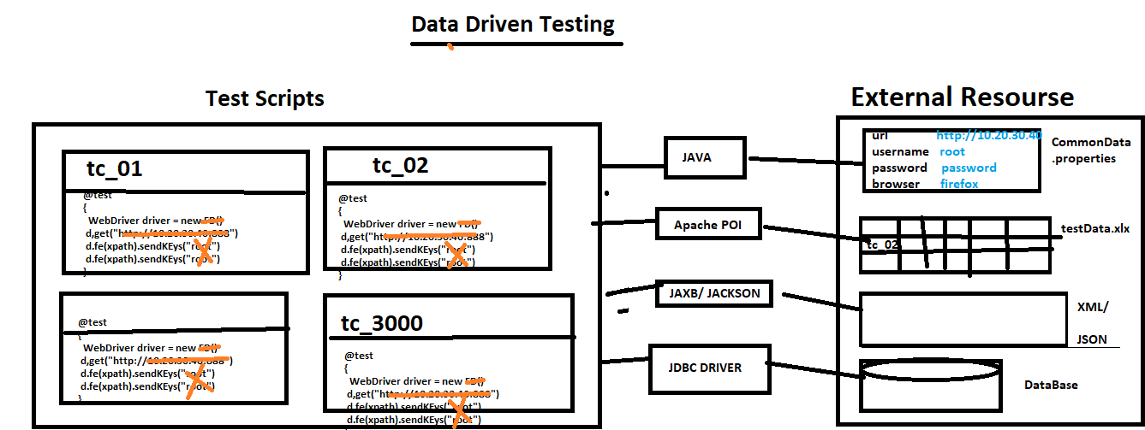

1. Why Data Driven testing ?

As per the rule of the automation data shouldn’t not hardcoded because data modification & maintenance is tedious job when you want to run the test with different data, instead we should get the data from external resource like xlsx, .properties file , db , XML, JSON

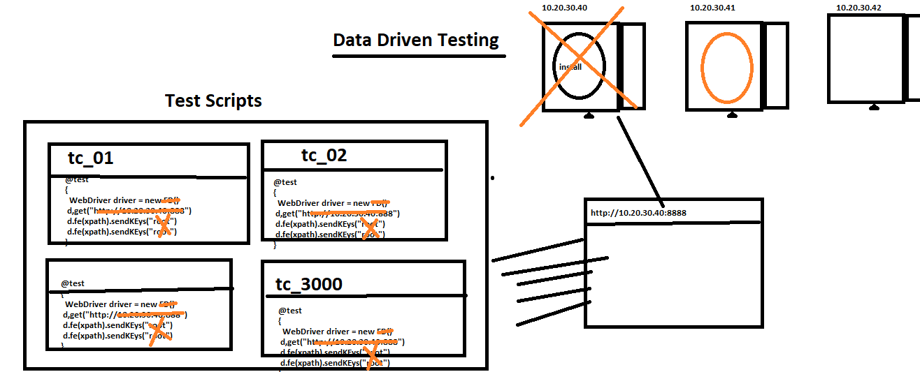

1. What is Advantages of Data driven testing
2. Maintenance of the test data is easy
3. Modification of the test data in external recourse is easy
4. Cross browser testing is easy (means change the browser in property File)
5. Running test scripts in different Environment is easy
6. Running test scripts in different credentials is easy
7. We can create the test data prior the Suite execution (we can also get the data from testData team)
8. Rerunning test Script with multiple time is easy
9. How to read data from properties File?

* Get the java Object of the Physical file using “FileInputSteam
* Create a Object “Properties” class & load all the keys
* Read the data using getProperty(“Key”)

Note : properties file light weight & faster in execution compare to Excel