What is Debugging ?

It’s one of the Execution mode in all IDE(Eclipse) , using to run the test in Slow Mode

Why Debugging or debug is required ?

When we / Jenkins execute 1000 of test scripts in a batch , there are few test got failed due to some issue , in order to find root cause (exact reason ) of the issue we go for debug mode

In Test Scripts development also will use debug mode to the find the failure reason of the issue

, because selenium all ways run test scripts from the beginning

Few Option In Eclipse for Debugging the test

Break Point : used to pause the execution in runtime & wait for user instruction

F5 : control get inside the calling function from called Function , & pause the execution inside the first line of the calling function

F6 : execute line by line

F7 : control get out of the calling function by executing remaining steps in fast mode & control pause the execution where its being called

F8 : execute test in fast mode from one break point to another breakpoint

Ctl+ F2 : terminate the execution

Two Debugging Window

Expression Window : we can execute piece of program in expressions window by modified the Code in runtime

Variable Window : where we can see all the variable / object value in run time

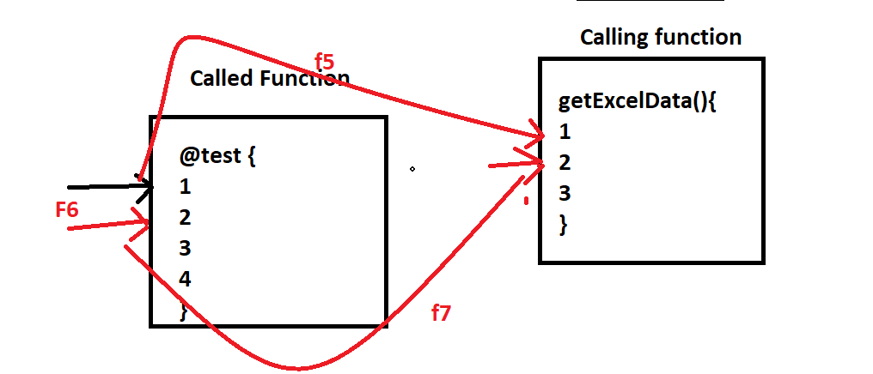

When Ever we 1000 of test Scripts we test got failed, what is your approach towards the failures?

1. Look at the html Report to check which test scripts is getting failed
2. Look the exception & line number of the failure
3. Look the screenshot of the failure
4. Put break point the specific step, where we you have suspect
5. Run the test scripts in debug mode
6. Find the root cause of the issue
7. If issue with respect to product, raise defect in Jira or, if issue with respect to test scripts modify the scripts