1. What is Github

It’s a distributed cloud centralized repository where we can maintain our sourceCode / TestScripts / CRS doc /build of the application in one place

There are 2 Software in GitREpository

1. Git HUB : Cloud based repository(software) , which is used maintain the source code & create an account[https://github.com] in order to use it [no need to install]
2. Git [Git client] : it’s a software should installed in client machine , used to communicate to GITHUB

Advantages of GitHud Cloud

1. Since its cloud based repository , no need have maintenance team to Software / HardWare
2. Cloud means pay rent for usage
3. Cloud software always access via internet
4. Cloud System / sever physically not present within the Organization , but present virtually
5. Initial investment is not required for Software/ Physical location
6. Scale UP / Scale Down is easy
7. File Share between the team members is easier
8. It provides remote access; it means anywhere contributors can access via internet
9. Provide History for changes made by users & backup facility
10. GitHub also provide platform to review the Code of Automaton test scripts
11. GitHub Also handle the conflict’s

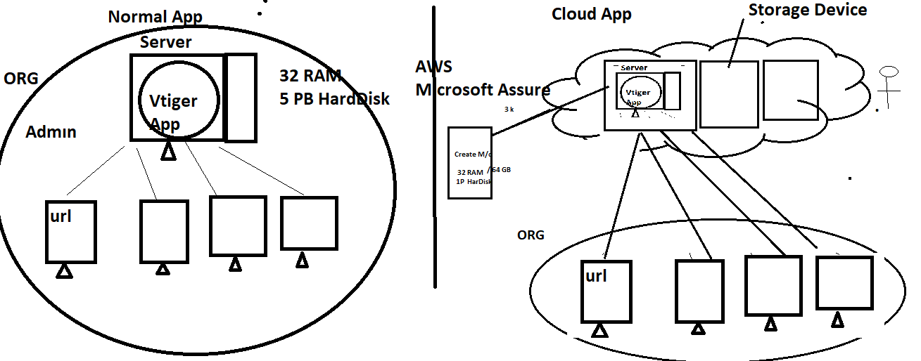

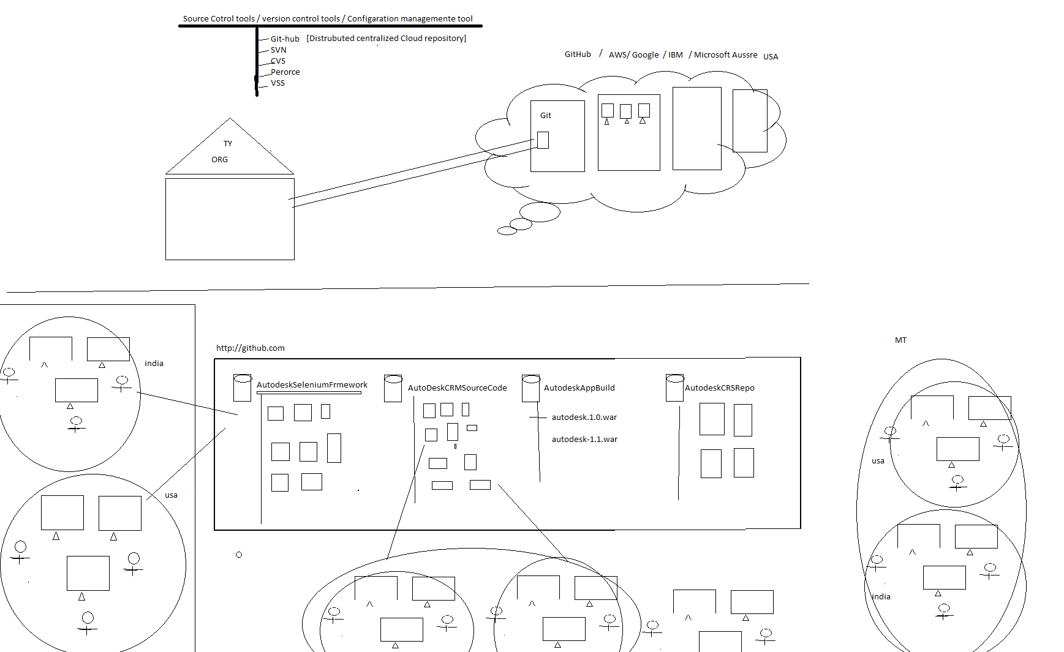

Developer Usage of Git : used to maintain the Source of the Application in one place

Automation Usage of Git : used to maintain the entire Automation framework in one place

DevOps Usage of Git : used to maintain the multiple application build version(like .exe, .war , .tar , .jar etc) in one place

Manual team Usage of Git : used to maintain the entire CRS / usecase of the application

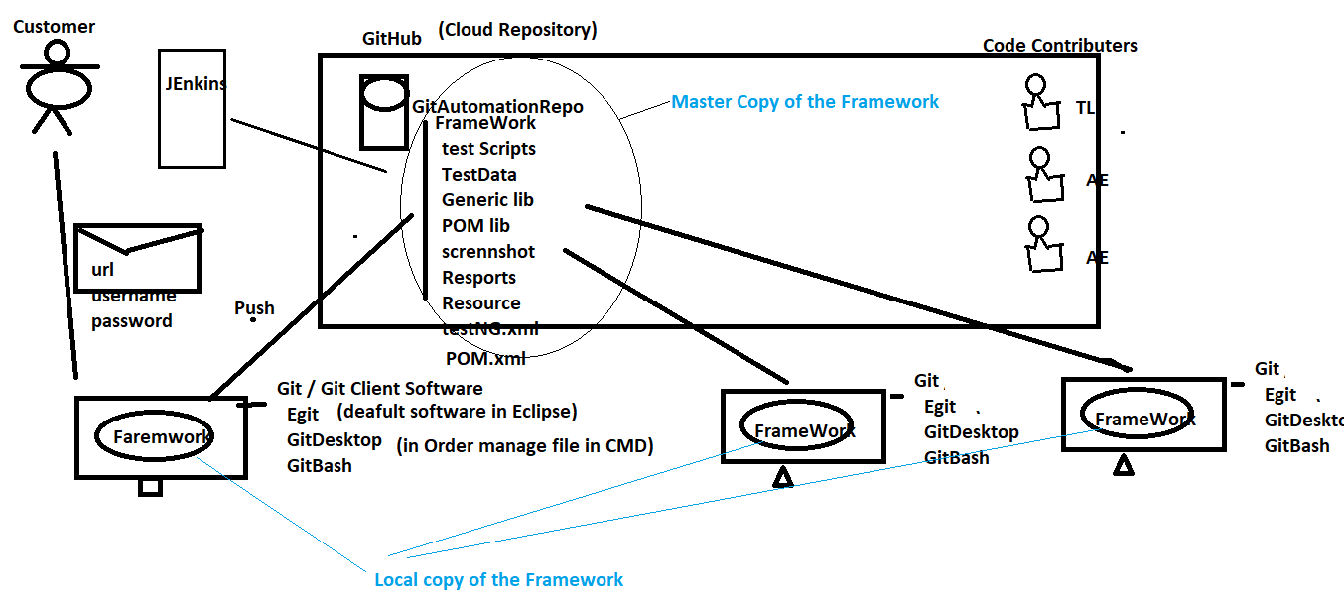

Git Architecture

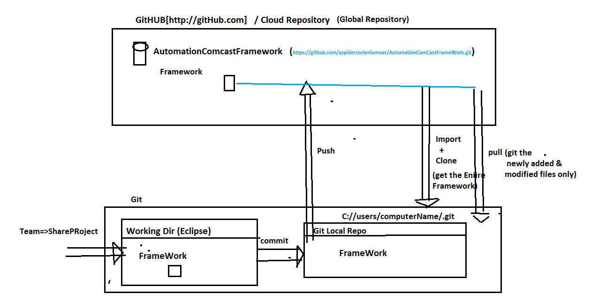

What is Git Conflits

When two or more engineers modified the same file , when Eng-1 one push the file to gitHub will not get any conflits , but Eng-2 try to push the same file to GitHub , will get git

Conflits (because that file already modified by EN-1)

Solution : Before push any to GitHub , we should mandatorily Pull the Project & select merge option , then remove comments manually & analyse the code then push it

What is Pull Request ?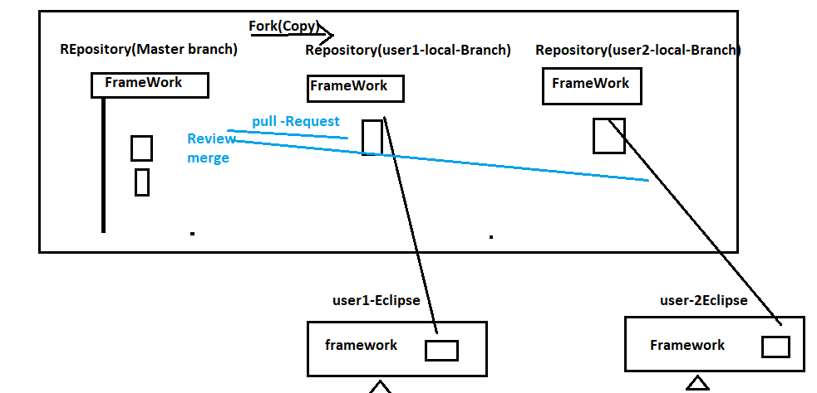

Whenever user made changes in the Programs , some Organization will not have access to push your changes to Master-Branch , in case we supposed to create a local branch using “fork” option , than push the changes to local branch & than create “Pull Request” to Team lead asking for “REVIEW & MERGE” to changes to master branch