1. What is Maven in Automation.

It’s build testing tool, which is used to check the integration & Compilations issues between the framework component ,whenever one users done the modification, addition deletion happened in the framework

1. Why maven if required?

When multiple engineer working with the same framework , their might be chances one engineer modification might affect entire framework , in order to resolve this issue we go for Maven

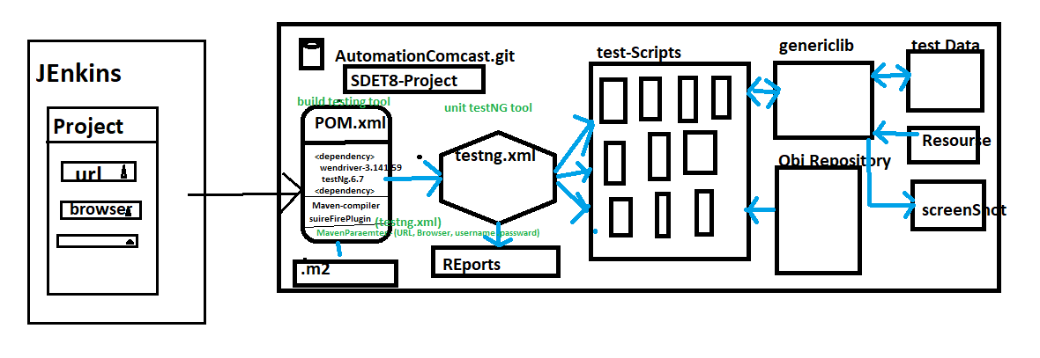

1. Advantages of Maven
2. Check the integration & compilation issue between the framework component whenever modification, addition deletion happened in the framework
3. handle dependencies jars
4. create framework configuration quick setup for new engineers (because all the required dependencies jar. Versions declared in POM.xml, you just to get the framework & run the POM(Update Maven Project) /CMD>mvn test)
5. create framework folder structure
6. we can run the test script in command Line without Eclipse
7. Which is used to check framework build broken or not ?
8. Maven majorly support in Jenkins for CD/CI[Jenkins]
9. Maven also support Profiling (we can have multiple testing.xml file in one Project, so that we go for Profile to execute specific xml file via CMD)

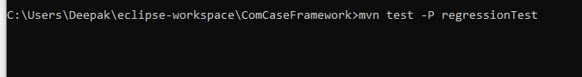

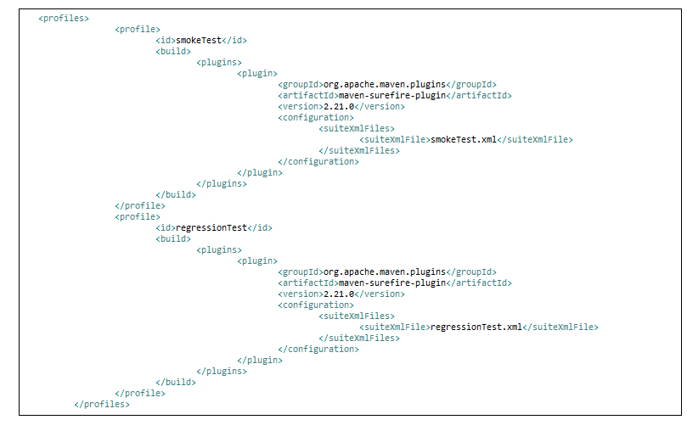 i. Maven also support Command Line parameters

-Dkey = value

Useage in java/Selenium Code

String var = system.getProperty(“Key”)

Eclipse Usage

Right Click on testing File -> Run Configuration 🡺

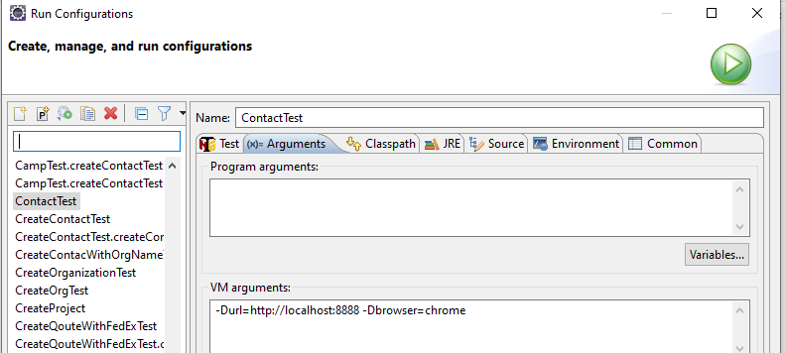

1. What all the Maven Software required to handle maven Project in real time?

* Tow software available in Maven

1. Maven Ellipse Plugin
2. Maven Command Line Plugin

🡺 Maven Ellipse Plugin : it’s a default plugin available in Eclipse Ide , used to create project in Eclipse

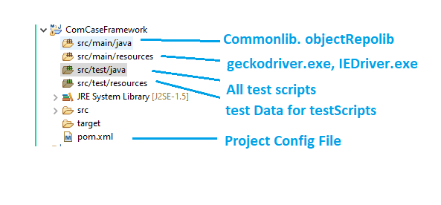

🡺Maven Command Line Plugin : it’s should be installed explicitly in all local computers , used to handle the Maven project in CMD line

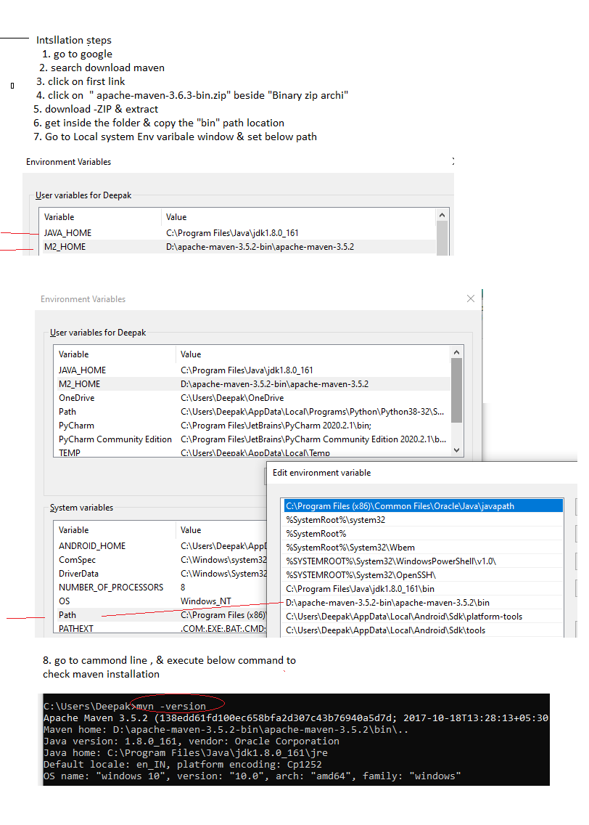

1. How to execute test in CMD
2. PRojecr🡺 RightClick🡺 Properies 🡺 copy the Project location

EG : C:\Users\Deepak\eclipse-workspace\ComCaseFramework

1. Open CMD

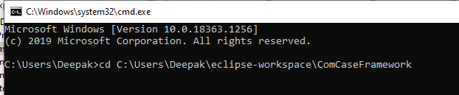

1. Execute Maven commands
2. Explain maven Build Life Cylcle

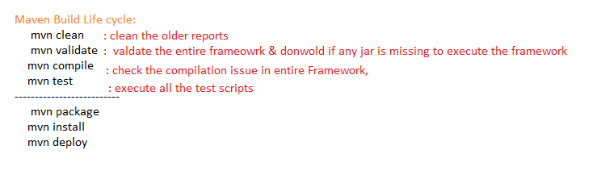

How to execute only one test using maven Cmd

