1. What is Object/Elements Repository

Its collection of elements locators & business libraries in one place , & its shared by multiple test scripts

X`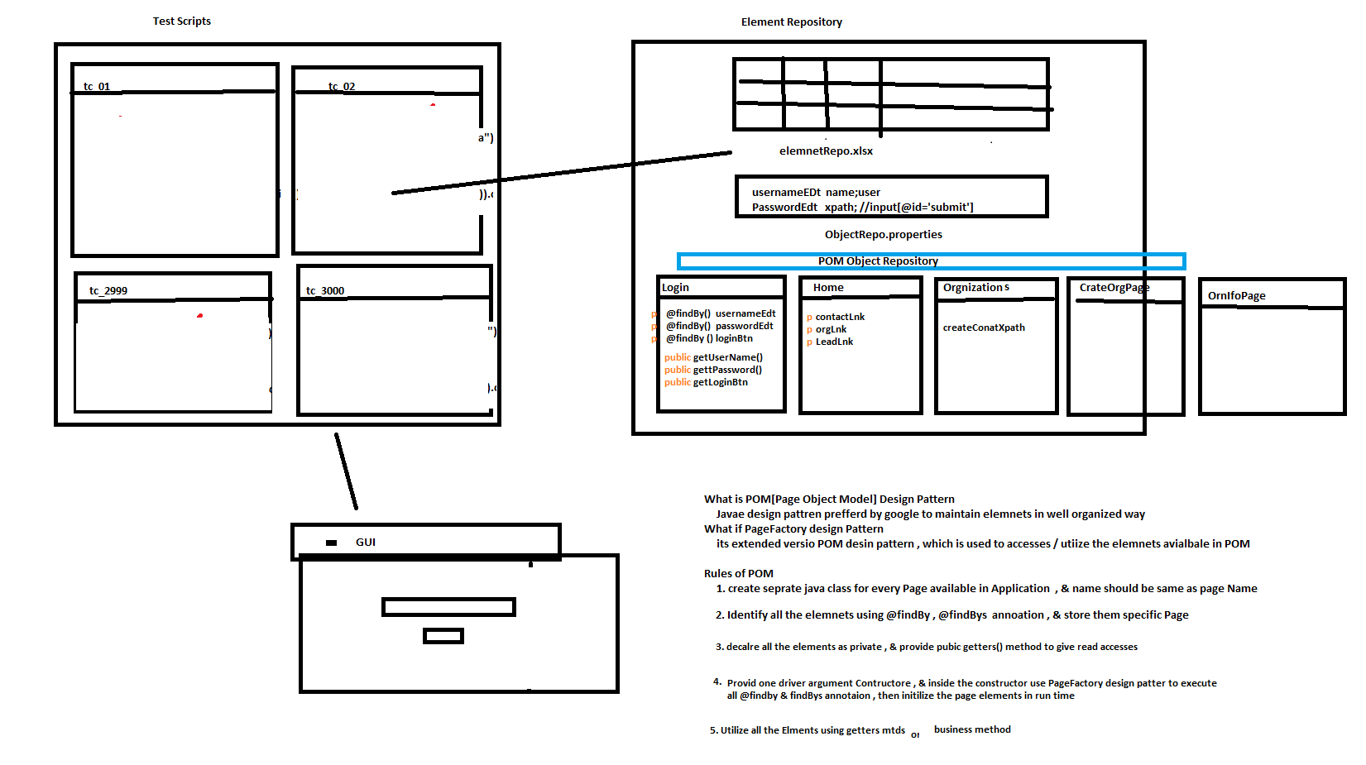

1. Why repository

As per the rule of the automation, we should not hardcode elements in test Scripts instead, we should get elements from Object Repository , because in Agile process due to frequent requirement changes , modification & maintenance of elements is tedious job

1. What is the advantages repository?
2. Reusability of elements, no need to write xpath again & again
3. Modification in Repository is easy, when GUI / frequent requirement changes
4. Maintenance is easy, because all the elements we kept in one place
5. Test Script Code Optimized
6. More Readability
7. Test Script development id faster due to business lib
8. Test Script is more robust
9. Handle Stale Elements Exception.