**SMART WATER MANAGEMENT**

**INTRODUCTION**

Smart water management refers to the use of technology and data monitor, control, and optimize the distribution and driven solutions to efficiently consumption of water resources. It aims to address water scarcity, reduce wastage, and improve overall water quality. Through the use of sensors, remote monitoring, and advanced analytics, smart water management systems provide realt ime insights and autom ation, enabling more sustainable and responsive water infrastructure. This approach plays a crucial role in conserving water, enhancing resilience to climate change, and ensuring a reliable water supply for communities and industries.

**VARIOUS METHODS USED**

1. Smart Sensors: These are deployed in water supply systems to collect realt ime data on water quality, f low rates, pressure, and temperature. They provide insights for effective monitoring and management.

2. IoT (Internet of Things): IoT devices enable remote monitoring and control of water infrastructure. They can detect leaks, measure water usage, and optimize water distribution.

3. Data Analytics: Advanced analytics software processes the data from sensors and other sources to identify patterns, trends, and anomalies, helping to make informed decisions.

4. Geographic Information Systems (GIS): GIS technology helps in mapping and visualizing water infrastructure, managing assets, and optimizing distribution networks.

5. Remote Metering: Smart water meters allow for accurate measurement of water consumption and can transmit data in real time, enabling efficient billing and leak detection.

6.Public Awareness Campaigns: Education and awareness programs encourage water conservation practices among the public.

**SOLUTIONS**

1.Leak Detection Systems: These systems use acoustic or pressure pipelines, minimizing water losses.

2based sensors to detect leaks in water . Automation and Control SSystem: Automated valves and can adjust water flow in response to demand, reducing wastage and improving system efficiency.

3 . Cloud Computing: Storing data and running analytics in the cloud allows for scalable and costsolutions for managing vast amounts of waterrelated data.

4 effective . Mobile Apps: These apps enable consumers to monitor their water usage, receive alerts about leaks, and make informed decisions about water conservation.

5 . Water Quality Monitoring: Continuous monitoring of water quality parameters such as pH, turbidity, and contaminants helps ensure safe drinking water and early detection of issues.

6 . Predictive Analytics: Machine learning models can predict water demand patterns, assist in infrastructure planning, and optimize water distribution.

**TECHNOLOGIES**

•IoT Sensors: Internet of Things (IoT) sensors are deployed throughout water infrastructure to collect data on water quality, pressure, and usage. These sensors provide real-time insights and enable remote monitoring.

• Monitoring and Telemetry: Remote monitoring systems allow water utilities to keep track of water infrastructure performance, detect leaks or anomalies, and remotely control water distribution.

•Data Analytics: Advanced data analytics and machine learning algorithms process the data collected by sensors to identify patterns, predict demand, and optimize water distribution and usage.

•SCADA Systems: Supervisory Control and Data Acquisition (SCADA) systems are used to manage and control various components of water infrastructure, such as pumps, valves, and treatment processes.

•GIS (Geographic Information Systems): GIS technology assists in mapping and visualizing water networks, helping utilities make informed decisions about infrastructure maintenance and expansion.

•Mobile Apps and Customer Portals: Utilities often offer mobile apps and online portals that allow customers to monitor their water usage, report issues, and receive alerts about service disruptions.

•Smart Meters: Advanced water meters equipped with communication capabilities provide real-time consumption data and help customers manage their water usage more efficiently.

•Leak Detection Systems: systems use acoustic and pressure sensors to identify leaks in the water distribution network, reducing water loss.

•Water Quality Monitoring: Sensors and analytical tools are used to continuously assess water quality, ensuring that it meets safety and regulatory standards.

•Predictive Maintenance: Predictive maintenance solutions use data analytics to forecast when equipment and infrastructure components may fail, allowing for proactive maintenance and cost savings.

•Water Treatment Technologies: water treatment methods, such as membrane filtration and UV disinfection, improve the quality of drinking water.

•Drones and Remote Sensing: Aerial and satellite imagery, along with drones, provide valuable data for monitoring water bodies, identifying pollution sources, and managing water resources.

**HARDWARES**:

1.Water quality sensor

2.Flow Meters

3.Pump and valves

4.Central server or cloud platform

5.pressure sensor

6.Remote monitoring device

7.power supply

**METHODOLOGIES**:

1.Data Collection: Gather data on the existing water infrastructure, including sensors, meters, and control systems, and their integration into the smart water management framework.

2. Assessment: Evaluate the effectiveness of IoT sensors, data analytics, and other technologies in monitoring water quality, detecting leaks, and optimizing water distribution.

3.Water Quality Analysis: Assess the impact of smart water management on water quality in terms of improved treatment processes and contamination detection.

4. Engagement: Analyze the adoption of customer-facing apps and portals to promote awareness and responsible water usage among residents.

5.Economic and Environmental Impact: Quantify the economic benefits through reduced water loss and operational costs and assess the environmental benefits in terms of resource conservation and reduced energy consumption

**BENEFITS**:

1. Water Conservation: Smart water management significantly reduces water wastage through real-time monitoring, leak detection, and efficient distribution. This helps in conserving precious water resources.
2. Improved Water Quality: Advanced sensors and treatment technologies ensure better water quality, reducing the risk of contamination and health hazards.
3. Cost Savings: Smart water systems can lower operational and maintenance costs by reducing labor requirements, optimizing resource allocation, and extending the lifespan of infrastructure.
4. Data-Driven Decision-Making: Data analytics provide actionable insights for water utilities, allowing them to make informed decisions, predict demand, and respond quickly to issues.
5. Customer Engagement: Customer portals and mobile apps empower consumers to monitor their water usage, encouraging responsible water consumption and reducing bills.
6. Environmental Benefits: Efficient water management reduces energy consumption, lowering the carbon footprint of water treatment and distributions

**SYSTEM FLOWCHART:** 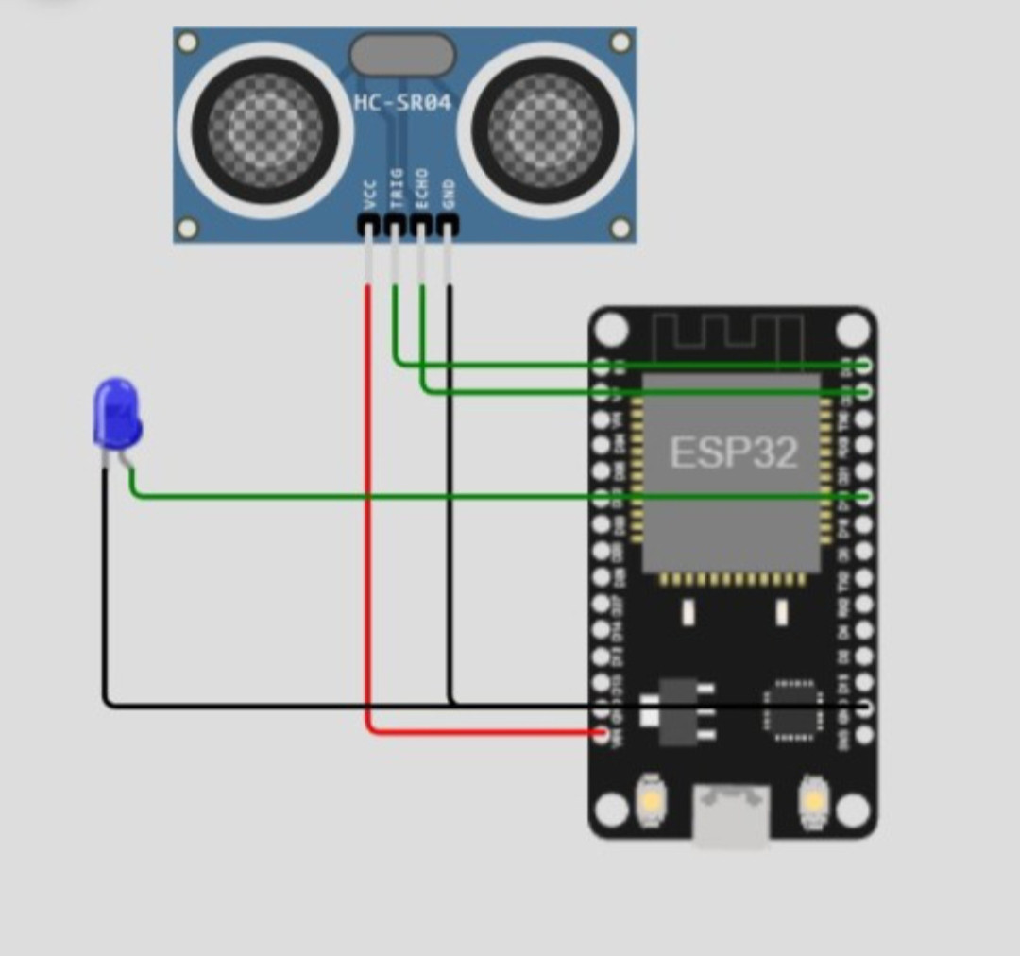

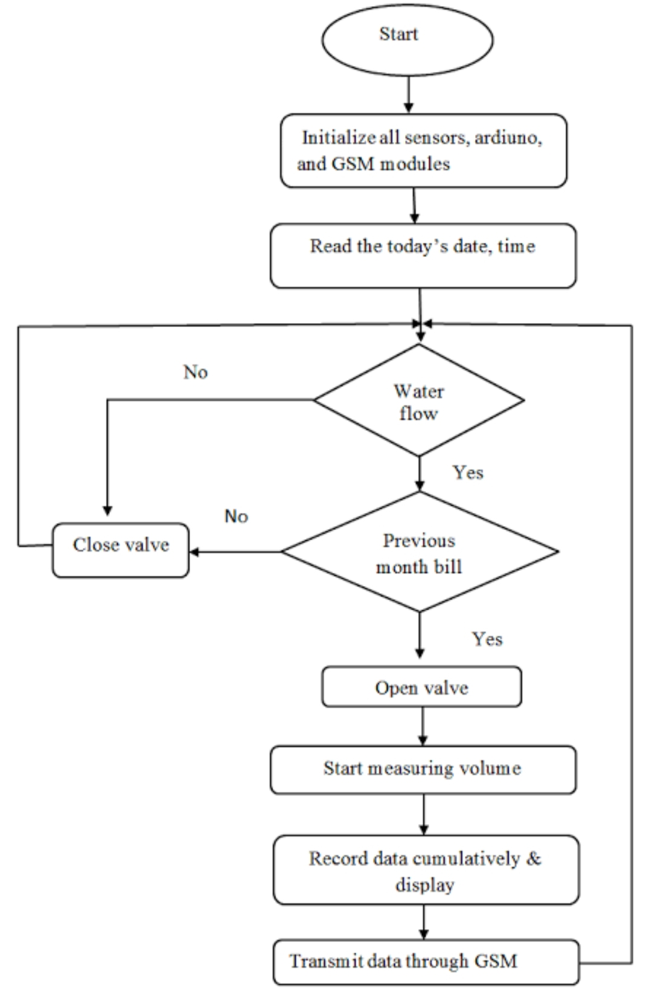

**PROGRAM**

#define PIN_TRIG 26

#define PIN_ECHO 25

#define LOWLED 18

#define MIDLED 19

#define HIGHLED 21

#define MOTOR 27

Unsigned int level = 0;

Void setup() {

pinMode(LOWLED, OUTPUT);

pinMode(MIDLED, OUTPUT);

pinMode(HIGHLED, OUTPUT);

pinMode(MOTOR, OUTPUT);

digitalWrite(LOWLED, HIGH);

digitalWrite(MIDLED, HIGH);

digitalWrite(HIGHLED, HIGH);

digitalWrite(MOTOR, LOW);

Serial.begin(115200);

pinMode(PIN_TRIG, OUTPUT);

pinMode(PIN_ECHO, INPUT);

}

Void loop() {

// Start a new measurement:

digitalWrite(PIN_TRIG, HIGH);

delayMicroseconds(10);

digitalWrite(PIN_TRIG, LOW);

// Read the result:

Int duration = pulseIn(PIN_ECHO, HIGH);

Serial.print(“Distance in CM: “);

Serial.println(duration / 58);

Serial.print(“Distance in inches: “);

Serial.println(duration / 148);

Level = (duration / 10);

If(level < 100)

{

digitalWrite(LOWLED, LOW);

digitalWrite(MOTOR, HIGH);

digitalWrite(HIGHLED, HIGH);

digitalWrite(MIDLED, HIGH);

}

Else if ((level > 200 ) && (level < 400))

{

digitalWrite(LOWLED, HIGH);

digitalWrite(HIGHLED, HIGH);

digitalWrite(MIDLED, LOW);

}

Else if (level >= 400 )

{

digitalWrite(HIGHLED, LOW);

digitalWrite(MIDLED, HIGH);

digitalWrite(LOWLED, HIGH);

digitalWrite(MOTOR, LOW);

}

Delay(1000);

}

**LINK**

[**https://wokwi.com/projects/380203288884062209**](https://wokwi.com/projects/380203288884062209)

**SIMULATION:**

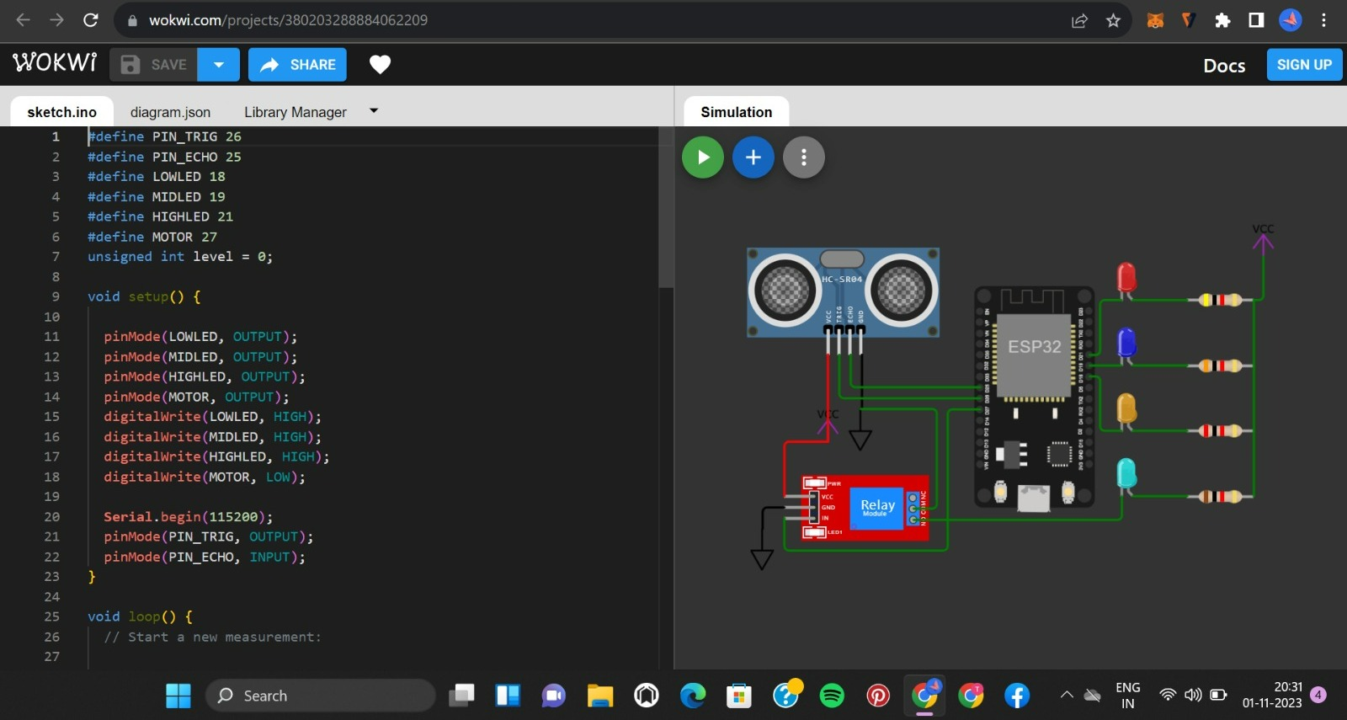

**CONCLUSION:**

Smart water management is a vital approach to addressing the growing challenges of water scarcity and quality in an increasingly urbanized world. Through the integration of technology, data analysis & practices, smart water management offers the potential to optimize water usage, reduce waste, and enhance the overall resilience of water resources. It not only benefits the environment but also supports economic and social well-being. However, successful implementation relies on collaboration between governments, industries, and communities, as well as continued research and investment in innovative solutions. The future of water sustainability depends on our commitment to adopting and advancing smart water management practices.