# Deploying Changes for OrderPaid.VendorNotification

1. Find the directory that hosts the application. (You can open the IIS. Find the site and right click and explore the files from the site)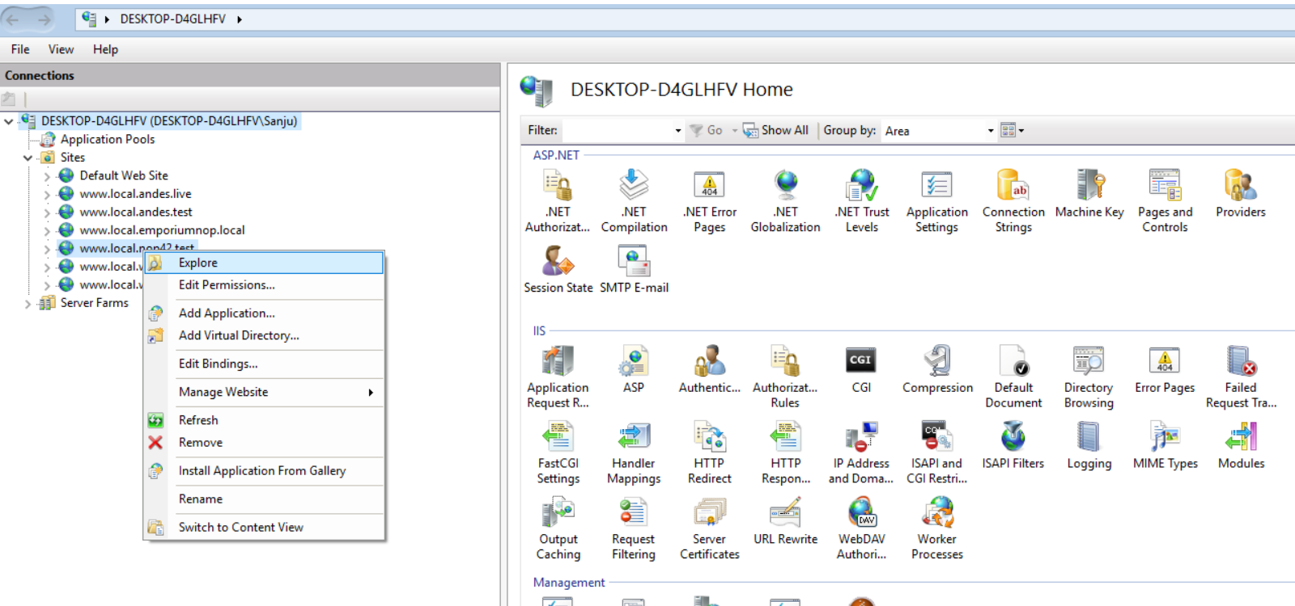
2. Find the file named “Nop.Services.dll” and “Nop.Services.pdb” and backup the files. (Backing up the file is important. We can roll back the site to initial state if anything goes wrong)

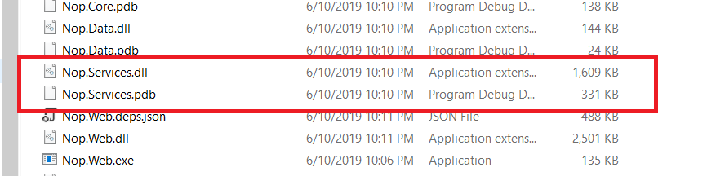

1. Copy and paste the “Nop.Services.dll” and “Nop.Services.pdb” and from the attachment which I have provided.
2. Restart the application.
3. Open the website, go to the {yourstore}/Admin/Language/Edit/1 and add the language resource with resource name “Messages.Order.Product(s).ManufacturePartNumber” and value as “MPN”

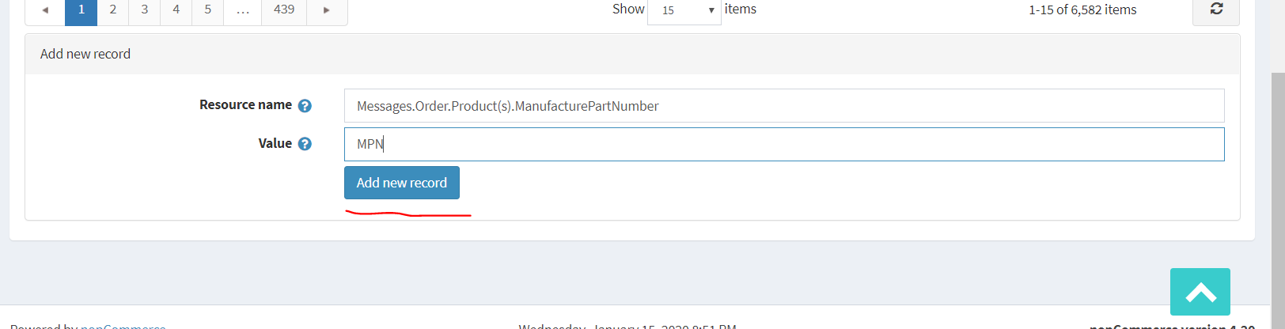

1. Restart the application
2. Test the feature and verify