What is DevOps?
DevOps is a combination of development (Dev) and operations (Ops). It is a culture and technical movement (practice) that bridges the gap between software developers and IT operations.
In short: DevOps is not a tool or a job title — it’s a culture, set of practices, and philosophy aimed at delivering software faster, more reliably, and with higher quality.

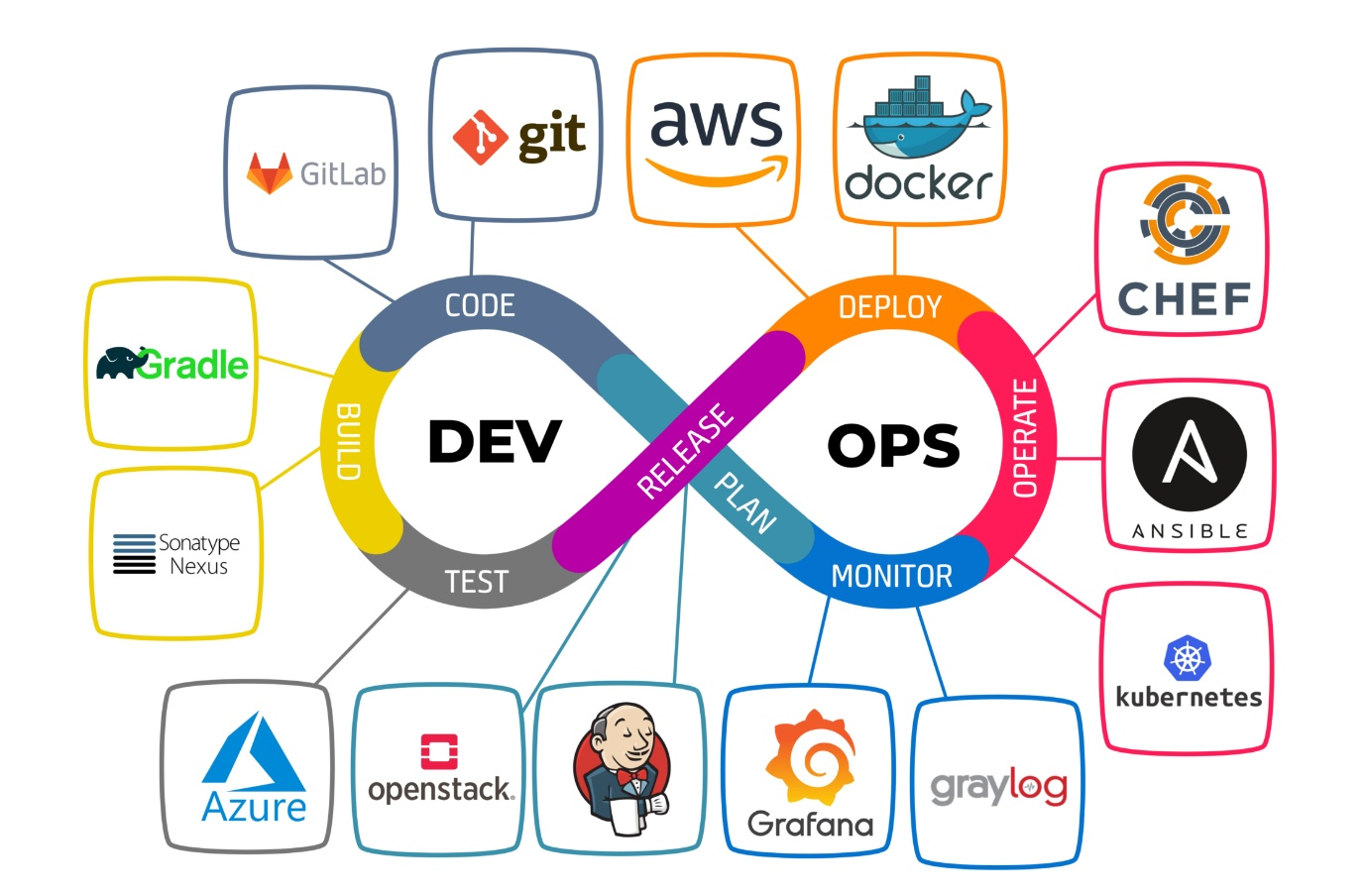

The goal is faster, high-quality software delivery.

Why is DevOps important?
- Speeds up the software development process.
- Improves collaboration between teams (Dev & Ops).
- Better product quality and faster issue resolution.

DevOps key principles?
- Collaboration: Developers and IT teams work together.
- Automation: Tasks like testing and deployment are automated.
- Continuous Improvement: Regularly enhance and optimize processes.

Development without DevOps
- Software updates took a long time to release.
- Developers and IT teams worked in silos, causing miscommunication.
- Manual processes led to more bugs and deployment failures.
- User’s feedback was not integrated quickly into updates.

Roles of a DevOps Engineer?
- Bridges the gap between development and IT teams.
- Ensure (be done) CI/CD pipelines are set up and working efficiently.
- Manage infrastructure, automation, and monitoring.
- Enhance (improve/increase) system reliability, scalability, and performance.

