THIRD IRIS
VISION-ONLY UAV SYSTEM · PROPOSAL WIREFRAME · 2026
Sees. Tracks. Needs no GPS.
An aerial system that detects, follows and intercepts a moving target — and navigates itself — using nothing but a camera, even under full GPS jamming.
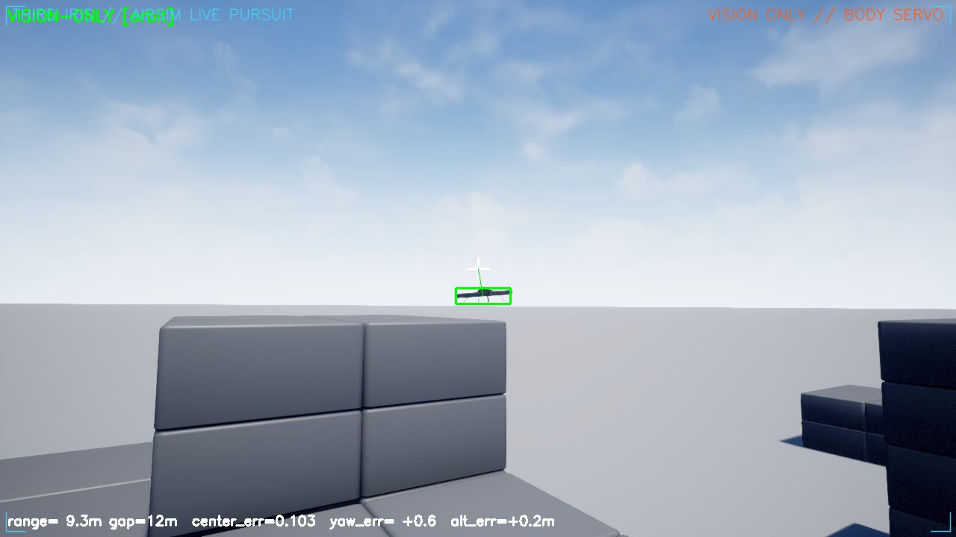
▲ Live drone-feed: target locked in flight, vision-only, no GPS. Range and telemetry overlaid on the on-board camera.
✎ EDIT: This is the cover. Swap headline / tagline freely; replace the image with any locked-target feed frame.
——————————————————————————————————————————————
THE PROBLEM
02 Why vision, not GPS
- GPS-dependent: GPS can be jammed or spoofed in contested airspace — it is the first thing to fail.
- Vision-driven: Cameras are passive — nothing to jam, nothing to spoof, no emissions to detect.
If the aircraft can see, it can navigate, track and finish the mission. The eye is the backup that cannot be jammed.
——————————————————————————————————————————————
SYSTEM CONCEPT
03 One camera, two minds
Every frame is consumed twice: one pipeline watches the TARGET (detect + follow), the other watches the WORLD to localize the aircraft itself. GPS becomes optional.
- SEE — detect + segment the target
- TRACK — lock on and predict its motion
- LOCATE — estimate own position with no GPS
- AVOID — steer around obstacles
- ACT — follow / intercept at 10 Hz
——————————————————————————————————————————————
HOW IT WORKS · TECHNICAL
04 How vision navigates without GPS
High-level terms only — enough to show the method, not a recipe to copy.
- Detection & segmentation: a fine-tuned single-stage neural detector with instance segmentation localizes the target every frame; a dedicated bird class suppresses false locks.
- Tracking: a multi-object tracker with re-identification holds a stable target ID; an image-space Kalman filter predicts the target's bearing and coasts through detection drop-outs.
- Visual servoing (GPS-free): guidance is computed in the body frame directly from the target's pixel bearing and depth — pixel offset becomes yaw-rate, climb and forward-velocity commands. Needing no absolute position, it is immune to GPS jamming.
- Self-localization (VIO / VINS): visual-inertial odometry fuses camera feature motion with the IMU at high rate to dead-reckon the drone's own 6-DOF pose when GPS is denied; a magnetometer bounds heading drift; place recognition (SLAM-style) corrects accumulated drift.
- Depth & 3-D: a depth sensor gives metric range to the target and a depth-as-LiDAR obstacle field for reactive avoidance, plus a live 3-D sense of the scene.
- Learned pilot: the flight policy is a small neural pilot — learned by imitating a classical guidance law, then improved with reinforcement learning — running instantly on-board.
——————————————————————————————————————————————
ACCURACY & VALIDATION
05 How accurate it is
All figures measured in simulation / on real validation data — not claimed.
Metric | Result
Target detection (real held-out) | mAP50 ≈ 0.80 and climbing
Target detection (simulation) | mAP50 ≈ 0.97
Target kept in frame (vision-only) | ≈ 90%+
Learned-pilot centering error | 0.107 — 2.5× tighter than hand-tuned law
Stand-off hold error | ≈ 4.3 m (vs 7.2 m baseline)
Collisions across maneuver suite | 0
Control loop / supervisor cadence | 10 Hz pilot · ~0.5 Hz agent
✎ EDIT: Update these numbers as training / sim runs improve. Detector mAP is mid-training here.
——————————————————————————————————————————————
PERCEPTION
06 Trained on the real threat
The detector is fine-tuned on ~50,000 real images of Shahed-type loitering munitions and quadcopters, plus synthetic data. Below: our model running on unseen real frames. (Note: the current public Shahed dataset proved low-quality; clean real frames here are quadcopters.)
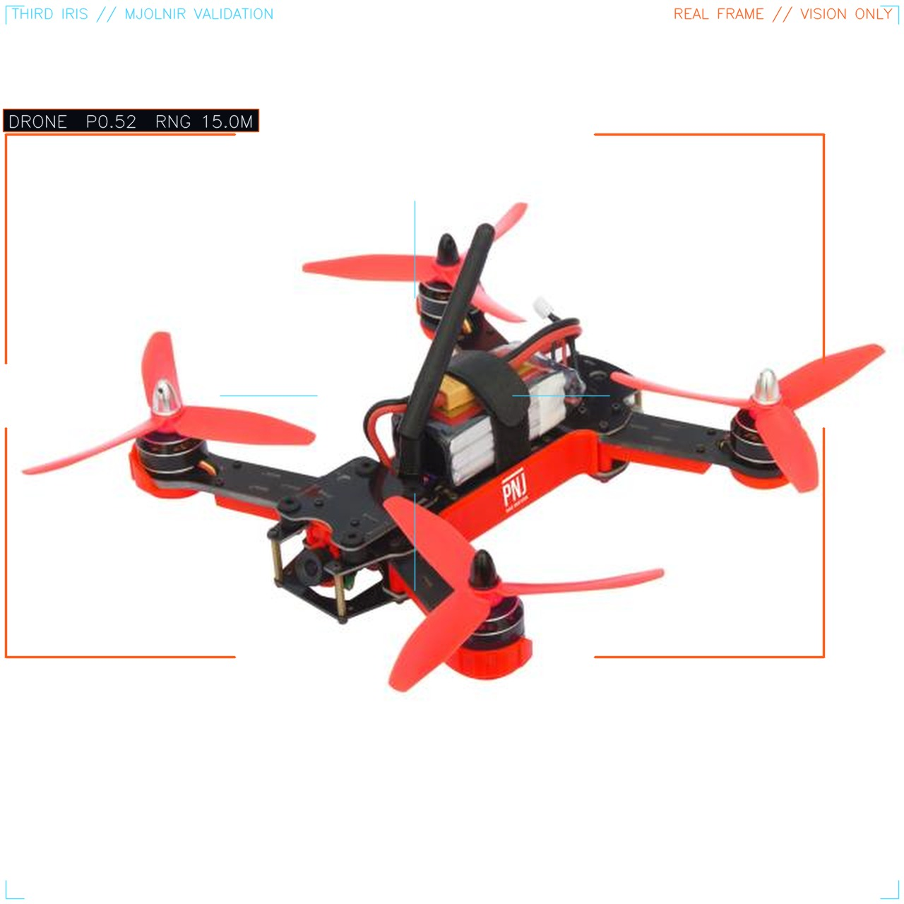
▲ Real quadcopter in flight — detected mid-manoeuvre.
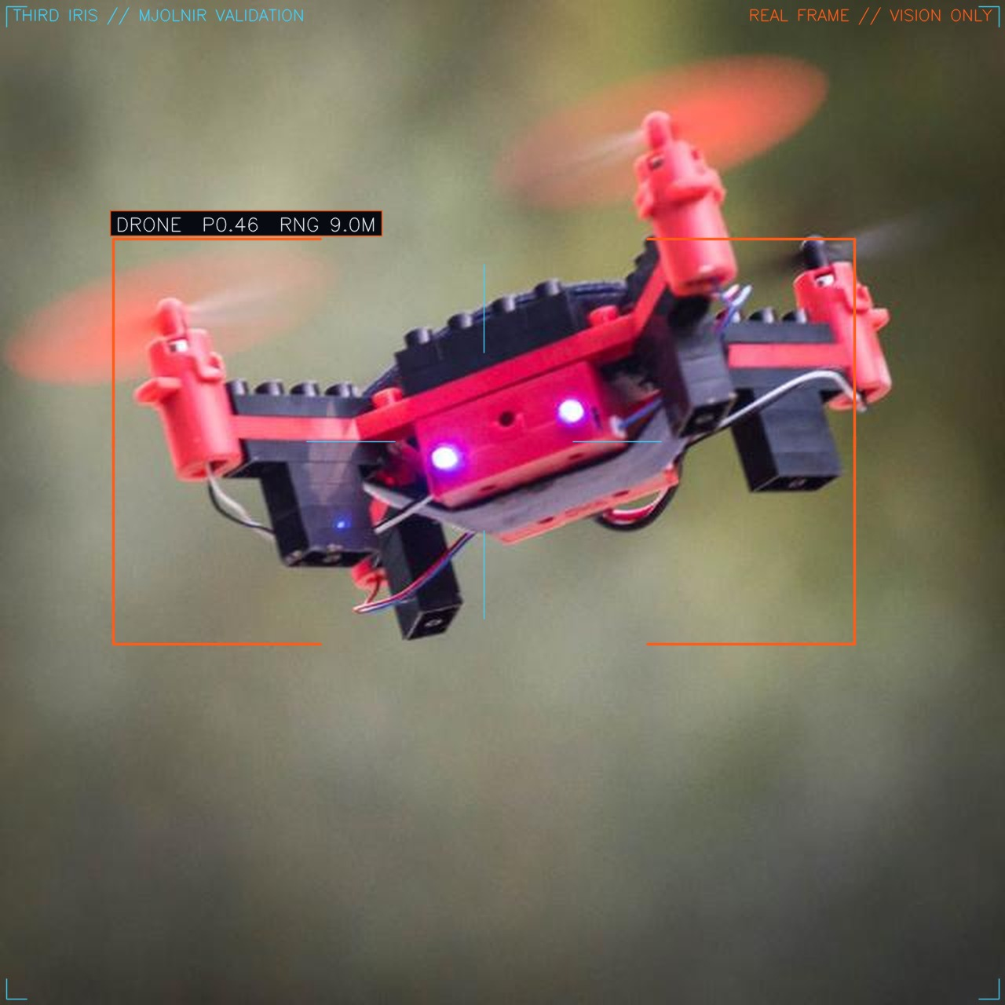
▲ Real quadcopter in flight — detected and bracketed by the on-board model.
✎ EDIT: Add / swap detection frames. Keep at least one Shahed and one quad.
——————————————————————————————————————————————
TRAINING & VALIDATION
07 It copies a master, then beats him
- Data: real + synthetic footage is segmented; birds, clutter and shadows are trained out.
- Imitate: a neural pilot learns by imitating a hand-built expert across thousands of randomized pursuit episodes.
- Exceed: reinforcement learning then trains past the teacher under realistic flight dynamics and detector drop-outs.
- Prove: every build re-flies orbit, zigzag, weave, climb and dive scenarios in simulation.
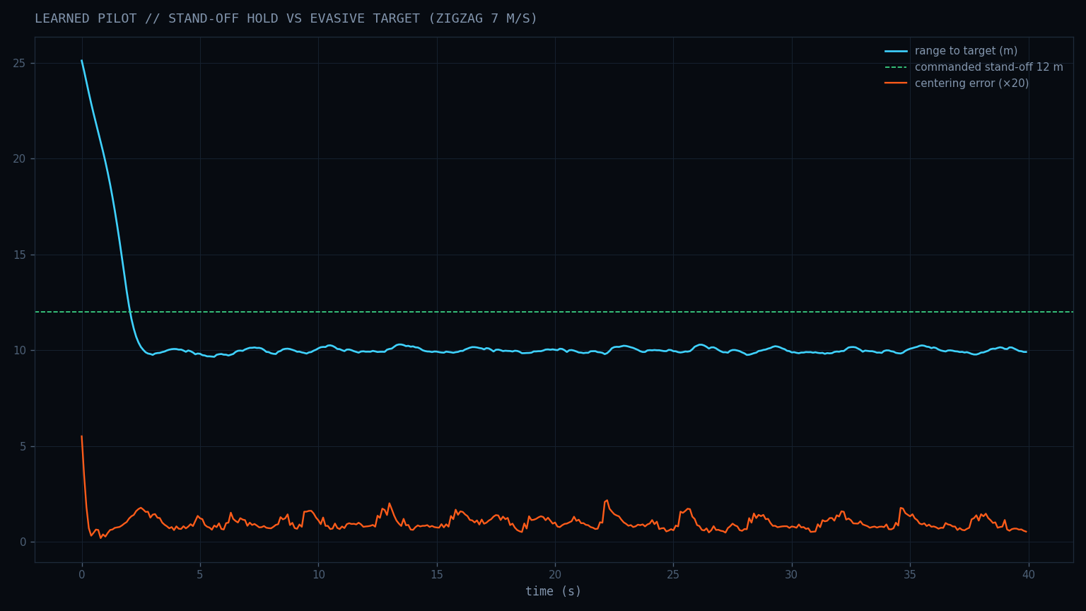
▲ Learned pilot holding stand-off against an evasive zig-zag target.
——————————————————————————————————————————————
TARGET FOLLOWING
08 Click the target — the aircraft does the rest
- click-to-lock in a live ground-station web UI.
- predictive lock leads the target and coasts through detection gaps.
- holds a chosen stand-off distance; speeds match, no spin.
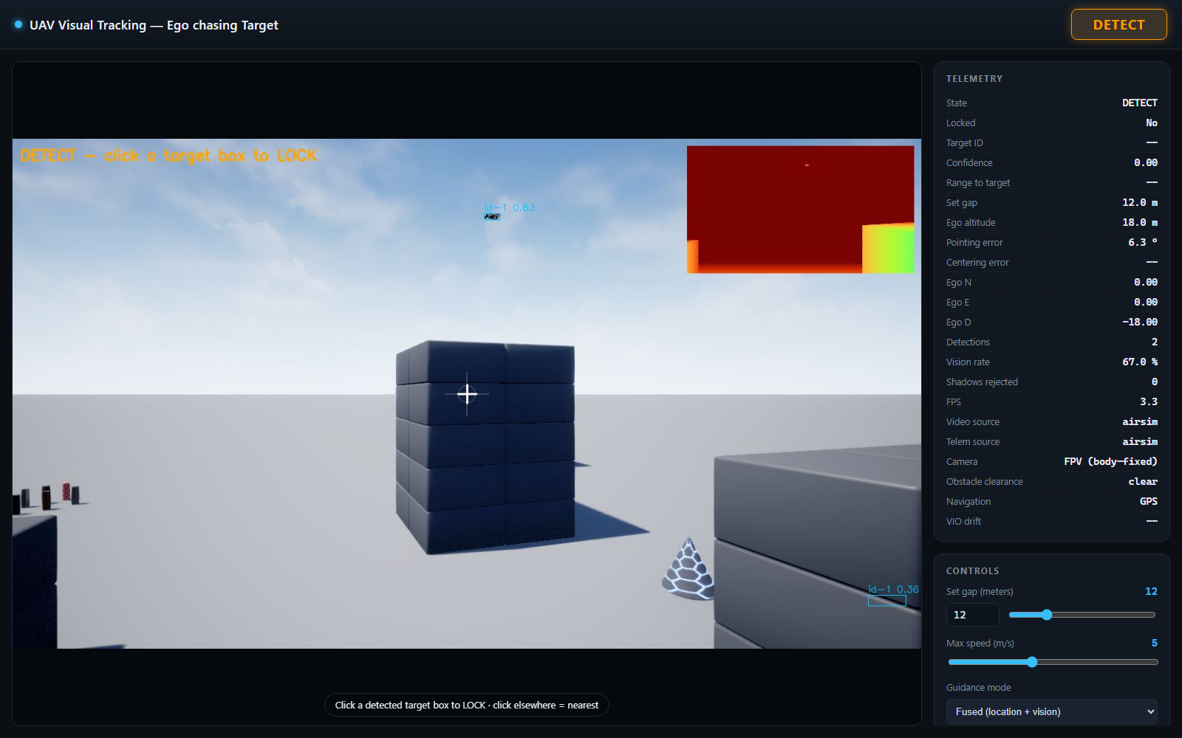
▲ Ground-station web UI: live feed, depth panel, lock and telemetry.
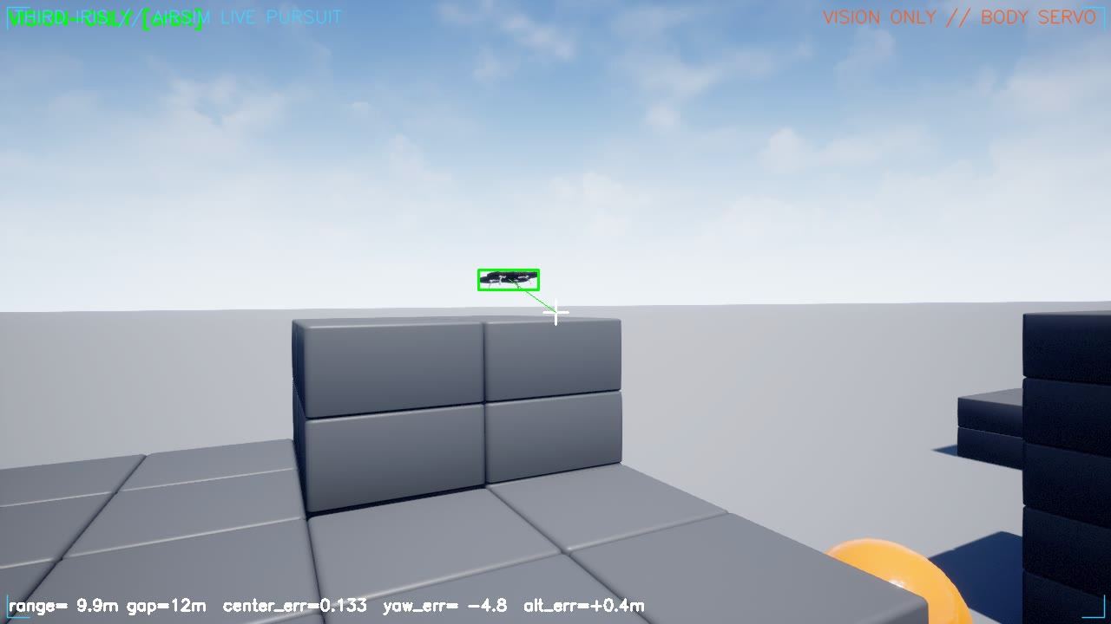
▲ Live pursuit frame — target locked at ~10 m, vision-only.
——————————————————————————————————————————————
SELF-LOCALIZATION
09 It knows where it is — without being told
- visual-inertial odometry fuses camera + IMU into a live position estimate (VINS-class).
- depth gives true metric distance; SLAM-style relocalization corrects drift.
- GPS available → vision + satellites fused. GPS jammed → seamless switch to vision-only.
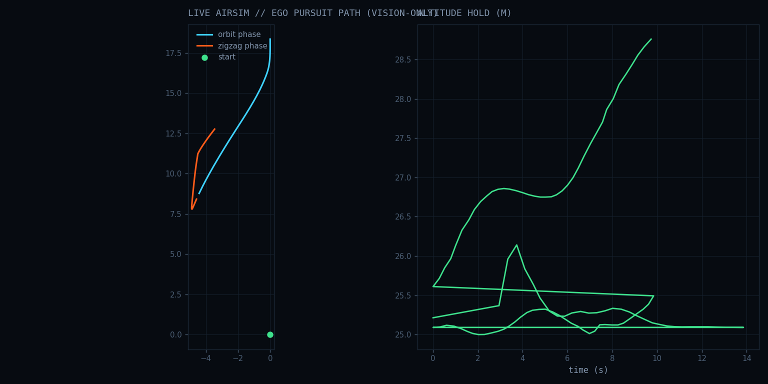
▲ Live run: ego pursuit path and altitude hold, vision-only.
——————————————————————————————————————————————
FLIGHT SAFETY
10 Dodges the world, keeps the lock
- the depth image is read as a wall of distances — depth-as-LiDAR, no extra sensor.
- reactive steering bends the path around obstacles while tracking continues.
- zero collisions across the simulated scenario suite.
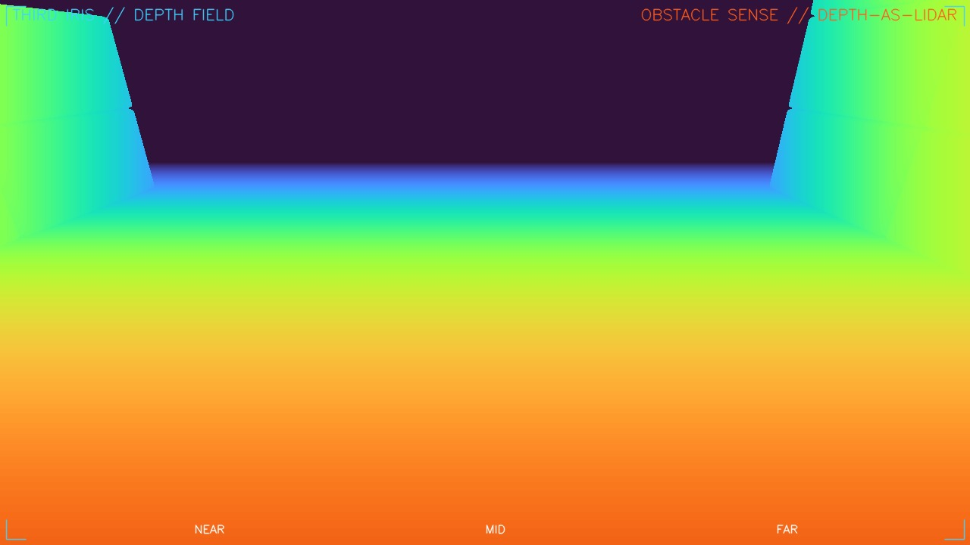
▲ Live depth field (near → far). Walls and ground resolved for avoidance.
——————————————————————————————————————————————
APPLICATIONS
11 Two markets, same eye
Commercial | Defense
• Follow-me cinematography  • GPS-poor infrastructure inspection  • Search & rescue (canyons / indoor)  • Warehouse & indoor inventory drones  • Urban-canyon delivery | • Counter-UAS / anti-Shahed interception  • ISR under GPS jamming  • Convoy & perimeter overwatch  • Contested-airspace navigation & strike  • Comms-denied autonomous missions
——————————————————————————————————————————————
INTELLIGENCE LAYER · FINAL PHASE
12 A System-2 mind on the aircraft
A small on-board language model supervises the mission — it advises, it never flies. The 10 Hz pilot, tracker and VIO stay untouched.
- Slow supervisor: a small quantized LLM (e.g. Qwen2.5-1.5B, 4-bit) on Jetson Orin reads telemetry text and emits a mode { SEARCH | TRACK | STRIKE | RETURN | HOLD } at ~0.5 Hz.
- Safety gate: a deterministic finite-state machine validates the proposal and clamps it to a geofence / altitude / battery safety envelope — the agent cannot command actuators.
- Fast stack: the fast neural pilot stays System-1 — instant, sub-millisecond.
Grounded in Hi Robot (Physical Intelligence, 2025), LLM-Land (on-device LLM + MPC, 2025), and NVIDIA GR00T's System-2 / System-1 split. Built in simulation as the final phase.
——————————————————————————————————————————————
STATUS & ROADMAP
13 Same software, sim to sky
- Done: full stack proven in AirSim simulation (detect · track · follow · avoid · GPS-jam handover).
- Done: detector + learned pilot trained on real data; RL pilot beats the hand-built expert.
- Next: production visual-inertial odometry (OpenVINS) fused into the flight controller.
- Then: same code on RealSense + Jetson Orin hardware; then the agentic supervisor.
If it can see, it can fight. Vision-only autonomy — jam-proof by physics, not by promise.

