**CONTACT**

**PROFILE**

**SANJU CHARAN SAMANTA**

**CIRICULIUM VITAE**

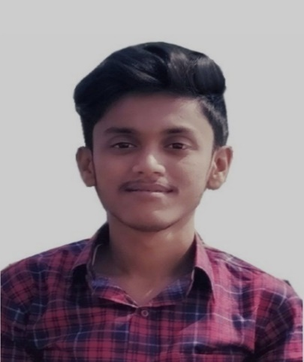

**GENDER: MALE**

**DOB: 15th DECEMBER, 1999**

 [www.linkedin.com/in/sanju-charan-samanta-651962206/](http://www.linkedin.com/in/sanju-charan-samanta-651962206/)

 sanju90837376902gmail.com

 +917477625726

ADDRESS: TAMLUK, PURBA MEDINIPUR, PIN - 721626 WEST BENGAL, INDIA

ALWAYS READY TO LEARN AND BE UPDATED TO TAKE CHALLENGES AND GAIN EXPERIENCE. LOOKING TO START THE CAREER AS AN ELECTRICAL ENGINEER OR AN ENTRY-LEVEL SOFTWARE ENGINEER WITH A REPUTED FIRM DRIVEN BY TECHNOLOGY.

**SKILLS**

* C
* HTML, CSS, BOOTSTRAP
* JAVASCRIPT

**EDUCATION**

|  |  |  |  |  |
| --- | --- | --- | --- | --- |
| **DEGREE** | **INSTITUTION** | **BOARD/UNIVERSITY** | **YEAR OF PASSING** | **PERCENTAGE/YGPA** |
| BACHELOR OF  TECHNOLOGY IN ELECTRICAL ENGINEERING | COLLEGE OF ENGINEERING MANAGEMENT,  KOLAGHAT | MAULANA ABUL KALAM AZAD UNIVERSITY | 2022 | 1ST YEAR: 7.47  2ND YEAR: 8.66  3RD YEAR: 9.60  4TH YEAR: PURSUING |
| HIGHER SECONDARY | BYABATTARHAT ADARSHA HIGH SCHOOL | WEST BENGAL COUNCIL OF HIGHER SECONDARY EDUCATION | 2018 | 80% |
| SECONDARY | RADHABALLAVPUR BHIMA CHARAN BASU VIDYAPITH | WEST BENGAL BOARD OF SECONDARY EDUCATION | 2016   * TVAS- INDUSTRIAL SKILLS FOR ELECTRICAL ENGINEERS (FROM TPSDI – JOJOBERA) * SOFT SKILL FROM NPTEL. * CUSTOMER SERVICE FOUNDATIONS AT LINKEDIN | 83% |

* WEB DEVELOPMENT AT INTERNSHALA (PURSUING).
* VOCATIONAL TRAINING UNDER WBSETCL.
* INTRODUCTION TO IOT FROM CISCO.

**TRAINING &**

**COURSES**

* ONLINE CALCULATOR USING HTML, CSS AND JAVASCRIPT

LINK- <https://sanjudidit.github.io/projects/CALCULATOR/>

* PORTFOLIO USING HTML, CSS (WORKING)

LINK- <https://sanjudidit.github.io/projects/portfolio/>

* STOPWATCH USING HTML, CSS AND JAVASCRIPT

LINK- <https://sanjudidit.github.io/projects/stopwatch/>

* ANIMATED TAB BAR USING HTML, CSS AND JAVASCRIPT

LINK- <https://sanjudidit.github.io/projects/animated-tab-bar/>

* LINE FOLLOWER AND BLUETOOTH CONTROLLED ROBOT USING ARDUINO
* POV DISPLAY USING ARDUINO
* TESLA COIL

**PROJECTS**

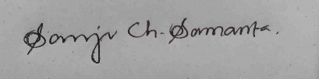

**DATE: 5TH OCTOBER, 2021**

* ENGLISH (READ, WRITE, SPEAK)
* BENGALI (READ, WRITE, SPEAK)
* HINDI (READ, SPEAK)

**HOBBIES**

**COMMUNICATION**

* COLLECTING DIFFERENT CURRENCIES
* ACTING

I hereby declare that all the information and facts given above are true to best of my knowledge and can be verified any time.

**DECLARATION**