Leadership Team

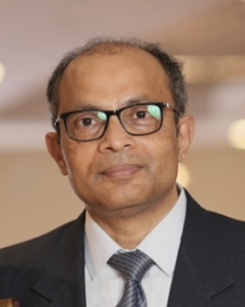

Shashishekara Anantharamaiah (Shashi)
Chief Technology Officer | Nexalytics DTX
Shashishekara Anantharamaiah (Shashi) is the Chief Technology Officer at Nexalytics DTX, responsible for shaping the organization’s technology strategy, platform architecture, and engineering excellence. With over 35+ years of global experience, he brings deep expertise in building secure, resilient, and scalable technology platforms for complex, high-reliability environments.
Shashi has held senior technology and leadership roles across leading global organizations including Siemens, ABB, John Holland, Invensys, Westinghouse, Foxboro , and Novell, working across Australia, Europe, the UK, and Asia. His experience spans transportation, energy, industrial automation, and enterprise software, where operational reliability and governance are critical.
At Nexalytics DTX, Shashi leads the convergence of engineering discipline with modern data, analytics, cloud, and real-time intelligence, enabling clients to modernize with assurance and security, performance, and regulatory alignment. He is known for building high-performing engineering teams and ensuring technology investments translate into measurable business outcomes.

Credentials & Education
- Fellow, Institution of Engineers Australia (FIEAust)
- Certified Engineering Executive (EngExec) from Institution of Engineers, Australia
- Chartered Professional Engineer (CPEng & RPEQ – Electrical and Management)PRINCE 2 Practitioner and Lean Six Sigma Black Belt
- Bachelor of Engineering (Electronics & Communication), National Institute of Technology Karnataka, India

