Vendor GRACE
Low-Level Design Data Model, Tech Stack & Workflow
Version 1.0 | August 2026 | Mirketa Inc. Salesforce Practice | Confidential

1. Purpose & Scope
This document defines the low-level design of Vendor GRACE (formerly VERA) the AI-assisted supplier onboarding and compliance application. It covers the Salesforce object model, the self-hosted Python/FastAPI compliance engine, and the real end-to-end request flow between them. Every object, field, and sequence step below was verified directly against the live org (sf data query / metadata retrieval) and the deployed Apex/LWC/Python source as of this document's date this is an as-built record, not a forward-looking design.
Standard Salesforce objects are reused wherever they satisfy the requirement (Account, Contact, User, ContentDocument, Case); custom objects exist only where the standard model has no equivalent see Section 6 for the reuse rationale.

2. System Topology
Salesforce consoles call a shared Apex controller layer, which reaches the Azure-hosted FastAPI engine over one Named Credential (Local_Compliance_Service). Postgres/pgvector, the policy corpus, and LangGraph's checkpoint state all live inside the Azure resource group; OpenAI is called only for chat/reasoning completions no source documents are sent to it.
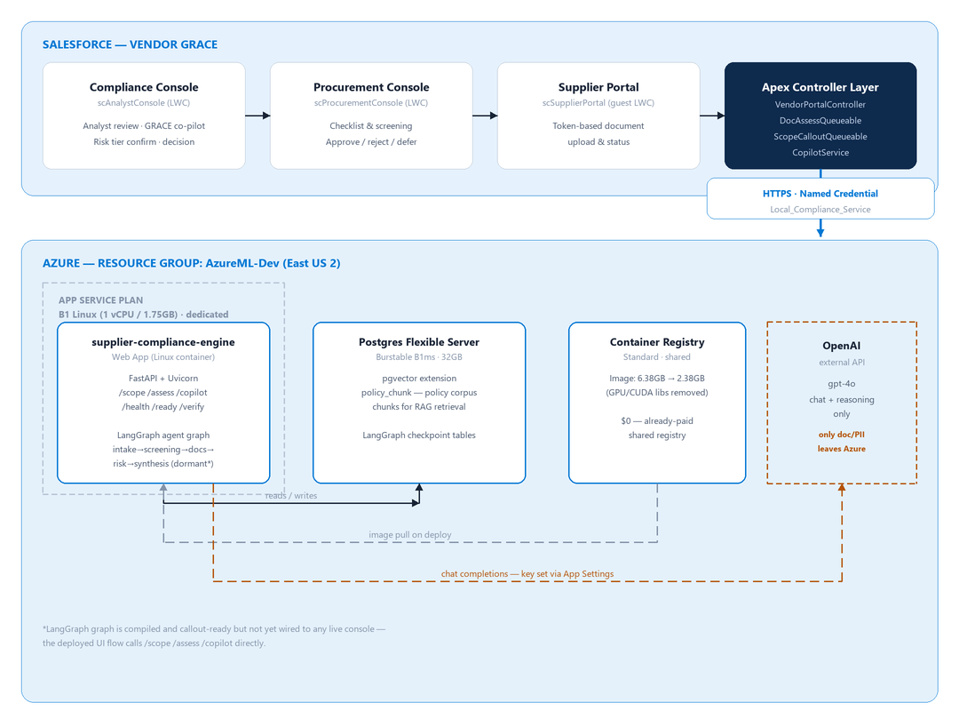
Figure 1 System topology: Salesforce consoles → Apex → Named Credential → Azure engine

3. Object Inventory
Every object below is confirmed referenced by live (non-test) Apex.
Object API Name | Type | Purpose | Status
Account | Standard | Supplier legal entity. No dedicated Record Type in use today differentiated by field state, not Record Type. | Live
Contact | Standard | Supplier-side contact (uploader identity where a Contact is used instead of guest token). | Live
User | Standard | Internal Procurement / Analyst / Admin user. | Live
ContentDocument / ContentVersion | Standard | Raw uploaded file (cert, policy, COI, etc.). | Live
ContentDocumentLink | Standard | Links the uploaded file to the Account / Compliance_Document__c. | Live
Account (self-lookup) | Standard | ParentId models the multi-tier sub-supplier hierarchy no separate junction object exists for this today. | Live
Compliance_Assessment__c | Custom | The central decision record one row per (Supplier x Requirement). Holds AI verdict, Procurement decision, and Analyst validation as three independently-tracked fields on the same row. | Live
Compliance_Document__c | Custom | Structured representation of one uploaded file extracted metadata, issuer, dates, confidence. | Live
Compliance_Document_Link__c | Custom | Junction enabling multiple documents to satisfy one requirement; each link carries its own verdict, parent rolls up worst-wins. | Live
Supplier_Profile__c | Custom | Extended compliance attributes (tier, criticality, commodity, region) read by the checklist-generation callout. | Live
Document_Extraction__c | Custom | Legacy pre-RAG extraction record (model name, confidence, raw response) a separate, earlier extraction path alongside the current /assess flow. | Legacy path
Audit_Log__c | Custom | Polymorphic business-event audit trail uploads, AI evaluations, Procurement/Analyst decisions, case closure. | Live
Policy_Document__c | Custom | Tracks the policy-corpus ingestion pipeline (chunk count, ingest job, failure reason) separate from the onboarding flow. | Live

Objects present in the original design spec, not found live
HITL_Review__c, Supplier_Relationship__c, Expiry_Event__c, Risk_Score__c (as a time-series object), and Regulatory_Rule_Source__c do not exist as separate objects in the current build. Their responsibilities were folded into fields on existing objects instead human review state lives on Compliance_Assessment__c (Analyst_Validated__c, Analyst_Comment__c), the compliance score is a single rolling field (Account.Risk_Score__c) recomputed in place rather than a time-series log, and expiry alerting runs off Compliance_Assessment__c.Valid_Until__c via the scheduled ComplianceExpiryBatch rather than a dedicated event object.

4. Object Specifications

4.1 Account (Standard) custom fields
Field API Name | Type | Description
Risk_Score__c | Number(3,0) | 0-100 compliance score. 0 until documents are assessed. Written by RiskScoreService.recompute. Higher = more compliant (inverted from a traditional risk scale).
Risk_Tier__c | Picklist | Low/Medium/High/Critical pure function of Risk_Score__c (85+/60+/35+/else). No independent tier computation exists.
Profile_Risk_Tier__c | Picklist | Frozen industry/material-profile tier snapshot from checklist generation display/context only, not blended into the live score.
Checklist_Item_Count__c | Number(3,0) | N checklist size frozen at first generation. Denominator for every document's point value in the score model.
Checklist_Seeded_By_Caller__c | Checkbox | True when Procurement's curated checklist was persisted directly, telling the async checklist job not to re-derive from the engine.
Onboarding_Status__c | Picklist | Draft / Screening / In Review / Approved / Rejected. Path-enabled pipeline stage.
Compliance_Case_Status__c | Picklist | Open / Closed - Compliant / Closed - Rejected distinct from onboarding stage; the field both queues filter on.
Analyst_Assigned_DateTime__c | DateTime | The single source of truth for handed off to Analyst. Set by assignToAnalyst, cleared by sendCaseBackToProcurement.
Assigned_By__c / Assignment_Reason__c | Lookup(User) / Text | Who handed off, and why also reused for the return-to-Procurement note.
Case_Closed_By__c / Case_Closed_DateTime__c | Lookup(User) / DateTime | Who closed the case and when.
Supplier_Portal_Token__c | Text(100) | Guest-accessible UUID embedded in the public portal URL. Never expires or rotates today (see Section 10).
Industry__c / Country_of_Origin__c | Picklist | Drives applicable-rule retrieval on /scope.
HITL_Threshold__c | Picklist | Human-in-the-loop routing threshold, compared against Risk_Tier__c to decide if Analyst review is required.
Cascading_Risk_Score__c / _Tier__c / _Source__c / _Driver__c / _Flag__c | Number/Picklist/Text/Lookup/Checkbox | Multi-tier risk rollup from sub-supplier hierarchy, computed by MultiTierRollupService.

4.2 Compliance_Assessment__c (Custom) the central decision record
Field API Name | Type | Description
Supplier__c | Master-Detail -> Account | Owning supplier. Deleting the Account cascades.
Requirement_Key__c | Text(255), External ID | Upsert key. Formats: <accId>__SCOPE_<domain>, SCREEN_<label>_<acc15>, USERADD_<label>_<acc15>.
Requirement_Label__c | Text(255) | Human label, snapshotted for historical reproducibility.
Status__c | Picklist | Compliant / Non-Compliant / At Risk / Pending the AI/rollup verdict. Worst-wins across linked documents when multi-doc.
Procurement_Decision__c | Picklist | Approved / Rejected / Deferred Procurement's own, independently-tracked checkpoint. Not the same field as Status__c.
Procurement_Decision_Reason__c / _By__c / _DateTime__c | LongText / Lookup / DateTime | Required reason and provenance for the Procurement decision.
Analyst_Validated__c | Checkbox | True once a human (Analyst, or Procurement pre-handoff) confirms the requirement.
Analyst_Comment__c | LongTextArea(4000) | Analyst's own note, distinct from the AI's Reason_Detail__c.
Severity__c | Picklist | Critical/High/Medium/Low drives the score penalty multiplier on Non-Compliant.
Reason_Code__c / Reason_Detail__c | Picklist / LongTextArea(4000) | Structured category + human-readable explanation of the verdict.
Compliance_Document__c | Lookup -> Compliance_Document__c | The single satisfying document (simple/legacy shape superseded by Compliance_Document_Link__c for multi-doc requirements).
AI_Confidence__c | Number(3,0) | 0-100 confidence from the engine's /assess verdict.
Valid_Until__c | Date | Expiry date source for ComplianceExpiryBatch renewal alerts.

4.3 Compliance_Document_Link__c (Custom) multi-document junction
Field API Name | Type | Description
Compliance_Assessment__c | Master-Detail | The requirement this document satisfies.
Compliance_Document__c | Lookup, cascade-delete | The specific uploaded file.
Status__c | Picklist | Compliant / Non-Compliant / At Risk / Pending / Superseded Superseded marks a stale link without deleting it, so history is preserved.
Severity__c / Reason_Code__c / Reason_Detail__c / AI_Confidence__c / Valid_Until__c |  | This file's own independent verdict fields the parent Compliance_Assessment__c rolls up worst-wins across all non-Superseded children.

4.4 Audit_Log__c (Custom) business-event trail
Distinct from Salesforce Shield Field Audit Trail: Shield tracks field-level changes; this object tracks decision-level events with full context (actor, AI model, confidence, reason).
Field API Name | Type | Description
Event_Type__c | Picklist, required | See declared values below.
Actor_Type__c / Actor_User__c | Picklist / Lookup(User) | System / User / AI, and the acting user when applicable.
Related_Object__c / Related_Record_Id__c | Picklist / Text | Polymorphic reference not a hard lookup, by design (see Section 6).
New_Value__c / Original_Value__c | LongText | Value change snapshot, or freeform log content.
AI_Model_Name__c / AI_Confidence__c | Text / Number | AI provenance when Actor_Type__c = AI.

CONFIRMED DEFECT undeclared picklist values
Live Apex writes Event_Type__c values that are NOT present in the field's declared picklist: Integration_Error (VendorPortalController.persistCuratedChecklist), Analyst_Decision_Recorded (saveDocValidation), and Case_Closed (closeCaseInternal). Because these inserts use Database.insert(..., false) (partial-success mode), the record-level failure is swallowed silently rather than surfaced these specific audit rows likely never get written. Fix: add the three values to the picklist's value set.

5. Custom Metadata Types
Deploy-time configuration, no admin DML required.
CMDT API Name | Queried by | Purpose
Compliance_Requirement__mdt | ComplianceRuleEngineService | Versioned deterministic rules (document type, required-for tier/region/industry, severity). Legacy rule engine largely superseded for onboarding by the /scope RAG path, but still present and live.
Compliance_Domain__mdt | ComplianceDomainController | Compliance domain catalog (Cyber, Finance, Trade, Quality, Material, Conflict, General, plus healthcare-specific domains) with display order and verifier authority.
Material_Type__mdt | VendorPortalController.resolveMaterialDomains | Maps material/commodity type picklist values to the compliance domains they trigger. Directly picklist-dependent see Section 10.
Risk_Rollup_Setting__mdt | MultiTierRollupService / Batch | Weighting configuration for multi-tier cascading risk (own score vs. sub-supplier vs. preferred/secondary/sole-source weight).
Compliance_Verification_Source__mdt | AuthoritativeVerificationService | External registry/authority callout config (endpoint template, cert-number source, valid-state mapping) for license/registry verification.

6. Standard Object Reuse Rationale
The model deliberately reuses Account, Contact, ContentVersion, and User rather than creating custom equivalents. Rationale, since this is often challenged in design review:
Standard Object | Why Reused (Not Replaced by Custom)
Account | Any downstream Sales/Service Cloud already references Account. A custom Supplier__c would fragment supplier 360, lose hierarchy/territory features, and duplicate standard fields.
Contact | Supplier-side contacts get standard email/phone and portal-user licensing for free a custom object would lose this.
ContentVersion | Salesforce Files is the native storage mechanism built-in versioning, sharing, preview, 2GB-per-file support. A custom file-holding object would lose all of it.
Audit_Log__c polymorphism | Related_Record_Id__c is a plain indexed Text field, not a hard lookup deliberately, so one audit object can reference Supplier, Compliance_Document, or Compliance_Assessment rows without three separate lookup columns or three separate audit objects.

7. Tech Stack & Tool Specification

Salesforce layer
Component | Detail
LWC | scProcurementConsole, scAnalystConsole, scSupplierPortal (guest)
Apex | VendorPortalController (~3000 lines, dominant controller), DocumentProcessingController
Async | Queueable Apex: ScopeCalloutQueueable, DocAssessQueueable, ScreeningQueueable
Scheduled | ComplianceExpiryBatch (weekly renewal sweep)
Auth | Guest-token portal (Supplier_Portal_Token__c) + Named Credential outbound

Compute Azure App Service
Component | Detail
Runtime | Linux container, B1 (1 vCPU / 1.75GB)
API | FastAPI + Uvicorn (ASGI)
Orchestration | LangGraph, compiled with a Postgres checkpointer (see Section 10 dormant relative to the live UI)
Embeddings | sentence-transformers, local in-container

Data Postgres
Component | Detail
Server | Flexible Server, Burstable B1ms, 32GB
Vector | pgvector, policy_chunk table for RAG retrieval
State | langgraph-checkpoint-postgres (graph run state)

Reasoning external
Component | Detail
Provider | OpenAI, model gpt-4o
Scope | Chat/reasoning calls only, no document storage
Fallback | Blank key -> engine runs Needs Analyst degraded mode, never fails closed

Integration
Component | Detail
Callout pattern | Synchronous Apex HTTP callouts (Http/HttpRequest) via Named Credential, not Platform Events an earlier platform-event hop was removed after it was found to misfire
External registries | Sanctions/PEP/entity screening via ScreeningService, license/registry checks via AuthoritativeVerificationService

Audit & security
Component | Detail
Business audit | Custom Audit_Log__c, decision-level (see Section 4.4 for a known defect)
Field audit | Salesforce Field Audit Trail on select fields
Sharing | OWD Private, explicit sharing rules; guest profile FLS coverage is incomplete (Section 10)

8. Workflow High-Level Sequence
Supplier self-registration -> checklist -> upload -> AI review -> screening -> analyst -> done. Steps 13-14 (analyst handoff) are conditional see the note in the figure, and Section 9 for the exact gate.
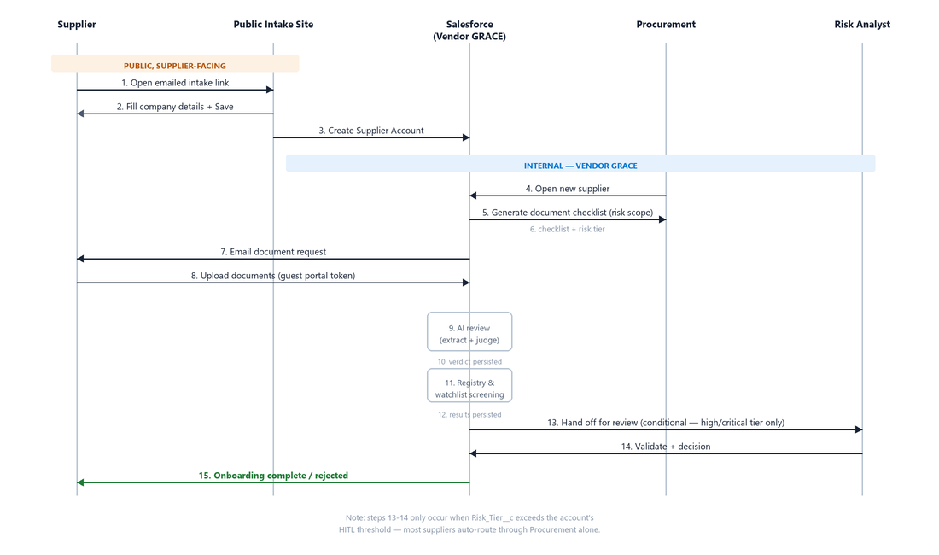
Figure 2 High-level onboarding sequence

9. Workflow Detailed Sequence
Real Apex/engine call chain, with sync vs. async execution mode and exactly what each step writes.
# | Actor -> Action | System / Method | Mode | Writes
1 | Procurement previews a checklist | generateChecklist -> ScopeService -> engine /scope | Sync | Nothing persisted preview only
2 | Procurement submits & screens | submitAndScreen -> persistCuratedChecklist, enqueues ScreeningQueueable | Sync + async | Account, Compliance_Assessment__c (upsert)
3 | Account insert trigger fires checklist generation | AccountTriggerHandler -> ScopeOnboardingService -> ScopeCalloutQueueable -> engine /scope | Async (Queueable) | Compliance_Assessment__c, Account.Profile_Risk_Tier__c/Checklist_Item_Count__c, Audit_Log__c (Checklist_Generated)
4 | Procurement requests documents | requestDocumentsFromSupplier -> generateSupplierPortalUrl -> email | Sync | Account.Supplier_Portal_Token__c, Audit_Log__c
5 | Supplier uploads via guest portal | resolveSupplierToken -> saveFileByToken / linkDocumentToComplianceByToken | Sync (guest) | ContentVersion, Compliance_Document__c, Compliance_Document_Link__c
6 | Upload triggers AI assessment | linkDocumentToComplianceInternal enqueues DocAssessQueueable -> DocAssessService -> engine /assess | Async (Queueable) | Compliance_Assessment__c.Status__c/Severity__c/Reason_Detail__c/AI_Confidence__c, Audit_Log__c (Compliance_Evaluated), then RiskScoreService.recompute
7 | Procurement approves / rejects / defers | recordProcurementDecision | Sync | Compliance_Assessment__c.Procurement_Decision__c(+Status__c), Audit_Log__c, then RiskScoreService.recompute
8 | Conditional handoff gate | assignToAnalyst gated by routeDecision(Risk_Tier__c, HITL_Threshold__c); also requires every uploaded doc to have a Procurement decision | Sync | Account.Analyst_Assigned_DateTime__c/OwnerId/Onboarding_Status__c='In Review'
9 | Analyst confirms / overrides | saveDocValidation | Sync | Compliance_Assessment__c.Analyst_Validated__c/Analyst_Comment__c(+Status__c override), Audit_Log__c*, then RiskScoreService.recompute
10 | Case closure (3 paths) | closeComplianceCase (Analyst) / onboardSupplierDirectly (Procurement, requires all Approved) / sendCaseBackToProcurement (reverse handoff) | Sync | Account.Compliance_Case_Status__c/Onboarding_Status__c/Case_Closed_By__c/_DateTime__c, Audit_Log__c*
11 | Compliance score recompute | RiskScoreService.recompute / recomputeBulk called from steps 6, 7, 9 and the scheduled ComplianceExpiryBatch | Sync (in-transaction) | Account.Risk_Score__c/Risk_Tier__c/Risk_Last_Computed__c additive per-document, capped at 97
12 | GRACE co-pilot Q&A | askCopilot -> CopilotService -> engine /copilot | Sync, on-demand | Read-only (optional feedback write via saveCopilotFeedback)

* Steps 9 and 10 write Audit_Log__c.Event_Type__c values not present in the field's declared picklist see the defect callout in Section 4.4.

10. Known Gaps & Open Items
Item | Detail | Status
LangGraph agent graph | A real, compiled StateGraph (intake->screening->documents->risk->synthesis->routing, with a human-approval conditional edge) exists in orchestrator.py and is exposed via /cases* endpoints with Postgres checkpointing but no live console calls it. All three LWCs call /scope /assess /copilot directly as stateless endpoints. | Dormant, not wired to UI
Audit_Log__c.Event_Type__c picklist | Integration_Error, Analyst_Decision_Recorded, Case_Closed are written by live Apex but absent from the declared picklist inserts likely fail silently under partial-success mode. | Confirmed defect
Guest Profile permissions | Zero explicit ObjectPermissions rows for the Supplier Portal Guest Profile on ContentDocument/ContentDocumentLink/Compliance_Document__c/Account the Apex logic works correctly end-to-end in isolated testing, but real guest-user portal actions (e.g. document removal) may fail under actual FLS enforcement. | Suspected gap, unconfirmed in prod
Picklist/CMDT dependency | Compliance_Requirement__mdt/Material_Type__mdt key off Industry and material-type picklist values. Removing/renaming a picklist value a customer's admin doesn't realize is load-bearing silently degrades checklist generation for that value no hard error surfaces. | Design risk for packaging
Supplier portal token lifecycle | Supplier_Portal_Token__c never expires or rotates a legitimate simple-link pattern today, not Salesforce's standard portal-identity model. | Accepted, hardening deferred
Compliance score ceiling | Deliberate design decision: MAX_SCORE = 97 a perfect 100 is never reachable even when every document is Compliant, so the number never reads as an assertion of zero residual risk. | By design, not a gap

Vendor GRACE Low-Level Design v1.0 | Verified against the live org and codebase, August 2026

