A Mechanistic Framework for Predicting the Biodegradation of Zinc Implants

Henaka Ariyarathna, Xuan Yang, Aijun Huang, Yunlong Tang$​^{*}$, Yuman Zhu$​^{*}$

H. Ariyarathna, X. Yang, A. Huang, Y. Tang, Y. Zhu
Monash Centre for Additive Manufacturing, Monash University, Wellington Rd, Clayton, VIC 3800, Australia
E-mail: Yunlong.Tang1@monash.edu, yuman.zhu@monash.edu

H. Ariyarathna, X. Yang, A. Huang, Y. Tang
Department of Materials Science and Engineering, Monash University, Wellington Rd, Clayton, VIC 3800, Australia

A. Huang, Y. Tang, Y. Zhu
Department of Mechanical and Aerospace Engineering, Monash University, Wellington Rd, Clayton, VIC 3800, Australia

Funding: Future Fellow project (FT230100180) of the Australian Research Council, Monash Graduate Scholarship (MGS)
Keywords: biodegradable implants, zinc, corrosion modeling, oxygen reduction kinetics, mass transport

Abstract
Zinc (Zn) is a promising biodegradable metal for temporary implants, yet predictive computational frameworks for its degradation under physiological conditions remain limited. In this study, a three-dimensional (3D) mechanistic reaction-diffusion model is developed by coupling oxygen reduction reaction (ORR) kinetics, mass transport, corrosion-product evolution, and moving-interface tracking. Initial sensitivity analysis demonstrates that dissolved oxygen availability primarily controls Zn biodegradation. Calibrated using three effective kinetic parameters against literature immersion mass-loss data over 14 days, the model predicts the 28-day mass-loss evolution measured in this study, yielding a root-mean-square error (RMSE) of 0.0159%. The simulations reveal a self-limiting mechanism in which corrosion-product accumulation progressively restricts oxygen transport to the metal surface, driving a transition from reaction-controlled to diffusion-controlled degradation. When applied without geometry-specific recalibration to a six-crown Zn stent, the model predicts approximately 6% mass loss after one month, of the same order of magnitude as reported in vivo observations, and captures crown-localized degradation driven by geometry-dependent oxygen transport. By linking implant geometry to degradation rate and spatial morphology, the framework provides a low-dimensional, mechanistic basis for predicting Zn implant degradation and supports degradation-informed implant design.

Table of Contents

Driven by the need for safer temporary implants, this study develops a 3D computational model to predict Zn biodegradation under physiological conditions. The results show that corrosion products progressively restrict oxygen supply and slow degradation, while implant geometry shapes localized material loss. The framework supports degradation-informed design and optimization of next-generation biodegradable stents and other architected implants.



Introduction
Biodegradable metallic implants are increasingly being explored for clinical applications that require temporary mechanical support followed by gradual resorption after tissue healing, thereby avoiding the long-term complications and secondary surgeries associated with permanent devices ^{[1–3]}. Among biodegradable metals, Zn has attracted considerable interest because its corrosion behavior lies between that of magnesium (Mg) and iron (Fe) ^{[4,5]}. This intermediate degradation profile provides a rate that is better aligned with tissue-healing timescales while producing negligible hydrogen evolution, making Zn particularly suitable for transient implant applications ^{[6–9]}. Despite these advantages, the clinical translation of Zn-based implants remains challenging because biodegradation continuously changes implant morphology and structural integrity. As material is progressively removed, local stress distributions, load-bearing capacity, and overall mechanical performance evolve throughout the implant's service life, complicating the prediction of long-term functionality ^{[10,11]}.
These effects are particularly important for architected biodegradable devices, including vascular stents, porous scaffolds, lattices, and fixation systems, which contain thin struts, crowns, pores, gaps, and junctions. Studies of porous Zn scaffolds have demonstrated that topology and permeability can strongly influence mass transport, corrosion-product accumulation, degradation kinetics, and localization, highlighting the governing role of geometry in corrosion progression ^{[12,13]}. These geometric effects can further evolve during corrosion, with accumulated degradation products modifying local transport pathways and surface reaction rates. Although in vitro and in vivo experiments provide essential insight into these processes, they remain costly, time-consuming, and difficult to generalize across the vast design space of implant architectures, material compositions, and physiological environments ^{[14,15]}. Predictive computational models are therefore required to quantitatively link implant architecture to degradation evolution and the resulting structural performance of biodegradable implants.
Most computational studies of biodegradable implants represent material loss using prescribed corrosion rates, stochastic pitting distributions, exposed-surface damage laws, or element deletion. These phenomenological approaches have provided valuable insights into stent recoil, radial support, fatigue resistance, and structural integrity, while remaining computationally efficient and readily coupled to mechanical analysis ^{[16,17]}. However, because the local electrochemical environment is not explicitly resolved, mechanistic descriptions of the processes governing material loss are embedded in calibrated parameters. Their predictive capability may therefore be limited outside the geometries and environmental conditions used for calibration ^{[18]}. By comparison, models developed for biodegradable Mg demonstrate that electrochemical reactions, species transport, corrosion-product evolution, interface motion, and corrosion-induced fracture can be coupled within a unified computational framework ^{[18,19]}. However, these formulations cannot be transferred directly to Zn because Mg corrosion is typically governed by anodic dissolution and hydrogen evolution ^{[20]}, whereas Zn degradation under aerated, near-neutral physiological conditions is strongly regulated by cathodic oxygen reduction ^{[21,22]}.
More recently, mechanistic descriptions of Zn biodegradation have started to emerge. For example, Chen et al. coupled electrochemical kinetics, mass transport, and corrosion-product formation under salt-spray conditions, demonstrating the feasibility of physics-based modeling approaches for Zn corrosion ^{[23]}. However, its one-dimensional (1D) formulation cannot resolve the spatially heterogeneous transport fields generated by complex implant architectures. Atomistic studies have further clarified how lattice distortion, alloy chemistry, oxygen adsorption, and surface chemistry influence Zn reactivity ^{[24]}, but these mechanisms have not yet been translated into implant-scale predictions of evolving degradation morphology. In addition, mechanistic biodegradation models commonly introduce numerous empirical fitting variables, producing high-dimensional parameter spaces that hinder calibration, sensitivity analysis, uncertainty quantification, and surrogate-model development ^{[25]}.
To address these gaps, a 3D mechanistic reaction-diffusion model was developed to predict Zn biodegradation under physiological conditions. The model couples ORR kinetics, multi-species transport, corrosion-product evolution, and level-set-method based interface tracking within evolving geometries. To limit parameter dimensionality while retaining the principal mechanisms governing Zn degradation, the formulation introduces three effective kinetic parameters representing oxygen reduction, net corrosion-product formation, and net corrosion-product dissolution. The transition from reaction-controlled to diffusion-controlled degradation emerges directly from the coupled reaction-transport equations. The model is calibrated and validated using independent experimental datasets for a simple Zn disc, then transferred to a geometrically complex Zn stent without additional parameter fitting. Using this approach, the present study investigates the role of oxygen availability in regulating Zn biodegradation and examines how implant geometry influences degradation through its effects on local transport conditions and corrosion-product evolution. The study therefore advances Zn biodegradation modeling from calibrated material-loss descriptions toward transferable, geometry-resolved prediction of evolving implant morphology.

Methods
A three-stage computational–experimental workflow was established to develop and evaluate the proposed Zn biodegradation framework (Figure 1). First, a mechanistic reaction–diffusion model was developed by coupling oxygen reduction, multispecies transport, corrosion-product evolution, and level-set-based tracking of the receding Zn surface. Second, the influential model parameters were identified through global sensitivity analysis and calibrated against published mass-loss measurements for a simple Zn disc geometry. The calibrated model was then independently validated using immersion data generated in the present study. Finally, the model was transferred, without geometry-specific parameter refitting, to a geometrically complex Zn stent to investigate how implant architecture modifies oxygen transport, corrosion-product evolution, and local degradation.


Figure 1. Computational–experimental workflow for developing, calibrating, validating, and applying the mechanistic Zn biodegradation model. (a) Reaction–diffusion model coupling species transport and corrosion-film evolution with moving-interface tracking; (b) calibration of the three effective kinetic parameters (k_{f}, k_{d}, k_{ORR}) against literature mass-loss data (0–336 h); (c) validation against the mass loss measured in this study (0–672 h) for Ø10 × 2 mm discs; and (d) model predictions for a six-crown Zn stent.

Experimental Procedure
Commercially pure Zn (99.99 wt%) was processed by casting, homogenization, and hot extrusion to produce fully dense rods (10 mm diameter), from which disc specimens (10 mm diameter, 2 mm thickness) were prepared. Prior to testing, specimens were mechanically ground through successive silicon carbide abrasive grades and finished with $1 μm$ diamond suspension to produce a reproducible and well-defined surface condition. The polished specimens were ultrasonically cleaned in Milli-Q water, acetone, and ethanol to remove residual surface contaminants, then dried and stored under vacuum until use. Hanks’ Balanced Salt Solution (HBSS; Gibco, calcium- and magnesium-free) was selected as the immersion medium.
Static immersion tests were conducted at 37 °C for 1, 3, 7, 14, and 28 days to characterize the in vitro degradation behavior of pure Zn and provide an independent dataset for model validation. The HBSS volume was maintained at 20 mL cm⁻² of exposed surface area and refreshed every 48 h to maintain physiologically relevant ion concentrations and prevent accumulation of dissolved $Zn^{2+}$ ions ^{[26]}. At each immersion time point, specimens were removed, gently rinsed with deionized water, and weighed to obtain the pre-cleaning mass. Corrosion products were subsequently removed using a 200 g L⁻¹ chromic acid solution in accordance with ISO 8407:2009. The cleaned specimens were rinsed, dried, and reweighed, and the mass loss was calculated from the difference between the initial and post-cleaning masses.

Mechanistic Modeling Framework
Existing models of Zn degradation are either atomistic, describing oxygen and chloride adsorption on Zn surfaces [24]; implant-scale finite element models in which material loss follows prescribed corrosion kinetics within a continuum-damage framework [11]; or a one-dimensional mechanistic description of uniform Zn corrosion under salt spray [23]. Mechanistic three-dimensional reaction–diffusion models with moving-interface tracking have been established for Mg [18,19], but they cannot be applied directly to Zn because Zn degradation is governed by cathodic oxygen reduction and the oxygen-limiting corrosion-product film. To our knowledge, the framework presented here is the first three-dimensional mechanistic model for Zn that explicitly couples oxygen-reduction kinetics, multi-species transport, corrosion-product film evolution, and level-set interface tracking, with a local velocity-selection rule that lets the controlling mechanism vary in space and time. Only three effective kinetic parameters require calibration, and localized degradation emerges from the coupled physics without prescribing spatially varying corrosion kinetics.

Electrochemical Mechanisms of Zn Biodegradation
Zn biodegradation in aerated physiological environments is governed by coupled anodic dissolution, oxygen reduction, and corrosion-product formation ^{[1]}, as shown in Figure 2a. The formed Zn(OH)$​_{2}$ layer subsequently dehydrates into more stable ZnO under physiological conditions ^{[26,27]}. This corrosion layer limits oxygen access to the Zn surface, shifting degradation from an initially reaction-controlled process to a transport-limited process ^{[22,26,27]}.
$Zn_{(s)}→Zn_{(aq)}^{2+}+2 e^{-}$ (1)
$2 H_{2}O_{(l)}+O_{2(g)}+4 e^{-}→4 OH_{(aq)}^{-}$ (2)
$Zn_{(aq)}^{2+}+2 OH_{(aq)}^{-}→Zn(OH)_{2(s)}↓$ (3)
$Zn(OH)_{2(s)}→ZnO_{(s)}+H_{2}O_{(l)}$ (4)
However, physiological electrolytes contain $Cl^{-}$ at concentrations sufficient to chemically destabilize the ZnO film through formation of soluble zinc-chloride complexes ^{[28]}:
$ZnO_{(s)}+H_{2}O_{(l)}+4 Cl_{(aq)}^{-}→{{\left[Zn{Cl}_{4}\right]}^{2-}}_{(aq)}+2 OH_{(aq)}^{-}$ (5)
Overall degradation therefore results from a dynamic balance between ORR-driven passivation and chloride-mediated film dissolution. Although phosphate and carbonate species may contribute to the formation of secondary corrosion products such as hopeite, smithsonite, and simonkolleite at longer timescales ^{[27]}, in vivo observations indicate that early degradation is dominated by a thin ZnO layer, with more complex phases appearing only after approximately 4.5 months ^{[29]}. Therefore, for the one-month simulation period considered here, the corrosion film is modeled as a single ZnO phase.


Figure 2. Schematic of the coupled mechanistic framework for Zn biodegradation in physiological media. (a) Electrochemical reactions governing Zn dissolution, oxygen reduction, film formation, and chloride-induced film breakdown, (b) porous corrosion-product film structure showing the influence of porosity and tortuosity on effective species diffusion, (c) level-set tracking of the moving metal-electrolyte interface and associated species transport.

Reaction-Diffusion Model
Based on the mechanisms described above, Zn biodegradation was formulated as a coupled reaction-diffusion formulation derived from the Nernst-Planck equation by neglecting electromigration and convection ^{[18,19]}. This simplification is justified by the assumption of local electroneutrality in physiological saline, where ionic transport is primarily diffusion-driven ^{[30]}, together with the static immersion conditions considered in this study ($u=0$). As a result, the governing transport equations reduce to a reaction-diffusion formulation:
$\frac{∂C_{i}}{∂t}=∇⋅(D_{i}^{\text{eff}} ∇C_{i})+R_{i}$ (6)
where $C_{i}$, $D_{i}^{\text{eff}}$, $R_{i}$​ denote species concentration, effective diffusivity, and reaction terms, respectively.
Five coupled fields are solved simultaneously: the concentrations of four dissolved species ($C_{Zn}$, $C_{Cl}$, $C_{OH}$, $C_{O_{2}}$), together with the corrosion-film field ($F$). Dissolved oxygen was treated as the primary cathodic reactant governing Zn biodegradation, while hydrogen evolution was neglected because of its minimal contribution. Consistent with rotating-disk electrode studies, ORR was modeled as a first-order reaction governed by the reaction rate coefficient $k_{ORR}$ and the local oxygen concentration ^{[22]}. The reaction term was applied exclusively at the moving Zn–electrolyte interface, such that oxygen must diffuse to the Zn surface before being consumed.
$\frac{∂C_{O_{2}}}{∂t}=∇⋅\left(D_{O_{2}}^{\text{eff}} ∇C_{O_{2}}\right)-k_{ORR} C_{O_{2}} δ_{Γ}$ (7)
Chloride acts as a catalytic species, being regenerated during film breakdown rather than consumed ^{[19]}:
$\begin{matrix}\begin{matrix}\frac{∂C_{Cl}}{∂t}=∇⋅\left(D_{Cl}^{eff} ∇C_{Cl}\right)\end{matrix}\end{matrix}$ (8)
Simultaneously, anodic dissolution releases $Zn^{2+}$ ions into the electrolyte, where they may either remain in solution or precipitate as corrosion products. At the metal-electrolyte interface, oxygen reduction proceeds via the four-electron ORR ^{[22]}, generating OH⁻ ions that increase the local alkalinity and promote formation of a ZnO-based corrosion-product film. At the same time, chloride-induced film dissolution releases hydroxide back into the electrolyte.
$\begin{matrix}\frac{∂C_{Zn}}{∂t}=∇⋅\left(D_{Zn}^{\text{eff}} ∇C_{Zn}\right)+2k_{ORR} C_{O_{2}} δ_{Γ}-\frac{∂F}{∂t}\end{matrix}$ (9)
$\begin{matrix}\frac{∂C_{OH}}{∂t}=∇⋅\left(D_{OH}^{\text{eff}} ∇C_{OH}\right)+4 k_{ORR} C_{O_{2}} δ_{Γ}-2\frac{∂F}{∂t}\end{matrix}$ (10)

Here, the corrosion-product film ($∂F/∂t)$ evolves through the balance between ZnO precipitation and chloride-mediated dissolution as follows:
$\frac{∂F}{∂t}=k_{f} C_{Zn}​\left(1-F/F_{max}\right)-k_{d} F C_{Cl}^{2}$ (11)
The kinetic parameters $k_{f}$ and $k_{d}$ govern the rates of corrosion-product film formation and chloride-mediated film dissolution, respectively. Precipitation is limited by a Langmuir-type saturation factor $(1-F/F_{max})$, which suppresses further growth as the film approaches its maximum density $F_{max}=ρ_{\text{film}}/M_{\text{film}}(1-ε)$ ^{[19]}. As the film accumulates, it impedes species transport by reducing the effective diffusivity according to ^{[31]}:
$D_{i}^{\text{eff}}=D_{i}^{0}​\left[\left(1-\frac{F}{F_{max}}\right)+\frac{F}{F_{max}}\frac{ε}{τ} \right]$ (12)
where $D_{i}^{0}$​ is the free-solution diffusivity, and the transport reduction depends on the film's porosity ($ε)$ and tortuosity ($τ)$ as shown in Figure 2b.
The evolving metal-electrolyte interface is tracked using the level set method, in which a signed-distance function ($ϕ)$ implicitly defines the interface as the zero-level set separating the metal and electrolyte domains, as shown in Figure 2c. Corrosion-driven interface motion is represented by the evolution of $ϕ$ according to the Hamilton-Jacobi equation ^{[32]}:
$\frac{∂ϕ}{∂t}+v_{n} |∇ϕ|=0$ (13)
where $v_{n}$ is the normal interface velocity obtained from the local corrosion kinetics (Equation (17)). A zero-normal-gradient boundary condition is imposed for the level-set function at external boundaries.

Interface Recession Velocity
Interface recession was modeled as the outcome of three competing rate limitations: interfacial reaction kinetics, oxygen transport to the metal surface, and Zn²⁺ transport away from the interface. The Zn-transport-limited recession velocity is obtained from the classical Stefan condition for a dissolving metal interface ^{[33]}:
$v_{Zn}=-\frac{D_{Zn}^{\text{eff}} ∇C_{Zn}⋅n}{[Zn]_{sol}-[Zn]_{sat}}$ (14)
where $[Zn]_{sol}$ is the solid molar density of Zn, and $[Zn]_{sat}$ is the $Zn^{2+}$ saturation concentration. Assuming first-order oxygen reduction kinetics and the reaction stoichiometry of Equation (1) and Equation (2), the reaction-limited recession velocity can be written as:
$v_{ORR}=-\frac{2 k_{ORR} C_{O_{2}}|_{Γ}}{[Zn]_{sol}}$ (15)
As corrosion products accumulate and restrict oxygen transport to the metal surface, an oxygen-transport-limited recession velocity is given by:
$v_{O_{2}}=-\frac{2 D_{O_{2}}^{\text{eff}} ∇C_{O_{2}}⋅n}{[Zn]_{sol}}$ (16)
The local recession velocity was determined as:
$v_{n}=min​\left(\left|v_{Zn}\right|, \left|v_{ORR}\right|, \left|v_{O_{2}}\right|\right)$ (17)
This limiting-rate formulation allows the controlling mechanism to vary spatially and temporally with the local physicochemical conditions, capturing the transition between reaction-controlled and diffusion-controlled Zn degradation (Section S1).

Numerical Implementation and Simulation Setup
The coupled reaction-diffusion and moving-boundary framework was implemented in FreeFEM++ and solved using first-order finite elements with implicit time integration. Parametrically generated implant geometries were discretized into tetrahedral meshes and embedded within an electrolyte domain at least three times larger than the implant characteristic dimension in each direction to minimize boundary effects. The level-set signed-distance function was periodically reinitialized to maintain numerical stability. To resolve steep concentration gradients near the corrosion front, distance-based mesh refinement was applied around the metal-electrolyte interface, with progressively coarser elements away from the surface. Mesh convergence analysis identified a final mesh containing 18.9 million tetrahedral elements, for which predicted mass loss changed by less than 1% with further refinement (Section S2).
Physiological initial and boundary conditions were imposed throughout the electrolyte domain, including continuous oxygen replenishment at the electrolyte-air interface and kinetic flux conditions at the moving metal-electrolyte boundary. Simulations were executed in parallel using FreeFEM++ MPI on a high-performance computing cluster, and degradation metrics together with concentration and interface fields were recorded at regular time intervals. Predicted mass loss, corrosion rate (Equation S1), Zn²⁺ concentration, pH (Equation S2), normalized film saturation, and dissolved oxygen concentration were extracted during post-processing. The transition between reaction-controlled and diffusion-controlled degradation was quantified using the local Damköhler number (Equation S3), while spatial distributions of oxygen concentration and corrosion-product film fields were used to interpret degradation mechanisms. Table 1 summarizes the model parameters, while Section S3 lists the computational parameters used in the simulations.

Table 1. Model parameters used in the Zn biodegradation simulation.
Property/Parameter | Symbol | Magnitude | Source
Material properties
Zn density | $$ρ_{Zn}$$ | 7.14 g cm⁻³ | ^{[34]}
Zn molar mass | $$M_{Zn}$$ | 65.38 g mol⁻¹ | ^{[34]}
Diffusion coefficients (37 °C)
$Zn^{2+}$ diffusivity | $$D_{Zn}^{0}$$ | 7.56 × 10⁻⁴ mm² s⁻¹ | ^{[35]}
$Cl^{-}$ diffusivity | $$D_{Cl}^{0}$$ | 2.16 × 10⁻³ mm² s⁻¹ | ^{[35]}
$OH^{-}$ diffusivity | $$D_{OH}^{0}$$ | 5.60 × 10⁻³ mm² s⁻¹ | ^{[35]}
$O_{2}$ diffusivity | $$D_{O_{2}}^{0}$$ | 2.60 × 10⁻³ mm² s⁻¹ | ^{[36]}
Film properties
Film density | $$ρ_{\text{film}}$$ | 5.606 g cm⁻³ | ^{[35]}
Film porosity | $$ε$$ | 0.25 | ^{[37]}
Film tortuosity  Film molar mass | $$τ$$  $$M_{film}$$ | 2.00  81.38 g mol−1 | ^{[38]}  ^{[34]}
Interface conditions
$Zn^{2+}$ sat. concentration | $$[Zn]_{sat}$$ | 10 mg L⁻¹ | ^{[39]}
Initial conditions
$Zn^{2+}$ concentration | $$C_{Zn}^{0}$$ | 0
$Cl^{-}$ concentration | $$C_{Cl}^{0}$$ | 142.3 mmol L⁻¹ | ^{[40]}
$O_{2}$ concentration | $$C_{O_{2}}^{0}$$ | 3.5 mg L⁻¹ | ^{[21]}
pH | – | 7.40 | ^{[41]}

Model Optimization and Calibration
To identify the dominant factors governing Zn biodegradation, a global sensitivity analysis (GSA) was performed using the Morris elementary effects method. Eight parameters associated with oxygen transport, corrosion-product evolution, electrochemical kinetics, and ionic diffusion were evaluated for their influence on cumulative mass loss (Section S4). This analysis identified the three effective kinetic parameters $k_{f}$, $k_{d}$, $k_{ORR}$ as influential controls on predicted Zn mass loss. These identified kinetic parameters were calibrated using Bayesian optimization (Section S5). The calibration used published 14-day mass-loss measurements obtained from revised simulated body fluid (r-SBF) immersion experiments reported by Liu et al. ^{[42]} (Table S7). Optimal parameter combinations were identified by minimizing the RMSE between simulated and literature mass-loss data. The calibrated model was then validated against the HBSS immersion dataset generated in the present study.
To further provide mechanistic insight into the effects of kinetic parameters on degradation, one-at-a-time parameter sweeps were performed for the kinetic parameters ($k_{f}$, $k_{d}$, $k_{ORR})$. Each parameter was varied across representative values while the remaining parameters were held constant. The resulting changes in mass loss, corrosion-film coverage, and interfacial oxygen concentration were analyzed to investigate the roles of passivation, film dissolution, and oxygen-reduction kinetics in governing Zn degradation behavior.

Zinc Stent Case Study
To evaluate the framework's transferability beyond the disc specimen, the model was applied to a six-crown Zn endovascular stent representative of previously reported stent designs ^{[43]}. In contrast to the disc specimen, which experiences relatively uniform electrolyte exposure, the stent contains complex geometric features, including curved struts, junction regions, and variable strut spacing, that can generate heterogeneous local transport conditions and degradation patterns. The stent geometry used the same meshing and numerical procedures described in Section 2.3. All simulations were performed using the calibrated parameter set ($k_{f}$, $k_{d}$, and $k_{ORR}$) without further adjustments. To ensure that differences in degradation behavior arose solely from geometric effects, the same physiological boundary and initial conditions used for the disc simulations were applied to the stent model. Predicted degradation kinetics were then compared with literature-reported in vivo observations for Zn stents ^{[10]}. To quantify geometry-dependent degradation, spatial distributions of oxygen concentration, corrosion-product accumulation, and interface recession were analyzed throughout the simulation. Cross-sectional profiles extracted from representative straight-strut and crown regions were used to evaluate local penetration depth and degradation heterogeneity.

Results and Discussion

Model Calibration Outcomes
The Morris sensitivity analysis revealed a clear hierarchy among the investigated parameters (Figure 3a). Dissolved oxygen availability ($C_{O_{2},0}$) was identified as the dominant control on Zn mass loss, followed by the ORR rate constant ($k_{ORR}$), effective film-dissolution coefficient $(k_{d})$, oxygen diffusivity ($D_{O_{2}}$), and effective film-formation coefficient $(k_{f})$. In contrast, the diffusivities of ${Zn}^{2+}$, ${Cl}^{-}$, ${OH}^{-}$ exhibited negligible sensitivity and were therefore fixed at literature values (Table 1). The strong sensitivity of oxygen-related parameters is consistent with experimental observations of Zn biodegradation, indicating that the model successfully reproduced the oxygen-controlled degradation behavior reported under physiological conditions ^{[21]}. Despite the significant influence on degradation, $C_{O_{2},0}$ and $D_{O_{2}}$ were fixed at literature-derived values to preserve physical realism and avoid compensatory parameter fitting. Calibration was therefore restricted to the three kinetic parameters $k_{f}$, $k_{d}$, and $k_{ORR}$.
These parameters were then calibrated within the 3D reaction-diffusion framework using Bayesian optimization. Following the initial exploration of the admissible parameter space, the optimization rapidly reduced the RMSE from approximately 0.28% to below 0.05% and identified a distinct optimum after 22 iterations (Figure 3b). Subsequent evaluations and local refinement produced no further improvement, indicating stable convergence rather than continued sensitivity to parameter exploration. The optimized parameter set (Table 2) yielded a minimum RMSE of 0.042% against the calibration dataset. These results show that the proposed three-parameter framework can closely reproduce the calibration measurements. The combination of low calibration error and rapid convergence supports the framework’s potential as a computationally tractable basis for predictive Zn biodegradation modeling, subject to independent validation.


Figure 3. Calibration of the Zn biodegradation model. (a) Morris sensitivity analysis showing the relative influence of model parameters on predicted Zn mass loss after 168 h; (b) Bayesian optimization history of the 3D reaction-diffusion model.

Table 2. Admissible search ranges and optimized values of the effective kinetic parameters used in the Zn biodegradation model.
Parameter | Unit | Range [min, max] | Optimized Value
$$k_{f}$$ | $$​ h^{-1}$$ | [1, 100] | 35.91
$$k_{d}$$ | $$​ mm^{6} g^{-2} h^{-1}$$ | [5, 100] | 27.17
$$k_{ORR}$$ | $$​ mm h^{-1}$$ | [0.05, 5.0] | 0.51

To further investigate the mechanistic roles of these effective kinetic parameters, local parameter sweeps were performed for $k_{f}$, $k_{d}$, and $k_{ORR}$. The mass-loss responses in Figure 4a–c demonstrate that the three kinetic parameters influence degradation through distinct but interconnected mechanisms. As expected, increasing $k_{f}$ reduced cumulative mass loss (Figure 4a), because of rapid corrosion-product formation, while, increasing $k_{d}$​ produced progressively higher mass loss (Figure 4b) by enhancing chloride-mediated dissolution of the corrosion-product layer. The strongest response was observed for $k_{ORR}$ for which increasing the oxygen-reduction rate coefficient markedly accelerated degradation and produced substantially greater cumulative mass loss (Figure 4c). However, the corresponding mass-loss trajectories also showed increasingly pronounced deceleration over time, despite higher overall degradation.
The associated film-coverage responses in Figure 4d–f explain how corrosion-product evolution contributes to these mass-loss trends. Increasing $k_{f}$​ accelerated the conversion of dissolved Zn²⁺ into corrosion products through the film-growth term, resulting in faster film accumulation and greater surface coverage (Figure 4d). Conversely, increasing $k_{d}$ enhanced the film dissolution term, reducing film retention and leading to lower surface coverage (Figure 4e). Variations in $k_{ORR}$, however, caused only modest changes in film coverage (Figure 4f), because oxygen reduction influences film growth only indirectly through its effect on the Zn²⁺ concentration. In contrast, $k_{f}$ and $k_{d}$​ act directly on the competing processes of film formation and dissolution, making film coverage substantially more sensitive to these parameters than to $k_{ORR}$.
These coupled mechanisms are further reflected in the evolution of interfacial oxygen availability shown in (Figure 4g–i). Conditions that promoted greater film coverage, specifically high $k_{f}$ and low $k_{d}$ produced lower interfacial oxygen concentrations because the accumulated corrosion-product layer increased resistance to oxygen transport. Nevertheless, the strongest oxygen depletion occurred at high $k_{ORR}$ (Figure 4i), where accelerated cathodic oxygen consumption reduced interfacial oxygen concentrations despite only modest changes in film coverage. As degradation progressed, the combined effects of corrosion-product accumulation and oxygen depletion increasingly restricted oxygen transport to the metal surface, limiting the oxygen reduction reaction and slowing subsequent corrosion. This progressive transition toward oxygen-transport limitation explains the stronger temporal deceleration observed in the high $k_{ORR}$​ simulations, despite their greater overall mass loss (Figure 4c).

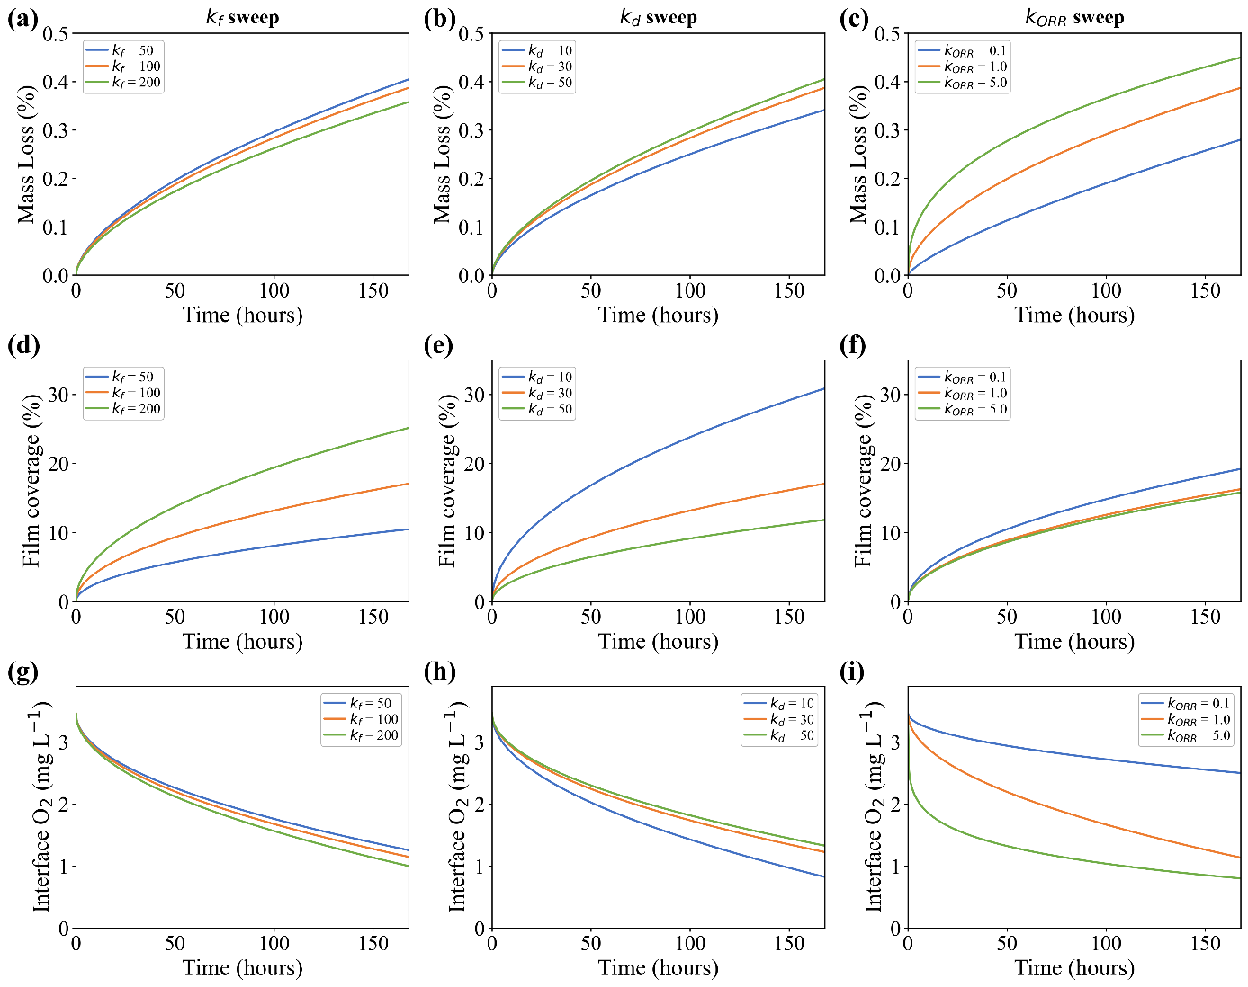
Figure 4. Local parameter sweeps of kinetic parameters. Panels (a–c) show cumulative mass loss (%), panels (d–f) show film coverage (%), and panels (g-i) show interfacial dissolved oxygen concentration (mg L⁻¹) as a function of time during parameter sweeps of $k_{f}$, $k_{d}$, and $k_{ORR}$, respectively.

In Vitro Degradation Behavior
Pure Zn exhibited strongly time-dependent degradation in HBSS, with cumulative mass loss increasing from 0.045% after 1 day to 0.209% after 7 days, before rising more gradually to 0.311% after 28 days (Table 3). Approximately 67% of the 28-day mass loss occurred within the first week, demonstrating a transition from rapid initial degradation to progressively slower material loss. This nonlinear response is consistent with the formation and maturation of Zn corrosion products in physiological chloride-containing media, which progressively restrict oxygen transport to the metal surface and suppress the cathodic oxygen-reduction rate. The measured mass-loss range and temporal deceleration agree with previous observations for commercially pure Zn under comparable physiological conditions ^{[42,44]}, providing a physically representative dataset for evaluating the model’s ability to capture both the magnitude and time dependence of Zn biodegradation.
Table 3. Cumulative mass loss of pure Zn discs during immersion in HBSS at 37 °C for up to 28 days. Values represent mean ± SD ($n=3$ per time point).
Immersion duration | Mass loss (mg) | Mass loss (%)
1 day | $$0.47±0.15$$ | $$0.045±0.016$$
3 days | $$1.20±0.40$$ | $$0.105±0.036$$
7 days | $$2.53±0.76$$ | $$0.209±0.061$$
14 days | $$3.03±0.74$$ | $$0.254±0.061$$
28 days | $$3.67±1.33$$ | $$0.311±0.115$$

Model Validation and Mechanistic Interpretation
The calibrated model was evaluated against the independent 28-day HBSS immersion dataset generated in this study. The predicted mass-loss trajectory closely matched the experimental measurements (Figure 5a), with an RMSE of 0.0159% and a $R^{2}$ of 0.9734. Importantly, the model reproduced both the magnitude and nonlinear temporal evolution of degradation without further parameter adjustment. The corresponding corrosion-rate evolution revealed rapid initial degradation followed by progressive deceleration (Figure 5b), indicating a shift from reaction-controlled to diffusion-limited behavior. Damköhler-number analysis quantified this transition, revealing an initial degradation regime governed by cathodic reaction kinetics. After approximately 40 h of immersion, oxygen transport became rate-limiting, marking the onset of diffusion-controlled degradation and driving the subsequent decline in corrosion rate.
To further investigate the origin of this deceleration, the coupled evolution of dissolved oxygen and corrosion products was examined over 672 h. Corrosion products progressively accumulated near the Zn surface, forming a distinct film layer by 168 h and developing into a dense near-surface region by 672 h (Figure 5c). As the film thickened, transport resistance increased, progressively restricting oxygen diffusion toward the interface. Oxygen depletion developed adjacent to the degrading surface owing to continuous ORR consumption (Figure 5d). The oxygen-deficient boundary layer expanded with immersion time, while radial concentration variations remained small, indicating predominantly one-dimensional transport normal to the surface. The combined effects of film-induced transport limitation and oxygen consumption reduced interfacial oxygen availability, thereby suppressing ORR activity and producing the gradual decline in degradation rate. This mechanism is also consistent with experimental observations of increasing corrosion-product resistance during Zn degradation ^{[44]}.

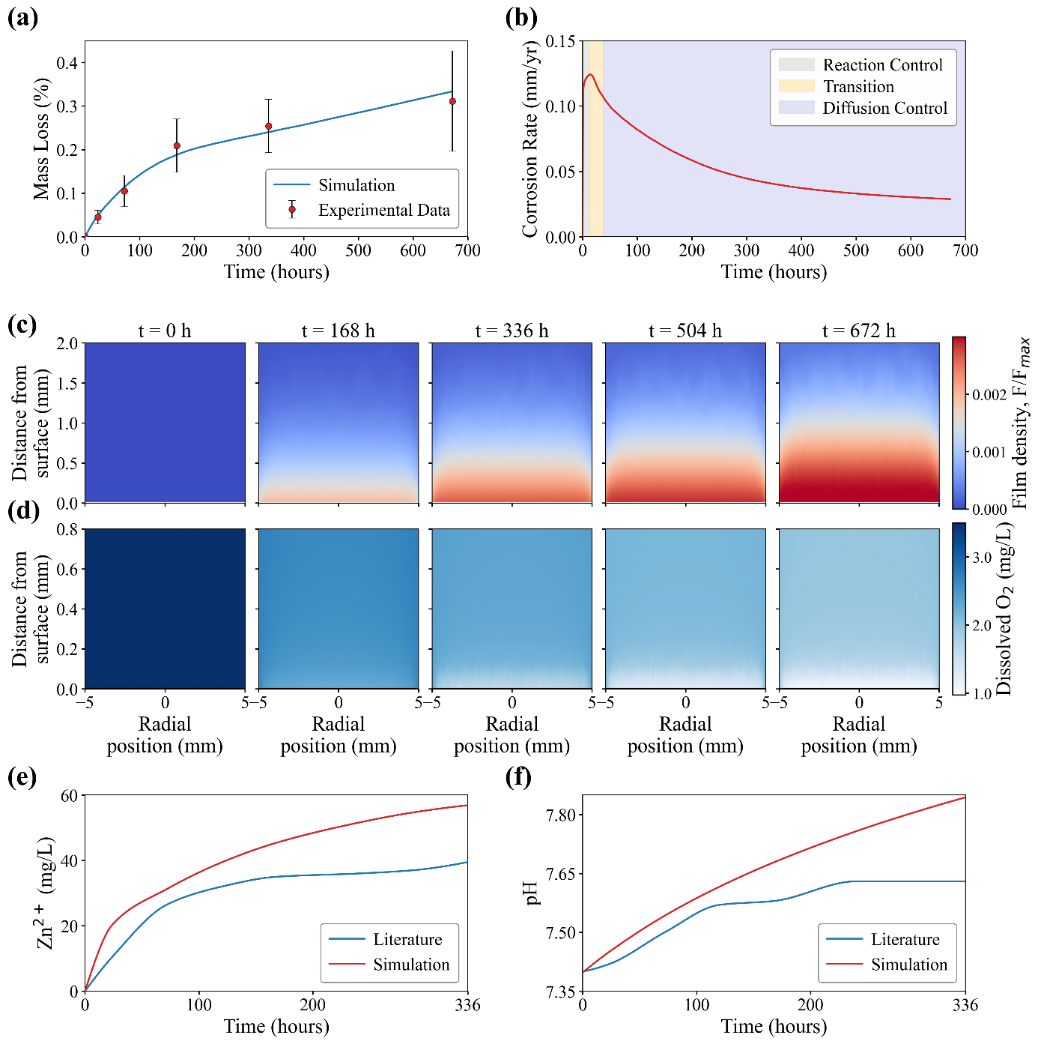
Figure 5. Model validation and mechanistic interpretation of Zn degradation. (a) Simulated and experimental mass loss of Zn over 672 h (error bars denote ±SD, $n=3$ per time point), (b) predicted corrosion-rate evolution highlighting the transition from reaction-controlled to diffusion-controlled degradation, (c) spatiotemporal evolution of normalized corrosion-product saturation ($F/{F_{max}})$​ and (d) dissolved oxygen concentration (mg L⁻¹), comparisons of simulated and literature-reported (e) Zn²⁺ concentration and (f) pH evolution during Zn degradation over 336 h ^{[42]}.

In addition to mass-loss validation, the model was evaluated against Literature measurements of $Zn^{2+}$ concentration and pH evolution reported by Liu et al. ^{[42]} (Table S8). As shown in Figure 5e,f, the model reproduced the overall evolution of both quantities, capturing the rapid initial increase followed by a gradual plateau (Pearson r = 0.96 for Zn²⁺ and 0.95 for pH). Because Zn²⁺ concentration and pH were excluded from the calibration objective, their comparison provides an out-of-objective evaluation of the coupled reaction terms. The overpredictions likely reflect the model's simplified treatment of solution chemistry. Specifically, the use of Tris-HCl as a buffer in the literature study limits the increase in pH, while ongoing complex precipitation in the r-SBF medium reduces the concentration of dissolved Zn²⁺, thereby constraining the late-stage accumulation of both parameters.

Case Study Results
To evaluate the ability of the calibrated framework to transfer across geometries, the disc-derived parameter set was applied to a six-crown Zn stent without geometry-specific recalibration. The simulation used the same material parameters and environmental conditions as the disc. As shown in Figure 6a, the predicted cumulative mass loss reached approximately 6% after 672 h, consistent with the reported one-month degradation range of 6–7% for Zn stents in vivo ^{[10]}. This agreement supports the physiological plausibility of the predicted magnitude but should not be interpreted as formal in vivo validation because the model does not resolve proteins, cells, tissue transport, blood flow, biological buffering, or the full in vivo corrosion-product chemistry. The higher mass loss is consistent with the observed relationship between surface area-to-volume ratio (SA:V) and degradation, where cumulative mass loss increased approximately linearly with SA:V (Figure S9). However, the stent exhibited less pronounced temporal deceleration in mass loss than the disc, indicating that geometric influences on degradation extend beyond SA:V alone.
This is also evident in the predicted corrosion-rate profiles. The stent corrosion rate initially increased to approximately 0.15 mm yr⁻¹ before progressively declining to approximately 0.06 mm yr⁻¹ at 672 h (Figure 6b), remaining higher than that of the disc. Because the corrosion rate was normalized by exposed surface area, this difference cannot be attributed to the stent’s greater surface exposure alone, indicating that geometry-dependent mass transport also enhanced its degradation. Consistent with this interpretation, oxygen transport became rate-limiting after approximately 100 h in the stent, compared with approximately 40 h in the disc, showing that the open architecture sustained reaction-controlled degradation longer before transitioning to oxygen-transport-limited behavior. This delayed onset of transport limitation maintained greater oxygen availability at the degrading surface, supporting higher corrosion rates and contributing to the increased cumulative mass loss observed in the stent.


Figure 6. Comparison of the predicted degradation behavior of a six-crown Zn endovascular stent and disc. (a) Cumulative mass loss, (b) corrosion rate evolution, highlighting the transition from reaction-controlled to diffusion-controlled degradation. The stent exhibited a delayed transition to diffusion control compared with the disc, resulting in sustained higher corrosion rates and greater overall mass loss.

The influence of geometry-dependent transport is further revealed by the spatial evolution of degradation shown in Figure 7. Localized recession became increasingly pronounced within the crown regions, although the overall stent topology remained preserved throughout the simulation (Figure 7a). Because no spatial variation in corrosion kinetics was prescribed, this heterogeneous degradation arose from the coupled effects of geometry, oxygen transport, corrosion-product accumulation, and interface recession. Oxygen availability remained higher along the outward-facing crown surfaces, which were exposed to the surrounding electrolyte and supplied from multiple directions, whereas transport to the inner-curvature regions was progressively restricted by geometric confinement and corrosion-product accumulation (Figure 7b). The resulting oxygen gradients around the crown perimeter produced corresponding spatial variations in local corrosion activity.
These variations are further resolved by the cross-sectional profiles shown in Figure 7c,d. Section 1, located along a relatively straight strut segment, exhibited comparatively uniform recession, with penetration depths ranging from approximately 3.69 to 4.82 $μ$m after 672 h (Figure 7c). This modest variation likely resulted from interactions between adjacent degrading struts, whose overlapping oxygen-depletion fields locally restricted oxygen availability. In contrast, Section 2 intersected the crown apex, where the inner and outer curvatures experienced markedly different transport conditions. Greater oxygen availability along the outward-facing surface produced deeper penetration of approximately 8.55 $μ$m, whereas penetration along the transport-restricted inner curvature remained approximately 4.76 $μ$m after 672 h (Figure 7d). This asymmetric recession shows that the nominal corrosion rate alone cannot predict local material loss because device geometry redistributes oxygen availability and corrosion activity across the implant surface.


Figure 7. Spatially resolved degradation of a six-crown Zn endovascular stent over 672 h. (a) Stent geometry with two representative cross-sections and enlarged views of strut recession at 0, 336, and 672 h, (b) schematic illustration of oxygen transport to the inner and outer-curvature surfaces of the stent crown, (c,d) evolution of the metal cross-sectional profiles at Sections 1 and 2, respectively.

Following the stent-scale analysis, the role of individual geometric features was further isolated using simplified wire configurations (Section S7). Increasing curvature progressively increased mass loss, with the 150° arc showing the highest degradation (Figure 8a). Although curvature altered the spatial distribution of degradation between the outward-facing and inner surfaces, these opposing local effects produced only modest changes in overall mass loss. In contrast, wire spacing had a more pronounced influence (Figure 8b). The mass-loss trajectories were initially similar but diverged later, suggesting that spacing became increasingly important as corrosion products accumulated. At a center-to-center spacing of 0.30 mm, overlapping oxygen-depletion fields restricted oxygen availability within the gap and suppressed the overall oxygen-reduction reaction, resulting in lower cumulative mass loss. Increasing the spacing to 1.60 mm weakened this interaction, allowing each wire to receive oxygen more independently and shifting the response toward that of the isolated wire. This transport-shielding behavior is consistent with observations in porous Zn scaffolds ^{[13]}, suggesting that the framework may also be applicable to predicting geometry-dependent scaffold degradation.
Although the effects on cumulative mass loss were relatively modest, geometry strongly influenced the spatial distribution of degradation. Mean penetration depths varied only slightly, ranging from approximately 2.1 to 2.7 µm across the curved-wire configurations (30°, 90°, and 150° arcs) and from 2.1 to 2.7 µm across the straight, closely spaced, and widely spaced wire configurations (Figure 8c). However, the directional recession ratios revealed substantial local asymmetry (Figure 8d). The outer-to-inner recession ratio increased from 1.6 for the 30° arc to 2.6 for the 90° arc and 13.2 for the 150° arc, demonstrating that increasing curvature progressively concentrated degradation along the oxygen-accessible outer surface while suppressing recession along the confined inner curvature. Similarly, the outward-facing to gap-facing recession ratio increased from 1.3 for the isolated wire to 4.5 for the closely spaced pair, before decreasing to 2.5 for the widely spaced pair. The pronounced asymmetry at close spacing resulted from oxygen depletion within the narrow gap, while the outward-facing surfaces remained accessible to the bulk electrolyte. Thus, curvature and spacing had only modest effects on mean penetration but strongly influenced where material loss occurred. Therefore, cumulative mass loss and nominal corrosion rate alone may conceal localized degradation that could govern strut thinning, stress concentration, and eventual structural failure.
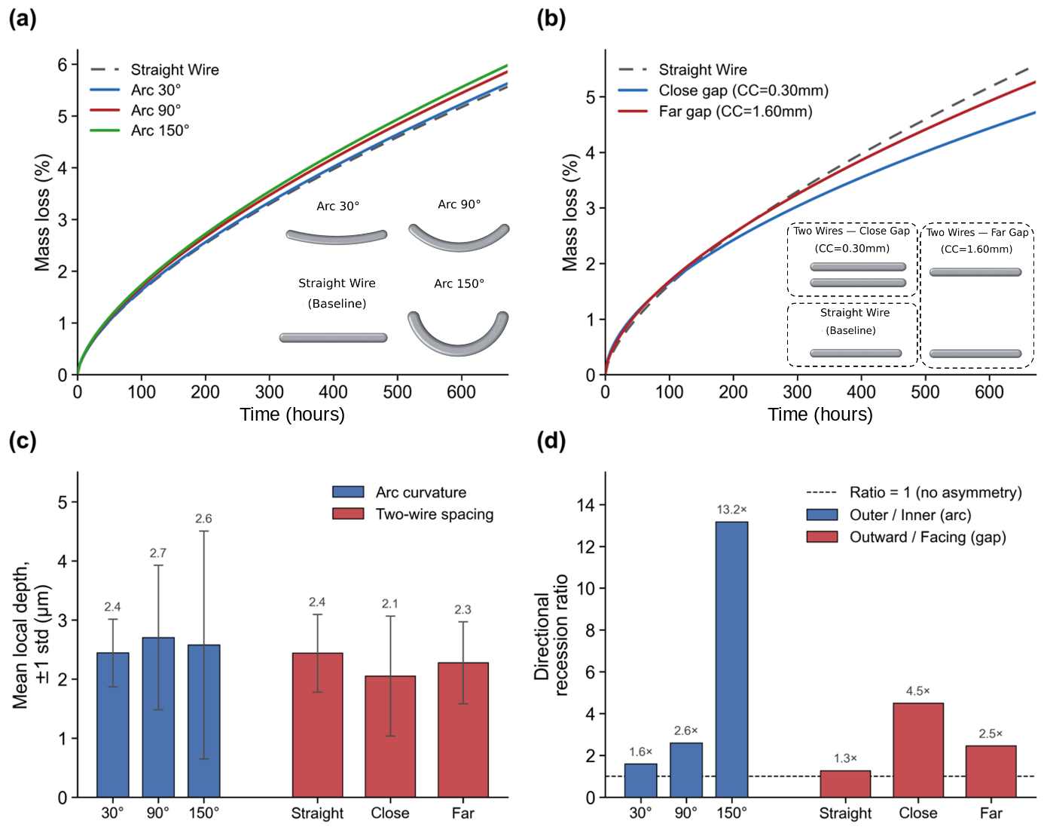
Figure 8. Effects of curvature and inter-wire spacing on the predicted degradation of simplified metallic structures. Cumulative mass loss for (a) straight and curved wires with arc angles of 30°, 90°, and 150°, (b) a straight wire and paired wires with close and far center-to-center spacings of 0.30 and 1.60 mm, (c) mean local penetration depth for the corresponding curvature and spacing configurations, and (d) directional recession ratios comparing the outer and inner surfaces of the curved wires and the outward-facing and gap-facing surfaces of the isolated and paired wires.

The present framework has several limitations that should be considered when extending it toward clinically predictive applications. The corrosion-product layer is treated as a homogenized ZnO-based film rather than a heterogeneous, composition-dependent structure. Secondary phosphate-, carbonate-, and calcium-containing phases that may develop over longer periods are therefore not explicitly resolved. The model also excludes proteins, cells, tissue interactions, blood flow, biological buffering, and the complete range of ionic reactions occurring in vivo. Moreover, the model assumes homogeneous electrochemical activity, preventing prediction of pitting, micro-galvanic coupling, and stress-assisted degradation. Although the model generated physiologically plausible stent predictions without geometry-specific recalibration, comparison with reported in vivo mass loss represents a predictive demonstration rather than formal validation. Further validation against spatially resolved measurements of corrosion-product coverage, oxygen availability, and local penetration is therefore required, particularly for complex implant geometries.
Future developments should incorporate physiologically realistic flow conditions, additional ionic species, multiphase corrosion-product evolution, and spatially heterogeneous electrochemical activity. Extending the framework to Zn alloys will also require accounting for alloying elements, secondary phases, and galvanic interactions. Although the current physics-based simulations remain computationally demanding, the reduced calibrated parameter space and the geometric and field data stored at each time step provide a strong basis for training surrogate models ^{[25]}. Once trained, these models could rapidly predict the temporal evolution of mass loss, local penetration, species distributions, and degradation morphology, enabling efficient exploration of large implant-design spaces. Coupling these predictions with mechanical analysis would further link geometry-dependent degradation to strut thinning, stress concentration, topological change, and loss of structural integrity. With appropriate experimental calibration and validation, the framework could consequently be extended from stents to porous scaffolds, fixation devices, and other architected biodegradable implants as an efficient platform for degradation-informed design.
Structural optimization of biodegradable implants, from patient-specific bone replacements to porous scaffolds, has so far targeted mechanical performance in the as-fabricated state ^{[45,46]}. For biodegradable implants, this approach is insufficient because geometry, mass transport, and degradation evolve in a coupled manner, continuously altering the load-bearing architecture and its mechanical response. By explicitly resolving the influence of geometry on local oxygen availability and surface recession, the present framework provides the degradation component required to extend structural optimization from the initial design state to performance throughout the degradation process.

Conclusions
Zn biodegradation under physiological conditions becomes an oxygen-transport-controlled process after an initial reaction-controlled stage in which implant geometry governs the spatial evolution of material loss. The proposed 3D reaction-diffusion model closely reproduced independent 28-day immersion data (RMSE = 0.0159%) and, without further calibration, predicted approximately 6% mass loss for a six-crown stent, of the same order of magnitude as reported in vivo observations. Mechanistic and sensitivity analyses identified oxygen availability as the primary driver of degradation, with corrosion-product accumulation progressively restricting transport and leading to diffusion-controlled behavior. Importantly, localized degradation emerged naturally from geometry-dependent transport phenomena, without imposing spatially varying corrosion kinetics. While curvature and inter-strut spacing produced only modest changes in cumulative mass loss, they strongly altered the distribution of material recession, demonstrating that global degradation metrics can obscure the localized thinning responsible for structural failure. These findings establish geometry as a critical determinant of biodegradable implant performance and provide a predictive framework for integrating degradation into the design and optimization of Zn stents and other biodegradable metallic implants, enabling structural performance to be considered throughout the implant lifetime rather than only at implantation.

Acknowledgements
The authors acknowledge the use of Monash University’s High-Performance Computing (M3) facility and the Monash eResearch Center for conducting the computational simulations reported in this work. Y.Z. acknowledges funding support from the Australian Research Council Future Fellow project (FT230100180). H.A. thanks the Monash Graduate Scholarship for its financial support.

Author contribution
Henaka Ariyarathna: Conceptualization, Formal analysis, Investigation, Methodology, Software, Visualization, Writing – original draft. Xuan Yang: Data curation, Investigation, Writing – original draft. Aijun Huang: Conceptualization, Funding acquisition, Project administration, Supervision. Yunlong Tang: Conceptualization, Supervision, Resources, Writing – review & editing. Yuman Zhu: Conceptualization, Supervision, Writing – review & editing.

Conflicts of Interest
The authors declare no conflicts of interest.

Code Availability Statement
The source code has been deposited in GitHub: https://doi.org/10.5281/zenodo.23053517

Data Availability Statement
The data that support the findings of this study are available from the corresponding author upon reasonable request.

Received: ((will be filled in by the editorial staff))
Revised: ((will be filled in by the editorial staff))
Published online: ((will be filled in by the editorial staff))

References
1. Y. F. Zheng, X. N. Gu, and F. Witte, “Biodegradable Metals,” Materials Science and Engineering: R: Reports 77 (2014): 1–34, https://doi.org/10.1016/j.mser.2014.01.001.
2. L. Fan, S. Chen, M. Yang, Y. Liu, and J. Liu, “Metallic Materials for Bone Repair,” Advanced Healthcare Materials 13, no. 3 (2024): 2302132, https://doi.org/10.1002/adhm.202302132.
3. H.-S. Han, S. Loffredo, I. Jun, et al., “Current Status and Outlook on the Clinical Translation of Biodegradable Metals,” Materials Today 23 (2019): 57–71, https://doi.org/10.1016/j.mattod.2018.05.018.
4. P. K. Bowen, E. R. Shearier, S. Zhao, et al., “Biodegradable Metals for Cardiovascular Stents: From Clinical Concerns to Recent Zn‐Alloys,” Advanced Healthcare Materials 5, no. 10 (2016): 1121–1140, https://doi.org/10.1002/adhm.201501019.
5. A. Atrens, G. Song, M. Liu, Z. Shi, F. Cao, and M. S. Dargusch, “Review of Recent Developments in the Field of Magnesium Corrosion,” Advanced Engineering Materials 17, no. 4 (2015): 400–453, https://doi.org/10.1002/adem.201400434.
6. G. Katarivas Levy, J. Goldman, and E. Aghion, “The Prospects of Zinc as a Structural Material for Biodegradable Implants—A Review Paper,” Metals 7, no. 10 (2017): 402, https://doi.org/10.3390/met7100402.
7. D. Vojtěch, J. Kubásek, J. Šerák, and P. Novák, “Mechanical and Corrosion Properties of Newly Developed Biodegradable Zn-Based Alloys for Bone Fixation,” Acta Biomaterialia 7, no. 9 (2011): 3515–3522, https://doi.org/10.1016/j.actbio.2011.05.008.
8. J. Rao, H. Gao, J. Sun, R. Yu, D. Zhao, and Y. Ding, “A Critical Review of Biodegradable Zinc Alloys toward Clinical Applications,” ACS Biomaterials Science & Engineering 10, no. 9 (2024): 5454–5473, https://doi.org/10.1021/acsbiomaterials.4c00210.
9. P. Zhao, Z. Wang, H. Yang, et al., “Biodegradable Zn‐Based Implants: Progress, Challenges, and Pathways toward Clinical Translation,” Advanced Science 13, no. 39 (2026): e76066, https://doi.org/10.1002/advs.76066.
10. H. Yang, C. Wang, C. Liu, et al., “Evolution of the Degradation Mechanism of Pure Zinc Stent in the One-Year Study of Rabbit Abdominal Aorta Model,” Biomaterials 145 (2017): 92–105, https://doi.org/10.1016/j.biomaterials.2017.08.022.
11. H. Zhang, T. Du, S. Chen, et al., “Finite Element Analysis of the Non-Uniform Degradation of Biodegradable Vascular Stents,” Journal of Functional Biomaterials 13, no. 3 (2022): 152, https://doi.org/10.3390/jfb13030152.
12. X. Wang, A. Liu, Z. Zhang, et al., “Additively Manufactured Zn‐2Mg Alloy Porous Scaffolds with Customizable Biodegradable Performance and Enhanced Osteogenic Ability,” Advanced Science 11, no. 5 (2024): 2307329, https://doi.org/10.1002/advs.202307329.
13. Y. Shi, W. Xu, H. Che, et al., “The Effect of Topological Design on the Degradation Behavior of Additively Manufactured Porous Zinc Alloy,” npj Materials Degradation 8, no. 1 (2024): 42, https://doi.org/10.1038/s41529-024-00451-z.
14. T. Albaraghtheh, R. Willumeit-Römer, and B. Zeller-Plumhoff, “In Silico Studies of Magnesium-Based Implants: A Review of the Current Stage and Challenges,” Journal of Magnesium and Alloys 10, no. 11 (2022): 2968–2996, https://doi.org/10.1016/j.jma.2022.09.029.
15. E. L. Boland, C. J. Shine, N. Kelly, C. A. Sweeney, and P. E. McHugh, “A Review of Material Degradation Modelling for the Analysis and Design of Bioabsorbable Stents,” Annals of Biomedical Engineering 44, no. 2 (2016): 341–356, https://doi.org/10.1007/s10439-015-1413-5.
16. D. Gastaldi, V. Sassi, L. Petrini, M. Vedani, S. Trasatti, and F. Migliavacca, “Continuum Damage Model for Bioresorbable Magnesium Alloy Devices — Application to Coronary Stents,” Journal of the Mechanical Behavior of Biomedical Materials 4, no. 3 (2011): 352–365, https://doi.org/10.1016/j.jmbbm.2010.11.003.
17. J. A. Grogan, B. J. O’Brien, S. B. Leen, and P. E. McHugh, “A Corrosion Model for Bioabsorbable Metallic Stents,” Acta Biomaterialia 7, no. 9 (2011): 3523–3533, https://doi.org/10.1016/j.actbio.2011.05.032.
18. M. Barzegari, D. Mei, S. V. Lamaka, and L. Geris, “Computational Modeling of Degradation Process of Biodegradable Magnesium Biomaterials,” Corrosion Science 190 (2021): 109674, https://doi.org/10.1016/j.corsci.2021.109674.
19. P. Bajger, J. M. A. Ashbourn, V. Manhas, Y. Guyot, K. Lietaert, and L. Geris, “Mathematical Modelling of the Degradation Behaviour of Biodegradable Metals,” Biomechanics and Modeling in Mechanobiology 16, no. 1 (2017): 227–238, https://doi.org/10.1007/s10237-016-0812-3.
20. S. Thomas, N. V. Medhekar, G. S. Frankel, and N. Birbilis, “Corrosion Mechanism and Hydrogen Evolution on Mg,” Current Opinion in Solid State and Materials Science 19, no. 2 (2015): 85–94, https://doi.org/10.1016/j.cossms.2014.09.005.
21. D. Zhang, L. Zhang, X. Zhang, et al., “Comparative Investigation of the Corrosion Behavior of Biomedical Zinc Alloys in Oxygen-Enriched Simulated Body Fluid Environments,” Materials Today Communications 39 (2024): 108811, https://doi.org/10.1016/j.mtcomm.2024.108811.
22. A. P. Yadav, A. Nishikata, and T. Tsuru, “Oxygen Reduction Mechanism on Corroded Zinc,” Journal of Electroanalytical Chemistry 585, no. 1 (2005): 142–149, https://doi.org/10.1016/j.jelechem.2005.08.007.
23. C. Chen, M. Hofmann, and T. Wallmersperger, “Modeling the Uniform Corrosion Behavior of Zinc in Salt Spray Testing,” npj Materials Degradation 10, no. 1 (2026): 37, https://doi.org/10.1038/s41529-026-00749-0.
24. V. A. Bryzgalov, A. A. Kistanov, A. A. Izosimov, and E. A. Korznikova, “Atomic-Scale Study of Lattice Distortion and Oxygen-Rich Environment Impact on the Surface Degradation Dynamics of Zinc-Based Alloys,” Computational Materials Science 252 (2025): 113797, https://doi.org/10.1016/j.commatsci.2025.113797.
25. T. AlBaraghtheh, R. Willumeit‐Römer, and B. Zeller‐Plumhoff, “Best Practices in Developing a Workflow for Uncertainty Quantification for Modeling the Biodegradation of Mg‐Based Implants,” Advanced Science 11, no. 46 (2024): 2403543, https://doi.org/10.1002/advs.202403543.
26. S. Huang, W. Wu, Y. Su, L. Qiao, and Y. Yan, “Insight into the Corrosion Behaviour and Degradation Mechanism of Pure Zinc in Simulated Body Fluid,” Corrosion Science 178 (2021): 109071, https://doi.org/10.1016/j.corsci.2020.109071.
27. X. Liu, H. Yang, Y. Liu, et al., “Comparative Studies on Degradation Behavior of Pure Zinc in Various Simulated Body Fluids,” JOM 71, no. 4 (2019): 1414–1425, https://doi.org/10.1007/s11837-019-03357-3.
28. M. E. McMahon, R. J. Santucci, and J. R. Scully, “Advanced Chemical Stability Diagrams to Predict the Formation of Complex Zinc Compounds in a Chloride Environment,” RSC Advances 9, no. 35 (2019): 19905–19916, https://doi.org/10.1039/C9RA00228F.
29. P. K. Bowen, J. Drelich, and J. Goldman, “Zinc Exhibits Ideal Physiological Corrosion Behavior for Bioabsorbable Stents,” Advanced Materials 25, no. 18 (2013): 2577–2582, https://doi.org/10.1002/adma.201300226.
30. R. M. Katona, J. Taylor, and R. F. Schaller, “Validating Corrosion Models: A Comparison of Governing Equations,” Corrosion Science 259 (2026): 113495, https://doi.org/10.1016/j.corsci.2025.113495.
31. P. Grathwohl, “Diffusion in Natural Porous Media: Contaminant Transport, Sorption/Desorption and Dissolution Kinetics,” Diffusion in Natural Porous Media: Contaminant Transport, Sorption/Desorption and Dissolution Kinetics, Springer: Boston, MA 1998, https://doi.org/10.1007/978-1-4615-5683-1.
32. J. W. Wilder, C. Clemons, D. Golovaty, K. L. Kreider, G. W. Young, and R. S. Lillard, “An Adaptive Level Set Approach for Modeling Damage Due to Galvanic Corrosion,” Journal of Engineering Mathematics 91, no. 1 (2015): 121–142, https://doi.org/10.1007/s10665-014-9732-3.
33. J. A. Grogan, S. B. Leen, and P. E. McHugh, “A Physical Corrosion Model for Bioabsorbable Metal Stents,” Acta Biomaterialia 10, no. 5 (2014): 2313–2322, https://doi.org/10.1016/j.actbio.2013.12.059.
34. J. R. Rumble, Ed., “CRC Handbook of Chemistry and Physics,” CRC handbook of chemistry and physics, 98th edition 2017-2018., CRC Press, Taylor & Francis Group: Boca Raton London New York 2017.
35. D. R. Lide, Ed., “CRC Handbook of Chemistry and Physics,” CRC handbook of chemistry and physics, 72nd ed., CRC Press: Boca Raton 1991.
36. P. Han, and D. M. Bartels, “Temperature Dependence of Oxygen Diffusion in H ₂ O and D ₂ O,” The Journal of Physical Chemistry 100, no. 13 (1996): 5597–5602, https://doi.org/10.1021/jp952903y.
37. S.-Y. Park, S.-H. Rho, H.-S. Lee, K.-M. Kim, and H.-C. Lee, “Fabrication of Highly Porous and Pure Zinc Oxide Films Using Modified DC Magnetron Sputtering and Post-Oxidation,” Materials 14, no. 20 (2021): 6112, https://doi.org/10.3390/ma14206112.
38. L. Holzer, P. Marmet, M. Fingerle, A. Wiegmann, M. Neumann, and V. Schmidt, “Tortuosity-Porosity Relationships: Review of Empirical Data from Literature,” in Tortuosity and Microstructure Effects in Porous Media, Vol. 333, Springer International Publishing: Cham 2023, pp. 51–89, https://doi.org/10.1007/978-3-031-30477-4_3.
39. K. Chen, X. Gu, H. Sun, et al., “Fluid-Induced Corrosion Behavior of Degradable Zinc for Stent Application,” Journal of Materials Science & Technology 91 (2021): 134–147, https://doi.org/10.1016/j.jmst.2021.02.050.
40. J. Tkacz, K. Slouková, J. Minda, et al., “Influence of the Composition of the Hank’s Balanced Salt Solution on the Corrosion Behavior of AZ31 and AZ61 Magnesium Alloys,” Metals 7, no. 11 (2017): 465, https://doi.org/10.3390/met7110465.
41. T. Kokubo, and H. Takadama, “How Useful Is SBF in Predicting in Vivo Bone Bioactivity?,” Biomaterials 27, no. 15 (2006): 2907–2915, https://doi.org/10.1016/j.biomaterials.2006.01.017.
42. L. Liu, Y. Meng, C. Dong, Y. Yan, A. A. Volinsky, and L.-N. Wang, “Initial Formation of Corrosion Products on Pure Zinc in Simulated Body Fluid,” Journal of Materials Science & Technology 34, no. 12 (2018): 2271–2282, https://doi.org/10.1016/j.jmst.2018.05.005.
43. E. Mostaed, M. Sikora-Jasinska, J. W. Drelich, and M. Vedani, “Zinc-Based Alloys for Degradable Vascular Stent Applications,” Acta Biomaterialia 71 (2018): 1–23, https://doi.org/10.1016/j.actbio.2018.03.005.
44. Y. Meng, L. Liu, D. Zhang, et al., “Initial Formation of Corrosion Products on Pure Zinc in Saline Solution,” Bioactive Materials 4 (2019): 87–96, https://doi.org/10.1016/j.bioactmat.2018.08.003.
45. Y. Li, J. Wang, K. Sheng, et al., “Optimizing Structural Design on Biodegradable Magnesium Alloy Vascular Stent for Reducing Strut Thickness and Raising Radial Strength,” Materials & Design 220 (2022): 110843, https://doi.org/10.1016/j.matdes.2022.110843.
46. J. Chen, F. Dong, and S. Liu, “Design and Mechanical Performance Evaluation of WE43 Magnesium Alloy Biodegradable Stents via Finite Element Analysis,” Metals 14, no. 6 (2024): 704, https://doi.org/10.3390/met14060704.

Supporting Information
Supporting Information is available from the Wiley Online Library or from the author.

