Supporting Information
A Mechanistic Framework for Predicting the Biodegradation of Zinc Implants
Henaka Ariyarathna, Xuan Yang, Aijun Huang, Yunlong Tang*, Yuman Zhu*
H. Ariyarathna, X. Yang, A. Huang, Y. Tang, Y. Zhu
Monash Centre for Additive Manufacturing, Monash University, Wellington Rd, Clayton, VIC 3800, Australia
H. Ariyarathna, X. Yang, A. Huang, Y. Tang
Department of Materials Science and Engineering, Monash University, Wellington Rd, Clayton, VIC 3800, Australia
A. Huang, Y. Tang, Y. Zhu
Department of Mechanical and Aerospace Engineering, Monash University, Wellington Rd, Clayton, VIC 3800, Australia
*Correspondence: Yunlong.Tang1@monash.edu, yuman.zhu@monash.edu
Contents
Section | Topic | Equations, tables and figures
S1 | Model equations and velocity-selection rule | Equations S1–S3; Table S1; Figures S1–S2
S2 | Geometry and mesh generation | Equation S4; Tables S2–S3; Figures S3–S4
S3 | Simulation settings and parameters | Table S4
S4 | Sensitivity analysis | Tables S5–S6; Figure S5
S5 | Bayesian calibration and validation | Equation S5; Tables S7–S10; Figure S6
S6 | Uncertainty analysis | Table S11; Figure S7
S7 | Case-study results | Table S12; Figures S8–S10
S8 | Oxygen mass balance | Table S13

S1. Model equations and velocity-selection rule
This section defines the quantities used to evaluate the simulations (Equations S1–S3) and documents the choice of velocity-selection rule (Rules A–D; Table S1 and Figures S1 and S2).
$$\begin{aligned}CR\left(t\right)=8.76×{10}^{4} \frac{W}{ρ_{Zn} A t}\#\left(S1\right)\end{aligned}$$
where $W$ (g) is the cumulative mass loss, $A$ (cm$​^{2}$) is the exposed area from the zero-level set $Γ(t)$, $ρ_{Zn}=7.14 g cm^{-3}$, and $t$ (h) is the exposure time, with both $W$ and $A$ updated at every time step.
$$\begin{aligned}pH=14+\log_{10}\left(\frac{C_{{OH}^{-}}}{1000}\right)\#\left(S2\right)\end{aligned}$$
where $C_{{OH}^{-}}$ is the hydroxide ion concentration in the electrolyte.
$$\begin{aligned}Da(x,t)=\frac{k_{ORR} C_{O_{2}}|_{Γ}}{D_{O_{2}}^{\text{eff}}(x,t) {\left|∇C_{O_{2}}⋅n\right|}_{Γ}}\#\left(S3\right)\end{aligned}$$
where $k_{ORR}$​ is the ORR rate constant, $C_{O_{2}}$ is the local oxygen concentration, $D_{O_{2}}^{\text{eff}}$​ is the effective oxygen diffusivity, and $∇C_{O_{2}}⋅n$ is the oxygen concentration gradient normal to the corroding surface. The Damköhler number represents the ratio of oxygen consumption to oxygen transport, with Da < 1 indicating reaction-controlled corrosion and Da > 1 indicating diffusion-controlled corrosion.
Four velocity-selection formulations were evaluated against literature Zn degradation data. The candidate formulations were:
$$Rule A: v = min(v_{Zn},v_{ORR}, v_{O_{2}})$$
$$Rule B: v = {\left[\left(\frac{1}{v_{Zn}} + \frac{1}{v_{ORR}} + \frac{1}{v_{O_{2}}}\right)\right]}^{-1}$$
$$Rule C: v = min(v_{Zn}, v_{ORR} + v_{O_{2}})$$
$$Rule D: v = min(v_{Zn}, v_{ORR}) (No oxygen diffusion cap)$$
Rule A (hard minimum) was adopted on physical and numerical grounds. Agreement with the literature data served as a consistency check rather than as the selection criterion, because RMSE depends on the calibration and could be reduced for any rule by recalibrating it.
First, Rule A encodes the physical picture that the slowest of the mutually exclusive rate capacities gates the interface. The simulations support this picture: after the initial reaction-controlled stage the interface is oxygen-diffusion-limited, and oxygen diffusion controls more than 99% of the interface area at 672 h. Blended rules (Rules B and C) change the prediction only where two velocities are comparable, which rarely occurs here, and they represent co-controlled mechanisms that the results do not show. Second, Rule D removes the oxygen-diffusion cap, so oxygen reduction proceeds irrespective of the local oxygen supply. This is inconsistent with oxygen-limited degradation and over-predicts the mass loss (0.58% at 168 h against 0.20% in the literature data, and 0.94% against 0.23% for Rule A at 672 h). Third, Rule A adds no parameters or regularization, whereas Rules B and C introduce blending terms. Fourth, the non-differentiability of the hard minimum did not cause switching artifacts: only two controlling-regime transitions occurred (1.2% of the 167 recorded steps), both during the initial transient. The same count was obtained for Rules B–D, so this criterion does not separate the rules but removes the main objection to Rule A.
Rule A also gave the lowest RMSE against the literature data (0.0568%, against 0.0770%, 0.0766% and 0.2983% for Rules B, C and D), and its 672 h mass loss (0.226%) was 17–18% higher than those of Rules B and C (0.185% and 0.188%). Because the rules were not recalibrated individually, these differences are supporting evidence only. Rule A was used for all simulations.
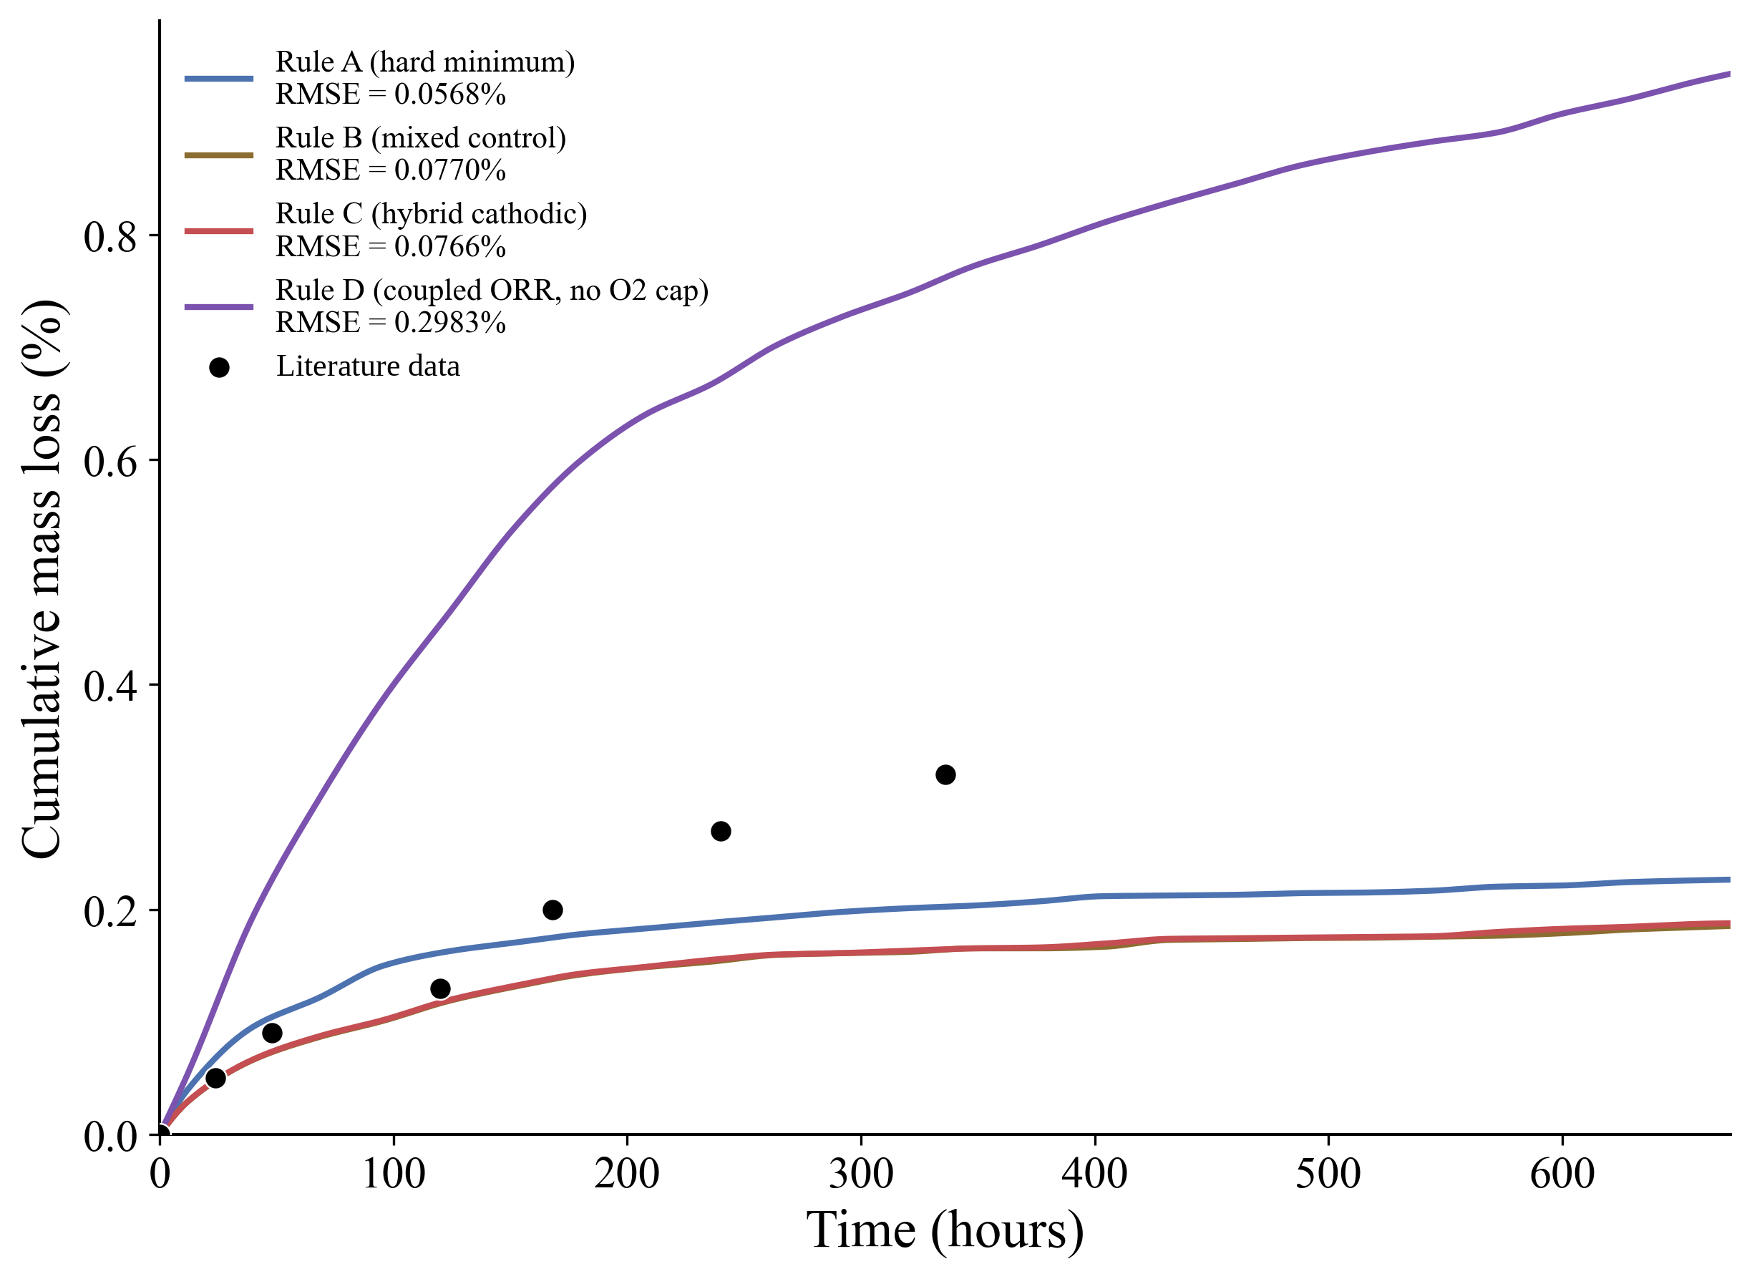
Figure S1. Literature and predicted cumulative mass loss obtained using four velocity-selection formulations. Rule A (hard minimum) had the lowest RMSE (0.0568%) and was adopted on the physical grounds described in the text. Rules B and C performed comparably, while Rule D markedly overpredicted degradation.
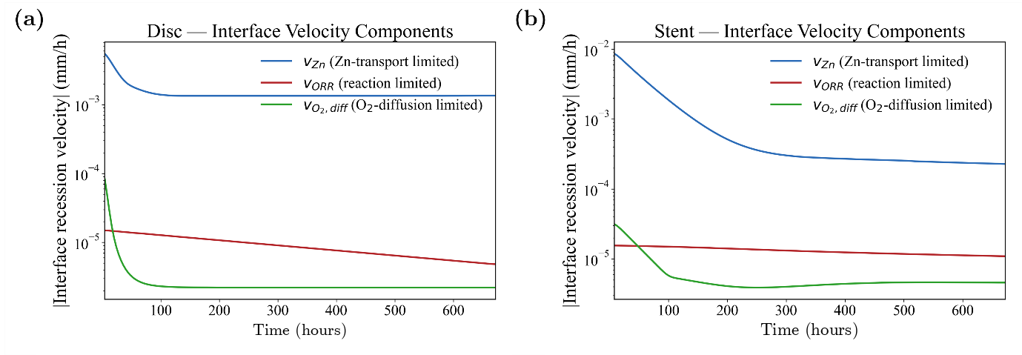
Figure S2. Interface recession velocity components for (a) a Zn disc and (b) a Zn stent during 672 h of immersion. The zinc transport-limited (v_{Zn}​), oxygen reduction-limited (v_{ORR}​), and oxygen diffusion-limited (v_{O2, diff}​) velocities are shown separately.
Table S1. Comparison of the candidate velocity-selection formulations. Rule A (hard minimum) gave the lowest RMSE and was adopted on physical grounds (see text).
Rule | Description | RMSE (%)
A | Hard minimum | 0.0568
B | Mixed control | 0.0770
C | Hybrid cathodic | 0.0766
D | Coupled ORR (no O2 cap) | 0.2983

S2. Geometry and mesh generation
STL implant geometries were converted into tetrahedral finite-element meshes using a Gmsh (v4.13.1)-based workflow [1], with TetGen [2] for tetrahedralization and MMG [3] for adaptive remeshing. Adaptive refinement was applied at the Zn-electrolyte interface, and the resulting Zn-electrolyte meshes were exported in FreeFEM/Medit (.mesh) format for all simulations in FreeFEM (v4.14) [4].
Table S2 and Figure S3 report the mesh convergence study, and Table S3 compares adaptive and uniform meshes of similar size.
Mesh convergence was assessed from the relative error of the predicted mass loss with respect to the reference mesh:
$$\begin{aligned}RelativeError \left(\%\right)=\frac{\left| MassLoss\left(L_{i}\right)- MassLoss\left(Reference\right)\right|}{MassLoss\left(Reference\right)} X 100\#\left(S4\right)\end{aligned}$$
where MassLoss_Li is the predicted mass loss for mesh level Li and MassLoss_Reference is the predicted mass loss for the reference mesh (21.25 million elements).
Table S2. Mesh convergence study showing the effect of mesh resolution on predicted 7-day mass loss. Relative errors are calculated with respect to the reference mesh (21.25 million elements).
Fidelity | Elements | Mass loss (%) | Relative error (%)
L1 (Very Low) | 182,768 | 1.439 | 1465.8
L2 (Low) | 802,365 | 0.4977 | 441.6
L3 (Medium) | 3,454,723 | 0.1633 | 77.7
L4 (High) | 4,990,080 | 0.1208 | 31.4
L5 (Very High) | 11,958,220 | 0.1002 | 9.0
L6 (Ultra High) | 18,864,900 | 0.0927 | 0.87
Reference | 21245,850 | 0.0919 | —
Table S3. Comparison between adaptive and uniform meshes at approximately 800,000 elements.
Mesh type | Elements | Mass loss (%) | Error vs. reference (%) | Improvement
Uniform Mesh | 799,520 | 2.8561 | 3007.8 | Baseline
Adaptive Mesh | 802,365 | 0.4977 | 441.6 | 0.8532
Reference Mesh | 21245,850 | 0.0919 | — | 1
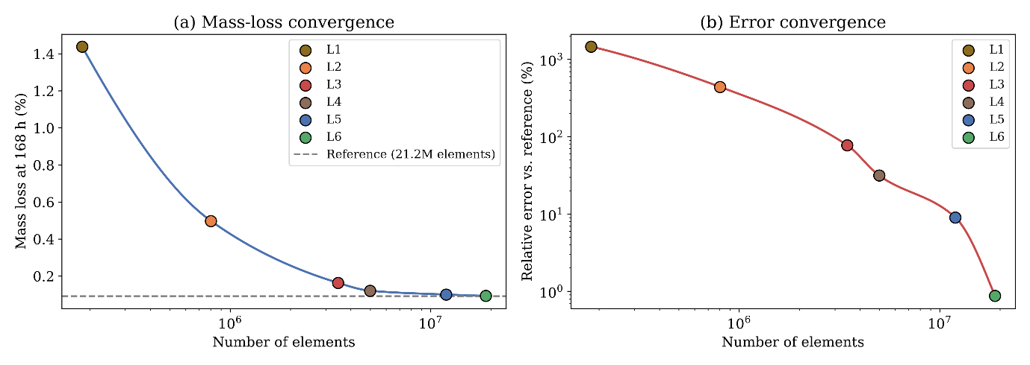
Figure S3. Mesh convergence analysis showing (a) predicted mass loss and (b) relative error as a function of mesh density. Predictions converged with mesh refinement, with <1% error for the final mesh.
Figure S4 shows the geometries and finite-element domains used in the simulations.
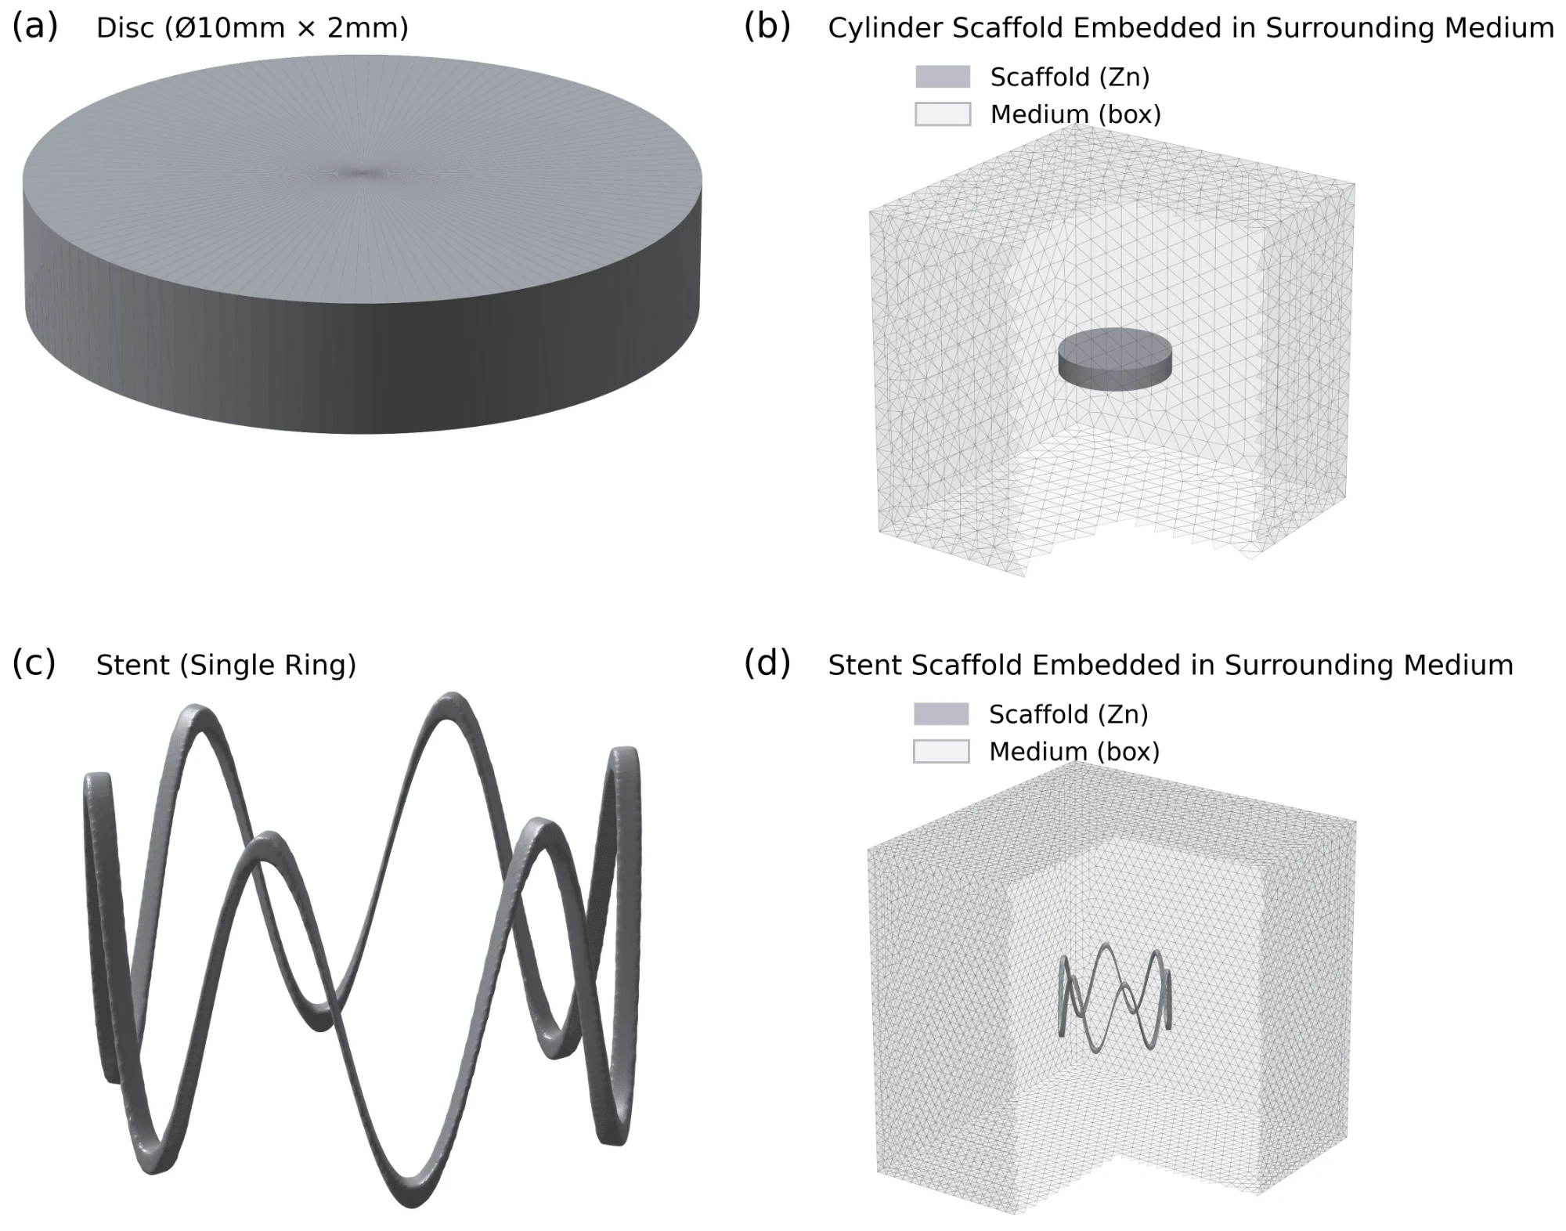
Figure S4. Generated computational geometries and finite-element domains used for Zn degradation simulations: (a) disc specimen (Ø10 mm × 2 mm), (b) disc embedded within the surrounding electrolyte domain, (c) single-ring six-crown stent, and (d) stent embedded within the surrounding electrolyte domain. The Zn structures are shown in dark grey, and the tetrahedral electrolyte domains are shown in light grey.

S3. Simulation settings and parameters
Table S4 lists the mesh, numerical integration, software and boundary-condition settings used for the disc calibration, disc validation and stent simulations. The simulations were run in FreeFEM (v4.14) [4] with PETSc [5] and Open MPI [6], and the level-set function was reinitialized with the fast marching method [7]. Geometry processing and post-processing used scikit-image [8], trimesh [9], meshio [10], SciPy [11], Matplotlib [12] and ParaView [13].
Table S4. Mesh generation, numerical integration, software implementation, and boundary-condition settings used for the disc-specimen and stent simulations.
Parameter | Disc Calibration | Disc Validation | Stent Simulation
Geometry
Domain size (X × Y × Z) | 30 × 30 × 30 mm | 30 × 30 × 30 mm | 30 × 30 × 30 mm
Specimen geometry | Ø 10 mm × 2 mm height | Ø 10 mm × 2 mm height | –
Outer diameter, Dout | – | – | 3.20 mm
Strut dimensions (w × h) | – | – | 0.15 mm × 0.15 mm
Crown amplitude, A | – | – | 1.00 mm
Axial length, Lz | – | – | 2.40 mm
Surface area | 219.9 mm² | 219.9 mm² | 19.46 mm²
Initial Volume | 157.08 mm³ | 157.08 mm³ | 0.361 mm³
SA/V ratio | 1.40 mm⁻¹ | 1.40 mm⁻¹ | 53.9 mm⁻¹
Mesh Properties
Number of elements | 802,365 | 18,864,900 | 21,099,161
Number of vertices | 121,120 | 2,847,652 | 3,523,952
Minimum element size | 0.1 mm | 0.04 mm | 0.01 mm
Maximum element size | 2.00 mm | 2.00 mm | 1.00 mm
Element type | Tetrahedral (P1 Lagrange) | Tetrahedral (P1 Lagrange) | Tetrahedral (P1 Lagrange)
Time Integration
Time step (Δt) | 0.25 h | 0.25 h | 0.25 h
Simulation duration | 336 h (14 days) | 672 h (28 days) | 672 h (28 days)
Level-set reinitialization interval (Fast marching method) | 1.0 h | 1.0 h | 1.0 h
Computational Resources
MPI processes | 50 | 50 | 64
Average DOF per process | 2,592 | 60,953 | 59,061
Preconditioner | Algebraic multigrid | Algebraic multigrid | Algebraic multigrid
Linear solver | GMRES (30 restart) | GMRES (30 restart) | GMRES (30 restart)
Linear solver tolerance | 1.0 × 10⁻⁶ | 1.0 × 10⁻⁶ | 1.0 × 10⁻⁶
Nonlinear solver tolerance | 1.0 × 10⁻⁴ | 1.0 × 10⁻⁴ | 1.0 × 10⁻⁴
Wall-clock time (per simulation) | 2 h | 68.9 h | 69.3 h
Software & Discretization
Finite element framework | FreeFEM (v4.14) | FreeFEM (v4.14) | FreeFEM (v4.14)
Time integration scheme | First-order backward Euler | First-order backward Euler | First-order backward Euler
Boundary Conditions
Container wall boundary condition | No-flux (zero Neumann) | No-flux (zero Neumann) | No-flux (zero Neumann)
Top surface boundary condition | Dirichlet | Dirichlet | Dirichlet
Dissolved oxygen concentration | 3.5 mg L⁻¹ | 3.5 mg L⁻¹ | 3.5 mg L⁻¹

S4. Sensitivity analysis
Table S5 lists the parameters varied in the Morris analysis [14], performed with SALib [15], and Table S6 gives the design settings.
Table S5. Parameters included in the Morris sensitivity analysis.
Parameter | Symbol | Range | Unit
Film formation rate constant | $$k_{f}$$ | 50–200 | $$h^{-1}$$
Film dissolution rate constant | $$k_{d}$$ | 1–50 | $${{mm}^{6}{ g}^{-2} h}^{-1}$$L² mol⁻² h⁻¹
Oxygen reduction rate constant | $$k_{ORR}$$ | 0.1–5.0 | $${mm h}^{-1}$$
Oxygen diffusivity | $$D_{O_{2}}$$ | 5–20 | $${{mm}^{2} h}^{-1}$$
Initial dissolved oxygen concentration | $$C_{O_{2},0}$$ | $$1×{10}^{-9} to 1×{10}^{-7}$$ | $${g mm}^{-3}$$
Zn²⁺ diffusivity | $$D_{Zn}$$ | 1.5–5.0 | $${{mm}^{2} h}^{-1}$$
Cl⁻ diffusivity | $$D_{Cl}$$ | 5–15 | $${{mm}^{2} h}^{-1}$$
OH⁻ diffusivity | $$D_{OH}$$ | 15–35 | $${{mm}^{2} h}^{-1}$$
Table S6. Morris design settings.
Setting | Value
Sensitivity method | Morris elementary effects
Software | SALib
Number of parameters | 8
Number of levels (p) | 4
Number of trajectories (r) | 20
Total model evaluations | 180
Response metric | Mass loss after 168 h
Figure S5 shows how the sensitivity indices evolve during the simulated degradation.
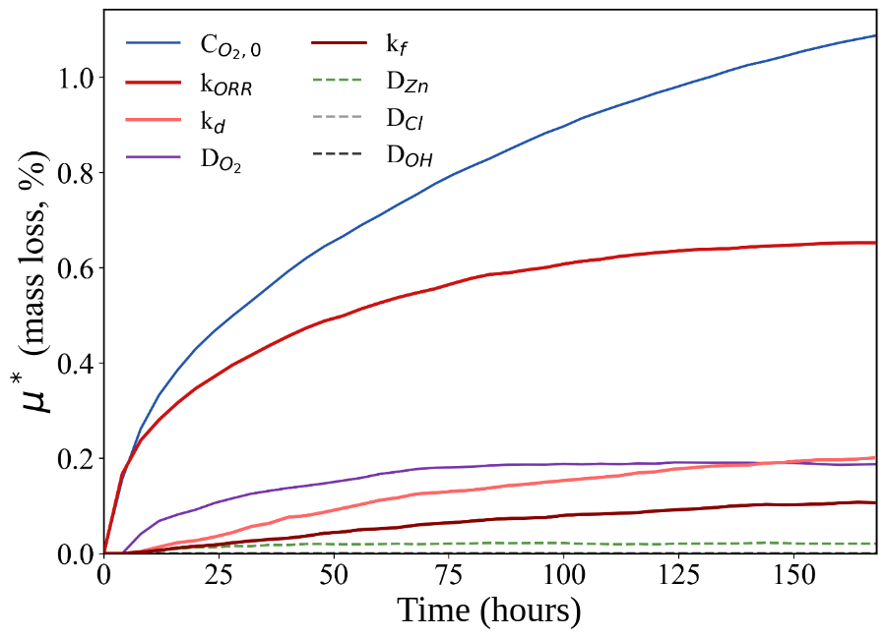
Figure S5. Time-dependent Morris sensitivity indices (μ∗) for the model parameters affecting predicted Zn mass loss during 168 h of degradation. The variation of μ∗ over time quantifies how each parameter's influence on the degradation response changes throughout the simulation period.

S5. Bayesian calibration and validation
Optimal parameters were identified by minimizing the RMSE between predicted and literature-reported 14-day mass-loss measurements. A Gaussian process (GP) surrogate model [16] was initialized using a 12-point Latin hypercube sampling (LHS) design [18] spanning the admissible parameter space and iteratively refined using the expected improvement (EI) acquisition function [17]. The literature data are from Liu et al. [19].
The RMSE was calculated as:
$$\begin{aligned}RMSE=\sqrt{\frac{1}{n}\sum_{i=1}^{n}{{\left[{MassLoss}_{Sim}\left(t_{i}\right)-{MassLoss}_{exp}\left(t_{i}\right)\right]}^{2}}}\#\left(S5\right)\end{aligned}$$
where n is the number of literature data points, and MassLoss_sim(t_i) and MassLoss_exp(t_i) are the simulated and literature mass loss at time t_i, respectively.
Table S7 lists the literature mass-loss data used for calibration.
Table S7. Literature mass-loss data used for Bayesian calibration (Liu et al. 2018).
Duration (days) | Time (hours) | Literature mass loss (%)
1 | 24 | 0.0500
2 | 48 | 0.0900
5 | 120 | 0.1300
7 | 168 | 0.2000
10 | 240 | 0.2700
14 | 336 | 0.3200
Tables S8 and S9 and Figure S6 compare the calibrated model with the literature data.
Table S8. Literature Zn dissolution and pH data used for validation (Liu et al. 2018).
Duration (days) | Time (hours) | Zn dissolution (mg/L) | pH
1 | 24 | 10.5 | 7.4
2 | 48 | 26.5 | 7.5
5 | 120 | 32 | 7.57
7 | 168 | 35 | 7.58
10 | 240 | 36 | 7.63
14 | 336 | 39.5 | 7.63
Table S9. Final calibrated-model predictions of mass loss compared with the literature mass-loss data used for calibration (Liu et al. 2018).
Time (hours) | Predicted mass loss (%) | Literature mass loss (%) | Absolute error (%)
0 | 0.0000 | 0.0000 | 0.000
24 | 0.049 | 0.0500 | 0.001
48 | 0.084 | 0.0900 | 0.006
120 | 0.158 | 0.1300 | 0.028
168 | 0.188 | 0.2000 | 0.012
240 | 0.214 | 0.2700 | 0.056
336 | 0.240 | 0.3200 | 0.080
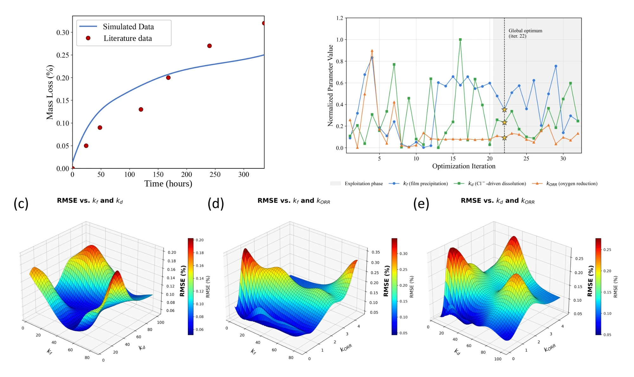
Figure S6. Bayesian calibration results: (a) simulated and literature mass loss, (b) normalized parameter trajectories, and (c–e) RMSE response surfaces for pairwise combinations of $k_{f}$, $k_{d}$, and $k_{ORR}$.
Table S10 lists the settings of the Bayesian optimizer.
Table S10. Bayesian optimization settings used for parameter calibration.
Setting | Value
Optimization method | Bayesian optimization
Surrogate model | Gaussian Process
Objective function | RMSE minimization
Parameters calibrated | $k_{f}$, $k_{d}$, $k_{ORR}$
Prior distribution | Uniform
Parameter bounds | Main-text Table 2
Random seed | 1
Initial sampling | 12-point Latin hypercube design (iterations 1–12)
Acquisition function | Expected improvement
Total iterations | 32 (optimum at iteration 22)
Noise treatment | Deterministic objective
Target RMSE | 0.05%

S6. Uncertainty analysis
Uncertainty in predicted mass loss arising from the calibrated kinetic parameters $k_{f}$, $k_{d}$, and $k_{ORR}$ was evaluated using 50 parameter sets sampled from a 2000-draw GP-bootstrap calibration ensemble. At 672 h, the ensemble median mass loss was 0.333%, with 50% and 95% intervals of 0.330–0.338% and 0.315–0.375%, respectively, closely matching the BO-optimum prediction of 0.333%. Four of six literature measurements fell within the 95% interval. Because the GP ensemble represents uncertainty in the calibration objective rather than a formal parameter posterior, these bands are reported as parameter-propagated ensemble intervals and exclude measurement, model-form, and numerical uncertainty.
Figure S7 shows the ensemble prediction and the distribution of mass loss at 672 h.
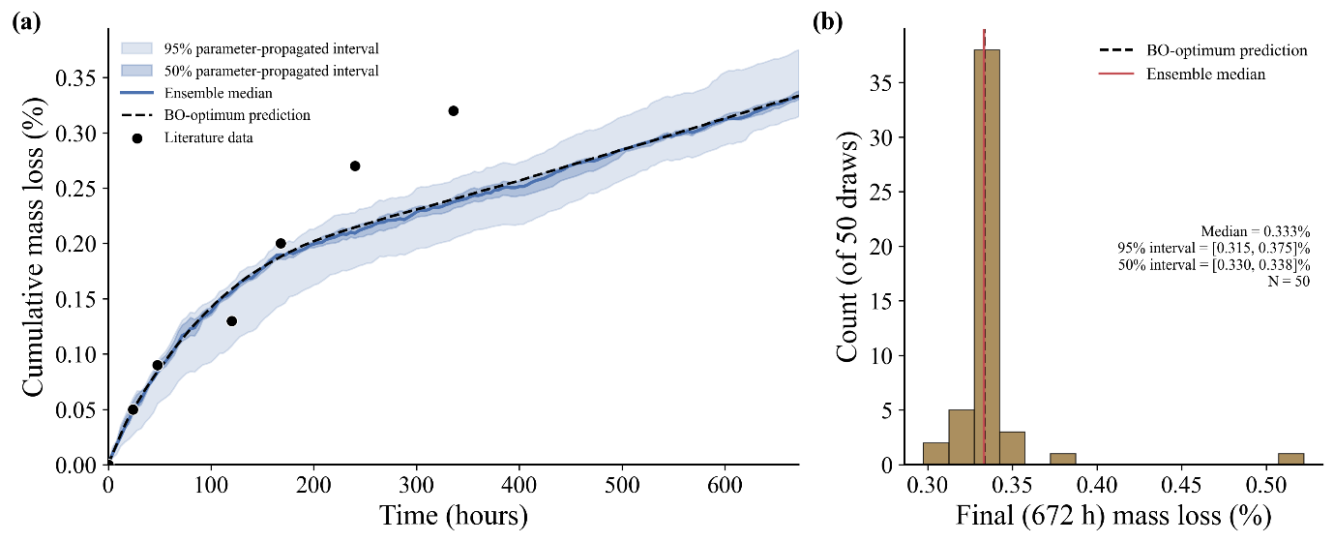
Figure S7. Parameter-propagated uncertainty in predicted Zn mass loss. (a) Ensemble median and 50% and 95% parameter-propagated intervals obtained from 50 kinetic-parameter sets, compared with the BO-optimum prediction and literature measurements. (b) Distribution of predicted mass loss at 672 h. The ensemble median was 0.333%, with 50% and 95% intervals of 0.330–0.338% and 0.315–0.375%, respectively. The intervals represent kinetic-parameter uncertainty only and are not Bayesian credible or predictive intervals.
Table S11 compares the simulated mass loss with the HBSS validation measurements and their experimental scatter.
Table S11. Comparison of simulated and measured mass loss in HBSS (validation) with the experimental scatter. Experimental values are mean ± SD (n = 3); |Error|/SD is the absolute error divided by the SD at the same immersion time. The validation RMSE of 0.0159% (R² = 0.9734) corresponds to 8.6% of the mean measured mass loss (0.185%) and 5.1% of the 28-day value.
Time (h) | Experiment (%, mean ± SD) | Simulation (%) | Error (%) | |Error|/SD
24 | 0.045 ± 0.016 | 0.049 | +0.004 | 0.28
72 | 0.105 ± 0.036 | 0.114 | +0.008 | 0.24
168 | 0.209 ± 0.061 | 0.188 | −0.021 | 0.34
336 | 0.254 ± 0.061 | 0.240 | −0.014 | 0.23
672 | 0.311 ± 0.115 | 0.333 | +0.022 | 0.19

S7. Case-study results
Figure S8 shows the spatial evolution of oxygen and film saturation in the stent. Table S12 and Figures S9 and S10 describe the controlled test structures and their results.
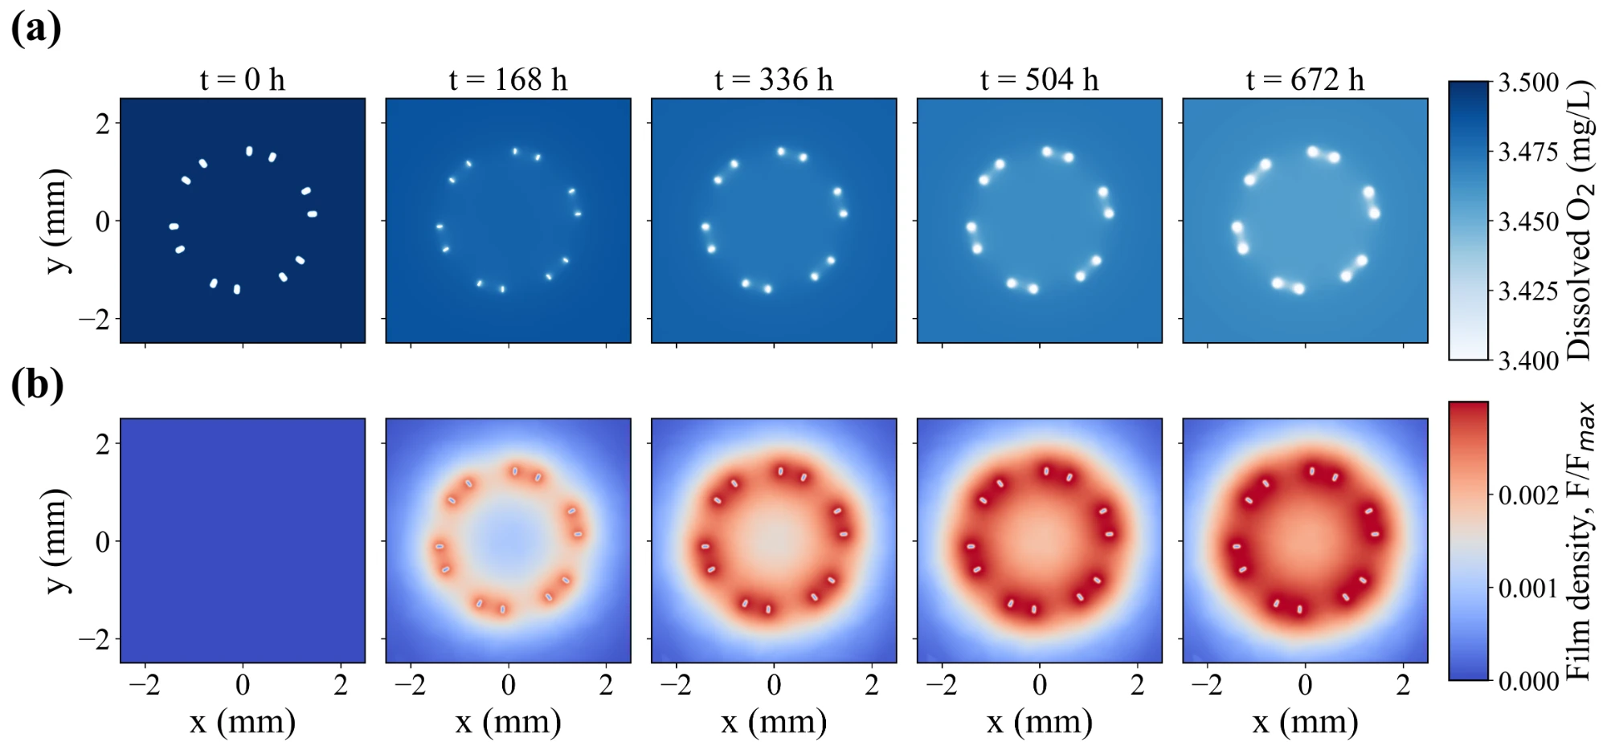
Figure S8. Spatial evolution of (a) dissolved oxygen concentration (C_{O2}​​) and (b) normalized corrosion-film saturation (F/F_{max}​) in a transverse cross-section of the six-crown Zn stent during 672 h of immersion.
Table S12. Geometric and computational parameters of the controlled test structures used in Figure 8.
Specimen / configuration | Geometry / inlet faces | Secondary dimension / wall faces | Cross-section | SA/V (mm⁻¹) | Electrolyte domain
Straight wire | Arc angle: 0°; R=∞ | Inner radius: N/A | 0.165 × 0.165 mm rounded-square wires | 24.11 | 30×30×30 mm
Arc 30° | Arc angle: 30°; R=3.15 mm | Inner radius: 3.0688 mm | 0.165 × 0.165 mm rounded-square wires | 24.11 | 30×30×30 mm
Arc 90° | Arc angle: 90°; R=1.05 mm | Inner radius: 0.9679 mm | 0.165 × 0.165 mm rounded-square wires | 24.11 | 30×30×30 mm
Arc 150° | Arc angle: 150°; R=0.63 mm | Inner radius: 0.5478 mm | 0.165 × 0.165 mm rounded-square wires | 24.11 | 30×30×30 mm
Close gap | Center-to-center spacing: 0.30 mm | Edge-to-edge gap: 0.135 mm | 0.165 × 0.165 mm rounded-square wires | 24.11 | 30×30×30 mm
Far gap | Center-to-center spacing: 1.60 mm | Edge-to-edge gap: 1.435 mm | 0.165 × 0.165 mm rounded-square wires | 24.11 | 30×30×30 mm
Low SA/V | Thickness = 0.2475 mm | Arc angle: 0° | 0.2475 × 0.2475 mm rounded-square wires | 16.07 | 30×30×30 mm
Mid SA/V | Thickness = 0.165 mm | Arc angle: 0° | 0.165 × 0.165 mm rounded-square wires | 24.11 | 30×30×30 mm
High SA/V | Thickness = 0.0825 mm | Arc angle: 0° | 0.0825 × 0.0825 mm rounded-square wires | 48.21 | 30×30×30 mm
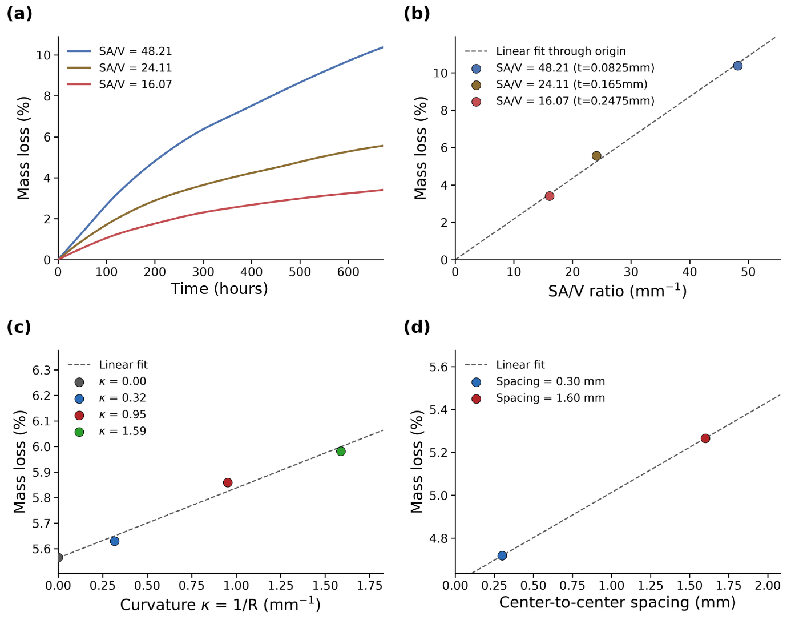
Figure S9. (a) Mass-loss evolution for different surface-area-to-volume ratios (SA/V). (b) Final mass loss as a function of SA/V. (c) Final mass loss as a function of wire curvature (κ = 1/R). (d) Final mass loss as a function of center-to-center inter-wire spacing. Dashed lines indicate linear fits. Higher SA/V, curvature, and spacing increased degradation, with SA/V exhibiting the strongest correlation with cumulative mass loss.
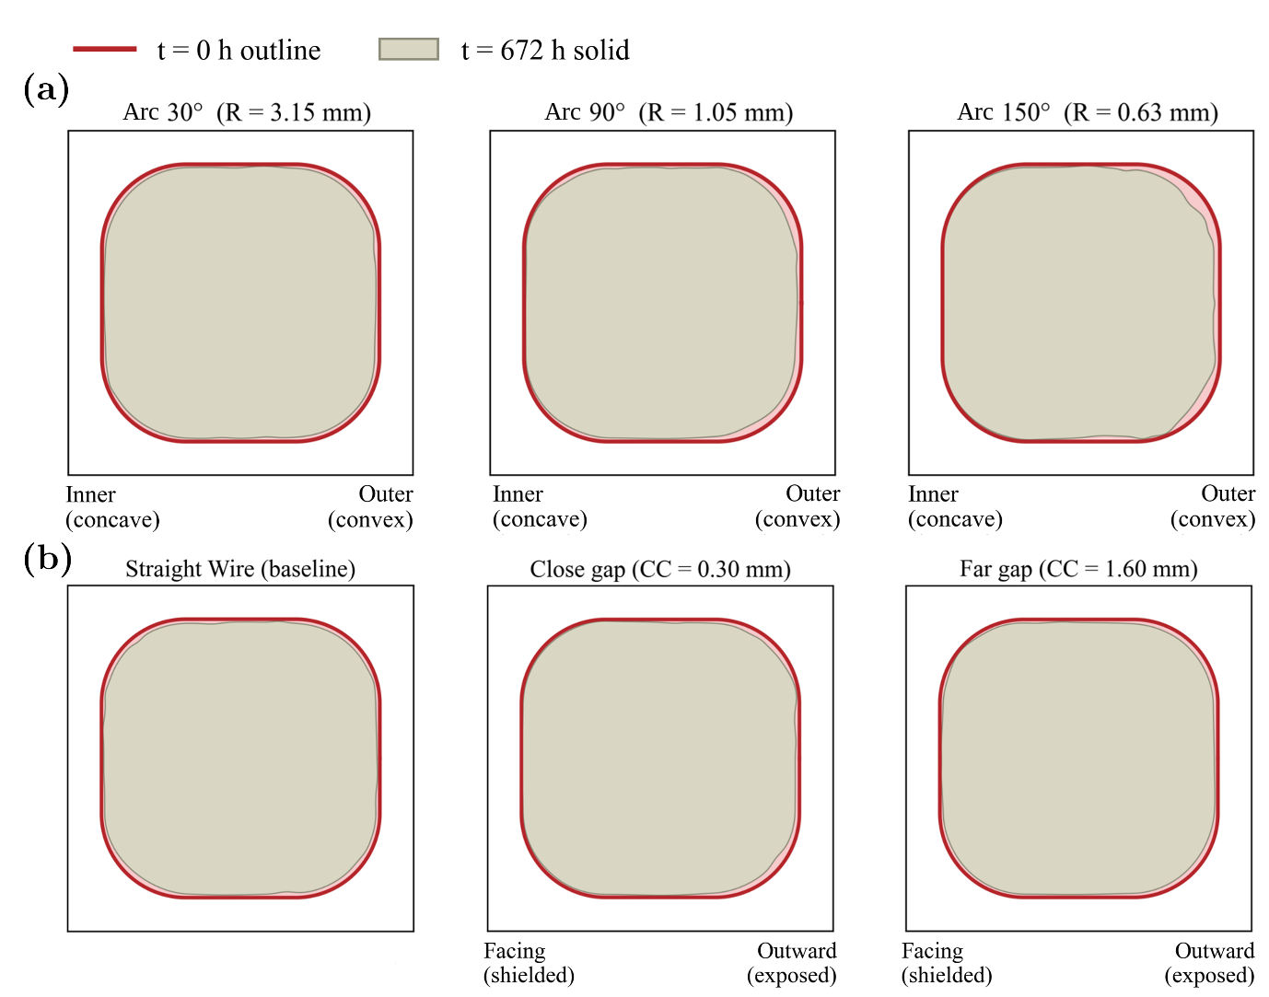
Figure S10. Cross-sectional corrosion morphology after 672 h. (a) Curved wires showing increasing preferential corrosion on the outer convex surface. (b) Straight and adjacent wires showing reduced corrosion on the shielded facing surface relative to the outward-exposed surface. CC denotes the center-to-center spacing.

S8. Oxygen mass balance
Table S13 compares the oxygen required by the reaction stoichiometry (1 mol O₂ per 2 mol Zn, Eqs. 1–2) for the Zn lost from the disc with the oxygen removed from the electrolyte domain by the interfacial sink. The solver stores C_O₂ as a mass concentration (g mm⁻³) and evaluates the ORR recession velocity without a molar-mass conversion, which Eqs. 15–16 represent by the factor M_O₂ = 32 (the numerical value of the molar mass of oxygen in g mol⁻¹) applied to a molar C_O₂. The recession velocity is therefore 32 times the stoichiometrically consistent value for the same k_ORR. With this factor, the reaction-limited ceiling at k_ORR = 0.51 mm h⁻¹ is 0.29 mm yr⁻¹ (about 22 µm in 28 days, roughly 3% mass loss), which is above the simulated rates. The reported results are therefore consistent with the equations as written, and Zn recession is not stoichiometrically coupled to O₂ consumption.
Table S13. Oxygen required for the Zn lost (stoichiometric) compared with the oxygen consumed at the interface in disc simulations at 24 h and 168 h. The last column is the ratio of the two.
Run | Time (h) | O₂ required (µg) | O₂ consumed (µg) | Required/consumed
Baseline (k_ORR 0.2) | 24 | 82 | 2.6 | 31.9
Baseline (k_ORR 0.2) | 168 | 393 | 16.5 | 23.8
k_ORR 0.04 | 24 | 17.5 | 0.5 | 32.0
k_ORR 0.04 | 168 | 87 | 3.8 | 23.2
k_ORR 1 | 24 | 330 | 10 | 32.9
k_ORR 1 | 168 | 1239 | 50 | 24.8

References
[1] C. Geuzaine, J.-F. Remacle, Int. J. Numer. Methods Eng. 2009, 79, 1309. https://doi.org/10.1002/nme.2579.
[2] H. Si, ACM Trans. Math. Softw. 2015, 41, 11. https://doi.org/10.1145/2629697.
[3] C. Dapogny, C. Dobrzynski, P. Frey, J. Comput. Phys. 2014, 262, 358. https://doi.org/10.1016/j.jcp.2014.01.005.
[4] F. Hecht, J. Numer. Math. 2012, 20, 251. https://doi.org/10.1515/jnum-2012-0013.
[5] S. Balay, S. Abhyankar, M. F. Adams, et al., PETSc/TAO Users Manual, Argonne National Laboratory, Lemont, IL, USA 2024, ANL-21/39 (Rev. 3.22). https://petsc.org.
[6] E. Gabriel, G. E. Fagg, G. Bosilca, et al., in Recent Advances in Parallel Virtual Machine and Message Passing Interface (Eds: D. Kranzlmüller, P. Kacsuk, J. Dongarra), Springer, Berlin, Heidelberg, Germany 2004, pp. 97–104. https://doi.org/10.1007/978-3-540-30218-6_19.
[7] J. A. Sethian, Proc. Natl. Acad. Sci. USA 1996, 93, 1591. https://doi.org/10.1073/pnas.93.4.1591.
[8] S. van der Walt, J. L. Schönberger, J. Nunez-Iglesias, et al., PeerJ 2014, 2, e453. https://doi.org/10.7717/peerj.453.
[9] M. Dawson-Haggerty, et al., trimesh, https://trimesh.org (accessed: October 2026).
[10] N. Schlömer, et al., meshio: Tools for mesh files, https://doi.org/10.5281/zenodo.1173115.
[11] P. Virtanen, R. Gommers, T. E. Oliphant, et al., Nat. Methods 2020, 17, 261. https://doi.org/10.1038/s41592-019-0686-2.
[12] J. D. Hunter, Comput. Sci. Eng. 2007, 9, 90. https://doi.org/10.1109/MCSE.2007.55.
[13] J. Ahrens, B. Geveci, C. Law, in The Visualization Handbook (Eds: C. D. Hansen, C. R. Johnson), Elsevier, Amsterdam, The Netherlands 2005, pp. 717–731.
[14] M. D. Morris, Technometrics 1991, 33, 161. https://doi.org/10.1080/00401706.1991.10484804.
[15] J. Herman, W. Usher, J. Open Source Softw. 2017, 2, 97. https://doi.org/10.21105/joss.00097.
[16] C. E. Rasmussen, C. K. I. Williams, Gaussian Processes for Machine Learning, MIT Press, Cambridge, MA, USA 2006.
[17] D. R. Jones, M. Schonlau, W. J. Welch, J. Glob. Optim. 1998, 13, 455. https://doi.org/10.1023/A:1008306431147.
[18] M. D. McKay, R. J. Beckman, W. J. Conover, Technometrics 1979, 21, 239. https://doi.org/10.1080/00401706.1979.10489755.
[19] L. Liu, Y. Meng, C. Dong, Y. Yan, A. A. Volinsky, L.-N. Wang, J. Mater. Sci. Technol. 2018, 34, 2271. https://doi.org/10.1016/j.jmst.2018.05.005.

