Supporting Information
A Mechanistic Framework for Predicting the Biodegradation of Zinc Implants
Henaka Ariyarathna, Xuan Yang, Aijun Huang, Yunlong Tang*, Yuman Zhu*
H. Ariyarathna, X. Yang, A. Huang, Y. Tang, Y. Zhu
Monash Centre for Additive Manufacturing, Monash University, Wellington Rd, Clayton, VIC 3800, Australia
H. Ariyarathna, X. Yang, A. Huang, Y. Tang
Department of Materials Science and Engineering, Monash University, Wellington Rd, Clayton, VIC 3800, Australia
A. Huang, Y. Tang, Y. Zhu
Department of Mechanical and Aerospace Engineering, Monash University, Wellington Rd, Clayton, VIC 3800, Australia
*Correspondence: Yunlong.Tang1@monash.edu, yuman.zhu@monash.edu
Contents
Section | Topic | Equations, tables and figures
S1 | Model equations and interface velocity | Equations S1–S3; Table S1
S2 | Geometry and mesh generation | Equation S4; Tables S2–S3; Figures S1–S2
S3 | Simulation settings and parameters | Table S4
S4 | Sensitivity analysis | Tables S5–S6; Figure S3
S5 | Bayesian calibration and validation | Equation S5; Tables S7–S10; Figure S4
S6 | Uncertainty analysis | Table S11; Figure S5
S7 | Case-study results | Table S12; Figures S6–S8
S8 | Interfacial balance, units and mesh correction | Table S13–S15

S1. Model equations and interface velocity
This section defines the quantities used to evaluate the simulations (Equations S1–S3) and derives the interface velocity from the interfacial oxygen balance.
$$\begin{aligned}CR\left(t\right)=8.76×{10}^{4} \frac{W}{ρ_{Zn} A t}\#\left(S1\right)\end{aligned}$$
where $W$ (g) is the cumulative mass loss, $A$ (cm$​^{2}$) is the exposed area from the zero-level set $Γ(t)$, $ρ_{Zn}=7.14 g cm^{-3}$, and $t$ (h) is the exposure time, with both $W$ and $A$ updated at every time step.
$$\begin{aligned}pH=14+\log_{10}\left(\frac{C_{{OH}^{-}}}{1000}\right)\#\left(S2\right)\end{aligned}$$
where $C_{{OH}^{-}}$ is the hydroxide ion concentration in the electrolyte.
$$\begin{aligned}Da(x,t)=\frac{k_{ORR} C_{O_{2}}|_{Γ}}{D_{O_{2}}^{\text{eff}}(x,t) {\left|∇C_{O_{2}}⋅n\right|}_{Γ}}\#\left(S3\right)\end{aligned}$$
where $k_{ORR}$​ is the ORR rate constant, $C_{O_{2}}$ is the local oxygen concentration, $D_{O_{2}}^{\text{eff}}$​ is the effective oxygen diffusivity, and $∇C_{O_{2}}⋅n$ is the oxygen concentration gradient normal to the corroding surface. The Damköhler number represents the ratio of oxygen consumption to oxygen transport, with Da < 1 indicating reaction-controlled corrosion and Da > 1 indicating diffusion-controlled corrosion.
$$Rule A: v = min(v_{Zn},v_{ORR}, v_{O_{2}})$$
$$Rule B: v = {\left[\left(\frac{1}{v_{Zn}} + \frac{1}{v_{ORR}} + \frac{1}{v_{O_{2}}}\right)\right]}^{-1}$$
$$Rule C: v = min(v_{Zn}, v_{ORR} + v_{O_{2}})$$
$$Rule D: v = min(v_{Zn}, v_{ORR}) (No oxygen diffusion cap)$$
Interfacial oxygen balance. At the metal–electrolyte interface, the oxygen flux supplied by diffusion equals the oxygen consumed by the cathodic reaction (Robin condition):
$$-{D_{O₂}}^{eff}\frac{∂C_{O₂}}{∂n}|_{Γ}=k_{ORR}C_{O₂}|_{Γ}$$
Over a transport length δ, with C_{b} the oxygen concentration outside the depleted layer, the supplied flux is D_{O2,eff}(C_{b} − C_{O2}|_{Γ})/δ. Equating it to k_{ORR}C_{O2}|_{Γ} gives C_{O2}|_{Γ} = C_{b}/(1 + k_{ORR}δ/D_{O2,eff}), so the interfacial flux is the series (harmonic) combination of the reaction and transport resistances:
$$J_{O₂}=\frac{C_{b}}{\frac{1}{k_{ORR}}+\frac{δ}{{D_{O₂}}^{eff}}}$$
The Damköhler number Da = k_{ORR}δ/D_{O2,eff} is the ratio of the transport resistance to the reaction resistance. For Da ≪ 1 the flux reduces to k_{ORR}C_{b} (reaction-controlled), and for Da ≫ 1 it reduces to D_{O2,eff}C_{b}/δ (diffusion-controlled) (Table S1).
Interface velocity. Each mole of O₂ reduced at the interface removes two moles of Zn (O₂ + 2Zn + 2H₂O → 2Zn²⁺ + 4OH⁻), so the normal velocity of the level set is
$$v_{n}=-\frac{2k_{ORR}C_{O₂}|_{Γ}}{M_{O₂}{[Zn]}_{sol}}$$
with [Zn]_{sol} = ρ_{Zn}/M_{Zn} (Eq. 14 of the main text). Because C_{O2}|_{Γ} is the interfacial concentration obtained from the Robin condition, the velocity follows the series flux J_{O2} above, and the transition between reaction-controlled and diffusion-controlled degradation emerges from the depletion of C_{O2} at the interface. The Zn²⁺ source and the O₂ sink use the same flux (Section S8). [Planar check to be added: numerical v_{n} versus the analytic series formula for a planar interface.]
Table S1. Limiting regimes of the interfacial oxygen flux.
Regime | Condition | Interfacial flux J_O₂
Reaction-controlled | Da ≪ 1 | k_ORR C_b
Transition | Da ≈ 1 | C_b/(1/k_ORR + δ/D_O₂^eff)
Diffusion-controlled | Da ≫ 1 | D_O₂^eff C_b/δ

S2. Geometry and mesh generation
STL implant geometries were converted into tetrahedral finite-element meshes using a Gmsh (v4.13.1)-based workflow [1], with TetGen [2] for tetrahedralization and MMG [3] for adaptive remeshing. Adaptive refinement was applied at the Zn-electrolyte interface, and the resulting Zn-electrolyte meshes were exported in FreeFEM/Medit (.mesh) format for all simulations in FreeFEM (v4.14) [4]. Table S2 and Figure S1 report the mesh convergence study, and Table S3 compares an adaptive mesh with a uniform mesh. [Table S2, Table S3 and Figure S1 are to be updated with the revised mesh-convergence data (21.2M-element reference).] Calibration used the 0.8M-element mesh (L2), with the simulated mass loss divided by 1.355846 to correct it to the fine-mesh basis (7-day value 0.2029% / 1.355846 = 0.1496%, compared with 0.1611% on the 18.9M-element mesh).
Mesh convergence was assessed from the relative error of the predicted mass loss with respect to the reference mesh:
$$\begin{aligned}RelativeError \left(\%\right)=\frac{\left| MassLoss\left(L_{i}\right)- MassLoss\left(Reference\right)\right|}{MassLoss\left(Reference\right)} X 100\#\left(S4\right)\end{aligned}$$
where MassLoss_Li is the predicted mass loss for mesh level Li and MassLoss_Reference is the predicted mass loss for the reference mesh (21.25 million elements).
Table S2. Mesh convergence study showing the effect of mesh resolution on predicted 7-day mass loss. Relative errors are calculated with respect to the reference mesh (Mass Loss values may differ from those of the calibrated model, as these validation cases were evaluated prior to model calibration).
Fidelity | Elements | Mass loss (%) | Relative error (%)
L1 (Very Low) | 182,768 | 0.3009 | 87.2
L2 (Low) | 802,365 | 0.2029 | 26.2
L3 (Medium) | 3,454,723 | 0.1682 | 4.6
L4 (High) | 4,990,080 | 0.1637 | 1.8
L5 (Very High) | 11,958,220 | 0.1616 | 0.5
L6 (Ultra High) | 18,864,900 | 0.1611 | 0.19
Reference | 21,245,850 | 0.1608 | —
Table S3. Comparison between an adaptive mesh and a uniform mesh (approximately 800,000 elements).
Mesh type | Elements | Mass loss (%) | Error vs. reference (%) | Improvement
Uniform Mesh | 799,000 | 0.2860 | 77.9 | Baseline
Adaptive Mesh | 802,365 | 0.2029 | 26.2 | 0.663
Reference Mesh | 21,245,850 | 0.1608 | — | 1
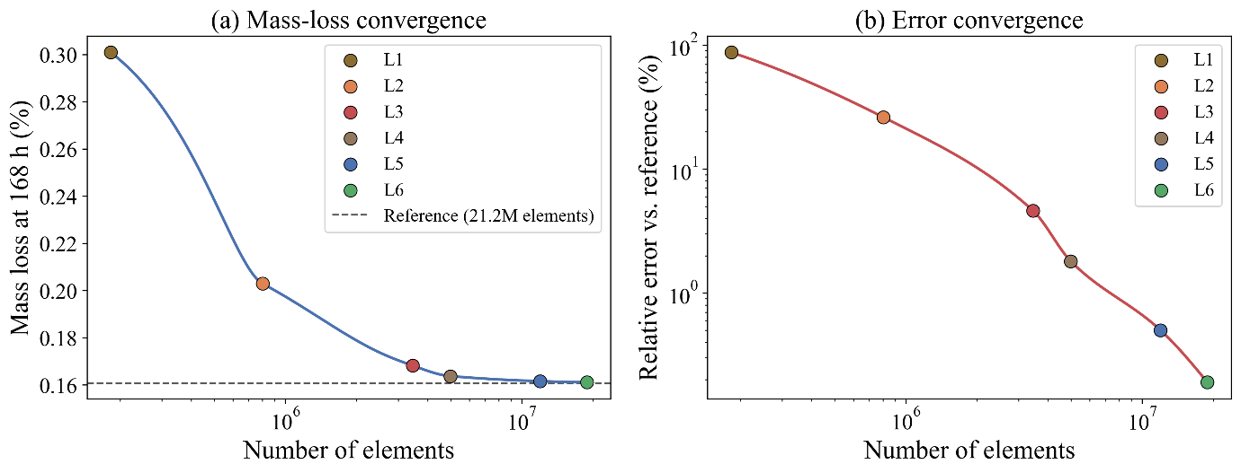
Figure S1. Mesh convergence analysis showing (a) predicted mass loss and (b) relative error as a function of mesh density. Predictions converged with mesh refinement, with <1% error for the final mesh.
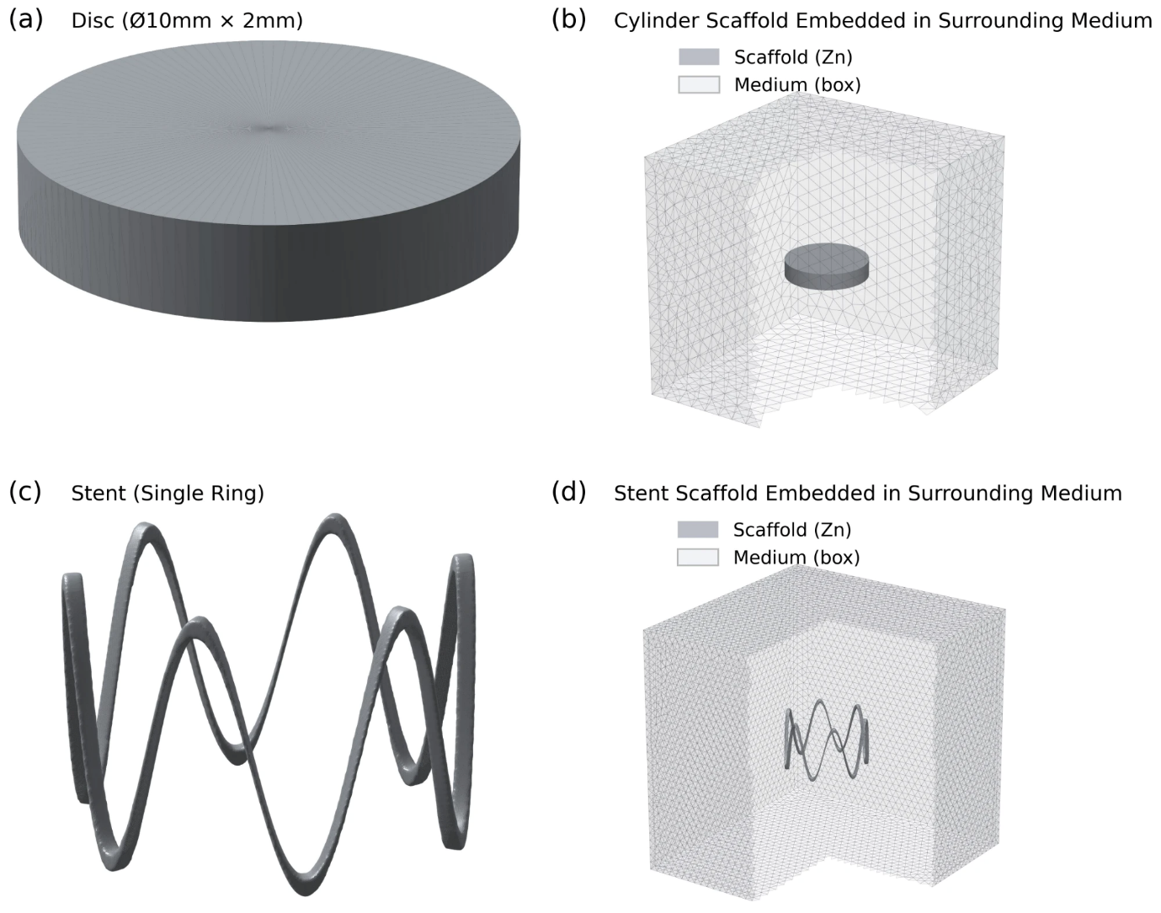
Figure S2. Generated computational geometries and finite-element domains used for Zn degradation simulations: (a) disc specimen (Ø10 mm × 2 mm), (b) disc embedded within the surrounding electrolyte domain, (c) single-ring six-crown stent, and (d) stent embedded within the surrounding electrolyte domain. The Zn structures are shown in dark grey, and the tetrahedral electrolyte domains are shown in light grey.

S3. Simulation settings and parameters
Table S4 lists the mesh, numerical integration, software, and boundary-condition settings used for the disc calibration, disc validation, and stent simulations. The simulations were run in FreeFEM (v4.14) [4] with PETSc [5] and Open MPI [6], and the level-set function was reinitialized with the fast marching method [7]. Geometry processing and post-processing used scikit-image [8], trimesh [9], meshio [10], SciPy [11], Matplotlib [12], and ParaView [13].
Table S4. Mesh generation, numerical integration, software implementation, and boundary-condition settings used for the disc-specimen and stent simulations.
Parameter | Disc Calibration | Disc Validation | Stent Simulation
Geometry
Domain size (X × Y × Z) | 30 × 30 × 30 mm | 30 × 30 × 30 mm | 30 × 30 × 30 mm
Specimen geometry | Ø 10 mm × 2 mm height | Ø 10 mm × 2 mm height | –
Outer diameter, Dout | – | – | 3.20 mm
Strut dimensions (w × h) | – | – | 0.15 mm × 0.15 mm
Crown amplitude, A | – | – | 1.00 mm
Axial length, Lz | – | – | 2.40 mm
Surface area | 219.9 mm² | 219.9 mm² | 19.46 mm²
Initial Volume | 157.08 mm³ | 157.08 mm³ | 0.361 mm³
SA/V ratio | 1.40 mm⁻¹ | 1.40 mm⁻¹ | 53.9 mm⁻¹
Mesh Properties
Number of elements | 802,365 | 18,864,900 | 21,099,161
Number of vertices | 121,120 | 2,847,652 | 3,523,952
Minimum element size | 0.1 mm | 0.005 mm | 0.005 mm
Maximum element size | 2.00 mm | 2.00 mm | 1.00 mm
Element type | Tetrahedral (P1 Lagrange) | Tetrahedral (P1 Lagrange) | Tetrahedral (P1 Lagrange)
Time Integration
Time step (Δt) | 0.25 h | 0.25 h | 0.25 h
Simulation duration | 336 h (14 days) | 672 h (28 days) | 672 h (28 days)
Level-set reinitialization interval (Fast marching method) | 1.0 h | 1.0 h | 1.0 h
Computational Resources
MPI processes | 4 | 50 | 64
Average DOF per process | 2,592 | 60,953 | 59,061
Preconditioner | Algebraic multigrid | Algebraic multigrid | Algebraic multigrid
Linear solver | GMRES (30 restart) | GMRES (30 restart) | GMRES (30 restart)
Linear solver tolerance | 1.0 × 10⁻⁶ | 1.0 × 10⁻⁶ | 1.0 × 10⁻⁶
Nonlinear solver tolerance | 1.0 × 10⁻⁴ | 1.0 × 10⁻⁴ | 1.0 × 10⁻⁴
Wall-clock time (per simulation) | 2 h | 68.9 h | 69.3 h
Software & Discretization
Finite element framework | FreeFEM (v4.14) | FreeFEM (v4.14) | FreeFEM (v4.14)
Time integration scheme | First-order backward Euler | First-order backward Euler | First-order backward Euler
Boundary Conditions
Container wall boundary condition | No-flux (zero Neumann) | No-flux (zero Neumann) | No-flux (zero Neumann)
Top surface boundary condition | Dirichlet | Dirichlet | Dirichlet
Dissolved oxygen concentration | 3.5 mg L⁻¹ | 3.5 mg L⁻¹ | 3.5 mg L⁻¹

S4. Sensitivity analysis
Table S5 lists the parameters varied in the Morris analysis [14], performed with SALib [15], and Table S6 gives the design settings.
Table S5. Parameters included in the Morris sensitivity analysis (the ranges might differ from calibration space as this was done prior to calibration of the model).
Parameter | Symbol | Range | Unit
Film formation rate constant | $$k_{f}$$ | 3×10⁴–3×10⁶ | $$h^{-1}$$
Film dissolution rate constant | $$k_{d}$$ | 1×10⁶–1×10⁹ | $$mm^{6} g^{-2} h^{-1}$$
Oxygen reduction rate constant | $$k_{ORR}$$ | 10–200 | $${mm h}^{-1}$$
Oxygen diffusivity | $$D_{O_{2}}$$ | 5–20 | $${{mm}^{2} h}^{-1}$$
Initial dissolved oxygen concentration | $$C_{O_{2},0}$$ | $1×{10}^{−9}–1×{10}^{−8}$ | $${g mm}^{-3}$$
Zn²⁺ diffusivity | $$D_{Zn}$$ | 1.5–5.0 | $${{mm}^{2} h}^{-1}$$
Cl⁻ diffusivity | $$D_{Cl}$$ | 5–15 | $${{mm}^{2} h}^{-1}$$
OH⁻ diffusivity | $$D_{OH}$$ | 15–35 | $${{mm}^{2} h}^{-1}$$
Table S6. Morris design settings.
Setting | Value
Sensitivity method | Morris elementary effects
Software | SALib
Number of parameters | 8
Number of levels (p) | 4
Number of trajectories (r) | 20
Total model evaluations | 180
Response metric | Mass loss after 168 h
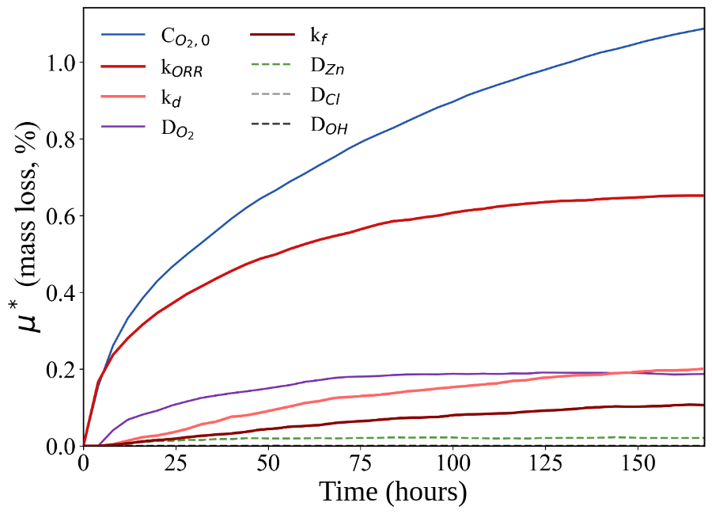
Figure S3. Time-dependent Morris sensitivity indices (μ∗) for the model parameters affecting predicted Zn mass loss during 168 h of degradation. The variation of μ∗ over time quantifies how each parameter's influence on the degradation response changes throughout the simulation period.

S5. Bayesian calibration and validation
Optimal parameters were identified by minimizing the RMSE between predicted and literature-reported 14-day mass-loss measurements. A Gaussian process (GP) surrogate model [16] was initialized using a 12-point Latin hypercube sampling (LHS) design [18] spanning the admissible parameter space and iteratively refined using the expected improvement (EI) acquisition function [17]. The literature data are from Liu et al. [19]. [Tables S9 and S10 and Figure S4 are to be updated for the revised model: BO settings, histories, response surfaces and parameter trajectories.]
The RMSE was calculated as:
$$\begin{aligned}RMSE=\sqrt{\frac{1}{n}\sum_{i=1}^{n}{{\left[{MassLoss}_{Sim}\left(t_{i}\right)-{MassLoss}_{exp}\left(t_{i}\right)\right]}^{2}}}\#\left(S5\right)\end{aligned}$$
where n is the number of literature data points, and MassLoss_sim(t_i) and MassLoss_exp(t_i) are the simulated and literature mass loss at time t_i, respectively. Table S7 lists the literature mass-loss data used for calibration.
Table S7. Literature mass-loss data used for Bayesian calibration (Liu et al. 2018).
Duration (days) | Time (hours) | Literature mass loss (%)
1 | 24 | 0.0500
2 | 48 | 0.0900
5 | 120 | 0.1300
7 | 168 | 0.2000
10 | 240 | 0.2700
14 | 336 | 0.3200
Tables S8 and S9 and Figure S4 compare the calibrated model with the literature data.
Table S8. Literature Zn dissolution and pH data used for validation (Liu et al. 2018).
Duration (days) | Time (hours) | Zn dissolution (mg/L) | pH
1 | 24 | 10.5 | 7.4
2 | 48 | 26.5 | 7.5
5 | 120 | 32 | 7.57
7 | 168 | 35 | 7.58
10 | 240 | 36 | 7.63
14 | 336 | 39.5 | 7.63
Table S9. Final calibrated-model predictions of mass loss compared with the literature mass-loss data used for calibration (Liu et al. 2018).
Time (hours) | Predicted mass loss (%) | Literature mass loss (%) | Absolute error (%)
0 | 0.0000 | 0.0000 | 0.000
24 | 0.049 | 0.0500 | 0.001
48 | 0.084 | 0.0900 | 0.006
120 | 0.158 | 0.1300 | 0.028
168 | 0.188 | 0.2000 | 0.012
240 | 0.214 | 0.2700 | 0.056
336 | 0.240 | 0.3200 | 0.080
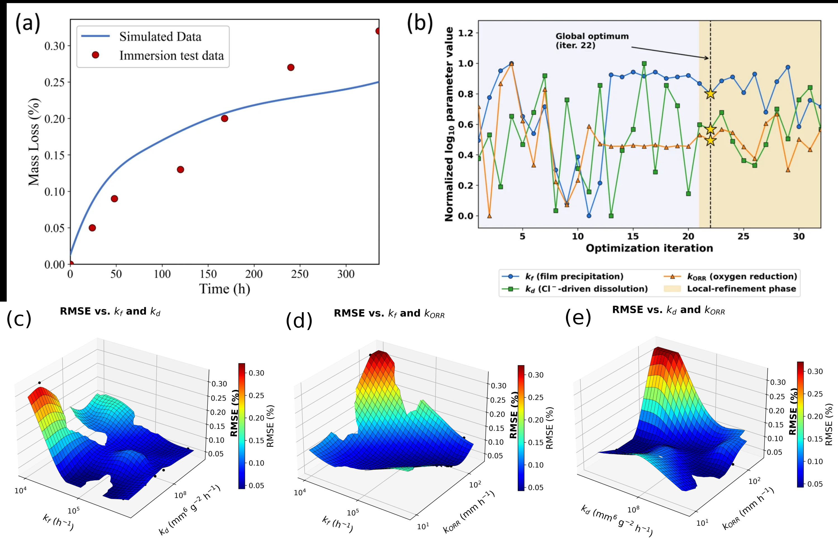
Figure S4. Bayesian calibration results: (a) simulated and literature mass loss, (b) normalized log10 parameter trajectories over the 32 evaluations (optimum at iteration 22), and (c–e) RMSE response surfaces for pairwise combinations of $k_{f}$, $k_{d}$, and (log axes; smoothed interpolants of the evaluations with kORR ≤ 200 mm h-1, shown only near evaluated points; black dots, evaluated parameter sets; star, optimum)$k_{ORR}$.
Table S10. Bayesian optimization settings used for parameter calibration.
Setting | Value
Optimization method | Bayesian optimization
Surrogate model | Gaussian Process
Objective function | RMSE minimization
Parameters calibrated | $k_{f}$, $k_{d}$, $k_{ORR}$
Prior distribution | Uniform
Parameter bounds | Main-text Table 2
Random seed | 1
Initial sampling | 12-point Latin hypercube design (iterations 1–12)
Acquisition function | Expected improvement
Total iterations | 32 (optimum at iteration 22)
Noise treatment | Deterministic objective
Target RMSE | 0.05%

S6. Uncertainty analysis
Uncertainty in predicted mass loss arising from the calibrated kinetic parameters $k_{f}$, $k_{d}$, and $k_{ORR}$ was evaluated using 50 parameter sets sampled from a 2000-draw GP-bootstrap calibration ensemble. At 672 h, the ensemble median mass loss was 0.333%, with 50% and 95% intervals of 0.330–0.338% and 0.315–0.375%, respectively, closely matching the BO-optimum prediction of 0.333%. Four of six literature measurements fell within the 95% interval. Because the GP ensemble represents uncertainty in the calibration objective rather than a formal parameter posterior, these bands are reported as parameter-propagated ensemble intervals and exclude measurement, model-form, and numerical uncertainty.
Figure S5 shows the ensemble prediction and the distribution of mass loss at 672 h.
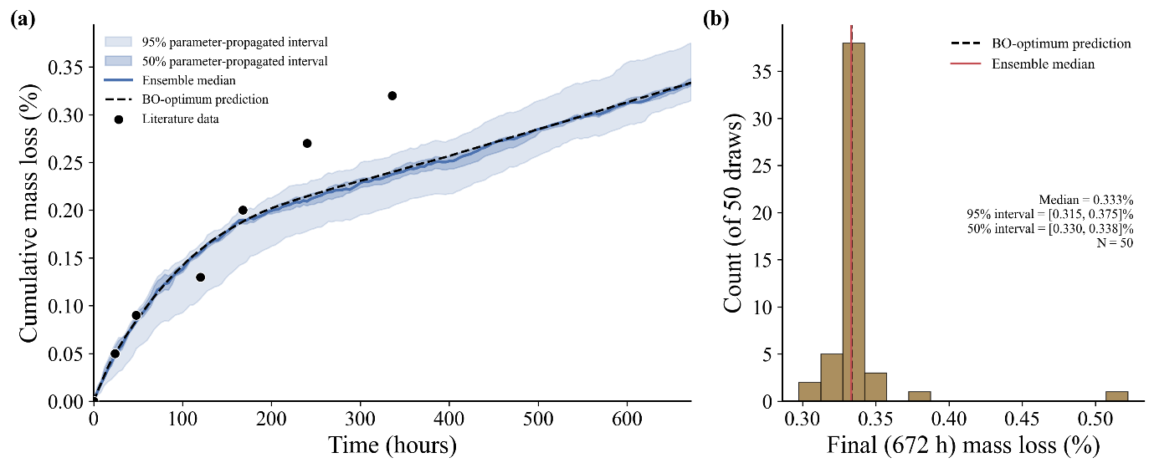
Figure S5. Parameter-propagated uncertainty in predicted Zn mass loss. (a) Ensemble median and 50% and 95% parameter-propagated intervals obtained from 50 kinetic-parameter sets, compared with the BO-optimum prediction and literature measurements. (b) Distribution of predicted mass loss at 672 h. The ensemble median was 0.333%, with 50% and 95% intervals of 0.330–0.338% and 0.315–0.375%, respectively. The intervals represent kinetic-parameter uncertainty only and are not Bayesian credible or predictive intervals.

Table S11. Comparison of simulated and measured mass loss in HBSS (validation) with the experimental scatter. Experimental values are mean ± SD (n = 3); |Error|/SD is the absolute error divided by the SD at the same immersion time. The validation RMSE of 0.0159% (R² = 0.9734) corresponds to 8.6% of the mean measured mass loss (0.185%) and 5.1% of the 28-day value.
Time (h) | Experiment (%, mean ± SD) | Simulation (%) | Error (%) | |Error|/SD
24 | 0.045 ± 0.016 | 0.049 | +0.004 | 0.28
72 | 0.105 ± 0.036 | 0.114 | +0.008 | 0.24
168 | 0.209 ± 0.061 | 0.188 | −0.021 | 0.34
336 | 0.254 ± 0.061 | 0.240 | −0.014 | 0.23
672 | 0.311 ± 0.115 | 0.333 | +0.022 | 0.19

S7. Case-study results
Figure S6 shows the spatial evolution of oxygen and film saturation in the stent. Table S12 and Figures S7 and S8 describe the controlled test structures and their results.
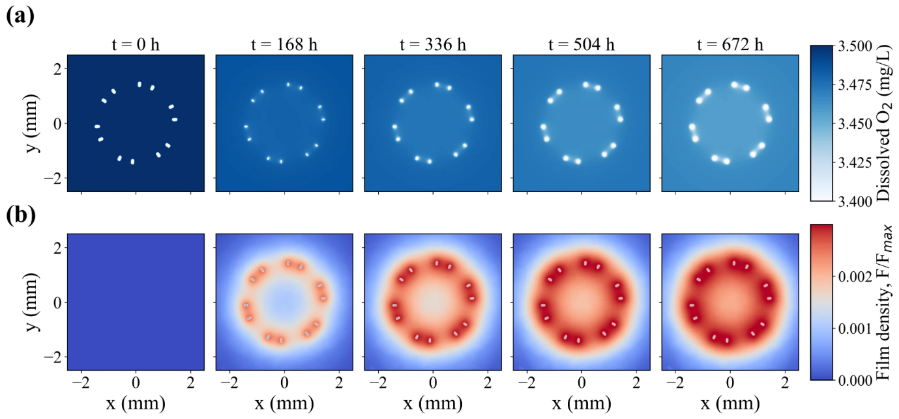
Figure S6. Spatial evolution of (a) dissolved oxygen concentration (C_{O2}​​) and (b) normalized corrosion-film saturation (F/F_{max}​) in a transverse cross-section of the six-crown Zn stent during 672 h of immersion.
Table S12. Geometric and computational parameters of the controlled test structures used in Figure 8.
Specimen / configuration | Geometry / inlet faces | Secondary dimension / wall faces | Cross-section | SA/V (mm⁻¹) | Electrolyte domain
Straight wire | Arc angle: 0°; R=∞ | Inner radius: N/A | 0.165 × 0.165 mm rounded-square wires | 24.11 | 30×30×30 mm
Arc 30° | Arc angle: 30°; R=3.15 mm | Inner radius: 3.0688 mm | 0.165 × 0.165 mm rounded-square wires | 24.11 | 30×30×30 mm
Arc 90° | Arc angle: 90°; R=1.05 mm | Inner radius: 0.9679 mm | 0.165 × 0.165 mm rounded-square wires | 24.11 | 30×30×30 mm
Arc 150° | Arc angle: 150°; R=0.63 mm | Inner radius: 0.5478 mm | 0.165 × 0.165 mm rounded-square wires | 24.11 | 30×30×30 mm
Close gap | Center-to-center spacing: 0.30 mm | Edge-to-edge gap: 0.135 mm | 0.165 × 0.165 mm rounded-square wires | 24.11 | 30×30×30 mm
Far gap | Center-to-center spacing: 1.60 mm | Edge-to-edge gap: 1.435 mm | 0.165 × 0.165 mm rounded-square wires | 24.11 | 30×30×30 mm
Low SA/V | Thickness = 0.2475 mm | Arc angle: 0° | 0.2475 × 0.2475 mm rounded-square wires | 16.07 | 30×30×30 mm
Mid SA/V | Thickness = 0.165 mm | Arc angle: 0° | 0.165 × 0.165 mm rounded-square wires | 24.11 | 30×30×30 mm
High SA/V | Thickness = 0.0825 mm | Arc angle: 0° | 0.0825 × 0.0825 mm rounded-square wires | 48.21 | 30×30×30 mm
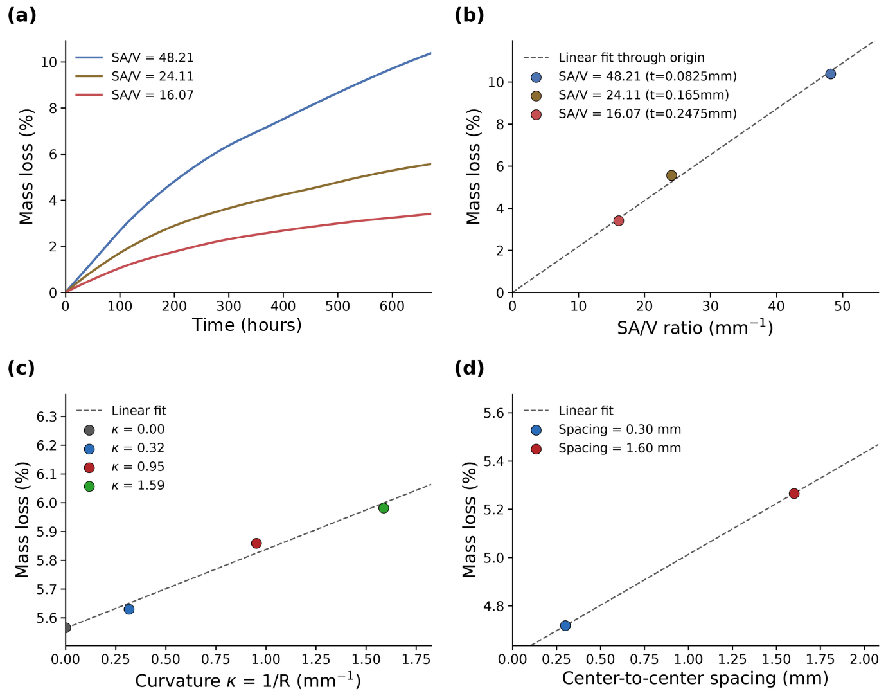
Figure S7. (a) Mass-loss evolution for different surface-area-to-volume ratios (SA/V). (b) Final mass loss as a function of SA/V. (c) Final mass loss as a function of wire curvature (κ = 1/R). (d) Final mass loss as a function of center-to-center inter-wire spacing. Dashed lines indicate linear fits. Higher SA/V, curvature, and spacing increased degradation, with SA/V exhibiting the strongest correlation with cumulative mass loss.
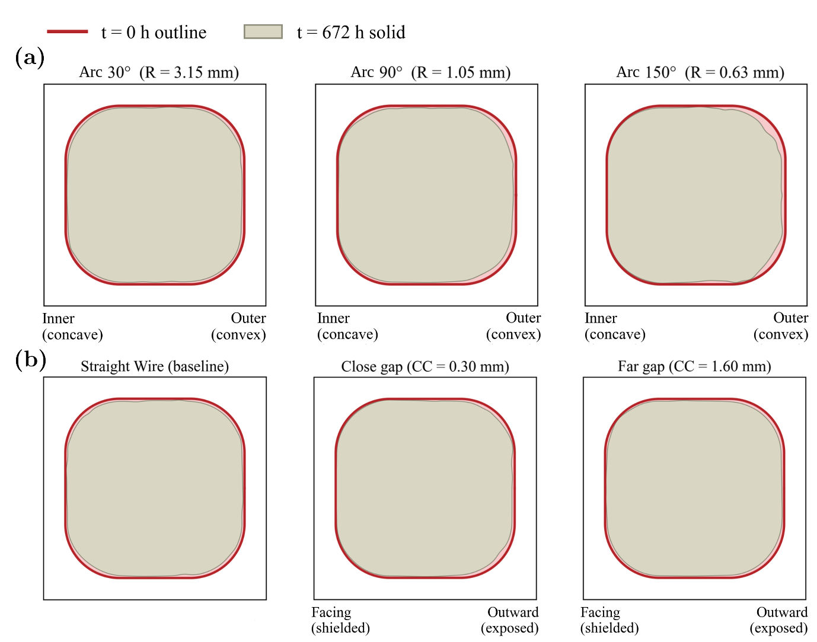
Figure S8. Cross-sectional corrosion morphology after 672 h. (a) Curved wires showing increasing preferential corrosion on the outer convex surface. (b) Straight and adjacent wires showing reduced corrosion on the shielded facing surface relative to the outward-exposed surface. CC denotes the center-to-center spacing.

S8. Interfacial balance, units and mesh correction
The interface couples O₂ consumption, Zn²⁺ release, OH⁻ generation and metal loss through O₂ + 2Zn + 2H₂O → 2Zn²⁺ + 4OH⁻. With the normal velocity v_{n} = −2k_{ORR}C_{O2}|_{Γ}/(M_{O2}[Zn]_{sol}) and [Zn]_{sol} = ρ_{Zn}/M_{Zn}, the metal removed per unit area and time is ρ_{Zn}|v_{n}| = 2(M_{Zn}/M_{O2})k_{ORR}C_{O2}, which equals the Zn²⁺ source in the Zn equation and 2M_{Zn}/M_{O2} times the O₂ consumed by the Robin sink k_{ORR}C_{O2}. F counts Zn-equivalent mass, so Zn removed by the interface = dissolved Zn + Zn in corrosion product + numerical residual.
Table S13. Units of the model quantities (all species fields in g mm⁻³ unless stated).
Quantity | Units
C_O₂, C_Zn, C_Cl (mass concentrations) | g mm⁻³ (C_Cl is converted to mol L⁻¹ in Eq. 11 by 10⁶/M_Cl)
C_OH | mol L⁻¹
F, F_max (Zn-equivalent mass) | g mm⁻³; F_max = ρ_film(1 − ε)
k_f | h⁻¹
k_d | L² mol⁻² h⁻¹
k_ORR | mm h⁻¹ (C_O₂ in g mm⁻³; the factor 1/M_O₂ is in Eq. 14)
v_n | mm h⁻¹
δ_Γ | mm⁻¹
ρ_Zn, ρ_film | g mm⁻³
[Zn]_sol = ρ_Zn/M_Zn | mol mm⁻³
M_O₂, M_Zn, M_Cl | g mol⁻¹
D, D_eff | mm² h⁻¹
[Table S14. Zn and O₂ balance (Zn removed, dissolved Zn, Zn in corrosion product, residual) at 24, 168 and 672 h, to be inserted from the revised runs.]
[Table S15. Mesh correction: coarse vs fine mesh mass-loss pairs and the correction constants, to be inserted.]
The coarse-mesh (L2) calibration simulations are related to the fine-mesh (L6) result by a single proportionality factor over 672 h, L2 = 1.355846 × L6 (r = 0.9986; Figure S9). The coarse-mesh mass-loss curves were divided by this factor.
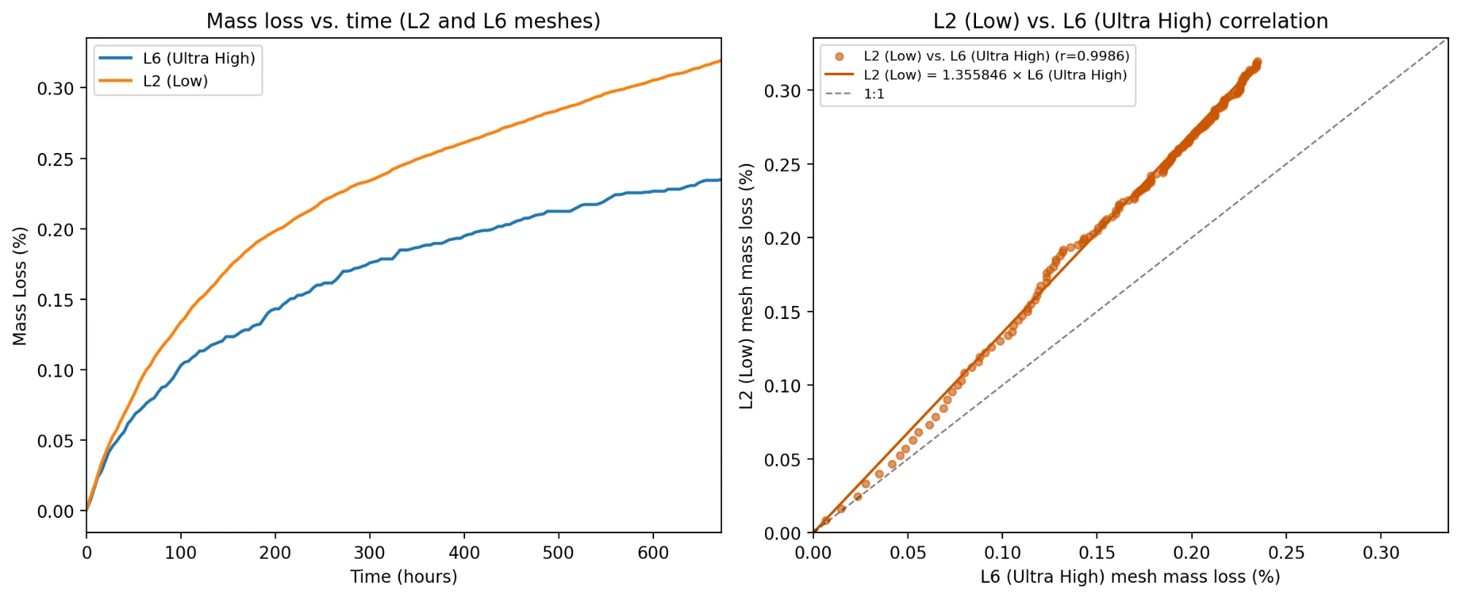
Figure S9. Mesh correction between the coarse (L2, low) and fine (L6, ultra-high) meshes. Left: mass loss versus time for the two meshes. Right: L2 versus L6 mass loss at matching times (r = 0.9986); the line through the origin is L2 = 1.355846 × L6, and the dashed line is 1:1.

S9. Computational domain and oxygen supply
The computational electrolyte domain (30 × 30 × 30 mm, 27 mL) is smaller than the experimental immersion volume (44 mL), so the oxygen reservoir available in the simulation is smaller than in the experiment. To show how the prediction depends on oxygen availability, the disc simulation was run with oxygen replenished through different faces of the domain (Figure S10a) and with different initial dissolved-oxygen concentrations (Figure S10b). With no oxygen-replenishing boundary, mass loss levelled off at approximately 0.055% within about 100 h, as the oxygen initially present in the finite domain was consumed. Replenishing oxygen through the top and bottom faces gave the same mass loss as replenishing it through all faces (approximately 0.43% at 672 h), and replenishing through the side faces alone gave approximately 0.40%, so the prediction is governed by the oxygen supplied through the boundary rather than by the domain volume itself. Predicted mass loss at 672 h increased from approximately 0.16% to 0.81% as the initial oxygen concentration was increased from 1.5 × 10⁻⁹ to 7.5 × 10⁻⁹ g mm⁻³ (Figure S10b), consistent with oxygen availability controlling the degradation rate. The no-flux and all-faces cases correspond to a sealed and an open container, respectively, and differ by about a factor of eight in mass loss at 672 h. Replenishing through the top and bottom faces compared with the side faces changes the distance over which oxygen must diffuse to the specimen, i.e. the effective liquid depth, and changed mass loss by only about 0.03 percentage points at 672 h (approximately 0.43% versus 0.40%).
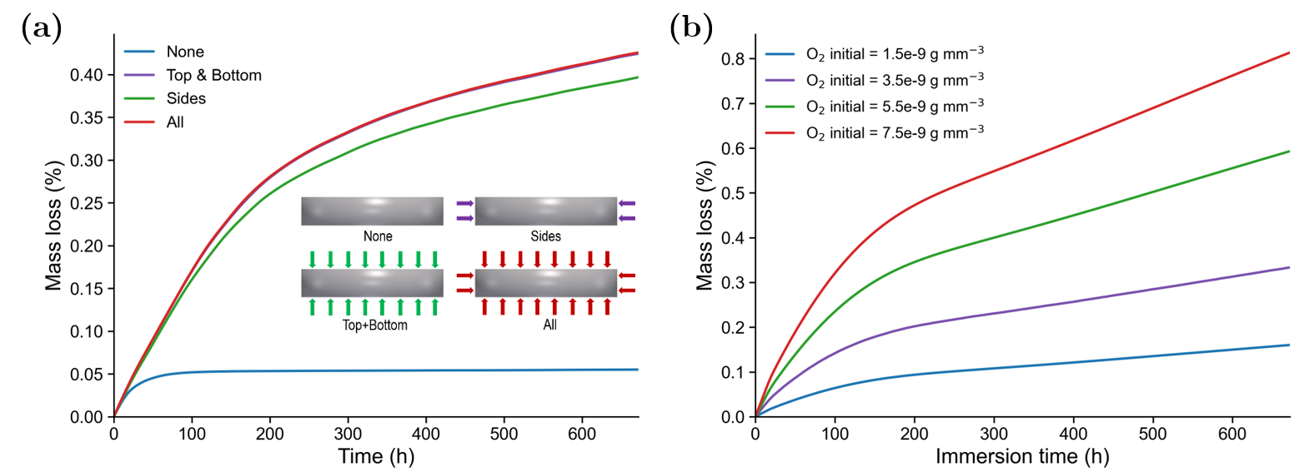
Figure S10. Effect of oxygen supply on predicted mass loss. (a) Mass loss for the disc with no oxygen-replenishing boundary (None), replenishment through the top and bottom faces, the side faces, or all faces; the inset shows the boundaries replenished in each case. (b) Mass loss for initial dissolved-oxygen concentrations of 1.5, 3.5, 5.5 and 7.5 × 10⁻⁹ g mm⁻³.
[Oxygen-supply accounting (O₂ entering through the top face vs O₂ consumed) to be added.]

References
[1] C. Geuzaine, J.-F. Remacle, Int. J. Numer. Methods Eng. 2009, 79, 1309. https://doi.org/10.1002/nme.2579.
[2] H. Si, ACM Trans. Math. Softw. 2015, 41, 11. https://doi.org/10.1145/2629697.
[3] C. Dapogny, C. Dobrzynski, P. Frey, J. Comput. Phys. 2014, 262, 358. https://doi.org/10.1016/j.jcp.2014.01.005.
[4] F. Hecht, J. Numer. Math. 2012, 20, 251. https://doi.org/10.1515/jnum-2012-0013.
[5] S. Balay, S. Abhyankar, M. F. Adams, et al., PETSc/TAO Users Manual, Argonne National Laboratory, Lemont, IL, USA 2024, ANL-21/39 (Rev. 3.22). https://petsc.org.
[6] E. Gabriel, G. E. Fagg, G. Bosilca, et al., in Recent Advances in Parallel Virtual Machine and Message Passing Interface (Eds: D. Kranzlmüller, P. Kacsuk, J. Dongarra), Springer, Berlin, Heidelberg, Germany 2004, pp. 97–104. https://doi.org/10.1007/978-3-540-30218-6_19.
[7] J. A. Sethian, Proc. Natl. Acad. Sci. USA 1996, 93, 1591. https://doi.org/10.1073/pnas.93.4.1591.
[8] S. van der Walt, J. L. Schönberger, J. Nunez-Iglesias, et al., PeerJ 2014, 2, e453. https://doi.org/10.7717/peerj.453.
[9] M. Dawson-Haggerty, et al., trimesh, https://trimesh.org (accessed: October 2026).
[10] N. Schlömer, et al., meshio: Tools for mesh files, https://doi.org/10.5281/zenodo.1173115.
[11] P. Virtanen, R. Gommers, T. E. Oliphant, et al., Nat. Methods 2020, 17, 261. https://doi.org/10.1038/s41592-019-0686-2.
[12] J. D. Hunter, Comput. Sci. Eng. 2007, 9, 90. https://doi.org/10.1109/MCSE.2007.55.
[13] J. Ahrens, B. Geveci, C. Law, in The Visualization Handbook (Eds: C. D. Hansen, C. R. Johnson), Elsevier, Amsterdam, The Netherlands 2005, pp. 717–731.
[14] M. D. Morris, Technometrics 1991, 33, 161. https://doi.org/10.1080/00401706.1991.10484804.
[15] J. Herman, W. Usher, J. Open Source Softw. 2017, 2, 97. https://doi.org/10.21105/joss.00097.
[16] C. E. Rasmussen, C. K. I. Williams, Gaussian Processes for Machine Learning, MIT Press, Cambridge, MA, USA 2006.
[17] D. R. Jones, M. Schonlau, W. J. Welch, J. Glob. Optim. 1998, 13, 455. https://doi.org/10.1023/A:1008306431147.
[18] M. D. McKay, R. J. Beckman, W. J. Conover, Technometrics 1979, 21, 239. https://doi.org/10.1080/00401706.1979.10489755.
[19] L. Liu, Y. Meng, C. Dong, Y. Yan, A. A. Volinsky, L.-N. Wang, J. Mater. Sci. Technol. 2018, 34, 2271. https://doi.org/10.1016/j.jmst.2018.05.005.

