**Plant growth analyser**

The main objective of this project was to find a way to analyse the growth of plants using an automated system. Foliage production of a plant can be a good indicator for its growth rate, as a result, measuring the leaf cover can allow us to analyse how well the plant is growing. This is to aid with tasks such as directly comparing the growth rate of plants under different conditions, for example, varying temperature and the wavelength of light used.

**How does it work?**

* The program is designed to have a video file of the plants growing. This video should ideally be a time-lapse whereby the growth experienced by a plant in one or two weeks, is compressed into a video lasting a few minutes.
* 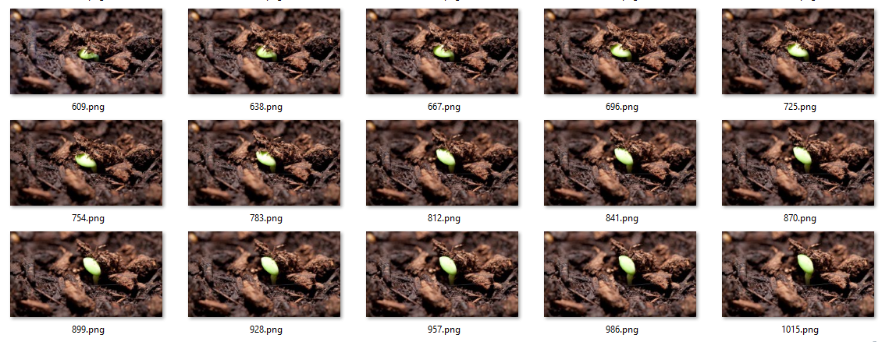Frames from the video will be extracted at a regular interval which can be set as a parameter in the source code and then saved to a sub-folder.
* Each extracted frame will then be analysed. This will involve creating a mask leaving only the green coloured pixels visible on each frame. The number of green coloured pixels will also be counted.

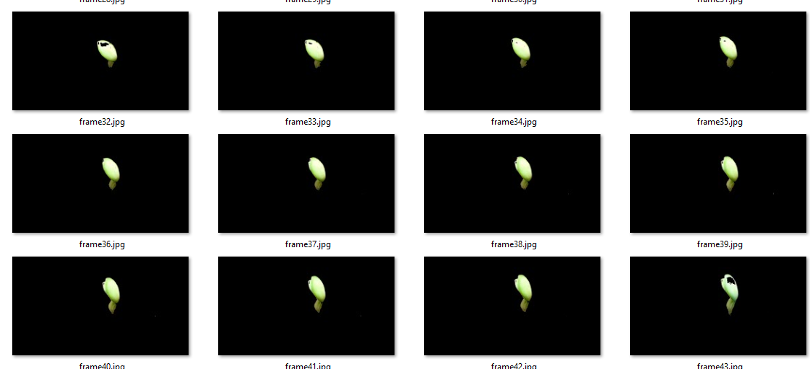

* A graph is plotted with the frame number against the number of green pixels.

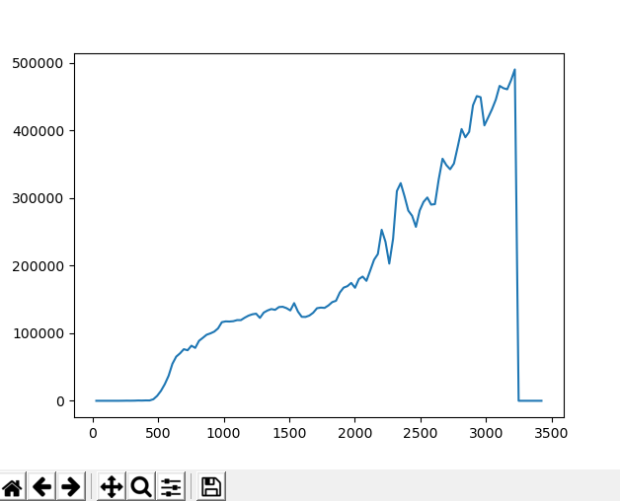

**Limitations:**

* One limitation is the fact that the video can only show one perspective of the plant. As the plant grows, its leaves will move and be at different angles relative to the camera, as a result, some area of the leaves maybe obscured effecting the accuracy of the graph.
* Another issue is lighting. The program identifies the green pixels within a given tolerance which is numerically defined in the programs parameters. For example, it will identify light green – dark green pixels. However, if the leaf is obscured by a shadow, it might appear even darker, which would result in the foliage not being considered a leaf.