**Text detection**

The aim of this project was similar to the object detection program. It was to detect, recognise and read out text that has been displayed in the cameras field of view. The idea being, that this could be coupled with the object detection program to allow for a comprehensive, text and object detection system.

**Pre requisites:**

In order for the program to detect and recognise the text from the video feed, a pre-trained model for text recognition is used called pytesseract. The paths to the directory of the module needs to be defined in the program.

In order for the text to be converted to audio, a ‘Text to speech’ engine is also used.

**How does it work?**

* The program makes use of threading to run two python programs at the same time. One thread will be working on processing the video feed, extracting any frames and cropping the text detected in the image. The other thread will work on the text recognition and generating and playing the generated mp3 file.
* Detected text will be cropped from the frame and saved in a separate folder. Then the pytesseract module will recognise and return the text in the image. The text will then be saved as a mp3 file and read out to the user.

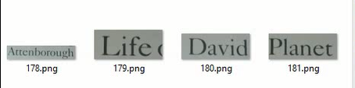

**Limitations:**

* The text detection and recognition is not accurate all the time as a result, some text may not be recognised or in some instances, the presence of text is detected, however the content of the actual text itself is not properly deciphered.
* Additionally, sentences are sometimes treated as individual words, as a result, when the text is read out, it is usually read out as individual words which is not that practical.