**PROJECT TITLE:BOOKNEST**

**(Where Stories Nestle)**

## 1. INTRODUCTION

## 1.1 Project Overview

Welcome to the Book-Store Application—a digital haven for book lovers, casual readers, and gift-seekers alike. Our platform is designed to bridge the gap between the tactile joy of traditional bookstores and the convenience of modern technology. Built with the robust MERN (MongoDB, Express.js, React, Node.js) stack, the Book-Store App offers an immersive, user-friendly experience for discovering, exploring, and purchasing books from a vast and diverse collection.

This application is more than just an online shop; it is a community space where users can browse by genre, author, or language, read reviews, and even reserve books for pickup. Whether you’re searching for the latest bestseller, a hidden gem, or a thoughtful gift, the Book-Store App brings the world of literature to your fingertips, anytime and anywhere.

## 1.2 Purpose

The purpose of this project is to provide a seamless, personalized, and accessible book-buying experience for users like Sarah, an avid reader with a busy schedule. The Book-Store App is designed to address the limitations of physical bookstores—such as limited hours and inventory—while preserving the joy of discovery and the sense of community that comes from sharing a love of books.

By leveraging modern technology, our goal is to make book discovery effortless, purchases secure, and the overall reading journey more enjoyable. The application also empowers sellers and administrators with efficient tools for inventory management, order processing, and analytics, ensuring a smooth operation behind the scenes.

## 2. IDEATION PHASE

## 2.1 Problem Statement

In today’s fast-paced world, many readers find it challenging to visit physical bookstores due to time constraints. This not only limits their ability to discover new books and authors but also diminishes the joy of browsing in a literary environment. The core problem is to create a digital solution that combines the convenience of online shopping with the personalized, engaging experience of a traditional bookstore.

## 2.2 Empathy Map Canvas

To truly understand our users, we created an empathy map focusing on individuals like Sarah:

* **Says:** “I wish I had more time to visit bookstores.”
* **Thinks:** “I want to find books that match my taste without endless scrolling.”
* **Does:** Browses online, reads reviews, seeks recommendations.
* **Feels:** Frustrated by limited time, excited to discover new reads, values convenience.

This empathy mapping guided our design choices, ensuring the app is intuitive, responsive, and tailored to the needs of modern readers.

## 2.3 Brainstorming

Our team brainstormed features that would set the Book-Store App apart:

* Personalized book recommendations
* Intuitive navigation and robust search filters
* Secure, streamlined purchasing
* Order history and shipment tracking
* Community features like reviews and ratings
* Admin and seller dashboards for efficient management

We prioritized features that enhance both user satisfaction and operational efficiency.

## 3. REQUIREMENT ANALYSIS

## 3.1 Customer Journey Map

The customer journey is carefully mapped to ensure a delightful experience at every step:

1. **Registration & Authentication:** Users create accounts securely and log in.
2. **Browsing:** Users explore books by genre, author, or popularity.
3. **Selection:** Users add books to their cart, adjust quantities, and proceed to checkout.
4. **Purchase:** Secure payment and order confirmation.
5. **Order Tracking:** Users can view order status and history.
6. **Feedback:** Users rate books and share reviews.

Each touchpoint is designed to be smooth, intuitive, and engaging.

## 3.2 Solution Requirement

**Functional Requirements:**

* User registration, authentication, and profile management
* Comprehensive book listings with detailed information
* Advanced search and filtering options
* Secure purchasing and order management
* Order confirmation and history tracking
* Admin and seller dashboards for inventory and user management

**Non-Functional Requirements:**

* Responsive design for all devices
* High performance and scalability
* Robust security for user data and transactions
* Integration with third-party APIs for payments and shipping

## 3.3 Data Flow Diagram

The Book-Store App’s data flow is structured for clarity and efficiency:

* **User Interface**: Where users interact with the app
* **Web Server**: Hosts the UI and processes requests
* **API Gateway**: Routes requests to relevant services
* **Authentication Service**: Manages secure access
* **Inventory Management**: Handles book data and stock levels
* **Order Management**: Processes purchases and tracks orders
* **Database**: Stores users, books, orders, reviews, and more

## 3.4 Technology Stack

* **Frontend**: React.js for dynamic, responsive interfaces
* **Backend**: Node.js and Express.js for efficient server-side logic
* **Database**: MongoDB for flexible, scalable data storage
* **Authentication**: JWT for secure user sessions
* **Version Control**: Git and GitHub for collaboration
* **Development Tools**: Visual Studio Code, npm, and more

## 4. PROJECT DESIGN

## 4.1 Problem Solution Fit

The Book-Store Application directly addresses the core problem by offering a platform that is always accessible, highly personalized, and rich in features. It brings the joy of book discovery to users’ fingertips, while providing sellers and admins with the tools needed for smooth operations.

## 4.2 Proposed Solution

Our solution is a full-featured digital bookstore that includes:

* User authentication and personalized dashboards
* Detailed book listings with images, descriptions, and reviews
* Advanced search and filtering tools
* Secure shopping cart and checkout process
* Real-time inventory management for sellers
* Comprehensive admin controls for user and order management
* Analytics and reporting for business insights

## 4.3 Solution Architecture

The architecture is modular and scalable:

* **User Interface Layer:** Built with React.js, ensuring a seamless experience across devices
* **Web Server:** Powered by Node.js and Express.js
* **API Gateway:** Directs traffic to appropriate microservices
* **Authentication Service:** Ensures secure access and data protection
* **Inventory & Order Management:** Handles all book and order-related operations
* **Database:** MongoDB stores all persistent data, supporting complex relationships (users-books, books-authors, etc.)

## 5. PROJECT PLANNING & SCHEDULING

## 5.1 Project Planning

The project was executed in structured phases:

1. **Requirement Gathering:** Understanding user needs and technical constraints
2. **System Design:** Creating wireframes, data models, and architecture diagrams
3. **Frontend Development:** Building the user interface with React.js
4. **Backend Development:** Setting up Node.js, Express.js, and MongoDB
5. **Integration:** Connecting frontend and backend, implementing APIs
6. **Testing:** Functional, performance, and security testing
7. **Deployment:** Launching the application and monitoring performance
8. **User Feedback:** Collecting feedback for continuous improvement

Each phase included clear milestones and deliverables to ensure timely progress.

## 6. FUNCTIONAL AND PERFORMANCE TESTING

## 6.1 Performance Testing

The Book-Store App underwent extensive testing to guarantee a smooth user experience:

* **Load Testing:** Ensured the app handles multiple users simultaneously
* **Response Time Measurement:** Optimized for quick page loads and search results
* **Security Testing:** Protected against vulnerabilities like SQL injection and XSS
* **Cross-Device Testing:** Verified consistent performance on desktops, tablets, and smartphones

Feedback from beta users was incorporated to further refine the app.

## 7. RESULTS

## 7.1 Output Screenshots

## Screenshots included:

Landing page:-

## C:\Users\arsha\OneDrive\Pictures\Screenshots\Screenshot 2024-03-25 090405.png

## Login Page:-

## C:\Users\arsha\OneDrive\Pictures\Screenshots\Screenshot 2024-03-25 090515.png

Home Page:-

## C:\Users\arsha\OneDrive\Pictures\Screenshots\Screenshot 2024-03-25 090405.png

Books Page:-

## C:\Users\arsha\OneDrive\Pictures\Screenshots\Screenshot 2024-03-25 090632.png

## Wishlist Page:-

## C:\Users\arsha\OneDrive\Pictures\Screenshots\Screenshot 2024-03-25 090648.png

## My Bookings Page :-

## C:\Users\arsha\OneDrive\Pictures\Screenshots\Screenshot 2024-03-25 091147.png

## Seller Dashboard:-

## C:\Users\arsha\OneDrive\Pictures\Screenshots\Screenshot 2024-03-25 091336.png

Seller Items: 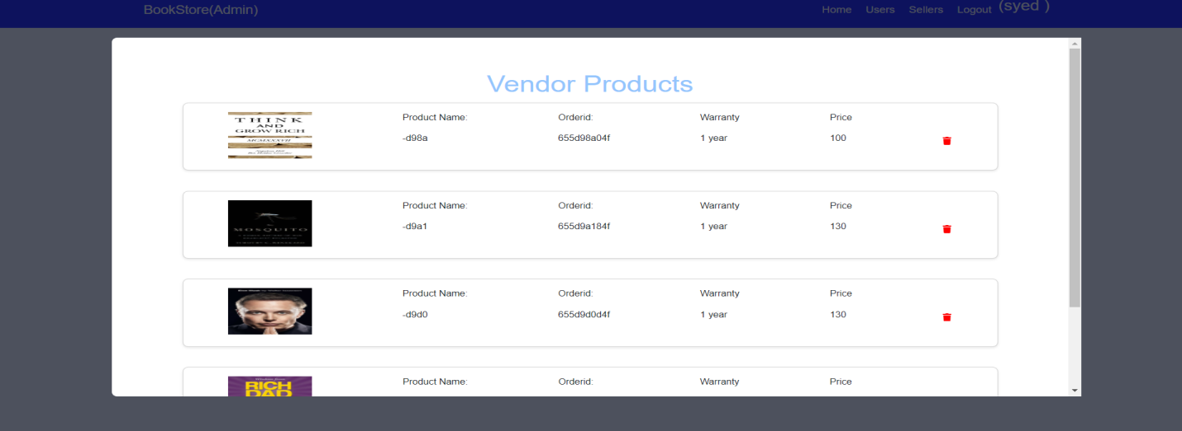

Admin Dashboard:-

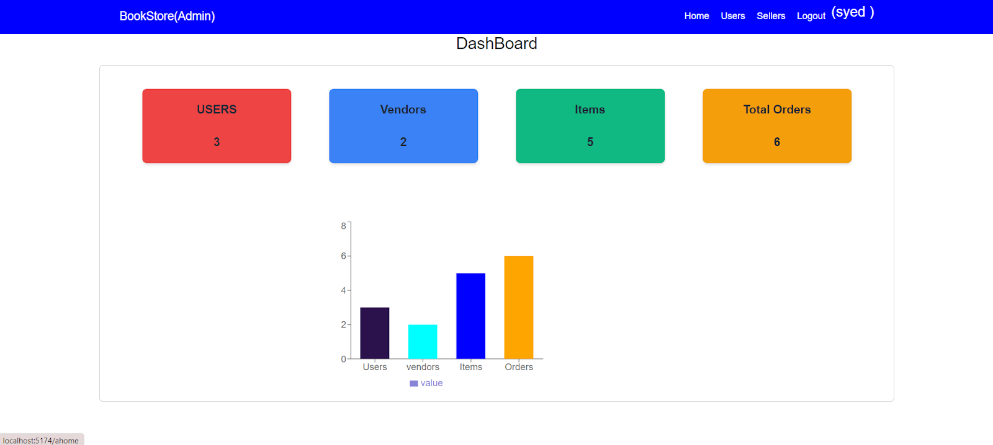

Users Page:

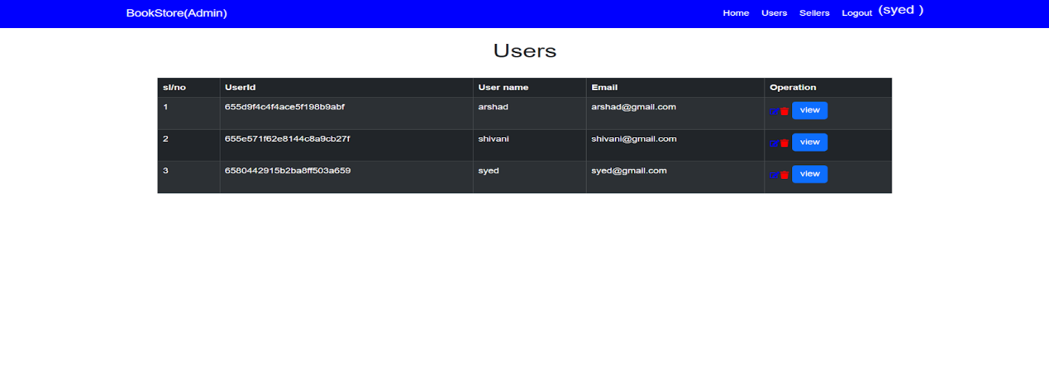

User Orders:

## C:\Users\arsha\OneDrive\Pictures\Screenshots\Screenshot 2024-03-25 091542.png

## Sellers Page:

## C:\Users\arsha\OneDrive\Pictures\Screenshots\Screenshot 2024-03-25 091556.png

## 8. ADVANTAGES & DISADVANTAGES

## Advantages

* **24/7 Accessibility:** Users can browse and buy books anytime, anywhere
* **Extensive Collection:** No physical space limitations
* **Personalized Recommendations:** Tailored to user preferences
* **Community Features:** Reviews, ratings, and wishlists
* **Secure Transactions:** Safe and reliable payment processing
* **Efficient Management:** Powerful dashboards for sellers and admins

## Disadvantages

* **No Physical Browsing:** Lacks the tactile experience of a bookstore
* **Internet Required:** Offline access is limited
* **Technical Issues:** Potential for bugs or downtime
* **Shipping Delays:** Physical book delivery may take time

## 9. CONCLUSION

The Book-Store Application successfully delivers a modern, convenient, and engaging platform for book lovers. By blending the best aspects of traditional bookstores with the power of technology, it creates a literary community that is accessible, efficient, and enjoyable. The project demonstrates the potential of the MERN stack in building scalable, user-focused applications and sets the stage for future innovation in the world of digital reading.

## 10. FUTURE SCOPE

* **E-Book Integration:** Offer digital downloads for instant reading
* **AI Recommendations:** Smarter, more personalized book suggestions
* **Community Features:** Reading groups, forums, and events
* **Mobile App Development:** Native apps for iOS and Android
* **Audiobook Support:** Integration with audiobook platforms
* **Global Expansion:** Multi-language support and international shipping

## 11. APPENDIX

* **Source Code:** https://github.com/sanjus0512/book-nest1
* **Project Demo Link:** **https://youtu.be/EAwxPVq41kw?si=3rp2bEQ3VCKBom6I**